MATHIAS MOORE ACTIVE DIRECTORY LAB

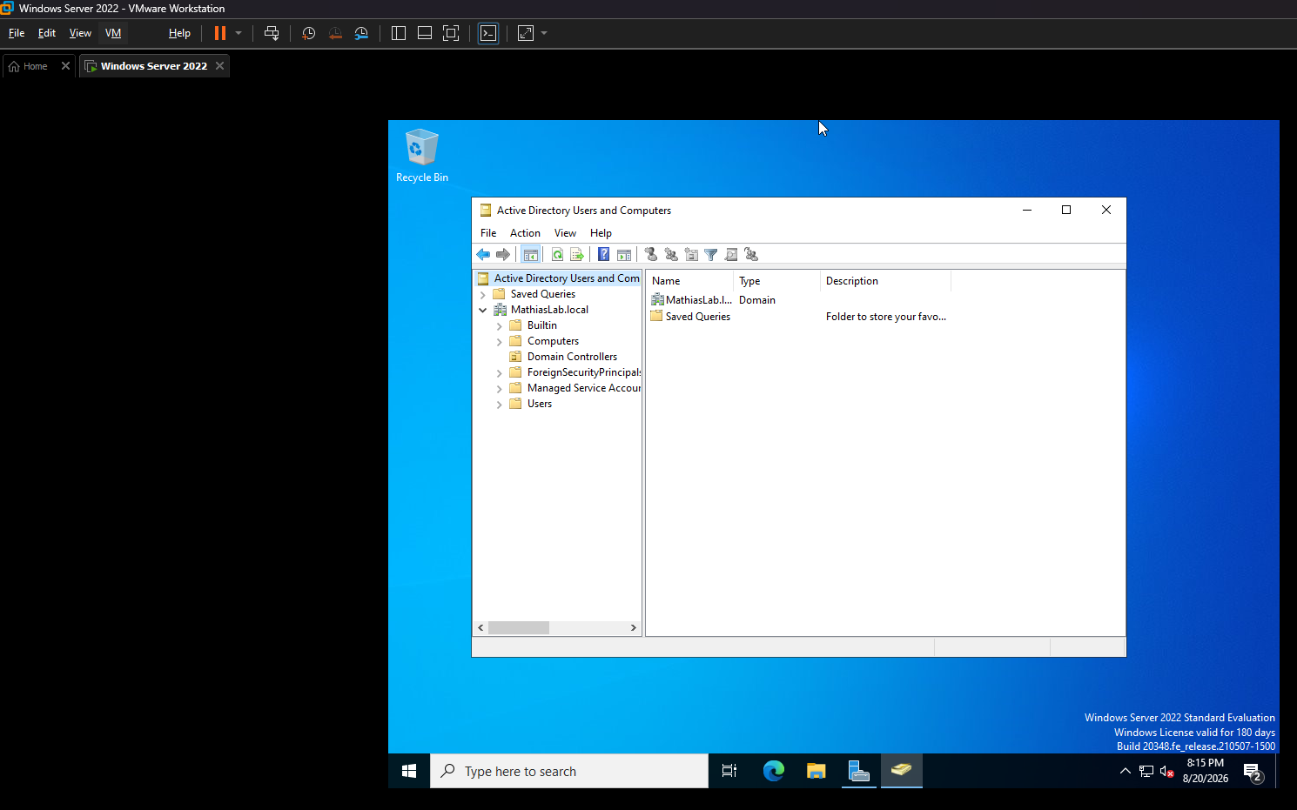
Active Directory Users and Computers: Shows the newly configured Active Directory domain and its default organizational containers. The Active Directory environment is hosted on a Windows Server virtual machine using VMware, providing a virtualized environment for domain administration and testing

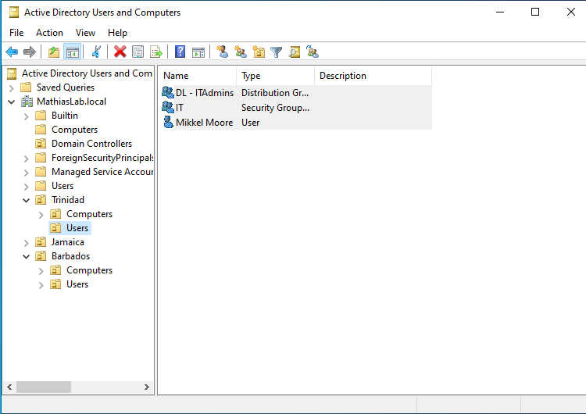

Created OUs based on country names, with separate Users and Computers sections under each country. A Security Group and Distribution Group were created for each country, along with a user account, demonstrating basic organizational, user, and group management in Active Directory.

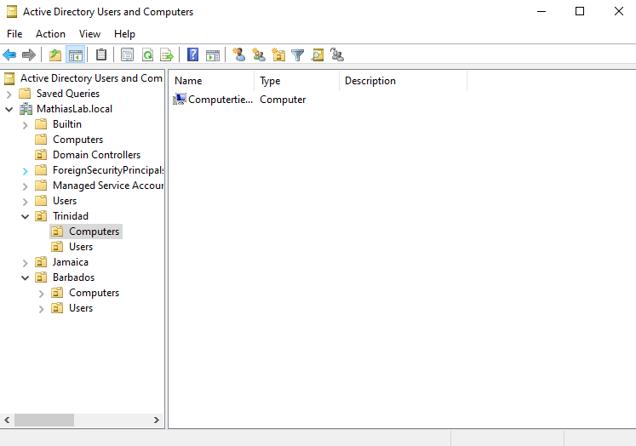

Created a dedicated computer account for each country within its respective Computers OU, demonstrating how domain-joined devices can be organized by geographic location in Active Directory.

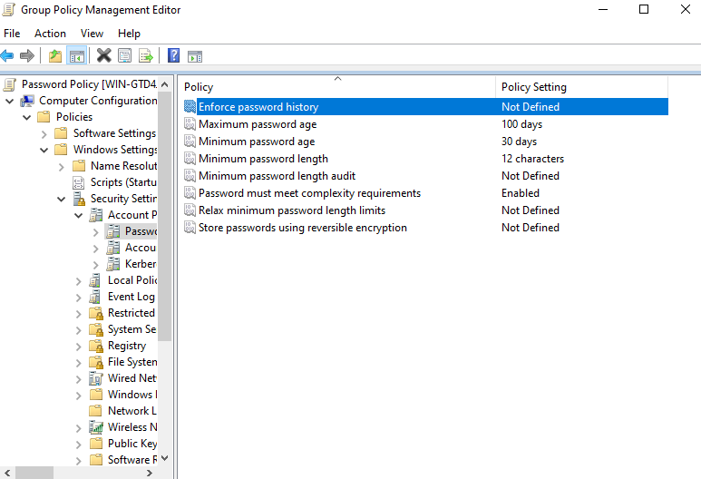
Created and configured a domain password policy to enforce password complexity and strengthen account security across the Active Directory environment.

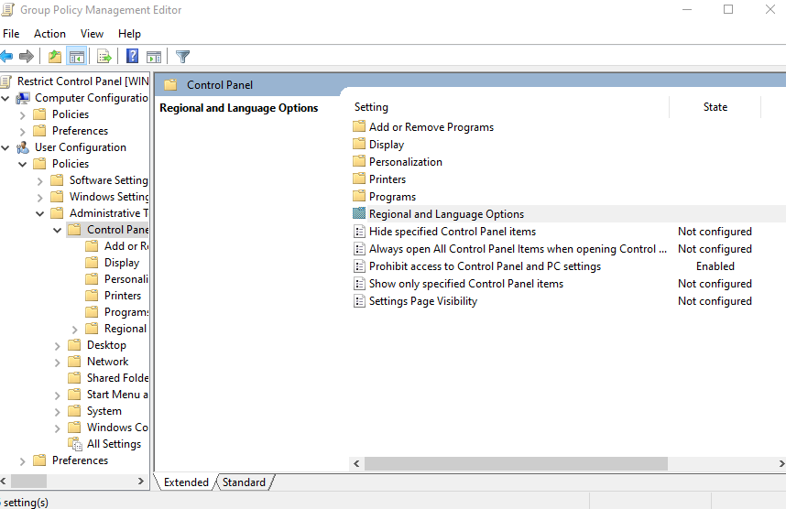

Configured a Group Policy under User Configuration to prohibit users from accessing Control Panel and PC Settings, restricting unauthorized system configuration changes.

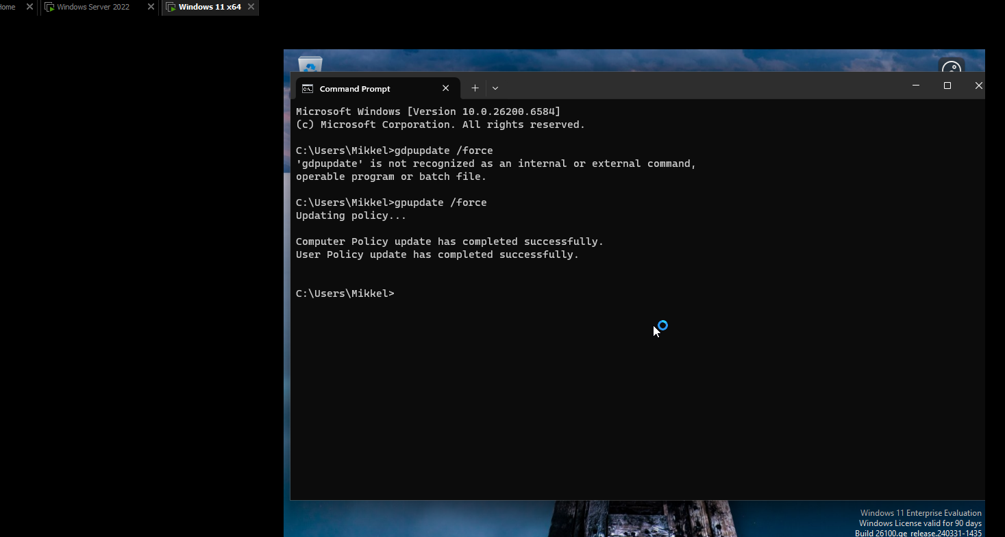

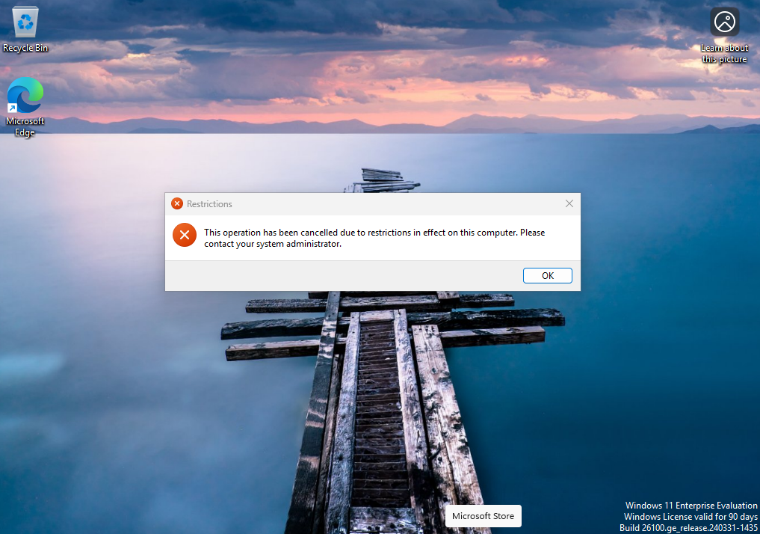

Set up a client VM and assigned the relevant IP addresses. Logged in with the user account I created, named Mikkel. Applied the group policy for that user and used the appropriate command to force it to apply immediately.

After this was done, a test was done to observe if the control panel could be opened and this confirmed the policy worked fine.

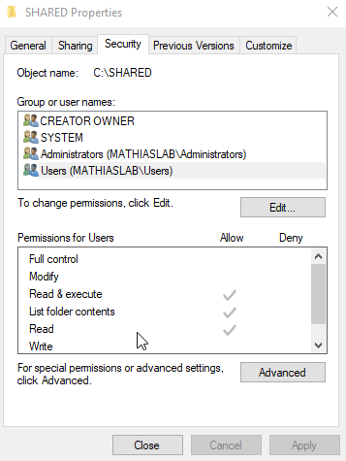

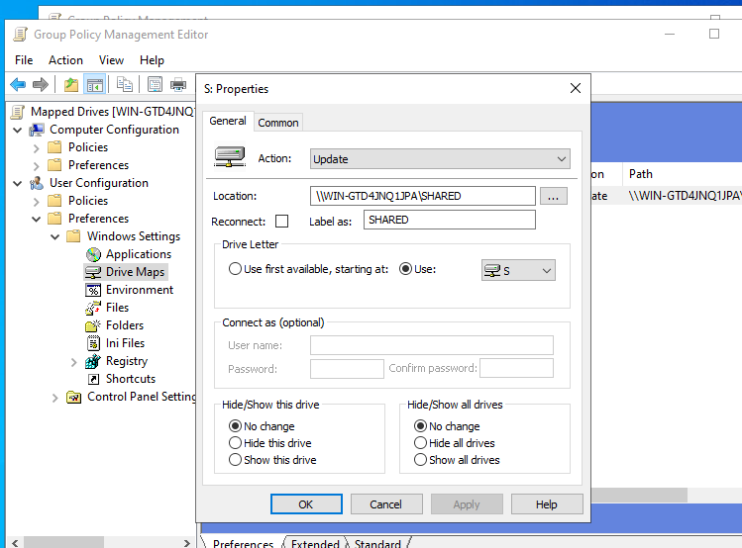
Created a shared folder and gave users of the domain access to it. In addition, I created a GPO to automatically map the network drives for users.

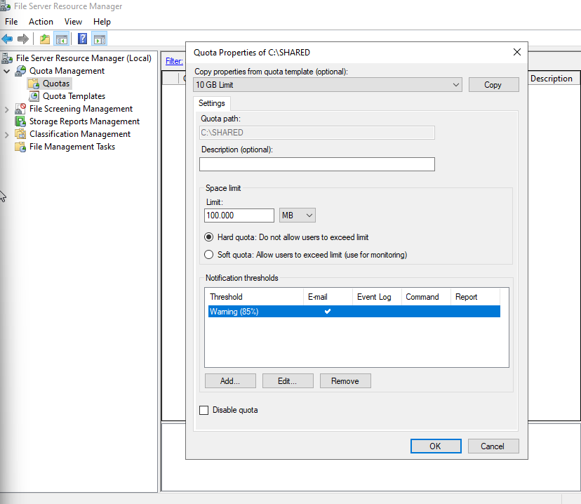

Set a 100MB quota for the shared folder and also added a notification threshold for the administrator to be alerted when the folder is at 85% of its capacity.

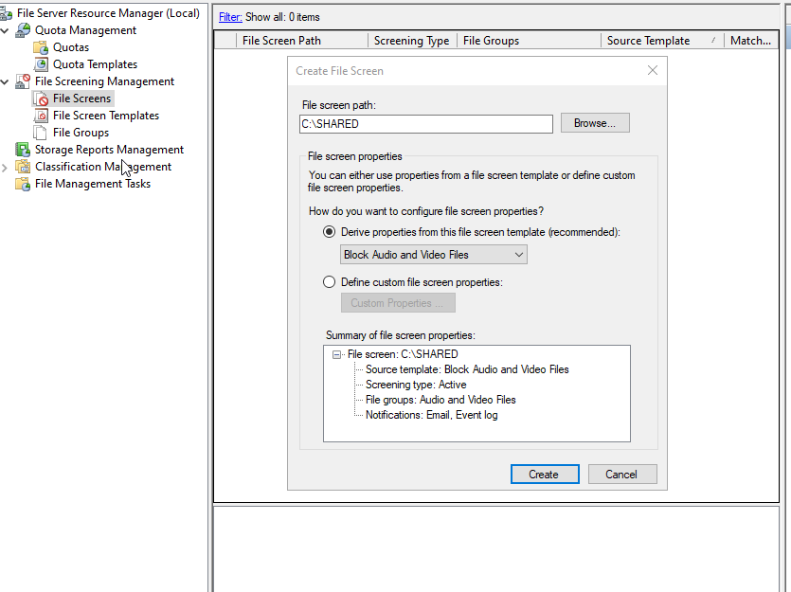

Created a file screen to manage what type of documents can be allowed to the shared folder. Audio and video files were blocked.

