Supplementary information

Identifying evolutionary and kinetic drivers of NAD-dependent signalling - Bockwoldt et al.

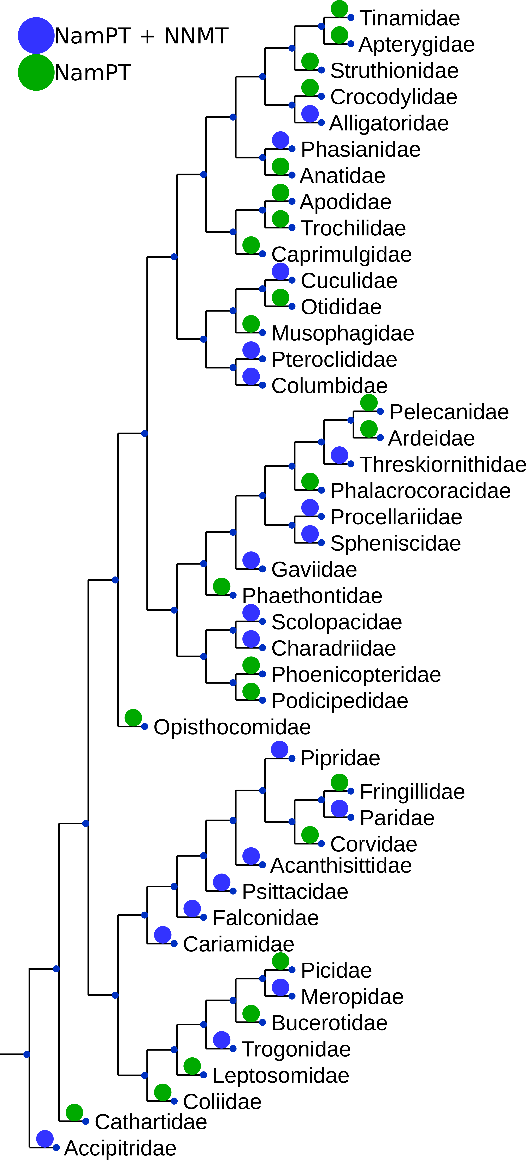

Supplementary Figure S2. **The phylogenetic distribution of NamPT and NNMT in birds and reptiles is scattered.** The phylogenetic distribution of birds and reptiles was adopted from {Prum2015}. Families are marked with a green circle if they possess NamPT without NNMT or a blue circle if they possess both NamPT and NNMT.

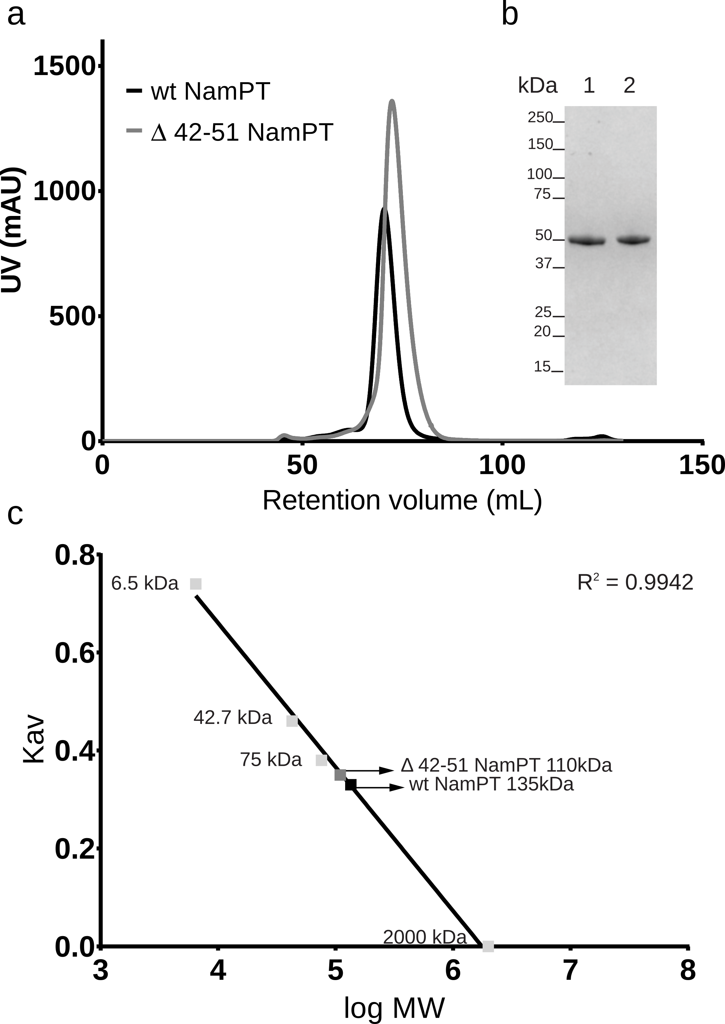

Supplementary Figure S3. **Purification of wt NamPT and Δ42-51 NamPT.** A) Elution profile of wildtype NamPT and mutant Δ42-51 on size-exclusion chromatography using a Superdex 200 16/60 column. B) Coomassie stained denaturating SDS-PAGE analysis of Δ42-51 NamPT (lane 1) and wt NamPT (lane 2). 3 µg of pooled enzyme eluted from SEC loaded onto the gel. C) The column was calibrated with apronitin 6.5 kDa, ovalbumine 42.7 kDa, coalbumine 75 kDa and blue dextran 2000 kDa. The partition coefficient (Kav) was determined for each standard (light grey squares) and plotted versus log10 molecular weight. The Kav was determined for wt NamPT and Δ42-51 NamPT and the apparent molecular weight calculated to be 135 kDa and 110 kDa, respectively.

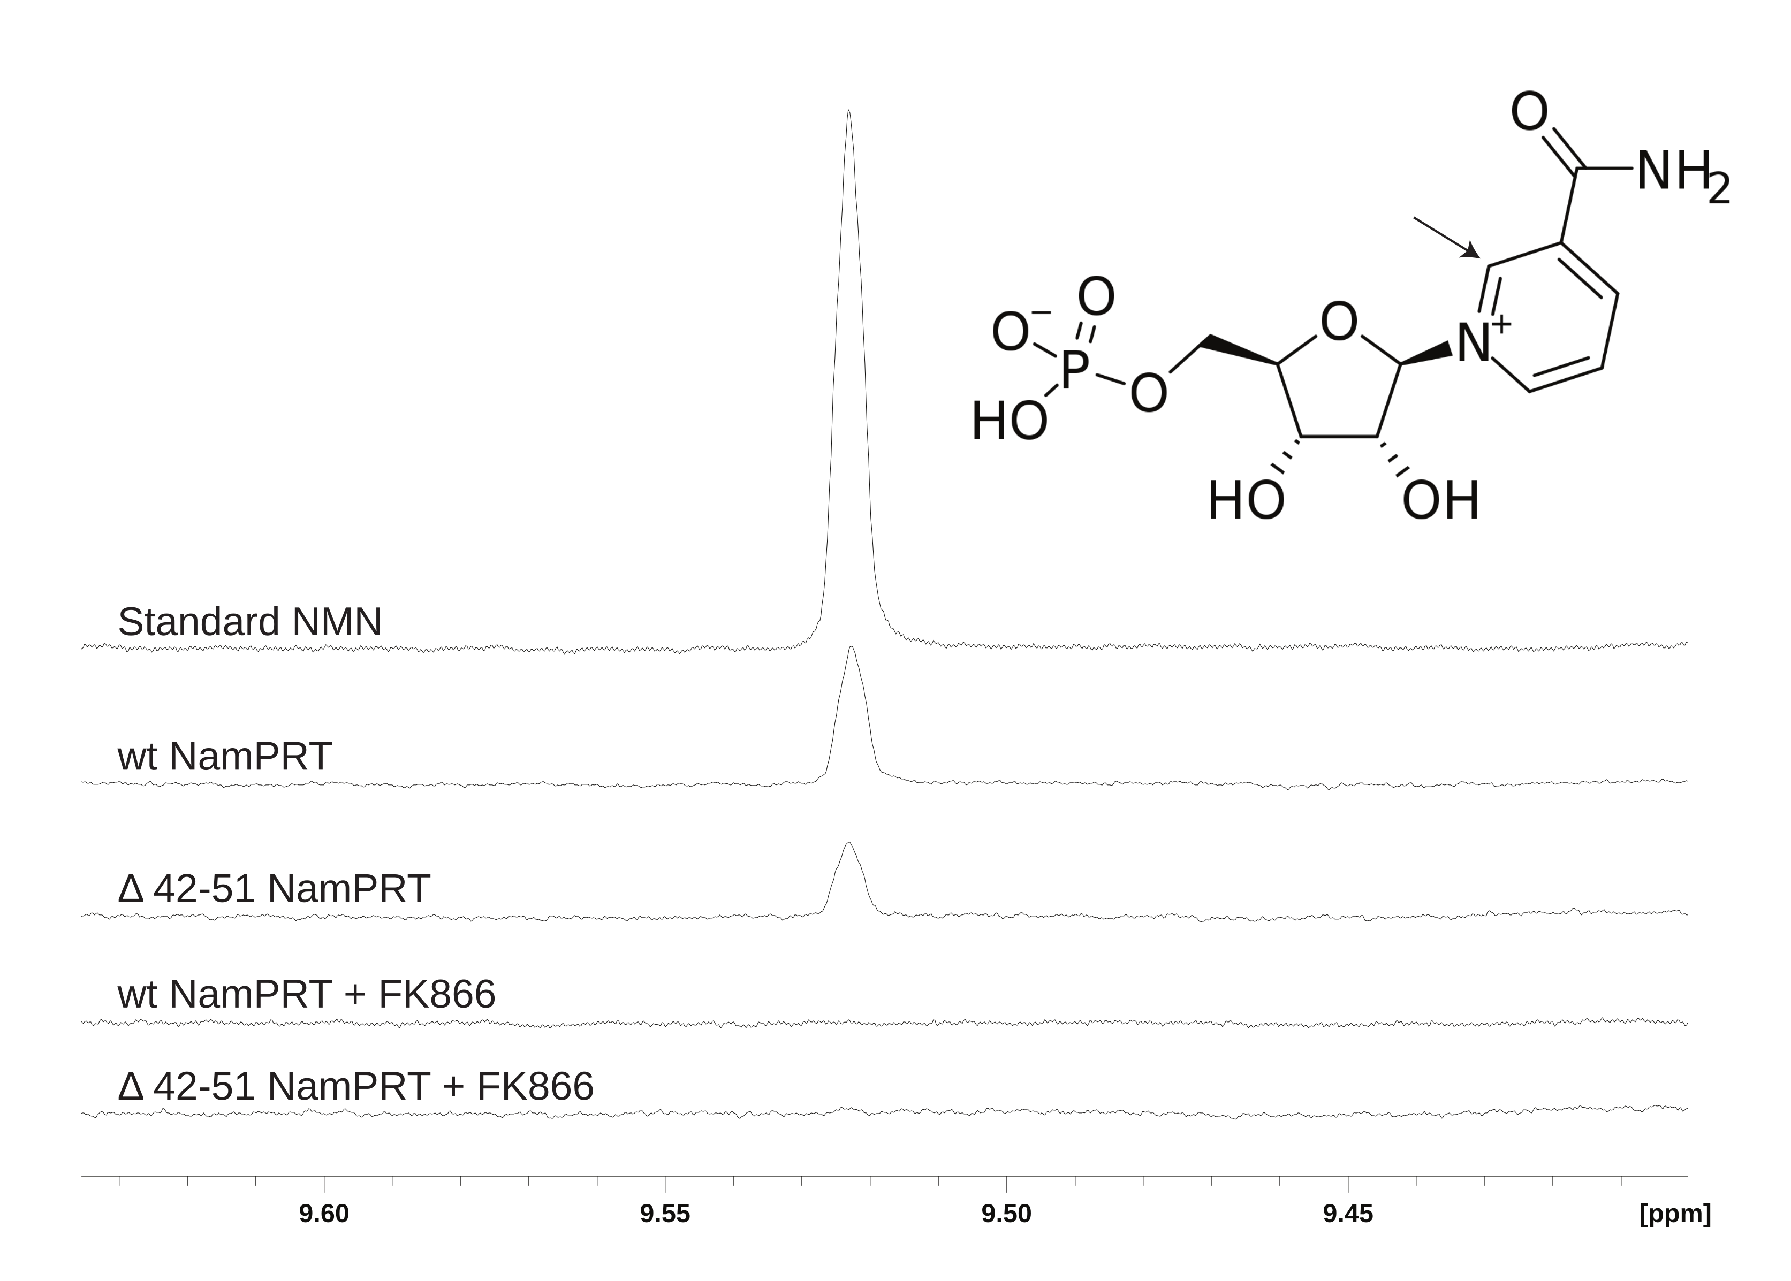

Supplementary Figure S4. **NMR measurement of NamPT activity.** NamPT activity was measured as described in Experimental Procedures and product (NMN) formation was detected using 1D 1H NMR spectroscopy. Inset on the right: molecular structure of NMN with the atom detected by NMR indicated by an arrow. The range used for NMN detection in typical 1D 1H NMR spectra of the enzymatic reactions is shown. NMN quantification was done with the singlet detected at 9.52 ppm. From the top to the bottom, peak detection of NMN standard (200 µM), wildtype NamPT (1 mM Nam and 1 mM PRPP), mutant Δ42-51 NamPT (1 mM Nam and 1 mM PRPP), wildtype NamPT with FK866, and mutant Δ42-51 NamPT with FK866. Incubation with inhibitor FK866 was done for 30 min at 30 °C.

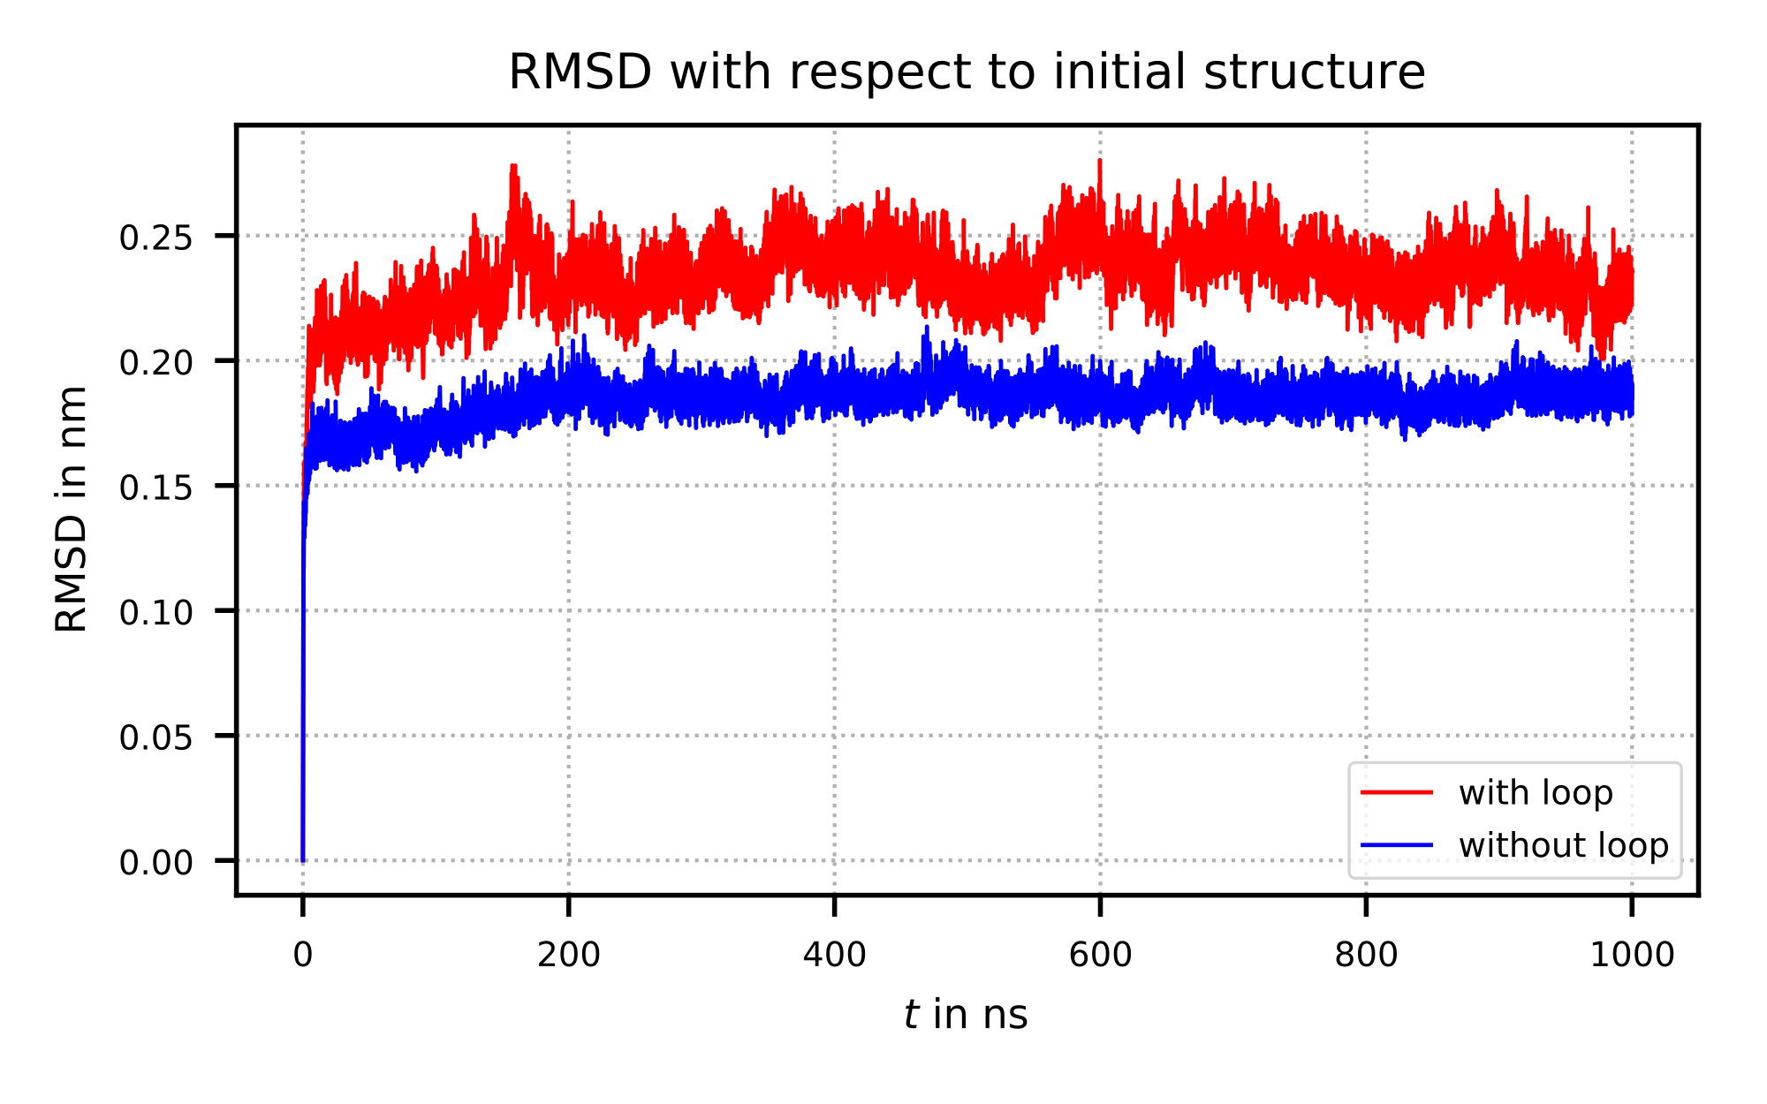Supplementary Figure S5. Root mean square deviation (RMSD) with respect to initial structure for simulation of NamPT with loop insertion (red) and without loop insertion (blue), respectively. The RMSD values for the entire simulation (in total 1000 ns) show stable structures with small fluctuations.