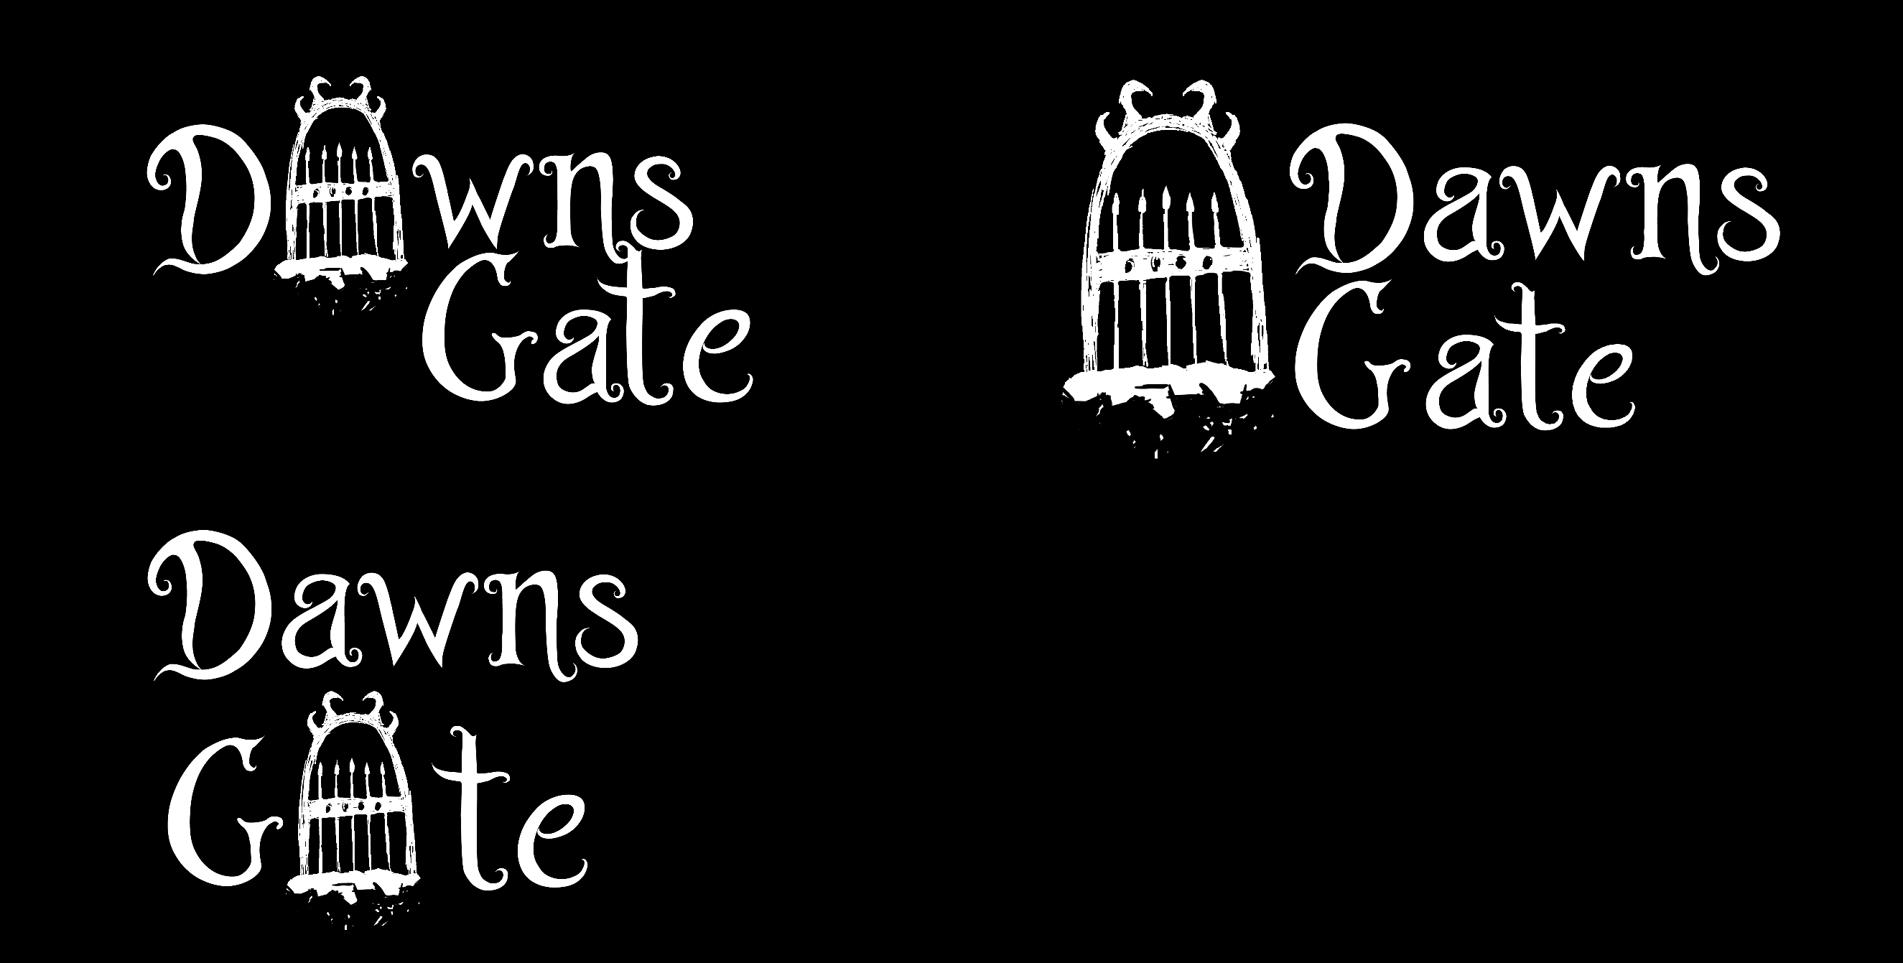

Game Design Document

Game design and development MSCs

Mathieu Schmerber

15 August 2022

Contents

Game design concepts 2

Overview 2

Overview 2

Short lore 3

Character, Controls, Camera 3

Combat 3

Run concept 3

Genre definitions 3

Run structure 3

Event rooms 3

Lunaris 3

Scaling 3

Run scaling 3

Lobby Scaling 3

Project management 3

Team 3

Sprints 4

Play testing 4

Artistic direction 4

Inspirations 4

Visuals 5

3D Art 5

2D Art and user interfaces 5

Visual effects 5

Musics and sounds 5

Theme choices 5

SOund design 5

Game development 5

Optimisation 5

Development Tools 6

Additional features 6

# Game design concepts

## Overview

### Overview

### Short lore

## Character, Controls, Camera

## Combat

## Run concept

### Genre definitions

### Run structure

### Event rooms

### Lunaris

## Scaling

### Run scaling

### Lobby Scaling

# Project management

## Team

## Sprints

## Play testing

# Artistic direction

## Inspirations

## Visuals

### 3D Art

### 2D Art and user interfaces

### Visual effects

## Musics and sounds

### Theme choices

### SOund design

# Game development

### Optimisation

### Development Tools

### Additional features