# *Résultat de recherche d'images pour "logo mtes"Résultat de recherche d'images pour "centre de ressources trame verte"*

# **BioDispersal v1.1 User Guide**

*Mathieu Chailloux, Jennifer Amsallem – Irstea – UMR TETIS*

# Abstract

In the context of ecological networks, many modelling methods are based on landscape permeability. BioDispersal has been designed to provide a friendly-user tool to produce permeability and dispersal maps. Implemented dispersal method computes reachable areas for a specie (or a set of species) from its living environments (considered as reservoirs of biodiversity) depending on its dispersal ability (expressed as maximum capacity) and on landscape permeability. A cost is assigned to each land cover class/element according to the energy spent to cross such element. Dispersal is performed by computing cumulative costs from starting pixels (reservoirs) until maximum capacity is reached. The set of pixels with a cumulative cost inferior to maximum capacity is then considered as dispersal area.

# Table of contents

[Prerequisites 1](#_Toc13056556)

[Installation 2](#_Toc13056557)

[Step by step 2](#_Toc13056558)

[Project file 3](#_Toc13056559)

[1. Parameters 3](#_Toc13056560)

[2. Subnetworks 4](#_Toc13056561)

[3. Selection 4](#_Toc13056562)

[4. Merge 6](#_Toc13056563)

[5. Friction 7](#_Toc13056564)

[6. Weighting 8](#_Toc13056565)

[7. Dispersal 9](#_Toc13056566)

[Example 11](#_Toc13056570)

# Prerequisites

BioDispersal is available in QGIS 3 (<https://www.qgis.org/fr/site/forusers/download.html>).

Tests have been performed using QGIS 3.4.7, GRASS 7.6.1 on Windows 10, Ubuntu 18.04.1 (bionic) and macOS Mojave (10.14) systems.

On Linux, package *python-gdal* is necessary.

File and directory names must not include spaces nor accents.

# Installation

To install BioDispersal from QGIS, go to ‘Plugins’ menu, ‘Install/Manage plugins’, search for ‘BioDispersal’ and press ‘Install’ button. A dear icon should appear in QGIS toolbar.

# Step by step

BioDispersal defines a 7-steps process:

1. Parameters setting: workspace, extent layer, spatial resolution
2. Subnetworks definition
3. Input data selection, classification and rasterization
4. Merge of selection results to produce specific land cover layer for each subnetwork.
5. Assignment of friction coefficients (moving costs) for each subnetwork and class.
6. Weighting of friction coefficients **(optional step)**, for instance depending on urban areas proximity, slope, …
7. Dispersal map computation for each subnetwork from start layer (reservoirs of biodiversity), maximal cost, and friction layer

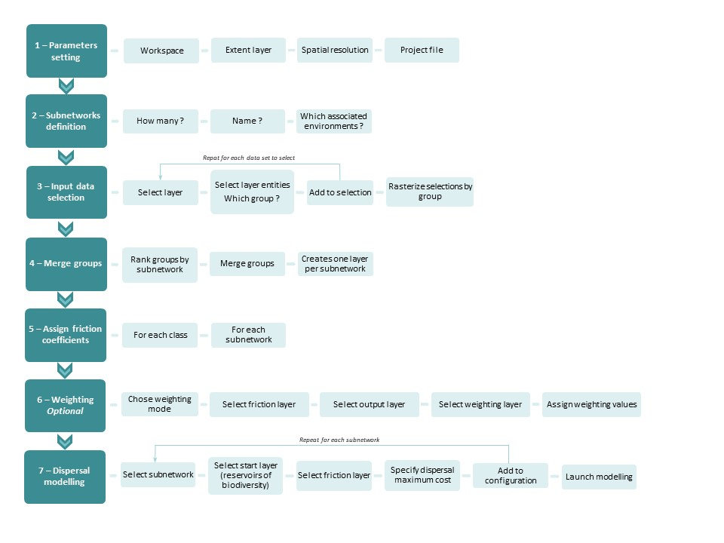Below Figure 1 illustrates these steps:

Figure 1 : BioDispersal steps

# Project file

**It is strongly recommended to save BioDispersal configuration at each modification.** Current configuration is displayed in visualization table in the graphical interface and can be saved in an .xml file called ‘project file’.

****Project file management:

**Open BioDispersal project**: select existing project (.xml) and open it.

**Save BioDispersal project as**: save project to new file (.xml) or overwrite existing file.

**Save project**: save project to file specified in ‘Parameters’ tab (*projectFile* field).

**About:** opens new window explaining BioDispersal development context.

# Parameters

**Parameters must be set before any processing. Workspace must be set before any file operation.**

**Workspace:** select workspace directory path from which relative paths are computed.

**Extent layer:** select territory extent layer. To avoid “border effect”, it is recommended to apply a buffer to administrative borders.

**Resolution**: specify spatial resolution of raster layers produced by BioDispersal in georeferenced units. Tests were only performed on metric systems. **Resolution has a huge impact on execution time.**

**Projection**: select coordinates projection system

Visualization table displays current configuration.

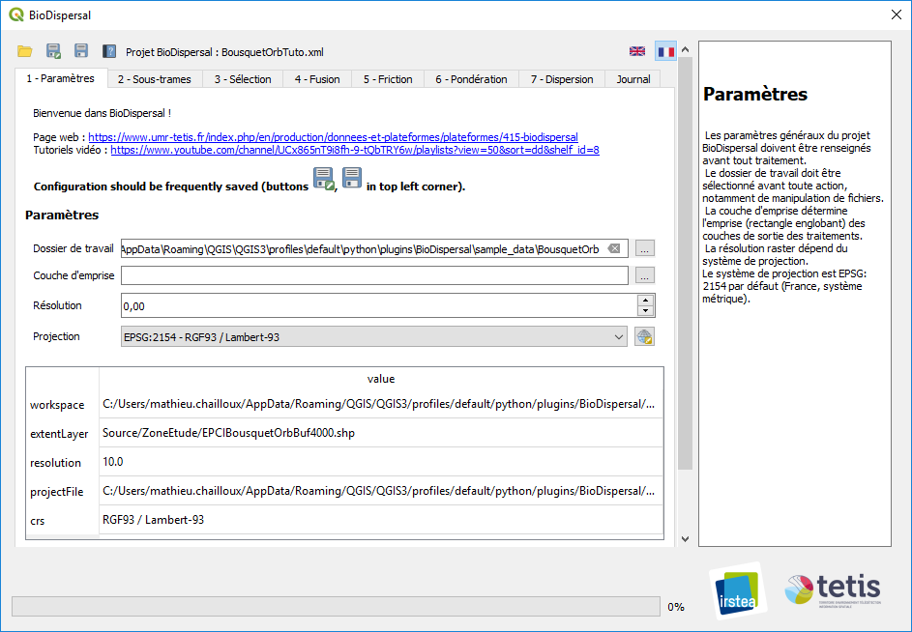

# Subnetworks

Subnetwork are used to represent environments with close properties (such as forest environments) and because modelling cannot be performed for each existing specie. Permeability and dispersal maps are then produced for each subnetwork.

**Name**: name subnetwork. Name must not include spaces nor special characters.

**Description**: subnetwork description.

Use  and  buttons to add and delete subnetworks.

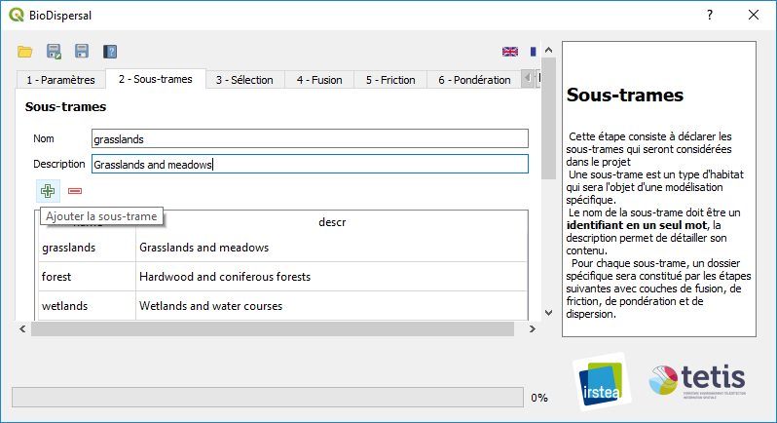Below picture illustrates BioDispersal project with 3 subnetworks:

# Selection

Selection step extracts and normalizes input data. Selection is performed from an input layer according to a selection mode and assigns a class and a group to selected data.

- Merge groups gather data according to thematic criteria (land cover, roads, water courses, …) and geometry/format (point, line, polygon, raster).

- Classes are automatically generated to discriminate data according to thematic and permeability criteria.

## Layer

**Format**: select input layer format (vector or raster).

**Select layer**: select a layer already loaded in QGIS from list.

**Open layer**: select new layer from file. Layer is loaded in QGIS and automatically selected. Vector layers encoding is automatically set to ‘UTF-8’ for Geopackages, ‘Latin-1’ for Shapefiles on Unix systems, ‘System’ for Shapefiles on Windows. If encoding is wrong, layer must be loaded from QGIS and encoding manually changed.

## Selection mode

Selection mode depends on layer format.

**C:\Users\amsallem\Pictures\Screenpresso\2018-06-25_18h33_53.pngVector**:

C:\Users\amsallem\Pictures\Screenpresso\2018-06-25_18h33_53.png **By field**: specify layer field from list. Input layer entities are selected and classified according to field values (one class per unique value).

**By expression**: select entities according to specified expression. If expression is empty, every entities is selected.

**Raster:**

**Create classes:** check this option to generate classes for each input raster layer unique value. Uncheck this option if layer just need to wrapped according to project parameters.

**Resampling mode:** resampling mode (*gdal\_warp* options).

To select data from input land cover layer, use selection mode ‘By Field’ or raster mode with ‘Create classes’ option checked.

Overlapping features of same layer with different permeability should be selected in different groups so that they can be ranked in next step.

## Group

**Add to group**: select existing group in which selected data is inserted.

**New group**: creates new group in which selected data is inserted. Chose name (without spaces nor special characters) and description then press “Add” button. New group is automatically selected.

## Classes/Groups table

Group are displayed in a visualization table.

To display classes, press **C:\Users\amsallem\Pictures\Screenpresso\2018-06-25_18h33_53.png** **Show classes.** A class is composed of a *name*, a *code* (pixel value in outputs), a description *descr* and a *group*. Classes are automatically generated. In **By expression** mode (VExpr), class name matches group name. In **By field** mode (VField), and **Raster** (RClasses if option ‘Create classes’ is checked), each input unique value matches a class named *groupname\_value.*

To display groups list, press **C:\Users\amsallem\Pictures\Screenpresso\2018-06-25_18h33_53.png** **Show groups**.

To delete a class or a group, select it and press  button.

## 🡺 Save selection

Press  to save current selection configuration. A new line appears in visualization table.

Repeat selection steps for each data to select.

User can order selection with buttons C:\Users\amsallem\Pictures\Screenpresso\2018-06-28_11h08_48.png C:\Users\amsallem\Pictures\Screenpresso\2018-06-28_11h08_23.png. This can be useful when performing several selections to a same group. In this case, selection order can matter as rasterization can erase previous data.

To delete a selection configuration, press .

## 🡺 Launch selections

To perform selections, press C:\Users\mathieu.chailloux\Pictures\Screenpresso\2018-08-07_16h37_45.png. For each vector group, selected entities are gathered into a temporary layer (*group\_vector.gpkg*) with following attributes: *origin* (input layer), *code* (class identifier). This layer is then rasterized according to parameters. For each raster group, input layer is reclassified and resampled.

Resulting layer *group.tif* is loaded in QGIS. Layer must not be already loaded in QGIS (otherwise an error such as ‘Permission denied’ occurs).

**Apply only to selected lines**: check this option to perform selection operation only to selected lines.

If resulting layer seems empty with value like 1.79769e+308, no entity has been selected.

**Processing can be long with huge layers such as land cover.**

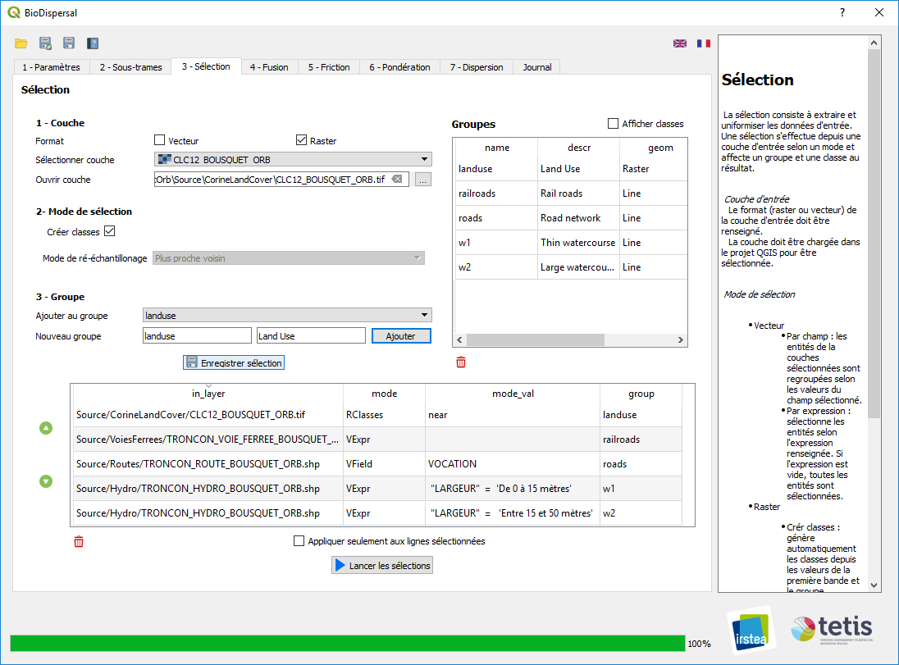

# Merge

For each subnetwork, results of selection step must be selected, ranked and merged.

For instance, roads data is often ranked before land cover because of its fragmentation role. More generally, data with low permeability or better precision is ranked first, except if some data is more relevant (for instance water courses before roads in ‘wetlands’ subnetwork).

**Subnetwork**: select current subnetwork. Groups are displayed in table.

**Rank layers**: rank groups with C:\Users\amsallem\Pictures\Screenpresso\2018-06-28_11h08_48.png C:\Users\amsallem\Pictures\Screenpresso\2018-06-28_11h08_23.png buttons.

**Reload layers**: press  to reload all groups for current subnetwork.

Press  to delete a group from current subnetwork.

**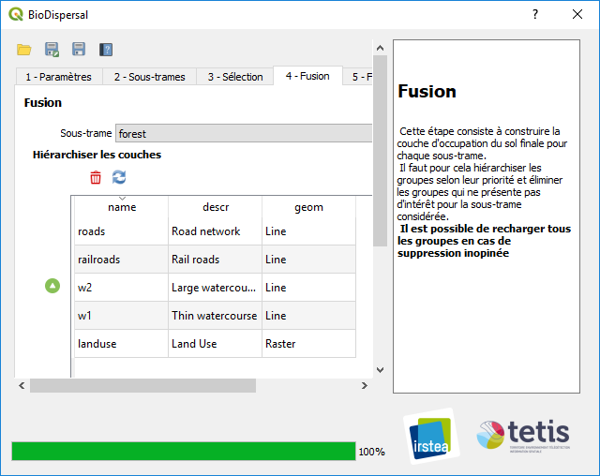Merge:** press C:\Users\mathieu.chailloux\Pictures\Screenpresso\2018-08-07_16h47_24.png to merge groups for each subnetwork. Resulting layers *subnetwork\_merged.tif* are loaded in QGIS.

# Friction

Friction table contains all classes of current configuration (one class per line).

Table columns contains class description *class\_descr*, class name *class*, class *code* (pixel value in raster layer) and friction coefficient for each subnetwork. **If coefficient cell is empty or contains string ‘None’ then matching class is ignored for matching subnetwork.**

**Coefficients choice:**

It can be difficult to find scientific references to assign coefficients. Coefficient of living environments is usually assigned to 1. Then, a good way to choose coefficient is to work with proportionality ; i.e. how much class A seems permeable comparing to class B ?

Elements that cannot be crossed shall have a huge coefficient, superior to maximum dispersion cost.

Press  to **Reload classes** according to current configuration.

Press  to **Import friction coefficients** from existing CSV (Comma-Separated Values) file. CSV separator must be “;”.

Press  to **Save friction table as CSV file.**

Press C:\Users\mathieu.chailloux\Pictures\Screenpresso\2018-08-07_17h02_36.png to **Compute friction layers.** A friction layer is produced for each subnetwork with class codes reclassified to matching friction coefficient (or NoData if no coefficient is specified). Resulting layers *subnetwork\_friction.tif* are loaded in QGIS with a predefined style: ‘Paletted/Unique values’ with color ramp ‘RdYlGn’ inverted. This means that green pixels represent high permeability to movements and red pixels a low permeability. Each coefficient value (cast to integer if needed) is represented by a different color.

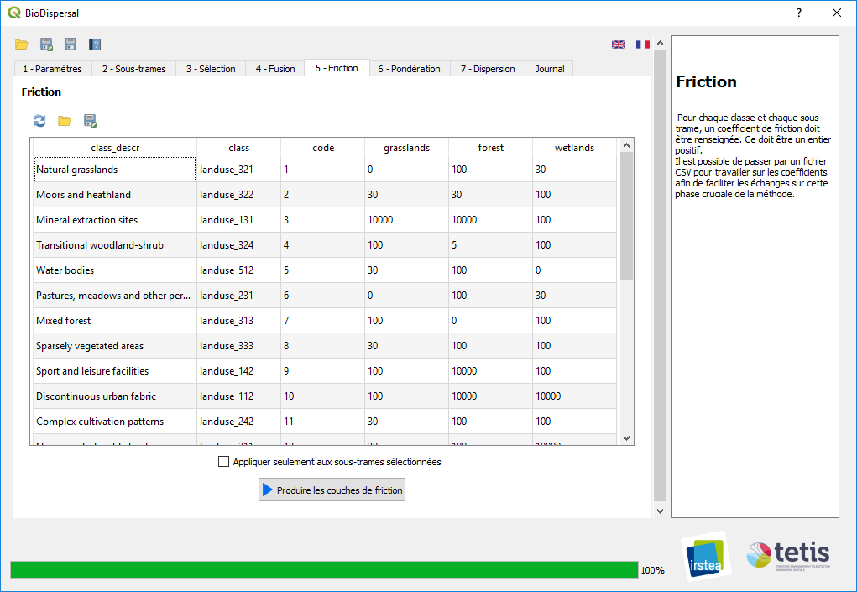

# Weighting

**This step is optional.**

Weighting allows to take into account elements not present in land cover, for instance slope or proximity to urban areas/roads. Weighting is performed from a **friction layer** produce in previous step, a **weighting layer** according to a **weighting mode**. If needed, layers are warped according to parameters so that they are aligned.

**Weighting mode**: chose weighting mode amongst below values. In these descriptions, “friction pixel” and “weighting pixel” represent aligned pixels of friction and weighting layers.

* *Minimum:* result is the minimum value of friction and weighting pixels
* *Maximum:* result is the maximum value of friction and weighting pixels
* *Multiplication:* result is the product of friction and weighting pixels
* *Intervals:* friction pixel is multiplied by weighting coefficient if ponderation pixel belongs to matching interval, and remains unchanged if no interval matches. This mode is used to perform weighting by slope for instance.
* *Buffers:* friction pixel is multiplied by weighting coefficient if distance to weighting layer belongs to matching interval. Distance to weighting layer is the minimum distance (in meters) to a pixel that is not NoData. This mode is used to perform weighting by distance to roads.

**Friction layer**: select or open friction layer.

**Output layer**: chose output layer path.

**Weighting:** select weighting layer and defines weighting parameters if needed

* *Intervals*: define value intervals [*low\_bound*,*up\_bound*] of weighting layer and associated weighting coefficients *pond\_value***. Intervals must contiguous.**
* *Buffers*: define distance intervals [*low\_bound*,*up\_bound*] of weighting layer and associated weighting coefficient *pond\_value***. Intervals must contiguous.**

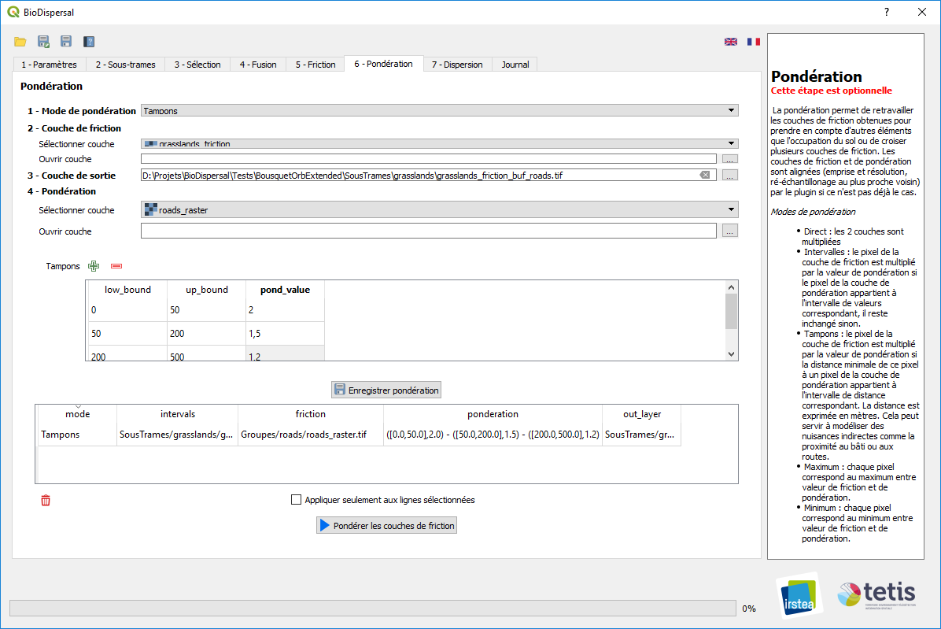

# Dispersal

Dispersal modelling is performed for each subnetwork from start layer (reservoirs of biodiversity), friction layer (weighted or not) according to dispersal maximum cost (maximum dispersal capacity expressed in cost unit).

**Start layer**: select or open start layer. Layer can be vector or raster, it is rasterized or warped according to parameters.

**Friction layer:** select or open friction layer already produced by BioDispersal.

**Maximum cost:** specify maximum dispersal cost (capacity). Huge cost can impact execution time.

**Output layer**: chose output layer path.

Press  to save dispersal current configuration.

*=> Set dispersal configuration for each subnetwork*

Press C:\Users\mathieu.chailloux\Pictures\Screenpresso\2018-08-07_17h14_49.png to launch dispersal modelling for each configuration. Resulting layers are loaded in QGIS with a predefined style: ‘Singleband pseudocolor’ with a random color ramp amongst single color ramps.

**Execution time depends mainly on raster layers size and also on maximum cost.**

**Apply only to selected lines**: check this option to launch modelling only to selected configurations.

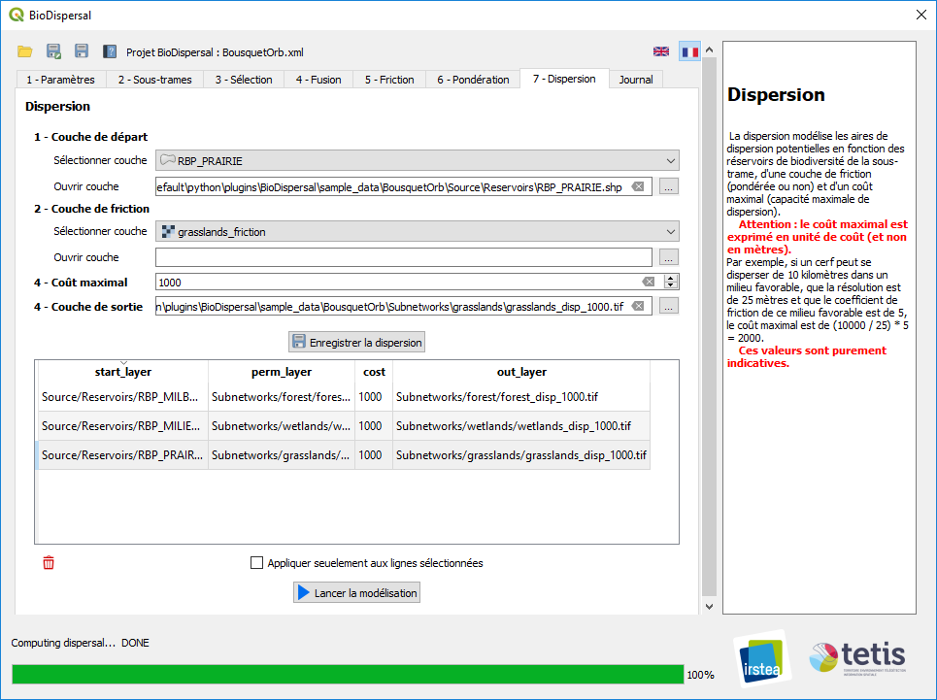



# Example

Sample data is provided with plugin in directory *sample\_data/BousquetOrb.*

Below table shows results of steps 3, 4, 5 and 7 of subnetwork grasslands in configuration of file *BousquetOrb.xml*:

|  |  |
| --- | --- |
| **3 - Sélection** (groupe *landuse*)C:\Users\mathieu.chailloux\AppData\Local\Microsoft\Windows\INetCache\Content.Word\landuseRaster.png | **4 - Fusion** (sous-trame *grasslands*)C:\Users\mathieu.chailloux\AppData\Local\Microsoft\Windows\INetCache\Content.Word\mergedGrasslands.png |
| **5 - Friction** (sous-trame *grasslands*)C:\Users\mathieu.chailloux\AppData\Local\Microsoft\Windows\INetCache\Content.Word\frictionGrasslands.png | **7 - Dispersion** (sous-trame *grasslands*)**C:\Users\mathieu.chailloux\AppData\Local\Microsoft\Windows\INetCache\Content.Word\dispGrasslands.png** |