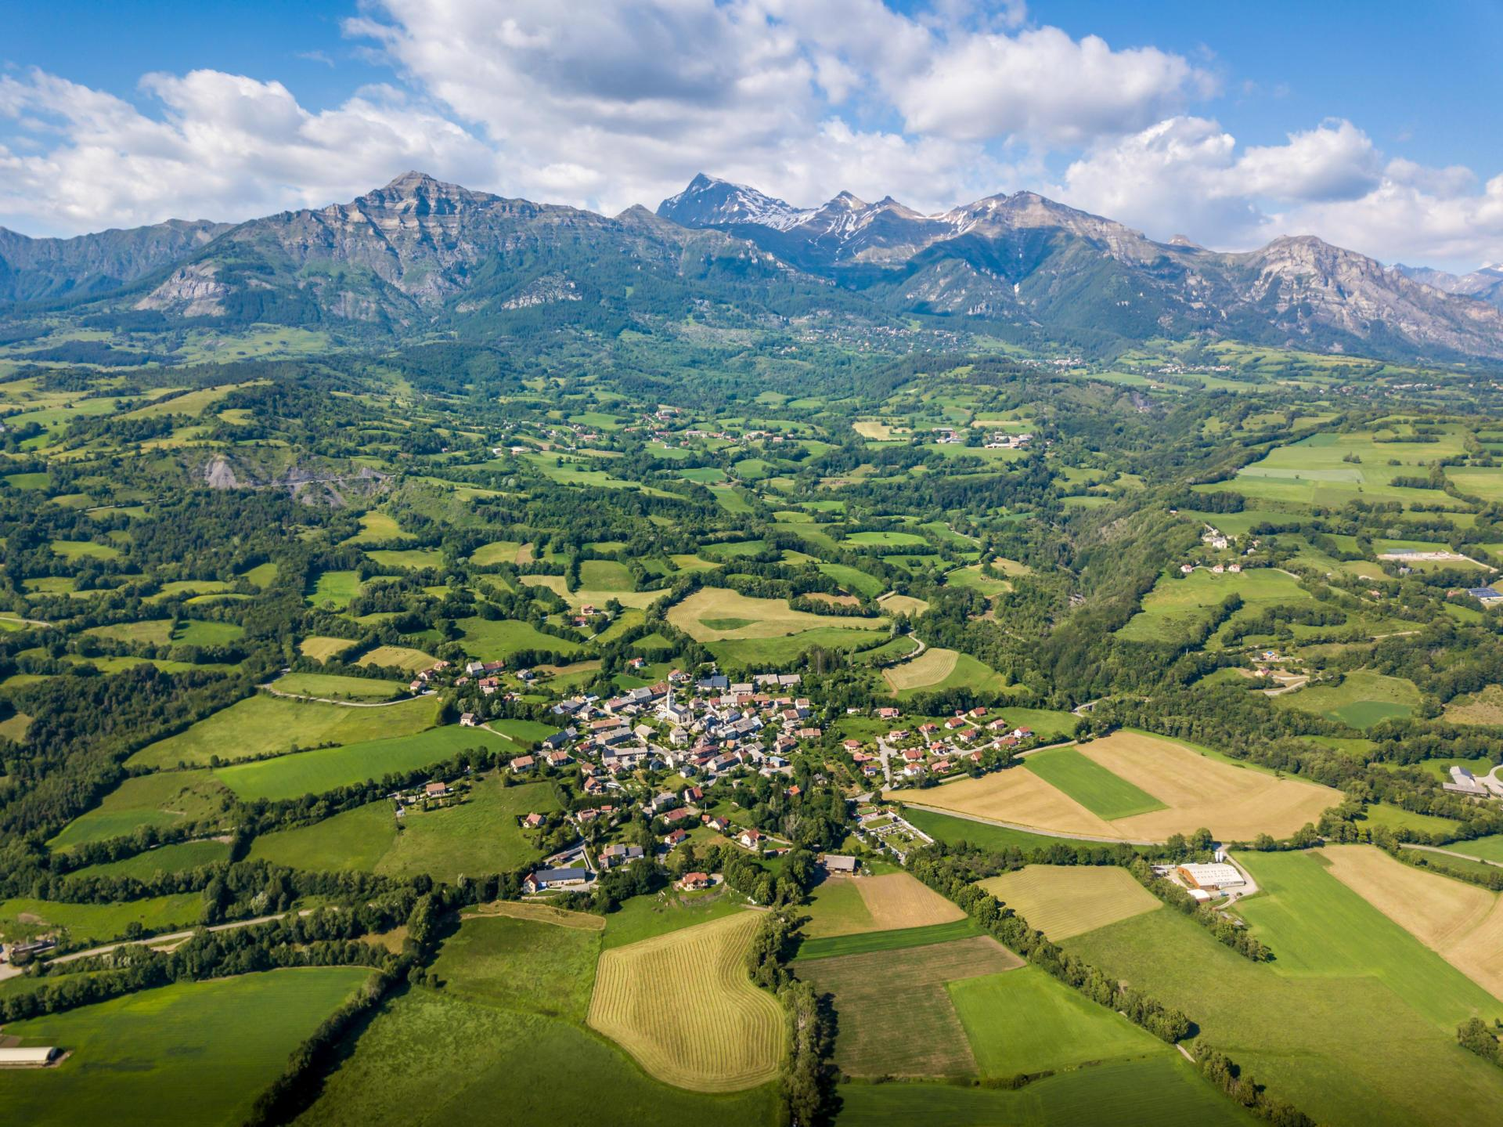



**>**

**MitiConnect v1.0 - User Manual**

**February 2024**

**Coordination**: Jennifer AMSALLEM, Sylvie VANPEENE

**Authors**: Mathieu CHAILLOUX, Simon TARABON

Center

Provence-Alpes-Côte d'azur

Contents

1 About MitiConnect 3

1.1 Preamble 3

1.2 Processing chain 3

1.3 Prerequisites 4

1.3.1 Configuration 4

1.3.2 Installation 4

1.4 Citation 5

1.5 Graphical interface 5

1.6 Project file 5

1.7 Video tutorials 6

1.8 Available data 6

2 MitiConnect step by step 8

2.1 General parameters (tab *1-Parameters*) 8

2.2 Import land use data (tab *2-Data*) 9

2.2.1 Vector data 10

2.2.2 Raster data 11

2.2.3 Create new land use layer 12

2.3 Definition of target species (tab *3-Species*) 12

2.4 Definition of friction values (Tab *4-Friction*) 14

2.5 Scenario definition (tab *5-Scenarios*) 16

2.6 Processing launches (tab *6-Launches*) 17

# About MitiConnect

## Preamble

MitiConnect[1] is a modeling tool to quantifiy the impact of development projects on ecological networks connectivity.

## Processing chain

MitiConnect is a QGIS plugin designed as a step-by-step process, from raw data integration to scenario comparison. Landscape graph construction is based on Graphab[2] . Other processing and the graphical interface are inspired by BioDispersal[3] . Each tab in the graphical interface corresponds to a step:

1. Definition of general parameters
2. Import data into the tool
3. Definition of target species
4. Definition of friction coefficients
5. Building scenarios
6. Treatment launches for each scenario/target species pair
   1. Land use constitution
   2. Friction layer creation
   3. Graphab project creation
   4. Link set creation
   5. Graph creation
   6. Connectivity metrics computing
   7. Scenario comparison

## Prerequisites

### Configuration

MitiConnect runs on any operating system (Linux, Windows, Mac, etc.) with a QGIS version greater than or equal to 3.16 (<https://www.qgis.org/fr/site/forusers/download.html>) and a Java version greater than or equal to 8 ([https://adoptopenjdk.net](https://adoptopenjdk.net/), preferably the 64-bit version).

Tests were carried out under QGIS 3.28, Windows 11 and Ubuntu 18.04.1 (bionic). Under Linux, installation of the *python-gdal* package is required. Some features may work without Java.

MitiConnect is freely available under GPL license.

File and folder names must not contain accents or spaces.

The amount of RAM required for computing depends on the size of the study area, the chosen spatial resolution and the number of patches per species.

### Installation

To install MitiConnect from QGIS, go to '*Plugins'* menu, then '*Install/Manage plugins'*. In '*All'* tab, search for the '*MitiConnect'* plugin, select it and press *'Install plugin'*.

To install the extension in QGIS from the .zip archive, go to '*Extensions'* menu, then '*Install/Manage plugins',* '*Install from zip*' and select the downloaded '*MitiConnect.zip'* file.

Once succesfully installed,  icon appears in QGIS toolbar and a new *MitiConnect* entry is available in '*Plugins*' menu. If the icon doesn't appear, go to the '*Plugins'* menu, uncheck and then recheck the line corresponding to *MitiConnect*.

## Citation

*Chailloux M., Tarabon S., Papet G., Amsallem J. & Vanpeene S (2024). MitiConnect: a QGIS plugin to assess mitigations scenarios impact on an ecological network using landscape graphs*

## Graphical interface

Graphical interface is launched from the  icon or from MitiConnect entry in the *Plugins* menu. The interface is tab-based, with each tab corresponding to a step in the method.

GUI also contains project management buttons, English/French translation buttons, description of the current tab and the processing progress bar.

## Project file

**We strongly recommend that you regularly save your MitiConnect project settings**. These settings are saved in an XML file.

The project file is managed using following buttons at the top left of the interface:

*Open a MitiConnect project*: select an existing project (.xml) and open it.

*Create a new project:* enter the workspace folder and the project name to initialize a MitiConnect project (create output folders and project file).

*Save project as*: save the project in a new file (.xml) or in an existing file which will be overwritten.

*Save project*: saves the project in the .xml file already created (*projectFile* table field).

## Video tutorials

Video tutorials illustrating step-by-step use of the tool are available at: https:[//www.youtube.com/playlist?list=PLh9oFe6PuPCUC2RQcDhRgl9oGP0tj91sv](https://www.youtube.com/playlist?list=PLh9oFe6PuPCUC2RQcDhRgl9oGP0tj91sv)

## Available data

An inventory and identification of available data ensures that the layers are assembled and that a synthetic, complete and relevant land use map is produced.

Various data sources can be used and combined in the background, for instance :

* Cesbio's LUO[4] covers all French departments,
* Regional data such as the MLU[5] in Ile-de-France, the OCSGE2[6] in Grand Est...,
* Urban Atlas[7] covering all major European metropolitan areas.

These data, complete and homogeneous over large study areas, can (and must) be supplemented by more precise data available on the whole the French territory:

* BD Topo® from IGN[8] ,
* Registre Parcellaire Graphique (RPG)[9] , farming parcels register,
* Local inventories of vegetation, wetlands, ponds or other remarkable habitats, etc.

The use of CORINE Land Cover data is strongly discouraged regarding data quality (1/100,000th).

# MitiConnect step by step

## General parameters (tab *1-Parameters*)

First step is to define the analysis framework. All parameters must be specified to enable processing. Workspace folder must be specified before further steps.

Specified parameters are displayed in the bottom table of this tab.

The elements to be filled in are as follows:

* **Workspace**: folder path in which the project and data outputs will be stored. It is best not to change workspace during the project.
* **Extent layer**: represent the study area boundaries. The spatial extent of the study must take into account the spatial configuration of ecological networks and the maximum dispersal capacity of species, to avoid any bound effect[10] . It is therefore advisable to apply a buffer area of at least 1.5 × the dispersal capacity of the most mobile species around the project or its geographical variants, or even more if the aim of the study is also to find *ex-situ* offsetting sites. Note that if the study area is underestimated at this stage, the project and associated modelling should be re-launched.
* **Resolution**: size of the pixels, expressed in meters, for all raster layers of the[11] project. Spatial resolution depends on scale and computing capacity. High resolution (low pixel size) refines the results, but increases computing time and requires greater computing capacity, especially if the study area is large. Depending on the scale, a resolution of between 5 and 10 m is recommended.
* **Projection**: reference coordinate system (default is EPSG:2154 / Lambert 93). The system must be a metric projection .

## Import land use data (tab *2-Data*)

This step is used to import input data and standardize it in raster format with the same resolution and extent, so that it can be properly aligned.

If you already have a complete land use map, you should still import it at this stage and then proceed to next step. Alternatively, you can create land use maps directly in MitiConnect by merging several imports, for instance to take account of linear features (cf. 2.2.3) and species-specific environments.

This tab is divided in several steps:

1. Import land use data
   1. Set import parameters by pressing or depending on layer format (vector or raster).
   2. Press Import button to start importing. Results are loaded into the Imports group,
2. (Optional) If needed (see above) create one or more land use layers.   
   *It may be a good idea to create several land use maps depending on the target species, for example distinguishing forest environments only for some of them.*
   1. Press  button and set the layer creation parameters
   2. Press  button to create layer(s)
3. Check imports and reclassification parameters in *Classes* table. You can change the new value and add a description.

### Vector data

* Enter import **name**. Output layer is named after it.
* Select source vector **layer.**
* (optional) If needed, define a **selection** expression. Only matching features in the source layer will be selected for import. The expression editor on the right helps user to build such expression.   
  *For example: "WIDTH" = 'From 0 to 15 meters' for a watercourse*
* Define **rasterization mode** :
  + By **Field value**: each unique value of this field will be considered as a specific class. **Keep original values** option ensures that reclassification keeps the same values if the field is numeric.
  + By **Fixed value**: all features will be associated with this value
* The **all pixels touch** option ensures that rasterization does not create artificial discontinuities for linear data such as roads (see Figure 7).
* The **buffer** option allows you to apply a buffer area to the input layer before rasterization.

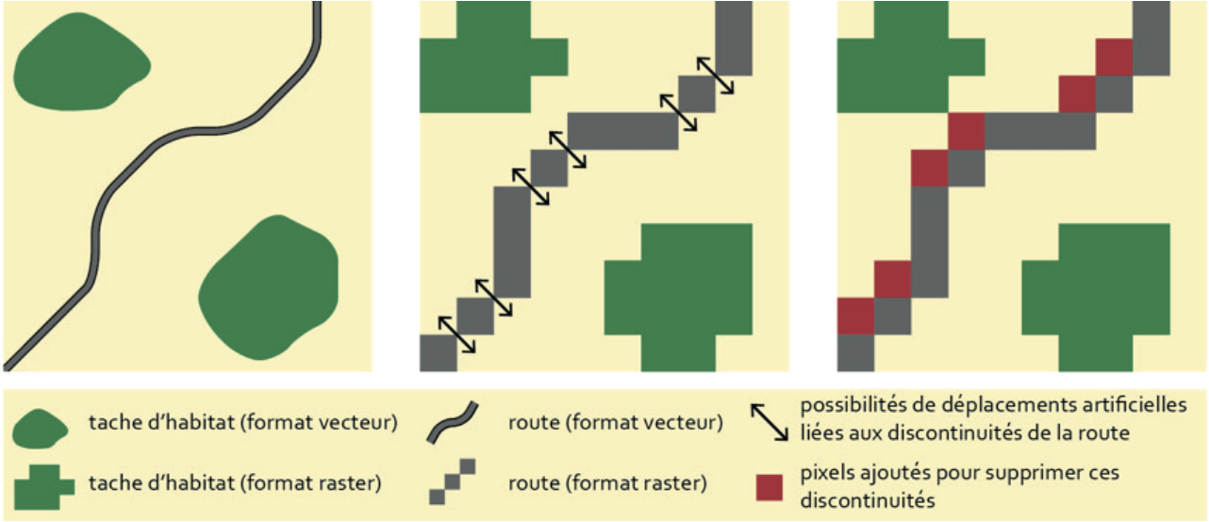Figure 7: all pixels touch option

### Raster data

* Enter import **name**. Output layer is named after it.
* Select source raster **layer.**
* **Keep original values** option ensures that the reclassification keeps the same values.
* Input raster layer is resampled with nearest mode.

### Create new land use layer

* Enter layer base **name**.
* Below table contains import names list. If some imports are missing, press the button to **reload** the list.
* **Delete** imports not required for current layer creation. Select unwanted imports and press the delete button.
* **Rank** imports. Select target import and press arrow buttons to upgrade or downgrade it. Output layer is produced by imports merge, according to specified ranking (above import will erase below ones).  
  *For example, linear features should be placed on top of the land use base layer. To deal with roads and watercourses crossings:*
  + *For an amphibian, the road (on a bridge or culvert) is not always an obstacle, as the species can follow the watercourse. In this case, the road network can be placed below the watercourse;*
  + *On the other hand, for other species (land mammals, birds, etc.), individuals will be more directly affected by the road, which may represent an obstacle. In this case, the road can be placed above the watercourse.*

## Definition of target species (tab *3-Species*)

As the analyses based on landscape graphs are species-centric, this third step is to define target species with their ecological parameters.

To add a species, press the "+" button and enter the following parameters:

The species **identifier** and optionally its **full** **name.Dispersal distance.** Maximum distance is the distance the species can cover during interpopulation exchanges**[12]** . The average distance is more a daily movement. It is easier here to find bibliography on the maximum dispersal distance of the species[13]. If the distance is expressed in meters, Graphab will translate it into cost units by linear regression. It is also possible to express this distance directly in cost units to compare 2 scenarios under the same conditions.**Land use** or import nameused for this species (cf 2.2.3)**Habitat codes**, i.e. land-use categories as reclassified in step 2, matching a habitat environment. Matching features will be dissolved to build patch layer.**Minimum patch size**[14] for the species to complete all or part of its life cycle. Patches smaller to this size will be excluded. It is a good practice to set a minimum value even if this information is not know to avoid isolated pixels being identified as nodes in ecological networks.**Connexity** defines the way patches are formed, considering 4 or 8 adjacent pixels to be part of the same patch.By default, **coefficients** are defined in the *4-Friction* tab, but they can also be imported from an existing layer.By default, **the extent** is a buffer area of 1.5 times the maximum dispersion around the project extent (see later in Tab *5 - Scenario*), but it can also be defined from a layer.

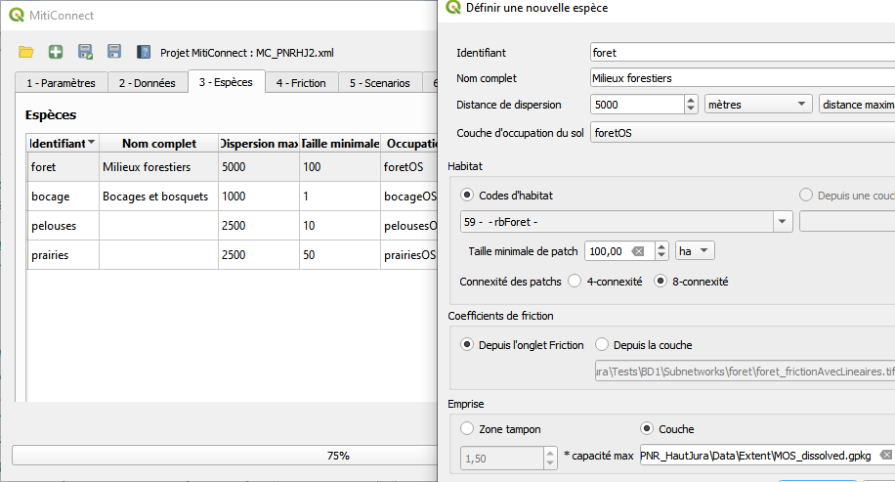Figure 12Tab 3 - Species

## Definition of friction values (Tab *4-Friction*)

Ecological network modeling using landscape graphs is based on the notion of environmental permeability, i.e. the ease with which a species can move through an environment.

This permeability is expressed by a numerical value called cost or friction value, which represent the energy required to pass through the environment. The lower this value, the more permeable the environment, making it easier to move.

Absolute value of these costs is not important; it's the ratio of proportionality between each friction class that determines that an environment A is, for example, 5 times more permeable than an environment B. However, the difference between classes must be clearly marked to avoid all environments to be equivalent for the species.

The numerical values of these costs must be strictly positive integers. If no value is specified, this land use category will be ignored for the matching species.

Coefficients can be filled in directly in the table, or via a CSV file (spreadsheet) using the buttons at the top left of the table.

If some values appear to be missing, press the refresh button to reload the entire table.

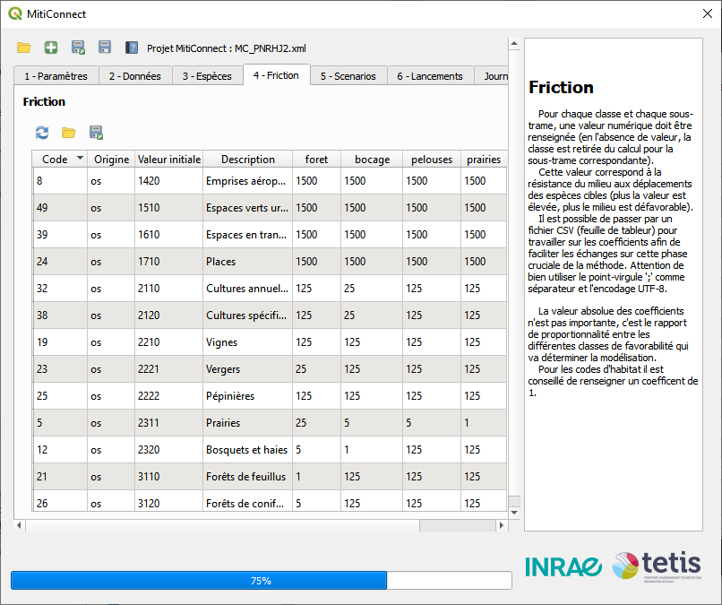Figure 13Tab 4 - Friction

## Scenario definition (tab *5-Scenarios*)

Scenarios are defined as land use changes representing a stage of mitigation hierarchy:

* Initial state
* Avoidance scenario, e.g. to test different possible extents for a linear transport infrastructure (LTI) project
* Mitigation scenario, e.g. to test different wildlife crossing locations across a LTI
* Offsetting scenario, e.g. to test the installation of new hedges

The initial scenario is already present in the interface. Other scenarios are defined by "stacking", i.e. based on an existing scenario.  
  
 To define a new scenario, specify:

* Scenario **name of** (a short identifier), and if needed a more complete **description.**
* **Base scenario** on which the land use changes will be applied
* Scenario **layer** containing the extent of the land use changes
* **Use layer extent** option specifies that the study area will be centered around the previous (land use changes) layer, according to the parameters specified in step 3 for the species concerned.  
  If several stacked scenarios use this option, their extents are dissolved.
* **Create a long-term scenario** option can be used to duplicate scenario in cases where land-use changes are not the same in the short and long term, typically for offsetting actions where the implanted environments are not functional for several years.
* **Value reclassification** defines to which land use classes (*Code* column in the *Friction* tab / *New value* column in the *Data* tab) are associated scenario layer features.
  + **By field value**: unique values of specified numeric field matches land use classes. If these values do not match land use classes, they can be modified later in the *Data* tab.
  + **Fixed value**: all features will be reclassified to this value.

## Processing launches (tab *6-Launches*)

This last tab lets you manage launches for each scenario and species.

The table is filled in automatically from the other tabs. Each line conntains to a scenario / species / extent tuple and displays additional information:

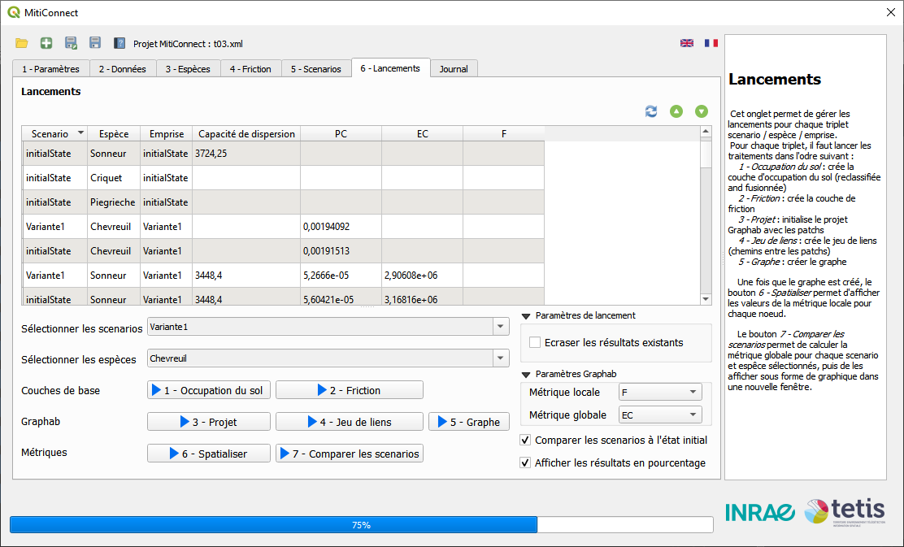Figure 15Tab 6 - Launches

* Dispersal capacity computed by Graphab when computing links set, expressed in cost unit. This capacity must be the same to compare 2 scenarios for a given species.
* Global metrics calculated at the scenario comparison stage

Initial state scenario for a specific species is duplicated for each extent to enable comparison under the same conditions (extent and maximum dispersal capacity). When a step is launched for a variant/species pair, it is also launched for the species' initial state with variant extent.

**Erase existing results** overwrites existing results if existing to ensure a clean re-launch.

To start launches, select scenarios and species, then press a step button:

1. **Land use**: Clips reclassified land use layer to matching extent boundaries
2. **Friction**: reclassifies land use to a friction layer according to the *Friction* tab
3. **Project**: initialization of Graphab project and identification of patches (biodiversity reservoirs)
4. **Linkset**: calculates all link sets, i.e. the shortest paths between patches. Each link contains its metric length and its cumulative cost (friction values sum of the pixels crossed).
5. **Graph**: builds landscape graph by keeping only those links whose cost distance is less than maximum dispersal capacity. The graph represents patches in the form of circles whose size depends on capacity (in this case, area), and selected links in the form of segments. The *Components layer* displays connected components, i.e. interconnected sub-networks.

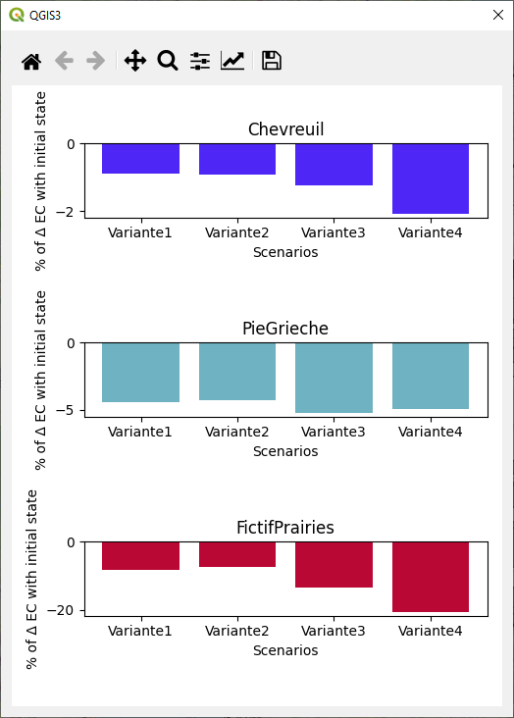Figure 16: Scenarios comparison

1. **Spatialize**: computes specified local metric for patches and displays the result as a colored legend.
2. **Compare scenarios**: computes specified global metric for each landscape graph and opens a window with a graph displaying difference of metric value between selected variant and initial state, expressed in percentage.

Figure 17: Launches results

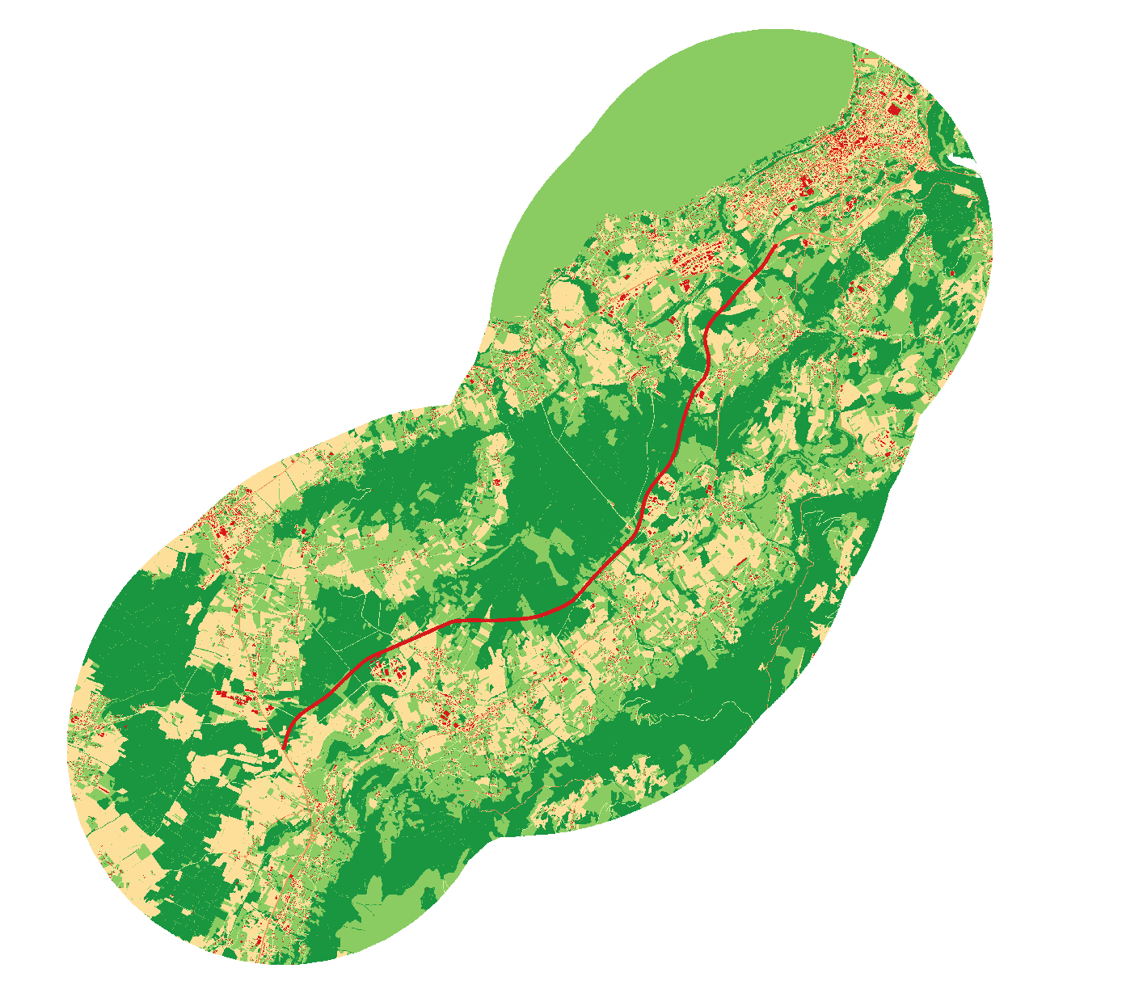

**2 - Friction**

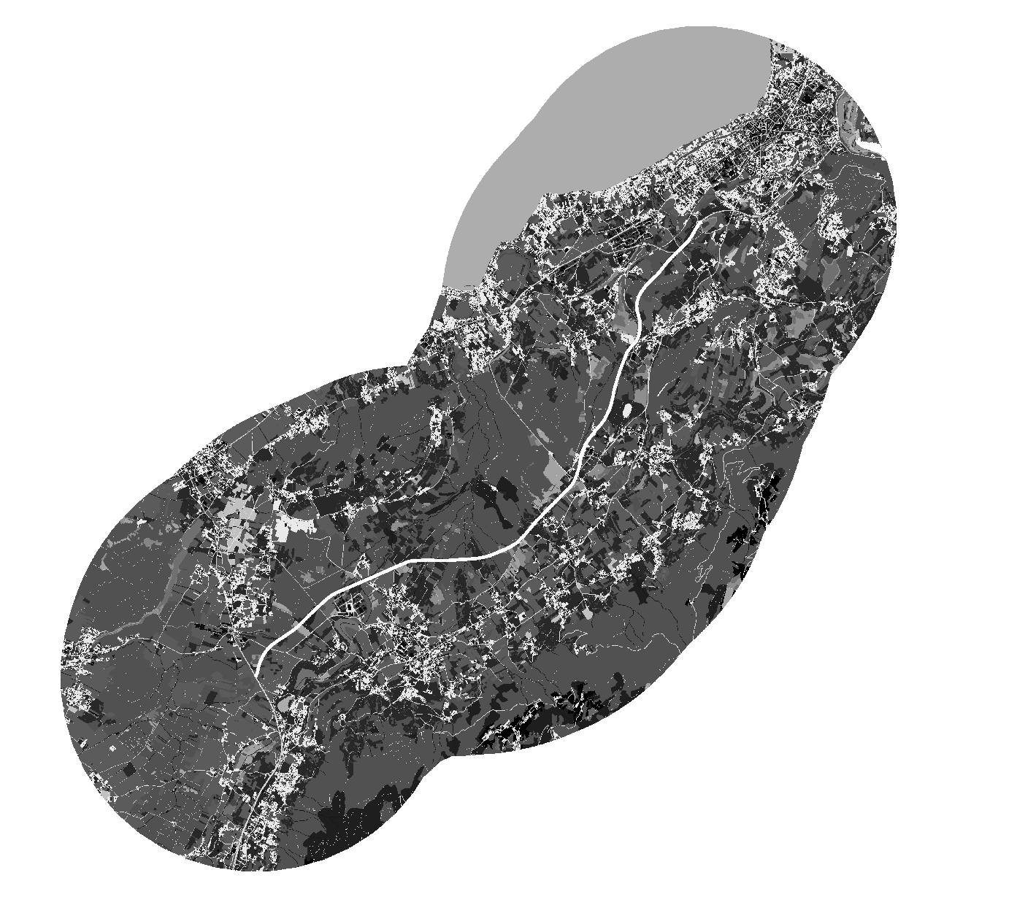

**1 – Landuse**

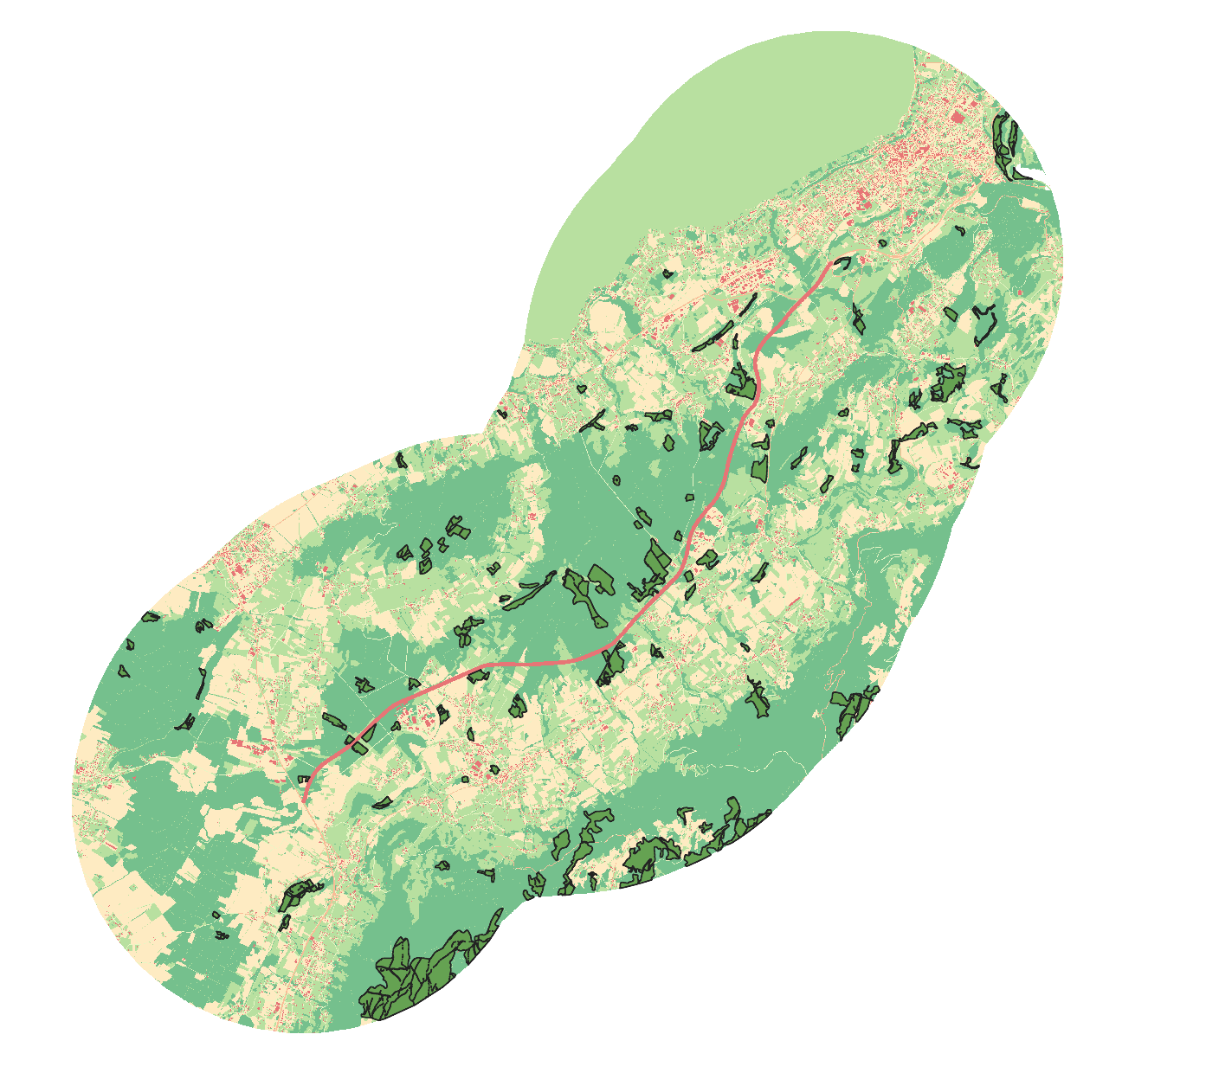

**3 - Project**

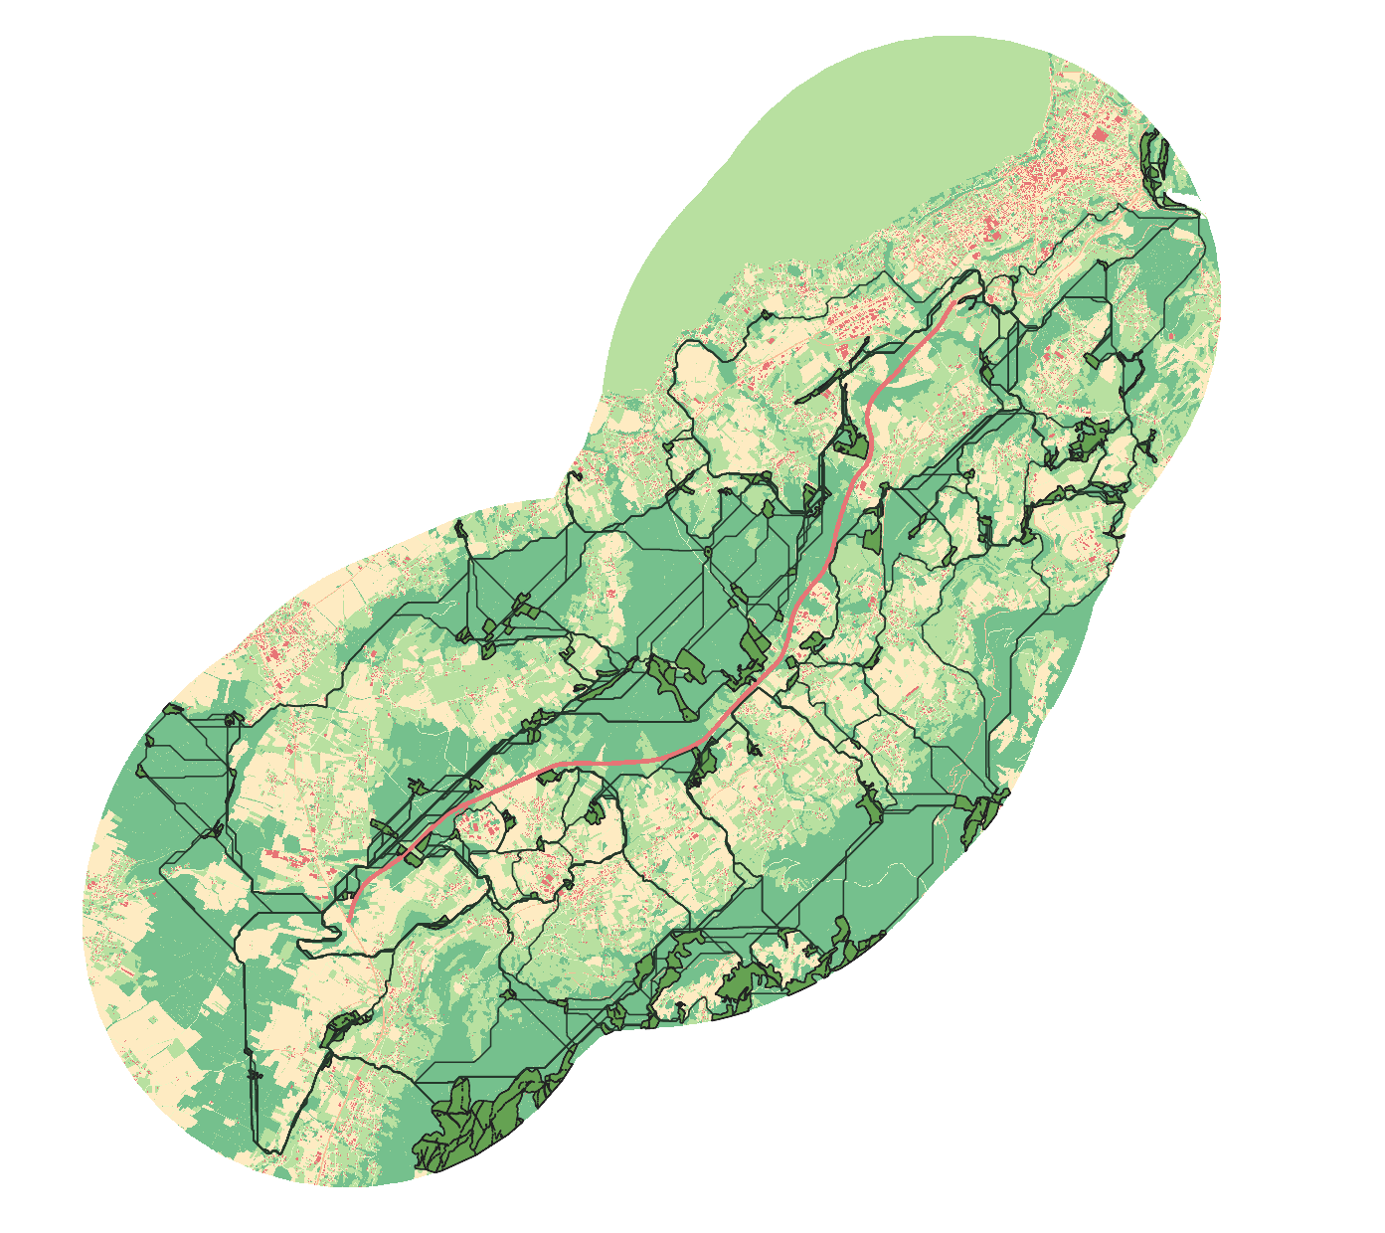

**4 - Linkset**

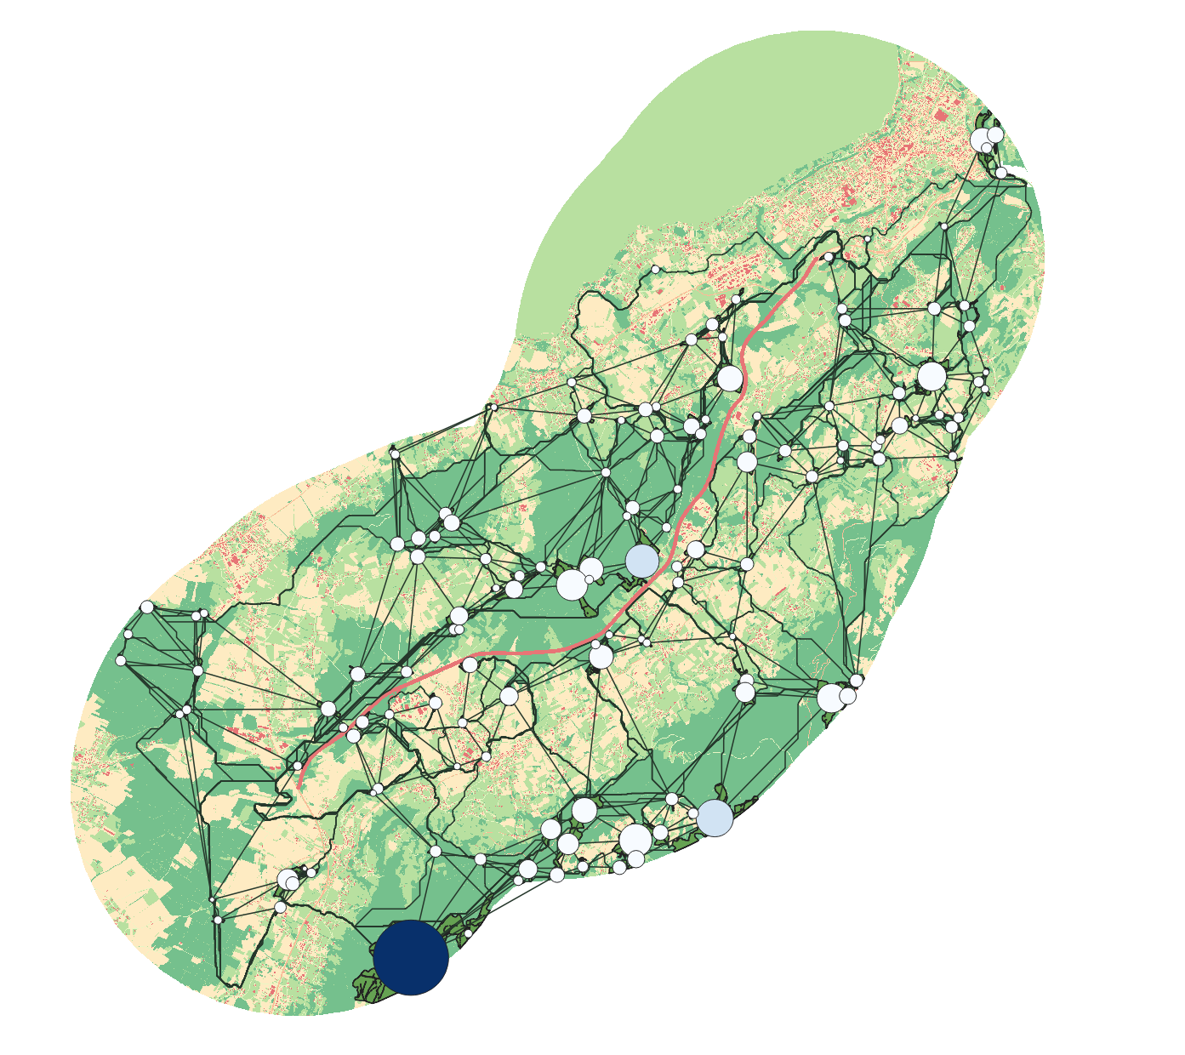

**5 - Graph**

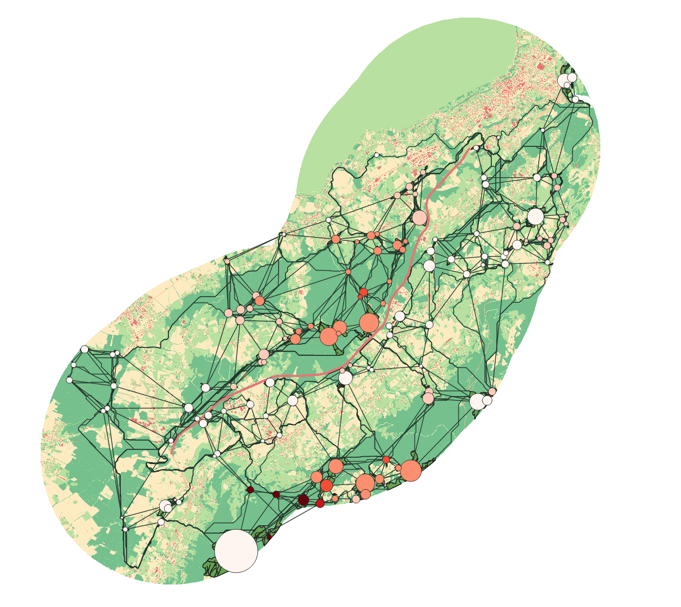

**6 - Spatialize**



**Center Provence-Alpes-Côte d'azur**

3275 route Cézanne CS 40061

13182 Aix-en-Provence

Phone: +33 (0)4 42 66 99 10

1. <https://github.com/MathieuChailloux/MitiConnect/blob/main/README.md>
2. <https://sourcesup.renater.fr/www/graphab/fr/home.html>
3. <https://umr-tetis.fr/index.php/fr/productions-fr/outils/biodispersal>
4. <https://www.data-terra.org/actualite/produit-theia-oso-2020-nouvelle-carte-doccupation-des-sols/>
5. <https://www.institutparisregion.fr/referentiels-geographiques/mode-doccupation-du-sol-mos/>
6. [https://ocs.geograndest.fr](https://ocs.geograndest.fr/)
7. <https://land.copernicus.eu/local/urban-atlas/urban-atlas-2018?tab=download>
8. <https://geoservices.ign.fr/telechargement>
9. <https://www.data.gouv.fr/fr/datasets/registre-parcellaire-graphique-rpg-contours-des-parcelles-et-ilots-culturaux-et-leur-groupe-de-cultures-majoritaire/>
10. Bound effect occur for spatial analysises where available data does not cover the whole study area (underestimation of the stakes).
11. Land use map is produced in raster format. This implies a simplification of reality to a given pixel for which a single type of environment is associated.
12. Ecological network modeling at the dispersal scale is the most common approach in population viability analyses.
13. Several metrics include a weighting in their calculation, where distances between patches are converted into probability of movement. Here, the software takes into account a low p-value (0.05).
14. Patch capacity reflects its "intrinsic quality", considered as an indicator of its demographic potential. Patch capacity is expressed by its surface area.