Anticipating linguistic change :
Implementation of a program modeling natural sound change

Sound change is one of the most influential factor accounting for linguistic change, and its study is therefore at the heart of several fields of linguistics. While phonetics and phonology study respectively the material and the theoretical conceptions of the sounds changes themselves, historical linguists endeavor is to uncover regular sound patterns to find correspondences across languages and to prove phonetic and semantic affiliation between words by establishing cognates (words sharing a common etymological origin, sometimes only rebuilt by the linguist, but never attested). While computational linguistics and NLP tools found broad uses in syntax and automatic translation, their application to phonology or research in historical linguistics have been quite limited, and restricted to some independent works.

Various programs have previously been developed to model phonetic change, such as the Phono software (Hartman & allii), but there were merely designed as representation tool, able to mechanically apply pre-encoded changes to a closed inventory of lexemes. Very recently, the latest neural networks have been used, (by Fourrier and Sagot) to perform a cognate prediction task, with promising success. This prediction task was conceived as a seq-2-seq task, similar to an automatic translation pipeline, but the elements of the sequence were not words, but phonemes . It is therefore possible not only to take phonemes as base unit of a NLP system, but also to find a satisfying and flexible computational representation of phonemes. Another task at the crossroads of historical linguistics and NLP is the rule inference task : from already established cognate lists, the computer is asked to find regularities across attested sound changes. Such a task is very difficult for it meets Sturtevant ’s paradox : while the disruptive phonetic erosion brings imbalance to regular paradigms, other phenomena, especially analogy, disrupt the regular application of sound change. But both alluded tasks, cognate prediction and rule inference require a lot of training data, which is not always available despite of the work of linguists.
That is why it becomes tempting to reverse the perspective : instead of looking for an application for the sparse evolution data available, we could try to model sound change and its application on a language state. With a script able to transform a language following regular rules and pattern, we would be able to keep track of every step of the evolution and use it for other purposes.

Generating data could serve several purposes such as :
* providing training data for more complex NLP task implying linguistic change (strategy adopted by Fourrier and Sagot, but with a minimal implementation of some changes of romance languages)
* disposing of a parametrizable tool to predict possible future evolution of existing languages.
* tuning an experimental device and taking some time to think about linguistic change is an occasion to better understand its key components and invariants.
* as a more recreational activity, being able to generate an infinity of non existent, but plausible mock languages.
Nevertheless, sound change is a very complex and multi-factorial phenomenon. Its representation demands a thorough analysis about the way to think what change is. We want our model to be as rich and flexible as possible, in order to reach the complexity and diversity of sound change as it is observed in the languages of the word. On the other hand, we want the system to be controllable and parametrizable to run several experiments, and it shouldn’t generate absurd changes, or display too frequently the rarest , yet attested, patterns of evolution. Such questions will be dealt with in the first part of this report.
We ‘ll next present the global functioning of our program and some key aspects of its implementation before putting it into good use. In a last section, some code parts or theoretical assumptions will be assessed, as several perspectives of future developments.

INDEX :

I) Modeling, aka simplifying sound change.

1) Embedding a sound : a way to encode information about a phoneme :
a) a first attempt in the early versions of the program :
b) a second attempt : nested tuples 2) Short considerations about languages
3) A brief typology of sound changes
4) What are the ingredient of a sound change ? General considerations about Change

II) Generating sound change : a user friendly manual

1) Generating changes and applying them.
2) Storing changes : designing a new datastructure.
3) Encoding and decoding change : a (not so readable) log system.
a) The first log is used to compare two languages.
b) The second log is used to provide a sort of history of the changes that have been applied between a language and another language that belongs to its descendants :
c) The third log is meant to be written and read by the computer and is the format chosen to store all the details about a given change.

III) Experiments, practice and performances

1) Measuring the impact of sound change and language similarity
2) Change and change back : cross linguistic experiments and language creation :
3) Performances :

IV) Perspectives

1) chaotic evolution and unpronounceable patterns : the plight of parameterization
2) Not implemented yet
3) Perspectives, possible application and so on

I) Modeling, aka simplifying sound change.

In order to build a sound change generator that will be used to transform a language into another one, a clear definition of what is sound change is to be settled on, forcing us to take position in some major scientific debates to find a way to implement the program. Our program takes as input a language, or at least words, considered as a list / string of phonemes. It will generate changes and apply them to these words keeping track of the derivation steps in some data structure we’ll present in a following section. We’ll therefore first present the way we decided to encode the phonetic information of words , and the process we use to convert raw linguistic data into the format we use.

1) Vectorizing a sound : a way to encode information about a phoneme :

Since the program should be able to take any existing language as input, and even artificial creation, selecting the written characters as minimal components to represent sounds seemed really unsatisfactory, for it doesn't help to generalize across languages or event think about the modalities of phonetic change. Moreover, for instance in french, there is not always a one-to-one correspondence between the graphemes and phonemes. A phonological transcription of the words should be chosen to avoid this kind of difficulties. We’ll use transcriptions in the IPA alphabet, for they are broadly available online (especially on the wiktionary) and widely used cross linguistically.
While some researchers such as Ciobanu, sometimes used text characters, most of the NLP community interested in historical linguistics also opted for a phonetic and not orthographic representation. Even if the IPA provide a large set of characters, it is not fine grained enough to display the diversity of sound change :
* they are some cases left unfilled in the IPA, while those sounds can be pronounced and could be attested in some languages.
* the position of a letter in the chart provides information about the phonological characteristic of a sound, but some choices are arbitrary : the order of the manners of articulation is partiallyrandom and do not account for a closer proximity between some values. Some information (the fact for instance, that approximant are voiced) has to be known in advance by the user, the information is not encoded in the IPA character itself.
That’s why even if the IPA is used as a basis and as a tool to display words, a feature based representation of phonemeswas chosen, as it became quite common. Hartman for instance opted in the tool Phono for a feature based format inspired by the works of Chomsky :
“Phono has adopted, with minimal modification, most of the features defined in The Sound Pattern of English (Chomsky and Halle 1968:298-329)—known as SPE—(20 of them in the present version) because that work represents a unique moment of near-consensus in the development of phonological theory.”
Chomsky and Halle listed around 26 (boolean) features, whose combination should produce all the existing phonemes of the IPA.
Such a representation is interesting because :
* it has a far richer semantic. There is always a simple way to check whether a sound is for instance stressed, round…
* it is extremely easy to modify a single parameter, and this will allow to modify several phonemes at the same time (the character driven approach used for automatic prediction task had to divide for instance, sonorization of intervocalic plosives into several operations : one for each plosive (t>d, k>g) … , but with a feature based representation, the change [sound] : False >True can be applied to a whole group of phoneme at once.
* this representation as a list of boolean is uniform and easy to manipulate.
On the other hand, it is maybe too schematic. It is a very practical and informative way to sort out sounds, but do not express the complexity of relations they share between them :
* some features just exist to separate two phonemes and are left inactive most of the time. There is a lack of balance between a group of major and determining features, and some others, barely used.
* there is no match between the whole space of boolean combination and the list of IPA characters, some boolean combinations could be generated, but do not correspond to pronounceable sound (labial and uvular and aspirated and nasal at the same time ?)
* the list of features is in fact not fixed, because phoneticians debate by means of article, on the importance or lack of importance of features. They do not have inherent reality.
* For some features (blackness, roundness, height of the tongue, place of articulation), binary values are not sufficient to express every possibilities. As a trick ,several boolean features are used to encode discrete values, but it is not really satisfactory.

Therefore the decided to develop a feature based representation of sound that avoid these pitfalls : by allowing discrete values as fields, and trying to make sure that there are not two features that cannot take a certain value simultaneously.

a) a first attempt in the early versions of the program :

A first version of a feature template was designed, close to the SPE representation, letting aside the features that were very scarce, and grouping together boolean features that encode discrete features together.
The distinction between vowel and consonant was encoded in the first feature, while the other features were ordered according to their importance.
Here is the list of the 12 features that were used.
syllabic | consonantal | height | back | round | voice | plosive | nasal | fricative | lateral | trill | aspiration

However, with such a feature representation, the program tended to generate unusual changes, switching a phoneme from vowel to consonant, and making some features preponderant (aspiration, nasal). This representation was too flexible on the one hand because there was no strict hierarchy between features, and on the other hand too expressive, because some incompatible features (fricative, trill, uvular) could be activated at the same time. Moreover, vowels and consonants shared two discrete fields (height and back) that had different ranges if the phoneme was a Vowel or if it was a consonant.

b) a second attempt : nested tuples

A more complex representation was built in order to assess these difficulties, first by creating a strong distinction between vowels and consonants (that became in the implementation two subclasses of the Phonem mother class) that both had specific and non redundant features. The incompatible features that were used to encode the manner of articulation were grouped in a tuple, and the possible values it can take are clearly delimited in the program, so that (to the best of the designer’s knowledge) every feature generated using this format in the program correspond to a phonem that can be pronounced

The semantic of features is sum up in the following diagram :

Phoneme
Coded as field (bool) of the phoneme Object
Row of length 5 encoding the second element of the features tuple
Second Tuple encoding secondary information about the phoneme
Vowell | Consonant
Syllabic
Voiced
Front (int between 0 and 2) | Place of articulation (int between 0 and 11)
Height (int between 0 and 6) | Plosive (bool)
 | Fricative (bool)
 | Nasal (bool)
 | Trill/Flap (int between 0 and 2)
 | Lateral (bool)
Round (bool) | Secondary articulation (int, some possibilities, same as the corresponding place)
Nasal (bool) | Pre-Nasal (bool)
 | Aspirated (bool)

2) Short considerations about languages

While phonemes or sound are the minimal item used in the program, we consider sound change as a more generic process affecting not a sound, but a whole language. A change doesn’t only modify a sound but modifies recurrent patterns of sounds that appear in the words of a given language. We will introduce two other crucial objects, words and languages , (as well as an intermediate one, the syllables) to serve as input of the Changer.

* words (to be exact, wordforms) :
A word of a language can be basically seen as an ordered sequence of sounds or phonemes, that can be uttered alone (formal autonomy) and has a meaning and/or functional role in the language.
Words are segmented into syllables that have a phoneme (usually a vowel) as its kernel. Syllables bear supplementary information such as stress accent (increased articulatory force compared to the other syllable of the word) or pitch/tone (Not implemented yet). These supplementary information modify the way a sound is uttered and then play a role in linguistic change.
A word can be represented in several ways, as it is taken into account in our program
citation form (in the original alphabet) : appressum
IPA representation : ap'pres.sum
syllabation : ap/'pres/sum/
CV structure : #VC/CCV'C/CVC# (the accent is marked after the V)
stress pattern : _/S/_
The global structure CV marks the distinction between consonants and vowels. (Later, a distinction between simple consonants and sonorants R could be implemented).

* languages :
Linguistic change do not only modify word-forms, but whole languages transforming them into new languages. At first, an innovation appear on a particular word-form, and is spread by usage until it becomes the new regular form and then acquires the status of change.
The general script will take a language as input, but this raises a simple but fundamental question : how to represent a language ? We’ll adopt a “performance” oriented approach, considering that a language is defined by the set of word-forms used by the speakers (as raw material) to build their sentences. That’s why a language will be represented by a dictionary (the keys are the written form in latin alphabet of the word in the base language, the values a word object linked to the word).
In our simple implementation, only the values of the voc dictionary can differ between two cognates languages, the inventory of words (that’s to say the keys) do never vary. This could be improved in future versions
* by making some words randomly disappear
* by allowing borrowings from other languages
* by implementing new ways to create words

TODO notion of language state

3) A brief typology of sound changes

We want to apply sound changes to languages and therefore need to find a satisfying balance between two contradictory objectives : developing a model of language change that is refined enough to mimic the complexity of attested sound change, but this representation needs to be constrained enough not to over-generate changes that are not attested. It should also be flexible and parameterizable, and the less computationally costly as possible, since we want to generate a big quantity of data. To do so, a change object needs to be designed.

We first need to establish a list of all the possible sound changes that are attested cross-linguistically, to determine their common points , and the specificity of each type of change.
* sound change : the way speakers pronounce a sound is modified, it becomes a new sound. Those modifications are not random but the two phonemes are related and only vary along one or a few features. In most cases, the change append by transmission of a phonetic feature from neighbor sounds (assimilation) or to maximize the distinction between two sounds (disimilation)
* two phonemes swap places (metathesis)
* a phoneme or a whole syllable disappears and isn’t uttered anymore (deletion, apocope)
* a phoneme in inserted, either to facilitate the pronunciation between two phonemes that are too different for them to be uttered one after the other (epenthesis) or because it received a superior articulatory force and was split into two identical phoneme (gemination, doubling)
*a phoneme or group of phonemes is deleted, because its pronunciation is too complex, or because it already appears in the word (haplology).
Linguist developed a very rich terminology to describe sound changes, but some of the terms are really precise and denote a very specific transformation (nasalization, labialization). These terms often work by pairs (change, reverse change), but encoding all these changes sub-types would be tedious and would not account for the common properties some changes share.

Since we represent words as a string of sounds, we can assimilate the different kind of phonetic changes to operation applied to a list. We ‘ll therefore need four specific kind of operations * one element of the list is modified : P_Change (P for Phonetic)
* two elements of the list are swapped : M_Change(M for Metathesis)
* an element is inserted in the list : I_Change(I for Insertion) (Implementation in progress)
* an element is deleted from the list D_Change (D for Deletion (Not implemented yet)
These operation have consequences on the other representations of the word (syllabic structure) and regularization functions will be required for the last types of change.

In addition to these phonetic changes, we want to take into account the modification of the stress and tone pattern in the words, because it can have an impact on subsequent changes. This type of change (S_Change, for Syllabic) needs to be treated separately, because they do not modify the phoneme string but another abstract representation of the word object, its accentual scheme.
In this first version of the program, changes are always applied inside the boundaries of word, whereas many phenomena impacting the end of a word are conditioned by the following one. These phonotactic phenomena that concerns the connected speech (sandhi) should be implemented in the future, when texts and not lonely words will be accepted as input for the program.

Last but not least, an important distinction has been made between changes or sound laws, that are punctual, and are not applied retroactively, and rules, which are phonetic invariant of a language (ex: greek do not tolerate final -m, consonant cluster simplification rules…).
Only changes are implemented , but a change could be converted to a rule by applying it to a modified word when a change happens. If the output of the change can trigger the application of the rule, it will be applied consequently.

4) What are the ingredient of a sound change ? General considerations about Change

A linguistic change denotes the modification of a language. Change could be mainly considered in two manners, either as an event or as a process.
We’ll rather adopt the first option, at least as old as the works of the Neo-grammarians, supposing there is a “ausnahmslosen Wirkung der Lautgesetze. “. Sound change is considered as the direct effect of sound laws that are applied at a given time in a systematic way. As German linguists first developed the concept of law, they firmly stated that :
* sound laws have no exception
* they are not retroactive
Vividly contested by other linguists (like Schuchartd for instance) because they didn’t take into account social and psychological parameters that could disrupt the ideal of a clean mathematical application of laws, this systematization could serve as first attempt to model change.
This concept of law is the first step of a formalism, that we could complete by viewing sound changes as mathematical functions, that transform some phonetic patterns into another pattern.

Ex : Change : f([s0s1s2...sn]) = [s’0s’1s’2...s’m]
where a sound could be left unchanged, disappear, switch place with another… A change is simply a function that transforms a sequence into another sequence.

If we see sound change as a functional application, several ontological questions surface : does a sound change exist only because it has been applied ? Or is there a set of possible changes |that all exist (the set of all functions transforming a possible sound into another sound taken from all the possible sounds) . A set |S|^{|S|} as a simplification.

To create a Change object, we need to find its key component :
* A sound change has what we named a “target”, it modifies a word, but more specifically a particular phoneme (even if its deleted, or inserted, and in a metathesis, the modification of the second phoneme can be considered as a direct consequence of the modification of the first. )
A change can concern a single phonem, but it can also modify several related phonemes, a whole natural class, or even all the phonemes.
When several phonemes are impacted, we will not generate several versions of the same change with different targets, but rather used a condensed way to design a class of phonemes. We use wildcards values (-1) to select all sounds without specifying this value. Using wildcards allow to create feature patterns that behave like masks that can be used to select sub-classes of sounds.
NB : it sometimes fails to capture precise sub-classes of natural classes, especially with numerical values, and sometimes a complex list of constrains is required to isolate a small group of phonemes.
* When a phoneme is modified, either one of several of its features get a new value.
We can consider that a sound that didn’t change underwent the application of the identity function.
We’ll consider that the target suffered a functional application (function that we will name “effect” in the code and that will be implemented using a dictionary ).
* while some sound changes apply universally and without any restriction, other are strictly determined by their close environment. A change is also defined by the list of conditions that should be satisfied for the change to be applied.
In our implementation, we distinguished two kinds of conditions :
* P_Conditions (Phonetic conditions) that represent the presence of certain phonemes in a specific relative position, around the target, or at some particular absolute positions (initial of final positions).
* S_Conditions (Syllabic conditions) providing information about the stress pattern of the word and of the syllable that contains the target.
These two types of condition seem to be sufficient to encompass every information about the context of a word.

This simple representation of sound change seems expressive and could serve as basis of the representation of sound change viewed as the ordered application of functions. It has been presupposed that a change is always applied whenever its conditions are satisfied, which is not always the case. Sporadic change could easily be implemented.

II) Generating sound change : a user friendly manual

We provided a brief theoretical presentation of sound change to justify some of the important choices we made to encode phonemes and sound changes. These choices are reflected in the implementation of the program. We now want to provide the user with a practical guide so that he can use the main functions of the program, that is to say :
* transform a given language given in input into a new one after a given number of change
* get access to the state of the language at every step of the derivation
* storing the changes in an economic and machine readable format so that the experiment with interesting results are reproductible.
In the next sections, we’ll both present the overall implementation allowing these functionalities and provide a short guide to use them.

1) Generating changes and applying them.

In our implementation, we distinguish between 5 different types of changes, all sub types of an abstract Change object. They are randomly generated by an object specifically designed for the task : a Change_generator
* Change generators
The Change generator is an object that is created to generate changes randomly.
It contains methods to set the initial parameters of the Change.
Creating randomly sound changes is maybe the most challenging part of the whole project, for we want not only to be able to generate all the possible changes attested, but the program should also only generate plausible changes. A lots of parameters are at stake and they all are interdependent.
Moreover, the 5 types of change have a different semantics and different initialization parameters.
Therefore our generator has to have different methods to parameterize each kind of change.
We have to choose a precise procedure to generate the change, but an infinity of different generator could be imagined. The Change_generator has been made an abstract class.

We ‘ll present the principles of the Baby_change_generator, its first implementation, and some of the (questionable) implementation choices that have been made.

* The parameters
In the first implementation of the program, the feature to be modified was chosen randomly, and given (also randomly) a new value. This lead to some chaotic results ; nasalization and aspiration, features at the end of the list were modified as frequently as the place of articulation, leading to strange languages where all was aspirated or nasalized. Some kind of changes are definitely more frequent than others. Some phonemes are also more prone to change than others, and there is a certain directionality in the change.
The question of estimating probability of language change is crucial. If we want to generate plausible changes, the program has to have parameters that make the probabilities to get the changes attested in reality high. But it is hard to evaluate whether the parameters chosen for the program are good or not, because we would need a way to compute the probability of a certain possible evolution path in the real word, which is of course impossible.
Therefore there is a lot of room for the generator to be parameterized :
- when we choose the type of change that will be applied
-when we choose the phoneme that will be targeted
-where required, when we choose the feature that will be modified
- when we decide to extend a target or a condition. (how many times, how)
-when we create the conditions (in average, how many condition does a change have ? )
Parameters can be of different kind : simple probabilities (extension) , distributions of probabilities over a list (on the type of change, over the number of condition…) or matrices of weights (for the probability to reach an output for a feature value given the input value of this feature in the target.
All these parameters are stored in the “Sampling” file, so that they can easily be adjusted, but they only have been roughly estimated. We would need to work deeply about these parameter constraints to tune the behavior of the generator and curb chaotic change.

* the golden rule : never generate a change that would change nothing.
We ll present the general functioning of the first implementation of the change generator.
Since (cf III on profiling) it requires a lot of resources to generate and apply changes, we want to avoid generating changes that would have no effect on the input language. The generator has been designed around this idea that the change that is being built will modify (at least one word !) of the language it will be applied on. To do so, a strict protocol has been written. The change Generator takes a language as input of the function that creates the change to be able to build it accordingly.
- the target of the change is selected among the language’s phonemes. There is no distribution of probability to favor a sound over the other, but to mimic the fact that a frequent phoneme is more likely to change, we randomly select a word of the language, and then a phoneme of this word.
The target is then extended (using wildcard) to a natural class, following a distribution of probability.
This part was common for the 4 changes dealing with phonemes. The next steps depend on the type of change wanted.
- for a P_change : the feature that will be modified is selected along a distribution of probability.
The output value of this feature is determined by a fixed matrix of weights.
- for a M_change : a feature is chosen ( along a distribution of probability over a subclass of features, since metathesis only occur in a closed number of situation ) so that the two swapped phonemes only differ by one or a small number of feature(s).
- for a I or D change, no other thing is to be done , except for some regularization processes
- for S_changes (only weakly parameterized for now) an input and an output property pattern is designed)

Until this step, we chose a phoneme from the language and a transformation that it will undergo. All the five types of changes are now treated in the same way during the last step of the process :
the conditioning. :
In the present implementation, the number of conditions to be added is chosen at the beginning of the conditioning phase. First a S_condition is optionally added. Then it is decided whether the P_condition will be absolute (fix the phoneme in an absolute position) or relative (concern a phoneme in a close range, up to three distant phonemes).
When the total number of condition is set using a probability distribution, each condition is created by a specific function with the following script :
the number of potential candidates (in the beginning before the conditioning, every word in the language containing the target) has to be specified as input of the function generate_cond.
From all the potential contexts, a word is singled out.
Indexes such as relative position are chosen along a distribution of probabilities. Then the stress pattern (S_condition) or target condition (P_condition) is selected deterministically using the fixed indexes provided, and the singled out word that serves as minimal context. The condition is then added to the change and tested to single out a new list of candidates that at least contains one element : the word singled out from the first candidate list in the beginning. By applying this process for every condition created, we ensure we have at least one word that is sure to be modified at the end of the procedure.

This method, despite its efficiency is not flawless : it encourages the program if the number of condition is high, to create very specific and conditioned changes (that only concern one or two words). If this kind of rare changes do happen in language evolution, they are usually rarer in reality than in our program.
The way we generate conditions after we select the target and the effect tends to minimize the link between a change and its context : in most cases, a phoneme is modified because of its context, the presence of the context determines the change to come, and not the opposite. Theoretically, a context is there before the change, so the order we generate the elements of a change is counter intuitive and opposed on this point on the way a language evolves.

In a second implementation, we should design a generator that builds contexts out of the language's words, and then builds the effects of the changes accordingly. By reversing the order of the process, we would except a greater coherence between effect and conditioning.

* The way a change is applied
To be able to keep track of each step of the derivation, we chose to generate a new language when a change is applied. This choice has heavy consequences on the computational abilities of the program, because it needs to initialize or copy new objects when a single change is applied. Moreover it requires a lot of current memory (up to 10 Gb for 400 changes and 100 branches).
When a change is created, we are sure it can be applied to the language.
The changer object then creates a new language (defined by a dictionary of words) by parsing every word in the original language and determining whether the word would be affected by the change or not. If that’s not the case, it reuses the same object already stored in the computer’s memory.
If the change is likely to modify the word, a new word is rebuilt from scratch.
The original word is parsed and rebuilt from left to right, and if the phoneme or the syllable satisfies the conditions of the change (match with the target of the change and conditions concerning the immediate context), the effect of the change is applied to the target, a new phoneme object is stored.
If there is no match with the target, the phoneme or syllable is simply copied, and a new word object is created using the list of Phoneme and Syllable objects that have been created or duplicated during this parsing.
The main advantage of this process is that every word and language that have been created by the program is stored in the memory and easily accessible in a data structure. Its main default is that its computationally costly to run.

The user of the program can also create custom changes and conditions. Some examples are available in the “test_conditions.py” file and all the informations to use the constructors are provided in the documentation.
Once created, a change can be applied to any language, or just to single words, so that one can ensure that the changes do modify a form and have the expected effect. All the information about the semantic of Changes and Conditions and the way to build them is also explained in the documentation. In the long run, the program could also be used easily to represent and model the known evolution of existing languages (for instance, from latin to french or spanish) and could allow to plot the derivation steps of a given form from the proto form to the actual one.

2) Storing changes : designing a new datastructure.

The program generates alternatively 2 kinds of objects : languages, and changes. A language is either initialized using external data, or derived from an existing language by the application of a change. A change creates a discrepancy between the original language and the one derived from it.

We assumed a common doctrine of historical linguistics, that is to say that languages are all linked with other languages and that this kinship can be represented in the form of a phylogenetic tree. In real life, languages are distinguished from one another using specific isoglosses (key difference in phonetics, morphology and syntax that allow to isolate a language from the other).
We will use this tree representation and this idea of isoglosses to store the data we generate, keeping in mind that this is of course important simplifications :
* this program only model phonetic change and doesn’t take into account morphology and syntax, while changes of this kind can play a key role in the creation of isoglosses.
* to be considered autonomous languages and not dialects / regional variants, two language states should be hardly understandable by the respective speakers of the other language. The distinction between two languages is assured not by one, but by a group of change. We simplify the idea of isoglosse considering at each step of the derivation, a single phonetic change creates a distinction between two languages.
However, the choice of a tree structure is legit, for it mimics the effect of long term language change. Trees are also a very convenient and well known datastructure.

At the heart of the script, some Changer objects are used to apply changes on given languages.
We created two instances of a Changer object. One of the sub-classes of Changer is able to read changes from log files to apply them back (see II.3) ) , and a Tree changer that generates a tree structure when the user provides a base language, the depth and the number of branches the tree should have, and also a Change_generator object able to produce a random change at each step of the derivation. We used the Change generator whose architecture has been described in II.1, but several Tree_Changers should be created with different kinds of generators.
Each node has access to its parent and eventual children, stores a language state (Language object), has an address (we used the Gorn adress), and if its not a terminal node of the tree, it also stores the change(s) applied to give birth to another branch.
# PB how is our implementation working ? Sometimes the change is lost is the change is stored by the parent. We didn’t made a distinction between tree and nodes object and consider that the global tree is encoded by the root node of the whole structure.
When one asks the Tree Changer to generate a tree, the function creates the root node, with a particular address. Then it creates the first branch of the tree, that has the depth given in input.
At each step, the Changer uses its Change generator to generate a random change, it applies it to the language stored on the current node. The newly created language is then used to build a new node, whose parent is the current one. The change is stored in the parent node, and the newly created node becomes the current node. This process is applied until the wanted depth is reached.
Then, when the first branch reached the wanted depth, the other branches are created successfully : a node is randomly picked among all the nodes already created. Then a change is created and applied, and from this grafted node, another branch emerges and is extended until it reaches the expected depth.
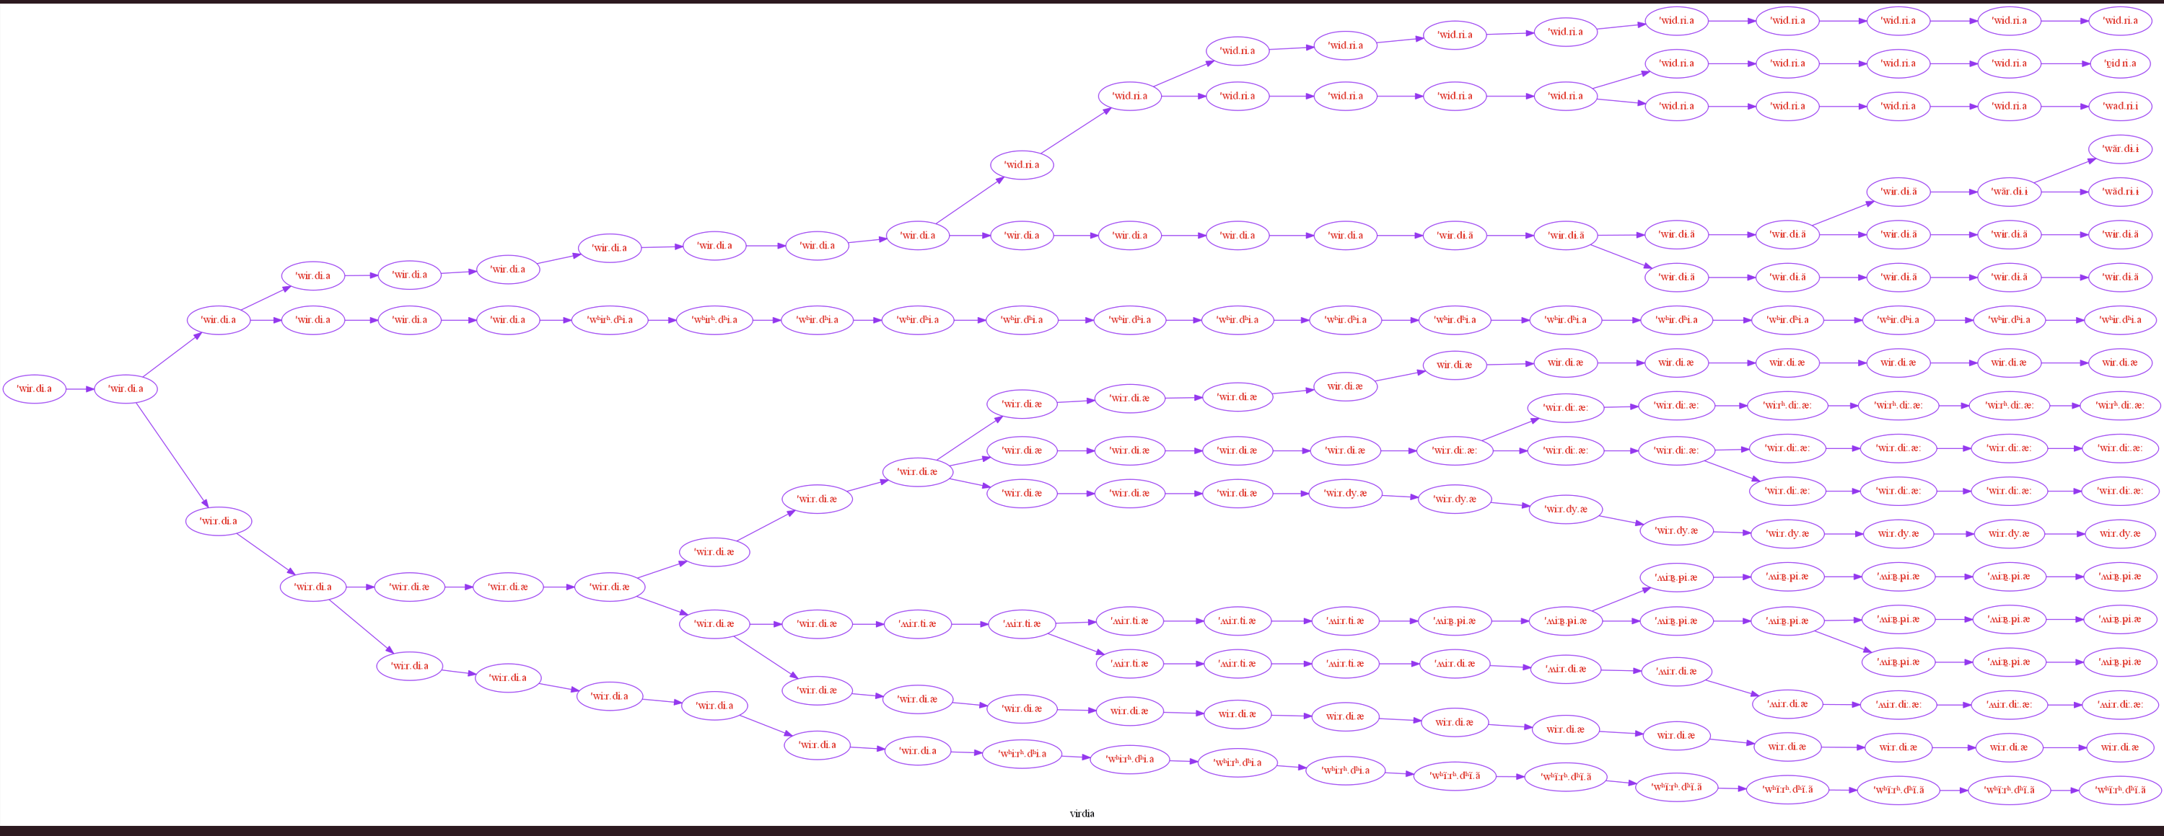
This first approximation of a phylogenetic tree is not a satisfying or accurate description of should be used as a practical storage data structure. Nonetheless, associated with some simple functions implemented using the DOT language, it provides the user with the ability to display the effects of the generated change. The function print_history_to_graph takes as input a word from the original language and gives back the realization of this form in every language stored in the structure. See : an example from Classical_latin with 42 changes and 20 different branches.

The function history_to_graph is its improved version with new functionalities :
* It takes not one but several words as input and study their history at the same time, displaying the form in a column.
* A node only appears if one of the input words has been modified or if two major branches in the tree split. It reduces the size of the graph and make the evolution of the words more readable.
* The color of the edge is defined by the status of the relation between the forms.
Purple means the branch corresponds to an important bifurcation in the history of the language, that lead to the creation of two distinct branches. Blue corresponds to a S_Change, green to a P_Change and red to a M_Change.
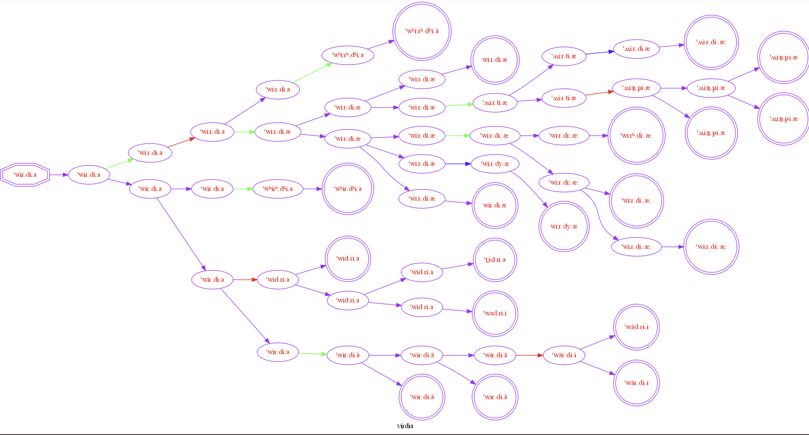
Input and terminal forms are showcased using a different form. This graph corresponds to the first one we displayed, the number of edges has been significantly reduced.

3) Encoding and decoding change : a (not so readable) log system.

The tree structure that has been elaborated has a very rich semantic, it stores all the langages and the relations they share, but the structure is quite heavy (use a quarter of the RAM memory of a good processor for a big tree).
It is therefore difficult to store information concerning different derivations to compare them. Moreover, if the pickle module is not used to store it, the data are lost. Even is the tree and graphs are useful to display the evolution of a given word, they do not provide easy access to the state of the language at a certain step of the derivation, or give precise information about the change that have been applied. One had to manually find the node to access to the change, or parse large lists of changes.
We developed different logs system to store in txt files the representations of the process we randomly generate.
* At the current time, these logs are only able to store the data generated from the main branch of the derivation.

a) The first log is used to compare two languages.
It is commonly used to compare the initial state and a leaf. An arrow represents the derivation link between each word in the first language and its cognate in the second langage.
We are going to solemnly compare the evolution between Latin and Latin*******************

a'ban.te -> a'ban.de
a'ban.te.o: -> a'ban.de.ɔ̞:
'ab.ba.to: -> 'ab.ba.dʌ̞:
ab'ba.tu.o: -> ab'ba.du.ɔ̞:
ab'bi.be.ro: -> ib'ba.be.rʌ̞:
ap'se.di.i: -> ip'zi.da.e:
ap'se.di.um -> ip'ze.da.ɯm
a'bys.si.mus -> e'buz.za.myz
'ak.ka -> 'ak.ka
'ak.ka.po: -> 'ak.ka.pʌ̞:
ak'kap.ti.o: -> ik'kap.da.ɔ̞:
...

b) The second log is used to provide a sort of history of the changes that have been applied between a language and another language that belongs to its descendants :
The changes are presented following the order of their application. We simply used the to_string function of each change to describe the change in the log. Then, several examples of modified words, and of the impacted phonemes are displayed

Here are some examples of a M_Change, a S_change and a P_change, all taken from the same derivation we introduced earlier.

CHANGE N°1 : ( M_change )

The phonemes matching the following target suffered a metathesis :
((6, 2, 0), (1, 0))
switching position with a phoneme displaying a different value for feature Height

EXAMPLES

ab'bi.be.ro: > ib'ba.be.ro:
ap'se.di.i: > ip'se.da.i:
ap'se.di.um > ip'se.da.um
a'bys.si.mus > i'bys.sa.mus
ak'kap.ti.o: > ik'kap.ta.o:
ak'koɡ.ni.to: > ik'koɡ.na.to:
ak'kol.li.ɡo: > ik'kol.la.ɡo:
ak.kom'pli:.re > ik.kom'pla:.re
'ak.kum.hi:k > 'ik.kum.ha:k
'ak.kum'il.le > 'ik.kum'al.le

CHANGE N°2 (S_change)

The syllables with a configuration :
[True, False, None]
moved to a new configuration [True, True, None]

EXAMPLES

a'ban.te > a'ba:n.te
a'ban.te.o: > a'ba:n.te.o:
'ab.ba.to: > 'a:b.ba.to:
ab'ba.tu.o: > ab'ba:.tu.o:
ib'ba.be.ro: > ib'ba:.be.ro:
ip'se.da.i: > ip'se:.da.i:
ip'se.da.um > ip'se:.da.um
i'bys.sa.mus > i'by:s.sa.mus
'ak.ka > 'a:k.ka
'ak.ka.po: > 'a:k.ka.po:

CHANGE N°3 (P_change)

If the following conditions were satisfied :
C: Rel pos : 1 Abs_pos : 42 Continu : False
Template :((-1, (1, 0, 0, 0, 0), 1), (0, -1, 0))

The phonemes matching the following target were modified :
((-1, 0, 1), (1, 0))
The feature Backness switched values from 0 to 2

Impacted phonems :
u > y
o > ø

EXAMPLES

ip'se.da.um > ip'se.da.ym
ak.kom'ple:s.ko: > ak.køm'ple:s.ko:
ik.kom'pla:.re > ik.køm'pla:.re
'ak.kum > 'ak.kym
'ik.kum.ha:k > 'ik.kym.ha:k
'ik.kum'al.le > 'ik.kym'al.le
'ik.kum'ap.se > 'ik.kym'ap.se
'ik.kum'as.te > 'ik.kym'as.te
ad'bas.sum > ad'bas.sym
ap'pres.sum > ap'pres.sym

c) The third log is meant to be written and read by the computer and is the format chosen to store all the details about a given change.
Here is an example with the same tree. For now, it only stores information about the main branch of the tree. As an example, we quote the whole log file.
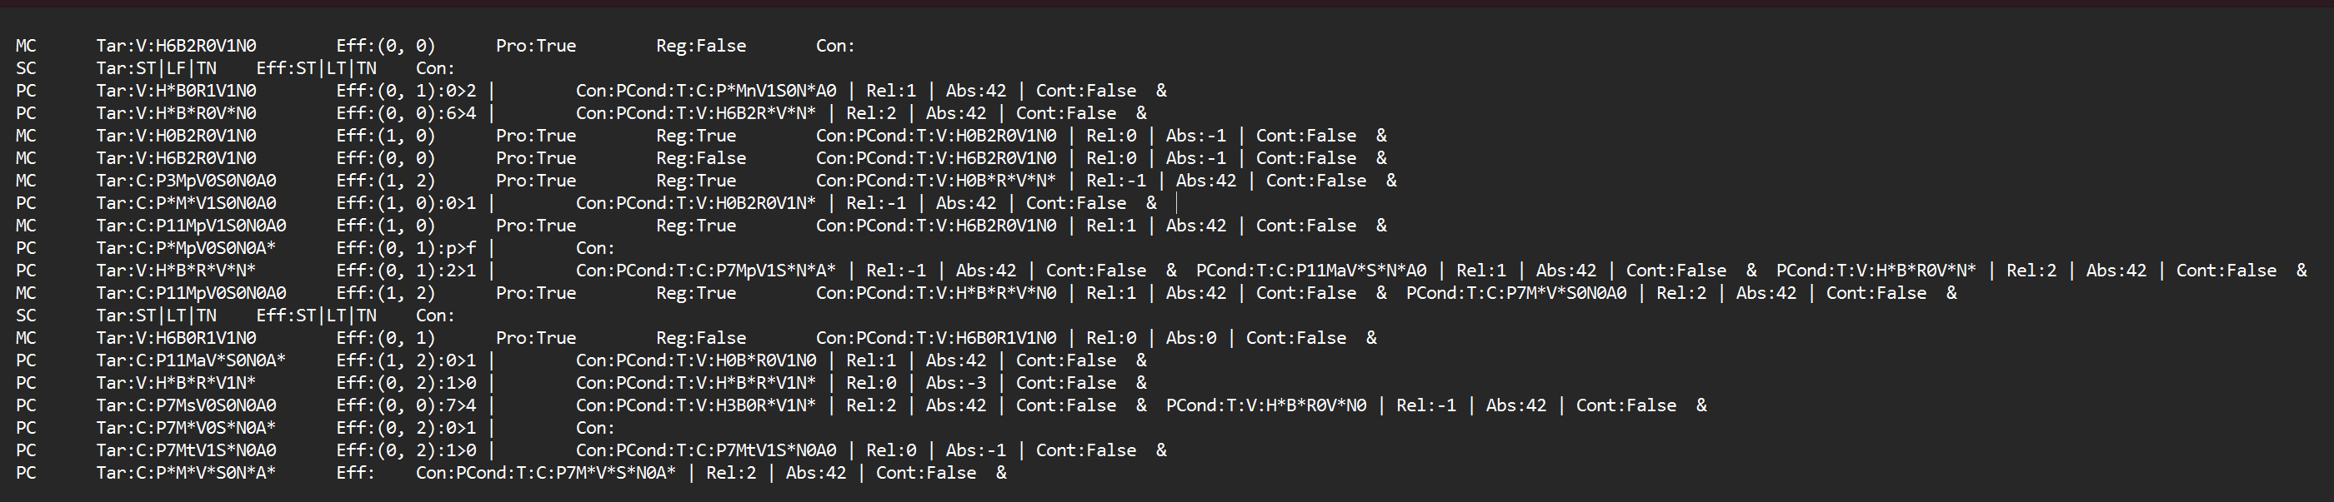

MC Tar:V:H6B2R0V1N0 Eff:(0, 0) Pro:True Reg:False Con:
SC Tar:ST|LF|TN Eff:ST|LT|TN Con:
PC Tar:V:H*B0R1V1N0 Eff:(0, 1):0>2 | Con:PCond:T:C:P*MnV1S0N*A0 | Rel:1 | Abs:42 | Cont:False &
PC Tar:V:H*B*R0V*N0 Eff:(0, 0):6>4 | Con:PCond:T:V:H6B2R*V*N* | Rel:2 | Abs:42 | Cont:False & MC Tar:V:H0B2R0V1N0 Eff:(1, 0) Pro:True Reg:True Con:PCond:T:V:H0B2R0V1N0 | Rel:0 | Abs:-1 | Cont:False &
MC Tar:V:H6B2R0V1N0 Eff:(0, 0) Pro:True Reg:False Con:PCond:T:V:H6B2R0V1N0 | Rel:0 | Abs:-1 | Cont:False &
MC Tar:C:P3MpV0S0N0A0 Eff:(1, 2) Pro:True Reg:True Con:PCond:T:V:H0B*R*V*N* | Rel:-1 | Abs:42 | Cont:False &
PC Tar:C:P*M*V1S0N0A0 Eff:(1, 0):0>1 | Con:PCond:T:V:H0B2R0V1N* | Rel:-1 | Abs:42 | Cont:False & MC Tar:C:P11MpV1S0N0A0 Eff:(1, 0) Pro:True Reg:True Con:PCond:T:V:H6B2R0V1N0 | Rel:1 | Abs:42 | Cont:False &
PC Tar:C:P*MpV0S0N0A* Eff:(0, 1):p>f | Con:
PC Tar:V:H*B*R*V*N* Eff:(0, 1):2>1 | Con:PCond:T:C:P7MpV1S*N*A* | Rel:-1 | Abs:42 | Cont:False & PCond:T:C:P11MaV*S*N*A0 | Rel:1 | Abs:42 | Cont:False & PCond:T:V:H*B*R0V*N* | Rel:2 | Abs:42 | Cont:False &
MC Tar:C:P11MpV0S0N0A0 Eff:(1, 2) Pro:True Reg:True Con:PCond:T:V:H*B*R*V*N0 | Rel:1 | Abs:42 | Cont:False & PCond:T:C:P7M*V*S0N0A0 | Rel:2 | Abs:42 | Cont:False &
SC Tar:ST|LT|TN Eff:ST|LT|TN Con:
MC Tar:V:H6B0R1V1N0 Eff:(0, 1) Pro:True Reg:False Con:PCond:T:V:H6B0R1V1N0 | Rel:0 | Abs:0 | Cont:False &
PC Tar:C:P11MaV*S0N0A* Eff:(1, 2):0>1 | Con:PCond:T:V:H0B*R0V1N0 | Rel:1 | Abs:42 | Cont:False &
PC Tar:V:H*B*R*V1N* Eff:(0, 2):1>0 | Con:PCond:T:V:H*B*R*V1N* | Rel:0 | Abs:-3 | Cont:False &
PC Tar:C:P7MsV0S0N0A0 Eff:(0, 0):7>4 | Con:PCond:T:V:H3B0R*V1N* | Rel:2 | Abs:42 | Cont:False & PCond:T:V:H*B*R0V*N0 | Rel:-1 | Abs:42 | Cont:False &
PC Tar:C:P7M*V0S*N0A* Eff:(0, 2):0>1 | Con:
PC Tar:C:P7MtV1S*N0A0 Eff:(0, 2):1>0 | Con:PCond:T:C:P7MtV1S*N0A0 | Rel:0 | Abs:-1 | Cont:False &
PC Tar:C:P*M*V*S0N*A* Eff: Con:PCond:T:C:P7M*V*S*N0A* | Rel:2 | Abs:42 | Cont:False &

Each change has unique property, and the methods used to encode and decode the changes are redefined in each class,
even if the general format is the same for every change :
*C Tar:************ Eff: (diff for each change type) | Con: c1 & c2 &… cn
* The type of the change is written at the beginning
* Then, information about the target (a feature with wildcard, except for S_Changes)
* The way the effect is described is different for each type of Change
* Then the conditions are listed, separated by a “&”. Conditions also have their own encoding, with the target they concern ans information about accent or position.
To store a change in a line or two, several choices were made. For instance a feature pattern will be represented in a very dense manner :
C:P*M*V*S0N*A* The first letter before the dots indicate whether the phoneme is a vowel or a consonant. Then, each feature was attributed a capital letter according to its semantics, and the value it was attributed directly follows it.
“*” means wildcard.
This compact format allows an easy and quick encoding and decoding. A, class Log_changer was created to automatically read a log file, and apply the encoded changes to a language.
This was first used to check that the encoding / decoding process had been correctly implemented.
It allows to keep track of a derivation in a few kilo octets, but could allow several experiments : what would be the result if we apply a succession of changes specifically designed for a given language to another one ? To estimate the importance of relative chronology in sound change, one could shuffle the order of the changes and try different combinations to see the influence on the outcome.

III) Experiments, practice and performances

After this short presentation of the general functionalities of the program, we’d like to provide a quick demonstration of its possible use, before briefly studying the computational performances.

1) Measuring the impact of sound change and language similarity

The program’s main purpose is to model sound change, and it could be used to simulate the evolution of a language and the separation between a mother tongue or proto language and a series of descendants.
We can now easily build pseudo phylogenetic trees.
Instead of just comparing the derived word-forms to see to what extend the generated forms are different, we have the log b to explain what happens between two languages.
To measure language similarity and the deviation between the modified language and its ancestor, we need a specific metric to quantify language change. We chose to study 4 metrics simultaneously to capture different kind of information :
* We first compare the similarity of the phonetic inventory of the two languages.
It will allow to determine (if we compare a proto languange to its descendants) how many new phonemes were created, and whether some phonemes totally disappeared during the evolution…
* We computed the exact match between phonemes. For now, insertion and deletions are not implemented so it is sufficient to parse the two words, and compute the percentage and exact match to see what portion of the original sequences have been left untouched. This score might be low. When insertion and deletion will be encoded, an adapted version of the Levensthein distance should be implemented.
* We also displayed the averaged Levensthein distance
* Since our algorithm works not with phonemes, but with feature as its basic element, we implemented a feature march similarity that counts the number of features two phonemes have in common, to have a more fine grained idea of the phonetic deviation.

First experiment : estimating the proximity between derived languages and their proto language

To study sound deviation, we suggest the following experiment :
We ‘ll run the basic program on latin, with a depth of 20 changes and 20 different branches.
We’ ll display for each language the final form for 5 words randomly selected in the vocabulary.
For each daughter language, we ‘ll compute the 4 similarity measures.
( We could also compute the min, average and max similarity measures between all the daughters languages. )

On the next page, you’ll find the graphic representation of the evolution of the 5 words

Language id | word1 | word2 | word3 | word4 | word5 | Phon invent sim | Phon match sim | Feat match Sim | Lev dist
Mother | mon'ta:.ni.a | im'bi.bi.to: | 'wul.ne.ro: | 'e.o | au'sa:.re | X | X | X | X
language 0 | mon̼'t̼ã:.n̼i.a | ĩm'bĩ.bĩ.to: | 'wul.nẽ.ro: | 'e.o | ãu'sa:.le | 0.52 | 0.51 | 0.89 | 4.97
language 1 | mon̼'t̼ã:.n̼i.a | ĩm'bĩ.bĩ.to: | 'wul.nẽ.ro: | 'e.o | ãu'sa:.le | 0.53 | 0.51 | 0.88 | 5.46
language 2 | mon̼'t̼ã:.n̼i.a | ĩm'bĩ.bĩ.to: | 'wul.nẽ.ro: | 'e.o | ãu'sa:.le | 0.51 | 0.51 | 0.90 | 4.91
language 3 | mon'tä̃:.ni.a | ĩm'bĩ.bɨ̃.to: | 'wuz.nɘ̃.ro: | 'e.o | ãu'sä:.ze | 0.67 | 0.57 | 0.88 | 4.41
language 4 | mo̥n'tḁ̃:.ni̥.ḁ | ĩ̥m'bĩ̥.bĩ̥.to̥: | 'wo̥l.nẽ̥.ru̥: | 'e̥.o̥ | ḁu̥'sḁ̃:.l̥e̥ | 0.46 | 0.35 | 0.82 | 7.26
language 5 | møn'tã:.ni.a | ĩm'bĩ.bĩ.tø: | 'wyn.lẽ.rø: | 'e.ø | ay'sã:.le | 0.69 | 0.50 | 0.89 | 4.34
language 6 | mon'tã:.ni.a | ĩm'bĩ.bĩ.to: | 'wun.lẽ.ro: | 'e.o | au'sã:.le | 0.77 | 0.60 | 0.91 | 3.60
language 7 | mon'tã:.ni.a | ĩm'bĩ.bĩ.to: | 'wun.lẽ.ro: | 'e.o | au'sã:.lʰe | 0.75 | 0.60 | 0.91 | 3.69
language 8 | mon'tã:.ni.a | ĩm'bĩ.bĩ.to: | 'wun.lẽ.ro: | 'e.o | au'sã:.lʰɤ | 0.71 | 0.60 | 0.91 | 3.68
language 9 | mon̪'tã:.n̪i.a | ĩm'bĩ.bĩ.to: | 'wul̟.nẽ.r̟o: | 'e.o | au'ɹ̥ã:.l̟e | 0.52 | 0.50 | 0.89 | 5.03
language 10 | mon'ta:.ni.ã | ĩm'bẽ.bẽ'to | 'wun.ʎẽ'ro | 'e.o | au'sã:.ʎe | 0.72 | 0.60 | 0.91 | 4.38
language 11 | mon.tã:.ni.a | ĩm'bĩ.bĩ.to: | 'wol.nẽ.ru: | 'e.o | au.sã:.le | 0.71 | 0.61 | 0.93 | 3.58
language 12 | mo:n'tä̃:.ni:.a: | ĩ:m'bĩ.bĩ:.to: | 'wul.nẽ:.ro: | 'e.o: | a:u'sä̃:.le: | 0.77 | 0.64 | 0.90 | 5.45
language 13 | 'mo:n'tã:'na:'i: | 'ĩ:m'bĩ'bĩ:'to: | 'wul'nẽ:'ro: | 'e'o: | 'a:u'sã:'le: | 0.75 | 0.63 | 0.92 | 7.24
language 14 | mon'tã:.na.i | ĩm'bĩ.bĩ.to | 'wul.nẽ.ro | 'e.o | au'sã:.le | 0.68 | 0.60 | 0.91 | 4.33
language 15 | mʷonʷ'tɶ̃:.nʷi.a | ĩb.mʷĩ.bĩ.to: | wur.nʷẽ.lo: | e.o | au'sɶ̃:.le | 0.66 | 0.53 | 0.90 | 4.74
language 16 | mon.di.na.a | im.bi.bi.do̥: | wur.ne.lo̥: | e.o̥ | eu.ra.za | 0.41 | 0.46 | 0.89 | 5.66
language 17 | m͜m̥on͜n̥'n͜ta.n͜n̥a.i | ɯb'mɯ.bɯ.to: | 'ʍol̥.n̥e.ɬo: | 'ɤ.o | ɑo'n̥ɑ.ɮɤ | 0.31 | 0.30 | 0.83 | 9.38
language 18 | m̥ʰon̥ʰ'tʰɑ:.n̥ʰɯ.ɑ | ip'm̥i.pi'tʰo: | 'ʍʰuɹ̥ʰ.n̥ʰe'r̥ʰo: | 'e.o | au'sa:.re | 0.45 | 0.47 | 0.86 | 5.73
language 19 | mɤn̪'t̟a:.n̪i.a | im'bi.bi.to: | 'wul̟.n̪e.r̟o: | 'ɛ.ɤ | au'θe:.r̟a | 0.60 | 0.61 | 0.92 | 3.13
Mean |  |  |  |  |  | 0.00

A quick study of this table already provides interesting informations. The languages are normally displayed in the same order as in the graph on the following page. Among other possible remarks :
* The program easily generates phonemes that didn’t exist in the mother language. When this phenomenon is usually restricted (around 25% of new phonemes), this phenomenon is sometimes out of control. For instance, for language 17 or 18, there is only a 31 or 45 % inventory simularity, that is to say that the number of phonemes doubled during the derivation, which is not a commonly attested phenomenon in sound change.
* The exact phon match score is rather law, and deeply impacted by the inflation of the number of phonemes : there is a clear correlation between the Inventory match score and the Phonetic Match score. Language 5 and 17 for instance have very different inventory similarity score (0.69 vs 0.31) but have the same feature similarity score (0.89). That means there is a strong conservation about features from the initial state, even if the ipa realization is modified.
* The feature based similarity metric seems to be less affected by the size of the inventory.

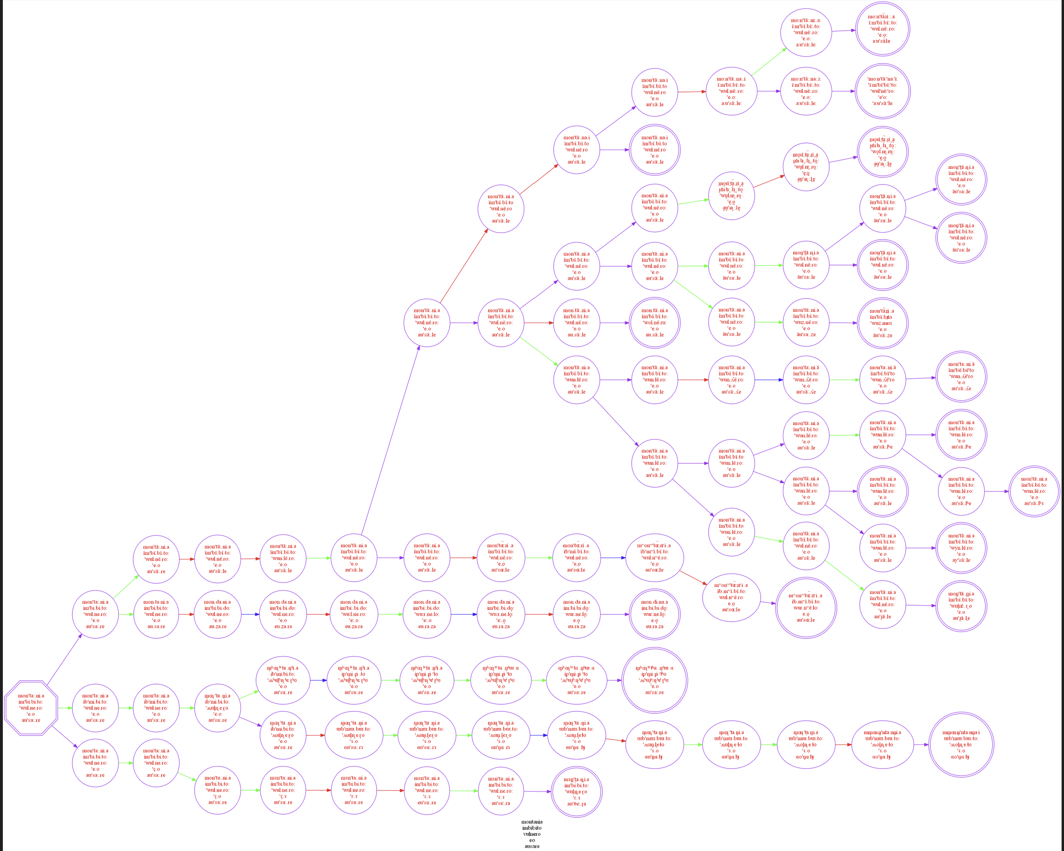
*second experiment : two languages following their own path : measuring the progressive differentiation between both language, and the mother tongue

We could run a second experiment to measure variation : picking a mother language and simultaneously generating two branches, with for instance 50 changes.
Every 5 change, we capture the word forms, and compute the similarity between each language and the mother language, and between the two daughters language.

Here are the results obtained with latin :

Language id | word1 | word2 | word3 | word4 | word5 | Phon invent sim | Phon match sim | Feat match sim | Lev dist
Mother langage | a.mi.ki'ta:.tis | 'bran.dus | af'fun.do: | 'pik.to: | e'pop.ta | 0.01 | 0.01 | 0.01 | 0.00
# with 5 changes
language 1 | a.mi̥.ki̥'ta:.si̥t | 'bran.du̥s | af'fu̥n.do | 'pi̥k.to | e'pop.ta | 0.87 | 0.87 | 0.98 | 1.41
language 2 | i.ma.ki'ta:.tis | bra:n.dus | af.fu:n.do: | pi:k.to: | e.po:p.ta | 1.00 | 0.88 | 0.98 | 1.94
Comparison |  |  |  |  |  | 0.87 | 0.79 | 0.96 | 3.22
# with 10 changes
language 1 | a.mi̥.ki̥'ta:.si̥t | 'bran.du̥s | af'fu̥n.do | 'pi̥k.to | e'pop.ta | 0.79 | 0.87 | 0.98 | 1.43
language 2 | i.ma.ki̥'ta:.ti̥s | bra:n.du̥s | af.fu̥:n.do: | pi̥:k.to: | e.po:p.ta | 0.87 | 0.71 | 0.94 | 3.57
Comparison |  |  |  |  |  | 0.85 | 0.74 | 0.94 | 3.93
# with 15 changes
language 1 | 'a:'mi̥:'ki̥:'ta:'si̥:t | 'bran'du̥:s | 'a:f'fu̥n'do: | 'pi̥k'to: | 'e:'pop'ta: | 0.74 | 0.82 | 0.97 | 5.36
language 2 | a.mi.ki̥'ta:.ti̥s | bra:n.du̥s | af.fu̥:n.do: | pi̥:k.to: | e.po:p.ta | 0.84 | 0.70 | 0.94 | 3.65
Comparison |  |  |  |  |  | 0.78 | 0.70 | 0.93 | 7.54
# with 20 changes
language 1 | 'a:'mi̥:'ki̥:'ta:'ti̥:s | 'bnar'du̥:s | 'a:f'fu̥n'do̥: | 'pi̥k'to̥: | 'e:'pop'ta: | 0.71 | 0.68 | 0.94 | 6.39
language 2 | i̥.ma.ki'ta:.ti̥t | bra:n.du̥t | af.fu̥:n.do: | pi̥:k.to: | a.po:p.te | 0.79 | 0.64 | 0.93 | 4.06
Comparison |  |  |  |  |  | 0.71 | 0.56 | 0.90 | 8.52
# with 25 changes
language 1 | 'ḁ:'mi̥:'ki̥:'sḁ:'ti̥:t | 'bnḁr'du̥:s | 'ḁ:f'fu̥n'do̥: | 'pi̥k'to̥: | 'e̥:'pop'tḁ: | 0.59 | 0.46 | 0.90 | 8.02
language 2 | i̥.ma.ki'ta:.ti̥t | bda:n.ru̥t | af.fu̥:d.no: | pi̥:k.to: | a.po:p.te | 0.72 | 0.62 | 0.92 | 4.22
Comparison |  |  |  |  |  | 0.56 | 0.46 | 0.88 | 9.64
# with 30 changes
language 1 | 'ḁ:'mi̥:'ɡi:'zḁ:'di̥:d | 'bnḁr'du̥:z | 'ḁ:v'vu̥n'do̥: | 'bi̥ɡ'do̥: | 'e̥:'bob'dḁ: | 0.61 | 0.33 | 0.87 | 8.96
language 2 | i.ma.ki̥'ta:.ti̥t | βda:n.ru̥t | af.fu̥:d.no: | ɸi̥:k.to: | a.ɸo:ɸ.te | 0.59 | 0.52 | 0.90 | 5.25
Comparison |  |  |  |  |  | 0.54 | 0.36 | 0.85 | 10.08
# with 35 changes
language 1 | i̥.mi̥.ɡi.zḁ.dḁd | 'bnḁr.du̥z | ḁv'vu̥n.do̥ | 'bi̥ɡ.do̥ | e̥'bob.dḁ | 0.61 | 0.33 | 0.85 | 6.48
language 2 | i.ma.ki̥'ta:.ti̥t | βrä:n.du̥t | af.fu̥:d.no: | ɸi̥:k.to: | a.ɸo:ɸ.te | 0.50 | 0.48 | 0.88 | 5.63
Comparison |  |  |  |  |  | 0.47 | 0.38 | 0.85 | 7.01
# with 40 changes
language 1 | i̥.mi̥.ɡi.zḁ.dḁd | 'b̪nḁr.du̥z | ḁv'vu̥n.do̥ | 'b̪i̥ɡ.do̥ | e̥'bob.dḁ | 0.57 | 0.30 | 0.84 | 6.73
language 2 | a.mi.ki̥'ta:.ti̥t | βnä:r.du̥t | af.fu̥:d.no: | ɸi̥:k.to: | e.ɸo:ɸ.ta | 0.50 | 0.50 | 0.89 | 5.50
Comparison |  |  |  |  |  | 0.45 | 0.35 | 0.85 | 7.30
# with 45 changes
language 1 | i̥.mi̥.ɡi.za.dad | 'b̪nar.do̥z | av'vo̥n.do̥ | 'b̪i̥ɡ.do̥ | e̥'bob.da | 0.53 | 0.36 | 0.85 | 6.56
language 2 | a.mi.ki̥'ta:.ti̥t | βnä:r.du̥t | af.fu̥:d.no: | ɸi̥:k.to: | e.ɸo:ɸ.ta | 0.36 | 0.41 | 0.86 | 6.35
Comparison |  |  |  |  |  | 0.32 | 0.31 | 0.81 | 8.23
# with 50 changes
language 1 | i̥.mʰi̥.ɡi.za.dad | 'b̪ran.do̥z | av'vo̥d.no̥ | 'b̪ʰi̥ɡ.do̥ | e̥'bob.da | 0.38 | 0.33 | 0.84 | 7.15
language 2 | a.mi.ki̥'tɛ̞:.ti̥t | βnʰä:rʰ.tu̥t | af.fu̥:t.nʰo: | ɸi̥:k.to: | e.ɸo:ɸ.ta | 0.25 | 0.29 | 0.82 | 7.92
Comparison |  |  |  |  |  | 0.22 | 0.22 | 0.77 | 9.67

We plot the edit distance, the inventory similarity and the feature similarity.
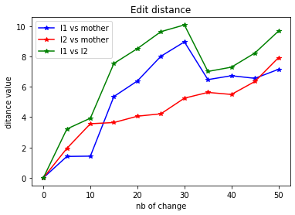

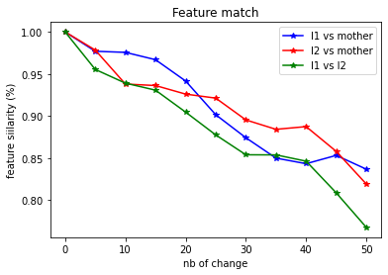
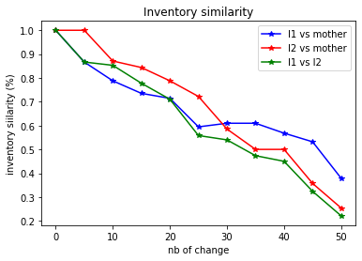

This allows the following remarks :
* As expected, similarity drops at each iteration, with some exception. For instance the feature match between l1 and the mother went higher between the status at change 40 and 45. Some changes might have restored some original feature value. On the other hand the edit distance increases.
* As changes add up, the similarity between the two daughter languages drops faster than their respective similarity with the mother. There is a superadditive effect / divergence between the two daughters language.
* we notice a significant drop in the edit distance between l1 and the mother and l1 and l2 between changes 30 and 35. It means language l1, which was in average more different from the mother than l2, underwent a change that restores some of the characteristics of the mother language.

2) Change and change back : cross linguistic experiments and language creation :

a) Estimating the importance of relative chronology

Idea for a third experiment : not to be launched until the encoding and decoding system worksperfectly.

WARNING : that is not the case.
The error comes from the reapplication of metathesis.
It seems that the metathesis are correctly encoded and decoded, but some error occurs when we try to apply them again.
Cf script to debug.

b) Cross linguistic experiments

For fun, one could apply changes generated for one language to another one.

3) Performances :

While the program runs in a respectable amount of time, it requires several minutes to generate more than 100 changes and 100 branches.
We will now briefly try to determine the importance of some parameters on the length of the derivation process,
and try to determine the parts of the program that consumes most of the computation time and suggest improvements.

a) Principles and parameters :

Two main operations are particularly time consuming : the change generation (different method used for each type of change) and the application of the change. We know :
* the computation time is (in the long run, because some changes take more time to generate than other) proportional to the number of change. In the worst case, it is also proportional to the number of branches in the tree.
So let n be the number of change, d the depth of the tree, g the complexity of change generation in the worst case, and a the complexity of the application, the general complexity of the the program is (g+a)*n*d
* The application part is proportional, of course, to the number of word in the language.
* The time taken to generate P_Change is also, in a lesser extend , influenced by the size of the vocabulary and the number of phonemes in a language.
Simple test for 500 random changes :
with classical latin (around 600 words) : 1 mn 39 . Apply language 1mn 20, M_Change 12 sec, P_change , 6 sec
with tokipona : 6 sec Apply language 3 sec, M_Change 3 sec
with english (around 4000 words) : 13.07 mn Apply language 11mn 77 M_Changes 2.77 mn, P_Changes 1,53 mn
(These test just have been run once, they are just useful to get an order of magnitude. The same operation should be launched at least 20 times to calculate the average and variance)

* Knowing that P_changes happen more frequently than M_changes, the performance of the functions dealing with M_changes are bad and should be improved.
*The operation of applying the change is more costly than its creation.

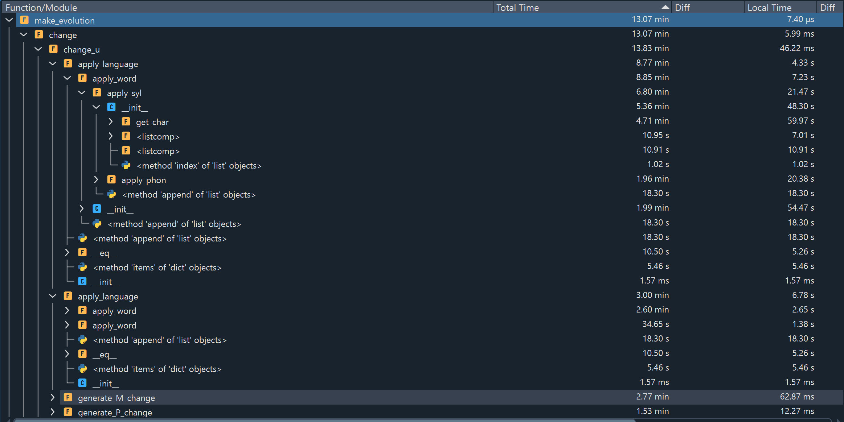
Here is a screenshot of the profiling data on the English test.
We learn that the initialization of the phoneme is one of the most costly operation of the program (takes half of the computation time when we add the init phase and the get_char method that links a feature pattern with its IPA representation.
On previous versions of the program, an auxiliary function used in the apply_phoneme function, list_to_tuple, used to transform an element into a P_change. Several versions have been tested (a recursive one, and another one, more rigid and conditioned by the chosen feature template). Choosing the second version nearly divided by two the average time of application of a P_change. So there is still place for improvement !

IV) Perspectives

The program described here is just the first draft of what could be a far more ambitious project. But even if the program is able to create coherent derivations, its behavior is still very different from “natural” language evolution. We could identify three main axes of development :
* work on some parameters of the program to limit its exotic productions and mimic “realistic sound change”
* Improve already implemented abilities of the program (log system, tree representation)
* Use the current functionalities as basis for more complex simulations.

1) chaotic evolution and unpronounceable patterns : the plight of parameterization

Even if the program runs and generates satisfying and coherent evolution path, when we launch it with an important number of changes (superior to 50), the language obtained at the end does not seems phonetically viable.
Some rare features (aspiration, prenazalization) are overspread, diacritics multiplied…
It is naive to think one could exactly simulate natural sound change because that would mean having access to cross linguistic parameters that are impossible to compute.
What phoneme is the most susceptible to change ? Which of its feature will be modified ? What is the influence of the phonetic context ? Does the fact that a phoneme was recently modified augment or diminish the probability it will be modified again in a near future ? A new area of phonetics tries to deal with these kind of questions, but it is still speculative.
In our implementation, we could work on two different axis :

* tuning the parameters :

As described earlier, the generation of changes is conditioned by numerous parameters stored in the “Sampling” file. A first way to improve the obtained result would be to test random values, or adjust the parameters in a direction we think will be beneficial, and estimate if the parameters are better than the one previously used. But to do that , one would need a metric to estimate whether a produced derivation is plausible following the attested sound changes, or not.

* limiting the phonetic inventory inflation

Another phenomenon already mentioned, and that may be linked with the previous one, is the chaotic augmentation of the number of phonemes. When a phoneme is modified by a P_change, one of its feature is modified, a new phoneme is often created. For instance, if aspiration occur in some contexts (intervocalic but not after a consonant), each plosive in the base language will be opposed to an aspirated counterpart and a lot of new phonemes will be created by a single change.
In average, attested languages have between 20 and 50 phonemes, but the program easily generates languages with more than 100 phonemes which is not desirable. One could think of several strategies to limit this inflation :
* tune the parameters so that the phonemes that are rarely attested in real world languages are rarely created by the program ; the dental nasal would for instance dominate and there wont be all the nasal variant for each point of articulation.
* Modify the way a P_change is generated so that the created change has very high probability (ideally it would become a parameter) to have as outcomes phonemes that are in the inventory of the base language. In other words, the probability that a new phoneme appears would be controlled and limited.
* implement a regularization function that matches the outcome value of a P_Change to a phoneme that is in the original language inventory if it wasn’t. This process could be applied 80% of the time for instance.
* Use this same kind of mechanism, but jut to eliminate phonemes that appear very rarely in the language, or that are too close to another one for the difference to be significative. One could develop a merge procedure.

Of course a combination of all these strategies could be used, and the process of finding the best way to deal with this phonetic inflation will be quite experimental.

2) Not implemented yet

The actual program still needs a lot of work to encompass the diversity of linguistic change, and the next development objectives should focus on :

* Optimizing the generation of a change :
We described in II.1) the process followed to ensure a generated change will always have an effect, but this is only a first procedure, and several other should be implemented ( by creating new Change generators sub classes). One should try for instance to select the context first, instead of the target.

* Work on the definition of what is a context
One should work again on what a context is. It is for now one described by conditions object, and event if complex context requirements can always be expressed using this condition system, and that a bunch of conditions always describe a particular context, it is not easy to make a conversion between the description (in natural language for instance) of a context and the set of conditions objects that are necessary to encode it.
The first step would be to develop a grammar for conditions (FOL with OR and AND functions at least) to enhance the expressivity and the conciseness of the context description.
Conditions are in the current implementation selected one by one, but concern different phonemes, without logical link. Maybe a function could be written to extract not a single condition, but several related conditions from a given word.

* Developing strategies to improve the program’s efficiency.
We chose during the development of the program to copy and create new objects when a change is applied to keep track of the derivation steps and avoid loosing information,but this choice has technical consequences.
We would like the program to run as fast as possible but also limit the quantity of data and memory used by the computer as it executes the script.
First idea : each language object has its specific address and stores a lot of words, its a relatively heavy object, but two related languages in fact only differ in some words, or in some phoneme patterns. It would be useful to develop a more economic object (language state) or a way to stock a language using its mother and the list of different words for instance, to avoid all these copies in the memory.
* implement the last two changes (already begun)
Insertions and deletions should be implemented.
These changes are maybe a bit harder to encode, especially insertion, because they do modify the size of a word. Therefore one would need methods to recompute and rearrange the syllabic structure of the word, but also to adapt the metrics currently used to measure language proximity.
Those changes need to be strongly conditioned (according to what is attested in known languages) because they are the more prone to generate chaotic change.
Once the mechanical application of these two changes will be done, they will have to be integrated in the Change_generator. This means :
- one will need to list the parameters used to randomly generate them, and integrate them in the sampling file
- the log system will need an update
- a mechanism will also be required to limit world shrinkage and expansion.

* Work could be done on the data-structures :
It is for now on easy to access to the main branch of the tree we use to store the language states, but all the trees should be made accessible as well, and readable in the log.
The encoding / decoding of logs should allow to build complex trees and not just linear sequences.

* Creating a way to store and reuse the result of multiple derivations.
The log system we created is compact and efficient, but for the data to be treated, the changes need to be applied again from the top to get the original tree structure back. It is therefore not practical at all to launch statistic analysis or wide comparisons.

* Work on a dynamic way to represent the data.
It would be nice to develop a dynamic tool (maybe in a pop up window) that allows to study a particular word-from, and with arrows navigating between the different forms it took

3) Perspectives, possible application and so on

The program could be developed further in various directions and acquire new abilities.

* A syntax to create changes manually.

We would like to develop a system that allows the user to manually and easily create Changes. We already have an encoder / decoder system for the logs, but its syntax is to dense to be easily readable and a fortiori writable by the user.
We’d like the user to have the possibility to encode a list of known changes to use the program for a simulation purpose : one would for instance manually re-encode all the phonetic changes from latin to french to be able to display each step of the derivation for every word. These changes could be (for fun) applied to an proto English or slavic basis.
To achieve that, one would need :
- a simple way to convert list of IPA phonemes or simple strings ( ex P = “all the plosives”, A “all the aspirated”) into a feature pattern. This transformation only need to work in one direction. When this is done, a specific but easy syntax could be adapted for each type of change, and changes could be read and converted from a csv file implementing this syntax.

* Dealing with the evolution of a language’s vocabulary.

In the current version of the program, the vocabulary is static during the derivation, which is not normally the case. Some words do disappear , some new appear. To model this other dimension of language change, on could implement the following mechanisms :
- sporadic change ; some random words do not apply a change as excepted.
- analogy : some phonetic sequence that are very similar to another one are replaced by this other sequence. It could also be considered as a subclass of P_change.
- word deletion. Some words randomly disappear.
-borrowing : a word form is replaced by its equivalent in another branch of the derivation, or a word from a completely different language is added to the vocabulary.
- word formation : one would need to create a new structure to describe a word (morphological structure, root, affixes) and the language would therefore have a new dictionary of affixes. These affixes could be used with existing word in the language to generate new word. To achieve that, one should add a lot of information about a word ( its part of speech, whether it is a root noun or already a secondary form…) and encode a basic version of morphology.
This would require some work but could give birth to new and interesting evolution patterns.

* a dynamic model of diffusion and areal influence

In our program , we assumed sound change happens uniformly , and that with each change, a branch splits the language that has undergone the change and the other that have not, but this is of course a simplification ; some changes only happen in specific areas. Moreover, some innovations can be shared by several affiliated languages that are differentiated by an isoglosse , and the program is currently not able to do that. One could implement an option so that a change created in a branch could be applied to some neighbors branch, but such a patch do not deal with the crux of the matter, that is to say that our program do not take into account geographical information and builds tree structure that do not account for this material aspect of sound change ; language are spoken on a specific territory.
To take this dimension into account, one could build a more complex simulation using our program as basis.
One could build a map (a 2D space with finite coordinates).
Then a multi agent program will be used to simulate spontaneous linguistic changes. A Changer object would serve as basis of an agent. An agent will be able to modify one specific coordinate in the map. In the following steps, the change could spread itself to the neighbors cases, or shrink. The case modified by a change is chosen (at least at the beginning) randomly, so that at some point, the area of influence of some changes will overlapp, and in the long run, each case of the 2D map will have a language, designing complex linguistic areas.

See for instance CIOBANU, FOURRIER or KONDRAK, cf bibliography
For a more fine grained reflexion, see for instnace Blevins : “Evolutionary Phonology: A holistic approach to sound change typology” or András Cser “Basic Types of Phonological Change “ https://www.oxfordhandbooks.com/view/10.1093/oxfordhb/9780199232819.001.0001/oxfordhb-9780199232819-e-036
Supposing here that the output word has the same length as the input one.
Intempestive remark : From a mathematical perspective, sound change could be represented as a context sensitive language, in which the set of terminal and non terminal symbols is the same : the set of all pronounceable sounds.
Outline (ucla.edu)
Need to be fixed in the implementation : it should be stored in the daughter node.
This creates artificial structures for the distance between a root and a leaf is always equal to the depth given in input, but this could be randomized easily.
We could change the names… but no better idea right now
To extend it, one could add the address of a branch at the beginning.

