**ABSTRACT**

|  |
| --- |
| Osteogenesis Imperfecta (OI) is an inherited form of bone fragility, also sometimes called "brittle bone disease". It is characterised by impaired synthesis of type I collagen, altered trabecular bone architecture and reduced bone mass. High resolution peripheral computed tomography (HR-pQCT) is a powerful method to investigate bone morphology of extremities, including the weight-bearing distal tibia. The resulting 3D reconstructions can be used as basis of micro-finite element (μFE) or homogenised finite element (hFE) models for bone strength estimation. The hFE scheme uses homogenized local bone volume fraction (BV/TV) and anisotropy information (fabric) to compute healthy bone strength within a reasonable computation time using fabric-elasticity relationships. Thus, the aim of this study is to investigate fabric-elasticity relationships in OI trabecular bone compared to healthy controls.  In this study, the morphology of distal tibias of 50 OI diagnosed people were compared to 120 healthy controls using second-generation HR-pQCT. Six regions of interest (ROIs) were selected per individual in a common anatomical region. A first age & gender matching allowed to perform a morphometric analysis and compare the outcome with literature. Then, stiffness tensors of ROIs were computed by FEA and multiple linear regressions were performed on the Zysset-Curnier orthotropic model to compare the two groups using 5 parameters. After initial fits with all the samples of each group, the data were filtered according to a fixed threshold for a defined coefficient of variation (CV) assessing the ROI heterogeneity. Second fits were performed on these filtered data sets and then additional fits were done on BV/TV & fabric anisotropy (DA) matched data to detect statistical differences between the two groups. This full and filtered data were in turn compared with previous results from μCT reconstructions obtained in other anatomical locations.  Compared to healthy controls, we found the OI samples to have significantly lower BV/TV and trabecular number (Tb N), significantly higher trabecular spacing (Tb Sp) and trabecular spacing standard deviation (Tb Sp SD), but no differences in trabecular thickness (Tb Th). This is in agreement to literature. The stiffness of ROIs from OI bone reached lower values and the multilinear fabric-elasticity fits tended to overestimate the stiffness in the lower range. Th filtering of highly heterogeneous ROIs removed these low stiffness ROIs and lead to similar correlation coefficients for both OI and healthy groups. Finally, the BV/TV & DA matched data revealed no significant differences in fabric-elasticity parameters between OI and healthy individuals. Compared to previous studies, the stiffness constants from the 61 μm resolution HR-pQCT ROIs were lower than for the 36 μm resolution μm uCT ROIs.  In conclusion, despite the reduced regression parameters found for HR-pQCT images, the fabric-elasticity relationships between OI and healthy individuals are similar when the trabecular bone ROIs are sufficiently homogeneous to perform the mechanical analysis. Since highly heterogenous ROIs coincide with very low BV/TV, we expect them to play a minor role in hFE analysis of distal bone sections or parts. |

**1. Introduction**

Osteogenesis imperfecta (OI) is an inherited form of bone fragility [Tournis 2018]. It was estimated to concern about 1/13'500 of births, less severe forms being not accounted in this estimation, as they are recognized later in life [Lindahl 2015]. Therefore, OI is considered as a rare metabolic bone disorder. Sillence classification [Sillence 1979] allows to define four main types of OI based on the clinical phenotype:

* Type I: less severe
* Type II: lethal at most shortly after birth
* Type III: most severe surviving form
* Type IV: intermediate severity

Also commonly known as "brittle bone disease", OI is characterized by impaired synthesis of type I collagen, leading to such brittle and fragile bones [LIM 2017].

Bone fragility in OI is complex and not totally understood, despite the investigations at different hierarchical levels. Multiple studies show that DXA areal bone mineral density (aBMD) tends to be lower in OI compared to healthy individuals [Folkestad 2012, Lindahl 2015, Scheres2018]. The microstructure is different as well. [Folkestad 2012], [Kocijan 2015], and [Rolvien2018] have shown that bone volume fraction (BV/TV) and trabecular number (Tb.N) in OI bone is lower than for healthy controls. Trabecular spacing (Tb.Sp) and inhomogeneity () are higher for OI bone, but the trabecular thickness (Tb.Th.) is not significantly different. At the ECM level, a recent study shown that in compression, OI bone tends to present higher modulus, ultimate stress and post-yield behaviour than healthy bone [Indermaur 2021].

High-resolution peripheral quantitative tomography (HR-pQCT) scans allow to perform *in vivo* assessment of trabecular architecture and volumetric bone mineral density (vBMD) in the distal radius and distal tibia [Boutroy 2005]. Moreover, the bony microstructure obtained from HR-pQCT can be used for finite element analysis (FEA) to predict mechanical properties [Boutroy 2008]. Homogenized finite element (hFE) is based on BV/TV and anisotropy information (fabric) of trabecular bone from HR-pQCT which to assess bone strength within reasonable computation time [Pahr 2009]. High correlations were found between patient-specific hFE and mechanical compression experiment of freshly frozed human samples at the distal radius [Varga 2011, Arias-Moreno 2019]. Thus, it could be legitimate to use hFE for OI patients bone strength estimation and potentially fracture risk assessment. However, HR-pQCT-based FEA relies on fabric-elasticity relationships. Therefore, the present study aims to compare trabecular bone microstructure of healthy and OI bone samples and to investigate the hypothesis of similar fabric-elasticity relationships.

**2. Methods**

**2.1 Subjects**

The healthy group includes a total of 120 patients from a previous reproducibility study performed at the University Department of osteoporosis in Bern [Schenk 2020]. The group is composed of 64 female and 56 male subjects aged between 20 and 92 years old with a median age of 26 [22 - 35] years. These subjects did not take any medication known to affect bone metabolism nor presented any prior osteoporosis fracture. The second group was scanned at the Shriners Hospital for Children and images were shared to our group by the McGill University in Montreal. This group includes a total of 50 OI diagnosed subjects, composed of 35 females and 15 males. The youngest and oldest patients are 19 and 69 year old, respectively. The median age is 44 [33 - 55] years. 35 subjects were diagnosed with OI type I, 2 with type III, and 13 with type IV.

**2.2 HR-pQCT**

HR-pQCT scans (XtremeCTII, SCANCO Medical, Brütisellen, Switzerland) were performed at the distal tibia on all patients from both groups. People of the healthy group were scanned using an in-house protocol as described in [Schenk 2020] whereas OI subjects were scanned using the manufacturer's standard protocol. The main differences of the in-house protocol with the manufacturer's standard protocol are the following:

1. The reference line is positioned at the proximal margin of the dense structure formed by the tibia plafond instead of the subchondral endplate of the ankle joint (standard clinical section) [Whittier 2020].
2. Three stacks were scanned proximal to the reference line instead of one stack at 22.5 mm proximal to the reference line for standard clinical section [Whittier 2020].

These differences are shown in Figure 1. For both groups, each stack consists of 168 voxels and a resolution of 61 μm in the three principal directions. This leads to a thickness of roughly 10.2 mm for each stack. Standardized scanning settings were used (voltage of 60 kVp, 900 μA, 100 ms integration time) for the healthy group as well as for the OI group. For the healthy group, motion artefacts of first, middle and last slice were graded on a scale of 1 (no motion artefacts) to 5 (extreme motion artefacts), as proposed by the manufacturer [Pialat 2012]. The final grade of each scan was defined as the highest slice grade. For the OI group, as the scan consist of one stack, only one grade is attributed using the same scale as for the control group. Scans were then processed independently of their quality grading. A summary of the scans grading densities is shown in Figure 2.

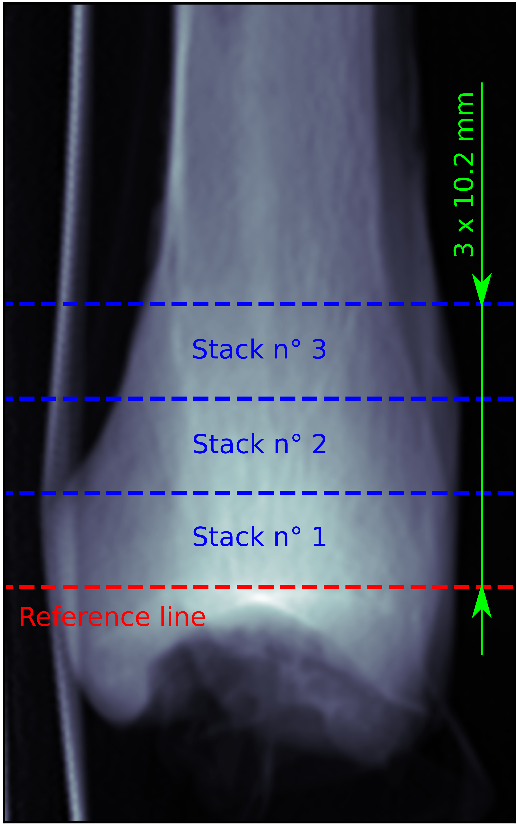 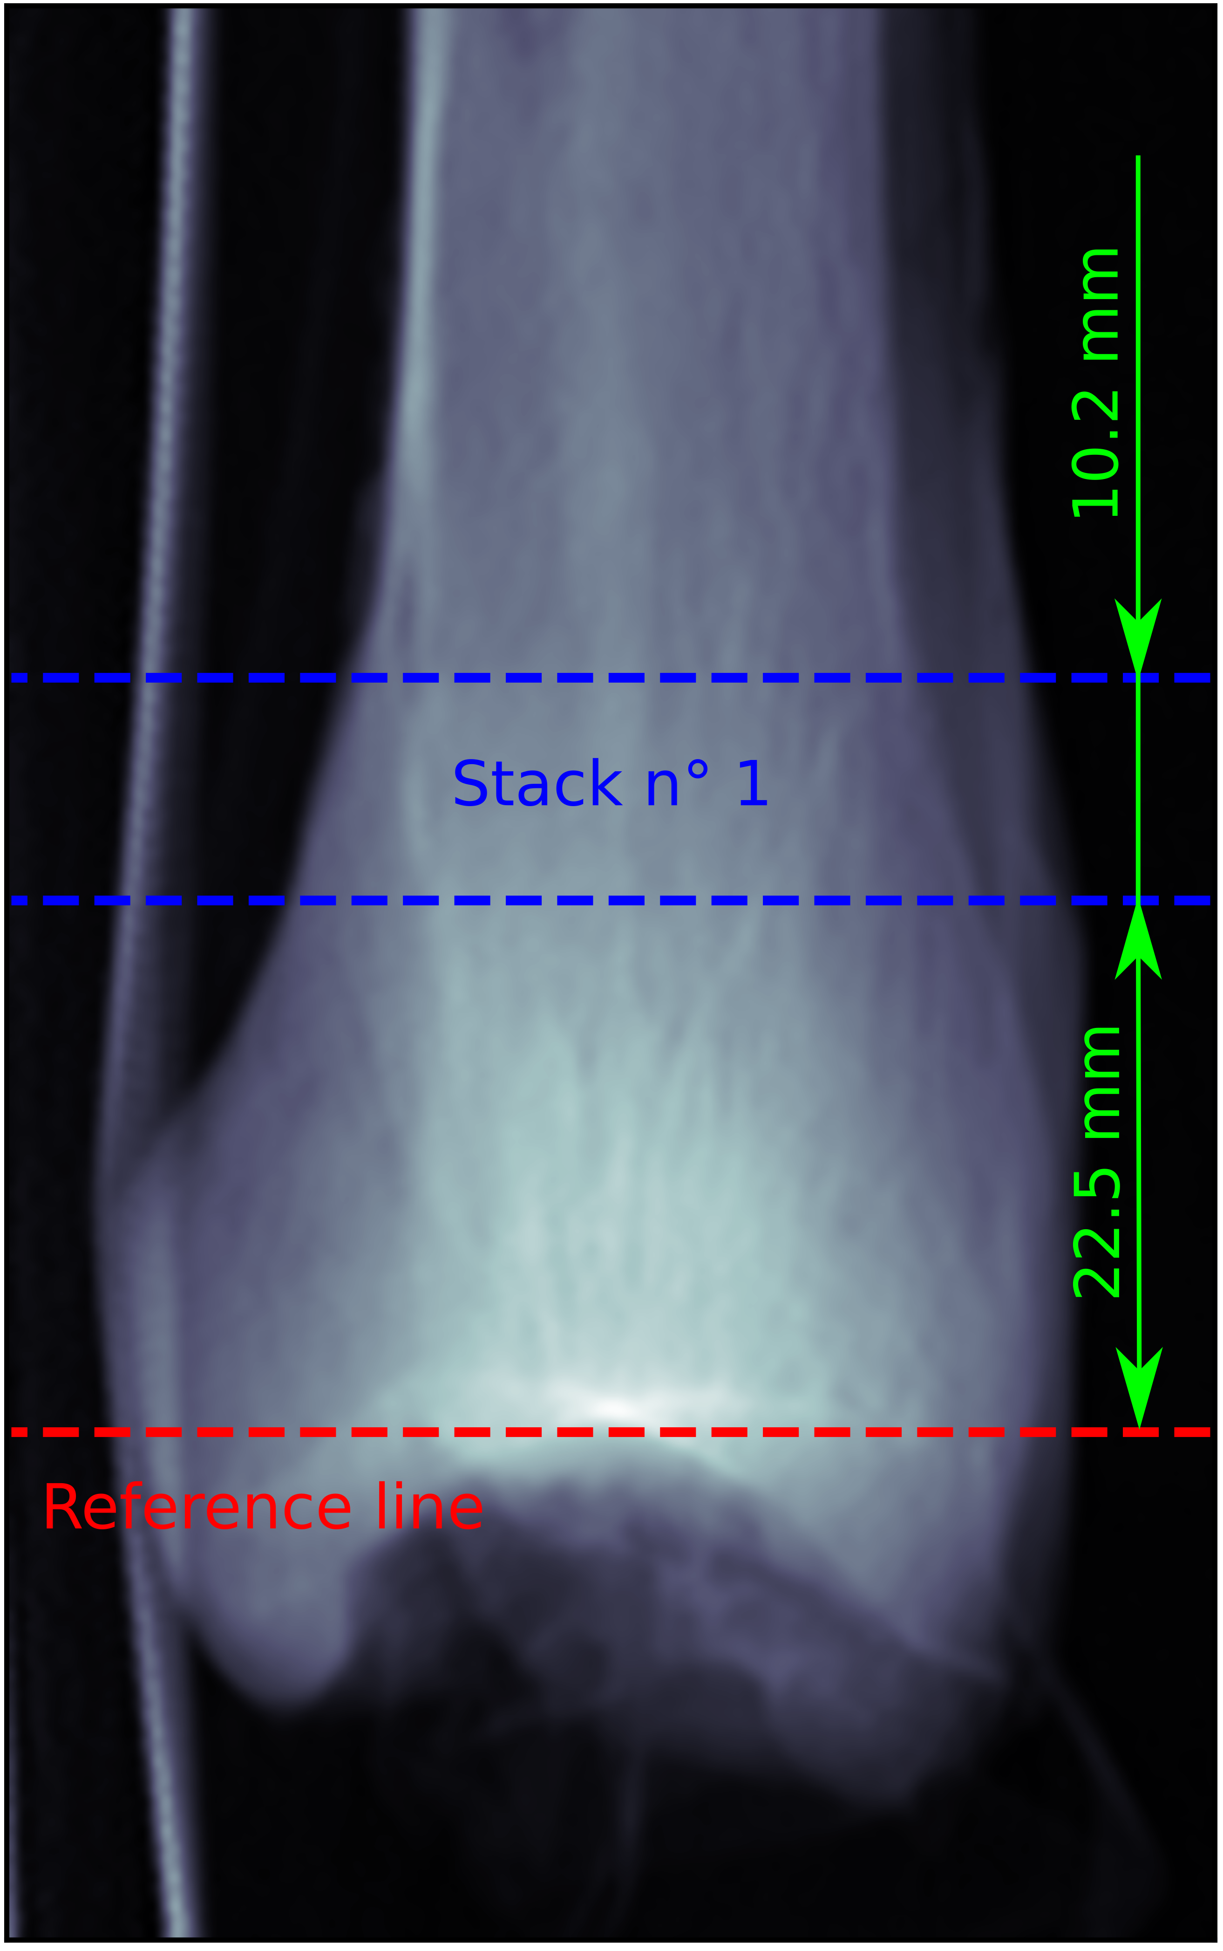

(a) Healthy group (b) OI group

**Figure 1**: Clinical section scanned for both group

**2.3 Image Analysis**

The HR-pQCT scans were evaluated using the manufacturer's standard evaluation protocol. Then, mask segmented images were used for further analysis.

In general, six ROI were randomly selected in each scan. Each ROI must contain trabecular bone, but no cortical bone. For the OI subjects, the stack was divided into two halves and the ROIs were selected to have the centres of three ROIs in the proximal half and three in the distal half. For the healthy controls, the ROIs were selected in the more proximal stack uniquely, see Figure 1a stack n° 3. As for the OI subjects, the stack is halved and centers of three ROIs were selected in both half.

The ROI is defined as a cube of 5.3 mm side length. This size is in agreement with the work of [Panyasantisuk 2015] and [Gross 2013], who performed similar analysis with femur μCT scans. It was determined by [Zysset 1998] and [Daszkiewicz 2017] to be the optimal size to obtain accurate FEA results.

The morphological analysis of ROIs was performed using medtool (v4.5; Dr. Pahr Ingenieurs e.U., Pfaffstätten, Austria). The morphological parameters analyzed are: BV/TV, SMI, trabecular number (Tb. N.), trabecular thickness (Tb. Th.), trabecular spacing (Tb. Sp.), and the standard deviation of the trabecular spacing (Tb. Sp. SD). ROI fabric was evaluated using MIL method [Moreno 2014]. The fabric tensor **M** is a positive-definite second-order tensor, shown in Equation 1 below:

where *mi* are the eigenvalues of **M** and **M***i* are the dyadic product of the corresponding eigenvectors **m***i* [Cowin1985, Harrigan1985]. The fabric tensor is independent of BV/TV and normalized with *tr*(**M**) = 3. The fabric eigenvalues allow to compute the degree of anisotropy (DA) of the ROI by dividing the highest eigenvalue by the lowest one.

**Figure 2**: Summary of the motion artefacts grading. Histograms show density of each grade within both group.

After ROI cleaning, i.e. deletion of unconnected region of bone material, a homogenized mechanical analysis was performed using ABAQUS 6.14. In brief: Each voxel of the cleaned ROI was converted to a fully integrated linear brick elements (C3D8) using a direct voxel conversion approach. Then a stiffness *E* of 10 000 MPa and a Poisson's ratio *ν* of 0.3 were assigned. The simulation consisted of 6 independent load cases, 3 uni-axial and 3 shear cases, using KUBCs [Panyasantisuk 2015]. Unlike PMUBCs, KUBCs do not require to rotate the ROI into fabric coordinate system. Such rotations would potentially decrease image quality. This homogenization process allows to calibrate the parameters of the Zysset-Curnier fabric-elasticity model [Zysset 1995]. This model builds the fourth order stiffness tensor 𝕊 using the BV/TV or *ρ*, fabric tensor **M**, three elasticity parameters *λ0*, *λ0'*, and *μ0*, and two exponents, *k* and *l*, as shown in Equation 2.

Where ⊗ and are the dyadic and symmetric product of second order tensors, respectively. The Zysset-Curnier model is built with the assumption of orthotropy and homogeneity. However, the trabecular structure is not perfectly homogeneous. In order to assess the ROI heterogeneity, a coefficient of variation (CV) is computed according to [Panyasantisuk 2015]: the ROI is divided into eight identical sub-cubes and BV/TV is computed for each of them. The CV is defined as the ratio between the standard deviation of these BV/TV and the mean value (Equation 3).

**2.4 Statistics**

The analyzed morphological parameters (BV/TV, Tb. N., Tb. Th., Tb. Sp., and Tb. Sp. SD, SMI, DA, and CV) were compared between the two groups. As the initial groups do not have similar distributions of age and sex, a matching was performed leading to identical mean and median age as well as identical gender distribution. Then, the selection of statistical test to perform was executed as follow:

1. For each parameter, the median value between the six ROI of the same individual was computed. The median was preferred over the mean because it is less influenced by outliers.
2. Normality of the distribution was assessed with QQ plot and Shapiro-Wilk test.
3. If normality assumption was met, Bartlett test for equal variances was performed. Otherwise, data were log transformed to try to achieve normal distribution. If even after log transformation, normality assumption was not met, original data space was kept and Brown-Forsythe test was applied to assess the equal variance assumption.
4. According to the previous results, t-test was performed if normal distribution and equal variance were met. If only the equal variances assumption was met, Mann-Whitney test was preferred. Finally, if none of these conditions could be assumed, a non-parametric permutation test was performed.

The general significance level was set to 95% for all tests. Confidence intervals in means difference was computed for t-tested variables to confirm p-values. As Mann-Whitney tests are performed on the median, only the corresponding p-value is presented. Finally, non-parametric permutation tests are less powerful but give an empirical 95% exclusion range and a p-value. If the difference in means belong to this exclusion range, it can be stated that group means are different with 95% certainty.

**2.5 Fit to model**

The stiffness tensors obtained from the mechanical simulations were transformed into fabric coordinate system and projected onto orthotropy, leading to 12 components. The resulting orthotropic stiffness tensors were then used to perform a multiple linear regression with the Zysset-Curnier model. Standard linear models assume independent and identically distributed (iid) variables. As this assumption is violated by the fact that six ROIs are analyzed individually, a linear mixed-effect model was preferred. This last model, shown in Equation 4 in Laird-Ware form [Laird 1982], considers the non-independence of ROIs from the same individual. A more detailed form of this model is presented in Appendix A1.



Where *Src* is the *r*th row and *c*th column of the non-zero element of the orthotropic stiffness tensor 𝕊 in Mandel notation [MANDEL 1965], *X* is a 12*n* x *p* design matrix containing the the BV/TV and fabric info of the *n* ROIs and *β* is a *p* x1 vector of fixed effects containing model parameters. *Z* is a 12*n* x *f* design matrix which contains data with individual dependence and *δ* is a *f* x1 vector composed of random factors. Finally, *ε* is a 12*n* x1 vector containing the regression residuals.

The linear regression was performed on both group (healthy and OI) separately. To improve the fit quality, the data sets were filtered. The aim here is to filter out ROIs violating the assumption of homogeneity. Therefore, analogously to the work of [Panyasantisuk 2015], a fixed threshold for the CV was used. To simplify comparison, we used the same value of 0.263 as exclusion criterion. Then the relation between BV/TV and CV was assessed using Spearman's correlation coefficient., To compare the stiffness constants (*λ0*, *λ0'*, and *μ0*) between the groups, regression must be performed on identical value ranges. Therefore, a matching was performed for BV/TV and DA to find corresponding control ROI for each OI in the filtered groups. Best correspondences were kept and duplicates were dropped. Finally, as the regression is performed in the log space, it is necessary to use identical exponents (*k* and *l*) for both groups, weighting identically BV/TV and DA between regressions, to compare stiffness constants. The exponents were determined by grouping healthy and OI for regression. Then a modified system was used to perform the fit on separated groups.

Another modification of the model was to add a regressor for the group variable (healthy or OI), i.e. add a column to the design matrix *X* and a row to the parameter vector *β*. This modified model is compared to the original by analysis of covariance (ANCOVA) using the fixed-effects only to determine the statistical significance of the group. Implementation of this modification was performed according to [Fox 2016]. The detailed linear systems for each model discussed here are available in Appendix A1 and a summary of the data sets used for the different methods is shown in Table 1.

The regression was performed using the statsmodels package from python 3.6. Regression quality was assessed using the adjusted Pearson correlation coefficient squared (*R*2adj) and relative error between the orthotropic observed and the predicted tensor using norm of fourth-order tensors (*NE*), see Equation 5 and 6.

Where *RSS* is the residual sum of squares and *TSS* is the total sum of squares i.e. the sum of the square of the observations y.

**3. Results**

**3.1 Morphological Analysis**

The results of the morphological analysis are summarized in Table 2. The individual matching for sex allowed to have similar group distributions with 17 females and 11 males in each group. The mean age of matched healthy subjects is 41y ± 14y and 41y ± 15y for the matched OI group. BV/TV of healthy subjects is higher than BV/TV of OI group with a 95% CI of [0.016, 0.101] and p-value <0.01. Similarly, trabecular number is higher in the matched healthy group compared to the matched OI group with a 95% CI of [0.099, 0.285] and a corresponding p-value <0.001. The trabecular thickness does not show significant differences between groups. On the other hand, trabecular spacing is higher in matched OI group compared to healthy individuals with a p-value of 0.01 and an exclusion range of (∞, -0.384] ⋃ [0.421, ∞). Trabecular spacing SD is higher in OI patients compared to matched healthy with a p-value of 0.02 and an exclusion range of (∞, -0.232] ⋃ [0.251, ∞). SMI as well as the degree of anisotropy are higher for matched OI than for healthy people with p-values <0.001 and of 0.02, respectively. Finally, the log transformation of the coefficient of variation gives the stronger difference in means with a p-value <0.0001 and a 95% CI of [−0.757, −0.333].

In the table, absolute values and p-values of test statistics are compared with literature. The present population is slightly younger compared to other study but stay in a similar range. Three other studies show significant differences for BV/TV, Tb N, Tb Sp, and Tb Sp SD and no significant differences for Tb Th[reference for studies!]. In the present study, absolute values of BV/TV, TB Th, Tb Sp, and Tb Sp SD are higher compared to literature. On the other hand, Tb N appears to lower compared to studies in literature.

**3.2 Linear Regressions**

Figure 3 shows the result of the (linear?) regression analysis of each individual group, between the values of observed tensors from mechanical simulations and the predicted values using the Zysset-Curnier model[reference?] and the parameters obtained after performing the regression with linear mixed-effect model. The fitted line is represented by the dashed line. *λii* stands for the diagonal terms of normal components of 𝕊 in Mandel notation [MANDEL 1965], *λij* for the off-diagonal terms of normal components, and *μij* for the shear components. For the healthy group (Figure 3a) the fit is performed on 720 ROIs leading to 8640 data points. The *R*2adj is slightly above 0.95 and the *NE* is of 18% ± 10%. The regression of the OI group (Figure XY) could only be performed on 294 ROIs, as it was not possible to find suitable ROIs for one patient. This leads to 3528 data points, an *R*2adj close to 0.85 and a *NE* of 62% ± 233%. It can be noticed that, as the values of observed tensor decreases, data points tend to be further apart from the diagonal (dashed line). Moreover, the data points from the tensors with lowest values are exclusively above the diagonal.

**Table 1**: Summary of the data set used for different methods

|  |  |  |  |  |
| --- | --- | --- | --- | --- |
| Data sets | Original | Age & gender matched | CV filtered | BV/TV & DA matched |

|  |  |  |  |  |  |  |  |  |
| --- | --- | --- | --- | --- | --- | --- | --- | --- |
| Group | Healthy | OI | Healthy | OI | Healthy | OI | Healthy | OI |
| Individuals | 120 | 50 | 28 | 28 | 119 | 38 | 58 | 33 |
| ROIs | 720 | 300 | 168 | 168 | 603 | 115 | 83 | 83 |
| Methods | Fit to model | | Statistics | | Fit to model | | Fit to model | |

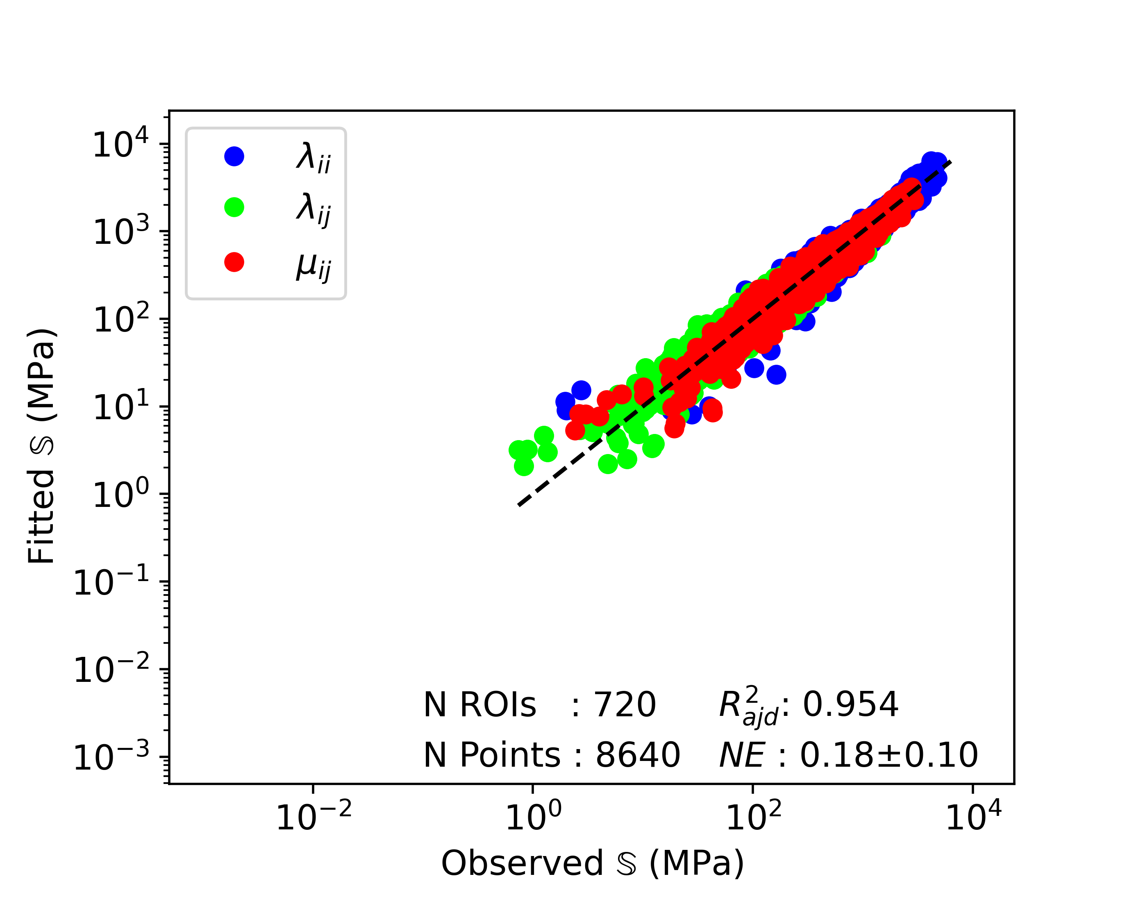

(a) Healthy group

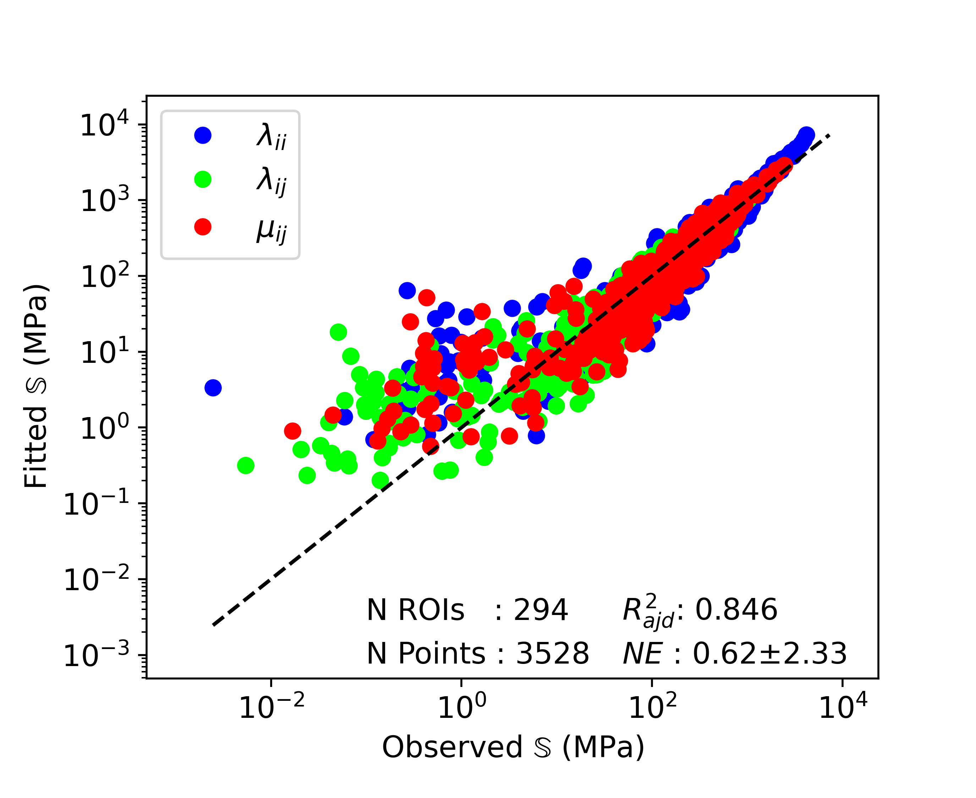

(b) OI group

**Figure 3**: Regression results using the fixed effects of the linear mixed-effect model on original data sets. *λii* stands for the diagonal terms of normal components of 𝕊 in Mandel notation [MANDEL 1965], *λij* for the off-diagonal terms of normal components, and *μij* for the shear components. The dashed line represents the fitted line.

The range of stiffness tensors of the OI group is wider compared to the one of the healthy group and ROIs with lower BV/TV present lower stiffness values.

The CV in relation to BV/TV is shown in Figure 4. The OI data reached higher CV values and lower BV/TV values compared to healthy data. Generally, the CV tends to increase with decreasing BV/TV. The Spearman coefficient is shown above the plot as value [95% CI]. Its value is negative and strictly different from zero. Finally, the CV threshold value used to filter the data is represented by the dashed line. It can be observed that a relatively important part of OI data will be filtered out. On the other hand, relatively

|  |
| --- |
| **Table 3**: Constants obtained with BV/TV and DA matched data sets. Comparison is performed between grouped (N ROIs = 166) and separated data sets (N ROIs = 83). Values are presented as value [95% CI] or mean ± standard deviation. |

|  |  |  |  |  |  |  |  |
| --- | --- | --- | --- | --- | --- | --- | --- |
| Data set | *λ0* | *λ0'* | *μ0* | *k* | l | *R*2adj | *NE* |
| Grouped | 4626 [3902-5485] | 2692 [2473-2932] | 3537 [3246-3855] | 1.91 [1.86-1.95] | 0.95 [0.93-0.97] | 0.936 | 18 ± 9 |
| Healthy | 4322 [3855-4846] | 2684 [2535-2842] | 3509 [3307-3724] | 1.91 | 0.95 | 0.836 | 21 ± 10 |
| OI | 4980 [4359-5689] | 2722 [2547-2909] | 3594 [3355-3849] | 1.91 | 0.95 | 0.861 | 20 ± 10 |

**Figure 4**: Coefficient of variation in relation to BV/TV. Spearman correlation coefficient *ρ* assess monotonic relation between two variable

few healthy data gets removed. Examples of extreme ROIs in terms of CV and BV/TV are shown in Appendix A2.

The regression results of the filtered data are presented in Figure 5. After filtering, healthy group is reduced to 119 individuals and 603 ROIs, resulting in 7236 data points, an *R*2adj close to 0.95 and a NE of 16% ± 8% (Figure 5a). In the OI group , more individuals were filtered, leading to 38 people, 115 ROIs and 1380 data points (Figure 5b). This resulted in an *R*2adj close to 0.95 and a *NE* of 17% ± 8%.

Regression results after BV/TV & DA ROI matching are shown in Table 3. The columns show the used data set, the fives parameters of the Zysset-Curnier model (k, l, …) and the assessment of fit quality (R²?). Grouping healthy and OI data together for regression lead to a *k* of 1.91 and a *l* of 0.95. Regression result shows a *R*2adj of 0.94 and a NE of 18% ± 9%. The second and the last row show regression results using separated data sets and imposing the exponents *k* and *l*. OI values are higher than healthy one. The increase is of 15%, 1%, and 2% for *λ0*, *λ0'*, and *μ0*, respectively. The ANCOVA performed to quantify the group statistical significance shows a p value of 0.7.

Table 4 shows results obtained compared to literature. [Gross 2013] has the larger number of ROIs. Data sets of [Panyasantisuk 2015] show BV/TV ranges slightly higher than in the present study and the one of [Gross 2013]. On the other hand, DA is higher in the present study than for [Panyasantisuk 2015] and [Gross 2013]. Setting the exponents *k* and *l* to the same values leads to lower stiffness constants for the observed data set compared to the other studies.

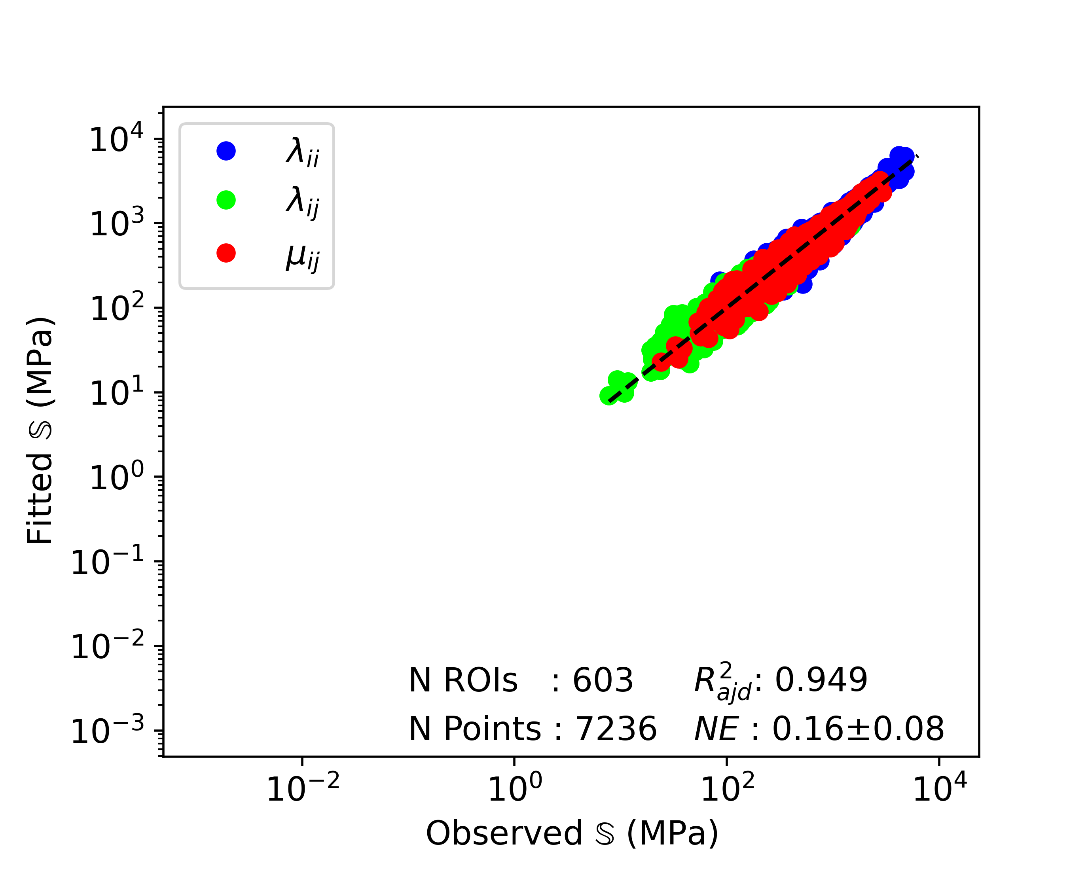

(a) Healthy group

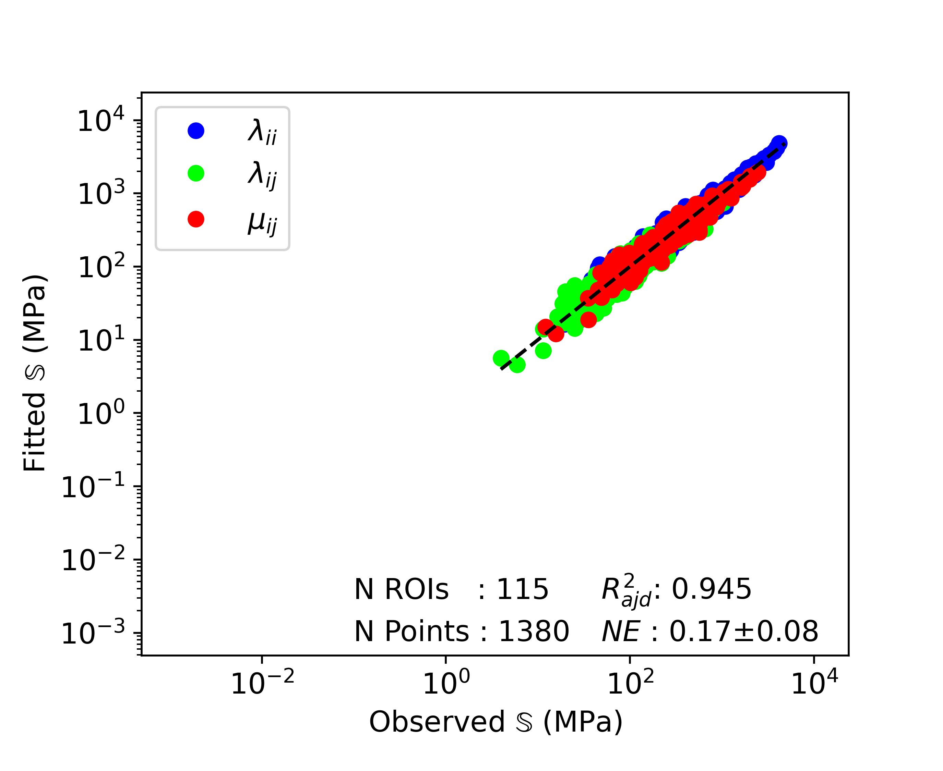

(b) OI group

**Figure 5**: Regression results using the fixed effects of the linear mixed-effect model on filtered data sets. *λii* stands for the diagonal terms of normal components of 𝕊 in Mandel notation [MANDEL 1965], *λij* for the off-diagonal terms of normal components, and *μij* for the shear components. The dashed line represents the fitted line.

**4. Discussion**

The As the previous studies have the same age range as our matched groups, we can compare morphological parameters. The imaging system explains most of the differences between the absolute morphological values of the present study compared to the others. [Folkestad 2012], [Kocijan 2015], and [Rolvien 2018] have performed their measurements on first generation XCT scanners, while we have used a second generation XCT. The work from [Agarwal 2016] showed that BV/TV, TbTh, and TbSp are higher in second generation XCT scanners and Tb N is lower, compared to first generation XCT. These results give confidence in our observed values. Another bias is introduced by the fact that the present study analyses the median values of six cubic ROIs with 5.3 mm side length. This conditions the TbN and TbSp as they depend on the ROI size. Moreover, conditions imposed for random ROI selection can lead to further biased values, specially of OI patient, as the ROI must contain a portion of trabecular bone. The CV values presenting the stronger significant difference between groups even given the low sample size show that heterogeneity is a main difference in OI patient compared to healthy individuals. Finally, the significant differences observed in BV/TV and DA even with matched age and gender justifies the choice of a variable matching for fabric-elasticity relationships analysis.

Regression performed on original data sets showed *R*2adj and *NE* in the expected range for the healthy group. Components of the stiffness tensors are distributed to both sides of the diagonal. On the other hand, regression of the OI data set presents lower *R*2adj than such fit reach usually. The important value of NE and its standard deviation shows that the fitted stiffness can deviate significantly from the observation. These differences come from ROIs presenting a low stiffness. The regression plot (figure XY) shows, that when the stiffness term decrease to 100 N/mm and lower, the fit tends to overestimate the stiffness. This is because ROI stiffness is highly dependent on BV/TV values. Some ROIs with low BV/TV don’t have every side of the cube connected by bone, leading to extremely low terms in the stiffness tensor, see Appendix A2. Trying to homogenize such ROIs can lead to errors of multiple order of magnitudes, as observed on the plot. Therefore, a filtering is indispensable to assess and compare fabric-elasticity relationships, as done by [Panyasantisuk 2015]. An alternative to CV filtering for assessing the ROI heterogeneity could be to compute the proportion of the area filled by bone on each of the six faces of the ROI.

Figure 4 presents the CV in relation to BV/TV. It shows a tendency of CV values to increase with decreasing BV/TV values. Effectively, if the quantity of material inside the ROI decreases, the distribution homogeneity of this mass is more sensitive and therefore can quickly become highly heterogeneous. A simple assumption about this relation is that it could be monotonic. Pearson's correlation coefficient being strictly negative confirms a negative monotonic relation. As some ROIs with higher BV/TV still present high CV values, imposing a fixed threshold for subsequent homogenization seems feasable.

The fits performed on filtered data sets present direct effect of filtering. For the healthy group (N=603), the relatively small decrease of *R*2adj (5‰) is negligible. On the other hand, *NE* values are decreased by 2% and therefore improved. These results are due to the filtering of data point further away from the diagonal (better *NE*) and some points close to the diagonal, leading to a smaller number of points (*R*2adj). For the OI group, filtering leads to an important improvement of the fit. *R*2adj, *NE*, and the range of stiffness values are almost at the level of the healthy group. These results give confidence to the filtering procedure and are a first step in accepting the hypothesis of healthy and OI trabecular bone having the same fabric-elasticity relationships.

After BV/TV and DA matching, grouping the data sets together leads to similar *R*2adj and NE as for the individual filtered data sets. This allows to determine values for *k* and *l* for the tibia at a spatial resolution of 61µm. Imposing these values to perform the fit on individually matched data sets allows to highlight differences, if any, between healthy and OI trabecular bone. The relatively low differences for *λ0'* and *μ0* once again supports the hypothesis for similar fabric-elasticity relationships between the two groups. For *λ0*, this relative difference being higher could rise some doubts about this similarity, but the 95% CI intervals still show a common range. Moreover, ANCOVA performed comparing the original formulation and the one with addition of a regressor for the group showed a p-value far above the 5% significance level. With this statistical non-significance of the groups and their low relative differences in the computed stiffness constants, it can be stated that: if trabecular bone is homogeneous enough, there is no reason to assume differences in fabric-elasticity relationships between healthy and OI trabecular bone. In FEA simulations, it is not possible to exclude part of the mesh because of high heterogeneity. Nevertheless, the error created by such ROIs is negligible as this concerns ROIs with extremely low stiffness leading to a minor impact on the full model.

Imposing *k* and *l* allows to estimate the effect of different image resolutions. [Panyasantisuk 2015] and [Gross 2013] both used femur scans with 18 µm spatial resolution and coarsened them to 36 µm. [Gross 2013] showed that different anatomical locations lead to only slight differences. Comparing regression of the filtered data set of [Panyasantisuk 2015] with the present study, the lower stiffness constants observed can be explained partially by the higher DA range and by the coarser resolution. Differences of *R*2adj and *NE* come from the imposition of *k* and *l* to a different value than the optimal ones. Then, comparing regression results of [Panyasantisuk 2015], [Gross 2013], and the present study, BV/TV ranges overlap. As for the filtered data sets, DA is higher in the present study and the stiffness constants remain lower than for the two other studies. Here, differences in DA can mainly be explained by the different anatomical location and differences in stiffness constants as a result of the different image resolutions. The distal tibia, unlike the proximal femur, is mainly loaded in one direction which explains this increase of DA. Lower stiffness constants are obtained because the coarser structure resulting from XCTII can’t be as optimized as the fine detailed structure obtained by µCT. Effectively, the architecture resulting from µCT scans can reproduce the optimized morphology of trabecular bone with a high fidelity. By decreasing the scan spatial resolution, the scanned structure becomes bulkier. Performing a fit on this less optimized structure leads to the observed lower stiffness constants. Finally, the comparison between *R*2adj and NE of current study without imposing *k* and *l* and the ones of [Panyasantisuk 2015] and [Gross 2013] shows that lower spatial resolution leads to lower fit quality. Nevertheless, *l* stays in the same range as for the two other studies, meaning the relative weight of DA remains constant. On the other hand, the higher *k* highlights an increased relative weight of BV/TV.

The main limitations of this study are the definition of "homogeneous enough" and the fact that it is limited to tibiae XCTII scans. The ROI homogeneity has an important impact on the analysis quality. As proposed earlier, ROI homogeneity could be assessed in another way to be able to propose a more precise ROI filtering for fitting. More investigations could be performed to improve the model for highly heterogeneous ROIs, but as it concerns mainly ROI with low stiffness the impact on FEA models can be negligible. A similar study could be performed on XCTII radii scans to confirm the low differences between anatomical locations for coarser resolution.

In conclusions, the samples analysed in the present study had similar morphology compared to data reported in the literature. We couln’t find differences in fabric-elasticity relationships between healthy and OI trabecular bone, when the ROIs were homogeneous enough. [Indermaur 2021] could show that the compressive behaviour of OI bone tissue is similar to the one of healthy control. If the tensile and shearing behaviour is similar as well, fabric-strength relationships will hold too. Therefore, OI bone fragility might mostly result from the decrease in BV/TV and the loss of homogeneity in its organization.

**Acknowledgements**

The authors acknowledge Christina Wapp from the ARTORG Center for Biomedical Engineering Research for her contribution to the building and interpretation of linear mixed-effect model and Mereo BioPharma for sharing the tibia XCTII scans of OI individuals. This work was internally funded by the ARTORG Center for Biomedical Engineering Research and Mereo BioPharma.

References

1. Agarwal, S., Rosete, F., Zhang, C., McMahon, D.J., Guo, X.E., Shane, E., Nishiyama, K.K., 2016. In vivo assessment of bone structure and estimated bone strength by first- and second-generation HR-pQCT. Osteoporosis International 27, 2955–2966. URL: http://dx.doi.org/10.1007/s00198-016-3621-8, doi:10.1007/s00198-016-3621-8.
2. Arias-Moreno, A.J., Hosseini, H.S., Bevers, M., Ito, K., Zysset, P., van Rietbergen, B., 2019. Validation of distal radius failure load predictions by homogenized- and micro-finite element analyses based on second-generation high-resolution peripheral quantitative CT images. Osteoporosis International 30, 1433–1443. doi:10.1007/s00198-019-04935-6.
3. Boutroy, S., Bouxsein, M.L., Munoz, F., Delmas, P.D., 2005. In vivo assessment of trabecular bone microarchitecture by high-resolution peripheral quantitative computed tomography. Journal of Clinical Endocrinology and Metabolism 90, 6508–6515. doi:10.1210/jc. 2005-1258.
4. Boutroy, S., Van Rietbergen, B., Sornay-Rendu, E., Munoz, F., Bouxsein, M.L., Delmas, P.D., 2008. Finite element analysis based on in vivo HR-pQCT images of the distal radius is associated with wrist fracture in postmenopausal women. Journal of Bone and Mineral Research 23, 392–399. doi:10.1359/jbmr.071108.
5. Cowin, S.C., 1985. The relationship between the elasticity tensor and the fabric tensor. Mechanics of Materials 4, 137–147. doi:https://doi.org/10.1016/0167-6636(85)90012-2.
6. Daszkiewicz, K., Maquer, G., Zysset, P.K., 2017. The effective elastic properties of human trabecular bone may be approximated using micro-finite element analyses of embedded volume elements. Biomechanics and Modeling in Mechanobiology 16, 731–742. doi:10.1007/s10237-016-0849-3.
7. Folkestad, L., Hald, J.D., Hansen, S., Gram, J., Langdahl, B., Abrahamsen, B., Brixen, K., 2012. Bone geometry, density, and microarchitecture in the distal radius and tibia in adults with osteogenesis imperfecta type i assessed by high-resolution pQCT. Journal of Bone and Mineral Research 27, 1405–1412. doi:10.1002/jbmr.1592.
8. Fox, J., 2016. Fox, Applied Regressions Analysis and Linear Models. URL: https://us.sagepub.com/en-us/nam/applied-regression-analysis-and-generalized-linear-models/book237254.
9. Gross, T., Pahr, D.H., Zysset, P.K., 2013. Morphology elasticity relationships using decreasing fabric information of human trabecular bone from three major anatomical locations , 793–800doi:10.1007/s10237-012-0443-2.
10. Harrigan, T.P., Mann, R.W., 1985. Characterization of microstructural anisotropy in cancellous bone using a second rank tensor. Journal of Materials Science 19, 761–767.
11. Indermaur, M., Casari, D., Kochetkova, T., Peruzzi, C., Zimmermann, E., Rauch, F., Willie, B., Michler, J., Schwiedrzik, J., Zysset, P., 2021. Compressive Strength of Iliac Bone ECM Is Not Reduced in Osteogenesis Imperfecta and Increases With Mineralization. Journal of Bone and Mineral Research doi:10.1002/jbmr.4286.
12. Kocijan, R., Muschitz, C., Haschka, J., Hans, D., Nia, A., Geroldinger, A., Ardelt, M., Wakolbinger, R., Resch, H., 2015. Bone structure assessed by HR-pQCT, TBS and DXL in adult patients with different types of osteogenesis imperfecta. Osteoporosis International 26, 2431–2440. doi:10.1007/s00198-015-3156-4.
13. Laird, N.M., Ware, J.H., 1982. Random-Effects Models for Longitudinal Data. Biometrics 38, 963–974.
14. Lim, J., Grafe, I., Alexander, S., Lee, B., 2017. Genetic causes and mechanisms of osteogenesis imperfecta. Bone 102, 40–49. doi:https://doi.org/10.1016/j.bone.2017.02.004.
15. Lindahl, K., Åström, E., Rubin, C.J., Grigelioniene, G., Malmgren, B., Ljunggren, Ö., Kindmark, A., 2015. Genetic epidemiology, prevalence, and genotype-phenotype correlations in the Swedish population with osteogenesis imperfecta. European Journal of Human Genetics 23, 1042–1050. doi:10.1038/ejhg.2015.81.
16. Mandel, J., 1965. Generalisation de la theorie de plasticite de w. t. koiter. International Journal of Solids and Structures 1, doi:https://doi.org/10.1016/0020-7683(65)90034-X.
17. Moreno, R., Borga, M., Smedby, Ö., 2014. Techniques for computing fabric tensors: A review. Mathematics and Visualization , 271–292doi:10.1007/978-3-642-54301-2_12.
18. Pahr, D.H., Zysset, P.K., 2009. A comparison of enhanced continuum FE with micro FE models of human vertebral bodies. Journal of Biomechanics 42, 455–462. URL: http://www.sciencedirect.com/science/article/piiS0021929008006064, doi:10.1016/j.jbiomech. 2008.11.028.
19. Panyasantisuk, J., Pahr, D.H., Gross, T., Zysset, P.K., 2015. Comparison of Mixed and Kinematic Uniform Boundary Conditions in Homogenized Elasticity of Femoral Trabecular Bone Using Microfinite Element Analyses. Journal of Biomechanical Engineering 137, 1–7. doi:10.1115/1.4028968.
20. Pialat, J.B., Burghardt, A.J., Sode, M., Link, T.M., Majumdar, S., 2012. Visual grading of motion induced image degradation in high resolution peripheral computed tomography: Impact of image quality on measures of bone density and micro-architecture. Bone 50, 111–118. URL: http://dx.doi.org/10.1016/j.bone.2011.10.003, doi:10.1016/j.bone.2011.10.003.
21. Rolvien, T., Stürznickel, J., Schmidt, F.N., Butscheidt, S., Schmidt, T., Busse, B., Mundlos, S., Schinke, T., Kornak, U., Amling, M., Oheim, R., 2018. Comparison of Bone Microarchitecture Between Adult Osteogenesis Imperfecta and Early-Onset Osteoporosis. Calcified Tissue International 103, 512–521. URL: http://dx.doi.org/10.1007/s00223-018-0447-8, doi:10.1007/s00223-018-0447-8.
22. Schenk, D., Mathis, A., Lippuner, K., Zysset, P., 2020. In vivo repeatability of homogenized finite element analysis based on multiple HR-pQCT sections for assessment of distal radius and tibia strength. Bone 141, 115575. URL: https://doi.org/10.1016/j.bone. 2020.115575, doi:10.1016/j.bone.2020.115575.
23. Scheres, L.J., van Dijk, F.S., Harsevoort, A.J., van Dijk, A.T., Dommisse, A.M., Janus, G.J., Franken, A.A., 2018. Adults with osteogenesis imperfecta: Clinical characteristics of 151 patients with a focus on bisphosphonate use and bone density measurements. Bone Reports 8, 168–172. URL: https://doi.org/10.1016/j.bonr.2018.04.009, doi:10.1016/j.bonr.2018.04.009.
24. Sillence, D.O., Senn, A., Danks, D.M., 1979. Genetic heterogeneity in osteogenesis imperfecta. Journal of Medical Genetics 16, 101–116. doi:10.1136/jmg.16.2.101.
25. Tournis, S., Dede, A.D., 2018. Osteogenesis imperfecta A clinical update. Metabolism: Clinical and Experimental 80, 27–37. URL: https://doi.org/10.1016/j.metabol.2017.06.001, doi:10.1016/j.metabol.2017.06.001.
26. Varga, P., Dall’Ara, E., Pahr, D.H., Pretterklieber, M., Zysset, P.K., 2011. Validation of an HR-pQCT-based homogenized finite element approach using mechanical testing of ultra-distal radius sections. Biomechanics and Modeling in Mechanobiology 10, 431–444. doi:10.1007/s10237-010-0245-3.
27. Whittier, D.E., Boyd, S.K., Burghardt, A.J., Paccou, J., Ghasem-Zadeh, A., Chapurlat, R., Engelke, K., Bouxsein, M.L., 2020. Guidelines for the assessment of bone density and microarchitecture in vivo using high-resolution peripheral quantitative computed tomography. Osteoporosis International 31, 1607–1627. doi:10.1007/s00198-020-05438-5.
28. Zysset, P.K., Curnier, A., 1995. An alternative model for anisotropic elasticity based on fabric tensors. Mechanics of Materials 21, 243–250. doi:10.1016/0167-6636(95)00018-6.
29. Zysset, P.K., Goulet, R.W., Hollister, S.J., 1998. A global relationship between trabecular bone morphology and homogenized elasticproperties. Journal of Biomechanical Engineering 120, 640–646. doi:10.1115/1.2834756.