
Mathieu
SERANDOUR
June 2022
SLR209 Project Report

Hierarchical approach for leader election in dynamic ad hoc networks

Abstract
We present a hierarchical approach to leader election algorithms in large scale dynamic networks, and bring a proof of concept algorithm based on the link reversal method. The goal of the approach is to build a tree of leaders: electing one global leader and multiple local leaders. The idea is to avoid situations in which every topology change causes a global leader reelection. Instead, only the local leader may be subject to change.

I. Introduction
The principle of leader election in a distributed network is the delegation of a task to be done by one node only, therefore not distributed. It is generally needed in a context in which distributed processes must perform a collective function and need a single process to act as a synchronizing leader. In distributed systems, whether wired or wireless, leader election is a helpful building piece, especially when failures are possible. The whole problem behind leader election is for all nodes to agree on which one is selected. As for peer to peer internet networks, any node can connect to any other. Then, the topology of the network is flexible. In a mobile ad hoc network however, messages are sent between two nodes either directly through a wireless link or through a series of wireless links that include one or more intermediary nodes. Only pairs of nodes that are physically adjacent to one another can directly communicate with one another. When two nodes become too distant from each other, the wireless link fails. In the same way, wireless links can be created dynamically when nodes that were previously too far apart to communicate move in order to put themselves in each other’s broadcast range. The topology is subject to changes, abruptly and frequently. The problem in these kind of networks is to maintain at all time the communication between a leader and every other node, despite of topological changes, and reelecting a leader when it is no longer reachable by every node.

II. From simple routing algorithm to leader election solution in dynamic networks
A class of leader election algorithms is based on height-based routing algorithms [3][4]. This sections aims to describe the idea of height-based routing algorithms and how it led to leader election algorithms in dynamic networks. The goal of a routing algorithm is to create a directed acyclic graph (DAG) in which only the only sink is the destination. A sink node is a node that has no outgoing links. Within this kind of networks, the outgoing links are directions to the destination. Gafni and Bertsekas [1] introduced two synchronous routing algorithms:
- Full link reversal: At every round, each node other than the destination which became a sink reverses all its links, meaning that all of its ingoing links become outgoing.
- Partial link reversal: This algorithm works in the same way as the full link reversal one, except that every node i other than the destination keeps a list of its neighboring nodes j that have reversed the direction of the corresponding links (i, i). At each iteration each node i that has no outgoing link reverses the directions of the links (i, j) for all j which do not appear on its list, and empties the list. If not such j exists (i.e., the list is full), node i reverses to the directions of all incoming links and empties the list.
Gafni and Bertsekas [1] also presented two height-based algorithms which are equivalent to the above algorithms. The main idea is for every node to maintain a height vector composed on one or multiple values. Height values are compared lexicographically. For each node i, the link (i,j) is defined as ingoing if and only if the the height of j is inferior to the height of i. When a node updates its height, it sends an update message to all of its peers, for every node to know the state of its peers.
- Full link reversal: the height is in the form. Whereis an unique identifier.is initially 0 for every node. The purpose of putting an unique identifier in the height vector is to break the symmetry during the initialization. When a node becomes a sink at the k th iteration, it updates itsvalue:

- Partial link reversal: the height is in the form. The valuefollow the same rules as above.is initially set to 0, and when a node becomes a sink at the k th iteration, it updates itsvalue:
If there exists a neighborofwith:
Otherwise,

Based on the same principle, the Temporally-Ordered Routing Algorithm (TORA) uses 5-values heights, targets dynamic networks and is also synchronous [2]. As the Gafni and Bertsekas algorithm, this one also constructs a direction oriented directed acyclic graph, but it also reacts to topological changes. Furthermore, it allows every node in the network to detect if the destination is reachable. The protocol’s reaction is structured as a temporally-ordered sequence of diffusing computations, each computation consisting of a sequence of directed link reversals.
The first three values in the height vectorrepresent a reference level. An unreflected reference level is created everytime a node other than the destination becomes a sink due to a link failure.represents a timestamp of this event,is the identifier of the node that created the reference level, andis a boolean value used to divide each of the unique reference levels into two unique sub-levels. If a node becomes a sink not because of a link failure, and its current reference level is an unreflected one (), it starts a reflection meaning that it swaps itsvalue. Its purpose is to distinguish the original reference level and its corresponding, higher reflected reference level. The fourth valueis a number that grows with the distance to the destination with respect with the reference level. The last value is a unique identifier. When a nodebecomes a sink again because of a link reversal, and all of its neighbors have the same reference reflected level with(meaning that the unreflected reference level was previously created byand got reflected before spreading back to), then the nodeknow for sure that it cannot reach the destination node.
Malpani et al. proposed a synchronous leader election algorithm mobile ad oc networks based on TORA. The idea is to have the current leader as the destination, and for every node to elect itself when it detects that the current leader is no longer reachable. To do so, a 6th height component is introduced:

represents the id of the current leader. If the network is no longer connected, a leader is elected in each connected component. If a node detects that there is no leader in its connected component, it declares itself as the leader and propagates the information to the other nodes in the new component.
When two components meet due to the formation of a new link, the leader of one of the components which has the lower identification number eventually becomes the leader of the new component.
Ingram et al. [4] designed a 7 values height-based asynchronous leader election algorithm based on the Malpani et al. [3] approach. It also targets dynamic networks but the algorithm is more complex. The key introduced idea is the use of causal clocks and to store the timestamp of the election of the current leader in the height.

III. Hierarchical approach
In this project we studied a hierarchical approach to leader election. The idea of this approach is to split the network into small partitions, elect a leader among each partition, then create super partitions, elect a leader for per super partition, etc. We split the problem into three different parts:
- A. Partitioning the network
- B. electing one leader per partition
- C. creating routes between the leaders of the new created partitions
Once we have these three parts working, we can run themtimes with right parameters to build alevel hierarchical structure.
Because of timing constraints, we only focus on B and C. Efficient distributed energy-efficient clustering algorithms exist [5] and could be used to solve problem A in our case. We also focus on static networks but our approach should be generalizable to dynamic networks.

Problem B
We introduced partition unique identifiers. We suppose that the algorithm solving problem A can produce such an identifier. This way, a node can easily detect whether or not a neighbor of his is in its partition. Problem B can then be solved using any leader election algorithm by only considering neighbors within the same partition in the process.
We chose to use the algorithm by Malpani et al. [3] to solve problem B, as it is quite efficient and simpler than algorithms. The drawback of this algorithm is that it is synchronous. It forces our hierarchical one to be also synchronous. Some improvement might be possible to make it asynchronous, for example by using the algorithm by Ingram et al. [4] instead. In this case, an asynchronous clustering algorithm should also be used.

Problem C
The goal of problem C is for any partition leader to be able to send a message to the leader of any neighbor partition of his. We define a partitionas a neighbor of partitionif there exists a link between a node withinand a node within .
Problem B gives that any node in a partition is capable of sending a message to its local leader. Therefore, solving problem C only requires for the leader of partitionto be able to send a message to one node within every neighbor partition.
One way to solve Problem C is to create the primitive for any nodeand a partition with identifierwithin the same connected component:

This primitive allows any node to send a message to a node in any partition within the same connected component.
A way to achieve that is to use a height based algorithm, similar to a leader election one. For example, an algorithm similar to the problem B one could be applied on the set of nodes:

The algorithm would have to be modified in such a way that the leader would have to be inand would represent the representative ofin. This way, a node incan send a message to the representative (as a representative oriented directed acyclic graph is generated) which will be able to redirect it to its partition leader.
The problem with this approach is that it is not very flexible: Consider that there are two links betweenand :neighbors of nodes in. Consider thatis elected as the representative ofin, and its link tofails. Then a reelection must be done.
Instead, another height based algorithm is possible using a single height valuefor nodeto reach.is set to 1 for every node who has a neighbor in, and represents the distance for every node from itself to the nearest node in. Every time a node updates its heightto, it broadcasts it to its neighbors. When a nodedetects that a neighbor of hisis at a distance:

Then it updates its own distance to:

We could also use a two values height algorithm like Gafni and Bertsekas [1] to be adaptive to dynamic networks.

IV. Implementation
The only messages that are sent are update messages, as for the height based algorithms [1][2][3][4]. The introduced fields areand the multiple partition heights. These fields are sent in update messages as well.
We wrote a proof of concept application in the python programming language, using an object oriented framework called Pykka for simulating distributed networks on the actor model. As the list type is compared lexicographically in python, we used the list[6] type for height values.
The goal of this proof of concept application is to run tests and validate the suitability of the hierarchical approach. Tests are presented in the next section.

Figure 1 shows the definition of variables for one actor. peers is a dictionary mapping unique identifiers to actor references of the neighbors of the actor. As we introduced in the preceding section, global partition heights are stored in the ̀heights variable. It is a dictionary mapping a unique partition identifier to a height vector. self.heights[self.pid] represents the Malpani et al. algorithm 6 values height, and the other stored heights have only one value.

Height = list[6]

class Actor:
peers: dict
heights: dict # partition id -> Height
pid: int
peer_heights: dict # node id -> {partition id -> Height}
peer_pids: dict# node id -> partition id
Figure 1 – Definition of variable

The idea of the implementation is that when an update message is received by node i from a neighbor j from the same partition, the Malpani et al. [3] algorithm is run with the local height of j, and the global partition heights of j are used to update the global heights of i, even if i doesn’t become a sink. If i detects that j has a global height for partition p and i does not, then i takes this height plus one as his global height for partition p. It then broadcasts his new state before the next round so that the information spreads. The main difference between this process and a routing algorithm is that the information spreads even if i doesn’t become a sink. It has a cost on the traffic.
The entire code is available in the archive of the project.

V. Tests
We used 4 parameters to procedurally create the network graph:
k: number of partitions
N: nodes per partition
p: connectivity parameter within a partition
P: connectivity parameter between partitions

There are exactly N nodes within each partition, and exactly k partitions. The entier network containsnodes. Each node is connected to at least other node in its partition, andin average.
Every partition is connected to at least one node in another partition, andin average.

The every drawn graphs, the nodes in the same partition are drawn in the same color. Within a partition, edges are directed from a node with a higher local height to a node with a lower local height. The output edge of a node to its peer with minimum height is drawn in red, while the others are gray.
Figure 3 shows the result of the algorithm using only a single partition. It is equivalent to the Malpani et al. algorithm. We can observe the generated directed acyclic graph in which 0 is the only sink. It means that node 0 was elected as the leader of the partition.
Figure 4 shows the result of the algorithm using four partitions. It is equivalent to the result of Malpani et al. algorithm on each partition. Indeed, we can see that the three sub graphs are acyclic and contain exactly one sink. We can see that node 0 was elected as the leader of the yellow partition, 4 is elected in the cyan partition and 8 is elected in the green partition. Inter partition edges are represented in bidirectional blue arrows. It shows how problem B is solved.
Figure 5 takes the same nodes and partitioning as in Figure 4, but shows in green links the directed acyclic graph oriented the yellow partition. Every edge goes from a node with global yellow partition heightto a nodewith global yellow partition height. The same kind of graphs are drawn on figure 6 and figure 7 for the cyan and green partition being the target.

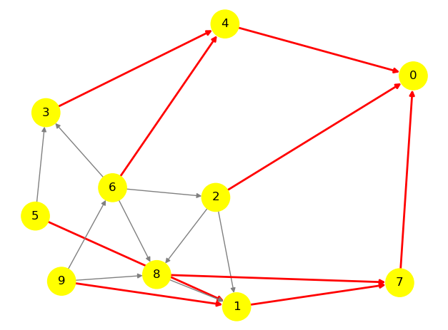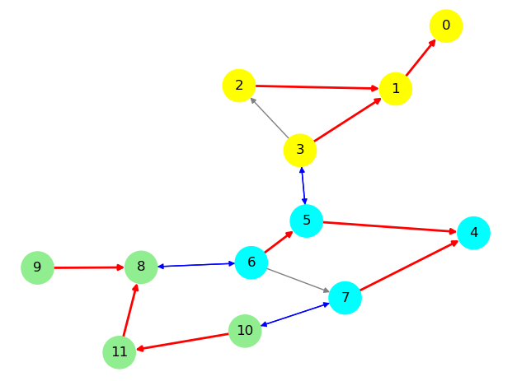
Figure 3: N = 10, k = 1, p = 2, P = 0 Figure 4: N = 4, k = 3, p = 2, P = 1

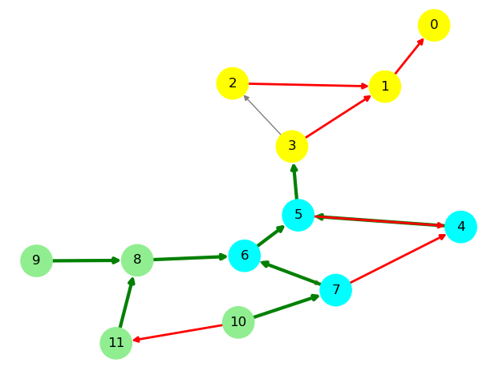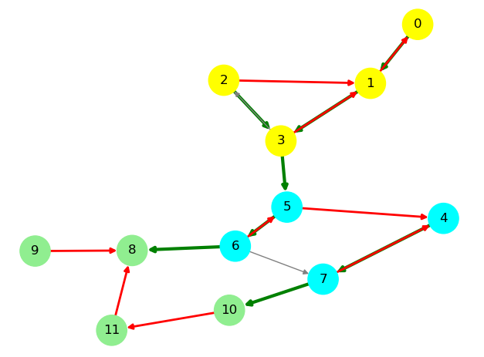
Figure 5: N = 4, k = 3, p = 2, P = 1 Figure 6: N = 4, k = 3, p = 2, P = 1
green links in direction to the yellow partition green links in direction to the green partition
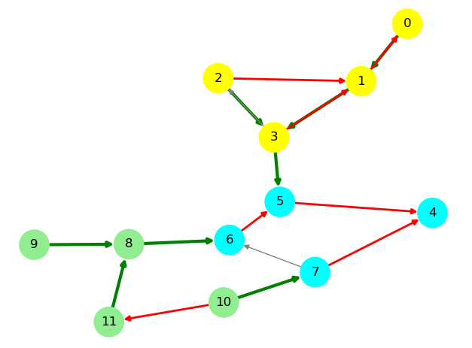
Figure 7: N = 4, k = 3, p = 2, P = 1
green links in direction to the cyan partition

VI. Conclusions
Our proof of concept application shows the cost of the hierarchical approach. In term of memory, every node has to store around two times more information than for the Malpani et al. algorithm [3] because it has to store its partition identifier, the partition identifiers of its neighbors and the extra heights. Besides, the traffic cost is high as explained in the implementation section. This cost can be counterbalanced by using another routing algorithm between the partitions.
This approach could be useful for data aggregation. Indeed, instead of having one leader which can be a process with very few computing power to process the data of the whole network, local leaders can do intermediary aggregating computations.

For example, a large sensor network could be able to take the measure average by having local leaders compute the local average and only sending average values to the global leader who would only have to aggregate a few values instead of the whole raw data.
This approach can also reduce the cost of leader reelection. When the leader is no longer reachable by a part of the network, current algorithms reelect a leader [3][4], which involves a high traffic cost. In our approach, only a leader reelection would happen to, but only across the sub leaders. The majority of the nodes in the network wouldn’t be impacted and wouldn’t have to update their height. Unfortunately, message passing between sub leaders uses the routing of ordinary nodes, so every node is likely to have a role in the reelection, which counterbalances the advantage of our approach.

VII. References
[1] E. Gafni and D. Bertsekas. Distributed algorithms for generating loop-free routes in networks with frequently changing topology. IEEE Trans. on Communications, C-29(1):11–18, 1981.
[2] V. Park and M. S. Corson. A highly adaptive distributed routing algorithm for mobile wireless networks. In Proc. INFOCOM ’97, pp. 1405–1413, 1997
[3] N. Malpani, J. Welch, and N. Vaidya. Leader election algorithms for mobile ad hoc networks. In Proc. ACM DIAL-M Workshop, pp. 96–104, 2000.
[4] R. Ingram, P. Shields, J. E. Walter and J. L. Welch, “An asynchronous leader election algorithm for dynamic networks,” 2009 IEEE International Symposium on Parallel & Distributed Processing, 2009, pp. 1-12, doi: 10.1109/IPDPS.2009.5161028.
[5] Li Qing, Qingxin Zhu, Mingwen Wang, Design of a distributed energy-efficient clustering algorithm for heterogeneous wireless sensor networks, Computer Communications, Volume 29, Issue 12, 2006, Pages 2230-2237, ISSN 0140-3664.

