ICHEC 2026
Camera Ready Instruction for Full Paper and Short Paper Track
Thank you very much for your contribution to ICHEC 2026. Please carefully read the following instructions for preparing the camera-ready version.
- Please make sure to upload your camera-ready version in the submission system by October 22, 2026 (23:59 AOE).
- Paper length: Authors are invited to submit original research papers in accordance with the Springer LNCS/CCIS format. The following categories of papers are accepted:
• Full papers: Minimum 12 pages (12-15 pages, main text, excluding references and appendices).
• Short papers: Minimum 6 pages (6-10 pages, main text, excluding references and appendices).
- Please prepare all of your source files (LaTeX files in Attachment 3 with all the associated style files, special fonts and eps files, or Word files in Attachment 3) in a folder and name the folder as your paper ID. You should supply the .bbl files to avoid the omission of data during conversion from bib to bbl.
- In addition, please prepare a final PDF of your paper and name it as "paper-ID.pdf" (e.g., paper-666 for paper 666).
- The corresponding author, please sign and date the following License to Publish form, " Attachment 1-LTP-xxx.docx," and scan it as a PDF. Please rename it as "LTP-ID.pdf" (e.g., "LTP-666.pdf" for paper 666). Please note that the digital signature is not acceptable.
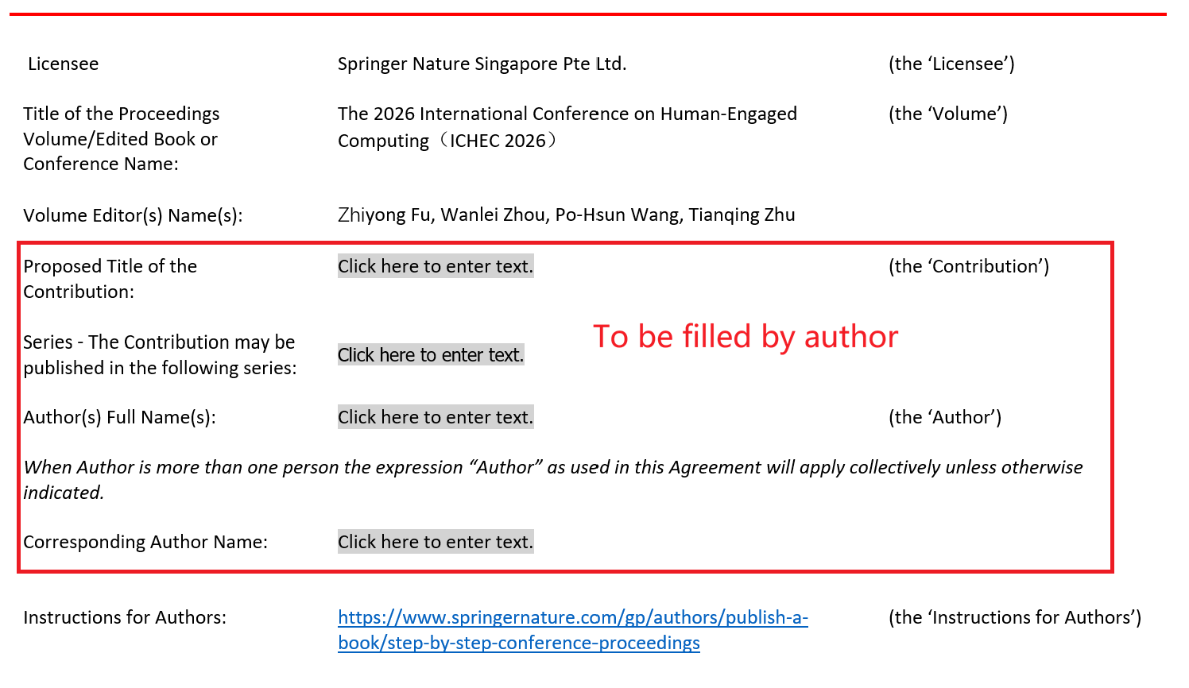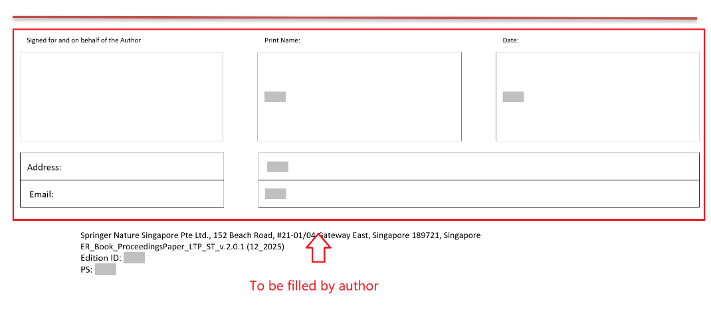
- Completed ICHEC 2026 Final Publication Information Template (Attachment 2) and name it as "Authors-ID.xlsx" (e.g., Authors-666 for paper 666).
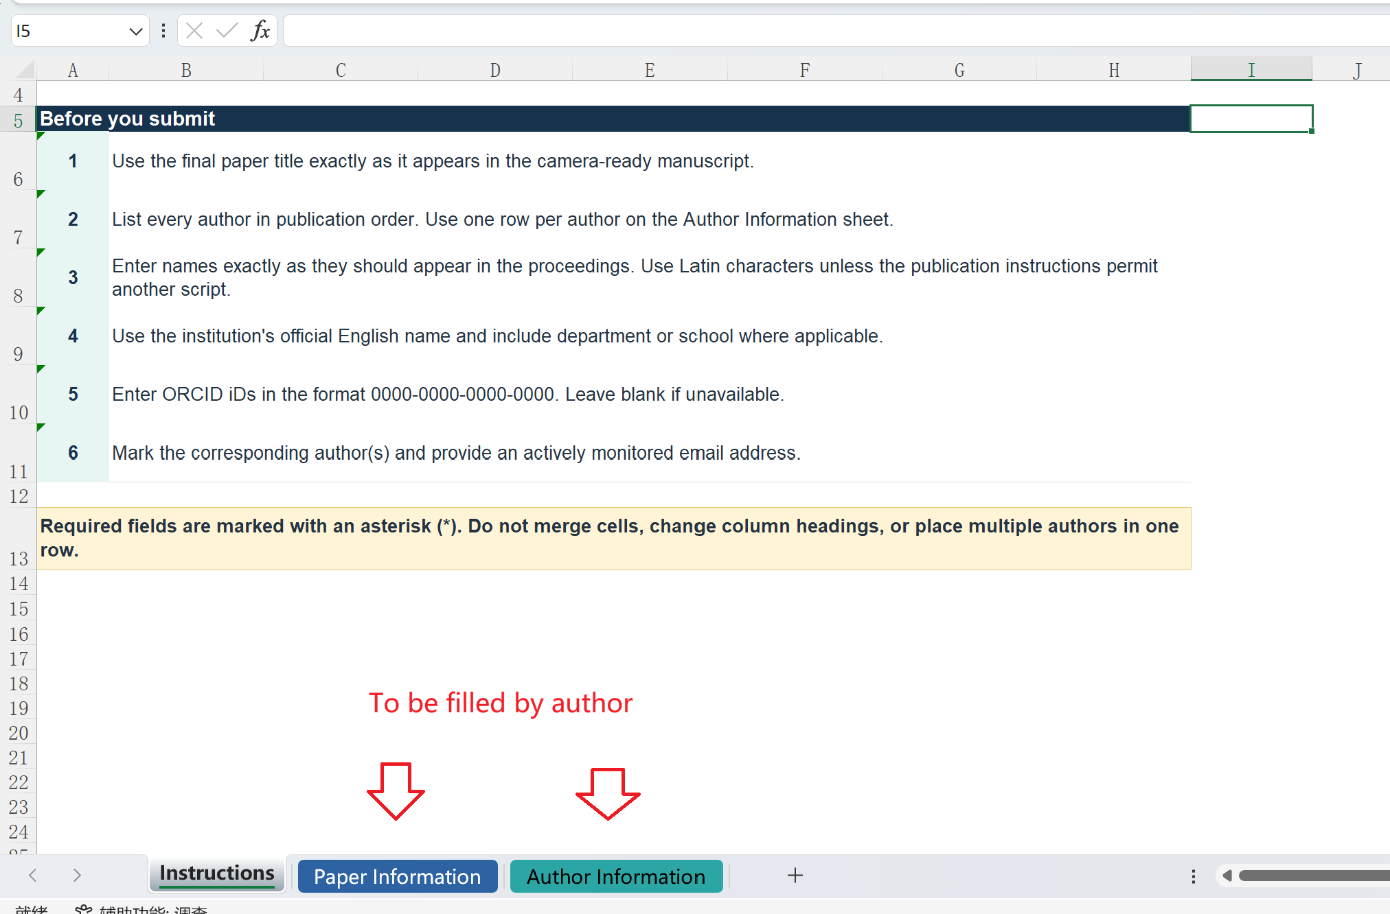
- Finally, please zip the above folder and two PDF files as a zip file and name it as your "paperID.zip" (e.g., "666.zip" for paper 666). Then, upload the zip file in the submission system.
For example, as shown in the following figure, if your paper ID is 666, you should have a folder named 666 containing all the files.
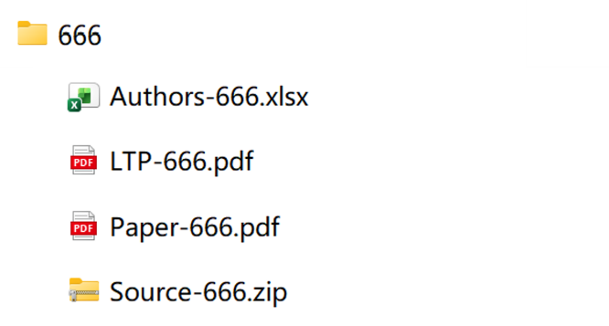

Please note the following instructions for the corresponding author.
- When submitting your paper, the authors should allot a corresponding author, who must be available to carry out a proof check of the paper. The corresponding author should be clearly marked as such in the header of the paper. He or she is also the one who signs the license-to-publish form on behalf of all the authors.
- Please note that the corresponding author cannot be changed once the paper and the license-to-publish form have been sent to us.
- We encourage the inclusion of all the authors' email addresses and ORCIDs in the header, but at the very least, the email address of the corresponding author should be present.

If you have any question, please feel free to send the inquiry to ichec2026.info@gmail.com, ichec2026publications@gmail.com. We will be happy to help you.

