* Check ok for summing the bouts + unbouted = total durations in the new dataset --> OK
* Check for bout, blocks and Nfrag variables
  + IN and LIPA: found no difference between bout, blocks and Nfrag variables, both at day and person level --> OK
  + MVPA:
    - No difference between Nbouts and Nblocks variables. --> OK
    - Little differences between Nblocks and Nfrag at day (average diff: 2.46) and person level (average diff: 0.594), certainly because a single MVPA fragment can correspond to several VIG and/or MOD blocks --> OK
* Correlations between the total durations were all 1.00 --> OK
* Check bout criteria for fragmentation metric computation:
  + *“Metrics related to Gini, CoV, or power spectrum now only calculated if the standard deviation in fragment duration is not zero, and if there are at least 10 fragments (5 inactive and 5 active). If this condition is not met the values will be NA.*” --> **this was verified, except for 3 days (day 2012-03-20 for stno 200100, 2013-01-30 for 230070, and 2012-12-09 for 70834) where the number of fragments in PA was >= 5 and fragmentation metric were NA. Please find below the sample of stno and calendar date with this issue for Gini, similar observation was made for cov and power spectrum.**

|  |  |  |  |  |  |  |  |  |  |
| --- | --- | --- | --- | --- | --- | --- | --- | --- | --- |
| **stno** | **calendar_date** | **FRAG_Nfrag_IN_day** | **FRAG_Nfrag_PA_day** | **FRAG_Gini_dur_IN_day** | **FRAG_Gini_dur_PA_day** | **Nblocks_day_total_IN** | **Nblocks_day_total_LIG** | **Nblocks_day_total_MOD** | **Nblocks_day_total_VIG** |
| 200100 | 2012-03-20 | 8 | 7 | 0.73598 | NA | 8 | 7 | 0 | 0 |
| 230070 | 2013-01-30 | 8 | 7 | 0.55685 | NA | 8 | 7 | 0 | 0 |
| 70834 | 2012-12-09 | 5 | 5 | 0.74759 | NA | 5 | 5 | 0 | 0 |

* + *“Other metrics related to binary fragmentation (mean_dur_PA, mean_dur_IN, Nfrag_PA, Nfrag_IN), are calculated when there are at least 2 fragments (1 inactive, 1 active). If this condition is not met the value will is set to zero.”* 
    - Consistent for IN and LIPA: we were able to compute mean bouts duration and to find similar estimates as GGIR --> OK
    - **MVPA: in day level summary, we identified several days (~ 2000) where FRAG_mean_dur_MVPA_day == 0, but where some MVPA fragments were detected (FRAG_Nfrag_MVPA_day > 0) and with some time in MOD (dur_day_total_MOD_min > 0) or in VIG (dur_day_total_VIG_min > 0)**. Please find below a subset of these days. You can find the full sample with the stno and calendar date in the attached script (line 334 – 343).

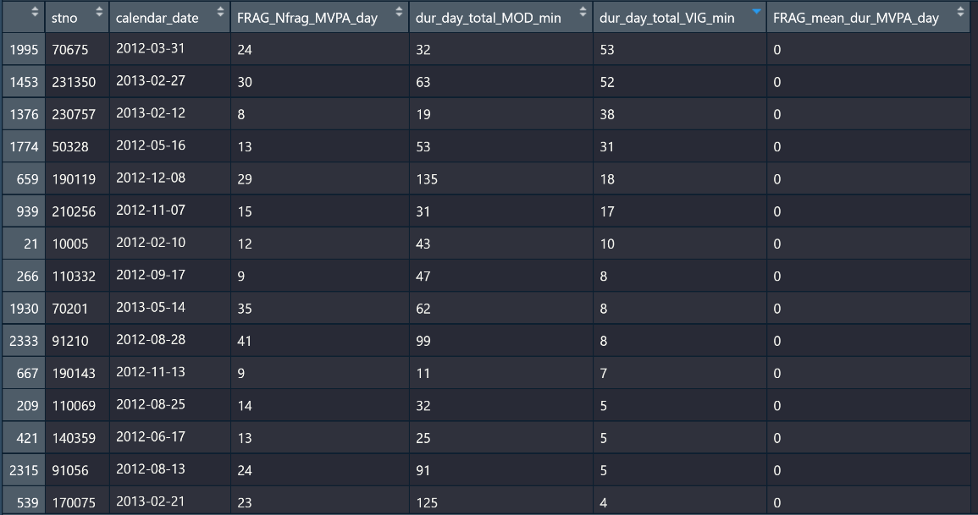

* + *“Metrics related to TP now only calculated if there is at least 1 inactivity fragment AND (1 LIPA OR 1 MVPA). If this condition is not met the TP metric value is set to zero.”* --> Verified, OK

D1 (New): Data 1 is 3rd May 2021

D2 (Original used): Data 2 is 7th October 2020

Table 1: Descriptive of duration variables by dataset

|  |  |  |  |  |  |  |  |  |
| --- | --- | --- | --- | --- | --- | --- | --- | --- |
|  | **D1 3rd May 2021** | | | | **D2 7th October 2020** | | | |
| **Durations** | **Mean** | **SD** | **Min** | **Max** | **Mean** | **SD** | **Min** | **Max** |
| Total day | 984.29 | 55.07 | 538.39 | 1320.71 | 984.29 | 55.07 | 538.39 | 1320.71 |
| Total SB | 717.84 | 100.19 | 394.14 | 1103.71 | 717.91 | 100.18 | 394.29 | 1103.71 |
| Total LIPA | 210.31 | 69.16 | 20.43 | 509.86 | 210.25 | 69.15 | 20.43 | 509.71 |
| Total Moderate | 55.15 | 37.41 | 0.00 | 282.14 | 55.14 | 37.40 | 0.00 | 282.14 |
| Total Vigorous | 0.99 | 3.75 | 0.00 | 117.86 | 0.99 | 3.75 | 0.00 | 117.86 |
| Total MVPA | 56.14 | 38.57 | 0.00 | 287.71 | 56.13 | 38.57 | 0.00 | 287.71 |

Table 2: Descriptive of fragmentation metrics by dataset

|  |  |  |  |  |  |  |  |  |
| --- | --- | --- | --- | --- | --- | --- | --- | --- |
|  | **D1 3rd May 2021** | | | | **D2 7th October 2020** | | | |
| **Metrics** | **Mean** | **SD** | **Min** | **Max** | **Mean** | **SD** | **Min** | **Max** |
| Mean_Sbout | 11.4793 | 6.0775 | 3.8391 | 128.6960 | 11.9947 | 6.2710 | 3.8366 | 79.6755 |
| ProlongSB30 | 384.8014 | 143.2632 | 34.2857 | 1031.7140 | 371.1966 | 141.9666 | 33.4286 | 1026.00 |
| NSbout | 71.8351 | 16.0057 | 12.4286 | 129.0000 | 70.1372 | 16.7467 | 13.9286 | 129.00 |
| Gini | 0.6766 | 0.0360 | 0.5399 | 0.8231 | 0.6850 | 0.0414 | 0.5399 | 0.8812 |
| Alpha | 1.7533 | 0.1275 | 1.3276 | 2.3585 | 1.7530 | 0.1267 | 1.3634 | 2.3602 |
| TPin2PA | 0.1054 | 0.0333 | 0.0114 | 0.2685 | 0.1042 | 0.0349 | 0.0132 | 0.2717 |
| TPin2LIPA | 0.0979 | 0.0307 | 0.0109 | 0.2524 | 0.0987 | 0.0327 | 0.0132 | 0.2598 |
| TPin2MVPA | 0.0053 | 0.0047 | 0.0000 | 0.0543 | 0.0055 | 0.0049 | 0.0000 | 0.0551 |

Table 3: Correlations for metrics between D1 and D2

|  |  |
| --- | --- |
|  | **Correlation** |
| Mean_Sbout | 0.9356 |
| ProlongSB30 | 0.9991 |
| NSbout | 0.9905 |
| Gini | 0.9417 |
| Alpha | 0.9974 |
| TPin2PA | 0.9929 |
| TPin2LIPA | 0.9872 |
| TPin2MVPA | 0.9956 |

Table 4: Differences in metrics where correlations are <0.99 (highlighted in yellow in table 4) between new (d1) and original dataset (d2)

Calculation of the change in values = (abs(d1-d2)/d2)*100

|  |  |  |  |
| --- | --- | --- | --- |
|  | **Mean (SD) difference (%)** | **Max difference (%)** | **Stno with max diff** |
| Mean_Sbout | 3.79 | 219.36 | 70208 (same as before) |
| Gini | 1.20 | 14.570 | 150155 |
| TPin2LIPA | 4.747774 | 64.83 | 230070 |

Table 5: mean difference between d1 and d2 by percentile for each of the metric. All values **mean percentage differences for 50th, 75th, 95th percentile of sample**

|  |  |  |  |  |  |  |
| --- | --- | --- | --- | --- | --- | --- |
|  | **50th** | **75th** | **95th** | **Max % difference** | **Absolute difference**  **D1-D2\*** | **Stno with max difference** |
| Mean_Sbout | 0.16 | 7.39 | 13.46 | 219.36 | 19.77623 | 70208 |
| ProlongSB30 | 3.59 | 5.10 | 8.61 | 23.62 | 28.71428 | 50371 |
| NSbout | 0.19 | 6.15 | 12.04 | 41.74 | -10.64286 | 70834 |
| Gini | 0.04 | 2.19 | 4.93 | 14.57 | -.116459 | 150155 |
| Alpha | 0.06 | 0.34 | 1.03 | 12.53 | -.1941789 | 70834 |
| TPin2PA | 1.87 | 6.20 | 12.66 | 64.83 | -.0258854 | 230070 |
| TPin2LIPA | 3.47 | 6.81 | 13.25 | 64.83 | -.0258854 | 230070 |
| TPin2MVPA | 3.40 | 7.57 | 21.87 | 635.71 | 0.000254 | 221029 |

*positive absolute difference means there was increase in the value in the dataset d1 from the older version d2. Negative absolute difference means there was a decrease in the value of metric for that individual in the new dataset compared to the older version.

* For TPin2MVPA, the largest percentage change between the datasets happened for stnos (%change) which seemed very high and might be helpful to check them as well : 30226 (223.33%), 120130 (251.22%), 220355 (356.94%), 221029 (635.71%).

Stno with missing weekend in the 20th April 2021 version comparison with current version (3rd may 2021):

* In the 20th April 2021 we saw that there were 2 stno’s with missing weekend values for certain metrics. In the current version there is none for those stno’s and there is no missing overall as well. So those 2 stnos could be checked as well (70834, 90212).

Table 6: Summary of bouted and unbouted variables specific to data version

|  |  |  |  |  |  |  |  |  |
| --- | --- | --- | --- | --- | --- | --- | --- | --- |
| **Bouted durations** | | | | | | | | |
| **Variables** | **D1 3rd May 2021** | | | | **D2 7th October 2020** | | | |
| **Bouted** | **Mean** | **SD** | **Min** | **Max** | **Mean** | **SD** | **Min** | **Max** |
| SB >30min | 384.80 | 143.26 | 34.29 | 1031.71 | 371.20 | 141.97 | 33.43 | 1026.00 |
| SB 10-30min | 185.79 | 44.98 | 35.62 | 363.57 | 171.55 | 41.41 | 33.57 | 336.57 |
| LIPA>10min | 26.46 | 21.41 | 0.00 | 249.71 | 20.07 | 17.69 | 0.00 | 219.57 |
| MVPA>10min | 12.65 | 17.20 | 0.00 | 209.43 | 10.70 | 15.49 | 0.00 | 192.43 |
| **Unbouted durations** | | | | | | | | |
| **Variables** | **D1 3rd May 2021** | | | | **D2 7th October 2020** | | | |
| **Unbouted** | **Mean** | **SD** | **Min** | **Max** | **Mean** | **SD** | **Min** | **Max** |
| SB | 147.25 | 40.98 | 18.43 | 295.29 | 178.19 | 42.90 | 31.71 | 333.43 |
| LIPA | 183.85 | 54.09 | 20.43 | 393.43 | 187.32 | 59.01 | 15.57 | 414.43 |
| Moderate | 43.16 | 27.33 | 0.00 | 195.43 | 44.90 | 28.57 | 0.00 | 208.29 |
| Vigorous | 0.33 | 0.81 | 0.00 | 15.14 | 0.37 | 0.91 | 0.00 | 16.71 |

Table 7: correlations for bouted and unbouted duration variables between D1 and D2 data versions

|  |  |
| --- | --- |
| **Bouted** | **Correlations between D1 an D2 variables** |
| SB >30min | 0.9991 |
| SB 10-30mins | 0.9849 |
| LIPA >10min | 0.9893 |
| MVPA >10min | 0.9945 |
| **Unbouted** | **Correlations between D1 an D2 variables** |
| SB | 0.9841 |
| LIPA | 0.9955 |
| Moderate | 0.9974 |
| Vigorous | 0.9793 |

Table 8: Details for specific stnos with the maximum difference for bouted and unbouted durations.

|  |  |  |  |  |  |
| --- | --- | --- | --- | --- | --- |
| **Bouted** | **D1 value**  **(in mins)** | **D2 value**  **(in mins)** | **Absolute difference (in min)** | **Max difference (%)** | **Stno** |
| SB >30min | 150.29 | 121.57 | 28.71 | 23.62 | 50371 |
| SB 10-30mins | 83.00 | 63.43 | 19.57 | 30.86 | 190256 |
| LIPA >10min | 10.29 | 1.57 | 8.71 | 554.55 | 70528 |
| MVPA >10min | 10.29 | 1.57 | 8.71 | 554.55 | 220829 |
| **Unbouted** | **D1 value** | **D2 value** | **Absolute difference (in minutes)** | **Max difference (%)** | **Stno** |
| SB | 23.43 | 53.43 | -30 | 56.15 | 90035 |
| LIPA | 20.43 | 15.57 | 4.86 | 31.19 | 190441 |
| Moderate | 0.43 | 0.29 | 0.14 | 50.00 | 50622 |
| Vigorous | 0.286 | 0.143 | 0.143 | 100.0 | 180201 |

Note: for unbouted vigorous, this one sample stno as there are multiple cases where individuals loses the amount of unbouted vigorous duration in the new dataset, however the values lost (<1 minutes) are very small. Similarly for LIPA bouted >10minuted in the new data 76 persons gained some amount of bouted LIPA durations, which ranged around 5 minutes or so. Likewise, 1 person gained some unbouted moderate duration (<1min gained).

Table 9: List of stnos to be checked due to high % change between D1 and D2

|  |  |
| --- | --- |
| **Variable** | **Stnos** |
| **Metrics** |  |
| Mean_Sbout | 70208 |
| Prolong30 | 50371 |
| NSbout | 70834 |
| Gini | 150155 |
| Alpha | 70834 |
| TPin2PA | 230070 |
| TPin2LIPA | 230070 |
| TPin2MVPA | 30226, 120130, 220355, 221029 |
| **Bouted durations** |  |
| SB >30min (same variable as prolong30) | 50371 |
| Bouted SB 10-30minutes | 190256 |
| Bouted LIPA >10minutes | 70528 |
| Bouted MVPA >10mins | 220829 |
| **Unbouted durations** |  |
| Unbouted SB | 90035 |
| Unbouted LIPA | 190441 |
| Unbouted Moderate | 50622 |
| Unbouted Vigorous | 180201 |