Supporting Information
From Mechanistic Understanding to Pilot Scale: Integrated Development of an Intensified Continuous-Flow Process for Unsymmetrical Phosphate Esters
Bayesian optimisation: reaction space, model and post-campaign analysis

S1. Reaction space as declared to the optimiser
Each variable was declared with an increment, so the optimiser searched a finite grid rather than a continuum and never proposed a setting the pumps and the thermostatic bath could not hold. A declared bound not falling on the increment is not itself a level, which is why [DMIPP] was searched to 6.6 M. One process constraint applied throughout, [DMIPP] ≤ [BuOH], enforced both when the initial design was drawn and when the acquisition function was maximised: the grid holds 239,250 combinations, of which 172,260 (72 %) satisfy it.
Variable | Range | Increment | Levels
[DMIPP] (M) | 1.0 – 6.6 | 0.2 | 29
[BuOH] (M) | 1.0 – 10.8 | 0.2 | 50
tBuOK loading (mol%) | 5.0, 7.5, 10.0 | — | 3
Temperature (°C) | 25 – 75 | 5 | 11
Residence time (min) | 0.5 – 2.5 | 0.5 | 5
Table S1. The five variables as discretised for the campaign. [DMIPP] and [BuOH] are concentrations in mol L⁻¹, so the process constraint compares them directly.

S2. Surrogate model and acquisition
Single-task Gaussian process: squared-exponential kernel with automatic relevance determination, one length scale per variable; constant mean; fitted noise; inputs scaled to the unit cube and the yield standardised; hyperparameters set by marginal-likelihood maximisation under log-normal priors. The fitted noise standard deviation is 1.9 percentage points of yield. Conditions were proposed by maximising qLogNEI, the log-transformed noisy expected improvement, over the grid subject to the process constraint, one experiment per iteration, the model being refitted from scratch each time. The initial design was ten points by constrained k-means over the feasible grid.

S3. Experimental data
# | Origin | [DMIPP]  (M) | [BuOH]  (M) | tBuOK  (mol%) | T  (°C) | t  (min) | Yield  (%)
1 | initial | 2.2 | 6.0 | 5.0 | 50 | 1.0 | 16
2 | initial | 5.0 | 8.6 | 7.5 | 60 | 2.0 | 50
3 | initial | 3.4 | 7.0 | 5.0 | 35 | 2.0 | 16
4 | initial | 5.2 | 8.4 | 7.5 | 40 | 1.0 | 19
5 | initial | 5.0 | 8.4 | 5.0 | 50 | 1.0 | 15
6 | initial | 3.0 | 7.4 | 10.0 | 65 | 1.0 | 69
7 | initial | 3.4 | 7.0 | 5.0 | 65 | 2.0 | 30
8 | initial | 2.2 | 6.0 | 7.5 | 60 | 2.0 | 61
9 | initial | 3.2 | 7.4 | 10.0 | 35 | 2.0 | 36
10 | initial | 2.2 | 5.8 | 7.5 | 35 | 1.0 | 16
11 | BO | 1.8 | 6.0 | 10.0 | 60 | 2.0 | 72
12 | BO | 1.0 | 3.8 | 10.0 | 70 | 2.0 | 85
13 | BO | 1.0 | 1.0 | 10.0 | 75 | 2.5 | 58
14 | BO | 1.0 | 5.0 | 10.0 | 75 | 1.5 | 77
15 | BO | 5.0 | 5.0 | 10.0 | 70 | 2.5 | 55
16 | BO | 1.0 | 1.0 | 10.0 | 70 | 2.0 | 73
17 | BO | 1.0 | 7.6 | 10.0 | 70 | 1.5 | 53
18 | BO | 1.6 | 3.4 | 10.0 | 65 | 1.5 | 88
19 | BO | 2.6 | 3.2 | 10.0 | 70 | 1.0 | 68
Table S2. The nineteen experiments of the campaign, in the order performed.

S4. Variable influence in the fitted model
Variable | Length  scale | Effect at the  optimum (pts) | Median effect over  the space (pts) | Predicted trend over  the range
Temperature | 0.64 | 55.9 | 31.4 | maximum near 70 °C
tBuOK loading | 0.88 | 41.2 | 25.3 | increasing
Residence time | 0.83 | 30.7 | 16.4 | maximum near 2 min
[BuOH] | 0.53 | 58.8 | 12.4 | maximum near 2.4 M
[DMIPP] | 0.86 | 11.6 | 8.6 | maximum near 3.4 M
Table S3. Quantitative basis for the trends reported in the main text, ordered by median effect. Length scales are on the unit cube and comparable to one another; the trend is the shape of the median predicted response across each variable's levels.
Length scales report how sharply the predicted yield turns over along each variable, not how much it moves: a long, steady slope has a long length scale and a large effect. Effects were therefore also measured directly, by sweeping each variable across its levels with the others held at the predicted optimum, and again over 200 feasible backgrounds drawn at random (median reported). [BuOH] has the shortest length scale of the five yet only the fourth largest median effect — it dominates near the optimum, where it moves the predicted yield by 58.8 percentage points, and matters little elsewhere. Only the tBuOK loading rises monotonically across its range; the other four turn over inside the domain. The residence time in particular predicts a maximum near 1.5–2 min, the median predicted yield running 28.2, 32.9, 35.1, 39.2, 38.0 % across 0.5, 1.0, 1.5, 2.0 and 2.5 min, so short residence times are predicted to be worse rather than better.

S5. The region interrogated for intensification
Of the 172,260 feasible grid points, 5,466 (3.2 %) satisfy both criteria used in the main text, a predicted yield above 70 % and a posterior standard deviation below 15 percentage points. The marginal ranges in Table S4 overstate that region: only 23 % of the combinations lying inside them qualify, so the variables cannot be varied independently within the quoted ranges. The region is absent at 5 mol% tBuOK and shrinks sharply between 10 and 7.5 mol%. It is nonetheless a single body rather than several isolated pockets: taking two conditions as adjacent when they differ by one increment in exactly one variable, the 5,466 conditions form one connected component.
Variable | All | tBuOK 7.5 mol%  (614) | tBuOK 10 mol%  (4,852)
[DMIPP] | 1 to 4.8 | 1 to 2.6 | 1 to 4.8
[BuOH] | 1 to 7.6 | 1.4 to 4.8 | 1 to 7.6
tBuOK loading | 7.5, 10 | 7.5 | 10
Temperature | 50 to 75 | 55, 60, 65, 70, 75 | 50 to 75
Residence time | 1, 1.5, 2, 2.5 | 1.5, 2 | 1, 1.5, 2, 2.5
Table S4. Extent of the region, overall and conditioned on tBuOK loading.
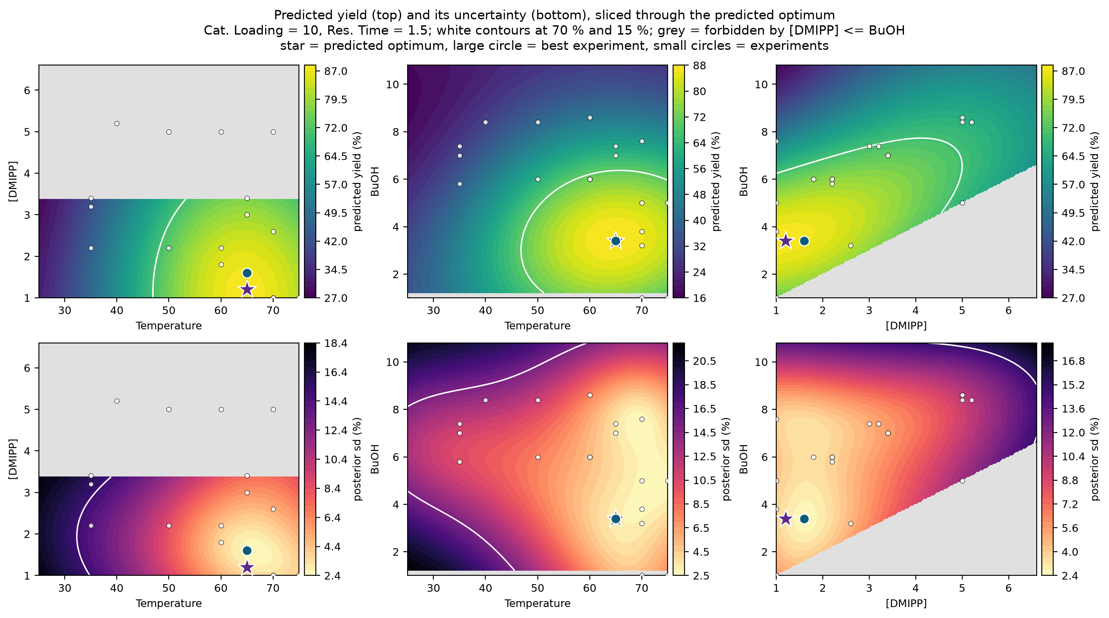
Figure S1. Predicted yield (top) and posterior standard deviation (bottom), sliced through the predicted optimum with the two remaining variables held there (10.0 mol%, 1.5 min). White contours: 70 % and 15 percentage points. Grey: forbidden by [DMIPP] ≤ [BuOH], whose extent depends on where the other concentration is held. Star, predicted optimum; large circle, best experiment; small circles, the nineteen experiments projected onto the plane of each panel.
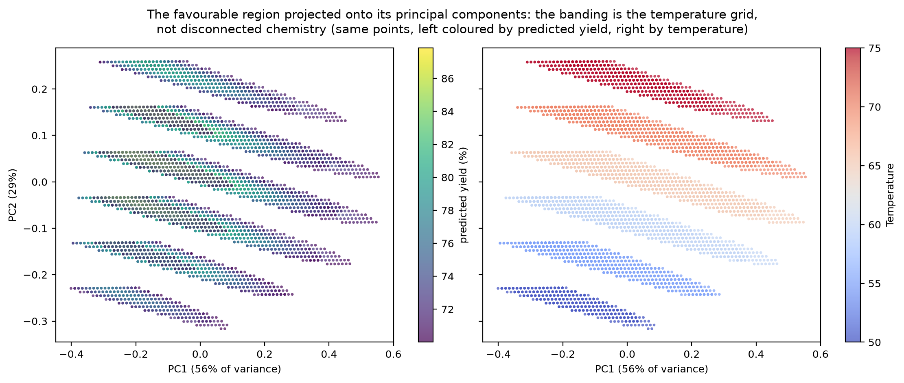
Figure S2. The same region projected onto the first two principal components of ([DMIPP], [BuOH], temperature), 56 % and 29 % of the variance, coloured by predicted yield (left) and by temperature (right). The banding is the temperature grid — PC2 loads 0.97 on temperature — not disconnected chemistry.

S6. Conditions returned under the process constraints
Restriction | [DMIPP]  (M) | [BuOH]  (M) | tBuOK  (mol%) | T  (°C) | t  (min) | Predicted  yield (%) | σ  (pts)
Unconstrained optimum | 1.2 | 3.4 | 10.0 | 65 | 1.5 | 87.8 | 3.2
tBuOK 5 mol% | 1.0 | 3.6 | 5.0 | 65 | 2.0 | 49.3 | 14.8
tBuOK 7.5 mol% | 1.0 | 3.2 | 7.5 | 65 | 2.0 | 76.3 | 9.3
[DMIPP] ≥ 5.5 M | 5.6 | 7.2 | 10.0 | 65 | 1.5 | 66.3 | 11.3
[DMIPP] 4.0–5.4 M | 4.0 | 5.4 | 10.0 | 65 | 1.5 | 76.1 | 8.0
t ≤ 1 min | 1.4 | 4.0 | 10.0 | 65 | 1.0 | 76.1 | 6.1
tBuOK ≤ 7.5 mol%, [DMIPP] ≥ 4 M, t ≤ 1 min | 4.0 | 6.4 | 7.5 | 70 | 1.0 | 54.8 | 10.8
Table S5. The highest predicted yield within each restriction, subject to σ < 15 percentage points. The three conditions carried forward in the main text are rows 5 ([DMIPP] 4.0–5.4 M), 6 (t ≤ 1 min) and 3 (tBuOK 7.5 mol%).
A restriction is not required to clear the 70 % threshold, so a low predicted yield with a small σ is the model asserting that the restriction costs yield: at 5 mol% tBuOK the best available is 49.3 % with σ = 14.8, at the edge of what was accepted. Had no point in a restricted region met the σ cap, that restriction would have returned nothing, indicating a region the campaign never sampled closely enough for the model to commit; this did not arise.

S7. Limitations of the model-based analysis
- σ is the surrogate's posterior standard deviation, not a measured reproducibility. It is calibrated only insofar as the fitted noise term reflects the experimental reproducibility, which nineteen experiments cannot establish; the 15-point cap means that the campaign passed close enough to a given region, not that the yield there is known to ± 15 %.
- All nine proposals were made at 10 mol% tBuOK, so the model is least informed at 5 and 7.5 mol% — the restrictions that ask most of it.
- Taking the highest predicted yield within a restriction is exploitation, appropriate for selecting conditions to confirm but not for further learning; an acquisition function would choose differently. Discretisation caps resolution at half an increment.

S8. Software
Python 3.11, BoFire 0.3.1, BoTorch 0.17.0, GPyTorch 1.15.2, PyTorch 2.10.0, scikit-learn. The initial design is seeded. The optimisation strategy draws its own Monte-Carlo seed unless one is supplied, so two runs on identical data can differ where candidate conditions score closely; the campaign was run unseeded and its final proposal was verified stable across repeated runs. Two notebooks reproducing every number, table and figure in this section are available at [URL].

References
(1) Ament, S.; Daulton, S.; Eriksson, D.; Balandat, M.; Bakshy, E. Unexpected Improvements to Expected Improvement for Bayesian Optimization. Adv. Neural Inf. Process. Syst. 2023.
(2) Balandat, M.; Karrer, B.; Jiang, D. R.; Daulton, S.; Letham, B.; Wilson, A. G.; Bakshy, E. BoTorch: A Framework for Efficient Monte-Carlo Bayesian Optimization. Adv. Neural Inf. Process. Syst. 2020.
(3) Durholt, J. P.; et al. BoFire: Bayesian Optimization Framework Intended for Real Experiments. 2024, arXiv:2408.05040.
(4) Kaneko, H. Sparse Sampling for Chemical Experiments. ACS Omega 2022, 7, 47789–47795.

