HUMAN-IN-THE-LOOP BAYESIAN OPTIMISATION · WEEKLY REPORT

Week of 7–13 September 2026
From “which reaction should the chemists be shown?” to a working REACTO page on which they can be shown it — with the in-silico arms, the trigger and the reproducibility fix that make the human arm interpretable.
CiTOS, ULiège · REACTO branch hitl-bench · study owner M. Croissant · written 14 September 2026
Key number | What it is
3 | benchmarks kept out of 12 grids: Suzuki I, Suzuki II, C–H arylation
65 % · 25 % · 50 % | plain-BO failure rate on 20 seeds (Suzuki II · Suzuki I · arylation)
+1.3 pt | paired gain of a random point at the alerts — the null model — over 40 branches
1 page | REACTO /hitl-live: chemists run the three trapped campaigns and answer the trigger

The week at a glance
Day | What happened
Mon 7 | The study moved into REACTO's own repository (branch hitl-bench) and now calls REACTO's optimiser; Olympus and its environment dropped; the Minerva grids verified and versioned; campaign core written; first five case II campaigns reproduce the known bimodality.
Tue 8 → Wed 9 | Trigger candidates measured on the Suzuki campaigns; overnight, nine additional reaction grids collected and plain BO run on each to find reactions where the optimiser can fail.
Wed 9 | Decisions: Suzuki cases I and II plus the EDBO+ C–H arylation are the study's reactions; the chemist may also stop a campaign (third answer at a checkpoint); no more Suzuki-only work.
Thu 10 | Provenance of every grid re-established and verified by script. Trigger frozen: P*, W = 5, threshold 0.30, cooldown 5. Three-arm design agreed. Root cause of non-reproducibility found and fixed in REACTO.
Thu 10 → Fri 11 | Overnight: reproducibility verified to twelve decimals; control arm and random-intervention arm computed (arylation complete, Suzuki II controls); figures for the article and the SI.
Fri 11 | Night report. The live HITL page built as a tested state machine (hitl_bench/live.py) with a thin Dash skin.
Sat 12 | Shown that the initial design alone decides a trapped campaign. Seeds chosen for the chemists from 20 controls per benchmark. Page verified in the browser; several fixes; English; chemistry cards with the source figures; the owner's own trial of the three campaigns.

0 · One repository, one optimiser: the move into REACTO
Until Monday the benchmark lived in a standalone folder (Documents/Thèse/BO/hitl-bench) with its own copy of the optimisation code, an Olympus installation that needed three patches to run (a circular import, sixteen Windows path fixes, a protobuf/TensorFlow 1.15 work-around) and a separate Python environment that turned out to be broken (the interpreter died on any BLAS call). None of that could be handed to a successor.
What changed on 7 September, and why:
- The study now lives inside REACTO, in hitl_bench/ on the branch hitl-bench of github.com/Mathildec25/dash-chem, and imports REACTO's own bayesian_optimization() instead of keeping a copy. There is a single Bayesian optimiser in the project, so the in-silico study tests literally the tool that will run the real campaigns.
- Olympus is out. The Minerva grids already carry yield and turnover, so no emulator, no TensorFlow 1.15 and no Python 3.7 are needed to reproduce any result. One environment, REACTO's venv, is enough.
- Input data are versioned, outputs are not. REACTO's .gitignore excluded every CSV; an exception now versions the benchmark grids (they are inputs, not exports), while results/, the chemists' files and the checkpoints are ignored.
- The old folder was emptied (eleven items, including the earlier results and exact fronts), a deletion confirmed as deliberate; the project restarted from zero in REACTO with the grids re-verified against a repaired Olympus (r ≥ 0.997, mean absolute gap ≤ 1 point).
- One scare on Tuesday morning: the working tree had been switched to main from the editor, so hitl_bench/ vanished from the disk. Nothing was lost — a branch is a drawer, not the desk — and since then every commit is pushed the day it is made; nothing exists only locally.

1 · Benchmarks: where they come from and why these three
A benchmark for this study must be a complete factorial grid (so the Pareto front is exact and a campaign is reproducible to the decimal), with named reagents (a chemist cannot argue with “L4”), and with room for a chemist to change the outcome — a reaction where plain BO always reaches the front measures nothing. The third criterion is read from the spread between seeds.
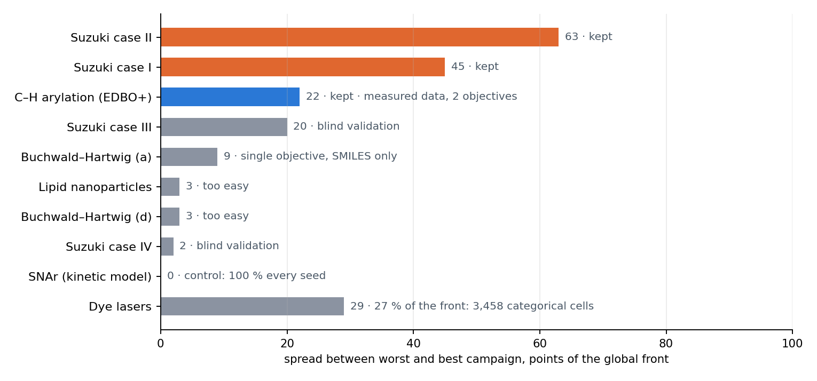
Spread between the worst and the best plain-BO campaign, in points of the global Pareto front (3–5 seeds, night of 8–9 September). Orange: kept as selection benchmarks; blue: kept, measured data; grey: rejected or blind validation.
Benchmark | Origin of the numbers | Points | Objectives | Status
Suzuki–Miyaura, cases I–IV | Reizman, Wang, Buchwald & Jensen, React. Chem. Eng. 2016 (droplet-flow campaigns, ~90 experiments per case) → Olympus Bayesian-neural-network emulators → complete grids published with Minerva (Sin et al., Nat. Commun. 2025), used verbatim | 5,670 | yield, TON | emulated, noiseless; I and II selection, III and IV blind validation
C–H arylation | Shields et al., Nature 2021, reaction 3 — 1-methyl-1H-imidazole-4-carbonitrile + 1-bromo-2-fluorobenzene, all 1,728 conditions run at Bristol Myers Squibb; reagent cost added by Torres et al., JACS 2022 (EDBO+). Our file equals theirs row for row | 1,728 | yield, reagent cost | measured, single run per condition
SNAr, Buchwald a–e, LNP, dye lasers | Summit kinetic model; Olympus datasets, identical to the repository | 768–3,458 | various | rejected; SNAr kept as a control

Two facts from the week that change how a result reads.
The two Suzuki surrogates agree on the winning catalyst. Summit's own MLP emulators, evaluated on the same 5,670-point grid, disagree with Olympus by 8.8 yield points on average (up to 34.6, always at low temperature) but put the front on the same catalyst in all four cases — PCy3 for case II as in the paper. The trap is chemistry, not an artefact of one surrogate. The arylation has tied acquisition values. At experiment 30, 175 of the 1,698 remaining candidates share the acquisition maximum to the last digit (192 categorical cells, 17 visited), so the tail of an unaided campaign is an alphabetical sweep. Suzuki has no ties. The tie fraction is computable during a live campaign and says whether the optimiser is still choosing or merely enumerating.

2 · Plain BO on the three benchmarks: how often it fails
Twenty control campaigns per benchmark (10 Latin-hypercube points, then 30 sequential qLogNEHVI proposals, one experiment at a time), all replayable since Thursday. “Failure” is ending below 90 % of the global front.
Benchmark | Trapped / 20 | What a trapped campaign looks like | First alert (median)
Suzuki II | 13 | PCy3 was drawn in the initial design at 0 % yield (low T) in every trapped campaign; the optimiser never returns to it and settles on XPhos or RuPhos | 22
Suzuki I | 5 | Xantphos dismissed for the same reason, but usually rediscovered late (experiment 27–35): a good catalyst found too late, not a wrong one | 23
Arylation | 10 | a good yield in the initial design (e.g. 77 % on CgMe-PPh) then a flat plateau while the optimiser sweeps tied candidates; most “failures” sit at 86–89 % | 18

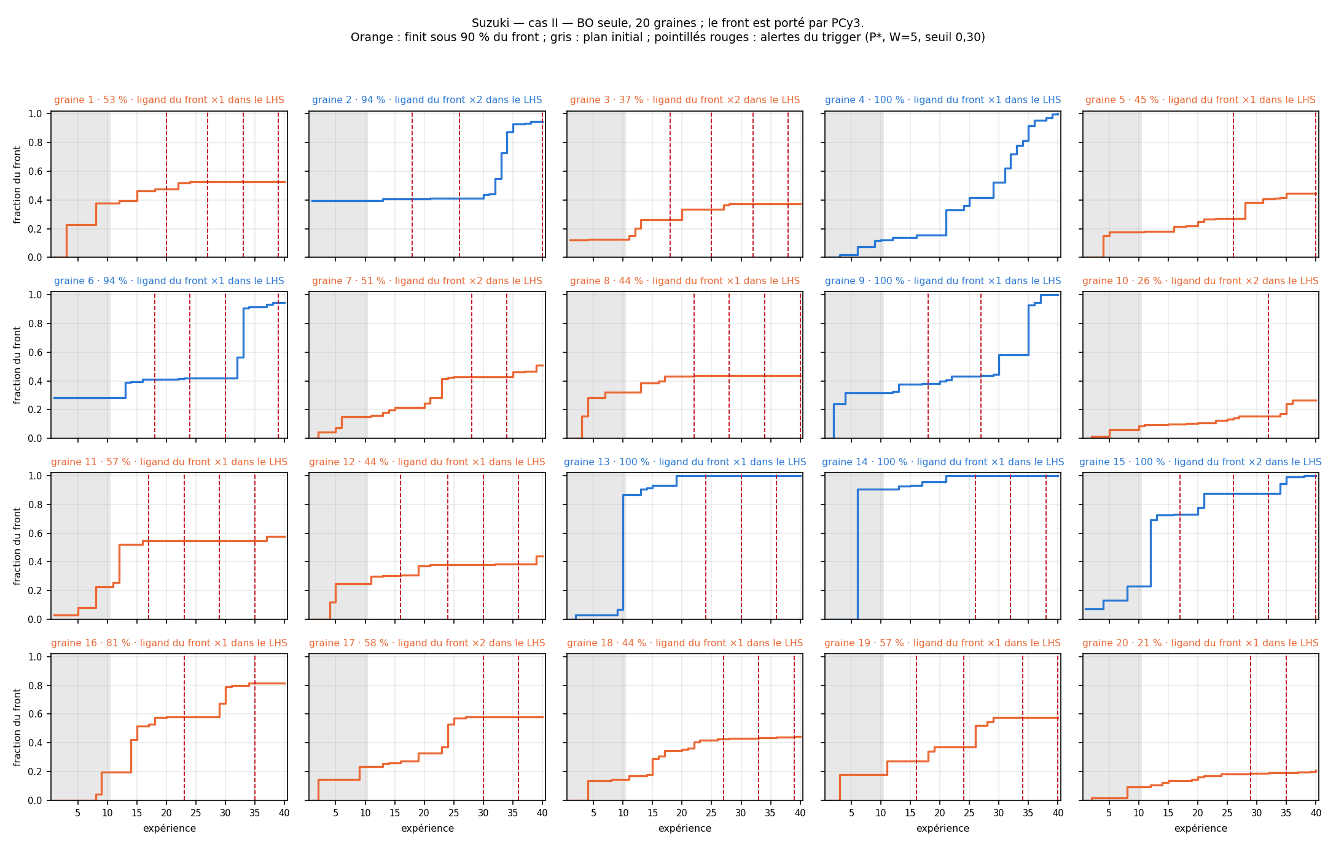
Suzuki case II, the 20 controls. Hypervolume as a fraction of the global front; orange campaigns end below 90 %; the grey band is the initial design; red dashes are the alerts of the frozen trigger. Thirteen campaigns trap on a catalyst that is not PCy3. Seed 12 (alert at 16, ends at 44 %) is the one assigned to the chemists.
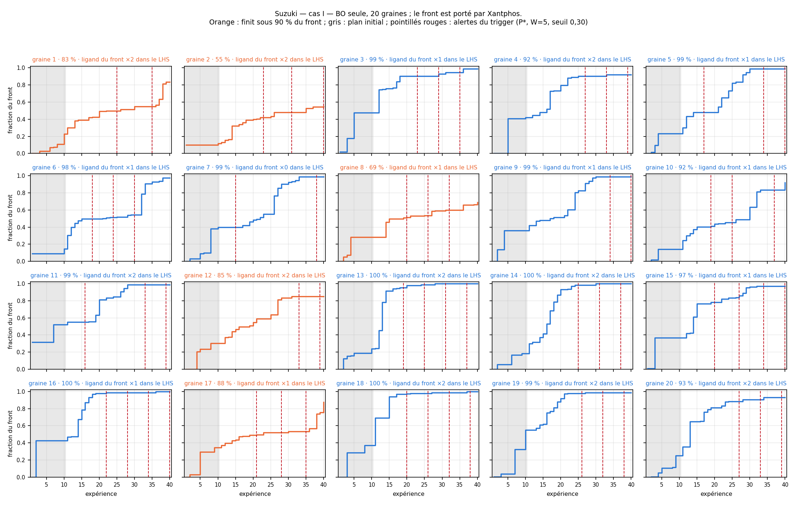
Suzuki case I, the 20 controls. Five trapped. Seed 8 (assigned) drew Xantphos once, at 40 °C, for 0 % yield; the optimiser only came back to it at experiment 27 and ran out of budget while climbing to 87 % yield. Its alert fires at 20, seven experiments before that rediscovery.

3 · The trigger, frozen
The alert is the owner's original signal with its denominator corrected — recent pace against the campaign's own average pace, both per experiment:
P* = (gain over the last W experiments / W) / (gain since the initial design / experiments since)
W = 5 threshold 0.30 cooldown 5 earliest alert: experiment 15 (= 10 + max(5 BO experiments, W)) no deadline
Why P* rather than P: under perfectly steady progress the original ratio decays like W/(t − n_init) whatever the campaign does, so its threshold silently encodes a firing time (0.10 fires at experiment 40 of a flawless campaign at budget 40, from experiment 40 onwards at budget 100). P* equals 1 under steady progress at any budget, so “0.30” means what it says. On the campaigns we hold the two are indistinguishable in detection; the threshold's portability decided it.
The pair (W, threshold) was chosen together, by measurement: at W = 5 a threshold of 0.10 leaves four campaigns silent, two of them failures; 0.30 alerts 13 of 13 failed case II campaigns at 2.5 solicitations each, first alert at 22.6 with 26 % of the final gain still to come — and the one campaign never interrupted is the one that reaches 100 %. W = 3 / 0.10 detects three experiments earlier (35 % of the gain left) at 3.1 solicitations; W = 5 was adopted for the load on five chemists. Cooldown 3 or 5 changes nothing to the first alert, only how often the chemist is disturbed afterwards.
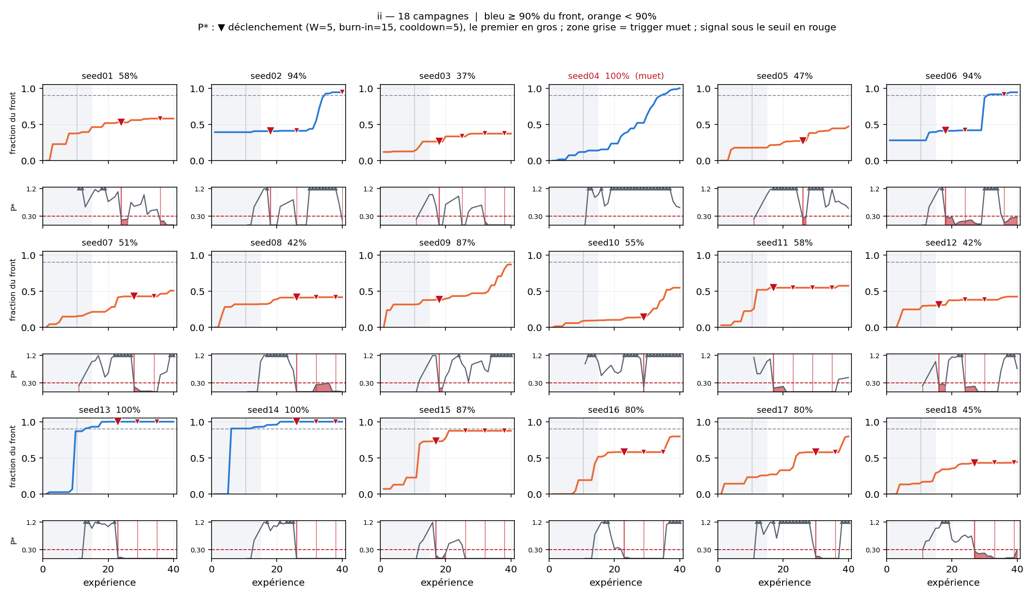
P* on 18 case II campaigns (the pre-fix set, used for tuning). Top rows: fraction of the front, blue ≥ 90 %, orange below. Bottom rows: P* against the 0.30 threshold, red where below; ▼ marks an alert, the first one enlarged. The trigger also fires on healthy campaigns (seed 06 at 94 %): it books an appointment, it does not diagnose — that is the chemist's job, and the reason the third answer “stop” exists.
What the chemist sees at an alert. The campaign pauses. Three answers: let the optimiser continue (its next proposal is shown), propose the next experiment yourself, or stop the campaign. Each answer is recorded with its moment, P*, the optimiser's proposal, and a free-text justification.

4 · Reproducibility, which blocked everything
Two identical runs of one campaign diverged from experiment 26. Cause: REACTO built the BoFire MoboStrategy without a seed, and BoFire then draws one from np.random.SeedSequence() — operating-system entropy, unreachable by torch.manual_seed or np.random.seed — at every one of the thirty acquisition steps. Where two candidates were nearly tied, the argmax flipped.
Fix: bayesian_optimization(..., seed=None) now passes a seed to the strategy when given (the application is unchanged bit for bit when it is not). The bench derives it arithmetically from the campaign seed and the iteration, 100000 + 1000·seed + iteration, so it can be recovered by hand from a log. Verified: two runs coincide on all 40 experiments and to the twelfth decimal on the area under the curve; a fork without intervention reproduces its parent exactly at branch points 15, 22 and 30. The 51 earlier campaigns stay valid as independent samples but cannot serve as controls; everything below was recomputed.

5 · The random-intervention arm: the null model, measured
Design, as agreed: three arms sharing their history up to the alert — plain BO (control), a random untested grid point injected at every alert (the null), a chemist's point at every alert (the human study). The injected point replaces the optimiser's proposal, so every arm spends exactly 40 experiments; alerts are recomputed on the branch after each injection; each control is branched several times with different draws.
C–H arylation | Campaigns | Mean fraction of the front | Reach 90 % | Experiments to 90 % (reachers)
Plain BO | 20 | 0.888 | 10 (50 %) | 26.2
+ random point at every alert | 40 branches, 130 interventions | 0.901 | 26 (65 %) | 26.4

Paired gain +1.3 points of the front; 18 of 40 branches improve, Wilson 95 % [31 %, 60 %]; range −26.7 to +23.1. A random point at the alerts moves a campaign a lot, in both directions, and on average almost not at all. That is the good outcome for the study: if the chemists beat this, it is expertise, not the effect of an exploratory shake. The little gain there is comes from luck on the catalyst: 25 of the 130 injected points carried a front ligand (19 %) and those gained +3.2 versus +0.9 — the quantity a chemist, who does not pick a ligand at random, has to beat.
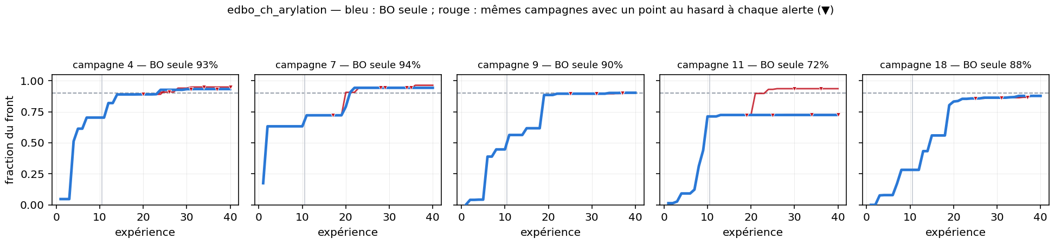
Five arylation campaigns at outcome quantiles. Blue: plain BO; red: the same campaign with a random point at each alert (▼). Campaign 11 is the exception that shows what an intervention can do; the other four show what it usually does.
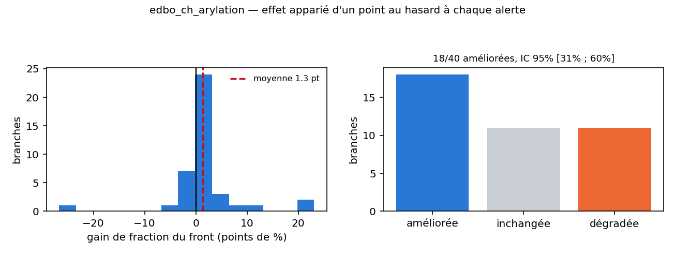
Distribution of the paired gain over the 40 branches, and the count improved / unchanged / degraded.
The most important warning of the week. The estimate of the random arm's gain collapsed as the sample grew: +4.0 points on 11 branches, +2.7 on 19, +1.3 on 40. This is small-sample optimism in its plainest form, and exactly the regime of a human arm with five chemists and a few answers each. Do not conclude on a mean over a dozen answers; compare paired, on the same checkpoints, against the random arm.

6 · The initial design decides — and that frames the human study
Every campaign is seeded by one integer that fixes both the Latin hypercube and the acquisition's Monte-Carlo samples, so “seed 2 is trapped” did not say which of the two was responsible. With the acquisition now seedable, the test was run: same initial design, four acquisition seeds.
Campaign | Initial design held | BO seeds tried | Outcome
Arylation, seed 2 | seed 2 | 4 | 72.5 % of the front, all four (only the tie-sweep tail differs)
Suzuki II, seed 3 | seed 3 (PCy3 drawn twice) | 4 | 37.3 %, all four; one visit to PCy3 in thirty experiments every time

Given this optimiser, the outcome is a function of the ten starting points; the acquisition's own randomness contributes nothing. It does not say another optimiser would be trapped by the same design.
Frame for the article (the owner's decision of 12 September). The human study is a case study on trapped initial designs: the base rate comes from the twenty seeds (13/20, 5/20, 10/20); on one trapped design per reaction, three paired branches share the history up to the alert — plain BO (deterministic given the design), a random point, a chemist. The question is precise: does a chemist called between experiments 15 and 22 get the campaign out of a trap that neither the optimiser nor chance leaves? Not “does HITL help on average”, which the sample size cannot carry.

The campaigns assigned to the chemists
Reaction | Seed | Plain BO ends at | First alert | The trap, readable in the data
Suzuki I | 8 | 69 % | 20 | Xantphos seen once at 40 °C → 0 %; rediscovered at 27, too late
Suzuki II | 12 | 44 % | 16 | PCy3 seen once at 0 %; campaign ends on XPhos and never returns
C–H arylation | 2 | 72 % | 16 | 77 % on CgMe-PPh in the initial design, then nothing for 28 experiments

Three different failure modes: a wrong catalyst for good, a good catalyst found too late, a plateau on a good ligand from the start.

7 · The live page in REACTO
/hitl-live replaces both the notebook and the static checkpoint page. The campaign is a state machine in hitl_bench/live.py, tested without any interface; the Dash page only draws it.
- Identical for everyone until they act. A chemist's campaign replays the assigned control — same initial design, same proposals in the same order — at one experiment per second. The moment they impose a point, the optimiser runs for real from there, seeded as the control was, so even the diverged part is replayable.
- The alert is the frozen trigger, evaluated on the live history exactly as on the random arm. The campaign pauses; the three answers are recorded with P*, the optimiser's proposal, timing and justification. A missing condition is refused, a blank choice is refused.
- Saved after every experiment, as a REACTO project (opens in Results like any other) and as a JSON carrying what Excel cannot.
- Chemistry first. A collapsible card shows the source figure — the four-case scheme for Suzuki, Fig. 4a of Shields et al. for the arylation — one sentence, conditions, what is controlled and measured, catalogue prices per gram behind the cost objective, sources. The experiments table (sortable, as in Results) comes right after; plots last. No hypervolume, no acquisition, no front, no published optimum.
- Resume as on the Optimization page: a returning chemist picks their name in a list; each campaign shows not started / in progress n/40 / paused at experiment k — waiting for you / finished. Names are case-insensitive.
- What the browser taught us. The whole callback chain passed over HTTP, and “Open” still did nothing in Chrome: the Dash renderer refuses a callback whose plain-id input is absent from the page. Fixed with pattern ids. A per-campaign lock keeps two ticks from stepping the same campaign during a 10-second live experiment. The Suzuki catalyst menus showed codes while the table showed names; both now go through one label, and the round trip is checked.
- L6 and L7 have names. The owner's scheme names them: PPh3 and P(t-Bu)3; the text of the article names only L1–L5. Chemists no longer see “P1-L7”.
The owner's own trial of the three campaigns (as “mc”) exercised every path: continue at four alerts on Suzuki II and on the arylation, an imposed point at 23 and a stop at 29 on Suzuki I (43.5 % against 48.0 % for plain BO at the same experiment). scripts/collect_live.py turns every chemist's files into two tables, one row per campaign (paired against the control at the same experiment and at the full budget) and one per decision.

8 · Open before the chemists start
- Justification. All 13 of the trial decisions carry no “why”; the field is optional. Making it mandatory (at least for “propose” and “stop”) is one line — the reasoning is half the result.
- Comparing a stopped campaign to a control that spent 40 experiments: report hypervolume and experiments separately, per experiment, or hold the stopped value flat to 40 (penalises early stops, rewards justified ones). collect_live.py currently reports both paired readings and settles nothing.
- Percentiles for a chemist's answer need many random draws at the same first alert (about 20 per assigned campaign); the random arm so far gives the mean effect of chance, not the distribution at an instant.
- Suzuki random branches have not been computed (arylation only); Suzuki I and II controls are complete.
- Figures and rights. The Reizman scheme is CC BY 3.0; Fig. 4a of Shields et al. is © Springer Nature — fine for the participants' page, permission or the redrawn scheme (kept in the repository) for the article. The source of the “Scheme 10” figure is still to be credited.
- Noise. The Suzuki grids are noiseless emulator output; any detector built on the GP's calibration is untestable there. The arylation is measured, single runs.

Everything above is in the repository: decisions and frozen settings in hitl_bench/CLAUDE.md; provenance in hitl_bench/data/README.md and data/other/README.md; per-benchmark reports regenerated by analyse_arms.py; the night report in docs/nuit_du_10_septembre.md; the chemists' protocol in docs/protocole_chimistes.md; figures in hitl_bench/figures/.

