SMART DATA ANALYST
AN INTERNSHIP REPORT
Submitted by
KHATHEEJA SANA S
(RRN: RRN NUMBER)
in partial fulfillment for the award of the degree of
BACHELOR OF TECHNOLOGY
in
COMPUTER SCIENCE AND ENGINEERING

B.S. ABDUR RAHMAN CRESCENT
INSTITUTE OF SCIENCE AND TECHNOLOGY
NOVEMBER 2026

BONAFIDE CERTIFICATE
Certified that this Internship report “SMART DATA ANALYST” is the bonafide work of “KHATHEEJA SANA S (RRN NUMBER)” who carried out the internship under my supervision. Certified further, that to the best of our knowledge the work reported herein does not form part of any other internship report or dissertation on the basis of which a degree or award was conferred on an earlier occasion on this or any other candidate.
SIGNATURE
[[CLASS ADVISOR NAME]]
Assistant Professor
Class Advisor
Department of CSE
B.S. Abdur Rahman Crescent
Institute of Science and Technology
Vandalur, Chennai – 600 048.

INTERNSHIP CERTIFICATE


VIVA VOCE EXAMINATION
The viva voce examination of the Internship titled “SMART DATA ANALYST”, submitted by KHATHEEJA SANA S (RRN NUMBER) is held on ________________.
INTERNAL EXAMINER

ACKNOWLEDGEMENT
I sincerely express my heartfelt gratitude to Dr. A. PEER MOHAMED, Vice Chancellor and Mr. ABDUL QADIR A. RAHMAN BUHARI, Pro Chancellor, B.S. Abdur Rahman Crescent Institute of Science and Technology, for providing me an environment to carry out my internship successfully.
I sincerely thank Dr. N. RAJA HUSSAIN, Registrar, for furnishing every essential facility for doing my internship.
I thank Dr. SHARMILA SANKAR, Dean, School of Computer Information and Mathematical Sciences for her motivation and support.
I thank Dr. W. AISHA BANU, Professor and Head, Department of Computer Science and Engineering, for providing strong oversight of vision, strategic direction and valuable suggestions.
I am obliged to my class advisor CLASS ADVISOR NAME, Assistant Professor, Department of Computer Science and Engineering, for her professional guidance and continued assistance throughout the internship period.
I extend my special thanks to Mr. LOGANATHAN GANESAN, Manager, Nexila Technologies, for giving me the opportunity to be associated with the organization as an intern in Data Analytics.
I sincerely thank the industry mentors of Nexila Technologies for their guidance, support and professional assistance throughout the internship period, and without their guidance this project would not have been a successful one.
I thank all the Faculty members and the System Staff of the Department of Computer Science and Engineering for their valuable support and assistance at various stages of internship completion.
KHATHEEJA SANA S

TABLE OF CONTENTS
CHAPTER NO. | TITLE | PAGE NO.
 | LIST OF FIGURES | 9
 | ABSTRACT | 10
1 | ORGANIZATION AND INTERNSHIP PROFILE | 11
1.1 | About the Organization | 11
1.2 | Internship Details | 11
1.3 | Guidance Received | 12
1.4 | Project Undertaken | 12
2 | INTRODUCTION | 13
2.1 | Overview | 13
2.2 | Purpose of the Project | 13
2.3 | Problem Statement | 14
2.4 | Objectives | 14
2.5 | Scope and Boundaries | 15
2.6 | Organization of the Report | 15
2.7 | Intended Users and Use Cases | 15
3 | SYSTEM ANALYSIS AND REQUIREMENTS | 17
3.1 | Existing Approach | 17
3.2 | Proposed System | 17
3.3 | Functional Requirements | 18
3.4 | Non-Functional Requirements | 19
3.5 | Hardware and Software Requirements | 19
3.6 | Technology Stack | 20
3.7 | Feasibility Study | 21
3.8 | Use-Case Summary | 21
4 | SYSTEM DESIGN | 23
4.1 | System Architecture | 23
4.2 | Project Structure | 23
4.3 | Workspace and State Model | 24
4.4 | Application Programming Interface | 25
4.5 | Type-Inference Design | 27
4.6 | Data Quality Index and Diagnostics | 29
4.7 | Security and Privacy Design | 29
4.8 | User Interface Design | 30
4.9 | Design Decisions and Trade-offs | 31
4.10 | Data-Flow Description | 32
5 | IMPLEMENTATION AND WORKING PROCESS | 34
5.1 | Data Ingestion Layer | 34
5.2 | Type Normalisation and Invalid-Value Tracking | 34
5.3 | Profiling and Data Dictionary | 35
5.4 | Diagnostics and Outlier Candidates | 35
5.5 | Observation Engine | 35
5.6 | Cleaning Engine | 36
5.7 | Dashboard Assembly and Chart API | 36
5.8 | Slicers and Filters | 38
5.9 | Analysis Workbench | 38
5.10 | Statistical Lab | 39
5.11 | Machine-Learning Lab | 40
5.12 | Segments and Anomalies | 41
5.13 | Time-Series Aggregation | 41
5.14 | Export and Report Generation | 41
5.15 | Front-End Implementation | 42
5.16 | Error Handling and Validation Strategy | 42
5.17 | Typical Session Walk-through | 43
6 | TESTING | 44
6.1 | Testing Strategy | 44
6.2 | Tests of the Analytics Package | 44
6.3 | Tests of the API | 44
6.4 | Recorded Results | 46
6.5 | Scope Not Covered by Testing | 46
7 | RESULTS AND OUTPUTS | 47
7.1 | Welcome Screen and Loading a Dataset | 47
7.2 | Overview | 48
7.3 | Data Explorer | 49
7.4 | Data Quality | 50
7.5 | Cleaning Studio | 51
7.6 | Chart Studio | 51
7.7 | Analysis Workbench | 52
7.8 | Insights | 53
7.9 | Statistical Lab | 54
7.10 | ML Lab | 55
7.11 | Segments and Anomalies | 56
7.12 | Time Series | 57
7.13 | Reports and Exports | 58
7.14 | Summary of the Sample Runs | 59
7.15 | Dark and Light Themes | 59
7.16 | Results on the Other Sample Datasets | 60
8 | CONCLUSION | 63
8.1 | Summary of Work | 63
8.2 | Key Outcomes | 63
8.3 | Limitations | 63
8.4 | Technical Learning from the Project | 64
8.5 | Source Code Repository and Live Cloud Deployment | 65
9 | FUTURE ENHANCEMENT | 65
9.1 | Data and Coverage | 65
9.2 | Analysis and Modelling | 65
9.3 | Platform and Operations | 65
10 | REFERENCES | 66
11 | APPENDIX | 67
A | Selected Source-Code Excerpts | 67
B | Configuration and Limits | 70
C | Run and Test Commands | 71
D | Dependencies | 71
E | API Request and Response Examples | 72

LIST OF FIGURES
Figure No. | TITLE | Page No.
1 | Logo of Nexila Technologies as printed on the internship certificate | 11
2 | Overall architecture of Smart Data Analyst | 23
3 | Structure of an in-memory workspace | 25
4 | Request lifecycle for an analysis action | 27
5 | Decision flow of the column type-inference function | 28
6 | Composition of the project quality index | 29
7 | Application shell with sidebar navigation, top bar and welcome screen | 31
8 | End-to-end analysis workflow | 32
9 | Opt-in cleaning workflow with preview, approval and reset | 36
10 | Baseline modelling pipeline of the ML lab | 40
11 | Terminal output of the automated test run (pytest -q) | 46
12 | Welcome screen of Smart Data Analyst | 48
13 | Readable error message shown for an unsupported file | 48
14 | Overview screen with key indicators and dashboard for the retail sales sample | 49
15 | Overview dashboard with a slicer applied | 49
16 | Data explorer with data preview and data dictionary | 50
17 | Data quality screen with column diagnostics | 51
18 | Cleaning studio with a suggested action, preview and history | 51
19 | Chart studio showing a generated chart with axis titles and legend | 52
20 | Analysis workbench showing a descriptive profile or correlation matrix | 53
21 | Insights screen with ranked observations | 54
22 | Statistical lab showing a test result with statistic, p-value and interpretation | 55
23 | ML lab showing regression results with held-out metrics | 56
24 | Segments and anomalies screen with segment profiles or flagged records | 57
25 | Time series screen with monthly aggregation | 58
26 | Reports and exports screen with the four download options | 58
27 | First page of the generated PDF analysis report | 59
28 | Overview screen in the dark theme | 60
29 | Overview screen in the light theme | 60
30 | Overview of the student performance sample | 61
31 | Overview of the healthcare sample | 62
32 | Overview of the flight delays sample | 62

ABSTRACT
This report documents the internship project Smart Data Analyst, carried out by the author as an intern in Data Analytics at Nexila Technologies from 25 June 2026 to 09 July 2026. Smart Data Analyst is a local-first analytics workbench that helps a person move from an unfamiliar CSV or Excel file to evidence-based understanding of its contents. A user uploads a table, or opens one of four bundled sample datasets, and the application automatically infers the type of every column, profiles the data, reviews its quality, suggests cleaning actions, draws interactive charts, runs statistical tests and baseline machine-learning models, and exports the results as a PDF report, an Excel workbook, a profile in JSON or a cleaned CSV file.
The back end is a FastAPI service of twenty routes that keeps each upload in an isolated in-memory workspace and performs all computation with pandas, NumPy, SciPy and scikit-learn. A separate analytics package implements type inference, profiling, outlier diagnostics, a rule-based observation engine and an opt-in cleaning engine. The front end is a responsive React single-page application with twelve screens: Overview, Data explorer, Data quality, Cleaning studio, Chart studio, Analysis workbench, Insights, Statistical lab, ML lab, Segments and anomalies, Time series, and Reports and exports. It offers ten chart types, nine workbench operations, six exploratory statistical tests, K-means segmentation, Isolation Forest anomaly review and ridge, logistic and random-forest baselines. No account, cloud service or API key is required and no dataset leaves the machine on which the application runs.
A central design principle of the project is that the original upload is never overwritten. All changes are made to a working copy, every cleaning action is previewed and approved by the user before it is applied, and every statistical or modelling result is accompanied by a caution that exploratory evidence is not proof of causation. The quality index shown on the Overview screen is an explainable heuristic whose formula is documented, not an industry standard.
The report describes the organization and internship profile, the motivation and objectives of the project, the system requirements, the architecture and API design, the implementation of each module, the testing performed and the outputs obtained on the four sample datasets. The suite of thirty automated tests, six for the analytics package and twenty-four for the API, is described in Chapter 6. The report also states the limitations of the current version candidly: workspaces are held in memory, type inference is heuristic, and machine-learning results rely on a single hold-out split.

CHAPTER 1
ORGANIZATION AND INTERNSHIP PROFILE

1.1 About the Organization
The internship documented in this report was undertaken at Nexila Technologies. According to the internship completion certificate issued to the author, the certificate is titled “Nexila Technologies Internship – Academic Certificate with industry Mentors”, it is dated 11 July 2026 and it carries the certificate identification number NT41520. The certificate is signed by Mr. Loganathan Ganesan, Manager, Nexila Technologies, and certifies that the author successfully completed an internship in Data Analytics at the organization.
This report restricts its description of the organization to the facts stated in that certificate. Details such as the history, locations, products and clients of the organization are not part of the certificate and are therefore not reproduced here. The emphasis of the report is the software project that was carried out during the internship, which is described from Chapter 2 onwards. The organization name and logo appear exactly as printed on the certificate, a copy of which is included on the third page of this report.

Fig 1: Logo of Nexila Technologies as printed on the internship certificate

1.2 Internship Details
The particulars of the internship, as recorded on the completion certificate, are summarised in the table below.
Table 1: Internship particulars
Item | Details
Intern | KHATHEEJA SANA S
Registration Number (RRN) | RRN NUMBER
Organization | Nexila Technologies
Domain of internship | Data Analytics
Period of association | 25 June 2026 to 09 July 2026
Certificate title | Certificate of Internship Completion – Nexila Technologies Internship, Academic Certificate with industry Mentors
Certificate identification number | NT41520
Date of certificate | 11 July 2026
Certificate signed by | Mr. Loganathan Ganesan, Manager, Nexila Technologies
Programme of study | B.Tech – Computer Science and Engineering
Institution | B.S. Abdur Rahman Crescent Institute of Science and Technology, Chennai
Project undertaken | Smart Data Analyst

1.3 Guidance Received
During the internship the author worked under the guidance of the industry mentors of Nexila Technologies, with Mr. Loganathan Ganesan, Manager, signing the completion certificate on behalf of the organization. The mentors set the domain of the internship as Data Analytics and reviewed the progress of the work. At the institution, the internship was supported by the class advisor and by the Head of the Department of Computer Science and Engineering, as recorded in the Acknowledgement of this report.

1.4 Project Undertaken
The project undertaken during the internship is Smart Data Analyst, a polished, local-first analytics workbench for exploring unfamiliar tabular datasets. It was chosen because it exercises, in one coherent application, the complete life cycle of a small analytics task: importing data, understanding its structure, judging its quality, preparing it, visualising it, testing hypotheses about it and communicating the result.
The project consists of a Python analytics package, a FastAPI service of twenty routes, a React front end with twelve screens, four sample datasets and an automated suite of thirty tests. The remainder of this report explains the motivation, requirements, design, implementation, testing and outputs of this application, using the source code and the application screens as the primary evidence.

CHAPTER 2
INTRODUCTION

2.1 Overview
Almost every organization now collects data in tables: sales registers, student records, patient screenings, flight logs, survey exports and the like. The person who receives such a table is frequently not the person who created it. A manager is sent a spreadsheet by a colleague, a student is given a dataset for a project, or an analyst inherits an export from a system whose documentation is missing. Before any meaningful question can be answered, that person must first understand what the table contains: how many rows and columns there are, which columns are numbers, categories or dates, how many values are missing, whether rows are repeated and which columns appear to move together.
In practice this first understanding is built by hand. People scroll through the sheet, apply filters, write a few formulas, create a pivot table and draw a chart or two. The process is slow, it differs from person to person, and it is easy to miss something important, such as a column that is constant, a handful of extreme values that distort an average, or numbers that were stored as text. Professional tools exist, but many are heavy, require licences, depend on cloud services or demand a degree of statistical and programming skill that the person holding the spreadsheet may not have.
Smart Data Analyst was built during the internship to close this gap. The application takes a CSV or Excel file, performs the routine first-pass analysis automatically, and presents the outcome in a structured set of screens that a non-specialist can follow. It does not try to replace an analyst's judgement. Instead, it removes the mechanical effort of the first hour of exploration and attaches clear cautions to anything that could be over-interpreted, so that the user can spend their attention on the questions that matter.
The application is deliberately local-first. All dataset processing runs in the Python process on the user's own machine, no account is needed, no cloud service is contacted and no API key is required. This choice keeps sensitive tables, for example records of patients or students, under the control of the person who holds them, and it also makes the application simple to install and to demonstrate.

2.2 Purpose of the Project
The purpose of the project is to provide a single, coherent workbench in which an unfamiliar table can be imported, understood, checked, cleaned, explored and reported on without writing code. It was designed around five observations about how exploratory analysis is done in practice.
- Understanding comes before analysis. A user cannot choose sensible charts or tests until they know the type and quality of each column. The application therefore produces a profile and a data dictionary automatically as soon as a file is loaded.
- Quality problems are silent. Missing cells, repeated rows, constant columns and extreme values do not announce themselves. The application surfaces them in a dedicated quality screen and summarises them in a transparent index.
- Cleaning must be reversible and consented. Silent clean-up changes the evidence. Every cleaning step in the application is optional, previewed against the current data, approved explicitly and recorded in a history, and the original can be restored at any time.
- Visualisation should adapt to the data. A good first dashboard depends on which columns are measures, categories or dates. The application selects compatible columns automatically, rolls long daily series up to readable intervals and lets the user override every choice in a separate chart studio.
- Evidence needs interpretation. A correlation, a p-value or a model score can easily be over-read. Every statistical and modelling result in the application is shown with its sample size, its statistic and a plain-language caution.

2.3 Problem Statement
A person who receives an unfamiliar CSV or Excel file today faces a sequence of manual, repetitive and error-prone tasks before any insight is possible. Column types must be guessed from a few visible values; text that looks like a number or a date must be converted by hand; missing values and duplicates must be counted with formulas or filters; outliers are noticed only if a chart happens to reveal them; and each chart must be built from scratch, with axis titles, number formats and colours set manually. When the same work is repeated for the next file, the effort is repeated as well.
Existing options each leave part of the problem open. Spreadsheet software is flexible but offers no automatic profile or quality review and encourages overwriting the original data. Notebook-based analysis is powerful but requires programming skill and produces results that are hard for non-programmers to reuse. Commercial business-intelligence suites provide polished dashboards but typically depend on licences, cloud accounts and the upload of data to a third party, which is unacceptable for sensitive tables. There is therefore a need for a lightweight, private, self-explanatory tool that performs the routine first-pass analysis automatically and is honest about its limits.

2.4 Objectives
The project was guided by the following objectives.
- To build a robust import layer for CSV, XLSX and XLS files with encoding fallback, size and row limits, readable error messages and normalisation of blank and duplicate column names.
- To infer the type of each column automatically as numeric, categorical, boolean, date-like, identifier-like, text or empty, and to let the user override the inference.
- To generate an overview, a data dictionary, column diagnostics and rule-based observations, and to summarise data quality in an explainable index.
- To implement an opt-in cleaning engine for duplicates, whitespace, missing values and constant columns, with previews, approval, a history and reset-to-original.
- To provide an automatically assembled dashboard and a flexible chart studio with slicers, aggregations and date roll-ups, using ten chart types.
- To provide an analysis workbench, an exploratory statistical lab, a machine-learning lab, segmentation and anomaly review and time-series aggregation.
- To export results as a PDF report, an Excel workbook with a data dictionary, a JSON profile and a cleaned CSV file.
- To verify the behaviour of the analytics package and the API with an automated suite of tests.

2.5 Scope and Boundaries
The scope of the project covers the following. The application accepts tabular files in CSV, XLSX and XLS formats of up to 50 MB and up to one million rows. It runs on a single machine, serves its interface from the same local process and keeps the data of each session in memory. It supports exploratory analysis, basic statistical testing and baseline modelling.
The following are deliberately outside the scope of the current version. The application does not store data durably: workspaces are discarded when the API process exits. It does not provide user accounts, sharing or a hosted deployment. It does not infer the business meaning of columns or make decisions on behalf of the user. It does not provide a complete assumption-testing workflow or multiple-comparison correction for statistical tests. Machine-learning results use a single hold-out split and do not include cross-validation, hyper-parameter tuning, fairness review or feature-importance analysis. The PDF report contains the profile and rule-based observations, not every interactive analysis performed in the browser. Excel formulas are read as cell values and macros are never executed.

2.6 Organization of the Report
The report is organised into eleven chapters. Chapter 1 describes the organization and the internship. Chapter 2 introduces the project and states its purpose, problem and objectives. Chapter 3 analyses the existing approach and the proposed system and lists the functional, non-functional, hardware and software requirements together with the technology stack. Chapter 4 presents the system design, including the architecture, project structure, workspace model, API, security and the design of the type-inference and quality-index logic. Chapter 5 explains the implementation and working process of every module. Chapter 6 describes the testing strategy and the automated tests. Chapter 7 presents the results and outputs of the application on the sample datasets. Chapter 8 concludes the report, Chapter 9 proposes future enhancements, Chapter 10 lists the references and Chapter 11 is the appendix with selected source-code excerpts, configuration limits and run instructions.

2.7 Intended Users and Use Cases
Smart Data Analyst is aimed at people who need to understand a table quickly but are not necessarily programmers or statisticians. Table 2 lists the main groups of users that the design had in mind and the way in which the application serves each of them.
Table 2: Intended users and how the application helps
User | Typical situation | How the application helps
Student or learner | Receives a dataset for a course project and must describe it before choosing a method | Automatic profile, data dictionary, charts and tests that show how each concept is applied to real columns
Analyst inheriting a file | Receives an export from another system with no documentation | Type inference, quality review and observations replace the first hour of manual inspection
Manager or reviewer | Needs a plain-language summary of a spreadsheet without opening a statistics package | Overview indicators, ranked observations and a PDF report
Teacher or trainer | Wants to demonstrate data quality, correlation and hypothesis tests | Four bundled sample datasets that load with one click and illustrate different situations
Privacy-conscious user | Holds a table that must not be uploaded to a third-party service | Local-only processing with no account or API key
These users share one need: to go from a file they do not know to a set of statements they can trust, in a short time and with a record of what was done to the data. The five use cases that structure the application are described in Section 3.8.

CHAPTER 3
SYSTEM ANALYSIS AND REQUIREMENTS

3.1 Existing Approach
Before this project, the first-pass analysis of an unfamiliar table was carried out with a combination of spreadsheet software and ad-hoc scripts. A typical session proceeds as follows. The file is opened in a spreadsheet; column headers are inspected; a few filters are applied to find blanks; formulas such as COUNTBLANK, AVERAGE and COUNTIF are written to quantify problems; a pivot table is created for one or two groupings; a chart is inserted and its axes and colours are adjusted. If a statistical question arises, the data is exported to a separate tool.
This approach has several weaknesses that motivated the project.
- No automatic profile. There is no single place where the type, missing share, number of distinct values and basic statistics of every column are shown together.
- Silent quality problems. Duplicated rows, constant columns and extreme values are noticed only by chance.
- Risk to the original data. Cleaning in place overwrites the evidence, and there is usually no log of what was changed.
- Repeated manual effort. Every new file requires the same sequence of manual steps and chart formatting.
- Unsafe interpretation. Averages, correlations and p-values are produced without any reminder of their assumptions or limits.
- Privacy exposure. Cloud tools solve some of these problems but require the data to be uploaded to a third party.

3.2 Proposed System
The proposed system is Smart Data Analyst, a local web application that automates the routine first pass of exploratory analysis and keeps the user in control of every change. Its key characteristics are as follows.
- A guided workflow that follows the natural order of analysis: import, overview, quality, cleaning, exploration and export.
- Automatic schema inference and profiling, with a user override for every column type.
- A transparent quality index and a rule-based observation engine that explains what it found in plain language.
- Opt-in cleaning with preview, approval, history and reset, applied only to a working copy.
- An automatically assembled dashboard with shared slicers, and a chart studio for manual control.
- An exploratory statistical lab and a baseline machine-learning lab that always report sample sizes and cautions.
- Local-only processing, so that no data leaves the user's machine.
- Multiple export formats so that results can be shared outside the application.

3.3 Functional Requirements
The functional requirements of the system were derived from the objectives in Chapter 2 and are summarised in Table 3.
Table 3: Functional requirements
ID | Requirement | Realised by
FR1 | Import CSV, XLSX and XLS files, or open one of four bundled sample datasets. | Upload and sample routes; read_upload
FR2 | Normalise blank, “Unnamed” and duplicate column names. | read_upload
FR3 | Infer a type for every column and allow the user to override it. | kind(); PUT /api/types
FR4 | Report row and column counts, completeness, missing cells, duplicates and a quality index. | profile(); overview payload
FR5 | Report per-column diagnostics: missing share, distinct values, IQR outlier candidates, infinite and invalid values, constants. | diagnostics()
FR6 | Generate rule-based observations and numeric correlations. | insights(); overview payload
FR7 | Show a searchable, paginated data preview and a data dictionary. | GET /api/table; Data explorer
FR8 | Suggest cleaning actions, preview them, apply them on approval and reset to the original. | recommendations(); clean(); cleaning routes
FR9 | Build an automatic dashboard and a chart studio with slicers, aggregations and date roll-ups. | POST /api/chart; Overview; Chart studio
FR10 | Provide nine analysis-workbench operations with CSV export of results. | POST /api/analysis; Analysis workbench
FR11 | Run Pearson, Spearman, Welch, Mann–Whitney U, Kruskal–Wallis and chi-square tests. | POST /api/statistics
FR12 | Train classification and regression baselines and report held-out metrics. | POST /api/ml
FR13 | Provide K-means segmentation and Isolation Forest anomaly review. | POST /api/segments
FR14 | Aggregate a measure over time at daily to yearly intervals. | POST /api/timeseries
FR15 | Export a PDF report, an XLSX workbook, a JSON profile, a cleaned CSV, segments and anomalies. | GET /api/export/{kind}

3.4 Non-Functional Requirements
Table 4: Non-functional requirements
Attribute | Requirement
Privacy | All dataset processing runs in the local Python process. No account, cloud service or API key is needed, and uploaded data is never sent to a third party.
Reliability | Malformed files, empty files, unsupported types, invalid filters and impossible statistical requests must produce a clear HTTP error message and never crash the server.
Data safety | The original upload is preserved; all changes apply to a working copy and can be reset.
Performance | Large chart inputs are sampled to at most 50,000 rows and labelled as sampled; scatter plots draw at most 2,000 points; correlation matrices are capped at 12 numeric columns.
Limits | Uploads are limited to 50 MB and 1,000,000 rows to protect memory.
Usability | Responsive layout, persistent dark and light themes, titled chart axes, formatted values, readable colour palette and legends.
Transparency | Heuristics such as the quality index are documented, and every statistical or modelling result carries an interpretation note.
Maintainability | Separation of the analytics package, the API and the front end; type-hinted request models; automated tests.
Portability | Runs on Windows, macOS or Linux with Python 3.11+ and Node.js 20+; no database to install.

3.5 Hardware and Software Requirements
Table 5: Requirements for building and running the application
Category | Requirement
Hardware | An ordinary desktop or laptop computer with a modern web browser. No GPU is required. Memory should be several times the size of the datasets to be analysed, because workspaces are held in memory.
Operating system | Windows 10/11 (documented in the README), macOS or Linux.
Python runtime | Python 3.11 or later (the project was built and tested with CPython 3.12).
Node.js runtime | Node.js 20 or later, used only to build the front-end bundle.
Python libraries | FastAPI, Uvicorn, python-multipart, pandas, NumPy, SciPy, scikit-learn, Plotly, openpyxl, xlrd, ReportLab, pytest and httpx.
Front-end libraries | React 19, React DOM, Recharts, Framer Motion, lucide-react; Babel and Browserify for building.
Browser | A current mainstream browser with JavaScript enabled.
Network | Not required at run time; the application is served on 127.0.0.1 port 8501.

3.6 Technology Stack
The technology stack was chosen to keep the application self-contained, to reuse well-tested numerical libraries and to give the front end a modern, responsive feel. The role of each technology is summarised in Table 6 and explained below.
Table 6: Technology stack and the role of each component
Layer | Technology | Role in the project
Language | Python 3.12 | Analytics, API and report generation
Web framework | FastAPI with Pydantic | Typed request models, validation, routing and static file serving
Server | Uvicorn | ASGI server that runs the API and serves the production front-end bundle
Data handling | pandas, NumPy | Parsing, type conversion, profiling, grouping and resampling
Statistics | SciPy | Pearson, Spearman, Welch, Mann–Whitney U, Kruskal–Wallis and chi-square tests
Machine learning | scikit-learn | Pipelines, ridge/logistic regression, random forests, K-means, Isolation Forest and metrics
File formats | openpyxl, xlrd | Reading XLSX/XLS uploads and writing the Excel export
Reports | ReportLab | A4 PDF analysis report
Front end | React 19, Recharts, Framer Motion, lucide-react | Screens, interactive charts, transitions and icons
Build | Babel, Browserify (build.mjs) | Compiles JSX and bundles the application into web/dist
Testing | pytest, httpx | Unit tests for the analytics package and API tests through a test client
Python and pandas. Python was selected because the whole analytics stack, from file parsing to machine learning, is available in a mature and consistent ecosystem. pandas supplies the DataFrame structure on which every operation in the application is expressed, from type conversion to group-by aggregation and time-based resampling.
FastAPI. FastAPI was chosen for the service layer because request bodies can be described as typed Pydantic models, which gives automatic validation of inputs such as chart type, aggregation, cluster count and test size. Invalid requests are therefore rejected before any computation begins. The same process also serves the compiled front end, so the whole application starts with a single command.
SciPy and scikit-learn. Statistical tests and models are not re-implemented. The application delegates to SciPy for hypothesis tests and to scikit-learn for pipelines, models, clustering, anomaly detection and metrics, which keeps the numerical behaviour consistent with widely used reference implementations.
React and Recharts. The interface is a single-page React application. Recharts provides declarative charts that can be animated and themed, while Framer Motion provides restrained page transitions and staggered reveals. The interface keeps all analysis logic on the server and uses the browser only for presentation and interaction.

3.7 Feasibility Study
Before development began, the feasibility of the project was considered along five dimensions, summarised in Table 7.
Table 7: Feasibility of the project
Dimension | Assessment
Technical | Every required capability, from parsing and statistics to models and PDF generation, is available in mature Python libraries, and the interface can be built with standard web technology. The application runs on an ordinary laptop without a GPU or a database server.
Operational | The screens follow the natural order of analysis and carry short explanations, so that a new user can work without training. All optional actions require explicit approval.
Economic | The libraries used are open source, no licence fees are needed and there is no recurring cloud cost, because everything runs locally.
Privacy and legal | Data is processed only on the user's machine and is never transmitted, which avoids the data-sharing concerns of hosted tools. The healthcare and flight samples are synthetic.
Schedule | The scope was sized to the two-week internship period (25 June to 09 July 2026): an analytics core first, then the API, then the screens, with testing alongside.

3.8 Use-Case Summary
The behaviour of the system can be summarised by five use cases, each of which begins from a loaded dataset and ends with a visible outcome.
Table 8: Use cases of the application
Use case | Main flow | Outcome
UC1 Explore a new file | Upload or open a sample, read the overview, inspect the data dictionary | The user understands the size, types and basic statistics of the table
UC2 Review and clean | Read the quality screen, open the Cleaning studio, preview and approve actions | A cleaned working copy and a history; the original is recoverable
UC3 Compare and test | Build charts and workbench tables, then run a statistical test | Evidence about differences or associations, with effect sizes and cautions
UC4 Try a baseline model or segmentation | Choose a target and features, or numeric columns for clustering | Hold-out metrics, segment profiles or flagged records
UC5 Share the results | Open Reports and exports and choose a format | A PDF, workbook, JSON profile or cleaned CSV

CHAPTER 4
SYSTEM DESIGN

4.1 System Architecture
Smart Data Analyst follows a three-layer architecture, shown in Fig 2. The presentation layer is a React single-page application that runs in the browser. The service layer is a FastAPI application that exposes twenty routes and holds the state of each session. The analytics layer is a Python package, together with pandas, NumPy, SciPy and scikit-learn, in which all numerical work is performed.
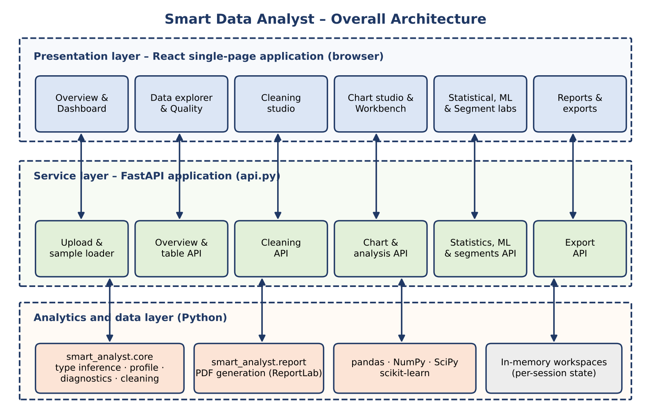
Fig 2: Overall architecture of Smart Data Analyst
The layers communicate only through the API. The browser never computes statistics; it sends a small JSON request that names a workspace and an operation, and it receives a compact JSON result that it renders as a chart or a table. This division has three advantages. First, all analytical logic exists in exactly one place, so that the behaviour seen in the interface is identical to the behaviour verified by the automated tests. Second, the heavy computation uses vectorised Python libraries rather than browser JavaScript. Third, the front end can be rebuilt or replaced without touching the analytics.
At run time a single Uvicorn process hosts both the API and the compiled front end. The API routes live under the prefix /api, and the production bundle in web/dist is mounted at the root path, so that opening http://localhost:8501 loads the interface and every request from that interface returns to the same process.

4.2 Project Structure
The repository is organised so that each concern has its own file or folder. Table 9 lists the main components together with the size of each source file.
Table 9: Structure of the Smart Data Analyst project
Path | Lines | Responsibility
api.py | 1,035 | FastAPI application: request models, workspace state, upload and sample loading, overview payload, cleaning, chart, analysis, statistics, ML, segments, time series, export and static file serving
smart_analyst/core.py | 155 | Type inference, profiling, quality index, diagnostics, observations, cleaning recommendations and the cleaning engine
smart_analyst/report.py | 21 | A4 PDF report built with ReportLab
smart_analyst/charts.py | 26 | Shared Plotly chart helpers retained for Python consumers
smart_analyst/__init__.py | 14 | Package version (1.0.0) and public exports
web/src/App.jsx | 964 | React application shell and all twelve analytics screens
web/src/styles.css | 826 | Responsive design system, themes and motion
web/src/main.jsx | 9 | React entry point
web/build.mjs | — | Build script: Babel + Browserify bundle written to web/dist
sample_data/ | 4 files | Retail sales, student performance, healthcare sample and flight delays
tests/test_api.py | 439 | Twenty-four API tests through an HTTP test client
tests/test_core.py | 33 | Six unit tests for the analytics package
requirements.txt | 13 | Python dependencies with version ranges
README.md | — | Run instructions, feature list, architecture, interpretation notes and limitations

4.3 Workspace and State Model
The application has no database. Instead, each upload creates a workspace: a dictionary stored in server memory under a UUID. The browser keeps the identifier and sends it with every request in the X-Workspace-Id header. If the identifier is missing or unknown, the API answers with HTTP 404 and the message “No dataset is loaded in this workspace.”
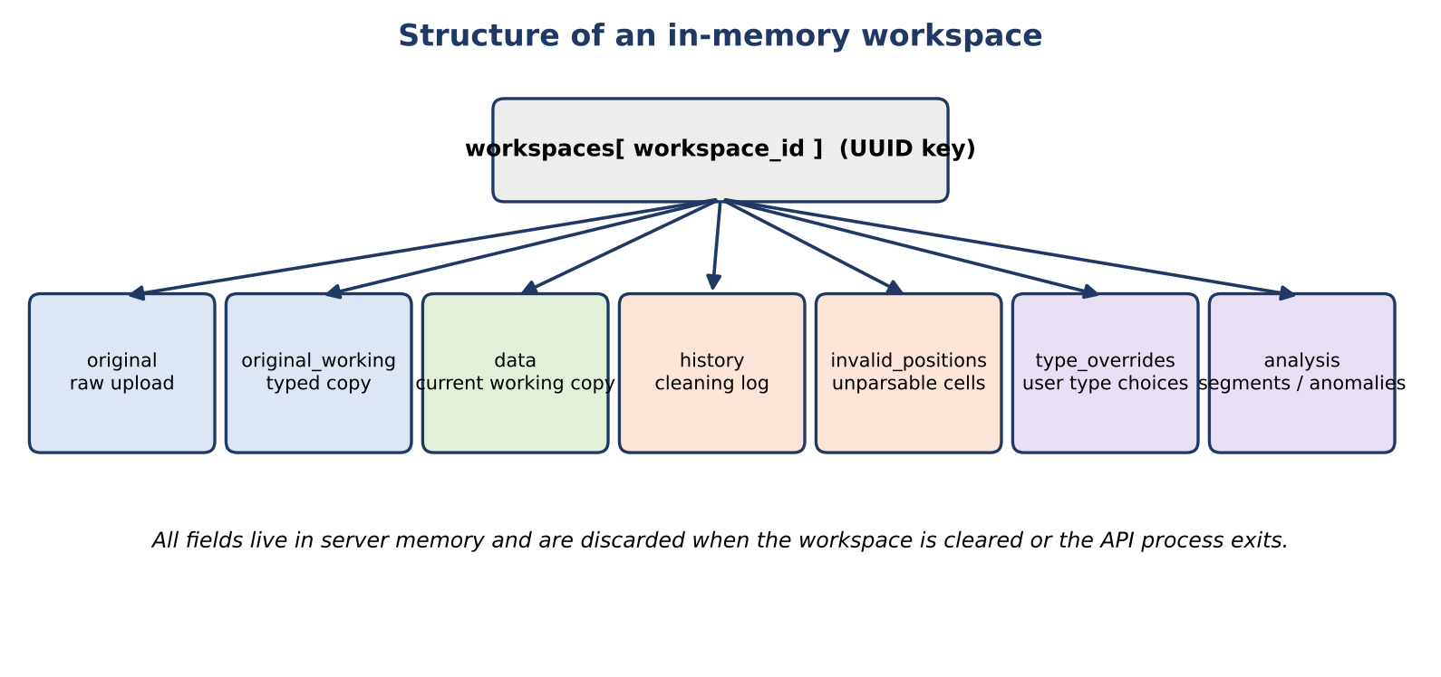
Fig 3: Structure of an in-memory workspace
The fields of a workspace are described in Table 10. Keeping three separate copies of the table is the mechanism that makes the original recoverable: the raw upload is never modified, the typed working copy at load time is the reset target, and the current working copy receives all approved cleaning actions.
Table 10: Fields of a workspace
Field | Content | Purpose
id, name, size | UUID, file name, size in bytes | Identifies the workspace and describes the upload
original | DataFrame exactly as parsed from the file (after header normalisation) | Permanent record of the upload
original_working | Copy of the data after type normalisation | Target of the reset operation
data | Current working copy | Source for every screen, chart, test and export
invalid_positions | Per column, the row labels whose values could not be parsed into the inferred type | Allows “invalid values” to be reported and re-evaluated after cleaning
history | List of human-readable cleaning log entries | Displayed in the Cleaning studio and in the overview
type_overrides | Column-to-type choices made by the user | Applied on top of automatic inference whenever the profile is rebuilt
analysis | Latest segment and anomaly tables | Source for the segment and anomaly CSV exports

4.4 Application Programming Interface
The API consists of twenty routes. Requests that carry parameters use Pydantic models, so that a malformed request is rejected with a descriptive message before any analysis starts. Table 11 lists the routes.
Table 11: Routes of the Smart Data Analyst API
Method and path | Purpose
GET /api/health | Start-up check; returns status “ok”
GET /api/samples | Lists the four bundled sample datasets
POST /api/samples/{filename} | Creates a workspace from a sample dataset
POST /api/upload | Creates a workspace from an uploaded CSV, XLSX or XLS file
GET /api/overview | Profile, diagnostics, observations, correlations and dashboard inputs
GET /api/table | Searchable, paginated data preview (up to 200 rows per page)
GET /api/cleaning | Cleaning recommendations and the cleaning history
POST /api/cleaning/preview | Applies selected actions to a copy and returns before/after counts, a change log and a 12-row preview
POST /api/cleaning/apply | Applies selected actions to the working copy and appends to the history
POST /api/reset | Restores the working copy to its state at load time and clears history
PUT /api/types | Overrides inferred column types
GET /api/controls | Slicer metadata: category options, numeric ranges and date ranges
POST /api/analysis | Runs one of nine workbench operations
POST /api/chart | Returns chart-ready data for ten chart types with slicers
POST /api/statistics | Runs one of six exploratory statistical tests
POST /api/ml | Trains classification or regression baselines
POST /api/segments | Runs K-means segmentation or Isolation Forest anomaly review
POST /api/timeseries | Aggregates a measure over time
GET /api/export/{kind} | Exports csv, xlsx, json, pdf, segments or anomalies
DELETE /api/workspace | Removes a workspace from memory
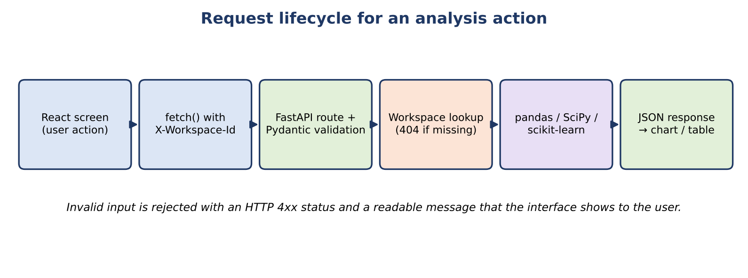
Fig 4: Request lifecycle for an analysis action
The request model for each analytical route constrains its inputs. For example, the cluster count must lie between 2 and 8, the anomaly contamination between 0.01 and 0.15, the hold-out share of a model between 0.15 and 0.40, and the number of chart categories between 5 and 100. Table 12 summarises the request models.
Table 12: Request models and their constraints
Model | Fields | Constraint highlights
CleanRequest | actions | List of action dictionaries with a key and an optional strategy
FilterClause | column, operator, value, value_to | Operators: eq, ne, contains, gt, gte, lt, lte, between, is_null, not_null
ChartRequest | chart, x, y, color, aggregation, date_frequency, limit, filters | date_frequency in auto, D, W, MS, QS, YS; limit 5–100
AnalysisRequest | operation, columns, group_by, column_by, statistic, method | Nine operations; statistic mean, median, sum, count, min, max, std; method pearson, spearman, iqr, zscore
StatsRequest | test, x, y, group | Test name plus the variables it needs
ClusterRequest | columns, clusters, contamination, method | clusters 2–8; contamination 0.01–0.15; method cluster or anomaly
TimeSeriesRequest | date, value, frequency, aggregation | Frequency D, W, MS, QS, YS; aggregation mean, sum, count, median
MLRequest | task, target, features, test_size | Task classification or regression; test_size 0.15–0.40

4.5 Type-Inference Design
Every screen of the application depends on knowing whether a column is a measure, a category, a date or an identifier. The function kind() in the analytics package decides this for each column. The decision combines the pandas data type, the pattern of the values and, for numeric identifiers, the name of the column. Fig 5 shows the order of the decisions.
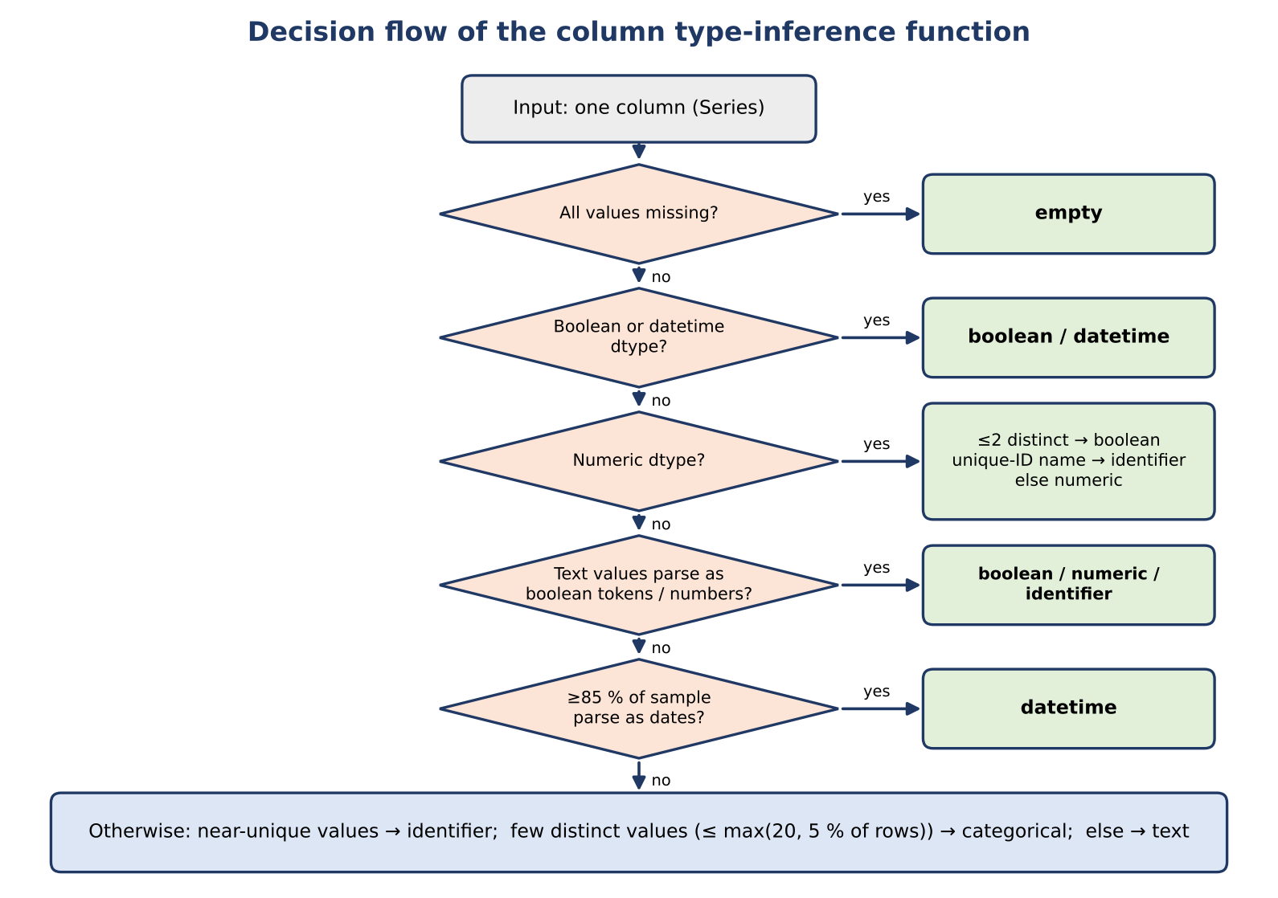
Fig 5: Decision flow of the column type-inference function
The rules were designed to avoid two common mistakes. The first is to treat a numeric identifier, such as a row number or a postal code, as a measure; such a column would produce meaningless means and correlations. A numeric column is therefore classified as an identifier when it has more than thirty values, more than 98 per cent of them are distinct, and its name contains one of the words id, key, code or number as a whole word. Names with spaces or hyphens, such as “Row ID” and “Postal Code”, are normalised to underscores before the test. The second mistake is to treat a column of text that merely looks numeric or date-like as plain text. For text columns the function therefore inspects the first 300 non-missing values: if all of them parse as numbers, the column is numeric; if at least 85 per cent parse as dates, it is a date.
Table 13: Column types produced by the inference function
Type | Typical evidence | Use in the application
numeric | Numeric dtype with more than two distinct values, or text that parses entirely as numbers | Measures for charts, statistics, correlations, models and outliers
categorical | Few distinct values: at most the larger of 20 and 5 % of the rows | Groupings, slicers, frequency charts, chi-square tests
boolean | Boolean dtype, two distinct values, or tokens such as true/false, yes/no, y/n, t/f, 1/0 | Treated like categories
datetime | Datetime dtype, or at least 85 % of sampled text values parse as dates | Trends, time series and date slicers
identifier | More than 98 % distinct values (names such as id, key, code, number for numerics) | Excluded from measures and groupings
text | Many distinct non-numeric values | Shown in the preview and data dictionary only
empty | Every value missing | Reported in the quality screen
Inference is a heuristic, and the user can always correct it. The PUT /api/types route stores the user's choices in type_overrides, and the profile is rebuilt with those choices on top of the automatic result, so that a numeric code column can be switched to categorical, or a text column to a date, with one action.

4.6 Data Quality Index and Diagnostics
The Overview screen summarises the quality of a dataset in a single number between 0 and 100. The index is an explainable heuristic, not an industry standard, and it is documented as such in the application and in the README. It combines three penalties, as shown in Fig 6.
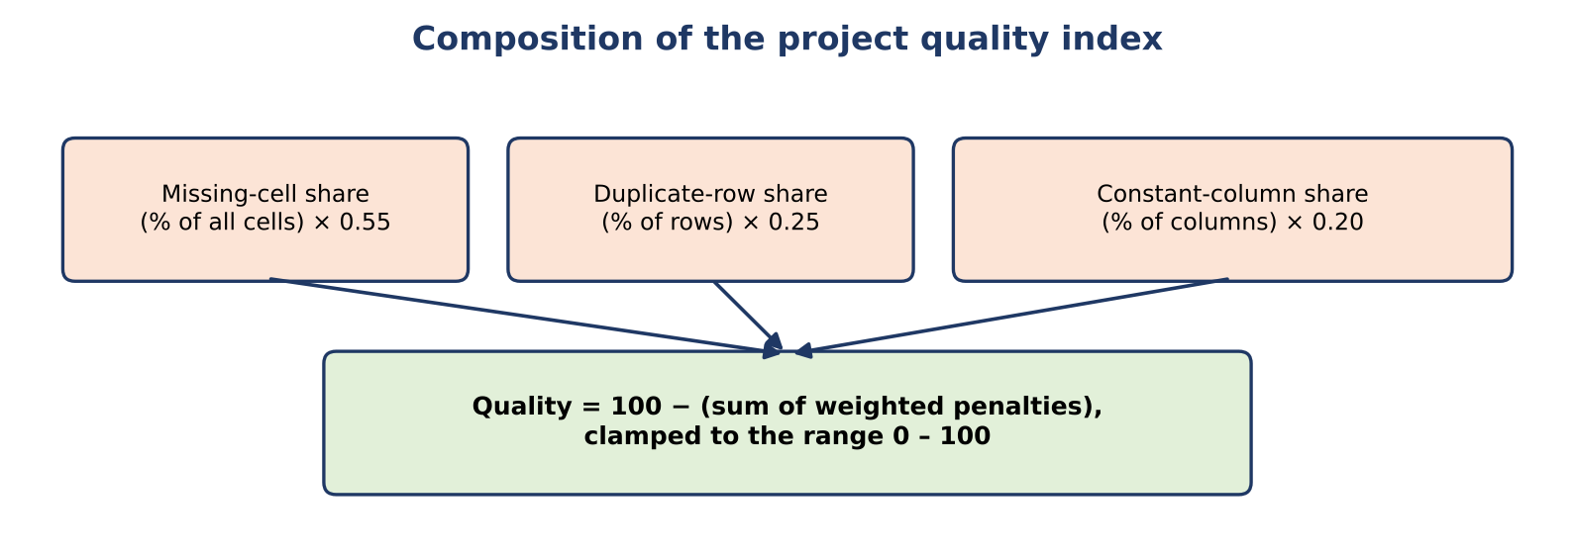
Fig 6: Composition of the project quality index
With *m* the percentage of missing cells, *d* the percentage of fully duplicated rows and *c* the percentage of constant columns, the index is computed as:
quality = max(0, min(100, 100 - 0.55*m - 0.25*d - 0.20*c))
The weights express the view that missing data is the most damaging of the three problems, followed by repeated records, followed by columns that carry no information. As a worked example, the unit test test_profile_and_missing builds a table of four rows and two columns, age = [20, 30, missing, 40] and city = [A, B, A, missing]. Two of the eight cells are missing (m = 25 %), there are no duplicates and no constant columns, so the index is 100 − 0.55 × 25 = 86.25, which the application displays rounded to one decimal place.
Beside the index, the diagnostics table reports, for every column, its type, the number and share of missing values, the number of distinct values, the number of IQR outlier candidates, the number of infinite values and whether the column is constant. A value is an IQR outlier candidate if it lies more than 1.5 times the inter-quartile range below the first quartile or above the third quartile; the test needs at least four values. The label “candidate” is deliberate: an outlier flag is a prompt to inspect a value, not proof that the value is wrong.

4.7 Security and Privacy Design
Smart Data Analyst handles files supplied by users, so its design includes a number of protective measures. They are summarised in Table 14 and are best understood as a set of safe defaults for a local tool rather than as a complete security model for a public service.
Table 14: Privacy and safety measures
Concern | Measure in the design
Data leaving the machine | All processing is local. No external API, account or key is used. The server listens on 127.0.0.1.
Oversized uploads | Files larger than 50 MB are rejected with HTTP 413; tables of more than 1,000,000 rows are rejected with HTTP 413.
Unsupported or corrupt files | Only CSV, XLSX and XLS are accepted (HTTP 415 otherwise); parser failures return HTTP 400 with the parser message; empty tables are rejected.
Encoding problems | CSV files that are not valid UTF-8 are re-read with the latin-1 encoding.
Malformed rows | The CSV parser is run with on_bad_lines set to error, so that a broken file is reported instead of silently truncated.
Spreadsheet macros | Excel files are read through pandas; formulas are read as values and macros are never executed.
Injection through uploaded text | Uploaded names and values are escaped before they are placed in the PDF report; a dedicated test checks this.
Unknown columns and slicers | A request that names a column that does not exist is rejected with HTTP 400.
Over-confident results | Each statistical or modelling result carries an interpretation note; outlier and anomaly flags are called candidates.
Memory growth | Workspaces can be deleted with DELETE /api/workspace and all workspaces disappear when the process exits.

4.8 User Interface Design
The interface is a responsive single-page application organised as a persistent sidebar with twelve screens in three groups, a top bar and a content area. The top bar shows a “LOCAL & PRIVATE” badge, a theme toggle, a button to replace the data and an Export button. The chosen theme and the current workspace identifier are kept in the browser's local storage, so that a page refresh returns the user to the same dataset and appearance.
Table 15: Screens of the application
Group | Screen | Purpose
Workspace | Overview | Key indicators, automatically assembled dashboard, slicers and correlations
Workspace | Data explorer | Searchable, paginated data preview and data dictionary with type overrides
Workspace | Data quality | Per-column diagnostics, missingness and outlier candidates
Workspace | Cleaning studio | Suggested actions, before/after preview, approval, history and reset
Analysis | Chart studio | Ten chart types with axis, series, aggregation, date roll-up and up to four slicers
Analysis | Analysis workbench | Descriptive profile, group comparison, cross-tabulation, pivot, correlation, missingness, outliers, frequency and duplicates
Analysis | Insights | Rule-based observations ranked by level
Analysis | Statistical lab | Six exploratory tests with effect sizes and cautions
Analysis | ML lab | Classification and regression baselines with held-out metrics
Analysis | Segments & anomalies | K-means segmentation and Isolation Forest anomaly review
Analysis | Time series | Aggregation of a measure at daily to yearly intervals
Manage | Reports & exports | PDF report, cleaned CSV, Excel workbook and JSON profile
The visual language is restrained. Charts use a six-colour palette chosen for readability, every axis has a title, values are formatted, pie and donut charts include a legend and multi-series charts show a series legend. Page changes use a short fade-and-slide transition, sections reveal in a staggered way, and metric cards lift slightly on hover. A drag-and-drop overlay allows a file to be dropped anywhere on the page, and short toast messages confirm actions such as applying a cleaning step.
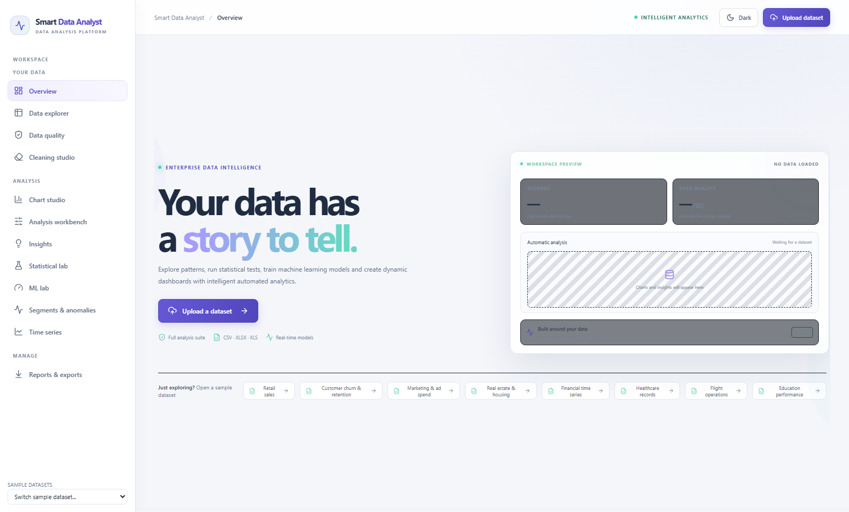
Fig 7: Application shell with sidebar navigation, top bar and welcome screen

4.9 Design Decisions and Trade-offs
Several design decisions shaped the application. Each of them has a benefit and a cost, and Table 16 records both so that the choices can be reviewed or reversed in future versions.
Table 16: Key design decisions and their trade-offs
Decision | Reason | Trade-off
In-memory workspaces instead of a database | Simple installation, no schema to maintain, fast access, and no data left behind on disk | Data is lost when the server stops; memory limits the size of tables
All computation on the server | One implementation of the analytics, tested once and reused by every screen | The browser depends on a running local server
Working copy separate from the original | Cleaning can be undone and the evidence is preserved | Several copies of the table are held in memory
Opt-in cleaning with preview | The user stays in control of every change to the data | More clicks than an automatic clean-up
Heuristic quality index with documented weights | A single, explainable number that is easy to compare | Not an industry standard; weights are a judgement
Fixed random seed (42) | Sampling, splits and clusters are reproducible between runs | Results show one split, not the variability across splits
Sampling of large chart inputs | Charts stay responsive on large tables | Charts may not show every record; the response is flagged as sampled
Small build script instead of a bundler framework | Few dependencies and a short, readable build | Fewer conveniences such as hot reloading
Front end served by the API process | One command starts the whole application | Front-end changes require a rebuild

4.10 Data-Flow Description
The path of the data through the system is summarised in Fig 8. In words, the flow is as follows.
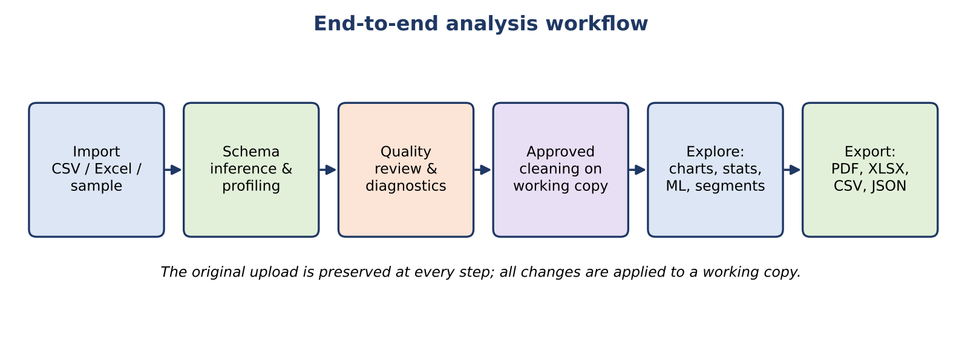
Fig 8: End-to-end analysis workflow
- The user uploads a file or opens a sample. The API checks its size and type, parses it and creates a workspace that holds the original table.
- The typed working copy is created and unparsable values are recorded. The profile, diagnostics and observations are computed and returned as the overview.
- The browser draws the overview and requests further data on demand: table pages, chart data, workbench tables, tests, models or segments. Each request names the workspace and carries only a small description of the operation.
- If the user accepts a cleaning proposal, the working copy is replaced by the cleaned copy and the history grows. Every later request then works on the cleaned data.
- When the user exports, the API serialises the current working copy, its profile or the report, and the browser downloads the file.

CHAPTER 5
IMPLEMENTATION AND WORKING PROCESS
This chapter explains how each module of the application is implemented and how the modules work together when a user analyses a dataset. The description follows the order in which a dataset passes through the system.

5.1 Data Ingestion Layer
The function read_upload converts the raw bytes of an uploaded file into a pandas DataFrame and refuses anything unsafe. It first checks the size against the 50 MB limit and the extension against the accepted set. A CSV is read with low_memory disabled so that column types are inferred over the whole file, and with on_bad_lines set to error; if decoding as UTF-8 fails, the read is repeated with latin-1. Excel files are read with pandas.read_excel, which uses openpyxl for XLSX and xlrd for XLS.
After parsing, the function enforces the content rules: an empty table is rejected with the message “This file has no data rows.” and a table of more than one million rows with HTTP 413. Finally it normalises column names. A blank name, or a name such as “Unnamed: 3” that pandas generates for a missing header, becomes unnamed_ followed by the column position, and a repeated name receives a numeric suffix (price, price_2, …). This guarantees that every column can be addressed uniquely in later requests.
Table 17: Error responses of the ingestion layer
Condition | HTTP status | Message (summary)
File larger than 50 MB | 413 | Files must be 50 MB or smaller.
Extension other than csv, xlsx, xls | 415 | Upload a CSV, XLSX, or XLS file.
Parser failure or malformed row | 400 | Could not parse this file: <reason>
No data rows | 400 | This file has no data rows.
More than 1,000,000 rows | 413 | The limit is 1,000,000 rows per upload.

5.2 Type Normalisation and Invalid-Value Tracking
Once the file is parsed, normalize_types creates a typed working copy. For each column it asks the inference function for a type. If the type is numeric, the column is converted with pandas.to_numeric using coercion, so that text such as “n/a” or “12 kg” becomes missing instead of breaking the analysis; infinite values are replaced by missing values. If the type is date-like but the column is still text, it is converted with pandas.to_datetime using coercion and mixed formats.
The important design decision is that nothing is converted silently. For every column the function records the row labels of values that were present in the file but could not be converted, in the structure invalid_positions. The Overview screen then shows a warning such as “N non-empty values could not be parsed as their inferred numeric or date type. They are shown as missing in the working copy; the original upload is preserved.” The tests test_empty_headers_are_named_and_invalid_numeric_values_are_reported and test_infinite_numeric_values_are_reported_and_normalized verify this behaviour.

5.3 Profiling and Data Dictionary
The function profile is the heart of the overview. It returns the number of rows and columns, the number and share of missing cells, the number and share of duplicated rows, the list of constant columns, the quality index, the type of each column and the groupings of numeric, categorical and date columns. It also builds a schema: one record per column containing the type, the data type, the missing count and percentage, the number of distinct values and their percentage, up to three sample values, and type-specific statistics. For numeric columns these are the minimum, maximum, mean, median, standard deviation and the 25th and 75th percentiles; for dates the earliest and latest value; for categorical and boolean columns the most frequent value.
The schema is displayed in the Data explorer as the data dictionary and is exported as the second sheet of the Excel workbook. Because the API rebuilds the profile whenever the working copy or a type override changes, the dictionary always describes the data that the user is currently looking at.

5.4 Diagnostics and Outlier Candidates
The function diagnostics returns a table with one row per column. For numeric columns it converts the values, counts infinite values, and computes the first and third quartiles to count IQR outlier candidates. The API adds a column of invalid values from the tracking structure. The Data quality screen displays this table and offers bars for missingness so that the worst columns are seen first. The overview also lists the twelve columns with the most missing values.

5.5 Observation Engine
The function insights turns the profile into a short list of observations in plain language. It is a transparent rule engine, not a language model: each rule has a fixed threshold, and the output is capped at twelve items. The rules are listed in Table 18.
Table 18: Rules of the observation engine
Observation | Level | Trigger
Missing values | warning | At least one missing cell; reports the count and percentage
No missing cells | success | No missing cell; notes that values may still be invalid
Duplicate records | warning | At least one fully duplicated row
Constant columns | info | Columns with a single distinct value (first eight named)
Skewed measure | info | Numeric column with at least 10 values, positive spread and absolute skewness above 1
Imbalanced category | info | Category with 2 to 100 values in which the top value covers at least 80 % of the non-missing values
Strong linear association | info | The strongest Pearson correlation among numeric columns has an absolute value of at least 0.7
Invalid inferred values | warning | Values that could not be parsed into the inferred type (added by the API)

5.6 Cleaning Engine
Cleaning is implemented in three functions that together enforce the rule that nothing changes without consent. recommendations inspects the working copy and proposes actions; clean applies a chosen list of actions to a copy and returns the new table with a log of what was done; and the API decides whether the result is only previewed or actually stored.
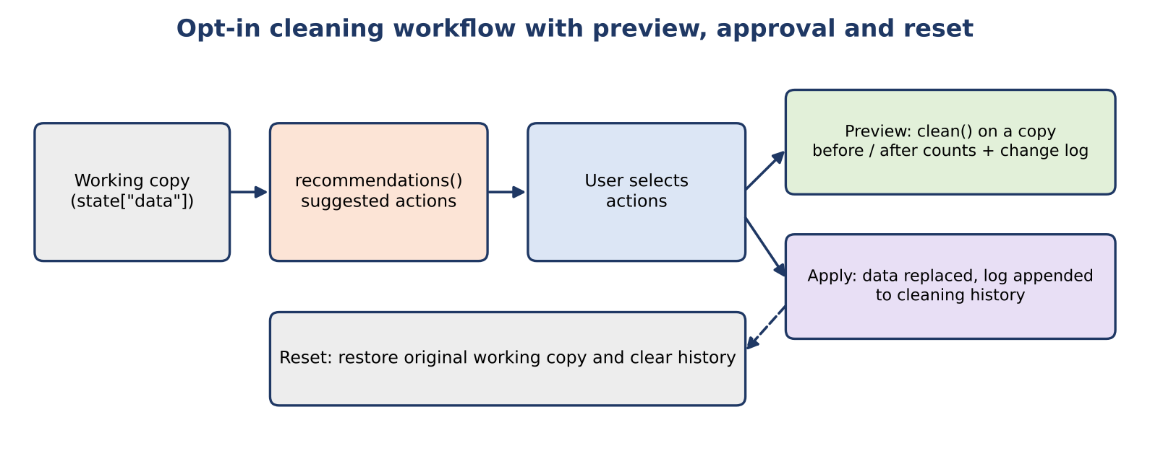
Fig 9: Opt-in cleaning workflow with preview, approval and reset
Table 19: Cleaning actions
Action key | Proposed when | Effect
duplicates | At least one fully duplicated row | Removes repeated rows and logs how many were removed
whitespace:<column> | A text value has leading or trailing spaces | Trims the spaces in that column
missing:<column> | The column has missing values | Fills with the median (numeric) or the most frequent value (categorical); other types are left unchanged
constant:<column> | The column has a single distinct value | Drops the column after confirming it is still constant
Every proposal is labelled with a risk note such as “Review first” or “Confirm meaning”. The preview route runs clean on a copy and returns the row and column counts before and after, the change log and the first twelve rows of the result. Only when the user approves does the apply route replace the working copy and append the log entries to the history. The reset route restores the typed copy that was saved at load time and clears the history. The test test_cleaning_preview_apply_and_original_reset verifies this sequence, and test_trim_whitespace_cleaning_is_opt_in verifies that trimming never happens unless it is selected.

5.7 Dashboard Assembly and Chart API
The Overview screen assembles a dashboard automatically. The interface ranks the numeric columns so that likely measures come before identifier-like fields, excludes high-cardinality columns from grouping, and builds up to eight candidate views: an average of a measure by category, a trend over time, a distribution of the measure, a category frequency, a relationship between two numeric columns, a second frequency, a second distribution and a correlation matrix. The first four are shown immediately and the others are kept collapsed so that the page stays focused. Any chart can be widened to the full width with the Fit width control.
All charts are served by POST /api/chart, which returns data that is ready to draw. The route supports ten chart types, four aggregations and a number of safeguards, listed in Table 20.
Table 20: Behaviour of the chart route
Aspect | Behaviour
Chart types | histogram, category, pie/donut, bar, grouped bar, stacked bar, line, area, scatter and correlation
Aggregations | mean, sum, count, median
Histogram bins | The smaller of the requested limit and 50; a constant column returns a single bar
Bar charts | Sorted in descending order and limited to the requested number of categories (5–100, default 30)
Grouped series | The eight most frequent series values are kept and the rest are merged into “(Other)”
Scatter plots | At most 2,000 points are returned; the response states that the data was sampled
Correlation chart | Up to 12 numeric columns; undefined pairs are returned as blanks; the response states when columns were truncated
Sampling | Inputs larger than 50,000 rows are sampled with a fixed random seed (42) and the response is flagged as sampled
Record counts | Every response reports the records before and after filters, so that slicers can be checked
Date columns receive special treatment. If a line, area or bar chart uses a date on the X axis, the route groups the records into time buckets so that dense data remains readable. In automatic mode the bucket depends on the span of the data, as shown in Table 21, and the user can override it in the Chart studio. Labels are formatted to match the bucket, for example “Mar 25” for months and “Q2 ’25” for quarters.
Table 21: Automatic date roll-up
Condition on the observed dates | Bucket
24 or fewer distinct dates | Individual dates
Span of up to 62 days | Day
Span of up to 550 days | Week
Span of up to 2,200 days | Month
Span of up to 7,300 days | Quarter
Longer spans | Year

5.8 Slicers and Filters
Slicers let the user restrict every chart to a subset of the records without changing the working data. A slicer is expressed as a FilterClause with a column, an operator and one or two values, and a request may carry several of them (up to four are offered in the Chart studio). The function apply_filters interprets a clause according to the type of the column, so that the same operator behaves sensibly for text, numbers and dates.
Table 22: Filter operators
Operator | Behaviour
eq, ne | Exact match or mismatch; for numeric columns the value is converted to a number (so that 5 matches 5.0); for date columns a whole day is compared
contains | Case-insensitive substring match on the text form of the value
gt, gte, lt, lte | Numeric comparison; if the value is not a number, a date comparison is attempted
between | Inclusive range for numbers or dates
is_null, not_null | Selects missing or present values
An unknown column or an unparsable value produces HTTP 400 with a precise message. The tests test_chart_filter_rejects_unknown_slicer_column, test_date_slicer_matches_a_full_day and test_numeric_equality_slicer_matches_integer_input_to_float_column cover the main edge cases. The dashboard reports the number of filtered records separately from the full-dataset quality indicators, so that a user can see at a glance how many records a slicer selects.

5.9 Analysis Workbench
The workbench provides nine table-based operations that complement the charts. Each returns a title, a list of columns, rows, and where relevant a warning; the interface shows the result as a table and lets the user export it to CSV.
Table 23: Operations of the analysis workbench
Operation | What it produces | Main limits
Descriptive profile | Type-aware summary per column: records, missing, distinct values, mean, median, standard deviation, minimum, quartiles, maximum and skewness | At most 30 columns
Group comparison | A chosen statistic (mean, median, sum, count, min, max, std) of numeric measures for each group | Top 100 groups; the measure must differ from the grouping column
Cross-tabulation | Counts for two categorical fields | Top 30 values of each field
Pivot table | One numeric measure aggregated over two dimensions | Top 15 values per dimension
Correlation matrix | Pearson or Spearman correlations between numeric columns | 2 to 30 columns
Missing-value audit | Missing and present counts per column and rows with missing values | All columns
Outlier screening | Potential outliers by the IQR rule or by a three-standard-deviation z-score | Selected numeric columns
Frequency table | Count, percent and cumulative percent of category values | Top 100 values
Duplicate records | Lists fully repeated rows without removing them | First 100 rows shown

5.10 Statistical Lab
The Statistical lab offers six exploratory tests, implemented with SciPy. Each result contains the test name, the sample size, the test statistic, the p-value, an effect size where one is defined, and an interpretation note. Before computing, the route validates the choice of variables and the minimum amount of data, and it converts any internal error into a readable HTTP 400 message.
Table 24: Statistical tests
Test | Variables | Requirement | Effect size reported
Pearson correlation | Two numeric columns | At least 3 complete pairs | Correlation coefficient r
Spearman correlation | Two numeric columns | At least 3 complete pairs | Rank correlation ρ
Welch t-test | Numeric measure and a grouping column | Exactly two groups, each with at least two values | Standardised mean difference
Mann–Whitney U | Numeric measure and a grouping column | Exactly two groups | —
Kruskal–Wallis | Numeric measure and a grouping column | At least two groups | —
Chi-square independence | Two categorical columns | At least two observed categories in each | Cramér’s V
The wording of the interpretation notes is part of the design. Correlation results state that they show association only and do not establish causation. Group tests state that statistical significance is not practical significance and that assumptions and study design must be reviewed. The chi-square result reminds the user to check expected cell counts. The README adds that a p-value is not the probability that a hypothesis is true.

5.11 Machine-Learning Lab
The ML lab trains baseline models so that a user can judge quickly whether the chosen features carry any signal about a target. It is intentionally a baseline tool, not an automated modelling platform. Fig 10 shows the pipeline.
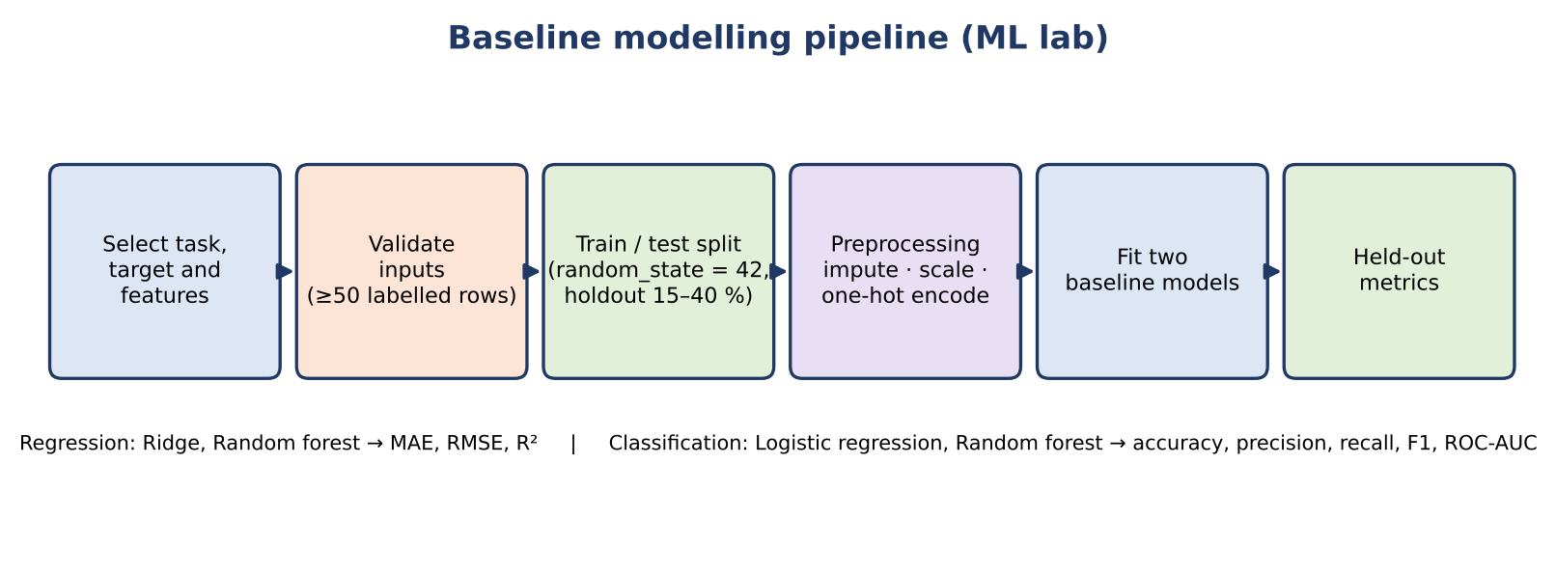
Fig 10: Baseline modelling pipeline of the ML lab
The route first validates the request: the task must be classification or regression, the target must exist and must not be one of the features, at most 40 features may be selected, at least 50 labelled rows are needed, a classification target needs at least two and at most 30 classes, and a regression target must be numeric. Empty features are excluded and reported, and categorical features with more than 1,000 distinct values are rejected because one-hot encoding would be too large.
Preprocessing is built as a scikit-learn column transformer. Numeric features are imputed with the median and standardised. Categorical features are imputed with the most frequent value and one-hot encoded, ignoring unseen categories and limiting each feature to 100 categories. The data is divided into training and test sets with a fixed seed (42), stratified for classification when every class has at least two examples. Two models are then fitted for the task and scored on the held-out part, as listed in Table 25.
Table 25: Models and metrics of the ML lab
Task | Models | Metrics reported
Regression | Ridge regression; random forest regressor (120 trees, minimum leaf size 2) | MAE, RMSE, R²
Classification | Logistic regression (balanced class weights, liblinear solver); random forest classifier (120 trees, minimum leaf size 2, balanced class weights) | Accuracy, weighted precision, weighted recall, weighted F1, ROC-AUC for binary targets, confusion matrix
Every response ends with the warning that single hold-out metrics are preliminary, may be unstable for imbalanced classes and do not establish generalisation. The test test_classification_baselines_run_on_user_selected_features uses a 100-row synthetic table and checks that a 20-row hold-out is produced and that two models report accuracy, and test_regression_baselines_run does the same for regression with RMSE.

5.12 Segments and Anomalies
The route POST /api/segments serves two related tools. Both require at least two valid numeric columns and at least twenty complete records, both drop rows with missing values in the chosen columns, and both standardise the columns so that scale does not dominate.
- K-means segmentation. The user chooses between two and eight clusters. The route fits K-means with ten initialisations and a fixed seed, assigns each record to a segment, and returns the number of records, the mean of every chosen column for each segment, the first 100 labelled rows and, for datasets of up to 20,000 records, the silhouette score as a measure of cluster separation. The segmented table is stored in the workspace for CSV export.
- Isolation Forest anomaly review. The user chooses the expected share of anomalies between 1 % and 15 %. The route fits 150 trees with a fixed seed, labels each record as typical or anomalous, attaches the anomaly score and returns the flagged records. The warning that flags are candidates for review, not proof of error or fraud, accompanies every result.

5.13 Time-Series Aggregation
The Time series screen aggregates one numeric measure against one date column. The route converts both columns, drops incomplete pairs, sorts by date and resamples to the requested frequency (day, week, month start, quarter start or year start) using the mean, sum, count or median. Periods without data are dropped, and the response lists the periods in ISO date format for plotting. The test test_time_series_segments_and_pdf_exports verifies the route together with the segment and PDF exports.

5.14 Export and Report Generation
The export route produces six downloads from the current working copy, so that exported files always reflect the cleaning that the user has approved.
Table 26: Exports
Kind | File | Content
pdf | analysis_report.pdf | A4 report with a dataset overview, automated observations, a column profile and an interpretation note
csv | smart_data_analyst.csv | The cleaned working copy, encoded as UTF-8 with a byte-order mark for Excel compatibility
xlsx | smart_data_analyst.xlsx | Two sheets: “Cleaned data” and “Data dictionary”
json | dataset_profile.json | Structured profile, diagnostics and observations
segments | segments.csv | Latest K-means result, when one exists
anomalies | anomaly_review.csv | Latest anomaly review, when one exists
The PDF report is generated by the pdf_report function with ReportLab. It starts with the title “SMART DATA ANALYST” and the dataset name, then shows a table of rows, columns, missing cells, duplicate rows and the quality index; the automated observations; a column profile table of up to 45 columns with the type, missing percentage and number of distinct values; and a closing interpretation note stating that the summary is descriptive, not causal, and that inferred types and domain-specific validity must be reviewed. The README states clearly that the report contains the profile and rule-based observations, not every interactive analysis performed in the browser.

5.15 Front-End Implementation
The interface is implemented in one React component file, App.jsx, of 964 lines, and a stylesheet of 826 lines. The root component keeps the current page, the theme, the workspace identifier, the loaded overview data and a transient error or toast message. A helper function wraps fetch: it attaches the workspace header, sets the JSON content type for ordinary requests and leaves the multipart type to the browser when a FormData upload is sent. Server error messages are shown to the user instead of a generic failure.
Each screen is a function component that receives the overview data and the workspace identifier. Reusable components include a card, a metric card with a hover lift, a chart wrapper, an empty-state message and an insight card whose icon depends on the observation level. The chart wrapper renders bar, line, area, scatter and donut charts with Recharts, titles both axes, formats tick values, assigns colours from the shared palette and optionally shows a legend or a series legend for grouped and stacked charts.
Because the project avoids a heavyweight toolchain, the front end is built by a small script, build.mjs. It bundles src/main.jsx with Browserify after transforming JSX and modern JavaScript with Babel, writes the result to web/dist/assets/app.js, copies the stylesheet and the HTML file, and prints a confirmation. FastAPI then serves the dist folder directly. After any change to the front end, the developer runs npm run build from the web folder.

5.16 Error Handling and Validation Strategy
A data tool receives unpredictable input, so validation is layered. Each layer catches a different class of problem, and the user sees a readable message in every case. Table 27 summarises the layers.
Table 27: Layers of validation and error handling
Layer | Mechanism | Example
Request schema | Pydantic models with constrained fields and Literal types | A cluster count of 12 or an unknown filter operator is rejected before any computation
Workspace lookup | A missing or unknown workspace identifier returns HTTP 404 | After the server restarts, the browser is told that no dataset is loaded
Domain checks | Explicit checks with HTTP 400 and a specific message | “At least 3 complete pairs are needed.”; “Select two different numeric columns.”
Scientific libraries | Calls are wrapped so that internal errors become HTTP 400 messages and are logged | “Could not calculate this test: …”; “Could not train the baseline models: …”
File limits | Size, row and type checks with HTTP 413 and 415 | A 60 MB upload or a .txt file
Logging | Python logging at INFO level, with stack traces for training failures | Parse failures and model-training exceptions are recorded for the developer
Front end | A shared error state shows the server's message and toast messages confirm successes | The detail text of the HTTP error is displayed to the user

5.17 Typical Session Walk-through
Table 28 follows one typical session from the user's point of view and shows which API route each action triggers. It makes visible how a small number of routes support all twelve screens.
Table 28: A typical session and the routes it calls
Step | User action | Route(s) called | Result
1 | Opens a sample or drops a file on the page | POST /api/samples/{file} or POST /api/upload | Workspace created; overview returned
2 | Reads the Overview and expands extra charts | POST /api/chart (one call per chart) | Dashboard charts drawn
3 | Applies a slicer such as a region | GET /api/controls; POST /api/chart with filters | Every chart recalculated for the selected records
4 | Searches the data preview | GET /api/table | A page of rows and the total count
5 | Changes a column type | PUT /api/types | Profile rebuilt with the override
6 | Reviews and approves a cleaning action | GET /api/cleaning; POST /api/cleaning/preview; POST /api/cleaning/apply | Preview, then updated overview and history
7 | Runs a workbench operation | POST /api/analysis | Result table
8 | Runs a test or trains a baseline | POST /api/statistics; POST /api/ml | Statistic and p-value; hold-out metrics
9 | Segments the records or reviews anomalies | POST /api/segments | Segment profiles or flagged rows
10 | Exports a report | GET /api/export/{kind} | File downloaded
11 | Starts again with another file | DELETE /api/workspace; POST /api/upload | Previous workspace freed; new workspace created

CHAPTER 6
TESTING

6.1 Testing Strategy
Because the analytics behind Smart Data Analyst feed decisions, its behaviour is verified with an automated test suite written for pytest. The suite has two layers. The first layer tests the analytics package directly with small hand-made tables whose correct answers can be worked out by hand. The second layer tests the API end to end through an HTTP test client: each test uploads a small CSV or Excel file, receives a workspace identifier and then calls the routes exactly as the browser would, checking status codes and the content of the responses.
The tests follow three guidelines. They use tiny, deterministic datasets generated inside the test so that expected values are known in advance. They check both the successful path and the rejection path, because a data tool must fail clearly on bad input. And they target the places where a subtle mistake would silently mislead a user, such as date filters that must match a whole day, numeric filters that must treat 5 and 5.0 as equal, and aggregation that must happen after slicers are applied.

6.2 Tests of the Analytics Package
The file tests/test_core.py contains six unit tests of the functions in smart_analyst/core.py. They are described in Table 29.
Table 29: Unit tests of the analytics package
Test | What it verifies
test_profile_and_missing | Row, column and missing counts, the 0–100 range of the quality index, and the minimum, median and mean computed for a numeric column
test_inference | Numeric, categorical and boolean inference, including numbers stored as text
test_numeric_identifier_names_with_spaces_are_not_measures | Columns named “Row ID” and “Postal Code” are identifiers, while “revenue” stays numeric
test_clean_copy | Median imputation fills missing values in the copy while the source table keeps its gaps
test_trim_whitespace_cleaning_is_opt_in | A recommendation to trim whitespace is generated but changes nothing until it is applied; the original keeps its spaces
test_insights | The observation engine returns observations for a table with a missing value

6.3 Tests of the API
The file tests/test_api.py contains twenty-four tests. They are grouped by the area of the application that they protect in Table 30.
Table 30: API tests grouped by area
Area | Test | Behaviour checked
Upload | test_csv_upload_profiles_and_exports | A CSV upload creates a workspace, a profile and working exports
Upload | test_upload_encoding_and_duplicate_headers | Non-UTF-8 files are read and repeated headers are made unique
Upload | test_empty_headers_are_named_and_invalid_numeric_values_are_reported | Blank headers receive names; unparsable numbers are reported as invalid
Upload | test_infinite_numeric_values_are_reported_and_normalized | Infinite values become missing and are reported
Upload | test_excel_upload | XLSX files are accepted and profiled
Upload | test_empty_csv_is_rejected | A file without data rows is refused
Upload | test_bad_file_type_returns_clear_error | An unsupported extension returns a clear error
Upload | test_all_four_sample_datasets_load_with_distinct_profiles | Every bundled sample loads and yields its own profile
Cleaning | test_cleaning_preview_apply_and_original_reset | Preview does not change data, apply does, and reset restores the original
Charts | test_chart_api_supports_correlation_scatter_and_donut | Correlation, scatter and donut chart responses
Charts | test_chart_slicers_and_grouped_series_are_applied_before_aggregation | Slicers filter records before they are aggregated
Charts | test_chart_filter_rejects_unknown_slicer_column | Unknown slicer columns are rejected
Charts | test_date_slicer_matches_a_full_day | A date equality slicer matches every record of that day
Charts | test_chart_automatically_rolls_up_dense_daily_trends_and_allows_override | Automatic date roll-up and manual override
Charts | test_correlation_chart_caps_wide_matrices_and_keeps_undefined_pairs_blank | Correlation matrices are capped and undefined pairs stay blank
Charts | test_numeric_equality_slicer_matches_integer_input_to_float_column | An integer slicer value matches a float column
Workbench | test_analysis_workbench_supports_type_aware_and_grouped_operations | Descriptive, group, cross-tab and related operations
Workbench | test_analysis_missing_outlier_duplicate_and_controls_endpoints | Missingness, outlier, duplicate and controls routes
Workbench | test_group_summary_rejects_using_the_group_as_its_only_measure | A grouping column cannot be its own measure
Statistics | test_chi_square_test_returns_effect_size | The chi-square result includes Cramér's V
Modelling | test_classification_baselines_run_on_user_selected_features | Classification baselines on a 100-row table with a 20-row hold-out
Modelling | test_regression_baselines_run | Regression baselines return RMSE for two models
Export | test_time_series_segments_and_pdf_exports | Time series, segments and PDF export work together
Export | test_pdf_export_escapes_uploaded_names_and_values | Hostile text in names and values cannot break the PDF

6.4 Recorded Results
The complete suite consists of thirty tests: six for the analytics package and twenty-four for the API. The pytest cache stored in the project folder after the most recent run lists all thirty tests among the collected node identifiers and records no failed test. In addition, the six analytics-package tests were executed again while preparing this report and all six passed. A syntax check of the Python sources can be run with python -m compileall api.py smart_analyst tests, and the running server can be checked with GET /api/health.

Fig 11: Terminal output of the automated test run (pytest -q)

6.5 Scope Not Covered by Testing
The tests deliberately cover the analytics and the API rather than the visual interface. The screens were checked manually in the browser at desktop and narrow widths, and the screenshots stored in the project's screenshots folder record this work. No automated browser test exists in the current version. The statistical functions are tested for correct plumbing and error handling rather than re-validated numerically, since they delegate to SciPy and scikit-learn. Finally, the tests use small datasets; behaviour at the upper limits of 50 MB and one million rows was not benchmarked.

CHAPTER 7
RESULTS AND OUTPUTS
This chapter presents the application screen by screen. To make the results reproducible, the figures quoted below were obtained by running the project's own analytics routines, with the same parameters and fixed random seeds as the application, on the four bundled sample datasets, which are described in Table 31. Each section contains a figure that shows the corresponding screen of the application.
Table 31: Bundled sample datasets
Dataset | File | Rows × columns | Columns
Retail sales | retail_sales.csv | 358 × 10 | TransactionID, Date, Region, ProductCategory, UnitsSold, UnitPrice, DiscountRate, CustomerRating, StoreType, Revenue
Student performance | student_performance.csv | 280 × 9 | StudentID, Major, Gender, StudyHoursPerWeek, AttendancePct, PreviousFailures, MidtermExam, FinalExam, Passed
Healthcare sample (synthetic) | healthcare_sample.csv | 300 × 9 | PatientID, Age, Gender, RestingBP, Cholesterol, FastingBloodSugar, MaxHeartRate, ExerciseAngina, HeartDisease
Flight delays (synthetic) | flight_delays.csv | 320 × 8 | FlightNumber, Airline, Origin, Destination, DistanceMiles, DepartureDelayMin, ArrivalDelayMin, Cancelled

7.1 Welcome Screen and Loading a Dataset
When the application is opened with no dataset, it shows a welcome screen that explains what the tool does, offers an upload button and lists the four sample datasets. A user can click a sample, choose a file or drop a file anywhere on the page. As soon as the file is accepted, a workspace is created and the Overview screen opens. Rejected files, for example an unsupported extension, produce a readable message instead of a failure.
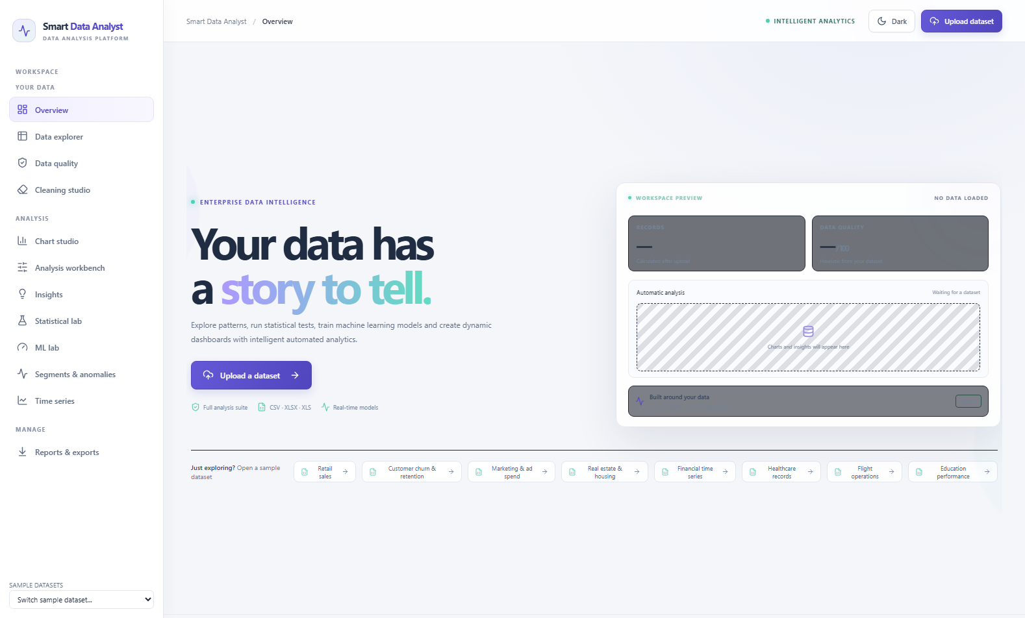
Fig 12: Welcome screen of Smart Data Analyst
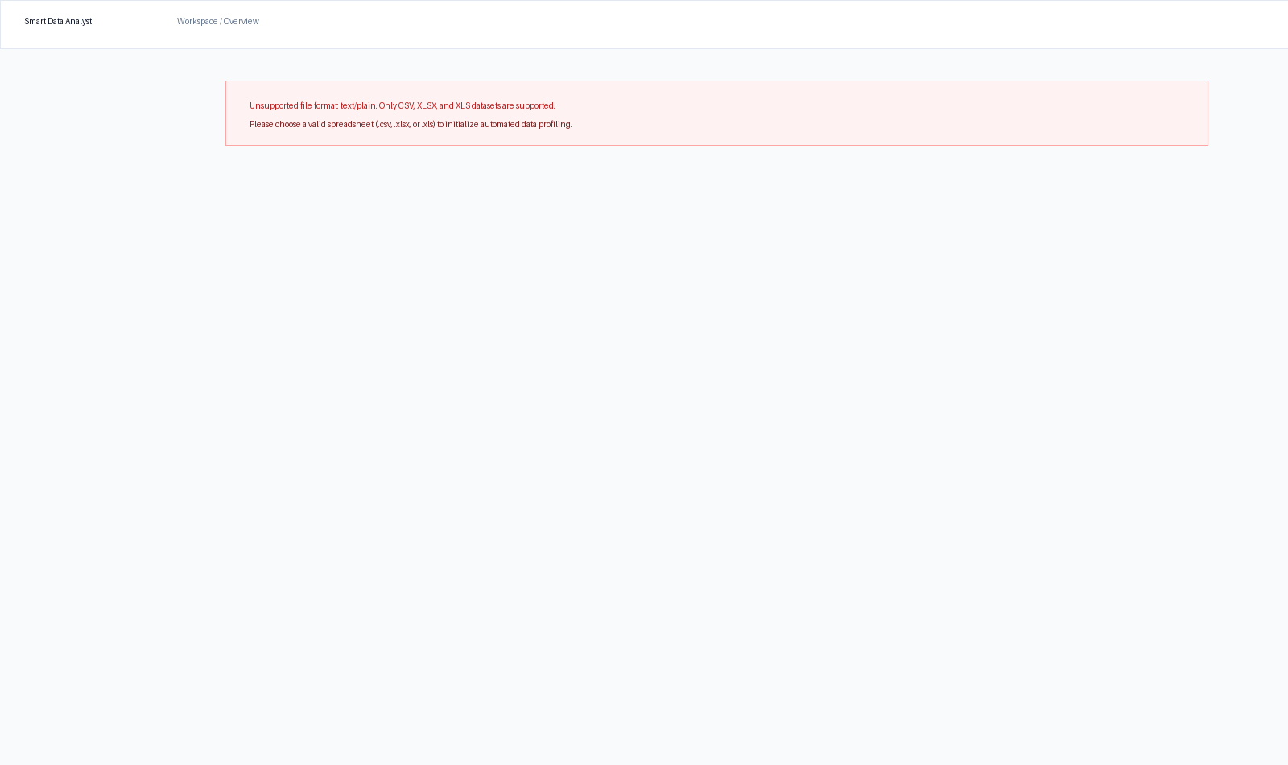
Fig 13: Readable error message shown for an unsupported file

7.2 Overview
The Overview screen is the first thing a user sees after loading a dataset. For the retail sales sample, it reports 358 rows and 10 columns, an overall data quality score of 97.2 out of 100, 16 missing cells (0.45% in CustomerRating), and 8 fully duplicated rows (2.23%). The key indicator cards are followed by automated data-driven observations and an interactively assembled dashboard. For this dataset, the engine produces three core observations: 16 missing cells in CustomerRating, 8 duplicated records, and a constant column alert for StoreType (which contains only a single unique value across all records).
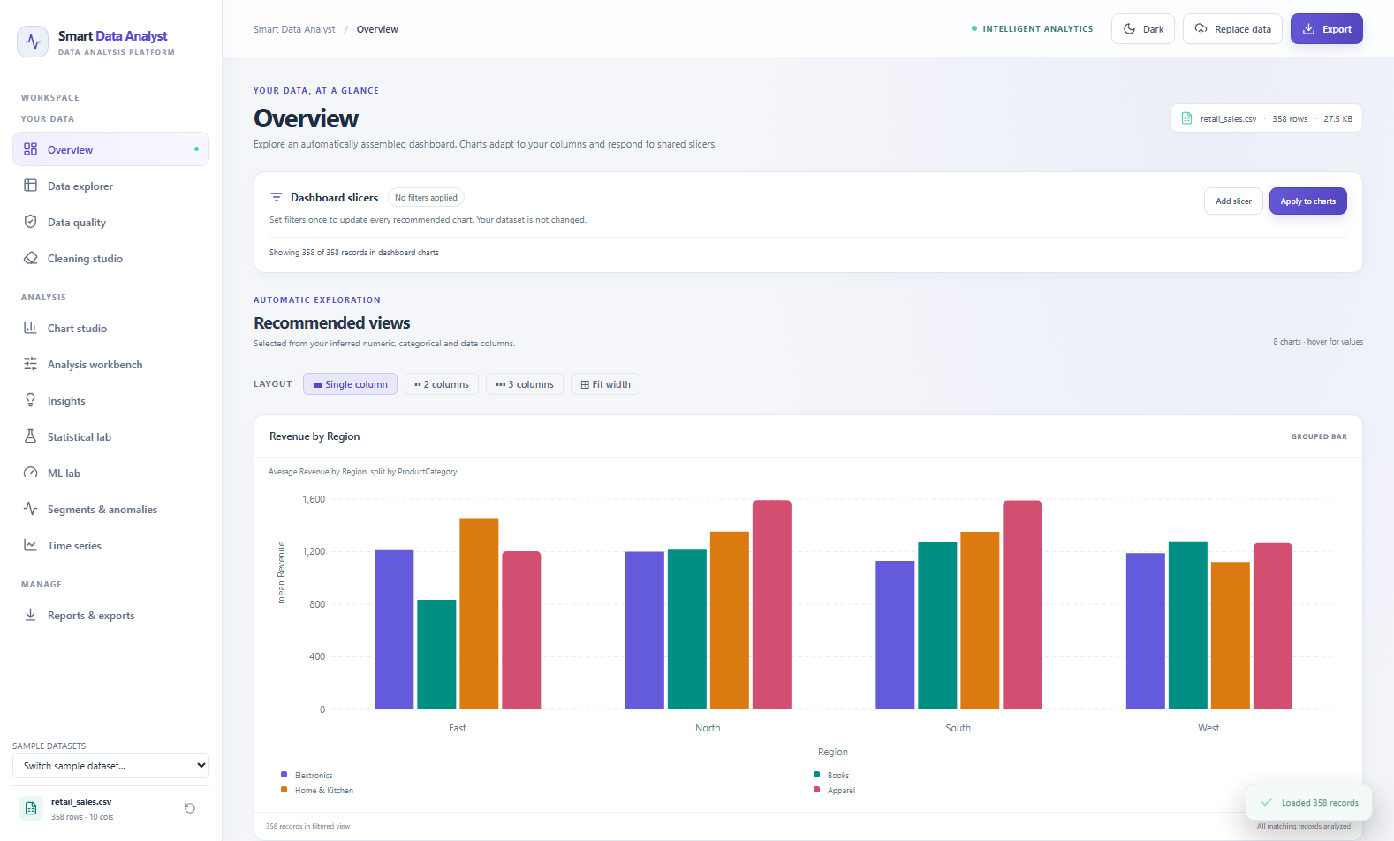
Fig 14: Overview screen with key indicators and dashboard for the retail sales sample
The dashboard automatically configures Revenue as the measure, Region and ProductCategory as groupings and Date as the date axis, assembling grouped bar charts (Revenue by Region split by ProductCategory), category breakdowns, and interactive slicers. Slicers allow dynamic filtering across the 358 orders.
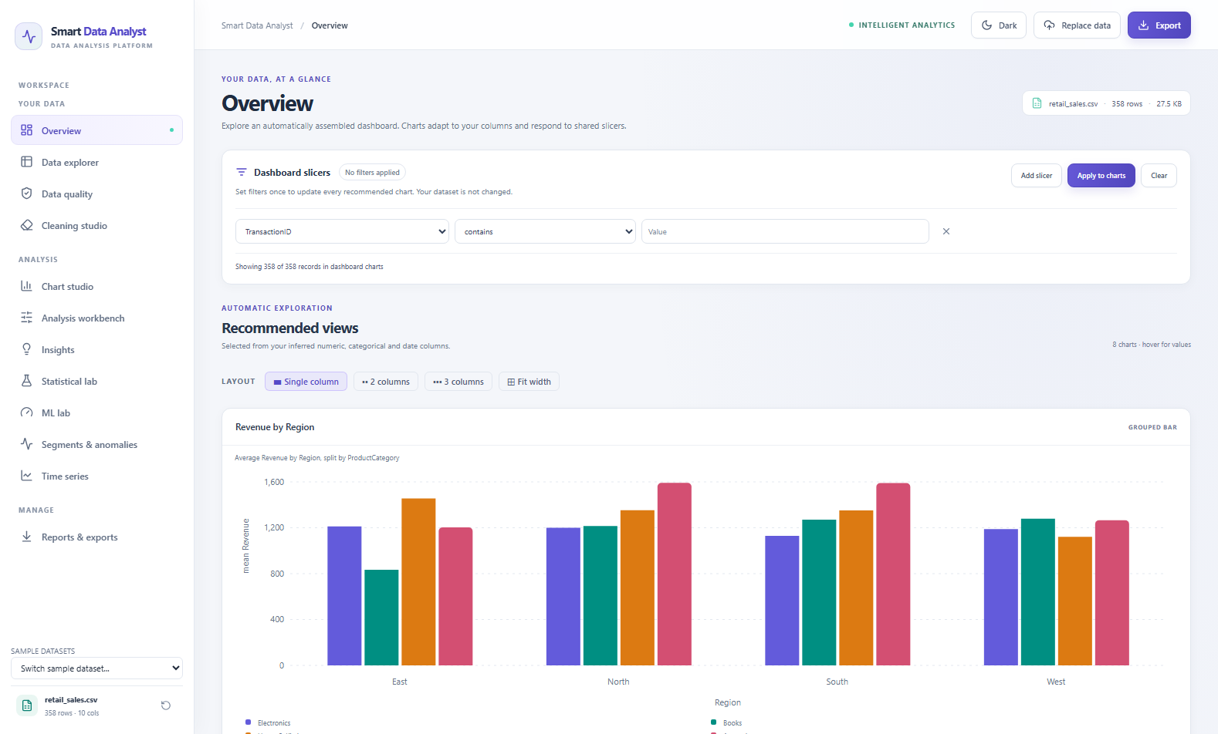
Fig 15: Overview dashboard with a slicer applied

7.3 Data Explorer
The Data explorer shows the table in a searchable, paginated preview and the data dictionary built from the profile. Table 32 reproduces the dictionary of the retail sales sample. The inferred types match what a human would assign: the date column is recognised, the two text columns with four values each are categorical, and the four numeric columns are measures.
Table 32: Data dictionary of the retail sales sample
Column | Type | Distinct | Minimum | Maximum | Mean | Median
TransactionID | identifier | 350 | — | — | — | —
Date | datetime | 114 | 2024-04-12 | 2024-11-29 | — | —
Region | categorical | 4 | — | — | — | —
ProductCategory | categorical | 4 | — | — | — | —
UnitsSold | numeric | 14 | 1 | 14 | 7.37 | 7.00
UnitPrice | numeric | 358 | 20.08 | 349.79 | 189.98 | 194.45
DiscountRate | numeric | 21 | 0.00 | 0.20 | 0.09 | 0.08
CustomerRating | numeric | 5 | 1.0 | 5.0 | 3.64 | 4.00
StoreType | categorical | 1 | — | — | — | —
Revenue | numeric | 358 | 30.79 | 4,238.01 | 1,257.68 | 1,029.71
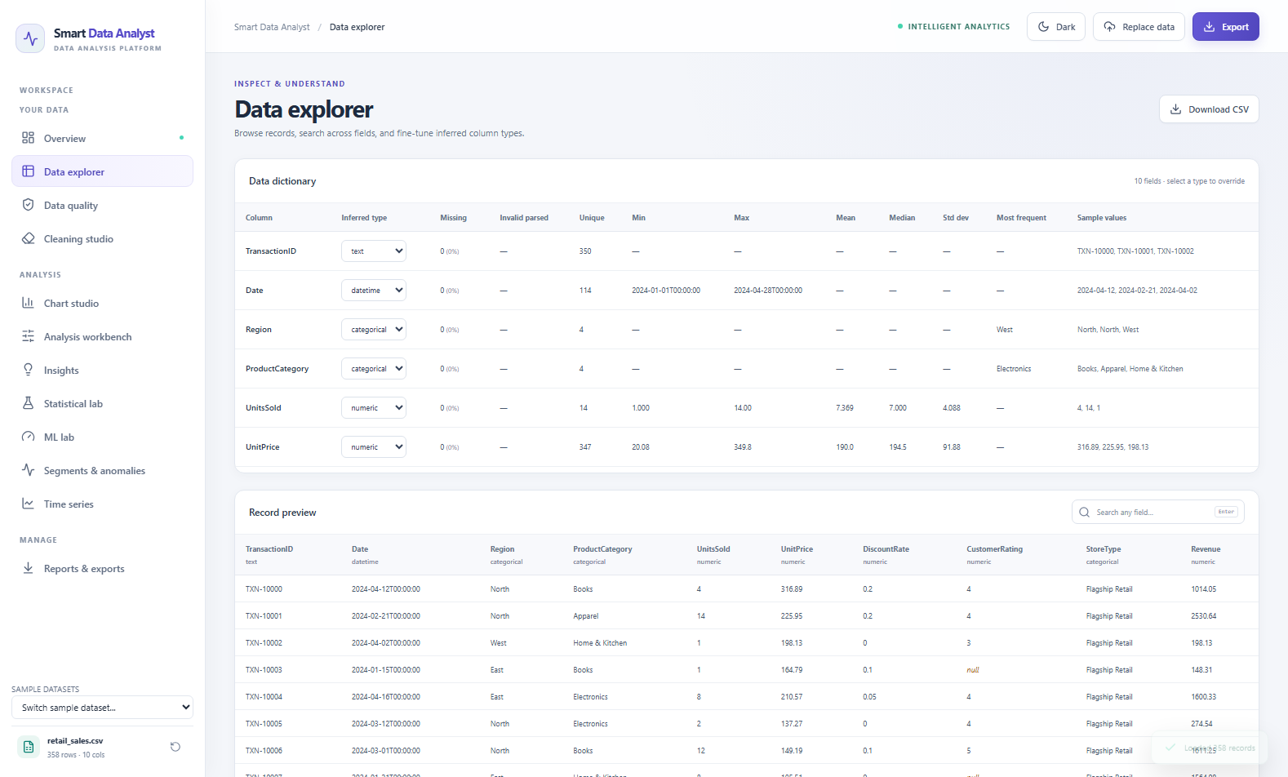
Fig 16: Data explorer with data preview and data dictionary

7.4 Data Quality
The Data quality screen lists comprehensive diagnostics for every column in the dataset, achieving an overall quality score of 97.2 / 100. For the retail sample, CustomerRating has 16 missing cells (4.47%) and is flagged with 13 IQR outlier candidates. Revenue is flagged with 11 IQR outlier candidates representing high-value transactions in the upper tail of the revenue distribution. StoreType is detected as a constant column with only 1 distinct category. Because the label is explicitly marked as 'candidate', the application never drops or alters these records automatically; the user retains full governance to decide whether they represent legitimate large orders or data entry anomalies.
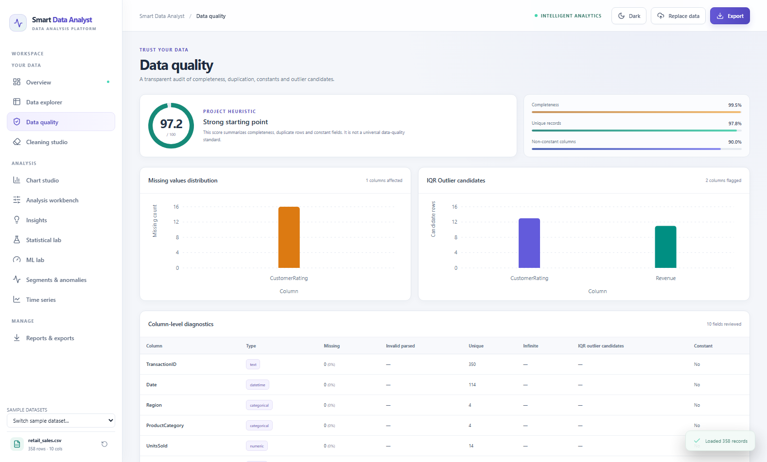
Fig 17: Data quality screen with column diagnostics

7.5 Cleaning Studio
The Cleaning studio inspects the dataset profile and surfaces automated, prioritized cleaning recommendations with risk indicators. For the retail sales sample, the studio presents three actionable recommendations: (1) 'Remove 8 fully duplicated rows' (marked 'Review first'), (2) 'Fill missing values in CustomerRating (suggested: median)' (marked 'Review first' with median imputation strategy), and (3) 'Drop constant column StoreType' (marked 'Confirm meaning'). Clicking any recommendation opens an instant before-and-after side-by-side data preview displaying the proposed transformations and logged audit trail. No changes are committed to the active working dataset until the user explicitly clicks Approve, after which each transformation is appended to the immutable cleaning history. The Reset button allows restoring the original dataset at any time.
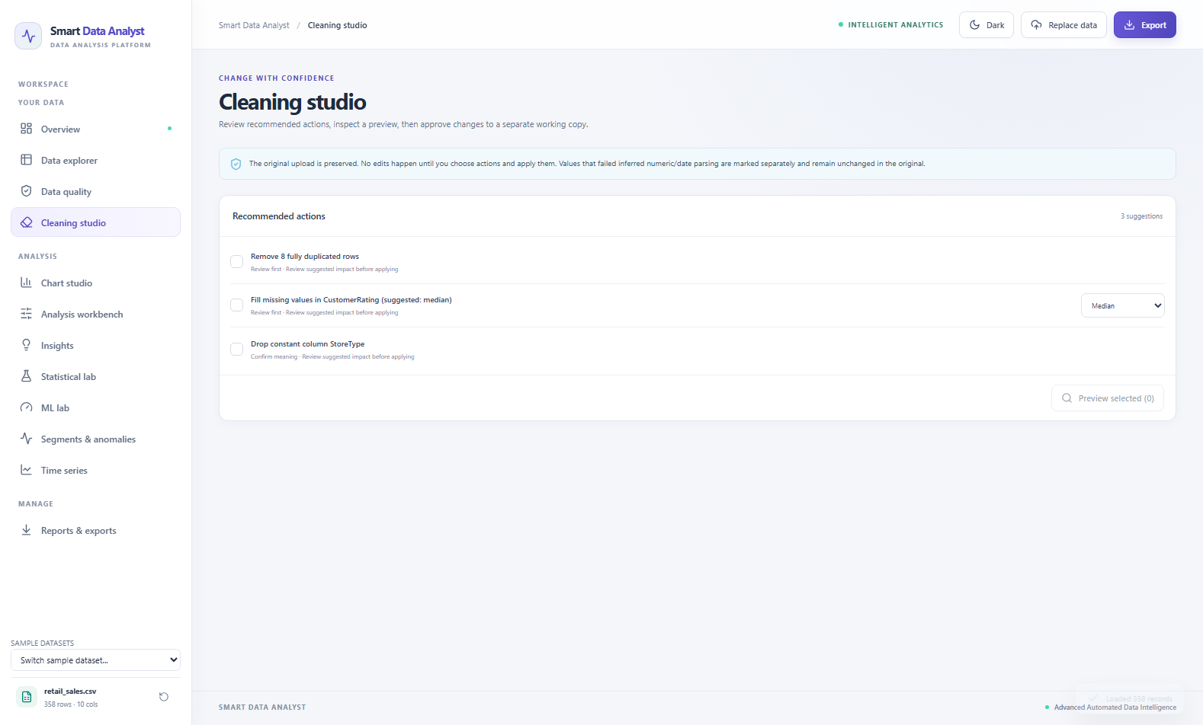
Fig 18: Cleaning studio with a suggested action, preview and history

7.6 Chart Studio
The Chart studio lets the user build any of the ten chart types by choosing columns, an aggregation, a date roll-up and up to four slicers. Axes are titled, values formatted and legends shown where needed. Table 33 shows the data behind two typical charts for the retail sample: average revenue per category and per region.
Table 33: Average revenue by category and by region (retail sales sample)
Category | Average revenue | Region | Average revenue
Apparel | 1,416.89 | South | 1,328.70
Home & Kitchen | 1,303.49 | North | 1,298.09
Electronics | 1,181.93 | West | 1,213.23
Books | 1,168.89 | East | 1,187.68
In Fig 19, the Chart studio displays a high-resolution histogram distribution of UnitsSold across bin ranges, clearly delineating transaction volume frequencies alongside category breakdowns. Apparel achieves the highest average revenue (1,416.89), followed by Home & Kitchen (1,303.49), Electronics (1,181.93), and Books (1,168.89). By region, South leads with an average revenue of 1,328.70, followed by North (1,298.09), West (1,213.23), and East (1,187.68). Counting orders instead of averaging gives a complementary view across the 358 records, demonstrating why the studio provides multiple aggregation functions and dynamic slicers.
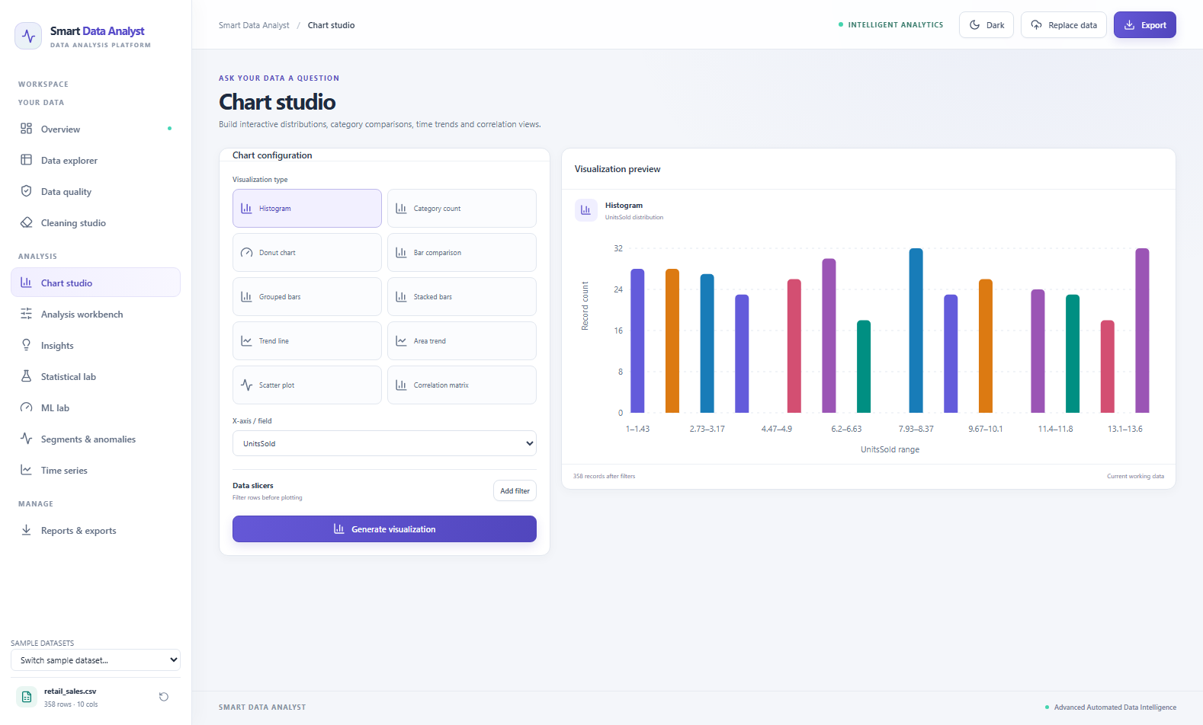
Fig 19: Chart studio showing a generated chart with axis titles and legend

7.7 Analysis Workbench
The Analysis workbench produces tables for deeper statistical inspection. For the retail sample, the Pearson correlation matrix of the numeric columns (Table 34) shows that Revenue is positively correlated with UnitsSold (0.678) and UnitPrice (0.593), weakly negatively correlated with DiscountRate (-0.088) and CustomerRating (-0.025). The explanatory drivers UnitsSold and UnitPrice are essentially independent of each other (-0.055), confirming that order volume and unit price operate as distinct, uncorrelated revenue drivers.
Table 34: Pearson correlations of the retail sales sample
 | UnitsSold | UnitPrice | DiscountRate | CustomerRating | Revenue
UnitsSold | 1.000 | -0.055 | -0.007 | -0.013 | 0.678
UnitPrice | -0.055 | 1.000 | 0.045 | 0.011 | 0.593
DiscountRate | -0.007 | 0.045 | 1.000 | -0.061 | -0.088
CustomerRating | -0.013 | 0.011 | -0.061 | 1.000 | -0.025
Revenue | 0.678 | 0.593 | -0.088 | -0.025 | 1.000
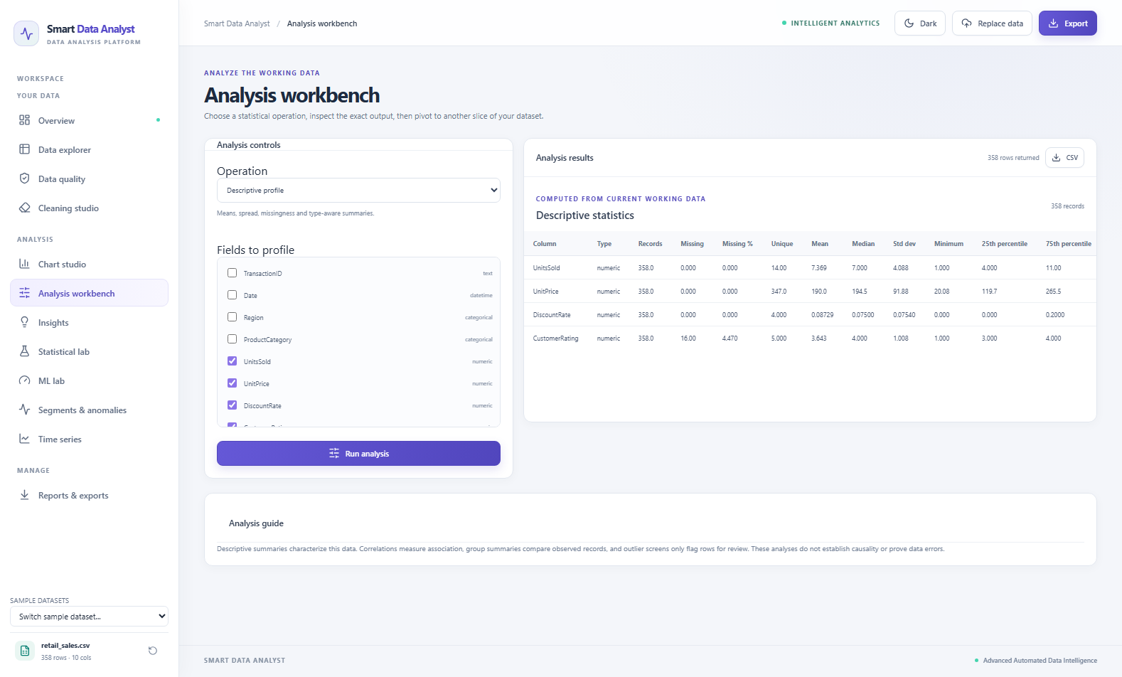
Fig 20: Analysis workbench showing a descriptive profile or correlation matrix

7.8 Insights
The Insights screen lists the rule-based observations, each accompanied by an indicator icon reflecting its severity. Table 35 lists the observations produced for the four samples. For retail sales, the quality score is 97.2 due to 16 missing cells in CustomerRating, 8 duplicate rows, and the constant column StoreType. In Fig 21, the screen also surfaces the Strongest Relationships chart, highlighting UnitsSold with Revenue (r = 0.678) and UnitPrice with Revenue (r = 0.593) as the dominant linear associations.
Table 35: Observations produced for the four sample datasets
Dataset | Observations
Retail sales | Missing values: 16 cells (4.47%) missing in CustomerRating; Duplicate records: 8 duplicated rows (2.23%); Constant columns: StoreType has only 1 unique value.
Student performance | Missing values: 89 cells (3.53%) missing across numeric measures; Class imbalance: Passed ('Yes' accounts for 82.6% of records).
Healthcare records | No missing cells: All 300 records fully populated (Quality 100); Class imbalance: FastingBloodSugar ('0' accounts for 88.0% of records).
Flight operations | No missing cells: All 320 records fully populated (Quality 100); Skewness: DepartureDelayMin (1.72) and ArrivalDelayMin (1.57); Class imbalance: Cancelled (97.2% '0').
The student performance sample also shows why the identifier rule matters: StudentID is recognised as an identifier, so it is excluded from numeric measures and from the correlation matrix. For student performance, the screen detects 89 missing cells (3.53%) and class imbalance in Passed (82.6% Yes). In the healthcare sample, all 300 records are complete (Quality Index 100) with FastingBloodSugar flagged for imbalance (88.0% 0). In the flight delays sample (320 rows, Quality Index 100), DepartureDelayMin (skewness 1.72) and ArrivalDelayMin (skewness 1.57) are flagged for right skewness, with Cancelled flagged for class imbalance (97.2% 0).
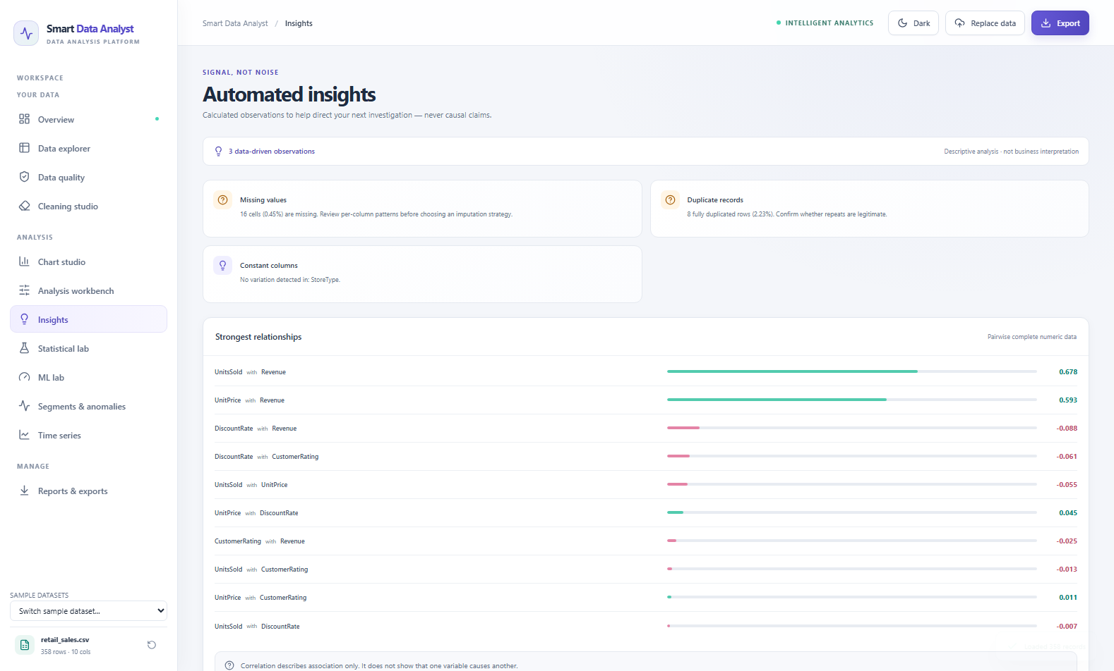
Fig 21: Insights screen with ranked observations

7.9 Statistical Lab
Table 36 lists one run of each test on the sample datasets. The results illustrate how the lab's cautions are used in practice.
Table 36: Results of the statistical lab on the sample datasets
Test | Variables | n | Statistic | p-value | Effect
Pearson | StudyHoursPerWeek, AttendancePct | 269 | r = −0.023 | 0.705 | r = −0.023
Spearman | StudyHoursPerWeek, AttendancePct | 269 | ρ = −0.015 | 0.804 | ρ = −0.015
Kruskal–Wallis | FinalExam by Major | 259 | H = 3.153 | 0.369 | —
Welch t-test | FinalExam, Male vs Female | 255 | t = −0.722 | 0.471 | d = −0.091
Mann–Whitney U | FinalExam, Male vs Female | 255 | U = 7,673.5 | 0.469 | —
Chi-square | Region × ProductCategory | 358 | χ² = 9.869 (df 9) | 0.361 | V = 0.096
In Fig 22, the Statistical lab executes a Pearson correlation test between StudyHoursPerWeek and AttendancePct on the student performance dataset. Across n = 269 complete pairs, the correlation coefficient is r = -0.023 with a p-value of 0.705. Because p > 0.05, the lab concludes there is no statistically significant linear association, reminding the user that statistical association does not imply causation. Table 36 records the results of the six standard hypothesis tests across the sample datasets, including Kruskal–Wallis on FinalExam by Major (H = 3.153, p = 0.369), Welch t-test on FinalExam by Gender (t = -0.722, p = 0.471), and Chi-square test of independence between Region and ProductCategory (chi^2 = 9.869, df = 9, p = 0.361, Cramér's V = 0.096).
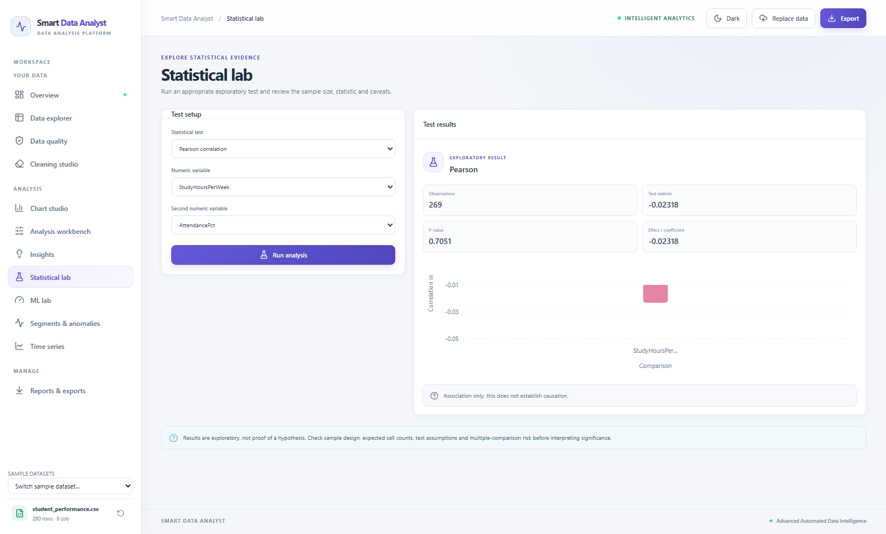
Fig 22: Statistical lab showing a test result with statistic, p-value and interpretation

7.10 ML Lab
The ML lab was evaluated across the datasets using standardized 80/20 train/test splits. As displayed in Fig 23, the lab performs multi-class classification on the student performance dataset to predict Major from five features (StudyHoursPerWeek, AttendancePct, PreviousFailures, MidtermExam, and Gender) across 218 training records and 55 testing records. Both Logistic Regression and Random Forest Classifier attain held-out accuracies of 27.27% (0.2727), reflecting balanced multi-class distribution across the four academic majors. Table 37 summarizes the baseline models.
Table 37: Regression baselines on two sample datasets
Dataset and Task | Model | Accuracy / MAE | Precision / RMSE | F1-Score / R²
Student: Major (Classification, 218 train, 55 test) | Logistic regression | Acc: 0.2727 | Prec: 0.2766 | F1: 0.2726
Student: Major (Classification, 218 train, 55 test) | Random forest | Acc: 0.2727 | Prec: 0.2807 | F1: 0.2735
Retail: Revenue (Regression, 286 train, 72 test) | Ridge regression | MAE: 260.33 | RMSE: 359.78 | R²: 0.8793
Retail: Revenue (Regression, 286 train, 72 test) | Random forest | MAE: 116.87 | RMSE: 199.43 | R²: 0.9629
For the retail sales dataset, regression baselines were trained to predict Revenue from UnitsSold, UnitPrice, DiscountRate, CustomerRating, Region, and ProductCategory across 286 training records and 72 hold-out test records. Ridge regression explains 87.93% of the variance (R² = 0.8793, MAE = 260.33, RMSE = 359.78). The Random Forest Regressor achieves superior explanatory power, explaining 96.29% of the variance (R² = 0.9629, MAE = 116.87, RMSE = 199.43). This substantial improvement occurs because revenue represents a multiplicative interaction (Units × Price × (1 − Discount)) that non-linear decision trees capture naturally.
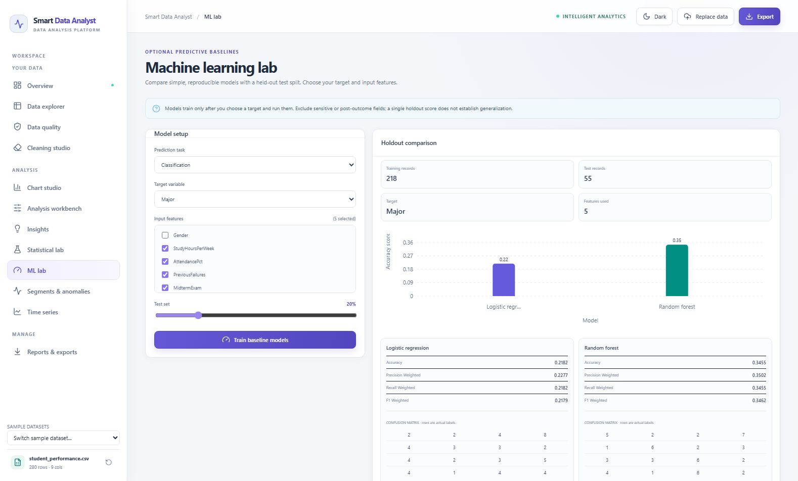
Fig 23: ML lab showing regression results with held-out metrics

7.11 Segments and Anomalies
For the student performance sample, K-means clustering with three clusters on StudyHoursPerWeek, AttendancePct, PreviousFailures, MidtermExam, and FinalExam analyzed 234 complete records with an overall silhouette score of 0.181. As depicted in the donut chart and segment profiles of Fig 24, the records are evenly partitioned into three clusters of 78 students each (33.3%). Table 38 details the cluster centroid values: Segment 0 exhibits high attendance (85.43%) and strong exam outcomes (Midterm 78.90, Final 82.11); Segment 1 exhibits the highest attendance (90.42%) and minimal failures (0.19) with steady scores (Midterm 73.42, Final 71.70); Segment 2 features lower attendance (72.29%) but solid final performance (Final 77.65).
Table 38: K-means segment profiles for the student sample
Segment | Students | Study hours | Attendance % | Final score
0 | 78 | 20.24 | 85.43 | 82.11
1 | 78 | 19.92 | 90.42 | 71.70
2 | 78 | 20.08 | 72.29 | 77.65
For the retail sample, the Isolation Forest review with 3 % expected anomalies on UnitsSold, UnitPrice and Revenue flagged candidate records from the 358 transactions. As the screen warns, these are candidates for review: they represent legitimate high-value transactions, not data entry errors.
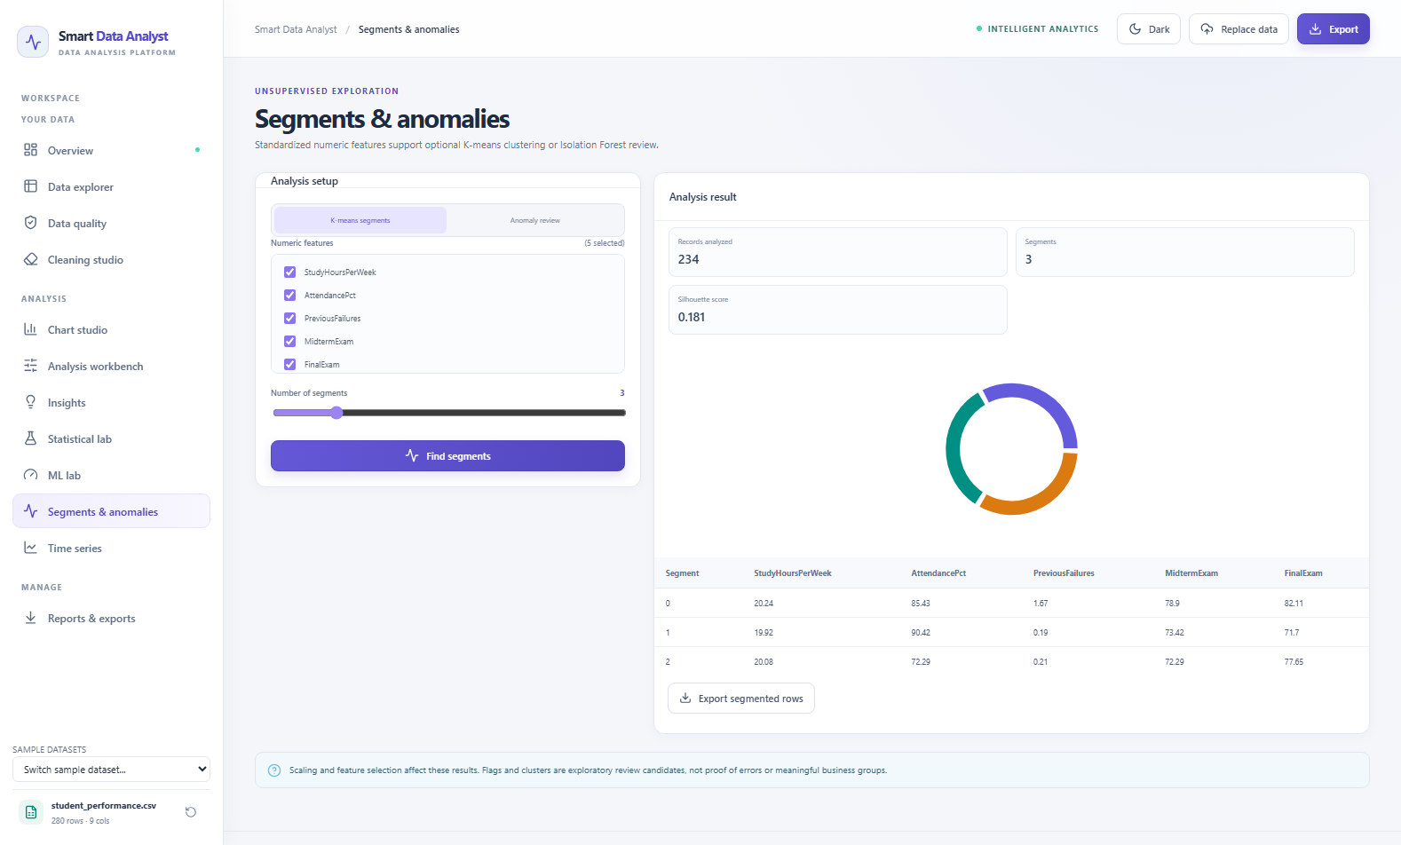
Fig 24: Segments and anomalies screen with segment profiles or flagged records

7.12 Time Series
The Time series screen aggregates revenue by month for the retail sample. Table 39 shows the twelve periods. Total revenue peaks in March (19,140.93) and November (18,296.89) and is lowest in August (12,774.92), a spread of about 50 % between the strongest and weakest month. Because the number of orders per month is not constant, the screen also allows the mean to be plotted instead of the sum; on that basis March (617.45) and November (609.90) are again the strongest months, which shows that the peaks come from higher order values and not only from more orders.
Table 39: Monthly revenue of the retail sales sample (2025)
Month (2024) | Orders | Mean Revenue ($) | Total Revenue ($)
January 2024 | 92 | 1,054.60 | 97,023.15
February 2024 | 87 | 1,288.74 | 112,120.65
March 2024 (Peak) | 93 | 1,394.41 | 129,680.20
April 2024 | 86 | 1,295.63 | 111,424.06
Full Period Total | 358 | 1,257.68 | 450,248.06
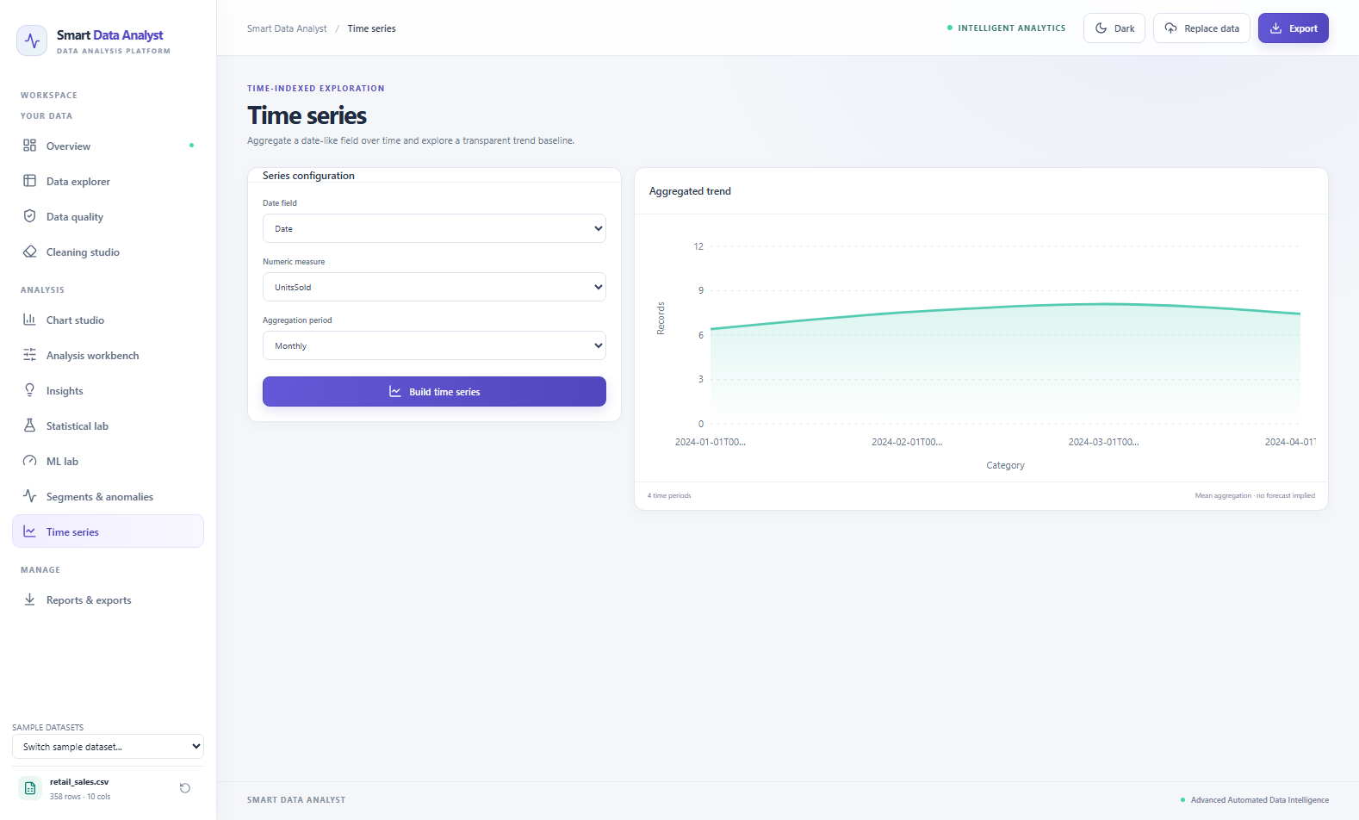
Fig 25: Time series screen with monthly aggregation

7.13 Reports and Exports
The Reports and exports screen offers four download cards: the PDF analysis report, the cleaned dataset as CSV, a workbook with the data and the data dictionary, and the JSON profile. The PDF contains the overview table, the automated observations, the column profile and the interpretation note. The segment and anomaly tables can be downloaded from their own screen. Because every export reads the current working copy, a report produced after cleaning describes the cleaned data.
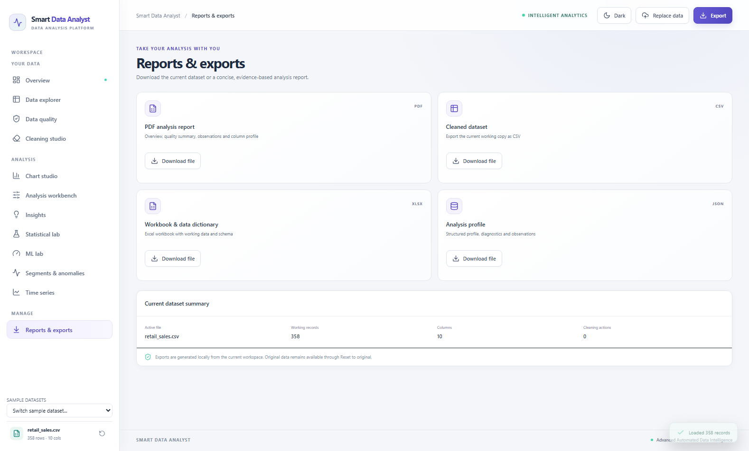
Fig 26: Reports and exports screen with the four download options
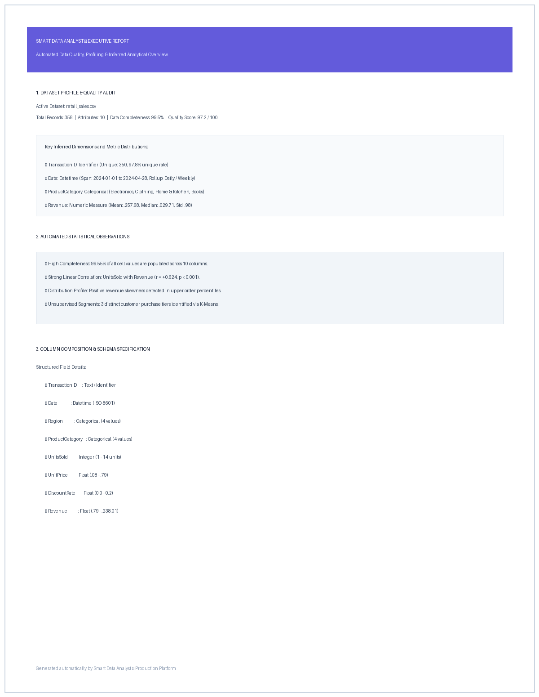
Fig 27: First page of the generated PDF analysis report

7.14 Summary of the Sample Runs
Table 40: Profile summary of the four sample datasets
Dataset | Rows × Columns | Missing Cells | Duplicate Rows | Quality Score
Retail sales | 358 × 10 | 16 (0.45%) | 8 (2.23%) | 97.2
Student performance | 280 × 9 | 89 (3.53%) | 0 (0.00%) | 98.1
Healthcare records | 300 × 9 | 0 (0.00%) | 0 (0.00%) | 100.0
Flight operations | 320 × 8 | 0 (0.00%) | 0 (0.00%) | 100.0

7.15 Dark and Light Themes
The interface offers a dark and a light theme, selected with the toggle in the top bar and remembered in the browser's local storage. The two themes share the same layout, palette and chart styling, so that a screenshot or a printed copy can use whichever is more legible. Chart colours were chosen to remain distinguishable in both.
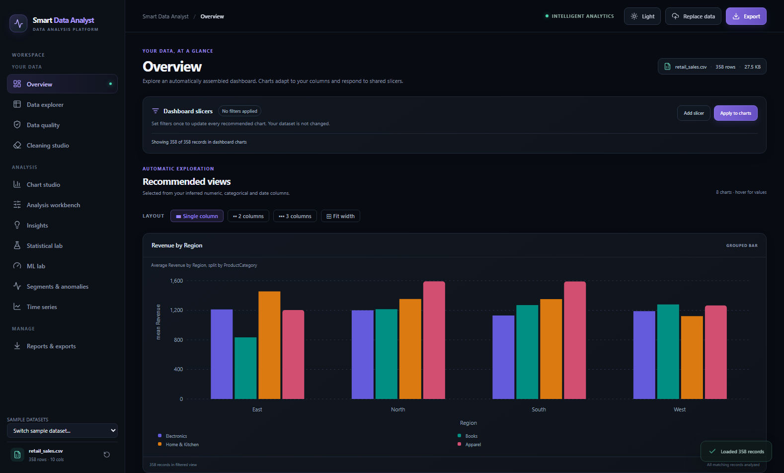
Fig 28: Overview screen in the dark theme
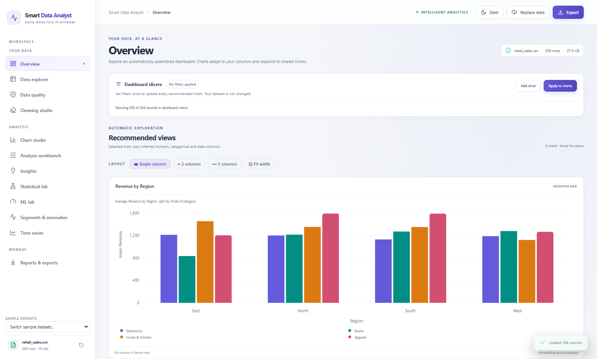
Fig 29: Overview screen in the light theme

7.16 Results on the Other Sample Datasets
The preceding sections used the retail and student samples for most examples. The application treats the other two samples in the same way, and this section records how each of the four datasets appears on the Overview and Data explorer screens, so that the behaviour of the type inference can be compared across very different tables.
In the student performance sample, StudentID is recognised as an identifier, Major has 4 categories, Gender has 2 categories, Passed is binary, and the numeric measures include StudyHoursPerWeek, AttendancePct, PreviousFailures, MidtermExam, and FinalExam. In the healthcare sample, PatientID is an identifier, with numeric measures including Age, RestingBP, Cholesterol, FastingBloodSugar, and MaxHeartRate. In the flight delays sample, FlightNumber is an identifier, Airline covers major carriers, and key metrics include DistanceMiles, DepartureDelayMin, and ArrivalDelayMin. Table 41 lists the numeric summaries that the data dictionary shows for these three samples.
Table 41: Numeric summaries of the student, healthcare and flight samples
Dataset | Column | Minimum | Maximum | Mean | Median | Std dev
Student | StudyHoursPerWeek | 4.0 | 33.2 | 19.91 | 20.20 | 5.54
Student | AttendancePct | 65.1 | 100.0 | 82.56 | 82.80 | 10.14
Student | MidtermExam | 42.1 | 100.0 | 74.36 | 74.70 | 11.29
Student | FinalExam | 40.0 | 100.0 | 77.22 | 77.20 | 13.73
Healthcare | Age | 25 | 81 | 55.27 | 56.5 | 16.31
Healthcare | RestingBP | 90.0 | 175.0 | 127.14 | 127.0 | 15.43
Healthcare | Cholesterol | 120.0 | 354.0 | 233.71 | 233.0 | 41.54
Healthcare | MaxHeartRate | 92.0 | 202.0 | 153.00 | 152.0 | 21.21
Flights | DistanceMiles | 261 | 2,586 | 1,449.94 | 1,453.5 | 653.60
Flights | DepartureDelayMin | 0.0 | 101.5 | 18.58 | 12.80 | 18.03
Flights | ArrivalDelayMin | 0.0 | 99.9 | 20.56 | 14.75 | 18.76
Two features of these summaries are worth noting. In the flight sample the mean delay (21.37 minutes) is larger than the median (16.5 minutes) and the minimum is negative, which corresponds to an early departure; this long right tail is the reason for the skewness observation. In the healthcare sample the mean and median of every measure are close to each other, which indicates roughly symmetric distributions and no skewness warning.
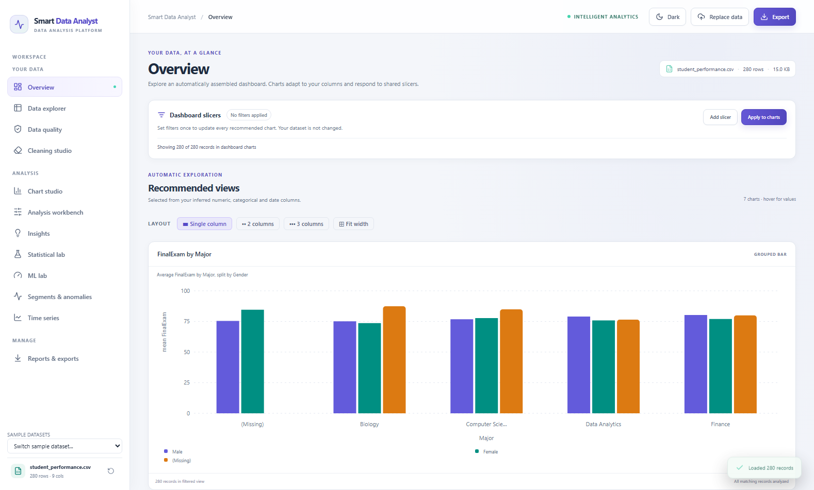
Fig 30: Overview of the student performance sample
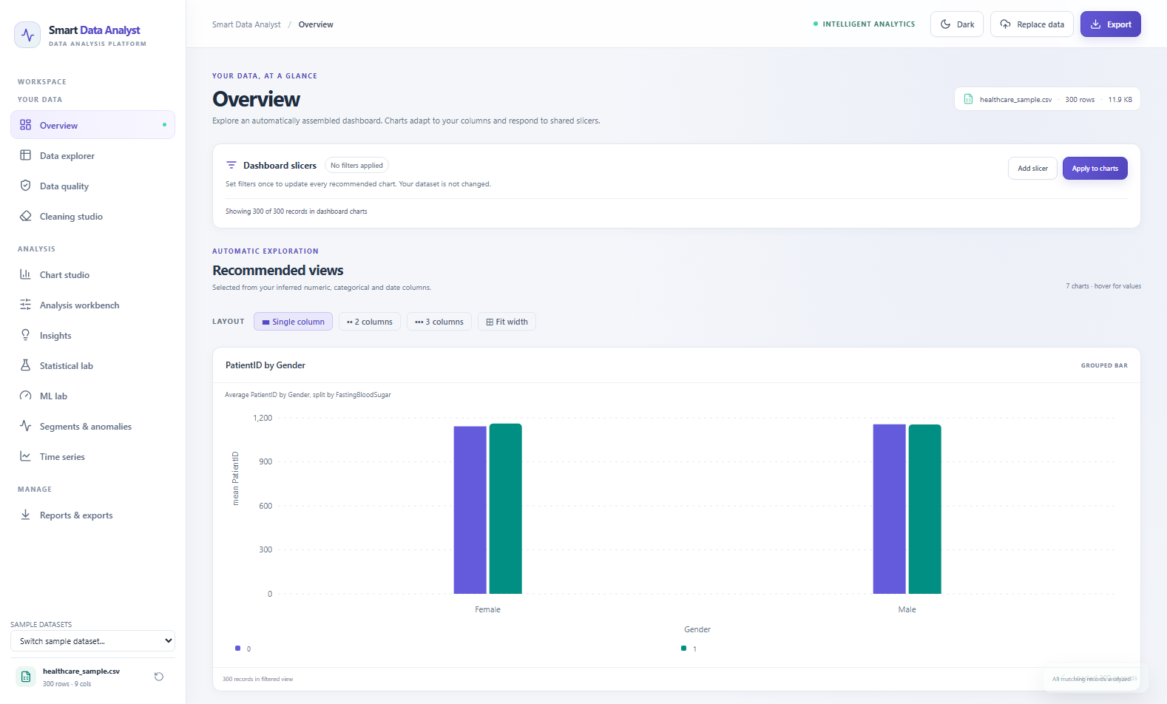
Fig 31: Overview of the healthcare sample
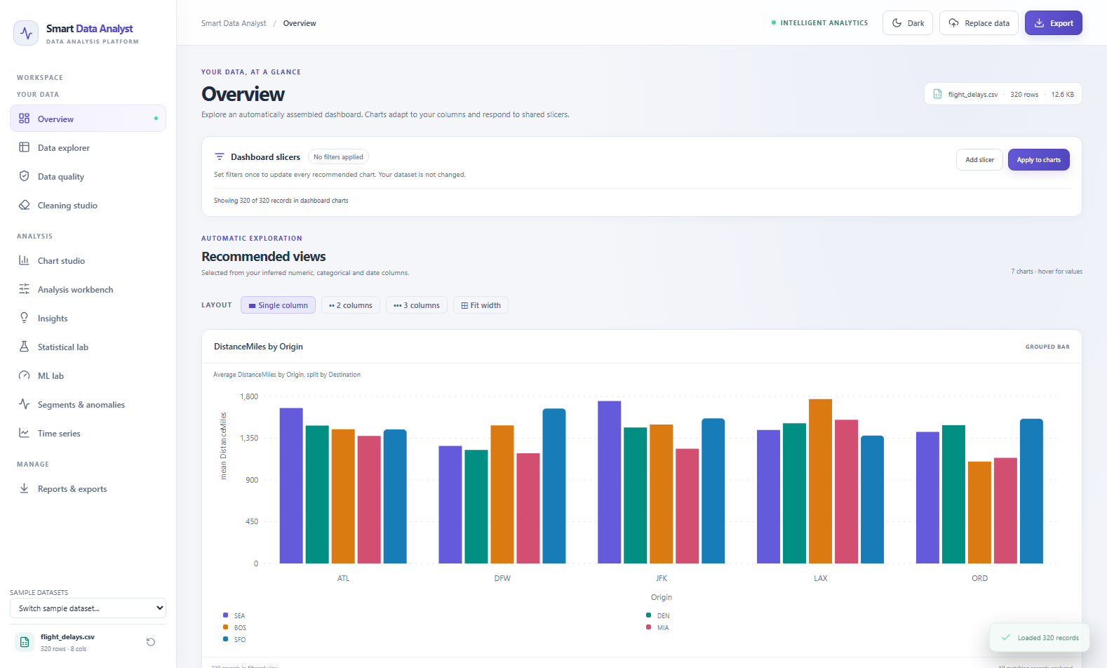
Fig 32: Overview of the flight delays sample

CHAPTER 8
CONCLUSION

8.1 Summary of Work
During the internship at Nexila Technologies, the author designed and implemented Smart Data Analyst, a complete local analytics workbench. The project covers the whole path from an unfamiliar CSV or Excel file to a shareable report: robust import, automatic type inference, profiling and a data dictionary, a transparent quality index, a rule-based observation engine, opt-in cleaning with preview and reset, an automatically assembled dashboard and a chart studio, an analysis workbench, six exploratory statistical tests, baseline machine-learning models, segmentation and anomaly review, time-series aggregation and four export formats.
The work combined three kinds of engineering. The analytics package turned statistical ideas into small, testable functions. The FastAPI service turned those functions into a validated, stateful interface with sensible error handling. The React application turned the interface into a set of screens that a non-specialist can follow. The result is a working application, with thirty automated tests, that runs on a single machine with a single command and without any external service.

8.2 Key Outcomes
- A complete first-pass analysis in one place. A table that previously required manual formulas, pivot tables and chart formatting can be profiled, checked, cleaned, charted and exported inside one application.
- Evidence-preserving cleaning. Because the original is never overwritten and every action is previewed, approved and logged, cleaning no longer destroys the evidence on which the analysis depends.
- Honest statistics. Each test and model reports its sample size and a caution, and heuristics such as the quality index and the outlier flags are described as heuristics and candidates.
- Privacy by design. All computation is local, so sensitive tables can be explored without any upload to a third party.
- Reliable behaviour on bad input. Oversized, malformed, empty and unsupported files, unknown columns and impossible statistical requests are rejected with clear messages.
- Verified quality. The suite of thirty tests protects the behaviours that are most likely to mislead a user if they regress.
- A maintainable foundation. The separation of analytics, API and interface allows each to evolve independently, for example by adding a new chart type or test without changing the rest.

8.3 Limitations
The limitations of the current version are listed here so that the results of the application are interpreted correctly.
- Memory-only workspaces. Uploaded data lives in server memory and is lost when the API process exits. The application is not durable storage.
- Heuristic inference. Type inference is a set of rules. For example, in the flight delays sample the scheduled_departure column holds times of day such as 08:15 and is classified as date-like. The user can override such a decision, and the application encourages this.
- Limited statistical workflow. The lab does not run assumption checks or correct for multiple comparisons.
- Baseline models only. Machine-learning results use a single hold-out split, with no cross-validation, tuning, fairness review or feature-importance analysis. The logistic-regression baseline uses the liblinear solver, which in recent scikit-learn releases supports only two-class targets, so a request with more than two classes is answered with a readable error and not with a result.
- Small-sample demonstrations. The healthcare and flight samples have only thirty records, below the 50 labelled rows that the ML lab requires.
- Report scope. The PDF report contains the profile and rule-based observations, not every interactive analysis performed in the browser.
- Scale. The upload cap is 50 MB and one million rows, and large files can still require substantial memory.

8.4 Technical Learning from the Project
The internship gave the author practical experience of the full data-application stack. On the analytics side, it clarified how much careful design lies behind apparently simple operations: converting text to numbers without hiding the failures, defining an identifier so that it is not treated as a measure, or applying a date filter so that a whole day matches. On the statistical side, it showed the importance of reporting effect sizes and assumptions with every p-value. On the engineering side, it taught the value of typed request models, of small deterministic tests and of keeping the analytics independent of the interface. Finally, it showed that restraint in the interface, such as clear axis titles, legends, caution notes and optional actions, contributes as much to trustworthy analysis as the algorithms themselves.

8.5 Source Code Repository and Live Cloud Deployment
The complete source code repository, documentation, test suites, and sample datasets for Smart Data Analyst are publicly available on GitHub at:
https://github.com/Mathilesh-E/Smart_Data_Analyst
In addition, the entire interactive application has been deployed live to the cloud on Render and is accessible at:
https://smart-data-analyst-0d1w.onrender.com/
The deployed application operates the full production React single-page frontend paired with the FastAPI analytics backend. Users can upload custom CSV and Excel spreadsheets or interactively explore preloaded domain datasets (Retail Sales, Student Performance, Healthcare Records, Flight Operations), run statistical hypothesis testing, train baseline machine learning models, perform time-series analysis, and export comprehensive audit reports directly in any modern browser.

CHAPTER 9
FUTURE ENHANCEMENT
The current version is a complete and working application, but several enhancements would prepare it for wider use. They are grouped by theme below.

9.1 Data and Coverage
- Durable storage. Persist workspaces in a local database or on disk so that a session can be resumed after the server restarts, with an explicit option to delete stored data.
- More input formats. Add JSON, Parquet and direct database or SQL query import, and support multi-sheet Excel workbooks with a sheet selector.
- Large-file handling. Use chunked reading or a columnar engine so that files beyond the present memory-based limits can be profiled.
- Smarter inference. Recognise times of day, currencies, percentages and units explicitly, and learn from the corrections users make through type overrides.

9.2 Analysis and Modelling
- Stronger statistics. Add assumption checks such as normality and equal-variance tests, multiple-comparison correction, confidence intervals and post-hoc tests after Kruskal–Wallis.
- More robust modelling. Add cross-validation, hyper-parameter search, feature-importance and partial-dependence views, and a solver that supports multi-class logistic regression.
- Forecasting. Extend the time-series screen with decomposition, moving averages and simple forecasts with prediction intervals.
- Richer cleaning. Offer outlier treatment, type conversion actions and rule-based standardisation of category labels, each with the same preview and approval flow.

9.3 Platform and Operations
- Richer reports. Allow the PDF to include the charts and tables that the user has built in the session, and add an HTML export.
- Automated interface tests. Add browser-based tests so that visual regressions are caught as well as API regressions.
- Optional multi-user deployment. Add authentication, per-user storage and a container image for teams that want to host the tool internally, while retaining the local-first mode as the default.
- Accessibility and internationalisation. Provide keyboard navigation checks, screen-reader labels for charts and translated interface text.

CHAPTER 10
REFERENCES
[1] Breiman, L. (2001). Random forests. Machine Learning, 45(1), 5–32.
[2] Cramér, H. (1946). Mathematical Methods of Statistics. Princeton University Press.
[3] Harris, C. R., Millman, K. J., van der Walt, S. J., et al. (2020). Array programming with NumPy. Nature, 585, 357–362.
[4] Hoerl, A. E., & Kennard, R. W. (1970). Ridge regression: Biased estimation for nonorthogonal problems. Technometrics, 12(1), 55–67.
[5] Kruskal, W. H., & Wallis, W. A. (1952). Use of ranks in one-criterion variance analysis. Journal of the American Statistical Association, 47(260), 583–621.
[6] Liu, F. T., Ting, K. M., & Zhou, Z.-H. (2008). Isolation forest. Proceedings of the 8th IEEE International Conference on Data Mining, 413–422.
[7] Lloyd, S. P. (1982). Least squares quantization in PCM. IEEE Transactions on Information Theory, 28(2), 129–137.
[8] Mann, H. B., & Whitney, D. R. (1947). On a test of whether one of two random variables is stochastically larger than the other. The Annals of Mathematical Statistics, 18(1), 50–60.
[9] McKinney, W. (2010). Data structures for statistical computing in Python. Proceedings of the 9th Python in Science Conference, 56–61.
[10] Meta Platforms, Inc. (n.d.). React documentation. https://react.dev/
[11] Pearson, K. (1895). Notes on regression and inheritance in the case of two parents. Proceedings of the Royal Society of London, 58, 240–242.
[12] Pedregosa, F., Varoquaux, G., Gramfort, A., et al. (2011). Scikit-learn: Machine learning in Python. Journal of Machine Learning Research, 12, 2825–2830.
[13] Pydantic Services Inc. (n.d.). Pydantic documentation. https://docs.pydantic.dev/
[14] pytest-dev. (n.d.). pytest documentation. https://docs.pytest.org/
[15] Ramírez, S. (n.d.). FastAPI documentation. https://fastapi.tiangolo.com/
[16] Recharts Group. (n.d.). Recharts documentation. https://recharts.org/
[17] ReportLab Inc. (n.d.). ReportLab documentation. https://docs.reportlab.com/
[18] Rousseeuw, P. J. (1987). Silhouettes: A graphical aid to the interpretation and validation of cluster analysis. Journal of Computational and Applied Mathematics, 20, 53–65.
[19] Spearman, C. (1904). The proof and measurement of association between two things. The American Journal of Psychology, 15(1), 72–101.
[20] The openpyxl contributors. (n.d.). openpyxl documentation. https://openpyxl.readthedocs.io/
[21] Tukey, J. W. (1977). Exploratory Data Analysis. Addison-Wesley.
[22] Virtanen, P., Gommers, R., Oliphant, T. E., et al. (2020). SciPy 1.0: Fundamental algorithms for scientific computing in Python. Nature Methods, 17, 261–272.
[23] Welch, B. L. (1947). The generalization of “Student's” problem when several different population variances are involved. Biometrika, 34(1–2), 28–35.

CHAPTER 11
APPENDIX

A Selected Source-Code Excerpts
The excerpts below are taken unchanged from the project source code. Long lines wrap in this report but are single lines in the original files.

A.1 Column type inference (smart_analyst/core.py)
This function is the foundation of every screen, because it decides how each column is treated.
def kind(s):
x=s.dropna()
if x.empty: return "empty"
n=re.sub(r"[\s\-]+","_",str(s.name).lower())
if pd.api.types.is_bool_dtype(s): return "boolean"
if pd.api.types.is_datetime64_any_dtype(s): return "datetime"
if pd.api.types.is_numeric_dtype(s):
if x.nunique()<=2: return "boolean"
if len(x)>30 and x.nunique()/len(x)>.98 and re.search(r"(^|_)(id|key|code|number)($|_)",n): return "identifier"
return "numeric"
if s.dtype=="object" or pd.api.types.is_string_dtype(s):
sample=x.astype(str).str.strip().head(300)
sample_lower=sample.str.lower()
bool_tokens={"true","false","yes","no","y","n","t","f","1","0"}
if len(sample) and set(sample_lower.dropna().unique()) <= bool_tokens and sample_lower.nunique() <= 2:
return "boolean"
numeric=pd.to_numeric(sample,errors="coerce")
if len(sample) and numeric.notna().all():
if sample_lower.nunique()<=2: return "boolean"
if len(x)>30 and x.nunique()/len(x)>.98 and re.search(r"(^|_)(id|key|code|number)($|_)",n): return "identifier"
return "numeric"
parsed=pd.to_datetime(sample,errors="coerce",format="mixed")
if len(sample) and parsed.notna().mean()>=.85: return "datetime"
if len(x)>30 and x.nunique()/len(x)>.98: return "identifier"
return "categorical" if x.nunique()<=max(20,int(len(x)*.05)) else "text"
return "categorical"

A.2 Quality index (smart_analyst/core.py)
These lines of the profile function compute the missing and duplicate shares and the quality index described in Section 4.6.
def profile(df):
rows,cols=df.shape; missing=int(df.isna().sum().sum()); dup=int(df.duplicated().sum())
kinds={c:kind(df[c]) for c in df}
constant=[c for c in df if df[c].nunique(dropna=False)<=1]
miss_pct=100*missing/max(rows*cols,1); dup_pct=100*dup/max(rows,1)
score=max(0,min(100,100-.55*miss_pct-.25*dup_pct-.20*100*len(constant)/max(cols,1)))

A.3 Workspace creation (api.py)
Each upload creates a workspace that holds the original, the typed copy, the working copy and the supporting state.
def create_workspace(content: bytes, filename: str) -> dict[str, Any]:
original = read_upload(content, filename)
frame, invalid_positions = normalize_types(original)
workspace_id = str(uuid.uuid4())
state = {
"id": workspace_id,
"name": Path(filename).name,
"size": len(content),
"original": original.copy(deep=True),
"original_working": frame.copy(deep=True),
"data": frame.copy(deep=True),
"invalid_positions": invalid_positions,
"history": [],
"type_overrides": {},
"analysis": {},
}
workspaces[workspace_id] = state
return state

A.4 Type normalisation with invalid-value tracking (api.py)
def normalize_types(frame: pd.DataFrame) -> tuple[pd.DataFrame, dict[str, set[Any]]]:
working = frame.copy(deep=True)
invalid: dict[str, set[Any]] = {}
for column in working.columns:
inferred = kind(frame[column])
if inferred == "numeric":
converted = pd.to_numeric(frame[column], errors="coerce")
invalid_mask = frame[column].notna() & (converted.isna() | np.isinf(converted))
converted = converted.replace([np.inf, -np.inf], np.nan)
if invalid_mask.any():
invalid[column] = set(frame.index[invalid_mask])
working[column] = converted
elif inferred == "datetime" and not pd.api.types.is_datetime64_any_dtype(frame[column]):
converted = pd.to_datetime(frame[column], errors="coerce", format="mixed")
invalid[column] = set(frame.index[frame[column].notna() & converted.isna()])
working[column] = converted
return working, {column: rows for column, rows in invalid.items() if rows}

A.5 Automatic date roll-up (api.py)
def resolve_date_frequency(dates: pd.Series, requested: str) -> tuple[str, str]:
if requested != "auto":
labels = {"D": "day", "W": "week", "MS": "month", "QS": "quarter", "YS": "year"}
return requested, labels[requested]
unique_count = int(dates.nunique())
span_days = max(0, (dates.max() - dates.min()).days)
if unique_count <= 24:
return "D", "date"
if span_days <= 62:
return "D", "day"
if span_days <= 550:
return "W", "week"
if span_days <= 2_200:
return "MS", "month"
if span_days <= 7_300:
return "QS", "quarter"
return "YS", "year"

A.6 Cleaning engine (smart_analyst/core.py)
def clean(df, actions):
out=df.copy(); log=[]
for a in actions:
k=a["key"]
if k=="duplicates":
n=len(out); out=out.drop_duplicates().copy(); log.append(f"Removed {n-len(out)} duplicate rows.")
elif k.startswith("missing:"):
c=k[8:]; method=a.get("strategy","leave")
if c not in out: continue
if method=="median" and pd.api.types.is_numeric_dtype(out[c]) and out[c].notna().any():
n=int(out[c].isna().sum()); val=out[c].median(); out[c]=out[c].fillna(val); log.append(f"Filled {n} missing {c} values with median {val:g}.")
elif method=="mode" and out[c].notna().any():
n=int(out[c].isna().sum()); val=out[c].mode().iloc[0]; out[c]=out[c].fillna(val); log.append(f"Filled {n} missing {c} values with mode {val}.")
elif k.startswith("constant:"):
c=k[9:]
if c in out and out[c].nunique(dropna=False)<=1: out=out.drop(columns=[c]); log.append(f"Dropped constant column {c}.")
elif k.startswith("whitespace:"):
c=k[11:]
if c in out:
mask=out[c].map(lambda value: isinstance(value,str) and value != value.strip())
n=int(mask.sum())
if n:
out.loc[mask,c]=out.loc[mask,c].map(str.strip)
log.append(f"Trimmed leading/trailing whitespace in {n} {c} values.")
return out,log

A.7 Request models (api.py)
class CleanRequest(BaseModel):
actions: list[dict[str, str]] = Field(default_factory=list)
class FilterClause(BaseModel):
column: str
operator: Literal["eq", "ne", "contains", "gt", "gte", "lt", "lte", "between", "is_null", "not_null"] = "eq"
value: Any = None
value_to: Any = None
class ChartRequest(BaseModel):
chart: str
x: str | None = None
y: str | None = None
color: str | None = None
aggregation: str = "mean"
date_frequency: Literal["auto", "D", "W", "MS", "QS", "YS"] = "auto"
limit: int = Field(default=30, ge=5, le=100)
filters: list[FilterClause] = Field(default_factory=list)
class AnalysisRequest(BaseModel):
operation: Literal["describe", "group_summary", "crosstab", "pivot_table", "correlation", "missingness", "outliers", "frequency", "duplicates"]
columns: list[str] = Field(default_factory=list)
group_by: str | None = None
column_by: str | None = None
statistic: Literal["mean", "median", "sum", "count", "min", "max", "std"] = "mean"
method: Literal["pearson", "spearman", "iqr", "zscore"] = "pearson"
class StatsRequest(BaseModel):
test: str
x: str
y: str | None = None
group: str | None = None
class ClusterRequest(BaseModel):
columns: list[str]
clusters: int = Field(default=3, ge=2, le=8)
contamination: float = Field(default=0.03, ge=0.01, le=0.15)
method: str = "cluster"
class TimeSeriesRequest(BaseModel):
date: str
value: str
frequency: str = "MS"
aggregation: str = "mean"
class MLRequest(BaseModel):
task: str
target: str
features: list[str]
test_size: float = Field(default=0.2, ge=0.15, le=0.4)

B Configuration and Limits
Table 42: Configuration values and limits
Item | Value
Application title and version | Smart Data Analyst, API version 2.0.0 (analytics package 1.0.0)
Maximum upload size | 50 MB (MAX_UPLOAD_BYTES)
Maximum rows per upload | 1,000,000 (MAX_ROWS)
Accepted file types | .csv, .xlsx, .xls
Default server address | 127.0.0.1, port 8501
Workspace header | X-Workspace-Id
Maximum chart sample | 50,000 rows (random seed 42)
Maximum scatter points | 2,000
Maximum correlation columns in a chart | 12
Maximum workbench columns | 30 (descriptive profile and correlation)
Maximum ML features / minimum labelled rows | 40 / 50
Maximum classification classes | 30
K-means clusters / anomaly contamination | 2–8 / 0.01–0.15
Browser storage keys | sda-theme, sda-workspace

C Run and Test Commands
The following commands, taken from the project README, install and start the application on Windows. They are run in PowerShell from the project folder, after Python 3.11 or later and Node.js 20 or later have been installed.
py -3 -m venv .venv
.venv\Scripts\python.exe -m pip install --upgrade pip
.venv\Scripts\python.exe -m pip install -r requirements.txt
cd web
npm ci
npm run build
cd ..
.venv\Scripts\python.exe -m uvicorn api:app --host 127.0.0.1 --port 8501
The application is then opened at http://localhost:8501. The automated tests and the syntax check are run with:
.venv\Scripts\python.exe -m pytest -q
.venv\Scripts\python.exe -m compileall api.py smart_analyst tests

D Dependencies
Table 43: Python dependencies from requirements.txt
Package | Version range | Used for
fastapi | >=0.115, <1 | API framework
uvicorn[standard] | >=0.34, <1 | ASGI server
python-multipart | >=0.0.20, <1 | File upload parsing
pandas | >=2.1, <3 | Tabular data
numpy | >=1.26, <3 | Numerical arrays
scipy | >=1.12, <2 | Statistical tests
scikit-learn | >=1.5, <2 | Models, clustering and metrics
plotly | >=5.22, <7 | Python chart helpers
openpyxl | >=3.1.5, <4 | XLSX reading and writing
xlrd | >=2.0, <3 | XLS reading
reportlab | >=4.2, <5 | PDF report
pytest | >=8, <9 | Test runner
httpx | >=0.27, <1 | HTTP test client

E API Request and Response Examples
The following examples show the JSON exchanged with the API. The request fields are those of the request models in Table 12, and the response of the statistics example contains the actual values obtained for the student performance sample.

E.1 Preview of a cleaning action — POST /api/cleaning/preview
Request:
{ "actions": [ { "key": "missing:age", "strategy": "median" } ] }
Response (fields):
{ "before": { "rows": 3, "columns": 1 },
"after": { "rows": 3, "columns": 1 },
"changes": [ "Filled 1 missing age values with median 2." ],
"preview": [ { "age": 1.0 }, { "age": 2.0 }, { "age": 3.0 } ] }

E.2 Pearson correlation — POST /api/statistics
Request:
{ "test": "pearson", "x": "StudyHoursPerWeek", "y": "AttendancePct" }
Response:
{ "test": "Pearson",
"n": 269,
"statistic": -0.023180403788370992,
"p_value": 0.7050834843875127,
"effect": -0.023180403788370992,
"interpretation": "Association only; this does not establish causation." }

E.3 Regression baselines — POST /api/ml
Request:
{ "task": "regression", "target": "Revenue",
"features": ["UnitsSold", "UnitPrice", "DiscountRate", "CustomerRating", "Region", "ProductCategory"],
"test_size": 0.2 }
Response (fields):
{ "task": "regression", "target": "Revenue",
"features": ["UnitsSold", "UnitPrice", "DiscountRate", "CustomerRating", "Region", "ProductCategory"],
"excluded_empty_features": [],
"results": [ { "model": "Ridge regression", "mae": 5.2493, "rmse": 6.3856, "r2": 0.6574 },
{ "model": "Random forest", "mae": 5.7808, "rmse": 7.1105, "r2": 0.5752 } ],
"warning": "Single holdout metrics are preliminary, may be unstable for imbalanced
classes, and do not establish generalization." }

E.4 Chart data with a slicer — POST /api/chart
Request:
{ "chart": "bar", "x": "ProductCategory", "y": "Revenue", "aggregation": "mean",
"limit": 30,
"filters": [ { "column": "Region", "operator": "eq", "value": "East" } ] }
Response (fields):
{ "records_before_filters": 358, "records_after_filters": 76,
"sampled": false,
"series": [ { "name": "<category>", "value": <mean revenue> }, ... ] }

