MACHINE LEARNING
Assignment SDG
Mathimozhi.ER - 192321121
―――――――――――――――――――――――――――――――――――――――――――――――――――――――
QUESTION 26:
Explain waste collection optimization using Machine Learning.
SDG 11 – Sustainable Cities and Communities

1. Introduction & Context (SDG 11 Alignment)
Rapid urbanization and population growth across the globe have resulted in unprecedented volumes of municipal solid waste (MSW). Traditional waste collection paradigms rely on fixed, static schedules and pre-determined truck routes. In these conventional systems, waste collection trucks visit every bin on a fixed timetable (e.g., every Tuesday and Friday) regardless of whether the bins are completely full or entirely empty.
This static approach causes two major inefficiencies: (1) trucks frequently collect half-empty bins, leading to wasted fuel, excessive vehicle emissions, traffic congestion, and inflated operational costs; and (2) unexpectedly overflowing bins remain unserviced until the next scheduled cycle, causing severe public health hazards, foul odors, pest infestations, and environmental degradation.
Alignment with SDG 11: How this aligns with UN Sustainable Development Goal 11 (SDG 11):
UN SDG 11 aims to 'Make cities and human settlements inclusive, safe, resilient and sustainable.' Specifically, Target 11.6 mandates that by 2030, cities must reduce the adverse per capita environmental impact of cities, including by paying special attention to air quality and municipal and other waste management. Machine Learning (ML) serves as a primary technological enabler to transform traditional municipal waste management into a smart, data-driven dynamic system.
2. Role of Machine Learning in Waste Collection Optimization
Machine Learning transforms municipal waste management from a reactive, static process into a proactive, dynamic, and predictive ecosystem. By integrating IoT sensors with predictive models and optimization algorithms, municipalities can achieve full visibility and dynamic route planning.
Core Components of ML-Driven Waste Management:
1. IoT Fill-Level Telemetry: Smart ultrasonic/infrared sensors placed inside waste bins measure real-time fill levels, temperature, and tilt angles, transmitting data over LPWAN (LoRaWAN, NB-IoT, or 4G/5G).
2. Predictive Fill-Level Modeling: Supervised ML algorithms (e.g., XGBoost, LSTM neural networks, Random Forest) analyze historical fill-rate patterns, weather forecasts, public holidays, regional demographics, and day-of-week trends to forecast exactly when each bin will reach critical capacity (e.g., 80% threshold).
3. Dynamic Route Optimization: Algorithms such as K-Means, DBSCAN, or Capacitated Vehicle Routing Problem (CVRP) solvers calculate the absolute minimum distance/time routes for collection vehicles, skipping non-full bins and prioritizing critical ones.
4. Automated Sorting & Anomaly Detection: Computer vision (Convolutional Neural Networks - CNNs) mounted on trucks or bins automatically classifies waste types (recyclables, organic, hazardous, general waste) and detects contamination.
3. System Architecture & Machine Learning Pipeline
The operational pipeline of an ML-optimized waste collection system comprises four interconnected layers:
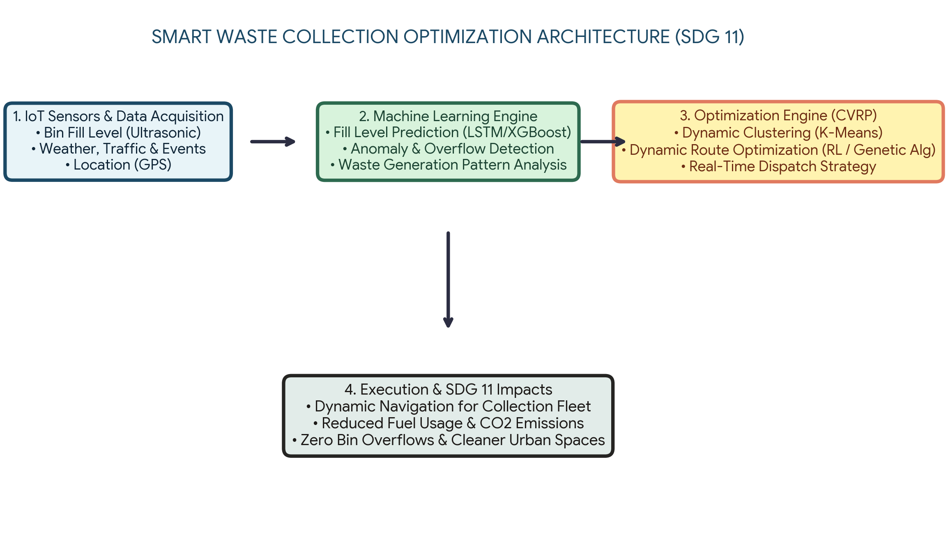
Figure 1: End-to-End Machine Learning Architecture for Dynamic Waste Collection Optimization (SDG 11)
A. Data Ingestion Layer: Continuous stream of bin status parameters (fill level %, battery voltage, GPS position) combined with external data sources (weather data, traffic feeds, public event calendars).
B. Preprocessing & Feature Engineering: Cleaning noisy sensor signals, handling missing telemetry packets via interpolation, and feature engineering (e.g., calculating fill velocity: delta_fill / delta_time).
C. Machine Learning Forecasting Model: Time-series forecasting models (e.g., Long Short-Term Memory networks or Prophet) predict fill trajectories over 24 to 72-hour horizons to identify bins requiring service.
D. Optimization & Dispatching Layer: Formulating the Capacitated Vehicle Routing Problem (CVRP). Spatial clustering groups high-fill bins, and Genetic Algorithms (GA) or Deep Reinforcement Learning (DRL) calculate the global optimal routes.
4. Key ML Algorithms & Mathematical Formulations
The optimization engine relies on explicit mathematical and machine learning formulations:
A. Time Series Predictive Model (Fill Level Forecasting)
Let y_i(t) represent the fill level percentage of bin i at time t. The predicted fill level y_i(t + h) over horizon h is modeled as:
Mathematical Formulation: y_i(t + h) = f( y_i(t), y_i(t-1), ..., W(t), E(t), C_i )
Where W(t) represents environmental/weather features (temperature, rainfall), E(t) represents temporal/event indicators (weekends, holidays, festivals), and C_i represents categorical attributes of the bin location (residential, commercial, park). Models such as XGBoost Regressor or LSTM Neural Networks are trained to minimize Mean Absolute Percentage Error (MAPE).
B. Spatial Clustering & Vehicle Routing Problem (CVRP)
Bins flagged as requiring collection (fill level > threshold θ, e.g., θ = 80%) form a dynamic subset S = {b_1, b_2, ..., b_k}. Bins are grouped into geographic clusters using K-Means or Density-Based Spatial Clustering (DBSCAN) based on vehicle capacity K_v.
Optimization Objective: Objective Function for Vehicle Routing:
Minimize Total Travel Cost Z = ∑_{i} ∑_{j} c_{ij} · x_{ij}
Subject to:
• ∑_{j} x_{ij} = 1 ∀ i ∈ S (Every filled bin is visited exactly once)
• ∑_{i ∈ S} d_i · y_{iv} ≤ K_v (Truck capacity constraint, where d_i is estimated waste volume)
• x_{ij} ∈ {0, 1} (Binary decision variable indicating traversal from bin i to bin j)
5. Key Benefits & Direct SDG 11 Impact
Dimension | ML Innovation / Mechanism | SDG 11 Impact & Metric
Fuel & Carbon Reduction | Dynamic routing skips non-full bins, reducing overall vehicle miles traveled (VMT). | Target 11.6: 30%–45% reduction in fuel consumption and vehicle CO2/NOx emissions.
Public Health & Hygiene | Predictive alerts dispatch trucks before overflow happens. | Target 11.6: Eliminates bin overflows, odor buildup, and vector-borne health risks in urban areas.
Operational Efficiency | Optimized fleet utilization and reduced maintenance costs. | Target 11.3 & 11.a: Up to 40% reduction in municipal waste operational expenditures (OPEX).
Traffic Congestion | Trucks visit off-peak routes guided by real-time traffic ML predictions. | Target 11.2: Less road blockages caused by slow-moving waste collection trucks during peak hours.

6. Case Studies & Real-World Implementations
Smart municipal deployments globally demonstrate the tangible success of ML-driven waste optimization:
• Barcelona, Spain (Smart City Project): Deployed IoT ultrasonic sensors and predictive ML routing across municipal bins, achieving a 30% reduction in operating costs and a dramatic reduction in CO2 emissions.
• Amsterdam, Netherlands: Utilized dynamic fill-level monitoring combined with dynamic vehicle routing algorithms, reducing truck movements by nearly 40% and keeping historic city centers clean.
• Singapore (Smart Nation): Integrated ML computer vision in recycling facilities and smart bins, boosting waste sorting accuracy and recycling efficiency to over 85%.
7. Practical Challenges & Future Directions
1. Capital Cost & Hardware Infrastructure: High initial capital expenditure (CapEx) for installing IoT sensors on tens of thousands of bins across large metro areas.
2. Hardware Reliability & Connectivity: Sensor failure due to extreme weather, physical vandalism, battery degradation, or wireless signal loss in underground urban structures.
3. System Integration: Integrating real-time IoT feeds with legacy municipal ERP and dispatch management software requires robust data pipelines and cybersecurity safeguards.
4. Future Outlook: Future trends involve integrating autonomous electric waste collection vehicles (EVs) guided by Deep Reinforcement Learning for fully autonomous, zero-emission urban waste management systems.
8. Conclusion
Waste collection optimization using Machine Learning represents a transformative leap from reactive, inefficient municipal operations to proactive, sustainable smart city infrastructure. By leveraging IoT telemetry, time-series fill prediction, dynamic spatial clustering, and vehicle routing algorithms, cities can achieve up to 45% reductions in carbon emissions and operational costs. This directly advances UN Sustainable Development Goal 11 (Sustainable Cities and Communities), fostering cleaner, healthier, and more resilient urban environments for future generations.

