Software Architecture and Design Specification
Project: Perishables Management System (PMS)
Version: 1.1
Authors: Project Team (Team 1)
Date: 08-10-2026
Status: Draft

Revision History
Version | Date | Author | Change Summary
1.0 | 07-10-2026 | Project Team | Initial SAD derived from SRS v1.0, System Architecture v1 and Test Case Document v1.
1.1 | 08-10-2026 | Project Team | Figure 1 replaced by the SRS v1.0 UML use-case diagram (component view kept as Figure 2); added use-case-to-component mapping, ADR table, SRS test references, Receipt Printer, additional API endpoints; open issues aligned with SRS and Test Case Document.

Approvals
Role | Name | Signature/Date
Project Guide
Project Team Representative
QA / Test Lead

1. Introduction
1.1 Purpose
This document specifies the architecture and design of the Perishables Management System (PMS), a web and mobile application for managing perishable goods in a retail store from receipt through sale, expiry or removal.
1.2 Scope
Covers PMS store services: product master data, batch-level stock tracking with FEFO selling, low-stock and expiry alerts, removals and stock counts, rule-based markdowns, refrigeration/temperature/door/power monitoring through simulated sensor inputs, dashboards and exportable reports, and role-based security. Supplier payments, billing, GST/tax filing and customer shopping functions are outside scope. The POS is simulated, monitoring is demonstrated with a sensor simulator, and the receipt printer is treated as an external device.
1.3 Audience
Developers, QA/test engineers, security reviewers, the project guide, and maintenance teams. Store managers and operational staff are represented through the system roles.
1.4 Definitions
PMS, Batch, FEFO, SKU, POS, UML, UC, ADR, STRIDE, RBAC, 2FA, REST, TLS, FSSAI, RTM. (See Appendix 5.1 for the full glossary.)

2. Document Overview
2.1 How to use this document
Provides architectural deliverables including the UML use-case diagram, UML component diagram, sequence diagrams, architecture decision rationale (ADR), threat model, API design and requirement traceability. Section 3 describes the structure of the system; Section 4 describes how it behaves and how its interfaces are defined.
2.2 Related Documents
- Software Requirements Specification (SRS) v1.0, PMS_SRS.docx, status Approved, 04-10-2026, including the UML use-case diagram in Section 7 (reproduced as Figure 1) and its Requirements Traceability Matrix (RTM) in Section 8.
- Test Case Document v1.0 (STP), PMS_Test_Cases_v1-1.pdf, 5 October 2026.
- PMS System Architecture v1, PMS_Architecture_v1-1.pdf: layered (3-tier) UML component view (reproduced as Figure 2).

3. Architecture

3.1 Goals & Constraints
Goals
- Secure: only authenticated, authorised users reach functions and data appropriate to their role (SO-1, SO-2).
- Reliable and available: 99.5% availability of store operating hours per month; sensing and alerts continue on backup power; no data loss during a network outage of up to 30 minutes (NFR-4, NFR-5).
- Responsive: stock changes visible on all screens within 5 s for 95% of updates; alerts delivered within 60 s of the triggering event (NFR-1, NFR-2).
- Scalable: at least 50 concurrent users, 5,000 batches and 100 sensors; a store ID on all store data so more stores can be added without schema changes (NFR-3, NFR-14).
- Maintainable and traceable: modular backend; every functional requirement traceable to at least one test case (NFR-15).
Constraints
- The POS is simulated and sensors are supplied by a sensor simulator through an authenticated device API.
- Supplier payments, billing, GST/tax filing and customer shopping are out of scope.
- Operating environment: browsers, Android and iOS phones and tablets; all components run as Docker containers on a Linux server; all communication over HTTPS (TLS 1.2+).
- Temperature records must follow applicable food-safety guidance such as FSSAI; temperature, stock and audit records are kept for at least 2 years (NFR-8, NFR-7).

3.2 Stakeholders & Concerns
Stakeholder | Concerns
Admin | User, role, store and system-settings management; account security.
Manager | Dashboards and reports, thresholds and markdown rules, timely low-stock/expiry/refrigeration alerts, acknowledging alarms.
Inventory Staff | Fast batch receipt, removals and stock counts; correct FEFO order; usability on tablet/phone.
Cashier | Reliable sale recording (POS, manual or CSV); expired stock cannot be sold.
POS / Sensor / Email / Receipt Printer systems | Stable, authenticated interfaces for sales events, sensor readings, notification delivery and receipt printing.
Management / Regulators | Food-safety compliance, record retention, audit trail.
Developers, QA, Project Guide | Modularity, testability, traceability of requirements to design and tests.

3.3 Component (UML) Diagram
UML use-case diagram of PMS, reproduced unchanged from SRS v1.0, Section 7 (Figure 1, next page): four roles specialising the abstract Store User, four external actors (Email Service, Sensor Simulator, Receipt Printer, POS Simulator) and 35 use cases in six packages. Use cases map to Figure 2 components as below (UC-30 is unused in the SRS numbering).
Use case(s) | Component(s) | Requirement(s)
UC-01 to UC-03 Login, Verify Two-Factor Code, Lock Account | Auth & Roles; Web App | SEC-1, SEC-3, NFR-10
UC-04 Reset Password | Auth & Roles; Email / SMS Gateway | SEC-5
UC-05 to UC-07 Manage User Accounts, Assign Role, Check Role Permission | Auth & Roles (checks apply to all modules) | SEC-2, SEC-4
UC-08, UC-09 Manage Products, Set Low-Stock Threshold | Products & Suppliers | FR-1
UC-10 to UC-14 Receive Batch, Record Restock, View Batch Age & FEFO Order, Physical Stock Count, Save Adjustment | Inventory & FEFO; Web App | FR-2, FR-4 to FR-6, FR-9
UC-15, UC-16, UC-23 Record Removal, Notify Batch Removal, Send Expiry Notifications | Expiry & Removal; Scheduler; Alerts | FR-12, FR-13, NFR-12
UC-17 to UC-20 Record Sale, Upload Sales CSV, Deduct Stock by FEFO, Reject Expired Batch Sale | Sales; Inventory & FEFO; Device API; Receipt Printer | FR-3, FR-7, FR-8
UC-21, UC-22, UC-24 Projected and Low-Stock Alerts, Send Notification | Scheduler; Alerts; Email / SMS Gateway | FR-10, FR-11, NFR-2
UC-28, UC-29, UC-31, UC-32 Receive Sensor Readings, Buffer & Sync, Equipment Failure Alert, Door-Open Alarm | Device API; Alerts; Sensor Simulator | FR-15 to FR-17, FR-19, NFR-5
UC-25 to UC-27 Configure Markdown Rules, Apply Markdown, Track Marked-Down Sales | Markdown & Reorder | FR-14
UC-33 to UC-36 Acknowledge Alarm, Monitor Refrigeration, View Dashboard, Export Reports | Alerts; Device API; Reports & Export; Web App | FR-15, FR-16, FR-18

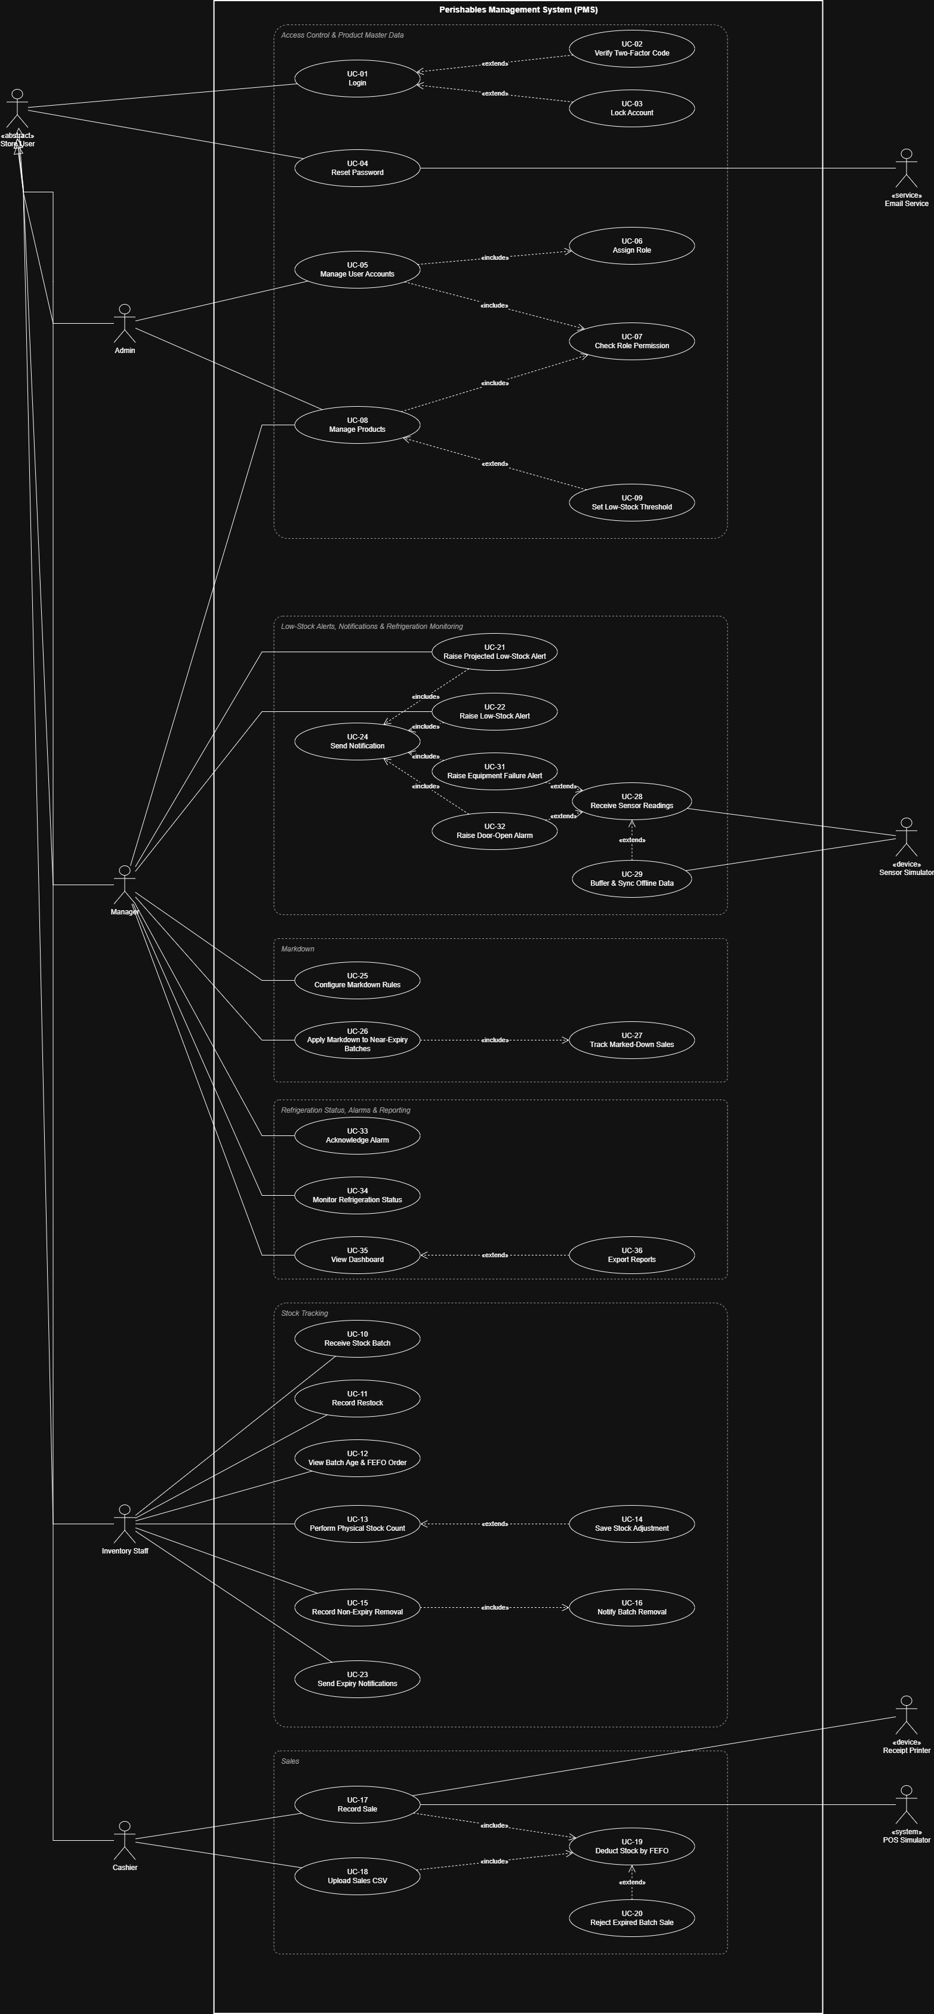
Figure 1: PMS UML use-case diagram (from SRS v1.0, Section 7)

Component view (System Architecture v1)
UML component view of PMS (System Architecture v1, reproduced unchanged): three tiers (Presentation, Application Layer, Data Layer) with provided/required interfaces and assembly connectors. The Receipt Printer actor of Figure 1 is not drawn in this view (see 3.4 and 4.6).
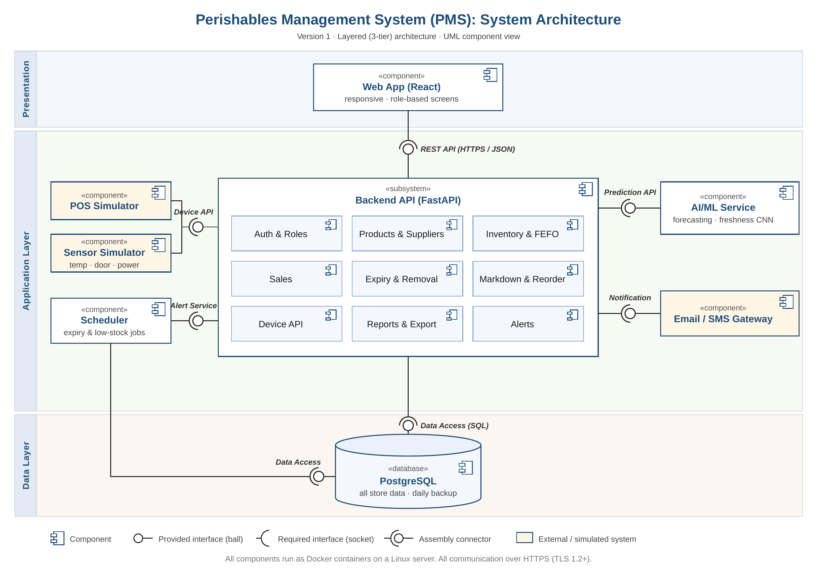
Figure 2: PMS System Architecture, layered (3-tier) UML component view

3.4 Component Descriptions
- Web App (React): responsive React application with role-based screens for Admin, Manager, Inventory Staff and Cashier. Talks only to the Backend API over the REST API (HTTPS/JSON).
- Backend API (FastAPI): FastAPI subsystem that holds all business logic, made of nine modules:
- Auth & Roles login, lockout after 5 failures, idle logout, 2FA for Manager/Admin, RBAC, user administration, password reset by email.
- Products & Suppliers product master data (units, shelf-life, storage type, temperature range, prices, thresholds) and supplier records.
- Inventory & FEFO batch receipt, restock, batch age/remaining shelf time, FEFO ordering and deduction, expired-batch blocking, stock counts and adjustments.
- Sales sale recording from POS, manual entry and CSV upload.
- Expiry & Removal pre-expiry/expiry handling and non-expiry removals with reason, worker and time.
- Markdown & Reorder rule-based markdowns within the Manager-set maximum discount; tracking of how much marked-down stock sells.
- Device API authenticated intake of sales events and temperature, door and power readings.
- Reports & Export dashboard data and exportable reports (PDF and spreadsheet-style export).
- Alerts creation, storage and dispatch of low-stock, projected low-stock, expiry, equipment, door and temperature alerts.
- POS Simulator: simulated sales source; calls the Device API.
- Sensor Simulator: simulated temperature, door and power readings; calls the Device API.
- Receipt Printer: external/simulated device that prints the receipt for a recorded sale (SRS 3.2; use case UC-17). Driven by the Sales module through a print interface (proposed). Not drawn in Figure 2.
- Scheduler: runs the expiry and low-stock jobs; calls the Alert Service interface of the backend and reads data directly through Data Access.
- AI/ML Service (optional): forecasting and freshness CNN, consumed by the backend through the Prediction API. Optional: not required by SRS v1.0, and core PMS functions work without it.
- Email / SMS Gateway: external/simulated delivery channel for notifications, called by the backend through the Notification interface.
- PostgreSQL: single data store for all store data, backed up daily; accessed through Data Access (SQL).
Interfaces shown in Figure 2
Interface | Provided by | Required by | Purpose
REST API (HTTPS/JSON) | Backend API | Web App | All user-facing operations
Device API | Backend API | POS Simulator, Sensor Simulator | Sales events and sensor readings
Alert Service | Backend API | Scheduler | Trigger expiry and low-stock checks
Prediction API (optional) | AI/ML Service (optional) | Backend API | Forecasting and freshness estimates
Notification | Email / SMS Gateway | Backend API | Deliver alerts and password-reset emails
Data Access (SQL) | PostgreSQL | Backend API, Scheduler | Persistence of all store data
Receipt printing (proposed, not in Figure 2) | Receipt Printer | Backend API (Sales) | Print the receipt of a recorded sale

3.5 Chosen Architecture Pattern and Rationale
Layered (3-tier) architecture was chosen: Presentation (Web App), Application Layer (Backend API and supporting components) and Data Layer (PostgreSQL). It gives a clear separation of concerns, lets role checks and business rules live in one place, and keeps the simulators and scheduler outside the user interface. The backend is organised as one subsystem with nine modules (a modular monolith). Microservices were rejected as overly complex for a single-store system with 50 concurrent users, 5,000 batches and 100 sensors; they would add deployment and consistency overhead (for example FEFO deduction and alerting must update stock atomically) without a matching benefit. The AI/ML service is kept as a separate component because it is optional to core operations and can fail or be replaced without affecting stock handling.

Architecture decision records (ADR)
ID | Decision | Rationale (requirements)
ADR-1 | Layered (3-tier) architecture: Presentation, Application Layer, Data Layer. | Clear separation of concerns; role checks and business rules in one place; simulators and scheduler stay outside the UI. (NFR-15)
ADR-2 | One FastAPI backend with nine modules (modular monolith); microservices rejected. | Single store with 50 users, 5,000 batches and 100 sensors; FEFO deduction and alerting must update stock atomically. (NFR-3)
ADR-3 | AI/ML service kept as a separate component behind the Prediction API. | Optional to core operations; can fail or be replaced without affecting stock handling.
ADR-4 | PostgreSQL as the single data store, with store ID on all store data. | One transactional store for FEFO updates; multi-store growth without schema change; daily backup and 2-year retention. (NFR-7, NFR-13, NFR-14)
ADR-5 | One authenticated Device API for all POS and sensor input; every event carries an eventId. | Real devices can replace simulators unchanged; resend after an outage is de-duplicated. (FR-17, FR-19, NFR-5)
ADR-6 | All components as Docker containers on a Linux server; HTTPS (TLS 1.2+) everywhere. | Simple repeatable deployment, automatic restart for availability, encrypted transport. (NFR-4, SEC-2)
ADR-7 | Alerts are created only by the Alerts module, stored in-app, then sent through the Notification interface. | Alert rules and delivery live in one place; an alert stays visible if delivery fails. (NFR-2, NFR-12)

3.6 Technology Stack & Data Stores
Area | Choice
Frontend | React web app, responsive for browsers, phones and tablets
Backend | FastAPI (Python) REST API; OpenAPI/Swagger documentation
Data store | PostgreSQL; store ID on all store data; daily backup with a tested restore; records retained at least 2 years
AI/ML (optional) | Forecasting and freshness CNN behind the Prediction API
Deployment | All components as Docker containers on a Linux server; containers restart automatically
Security | HTTPS (TLS 1.2+) for all communication; salted password hashes; employee data encrypted at rest; 2FA for Manager and Admin
Testing tools | pytest, httpx, Postman, Playwright, Locust (per the Test Case Document)

Offline handling: the POS and sensor sources buffer events locally during a network outage and resend them afterwards; the Device API de-duplicates by event ID so a resend never creates duplicate sales or readings (FR-19, NFR-5).

3.7 Risks & Mitigations
Risk | Mitigation
Network failure loses sales or sensor events | Local buffering at the source and de-duplicated synchronisation; verified with a 30-minute outage test (NFR-5).
Alerts arrive late (more than 60 s) | Scheduler-driven checks plus event-driven checks on every sale and reading; alert delivery time monitored (NFR-2).
Concurrent sales corrupt batch quantities or break FEFO order | FEFO deduction runs in a single database transaction with row locking on the affected batches.
Expired stock sold to a customer | Expired batches are excluded from deduction and rejected explicitly (FR-7).
Single server is a single point of failure for 99.5% availability | Docker restart policy, daily database backup, tested restore (NFR-4, NFR-13).
Notification gateway or AI/ML service unavailable | Alerts are stored and shown in the app even if delivery fails; core stock functions do not depend on the AI/ML service.
Credential attacks or privilege misuse | Lockout after 5 failures, salted hashes, RBAC on every endpoint, 2FA for Manager/Admin (SEC-2, SEC-3, NFR-9, NFR-10).
Simulated POS/sensors differ from real hardware | Devices use the same authenticated Device API contract, so real devices can replace simulators without backend change.

3.8 Traceability to Requirements
Requirement IDs follow SRS v1.0. The full requirement-to-test matrix is in SRS Section 8 (RTM); the last column repeats the test case IDs given there. Use-case coverage is in 3.3.
Req ID | Requirement | Component(s) | SRS test ref
FR-1 | Product master data | Products & Suppliers | TC-PROD-01
FR-2 | Record received batch | Inventory & FEFO | TC-STK-01
FR-3 | FEFO deduction on sale | Sales, Inventory & FEFO | TC-STK-02
FR-4 | Restock adds stock | Inventory & FEFO | TC-STK-03
FR-5 | Batch age and remaining shelf time | Inventory & FEFO, Web App | TC-STK-04
FR-6 | FEFO selling-order suggestion | Inventory & FEFO | TC-STK-05
FR-7 | Block sale of expired batch | Inventory & FEFO, Sales | TC-STK-06
FR-8 | Manual and CSV sales | Sales | TC-STK-07
FR-9 | Physical stock count and adjustment | Inventory & FEFO | TC-STK-08
FR-10 | Projected low-stock alert | Scheduler, Alerts | TC-ALT-01
FR-11 | Low-stock alert | Alerts | TC-ALT-02
FR-12 | Pre-expiry and expiry notifications | Scheduler, Expiry & Removal, Alerts | TC-EXP-01
FR-13 | Non-expiry removals | Expiry & Removal | TC-EXP-02
FR-14 | Rule-based markdowns | Markdown & Reorder | TC-EXP-03
FR-15 | Refrigeration unit failure alert | Device API, Alerts | TC-SEN-01
FR-16 | Door-open-too-long alarm | Device API, Alerts | TC-SEN-02
FR-17 | Authenticated sensor intake | Device API | TC-SEN-03
FR-18 | Dashboard and reports | Reports & Export | TC-REP-01
FR-19 | Offline buffering and sync | POS/Sensor Simulator, Device API | TC-REP-02
SEC-1 | User ID and password login | Auth & Roles | TC-AUTH-01
SEC-2 | Role-based access | Auth & Roles (all modules) | TC-AUTH-02
SEC-3 | Lockout and idle logout | Auth & Roles | TC-AUTH-03
SEC-4 | User account administration | Auth & Roles | TC-AUTH-04
SEC-5 | Password reset by email | Auth & Roles, Email / SMS Gateway | TC-AUTH-05
NFR-1 | Stock updates within 5 s | Backend API, PostgreSQL, Web App | TC-PERF-01
NFR-2 | Alerts within 60 s | Alerts, Scheduler, Email / SMS Gateway | TC-PERF-02
NFR-3 | 50 users, 5,000 batches, 100 sensors | Backend API, PostgreSQL | TC-PERF-03
NFR-4 | 99.5% availability, backup-power sensing | Docker deployment, Device API | TC-REL-01
NFR-5 | No loss in 30-minute outage | Device API, POS/Sensor Simulator | TC-REL-02
NFR-6 | 30-minute training usability | Web App | TC-UX-01
NFR-7 | 2-year record retention | PostgreSQL | TC-DATA-01
NFR-8 | Food-safety (FSSAI) compliance | Device API, Reports & Export | TC-COMP-01
NFR-9 | Salted password hashes | Auth & Roles, PostgreSQL | TC-SEC-06
NFR-10 | 2FA for Manager and Admin | Auth & Roles | TC-SEC-07
NFR-11 | Employee data encrypted at rest | Auth & Roles, PostgreSQL | TC-SEC-08
NFR-12 | Removal notification within 2 min | Expiry & Removal, Alerts | TC-PERF-04
NFR-13 | Daily backup and tested restore | PostgreSQL | TC-REL-03
NFR-14 | Store ID on all store data | PostgreSQL | TC-SCAL-01
NFR-15 | FR-to-test traceability | This document, SRS RTM | TC-RTM-01

3.9 Security Architecture
Threat Modeling (STRIDE):
Threat | PMS scenario | Mitigation
Spoofing | Impersonating a user, or a fake sensor/POS posting data | Unique user ID and password with lockout and 2FA for Manager/Admin; device key on the Device API (401 on invalid key)
Tampering | Altering stock, prices, removals or readings | RBAC on every action; removals and adjustments require reason, worker and time; HTTPS (TLS 1.2+); input validation (400 on malformed data)
Repudiation | A worker denies a removal or adjustment | Audit records (who, what, when) retained at least 2 years
Information disclosure | Credentials or employee data exposed | Salted password hashes only; employee data encrypted at rest and visible only to authorised Manager roles; generic login errors; TLS in transit; no secrets in logs
Denial of service | Flooding login or Device API | Account lockout; rate limiting on login and Device API; per-device keys; container auto-restart
Elevation of privilege | Cashier calling Manager/Admin endpoints directly | Server-side RBAC (403 Forbidden, attempt logged); Admin-only user administration

4. Design

4.1 Design Overview
PMS is designed with a layered structure and a modular backend for separation of concerns and easier maintenance. The Web App calls the REST API; the simulators call the Device API; the Scheduler invokes the Alert Service on a timetable. Every request passes authentication and role checks in Auth & Roles before reaching a module. Modules read and write PostgreSQL through the Data Access interface, and every store record carries a store ID. Stock-changing operations (sale, restock, removal, count adjustment) run as database transactions and write who/what/when audit information. The Alerts module is the only place that creates alerts and calls the Notification interface, so alert rules and delivery live in one place.

4.2 UML Sequence Diagrams
Three flows specific to PMS are shown: login with lockout and 2FA, a sale with FEFO deduction and low-stock alert, and a sensor reading that raises an alarm. Flow 1 realises UC-01 to UC-03; Flow 2 realises UC-17, UC-19, UC-20, UC-22 and UC-24; Flow 3 realises UC-28, UC-31, UC-32, UC-24 and UC-33 (Figure 1).
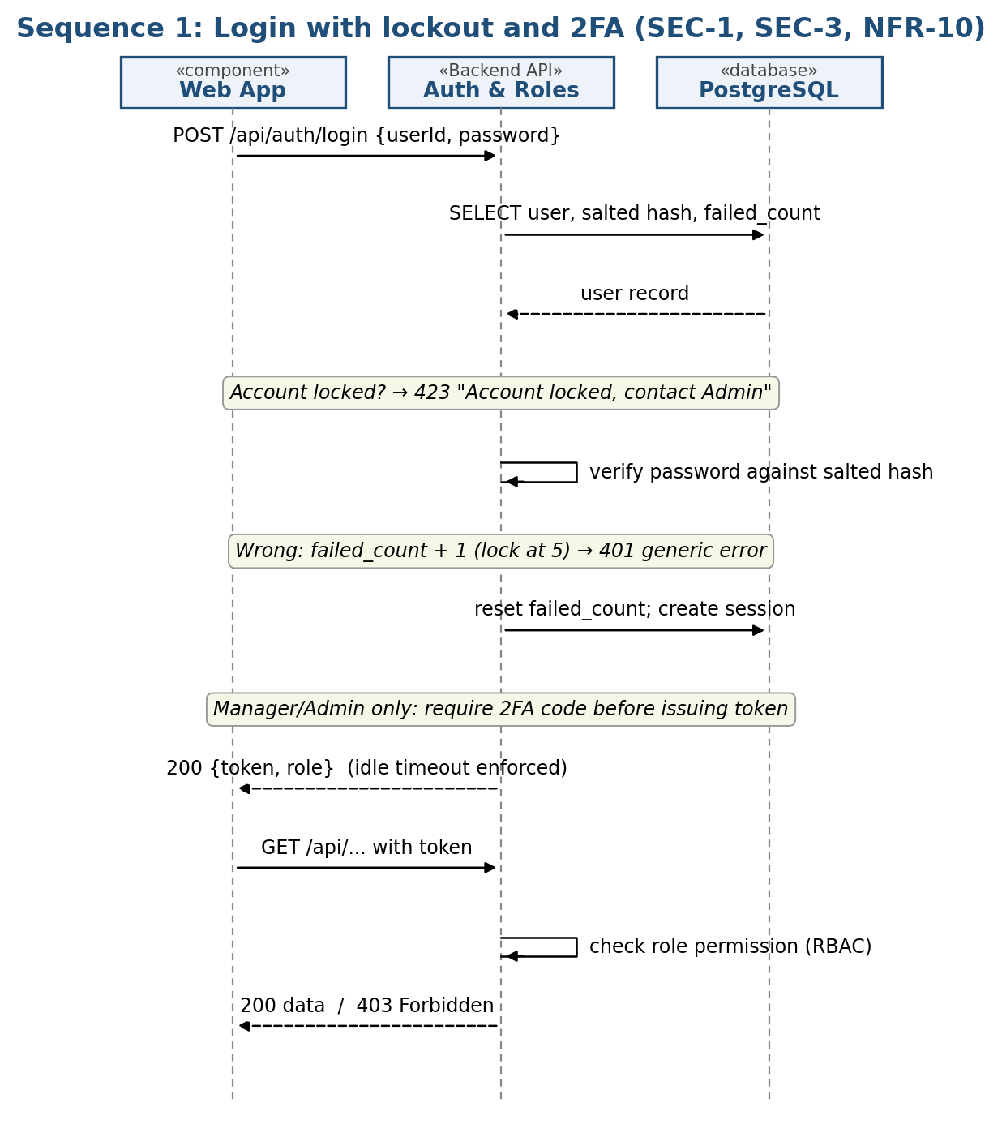
Figure 3: Login with lockout and 2FA
Flow 1. The Web App sends credentials to Auth & Roles. After the fifth consecutive failure the account is locked. Manager and Admin logins additionally require a 2FA code. Every later call is checked against the role, and idle sessions are ended.

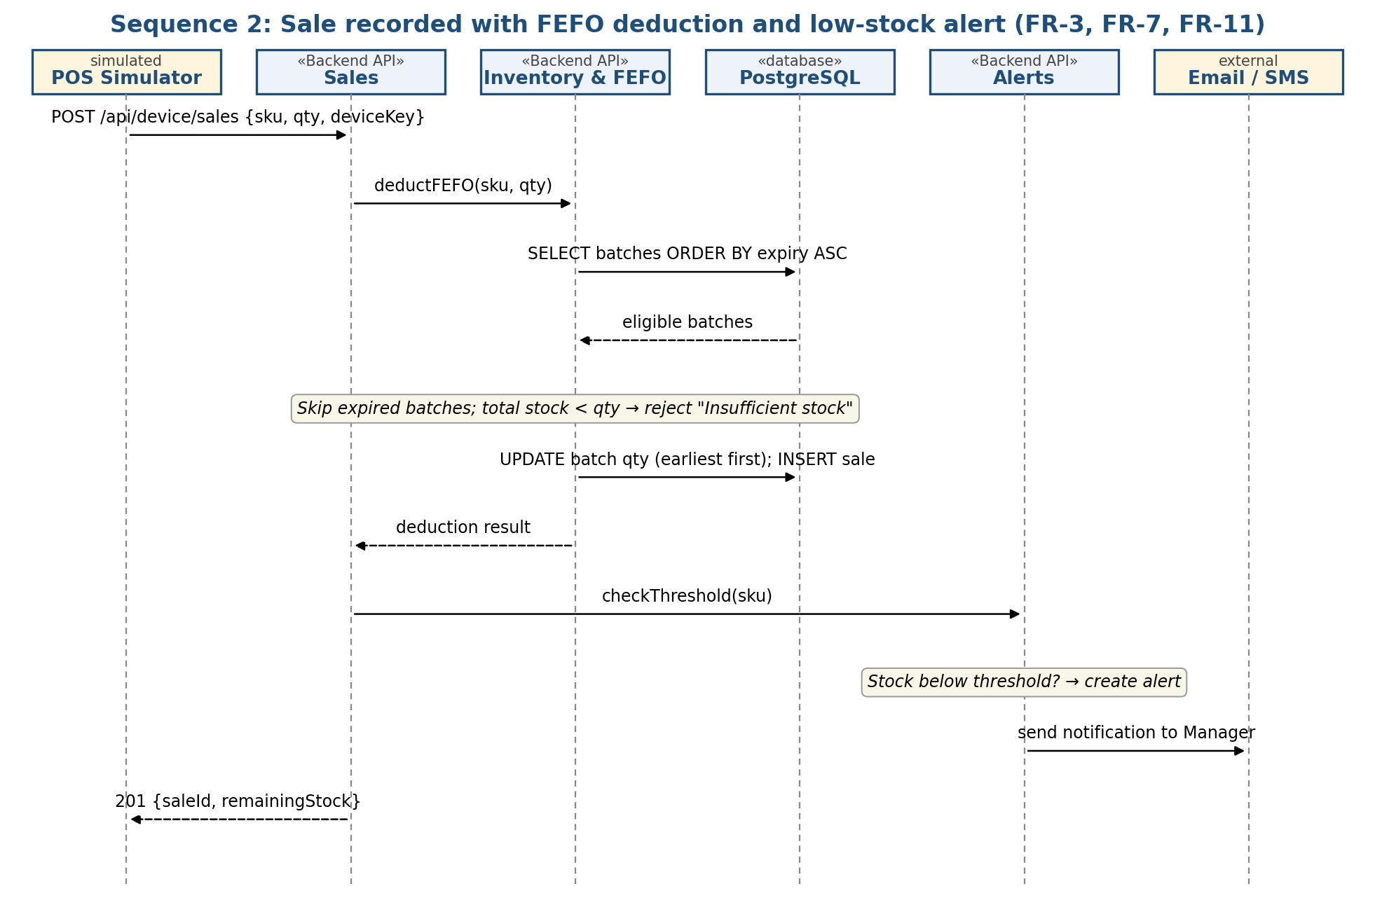
Figure 4: Sale recorded with FEFO deduction and low-stock alert
Flow 2. The POS Simulator posts a sale to the Device API; Inventory & FEFO takes stock from the earliest-expiring eligible batches, skips expired batches and rejects a sale larger than available stock. Alerts then checks the threshold and notifies the Manager.

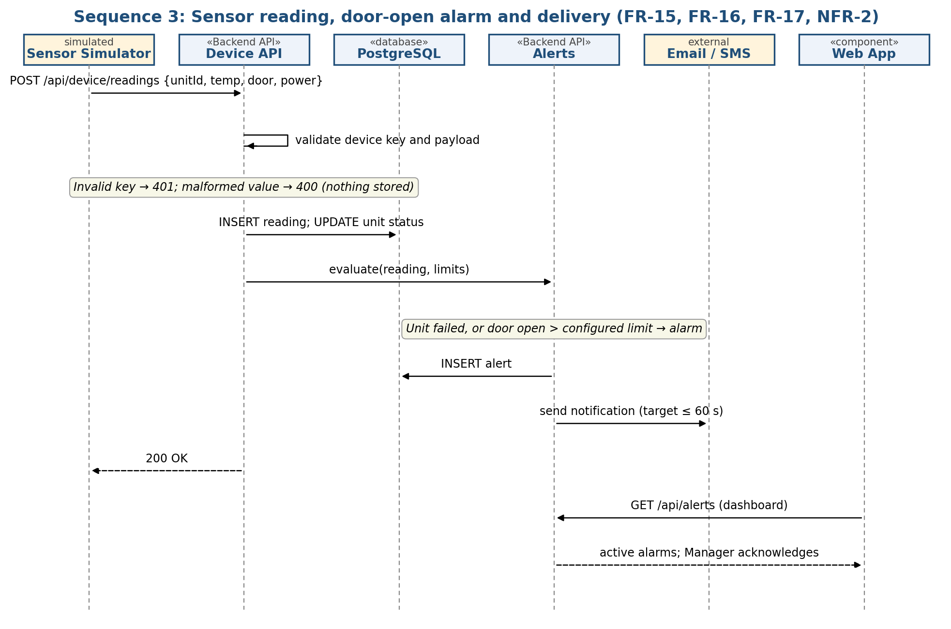
Figure 5: Sensor reading and door-open / unit-failure alarm
Flow 3. The Sensor Simulator posts a reading with its device key. Valid readings are stored; Alerts evaluates the unit status and door-open duration, stores any alarm, sends the notification and shows the alarm on the dashboard for the Manager to acknowledge.

4.3 API Design
Interface definitions for the Backend API (REST, HTTPS/JSON). All endpoints except login require a session token; Device API endpoints require a device key instead. Error bodies use the standard format in 4.4. Paths /api/users and /api/markdown-rules come from the Test Case Document; the other paths are proposed by this design and will be published through Swagger.
Authentication (Auth & Roles)
Item | Definition
Endpoint | /api/auth/login
Method | POST
Request | {userId, password, otpCode (Manager/Admin only)}
Response | 200 {token, role, expiresIn}
Errors | 401 Invalid user ID or password (same message for unknown user); 423 Account locked, contact Admin; 400 missing field.

Record a sale (Device API)
Item | Definition
Endpoint | /api/device/sales
Method | POST
Auth | Device key header
Request | {eventId, sku, quantity, unit, soldAt}
Response | 201 {saleId, batchesUsed[{batchId, qty}], remainingStock}
Errors | 401 invalid device key; 400 malformed data; 409 duplicate eventId (already stored); 422 Insufficient stock; 422 Batch expired.

Record a sensor reading (Device API)
Item | Definition
Endpoint | /api/device/readings
Method | POST
Auth | Device key header
Request | {eventId, unitId, type: temperature|door|power, value, recordedAt}
Response | 200 {status: "stored", alertRaised: true|false}
Errors | 401 invalid device key; 400 validation message for malformed value (for example "abc"); reading not stored.

Receive a batch (Inventory & FEFO)
Item | Definition
Endpoint | /api/batches
Method | POST
Role | Inventory Staff, Manager
Request | {productId, supplierId, quantity, unit, receivedAt, expiryDate}
Response | 201 {batchId}
Errors | 400 expiry date must be after received date; 400 quantity must be greater than 0; 403 role not permitted.

FEFO suggestion (Inventory & FEFO)
Item | Definition
Endpoint | /api/batches/fefo?productId={id}
Method | GET
Response | 200 [{batchId, quantity, expiryDate, daysInStore, daysToExpiry}] sorted by expiry ascending
Errors | 404 unknown product; 403 role not permitted.

Record a removal (Expiry & Removal)
Item | Definition
Endpoint | /api/removals
Method | POST
Role | Inventory Staff, Manager
Request | {batchId, quantity, reason}
Response | 201 {removalId, remainingBatchStock}
Errors | 400 reason is mandatory; 422 Quantity exceeds batch stock; 403 role not permitted.

Alerts and reports (Alerts, Reports & Export)
Item | Definition
Endpoints | GET /api/alerts?status=active; POST /api/alerts/{id}/acknowledge; GET /api/reports/{type}?from=&to=&format=pdf|csv
Response | 200 list of alerts / 200 file download; "No data for this period" for an empty range
Errors | 403 role not permitted; 400 invalid date range.

Role-protected administration
Item | Definition
Endpoints | GET /api/users; POST /api/markdown-rules
Rules | Users: Admin only. Markdown rules: Manager only, discount must not exceed the configured maximum.
Errors | 403 Forbidden (attempt logged); 422 Discount exceeds maximum.

Internal component interfaces
Interface | Operation | Input / Output
Alert Service (Scheduler → Backend) | runExpiryCheck(), runLowStockCheck() | No input; creates pre-expiry, expiry and projected low-stock alerts (7-day average daily sales, default threshold 10 units)
Prediction API (Backend → AI/ML) (optional) | forecast(productId), freshness(image) | Demand forecast / freshness estimate
Notification (Backend → Email/SMS) | send(recipient, subject, body) | Delivery status; failures retried and the alert remains visible in-app
Print (Backend -> Receipt Printer), proposed | printReceipt(saleId) | Receipt data for the sale; print status returned. A print failure does not undo the sale.
Additional endpoints (proposed)
Endpoints needed by the remaining requirements and use cases; paths and bodies are proposed by this design and follow the error format in 4.4.
Endpoint | Role | Purpose, request / response, errors
POST /api/products; PUT /api/products/{id}; PATCH /api/products/{id}/deactivate | Manager, Admin | FR-1 / UC-08, UC-09. Body: name, category, unit (kg|piece|l), shelfLifeDays, storageType, tempMin, tempMax, costPrice, sellingPrice, lowStockThreshold (default 10). 400 missing field or tempMin >= tempMax or negative price; 403 role not permitted.
POST /api/restocks | Inventory Staff, Manager | FR-4 / UC-11. {productId, quantity, unit}; 201 {newStock}; 400 quantity must be greater than 0.
POST /api/stock-counts | Inventory Staff, Manager | FR-9 / UC-13, UC-14. {batchId, countedQuantity, reason}; 201 {variance, newStock} with reason, worker and time saved; 400 reason is mandatory.
POST /api/sales | Cashier | FR-8 / UC-17. Manual sale {sku, quantity, unit}; 201 as for the device sale; 422 Insufficient stock; 422 Batch expired.
POST /api/sales/csv | Cashier | FR-8 / UC-18. Multipart CSV file; 200 {imported, failed, errors[{line, message}]}; valid rows are imported and bad rows reported with their line number.
POST /api/users; PUT /api/users/{id}; PATCH /api/users/{id}/deactivate | Admin | SEC-4 / UC-05, UC-06. {userId, name, role, email}; 409 User ID already exists; 403 Forbidden.
POST /api/auth/password-reset; POST /api/auth/password-reset/confirm | Public (reset link) | SEC-5 / UC-04. {userId} sends a one-time link by email; confirm {token, newPassword}; 400 link invalid, used or expired.
POST /api/auth/logout (idle sessions end automatically) | Any logged-in user | SEC-3. 204 No content; an expired session returns 401.

4.4 Error Handling, Logging & Monitoring
- Standardized error messages: every error returns {error: {code, message, details}} with the correct HTTP status (400, 401, 403, 404, 409, 422, 423). Login errors never reveal which field was wrong.
- Logging: no passwords, hashes, device keys, tokens or employee data in logs. Access-denied attempts, failed logins, stock adjustments and removals (with user, reason and time) are logged for audit.
- Monitoring: transaction failure rate, API response time, stock-update latency (5 s target), alert delivery time (60 s target), uptime and container health, sensor heartbeat, offline-sync queue size, backup success.

4.5 UX Design
Responsive web/mobile UI usable on browsers, phones and tablets, with screens and actions limited by role (for example, the Cashier sees only sales screens). A dashboard shows low stock, items expiring soon and active alarms. The stock screen shows time in store and time to expiry with batches in FEFO order. Validation errors are shown next to the field. The interface is designed so that a new staff member can perform routine tasks after no more than 30 minutes of training (NFR-6).

4.6 Open Issues & Next Steps
- Test Case Document alignment: the Test Case Document numbers requirements differently from SRS v1.0 (for example FR-31, FR-43, NFR-26 against FR-1 to FR-19, SEC-1 to SEC-5, NFR-1 to NFR-15), counts 44 requirements where SRS v1.0 has 39, includes an attendance feature (FR-24 to FR-27) that is not in the SRS, uses test case IDs that differ from the SRS RTM (for example TC-MD-01 against TC-PROD-01), and gives a 3 s stock-update target where NFR-1 says 5 s. This SAD follows the SRS throughout. The Test Case Document is to be renumbered to SRS v1.0 IDs, with attendance removed and the target set to 5 s.
- SRS clean-up (no effect on the architecture): add the missing Section 6 (Quality Attributes & Acceptance Tests) to the SRS body; add a receipt-printing requirement (this SAD already includes the Receipt Printer as an external device with a proposed print interface, in 3.3, 3.4 and 4.3, and notes that Figure 2 does not show it); add UC-30 to the use-case diagram and link UC-29 Buffer & Sync Offline Data to the POS Simulator as well as the Sensor Simulator (this SAD already covers buffered sales in 3.6, FR-19 and NFR-5); and correct "System Inteference" (FR-19), "Reciept" (2.3, 3.2) and the Section 4 note that says IDs follow F-### when they are FR-, SEC- and NFR-.
- Select the 2FA method, the device-key issuing process and the exact location of the offline buffer.
- Future enhancements: reorder suggestions, multi-store roll-out using the store ID, real POS and sensor integration.

5. Appendices
5.1 Glossary
Term | Meaning
PMS | Perishables Management System
Batch | A quantity of one item received together and sharing one expiry date
FEFO | First Expired, First Out: the batch with the earliest expiry is sold first
SKU | Stock Keeping Unit; one distinct product
POS | Point of Sale; the billing counter/system
ADR | Architecture Decision Record
STRIDE | Spoofing, Tampering, Repudiation, Information disclosure, Denial of service, Elevation of privilege
RBAC | Role-Based Access Control
2FA | Two-factor authentication
REST | Representational State Transfer; HTTP/JSON API style
TLS | Transport Layer Security
FSSAI | Food Safety and Standards Authority of India
RTM | Requirements Traceability Matrix
UML | Unified Modeling Language
UC | Use case, as numbered UC-01 to UC-36 in the SRS use-case diagram
TC | Test case

5.2 References
IEEE 42010, OWASP, NIST SP 800-160, RFC 9293 (TCP, as cited in the SRS), FSSAI food-safety guidance, PMS SRS v1.0, PMS Test Case Document v1.0, PMS System Architecture v1, SRS Section 7 use-case diagram.
5.3 Tools
PlantUML, draw.io, Swagger (OpenAPI, generated by FastAPI). The sequence diagrams in this document were drawn with a script and can be recreated in PlantUML.

