**Exercise 1: Mocking and Stubbing**

**ExternalApi.java**

package com.example;

// This simulates an external dependency

public interface ExternalApi {

String getData();

}

**MyService.java**

package com.example;

public class MyService {

private ExternalApi api;

public MyService(ExternalApi api) {

this.api = api;

}

public String fetchData() {

return api.getData();

}

}

**MyServiceTest.java**

package com.example;

import org.junit.jupiter.api.Test;

import static org.junit.jupiter.api.Assertions.*;

import static org.mockito.Mockito.*;

public class MyServiceTest {

@Test

public void testExternalApi() {

// Step 1: Create mock

ExternalApi mockApi = mock(ExternalApi.class);

// Step 2: Stub method

when(mockApi.getData()).thenReturn("Mock Data");

// Step 3: Use mock in service

MyService service = new MyService(mockApi);

String result = service.fetchData();

// Step 4: Assert result

assertEquals("Mock Data", result);

}

}

**Output:**

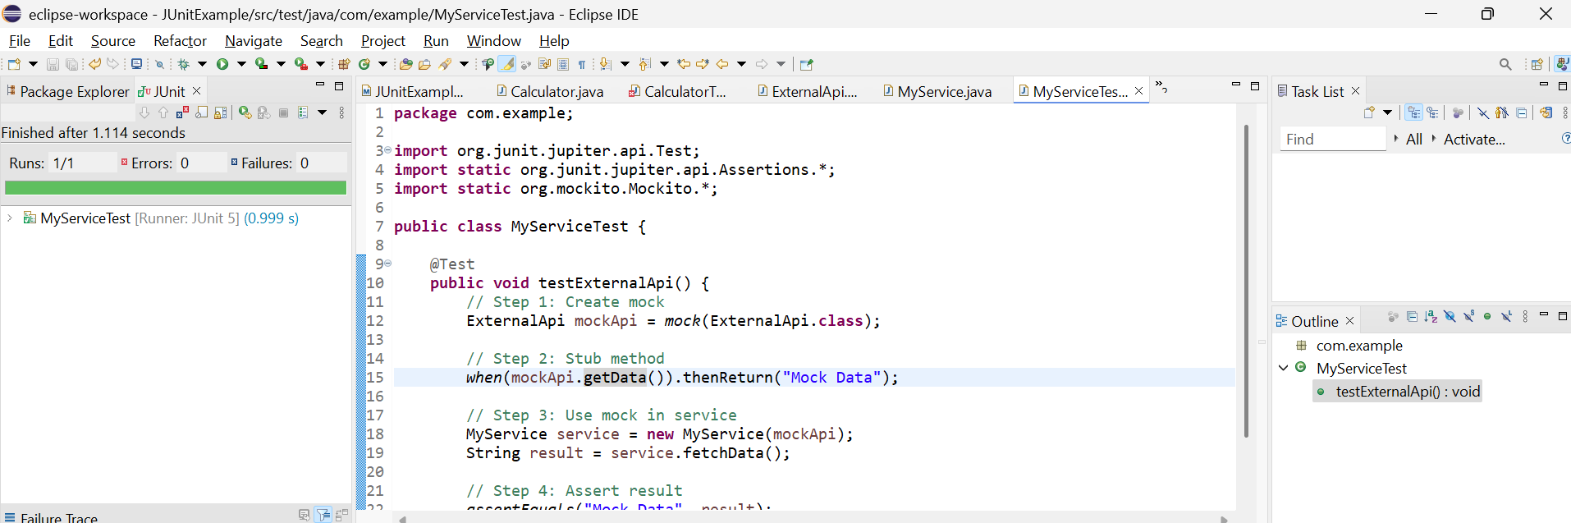

**Exercise 2: Verifying Interactions**

**ExternalApi.java**

package com.example;

// This simulates an external dependency

public interface ExternalApi {

String getData();

}

**MyService.java**

package com.example;

public class MyService {

private ExternalApi api;

public MyService(ExternalApi api) {

this.api = api;

}

public String fetchData() {

return api.getData();

}

}

**MyServiceTest.java**

package com.example;

import org.junit.jupiter.api.Test;

import static org.mockito.Mockito.*;

public class MyServiceTest {

@Test

public void testVerifyInteraction() {

// Step 1: Create mock object

ExternalApi mockApi = mock(ExternalApi.class);

// Step 2: Inject mock into service

MyService service = new MyService(mockApi);

// Step 3: Call method

service.fetchData();

// Step 4: Verify that getData() was called

verify(mockApi).getData(); // ✅ This is what we're testing

}

}

**Output:**

