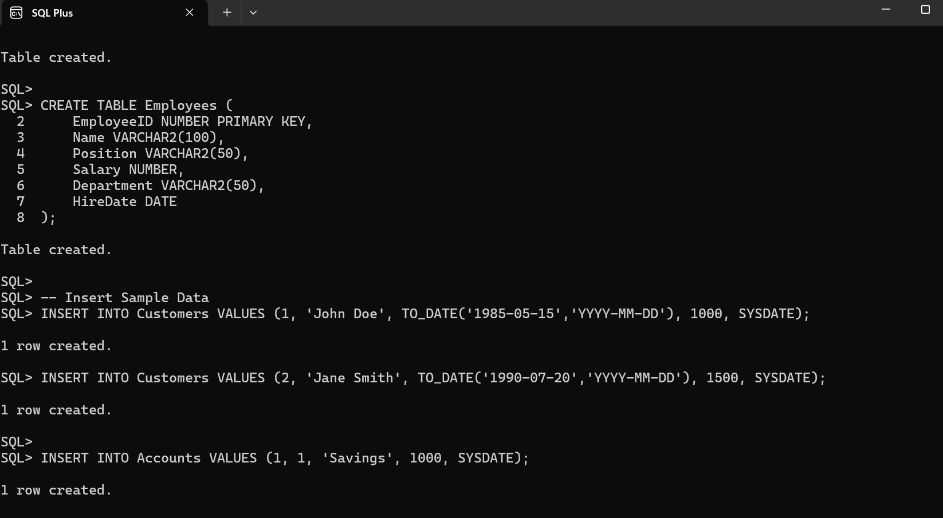

Exercise 1: Control Structures

BEGIN

FOR cust IN (SELECT * FROM Customers) LOOP

IF MONTHS_BETWEEN(SYSDATE, cust.DOB) / 12 > 60 THEN

UPDATE Loans SET InterestRate = InterestRate - 1 WHERE CustomerID = cust.CustomerID;

END IF;

END LOOP;

END;

/

**Output**

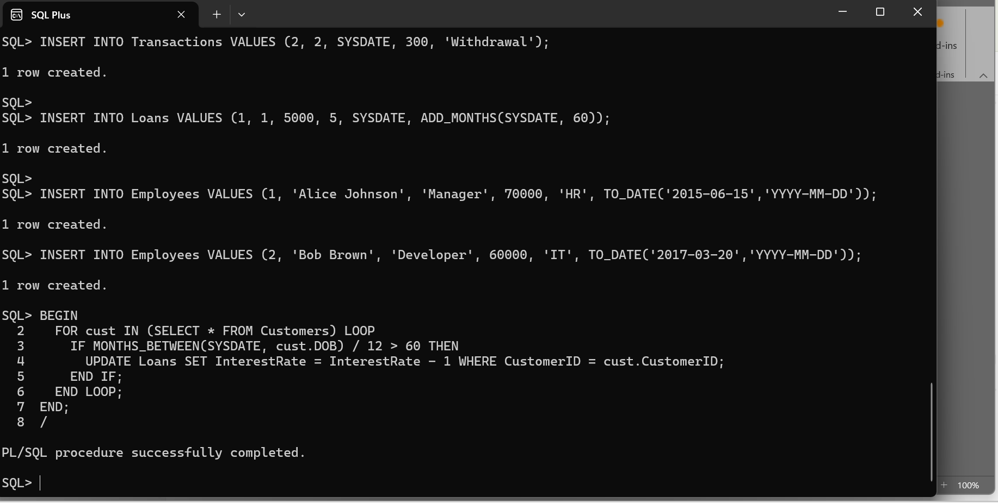

**Exercise 2: Error Handling**

**Scenario 1:**

CREATE OR REPLACE PROCEDURE SafeTransferFunds (

p_from_account_id IN NUMBER,

p_to_account_id IN NUMBER,

p_amount IN NUMBER

) IS

insufficient_balance EXCEPTION;

v_balance NUMBER;

BEGIN

-- Check balance in source account

SELECT Balance INTO v_balance FROM Accounts WHERE AccountID = p_from_account_id;

IF v_balance < p_amount THEN

RAISE insufficient_balance;

END IF;

-- Deduct from source

UPDATE Accounts

SET Balance = Balance - p_amount

WHERE AccountID = p_from_account_id;

-- Add to destination

UPDATE Accounts

SET Balance = Balance + p_amount

WHERE AccountID = p_to_account_id;

COMMIT;

DBMS_OUTPUT.PUT_LINE('Transfer successful.');

EXCEPTION

WHEN insufficient_balance THEN

ROLLBACK;

DBMS_OUTPUT.PUT_LINE('Error: Insufficient balance for transfer.');

WHEN OTHERS THEN

ROLLBACK;

DBMS_OUTPUT.PUT_LINE('Error occurred: ' || SQLERRM);

END;

/

**Scenario 2:**

CREATE OR REPLACE PROCEDURE UpdateSalary (

p_employee_id IN NUMBER,

p_percentage IN NUMBER

) IS

v_salary NUMBER;

BEGIN

-- Fetch current salary to verify employee exists

SELECT Salary INTO v_salary FROM Employees WHERE EmployeeID = p_employee_id;

-- Update salary

UPDATE Employees

SET Salary = Salary + (Salary * p_percentage / 100)

WHERE EmployeeID = p_employee_id;

COMMIT;

DBMS_OUTPUT.PUT_LINE('Salary updated successfully.');

EXCEPTION

WHEN NO_DATA_FOUND THEN

DBMS_OUTPUT.PUT_LINE('Error: Employee not found.');

WHEN OTHERS THEN

DBMS_OUTPUT.PUT_LINE('Error occurred: ' || SQLERRM);

END;

/

**Scenario 3:**

CREATE OR REPLACE PROCEDURE AddNewCustomer (

p_id IN NUMBER,

p_name IN VARCHAR2,

p_dob IN DATE,

p_balance IN NUMBER

) IS

BEGIN

INSERT INTO Customers (CustomerID, Name, DOB, Balance, LastModified)

VALUES (p_id, p_name, p_dob, p_balance, SYSDATE);

COMMIT;

DBMS_OUTPUT.PUT_LINE('Customer added successfully.');

EXCEPTION

WHEN DUP_VAL_ON_INDEX THEN

DBMS_OUTPUT.PUT_LINE('Error: Customer ID already exists.');

WHEN OTHERS THEN

DBMS_OUTPUT.PUT_LINE('Error occurred: ' || SQLERRM);

END;

/

**Output**

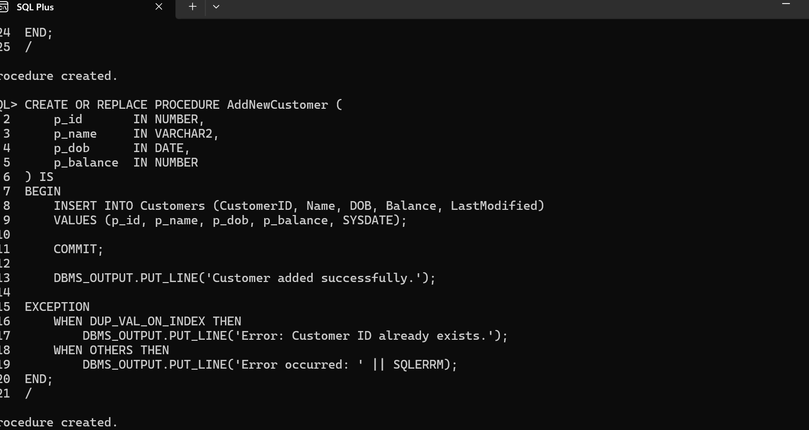

**Exercise 3: Stored Procedures**

**Scenario 1:**

CREATE OR REPLACE PROCEDURE ProcessMonthlyInterest IS

BEGIN

UPDATE Accounts

SET Balance = Balance + (Balance * 0.01),

LastModified = SYSDATE

WHERE AccountType = 'Savings';

COMMIT;

DBMS_OUTPUT.PUT_LINE('Monthly interest processed for savings accounts.');

END;

/

**Scenario 2:**

CREATE OR REPLACE PROCEDURE UpdateEmployeeBonus (

p_department IN VARCHAR2,

p_bonus_pct IN NUMBER

) IS

BEGIN

UPDATE Employees

SET Salary = Salary + (Salary * p_bonus_pct / 100)

WHERE Department = p_department;

COMMIT;

DBMS_OUTPUT.PUT_LINE('Bonus updated for ' || p_department || ' department.');

END;

/

**Scenario 3:**

CREATE OR REPLACE PROCEDURE TransferFunds (

p_from NUMBER,

p_to NUMBER,

p_amt NUMBER

) IS

v_balance NUMBER;

BEGIN

SELECT Balance INTO v_balance FROM Accounts WHERE AccountID = p_from;

IF v_balance < p_amt THEN

RAISE_APPLICATION_ERROR(-20001, 'Insufficient funds.');

END IF;

UPDATE Accounts SET Balance = Balance - p_amt WHERE AccountID = p_from;

UPDATE Accounts SET Balance = Balance + p_amt WHERE AccountID = p_to;

COMMIT;

DBMS_OUTPUT.PUT_LINE('Funds transferred successfully.');

EXCEPTION

WHEN OTHERS THEN

ROLLBACK;

DBMS_OUTPUT.PUT_LINE('Error: ' || SQLERRM);

END;

/

**Output :**

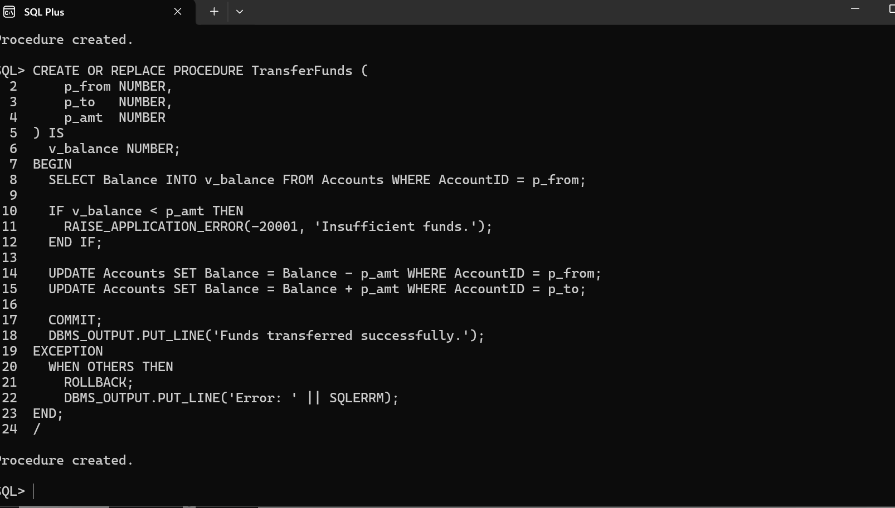

**Exercise 4: Functions**

**Scenario 1:**

CREATE OR REPLACE FUNCTION CalculateAge (

p_dob DATE

) RETURN NUMBER IS

BEGIN

RETURN FLOOR(MONTHS_BETWEEN(SYSDATE, p_dob)/12);

END;

/

**Scenario 2:**

CREATE OR REPLACE FUNCTION CalculateMonthlyInstallment (

p_amount NUMBER,

p_rate NUMBER,

p_years NUMBER

) RETURN NUMBER IS

v_months NUMBER := p_years * 12;

v_r NUMBER := p_rate / (12 * 100);

BEGIN

RETURN ROUND(p_amount * v_r / (1 - POWER(1 + v_r, -v_months)), 2);

END;

/

**Scenario 3:**

CREATE OR REPLACE FUNCTION HasSufficientBalance (

p_account_id NUMBER,

p_amount NUMBER

) RETURN BOOLEAN IS

v_balance NUMBER;

BEGIN

SELECT Balance INTO v_balance FROM Accounts WHERE AccountID = p_account_id;

RETURN v_balance >= p_amount;

EXCEPTION

WHEN NO_DATA_FOUND THEN

RETURN FALSE;

END;

/

**Output:**

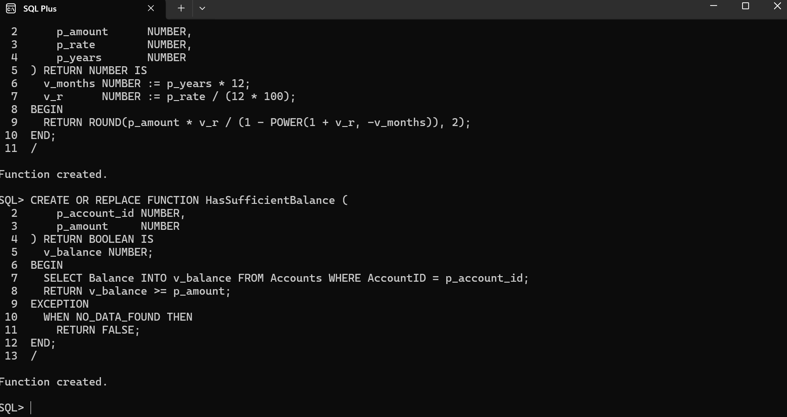

**Exercise 5: Triggers**

**Scenario 1:**

CREATE OR REPLACE TRIGGER UpdateCustomerLastModified

BEFORE UPDATE ON Customers

FOR EACH ROW

BEGIN

:NEW.LastModified := SYSDATE;

END;

/

**Scenario 2:**

CREATE TABLE AuditLog (

LogID NUMBER GENERATED ALWAYS AS IDENTITY,

AccountID NUMBER,

Action VARCHAR2(50),

LogTime DATE

);

CREATE OR REPLACE TRIGGER LogTransaction

AFTER INSERT ON Transactions

FOR EACH ROW

BEGIN

INSERT INTO AuditLog (AccountID, Action, LogTime)

VALUES (:NEW.AccountID, 'Transaction Inserted', SYSDATE);

END;

/

**Scenario 3:**

CREATE OR REPLACE TRIGGER CheckTransactionRules

BEFORE INSERT ON Transactions

FOR EACH ROW

DECLARE

v_balance NUMBER;

BEGIN

SELECT Balance INTO v_balance FROM Accounts WHERE AccountID = :NEW.AccountID;

IF :NEW.TransactionType = 'Withdrawal' AND :NEW.Amount > v_balance THEN

RAISE_APPLICATION_ERROR(-20002, 'Withdrawal exceeds balance.');

ELSIF :NEW.TransactionType = 'Deposit' AND :NEW.Amount <= 0 THEN

RAISE_APPLICATION_ERROR(-20003, 'Deposit amount must be positive.');

END IF;

END;

/

**Output:**

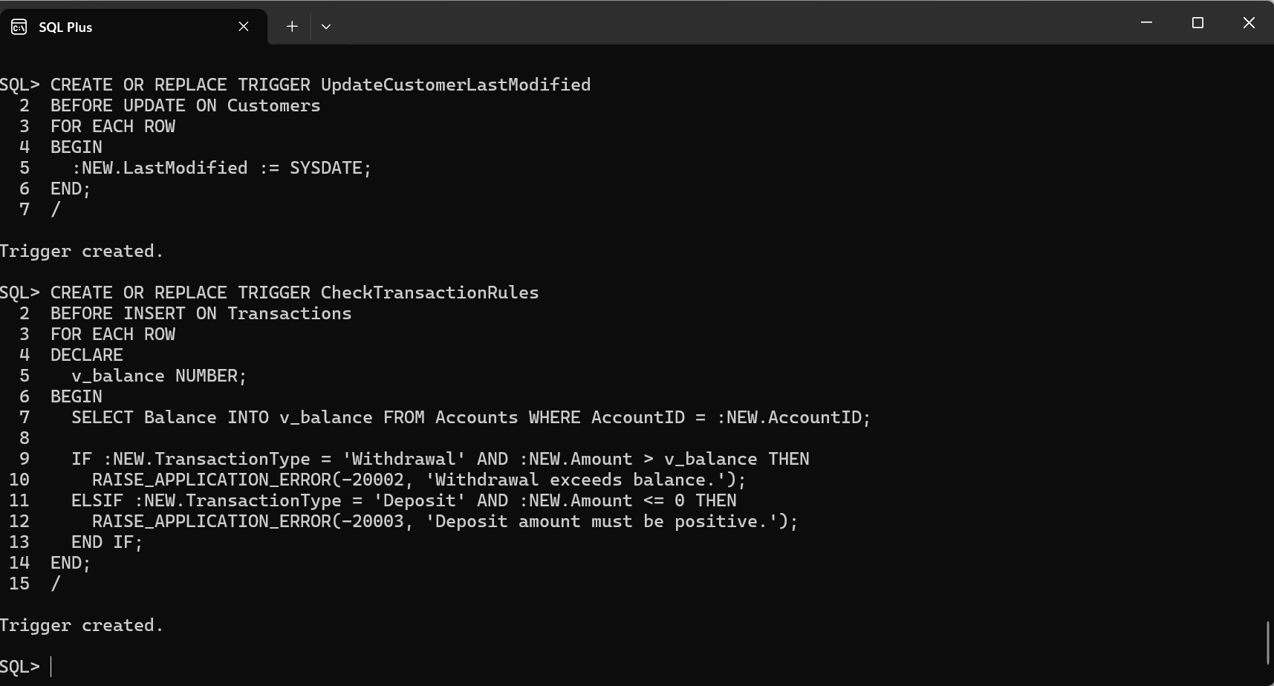

**Exercise 6: Cursors**

**Scenario 1:**

BEGIN

FOR rec IN (

SELECT A.CustomerID, T.TransactionDate, T.Amount, T.TransactionType

FROM Transactions T

JOIN Accounts A ON A.AccountID = T.AccountID

WHERE EXTRACT(MONTH FROM T.TransactionDate) = EXTRACT(MONTH FROM SYSDATE)

) LOOP

DBMS_OUTPUT.PUT_LINE('Customer ' || rec.CustomerID || ': ' || rec.TransactionType || ' of $' || rec.Amount);

END LOOP;

END;

/

**Scenario 2:**

DECLARE

CURSOR fee_cur IS SELECT AccountID, Balance FROM Accounts;

BEGIN

FOR rec IN fee_cur LOOP

UPDATE Accounts

SET Balance = Balance - 100, LastModified = SYSDATE

WHERE AccountID = rec.AccountID;

END LOOP;

COMMIT;

DBMS_OUTPUT.PUT_LINE('Annual fee applied.');

END;

/

**Scenario 3:**

DECLARE

CURSOR loan_cur IS SELECT LoanID, InterestRate FROM Loans;

BEGIN

FOR rec IN loan_cur LOOP

UPDATE Loans

SET InterestRate = rec.InterestRate + 0.5

WHERE LoanID = rec.LoanID;

END LOOP;

COMMIT;

DBMS_OUTPUT.PUT_LINE('Loan interest rates updated.');

END;

/

**Output:**

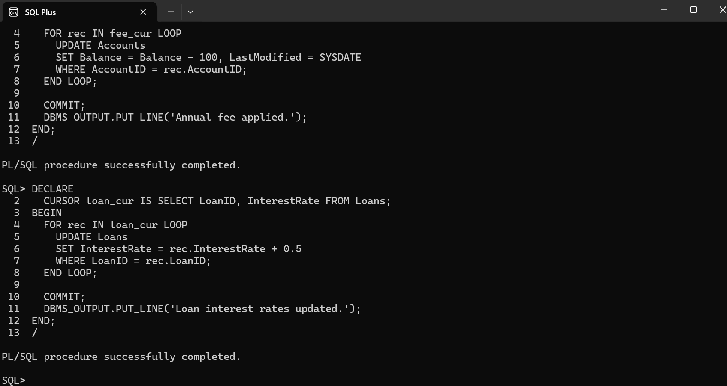

**Exercise 7: Packages**

**Scenario 1:**

CREATE OR REPLACE PACKAGE CustomerManagement IS

PROCEDURE AddCustomer(p_id NUMBER, p_name VARCHAR2, p_dob DATE, p_balance NUMBER);

FUNCTION GetBalance(p_id NUMBER) RETURN NUMBER;

END;

/

CREATE OR REPLACE PACKAGE BODY CustomerManagement IS

PROCEDURE AddCustomer(p_id NUMBER, p_name VARCHAR2, p_dob DATE, p_balance NUMBER) IS

BEGIN

INSERT INTO Customers VALUES (p_id, p_name, p_dob, p_balance, SYSDATE);

END;

FUNCTION GetBalance(p_id NUMBER) RETURN NUMBER IS

v_balance NUMBER;

BEGIN

SELECT Balance INTO v_balance FROM Customers WHERE CustomerID = p_id;

RETURN v_balance;

END;

END;

/

**Scenario 2:**

CREATE OR REPLACE PACKAGE EmployeeManagement IS

PROCEDURE HireEmployee(p_id NUMBER, p_name VARCHAR2, p_pos VARCHAR2, p_salary NUMBER, p_dept VARCHAR2, p_date DATE);

FUNCTION GetAnnualSalary(p_id NUMBER) RETURN NUMBER;

END;

/

CREATE OR REPLACE PACKAGE BODY EmployeeManagement IS

PROCEDURE HireEmployee(p_id NUMBER, p_name VARCHAR2, p_pos VARCHAR2, p_salary NUMBER, p_dept VARCHAR2, p_date DATE) IS

BEGIN

INSERT INTO Employees VALUES (p_id, p_name, p_pos, p_salary, p_dept, p_date);

END;

FUNCTION GetAnnualSalary(p_id NUMBER) RETURN NUMBER IS

v_salary NUMBER;

BEGIN

SELECT Salary INTO v_salary FROM Employees WHERE EmployeeID = p_id;

RETURN v_salary * 12;

END;

END;

/

**Scenario 3:**

CREATE OR REPLACE PACKAGE AccountOperations IS

PROCEDURE OpenAccount(p_id NUMBER, p_custid NUMBER, p_type VARCHAR2, p_balance NUMBER);

PROCEDURE CloseAccount(p_id NUMBER);

FUNCTION TotalBalance(p_custid NUMBER) RETURN NUMBER;

END;

/

CREATE OR REPLACE PACKAGE BODY AccountOperations IS

PROCEDURE OpenAccount(p_id NUMBER, p_custid NUMBER, p_type VARCHAR2, p_balance NUMBER) IS

BEGIN

INSERT INTO Accounts VALUES (p_id, p_custid, p_type, p_balance, SYSDATE);

END;

PROCEDURE CloseAccount(p_id NUMBER) IS

BEGIN

DELETE FROM Accounts WHERE AccountID = p_id;

END;

FUNCTION TotalBalance(p_custid NUMBER) RETURN NUMBER IS

v_total NUMBER;

BEGIN

SELECT SUM(Balance) INTO v_total FROM Accounts WHERE CustomerID = p_custid;

RETURN NVL(v_total, 0);

END;

END;

/

**Output:**

