**Exercise 1:**

**App.js**

**import React from 'react';**

function App() {

  return (

    <div>

      <h1>Welcome to the first session of React</h1>

    </div>

  );

}

export default App;

**Output:**

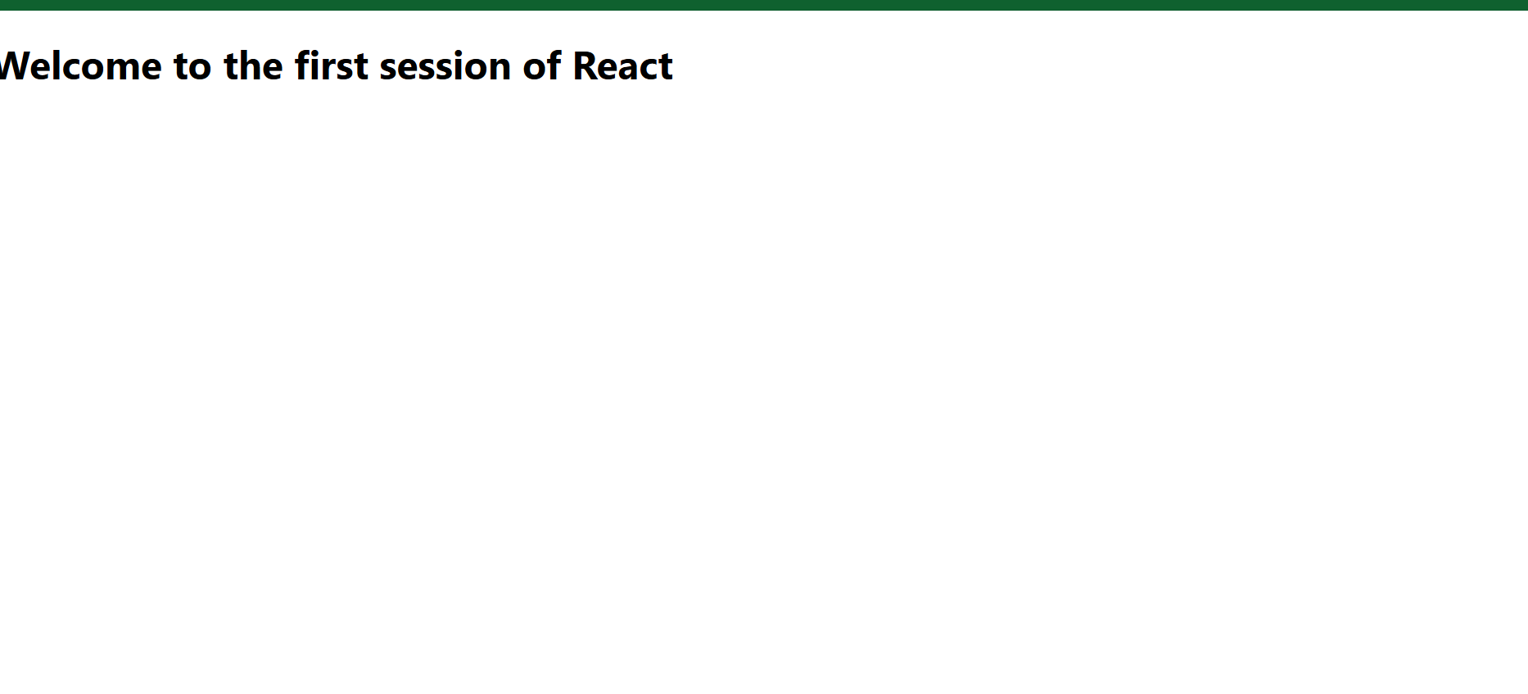

**Exercise 2:**

**Home.js**

import React from 'react';

function Home() {

return (

<div>

<h2>Welcome to the Home page of Student Management Portal</h2>

</div>

);

}

export default Home;

**About.js**

import React from 'react';

function About() {

return (

<div>

<h2>Welcome to the About page of the Student Management Portal</h2>

</div>

);

}

export default About;

**Contact.js**

import React from 'react';

function Contact() {

return (

<div>

<h2>Welcome to the Contact page of the Student Management Portal</h2>

</div>

);

}

export default Contact;

**Output:**

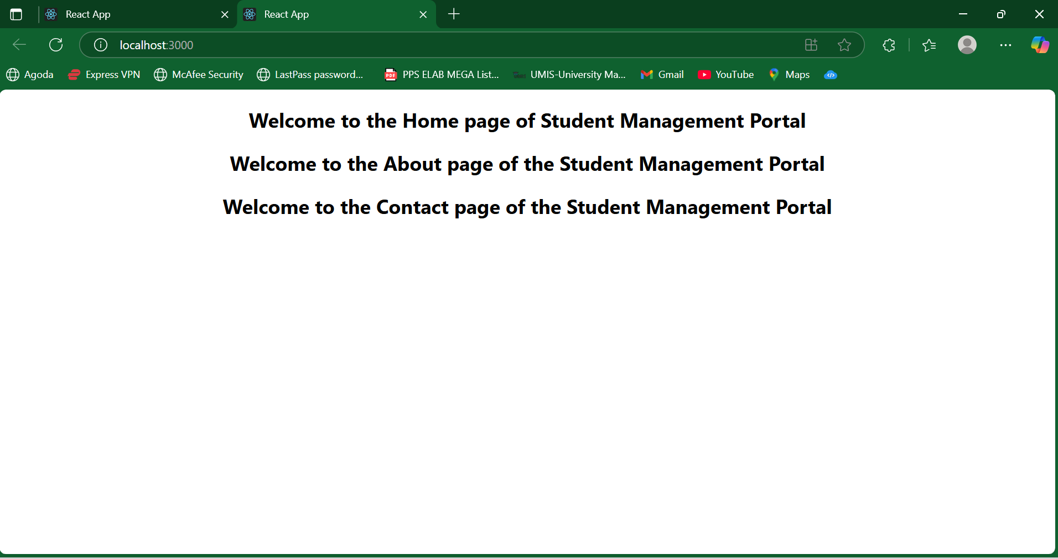

**Exercise 3:**

**CalculateScore.js**

import React, { useState } from 'react';

import '../Stylesheets/mystyle.css';

function CalculateScore() {

const [name, setName] = useState('');

const [school, setSchool] = useState('');

const [total, setTotal] = useState('');

const [goal, setGoal] = useState('');

const [average, setAverage] = useState(null);

const handleCalculate = () => {

const avg = Number(total) / 5;

setAverage(avg.toFixed(2));

};

return (

<div className="score-container">

<h2>Student Score Calculator</h2>

<input type="text" placeholder="Enter Name" value={name} onChange={(e) => setName(e.target.value)} />

<input type="text" placeholder="Enter School" value={school} onChange={(e) => setSchool(e.target.value)} />

<input type="number" placeholder="Enter Total Marks" value={total} onChange={(e) => setTotal(e.target.value)} />

<input type="text" placeholder="Enter Goal" value={goal} onChange={(e) => setGoal(e.target.value)} />

<button onClick={handleCalculate}>Calculate Average</button>

{average && (

<div className="result">

<p>Name: {name}</p>

<p>School: {school}</p>

<p>Goal: {goal}</p>

<p>Average Score: {average}</p>

</div>

)}

</div>

);

}

export default CalculateScore;

**mystyle.css**

.score-container {

margin: 20px auto;

padding: 30px;

width: 300px;

background-color: #f3f3f3;

border-radius: 10px;

text-align: center;

box-shadow: 0 0 10px rgba(0, 0, 0, 0.1);

}

.score-container input {

margin: 8px 0;

padding: 8px;

width: 90%;

border: 1px solid #ccc;

border-radius: 5px;

}

.score-container button {

margin-top: 10px;

padding: 8px 16px;

background-color: #28a745;

border: none;

color: white;

border-radius: 5px;

cursor: pointer;

}

.score-container .result {

margin-top: 20px;

background-color: #e9ffe9;

padding: 10px;

border-radius: 5px;

}

**App.js**

import React from 'react';

import './App.css';

import CalculateScore from './Components/CalculateScore';

function App() {

return (

<div className="App">

<CalculateScore />

</div>

);

}

export default App;

**Output:**

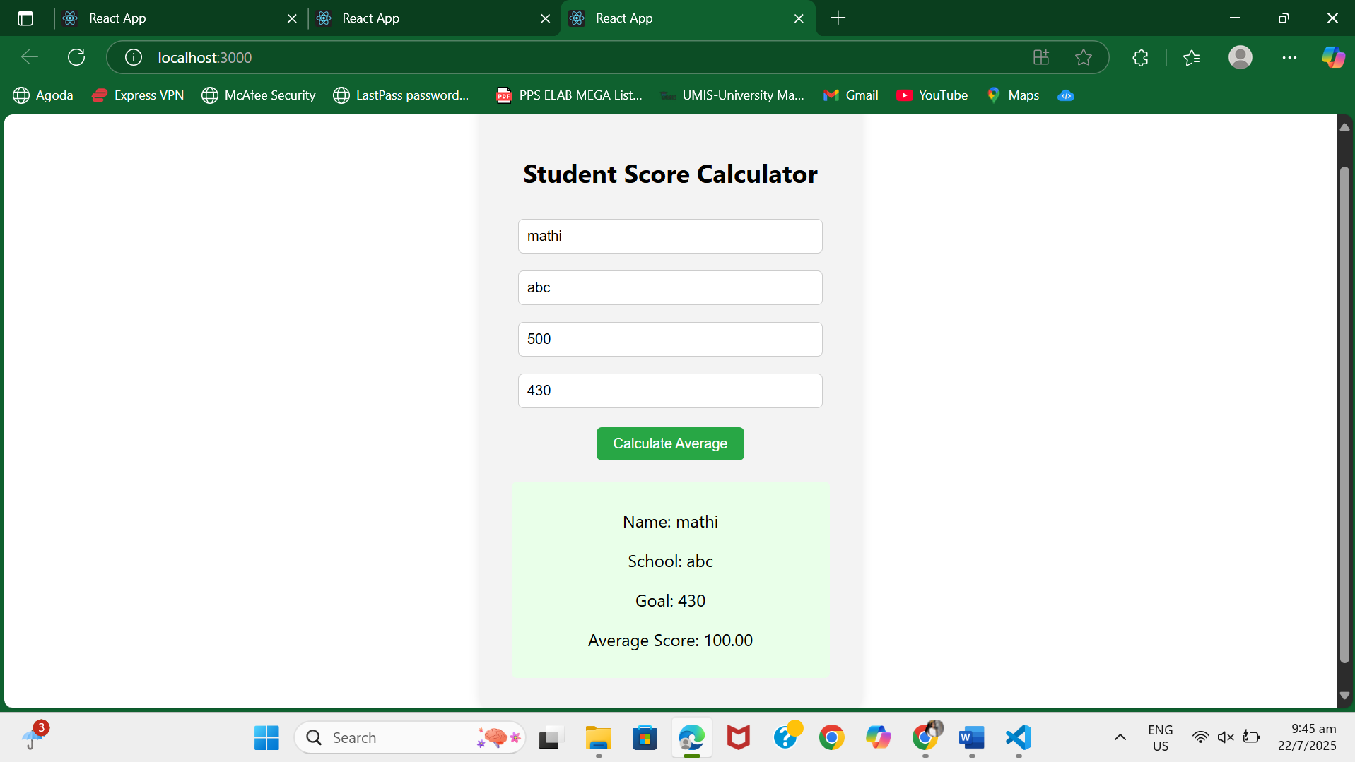

**Exercise 4:**

**Post.js**

// Post.js

class Post {

constructor(userId, id, title, body) {

this.userId = userId;

this.id = id;

this.title = title;

this.body = body;

}

}

export default Post;

**Posts.js:**

// Posts.js

import React, { Component } from 'react';

import Post from './Post';

class Posts extends Component {

constructor(props) {

super(props);

this.state = {

posts: [],

hasError: false,

};

}

// Fetch posts from the API

loadPosts = async () => {

try {

const response = await fetch('https://jsonplaceholder.typicode.com/posts');

const data = await response.json();

const postObjects = data.map(item => new Post(item.userId, item.id, item.title, item.body));

this.setState({ posts: postObjects });

} catch (error) {

this.setState({ hasError: true });

console.error("Error fetching posts:", error);

}

};

// Lifecycle hook

componentDidMount() {

this.loadPosts();

}

// Error boundary

componentDidCatch(error, info) {

alert('Something went wrong while rendering posts.');

console.error("Error caught in componentDidCatch:", error, info);

}

render() {

return (

<div>

<h1>Blog Posts</h1>

{this.state.posts.length === 0 ? (

<p>Loading...</p>

) : (

this.state.posts.slice(0, 10).map((post) => (

<div key={post.id} style={{ marginBottom: "20px" }}>

<h3>{post.title}</h3>

<p>{post.body}</p>

</div>

))

)}

</div>

);

}

}

export default Posts;

**App.js**

import React from 'react';

import './App.css';

import Posts from './Posts';

function App() {

return (

<div className="App">

<Posts />

</div>

);

}

export default App;

**Output:**

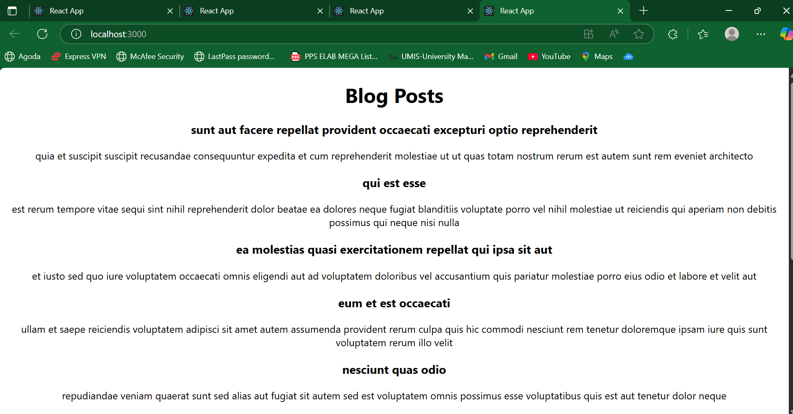

**Exercise 5:**

**CohortDetails.module.css**

.box {

width: 300px;

display: inline-block;

margin: 10px;

padding: 10px 20px;

border: 1px solid black;

border-radius: 10px;

}

dt {

font-weight: 500;

}

**CohortDetails.jsx**

import React from 'react';

import styles from './CohortDetails.module.css';

function CohortDetails(props) {

const { name, startDate, endDate, status } = props;

const statusStyle = {

color: status === 'ongoing' ? 'green' : 'blue',

};

return (

<div className={styles.box}>

<h3 style={statusStyle}>{name}</h3>

<dl>

<dt>Start Date:</dt>

<dd>{startDate}</dd>

<dt>End Date:</dt>

<dd>{endDate}</dd>

<dt>Status:</dt>

<dd>{status}</dd>

</dl>

</div>

);

}

export default CohortDetails;

**App.js**

import React from 'react';

import './App.css';

import CohortDetails from './CohortDetails';

function App() {

return (

<div className="App">

<CohortDetails name="React Bootcamp" startDate="2025-06-01" endDate="2025-07-15" status="ongoing" />

<CohortDetails name="Java Basics" startDate="2025-05-01" endDate="2025-06-10" status="completed" />

</div>

);

}

export default App;

**Output:**

