Docker containerization

Index
italic _words - referral words
Underlined words - words exactly used

Docker commands:

Commands | Definition | Example
Docker pull image_name | Pulls the image from the docker hub
Docker run image_name | Runs the image-> container
- Docker run image_name:ver | Pulls the specified version of docker and runs the image in a single shot | Docker run redis:4.0
- Docker run --name container_name image_name | Image_name - name we’re assigning for the container
Naming the container | While creating the container:  - Docker run --name container_name image_name  Renaming  - docker rename <current_auto_name_or_id> <new_name>
Docker stop container_name | Stops the container
Docker start -d container_name | starts/Restarts the container detached
- Docker attach container_name | To attach to the container’s cmd prompt
Docker rm container_name | Removes the container
- Docker rm -f container_name | Force removal, -f: removes the running container too
- Docker rmi image_name | Removes image  - The container must be removed before rmi.
Docker ps -s | process status of running containers with size(-s)
- Docker ps -a | Process status of all(running & stopped) containers
Docker images | Shows all the images
Binding
- Binding the container port to a host port
Docker run -p host_port:container_port container name | Assigning host port to the container port; so that the process running in the container’s specified port can hear through the host's specified port. | docker run -d -p 6001:6379 --name redis_1 redis
Network
Docker network create network_name | To create an isolated network from the local machine’s network
Troubleshooting & Logs
Docker logs container_name
- Docker logs -f container_name | Follow up with the real time logs
docker exec -it <container_name> /bin/bash | Getting into the container as root user - to manage the processes & complexities in the container  - All the host commands won’t be available inside container
docker logs container_id | tail
- Shows the last activity in logs - last 10 lines
docker logs -f container_id
- Follow up with the real time logs

Docker Compose
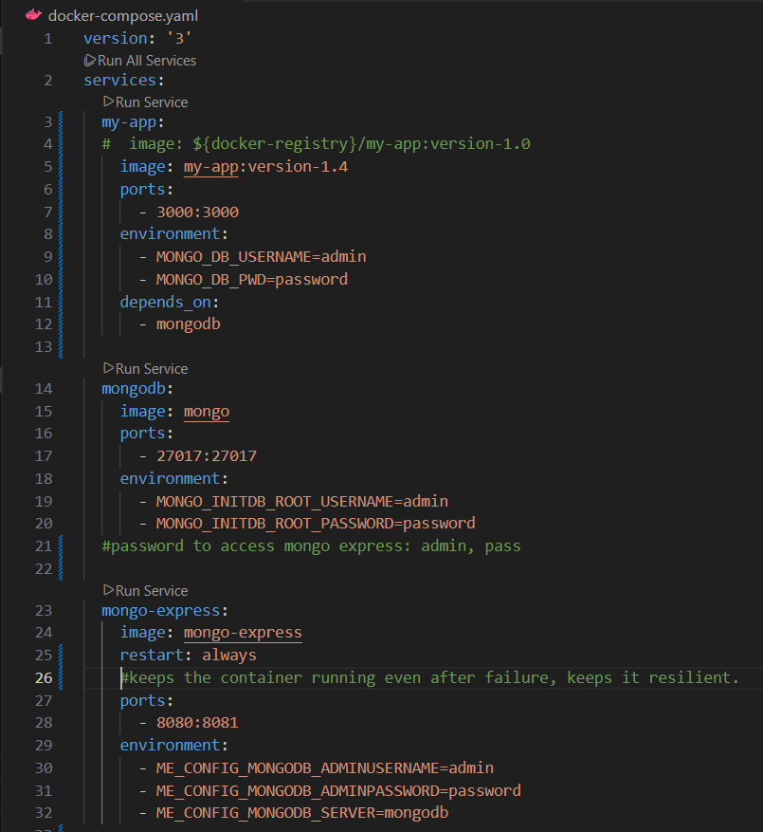
- To manage multi-container application using a single YAML file.
Compose
- YAML file is created mentioning all the container requirements
- Takes care of creating the network
docker compose -f docker-compose.yaml -p project_name up -d | up - creates the container
docker compose -f docker-compose.yaml -p project_name down | Down - deletes the container
docker compose -f docker-compose.yaml -p project_name | Restart - to cover up the naunces
  start
  stop
  restarestart
docker compose -f docker-compose.yaml -p project_name ps | Ps - process status  Shows the container’s ps specifically - with file name and project name.

Dockerfile
- Creating Image from an application

1. Creating the docker file.  Docker file content: | FROM node  ENV MONGO_DB_USERNAME=admin \  MONGO_DB_PWD=password  RUN mkdir -p /home/app  COPY. /home/app  CMD ["node", "server.js"] | Specifies the required images for this image  Run - to run any command inside container  Copy - copy content from host(outside container space) into container  Cmd - to execute a command while starting a container  - This be overrode by “docker run + commands”
 | FROM node:13-alpine  # Define environment variables  ENV MONGO_DB_USERNAME=admin \  MONGO_DB_PWD=password  # Set working directory inside the container  WORKDIR /home/app  # Copy package.json and package-lock.json first  COPY ./app/package*.json ./  # Install dependencies  RUN npm install  # Copy rest of the application  COPY ./app/ .  # Expose port (optional, for documentation)  EXPOSE 3000  # Start the app  CMD ["node", "server.js"] | Making sure the package*.json file deploys first is important
2. Building image from the Dockerfile | Docker build -t my-app:version-1.0 dir  //once an image’s created, any changes in the Dockerfile has to be rebuilt | -t - tag - to attach any tag to the image name  - Version - to specify the version  My-app - docker file name  Dir - specifies where docker looks for docker file
3. Run the image | Docker run my-app:version-1.0
4. Get into container’s terminal | docker exec -it 51c6912d69f5 /bin/sh  (or)  docker exec -it 51c6912d69f5 /bin/bash | -it - interactive terminal  /bin/sh or /bin/bash - either 1 works  exit - to get out of the terminal

Docker Concepts

Multistage build
Having stages as build stage, Runtime stage will remove the unnecessaries that are required in build stage and the final image with runtime stage(required envt for the application to run) will be of smaller size(1 GB to 200 MB)

# Stage 1: Build
FROM node:18 AS builder
WORKDIR /app
COPY package*.json ./
RUN npm install
COPY . .
RUN npm run build

# Stage 2: Runtime
FROM node:18-slim
WORKDIR /app
COPY --from=builder /app/dist ./dist
COPY package*.json ./
RUN npm install --only=production
CMD ["node", "dist/server.js"]

Cache optimization
Docker stores cache layer for each instruction in the docker file

While “Docker build” docker checks the codebase status with the cache of each instruction, when there’s no change in the codebase, docker uses the cached for build.

Health checks

Docker Project Summary
- Pull mongoDB and mongo express
  - docker pull mongo
  - docker pull mongo-express
- Creating a docker network
  - docker network create mongo-network

- Running mongo db in the mongo-network | image: mongo

docker run -d  -p 27017:27017 \  --name mongodb \  -e MONGO_INITDB_ROOT_USERNAME=admin \  -e MONGO_INITDB_ROOT_PASSWORD=password \  --network mongo-network \  mongo | Specifying port  Name of the db container  Setting db username and  Setting db password  Specifying the network created  Image name

- Running mongo express in the mongo-network | image: mongo-express

docker run -d \  -p 8081:8081 \  --name mongo-express \  --network mongo-network \  -e ME_CONFIG_MONGODB_ADMINUSERNAME=admin \  -e ME_CONFIG_MONGODB_ADMINPASSWORD=password \  -e ME_CONFIG_MONGODB_SERVER=mongodb \  Mongo-express | Specifying port  Name of mongo express container  Specifying mongo-network  Mongo db username &  Password  Database name  Specifying the image

- The mongo-express container is running in the port 8081 access it from the localhost:8081 in browser with the default creds(admin & pass)
- Run the demo node js application in port 3000 with all the connections to mongodb already provided in the code itself.

- Instead of using run for each action, we prefer docker- compose with yaml file
- Creating docker image of the container
  - Creating docker file(with all the files used in developing the apln) -> creating image from the dockerfile -> running container from the image ->
- Docker registry
- Create a repository/registry in AWS
- Then push the docker image in the aws ecr repository
  - Login into email from the terminal
  - Recreate the image in the AWS image forma [registry_domain/ image_name:tag]
  - Push it into AWS

— Done sofar

- Create application - keep all the application related files(necessary to run) under app
  - Make the application into an image - docker file –
  - Problem: here’s the problem, the imaged application’s not working while the apln alone itself’s working.
    - Soln: the package*.json files are imported first then npm is installed then we copied everything inside the container - made npm installed properly with pkg*.json files.
- Pull necessary images for the application to run
- Put all the images in 1 YAML file to run together - docker compose

Docker practice

Docker | Docker compose
Docker pull
Docker run --rm -p 8080:8080 --name container_name image_name  --rm: removes the container once it’s stopped  - p: binds/connects the host port with the container port  --name: name on which the container is created | Docker -f docker_compose.yaml -p project_name up -d  Docker -f docker_compose.yaml -p project_name down
Docker stop | Docker -f docker_compose.yaml -p project_name stop
Docker start -d | Docker -f docker_compose.yaml -p project_name start  Docker -f docker_compose.yaml -p project_name restart
Docker rm -f container_name
Docker ps -as | Docker -f docker_compose.yaml -p project_name ps
Docker logs -f container_name
Docker attach container_name
- To get into container cmd

Docker exec -it container_name /bin/bash
- Get into container root folder

Docker compose.yaml - sirped
services:
my-app:
# image: ${docker-registry}/my-app:version-1.0
image: my-app:version-1.4
restart: always
#keeps the container running even after failure, keeps it resilient.
ports:
- 3000:3000
environment:
- MONGO_DB_USERNAME=admin
- MONGO_DB_PWD=password
depends_on:
- mongodb

Docker file

