Kubernetes

Certified Kubernetes Application Developer (CKAD)
  - Theory

Intro
K8s cluster operates on 2 levels:
The least reqt of an architecture is 2 Master nodes and 3 worker nodes
- Master node
  - API Server is load balanced
  - Etcd – Distributed storage across all master nodes
- Worker nodes

Master node: contains 4 processes called Control Plane | Worker layer
- API Server - Entry point of K8s  - handles cluster mngt requests and authentication(kubectl).  - Based on the request the object(eg: pod) will be created by the respective controller  - Scheduler  - Schedules a pod in the Cluster node  - Once Scheduler schedules in which node the pod has to be installed,  - Kubelet installs the pod in the specified node  - Then Container Runtime runs the pod  - Kube Proxy sets IP route table for the pod in network  - Control Manager== Enforcer  - Ensures the cluster state matches the desired state by checking cluster changes (if anything happens to node), through Scheduler  - Etcd – contains the info of cluster state  - Distributed storage/database of the node & pod conditions and state information | Request: kubectl apply -f deployment.yaml  API Server: Receives request → writes desired state to etcd.  - A deployment object will be created  - API Server notifies deployment controller regarding this new object  - Deployment Controller – creates replicaset, Replicaset Controller – creates pods  - Pods aren’t scheduled to any node yet  Scheduler: schedules the pod in the node(Updates Pod object in etcd via API Server)  Kubelet on the node: sees the pod & tells CR container runtime(containerd).  CR will pull image, create and start the container, manages the lifecycle.  Kube-proxy: Sets up networking – sets up IP route table.  Controller Manager: Ensures desired state matches actual state → reschedules if failures occur.  etcd: Always holds the truth of the cluster’s state.
Controller Manager ---\
Scheduler ---------------- > API Server communicates to> | etcd |
Kbelet -------------------/
- All k8s components will be in connection with API server to check for changes in etcd.
Eg: When the Deployment object is created, the API Server sends a watch event to the controller.

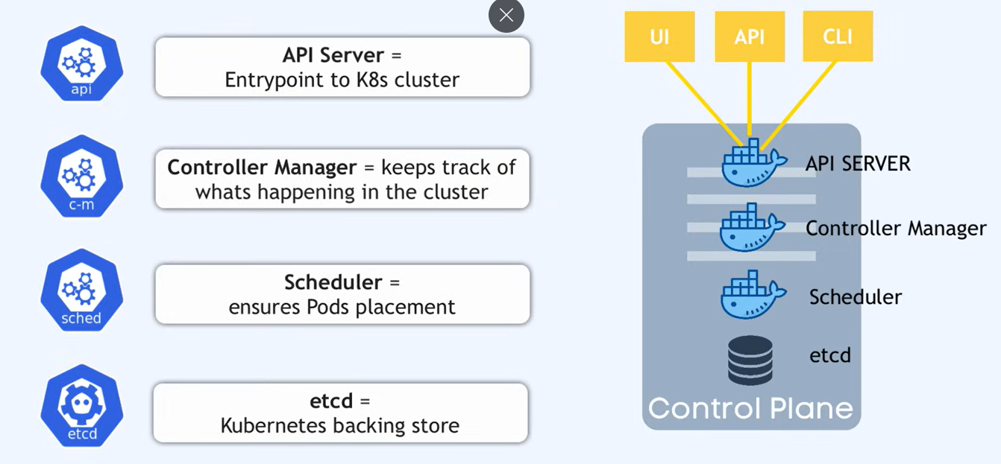

Worker node: contains 3 components – Kubelet, Kube Proxy, Container runtime
- Container runtime – runs containers in pod
- Kube proxy – routing requests among pods (both external & internal)
- Kubelet – installs(pulls image) & ensures the pods are running healthy

- Kubelet – node agent of the node
  - Responsibility – restarts containers if they fail as per pod defn
- Kube proxy
  - Forwarding requests to the pods | Handles pod networking
- Container runtime
  - Engine – runs images in the pod
  - Responsibility – starts & stops pod as instructed by kubelet

K8s Components
- Node
  - contains serveral pods based on the resource availability and requirement
- Pod contains
  - one container – when it’s loosely coupled
  - 1+ container – when it’s tightly coupled
- Service – Used for communication(-> requests and <- responses) to pods
  - Also acts as a Load Balancer
  - External service – for external communication
  - Internal service – for internal communication
  - Ingress – related to DNS – to associate a domain name to pods IP
- Configmap – maps how application behaves
  - Stores application configuration(application behaviour) - application settings at runtime
  - Secret – stores sensitive data in encrypted fromat
- Volumes
  - To store data – Volumes contains the DB, whereas pods contain the aplns
  - Kubernetes has no Data Persistence
- Deployment - Replicas of application pod(Blueprint)
  - For stateless aplns
  - StatefulSet – for stateful aplns and DBs
    - StatefulSet – takes care of synchronizing the data to the core and avoids inconsistencies

User Request flow through k8s
K8s CoreDNS resolves the application name to cluster IP.
- ?Service forwards the request to respective pod endpoint based on the labels
- ?KubeProxy setsup the route table for the request to reach the endpoint
• User hits https://myapp.example.com.
• DNS resolves to the cloud LoadBalancer IP.
• LoadBalancer forwards traffic to NodePort on cluster nodes.
• kube-proxy routes to Service → Endpoints → Pod IP.
• Pod container receives request on port 80/443.
• Application responds → flows back through the same path.

Certified Kubernetes Application Developer (CKAD)

CKAD Certification

Cluster Management/ Kubectl management commands
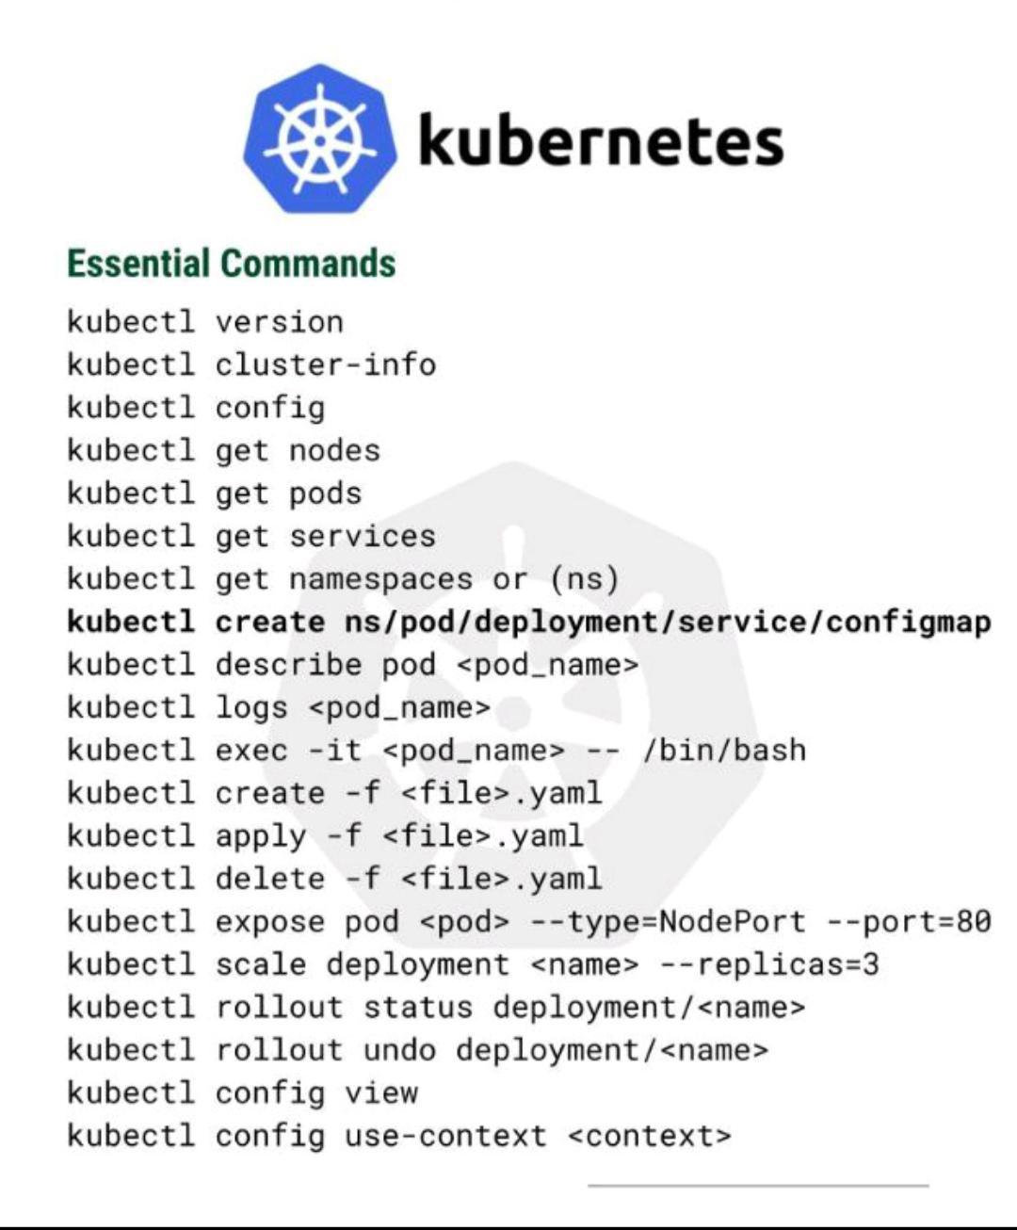

Kube config: contains the current cluster details
- To switch cluster: kubectl config use-context my-cluster-context
K8s health checks:
oc get clusteroperators
-- checks if the cluster operators are working fine if any operator is degraded that will result in issues, we’ll see that

What happens when manifest objects are deleted ?
Eg:
- Deployment manifest will create a ReplicaSet object which manages the pods created.
- Upon deleting the deployment manifest, replicaset ensures the specified pods are running.
- Upon deleting the replicaset,
  - By default, all the pods attached to the replicaset will be deleted.
  - By cascading, the pods will be unattached and run independently.

Resource kinds(objects)
An object will be created for the specified kind
Kind(Resource object) | apiVersion | Role | Description | Others
Pod | v1 | Basic workload unit | Managed by ReplicaSet, Deployment, Job, etc.
ReplicaSet/ ReplicationController | apps/v1 | Ensures N Pods | Provides pods  Controlled by Deployment
Deployment | apps/v1 | Declarative updates | Takes care of deploying the pods in server  Deployment includes – rolling updates, roll back, versioning,.  Owns ReplicaSets; indirectly manages Pods
Service | v1 | Networking abstraction | Takes care of networking  Targets Pods via labels; stable endpoint
Namespace | v1 | Logical grouping | Inside the cluster the resources are segregated into Dev, Staging, Production Namespaces  Contains Pods, Services, Quotas, etc.
ResourceQuota |  | Namespace-wide limits | Applies to all objects in a Namespace
LimitRange |  | Per-Pod/container limits | Complements ResourceQuota
ConfigMap/Secret |  | Configuration storage | Mounted into Pods
PersistentVolume/PVC |  | Storage resources | Bound to Pods via claims

YAMLfile - Top level fields
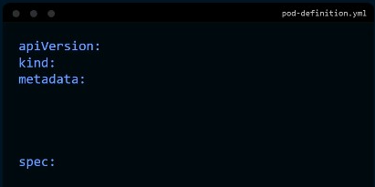
Metadata: only predefined values are allowed inside metadata, however, in the metadata field – labels – we can add: key- value pairs as we wish.
Spec: specifications of the kind and pod
Notes:
- Once the Yaml file is executed(applied) API Server will create object of the yaml and the object will be stored in etcd(the source of truth), then controller & scheduler will work on creating resources respective to the object.

Kubernetes File Structure
Directory | Contents | Purpose
/etc/kubernetes/manifests/ | Static Pod YAMLs: kube-apiserver.yaml, kube-controller-manager.yaml, kube-scheduler.yaml, etcd.yaml | Defines how control plane components run as Pods. Managed directly by kubelet.
/etc/kubernetes/pki/ | Certificates and keys | TLS certs for API server, kubelet, etcd, and client authentication.
/etc/kubernetes/enc/ (custom) | EncryptionConfiguration files (e.g., enc.yaml) | Defines encryption providers and resources (like Secrets) to encrypt at rest.
/var/lib/etcd/ | etcd data directory | Stores all cluster objects (Pods, Deployments, Services, Secrets, ConfigMaps, etc.) in a key-value format.

API server will create object of the yaml file(i.e., resource kinds) and store those objects in etcd
Manifest files: yaml file of control plane components
- Kubelet takes care of the control plane(kube-apiserver.yaml, kube-controller-manager.yaml, kube-scheduler.yaml, etcd.yaml) ensuring the control plane component pods are always running.

Ex: pod_definition.yaml
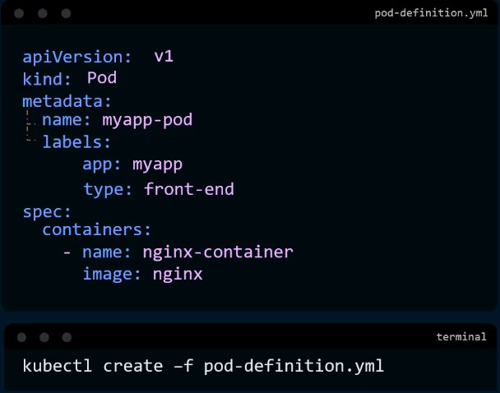

Replication Controller
: sets up replication of pods
- Ensures the specified no. of pods are running all the time irr of failure.
- Takes care of load balancing and scaling out(out of the node)
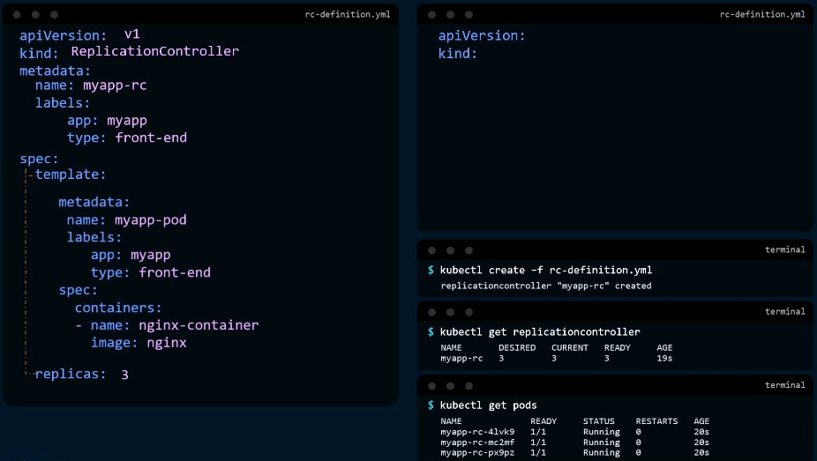

ReplicaSet
= Replica Controller + Selector(Mandatory)
With selector, Replica Set takes care of pods which aren’t created in the specified template.
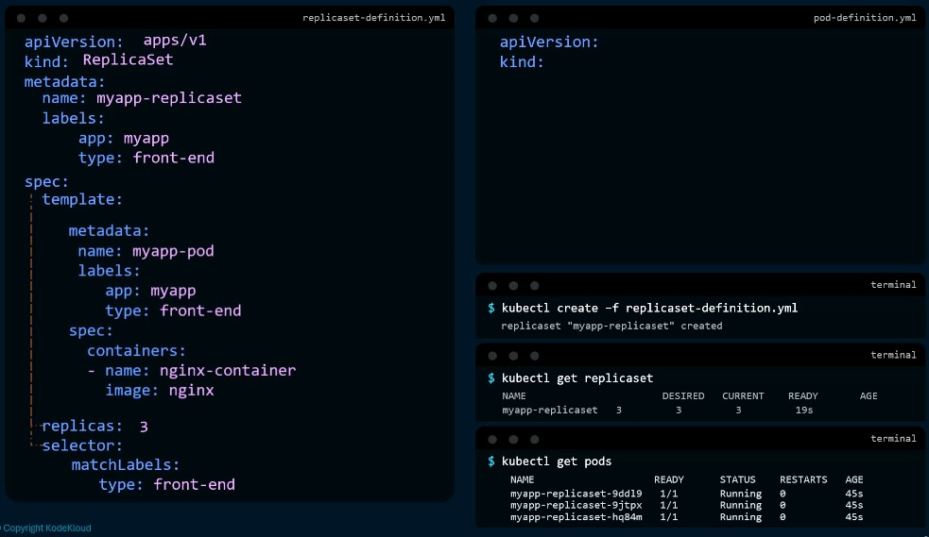
The type: front-end brings other pods of the same type(label) under this ReplicaSet control.
A ReplicaSet object will be created upon applying replicaset manifest file
- Upon deleting the replicaset: kubectl delete replicaset myapp-replicaset, both the replicaset object and pods created&controlled by the replicaset will be deleted.

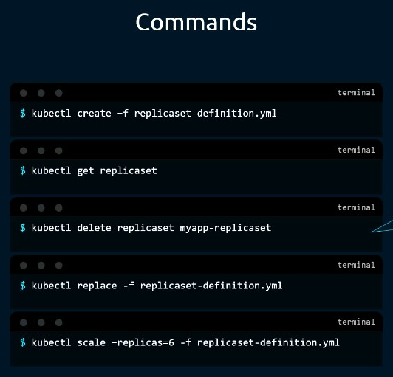
- Diff bw apply & replace:
  - Apply merges the changes alone into existing resource
  - Replace deletes the existing resource and creates new resource

Deployments
Similar to ReplicaSet | Takes care of no. of units to be deployed
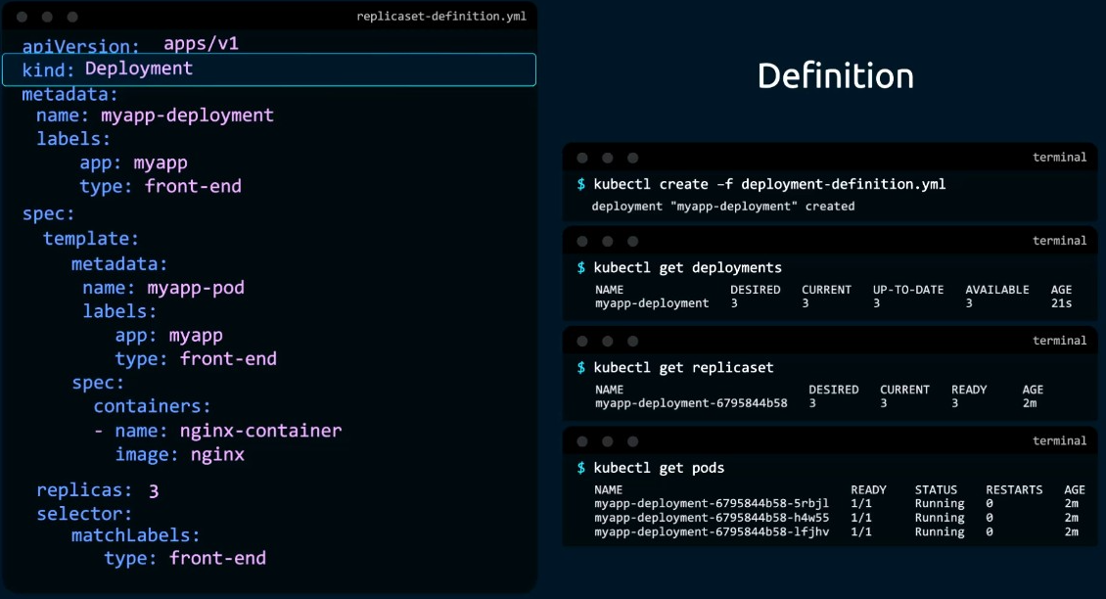

Scaling of Mysql Server:
Master server will be handling the RW,
1 new slave1 server will be introduced, master writes all its data onto the slave
- then master continously replicates the data into slave(slave will be used only for read purpose)
  - for this, slave should be mapped to the master(master should have unique name)
slave1 does the same for slave2

requirements to achieve this:
- Want pods to be created in linear order pod1 1st then pod2,..
- pods should have a unique name
  - recreating pods on the same name, that’s where we use: Stateful Set

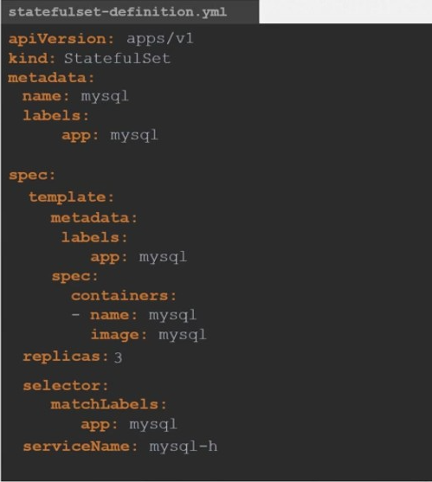
Stateful set
: Ordered Graceful Deployment
- creates pods in linear order with unique name
- recreates the pod in the same unique name

Services
Ensures connectivity interms of loose coupling between components
Types of Service:
- LoadBalancer – LB forwards the incoming request from public to pods
- ClusterIP – Forwards the requests from one pod to another pod in the same cluster.
- ExternalName - Forwards the requests from pods to external services
Load Balancer Service
- LB routes traffic into the cluster’s Service.
- Service forwards to Pods with label app=myapp.
ClusterIP
- Client Pod in the same namespace sends request to a service myapp-service:80.
- Service forwards traffic to one of the Pods with label app=myapp within the cluster.
- Service forwards the traffic to selector label
ExternalName
apiVersion: v1
kind: Service
metadata:
name: payments-api
namespace: production
spec:
type: ExternalName
externalName: payments.company.com
- Routes the traffic from pods to external services beyond clusters
- There will be one ExternalName Service per external dependency

Environment variables, Secrets, ConfigMaps

Commands & Arguments
Docker file:
CMD - replaces the value with the passed argument
Eg:
CMD ["sleep", "5"]
Docker run image_name sleep 10
Command will be executed as CMD ["sleep", "10"] -> Sleep for 10 secs

ENTRYPOINT - appends the passed argument value to the existing
Eg:
ENTRYPOINT ["sleep"]
Docker run image_name 10
Command will be executed as ENTRYPOINT ["sleep", "10"] -> sleeps for 10 secs

--> CMD will act as default value
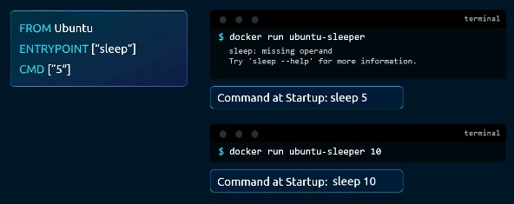

K8s
Respective k8s commands and arguments
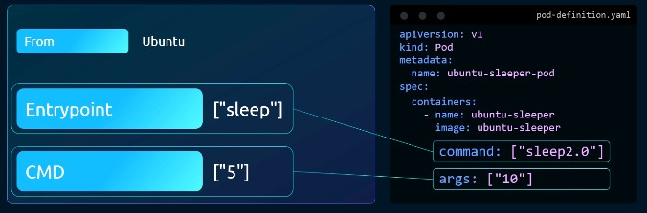

ConfigMaps
- Contains key value pairs, that will be called in the pod Spec.
- The key value pair data can be passed as a configmap yaml file as a whole, as a single envt variable, as a volume
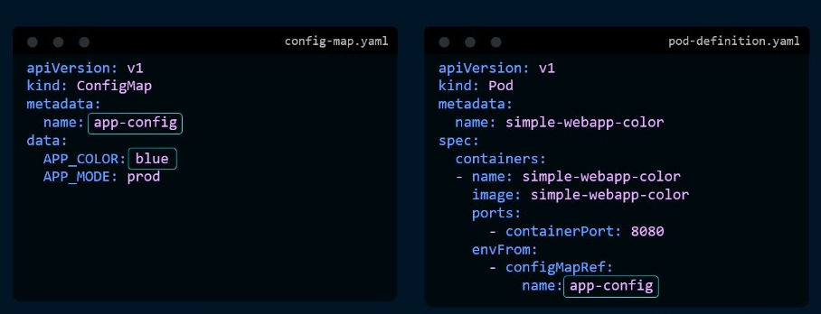

Secrets
Similar to configmaps, but stores the secrets(password & other essential infos) in encrypted format
To store the secrets in encrypted format:
- echo -n ‘secret’ | base64
decode the secrets:
- echo -n ‘hashed_secret’ | base64 –decode
the secret object stored in etcd will expose the ‘secret values’ written in secret.yaml file. To prevent that secret leakage, we’re encrypting the secrets at etcd - Encrypting Secrets Data.

Encrypting Secrets Data
Resource kind: EncryptionConfiguration

Custom Resource Definition
When we create normal resource(eg: deployment.yaml) k8s will store the resource details in Etcd. And the corresponding resource controller will monitor the resource object, create and manage the pods specified by the resource.
Resource Controller manages the state of the resource object as specified

Pods

Designing Pod

Pods II

Multi Container Design Patterns
- Co located Container – 1+ containers run parallely
- Regular Init Container – Init containers 1st start and sets up the space for main container and stops once the job is done
  - Order matters with the instruction initContainers:,
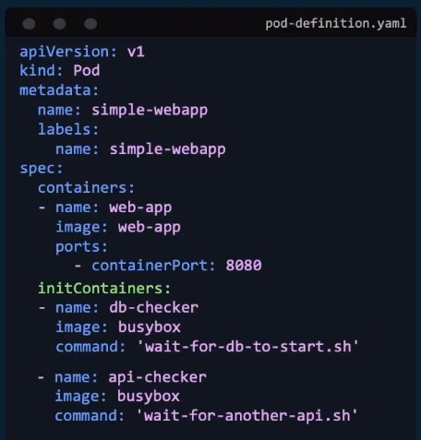
- Side car Container - side car containers start 1st and runs along with the main container and stops after the main container is stopped.
  - Runs along with the main container with restartPolicy: Always,
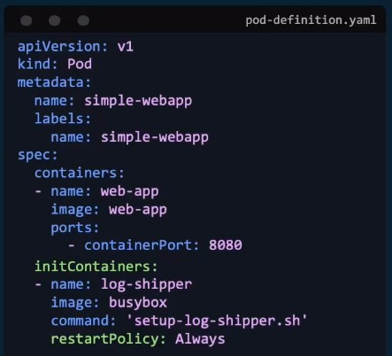

Pod Lifecycle and Status
Conditions
- Pending – Scheduler plans to place the pod
  - Pod Scheduled - ✅once the pods are scheduled
  - Pod Initialized
- Container Creating – images required are pulled and the container is getting started
  - ContainersReady – ✅once the containers in pods are ready
  - Ready - ✅once the pod itself is ready
- Running

Pods Health - Probing
Readiness Probe:
To ensure that the container is running& the pod is responsive, we’re probing the pods regularly with readiness probe:
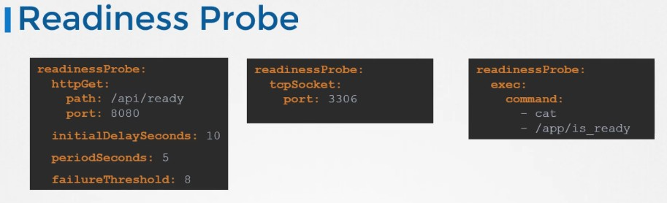

Liveness Probe:
To ensure that the application inside the container is running properly
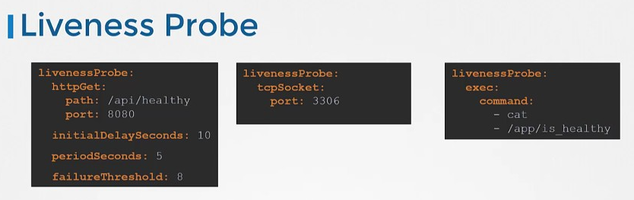

Configuration of pods

Security Contexts
Docker
- to manage user access, and privileged accesses of the processes inside container
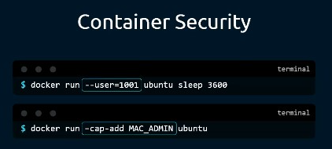

Kubernetes
- runAsUser can be specified at Dockerfile level, pod level or Container level
- specificaiton in K8s has the higher privilige and priority
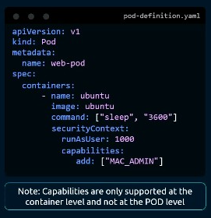

Resource Requests & Limits
Resource Request: the amount of cpu, mem required by the container, based on this only the pod will be scheduled in a node
Resource Limit: the max limit a container could access
Default behaviour: consumes as much resources as required from the node
- to set default value for all the containers, we can use the resource kind: LimitRange
- setting up limit range doesn’t affect existing pods it will be effective on the newly created pods.

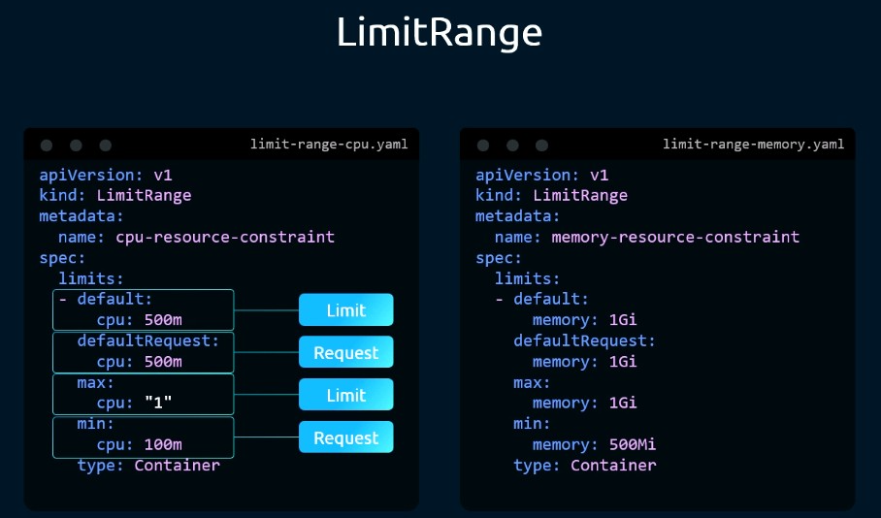

Accounts
2 types of accounts:
- User account
- Service account – account used by interacting services
  - For every namespace – a default service account will be available – limited usage only to check pod conditions.

Scheduling/Restricting pods in/to respective nodes
Taints & Tolerations | Node Selector | Node Affinity
Node’s pespective on accepting only tolerant pods | Pod’s perspective on being scheduled on the right labeled node.  - Strictly scheduled on the labeled nodes | Pod’s perspective on being scheduled on the right labeled nodes.  - Match expressions provide the flexibilty for the pod to be scheduled in more than one node

Taints & Tolerations
- Configured to restrict nodes from accepting other than certain pods
- ❌Won’t gaurantee a pod will always be specified in the certain node ✅Node Affinity
taint:
kubectl taint nodes node1 app=blue:NoSchedule
tolerations:
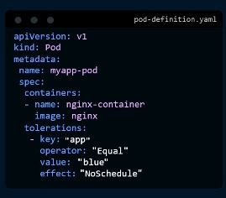

Node Selector
Labeling Node:
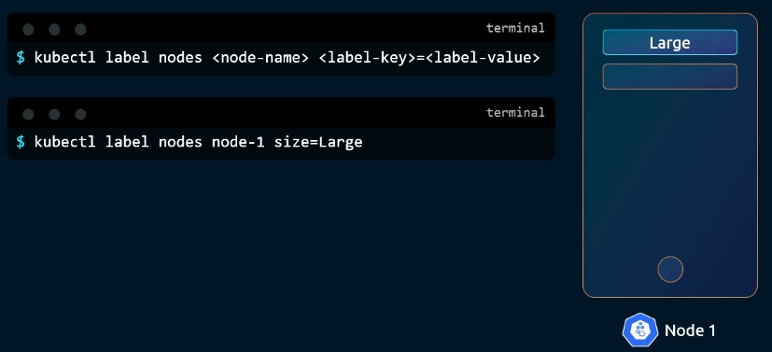
Pod Definition:
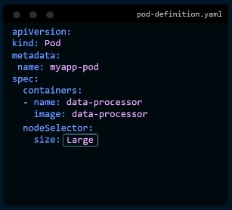

Node Affinity
#comments
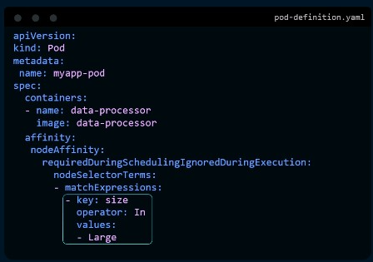
matchExpressions:
operators:
- In
- NotIn
- Exists – used to avoid labelling all the nodes with small capability

Services & Networking
kind: NetworkPolicy
policy types: ingress, egress

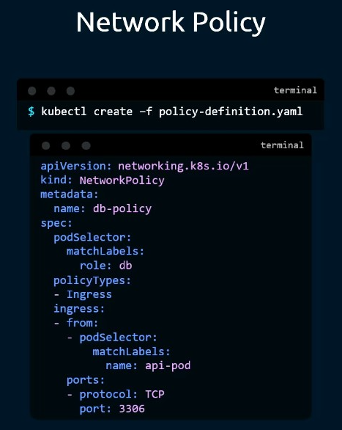
Network policies
Ingress rules:
Pod selector: which pod this rule should be applied to
policyTypes: Ingress
Ingress
From:
  - pod selector: from which pods
Ports: in this protocol, port

Egress:
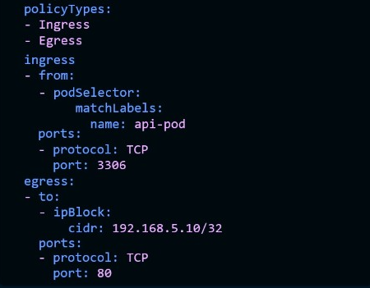
if ingress is allowed, then egress is allowed by default(when request is allowed, response is allowed by default)
-}egress is required when request starts from the pod, not as a response.

Service Vs Ingress rules
- Creating individual service(type: loadbalancer) for each microservice along with cloud provided load balancer will cost much
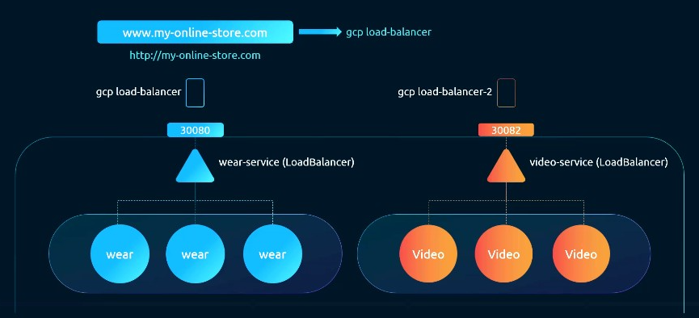
- Solution: using ingress manifest to manage forwarding request to the respective service rather than using dedicated load balancers
  - That way, we’re replacing the ‘reqt of a proxy server’ with ‘ingress controller’ and the configurations with ingress rules (ingress resources)
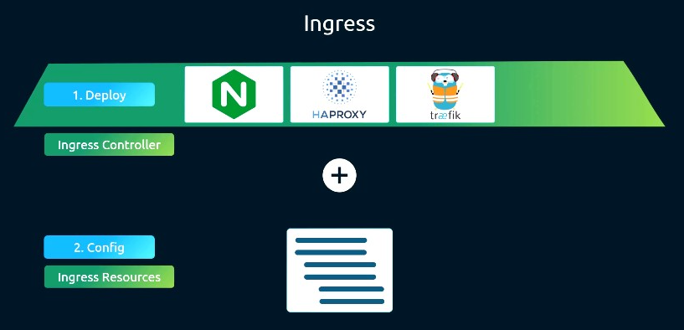
Routing requests(load balancing) with,
Proxy servers === Ingress controller
Configuration === Ingress resources

Deploying Ingress Controller
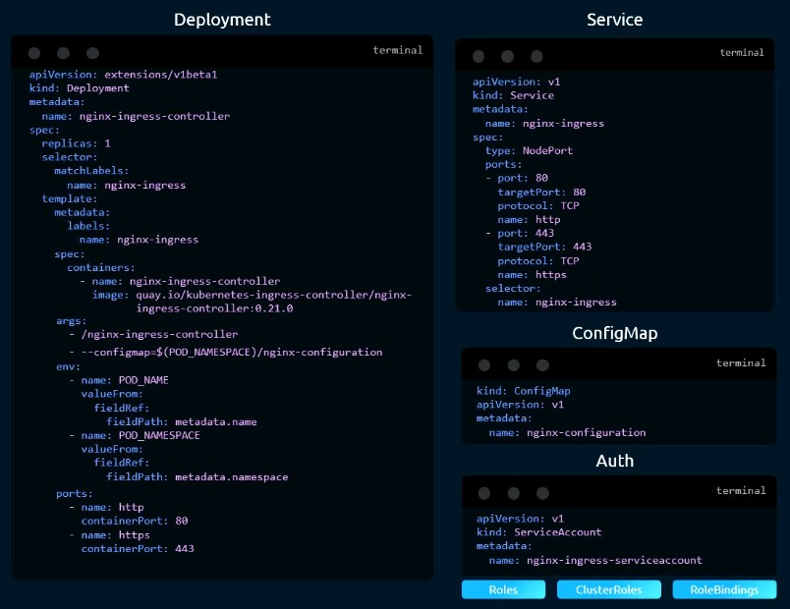

Ingress Resources
- Specifies the path to the respective services, then services will route it to the pods.
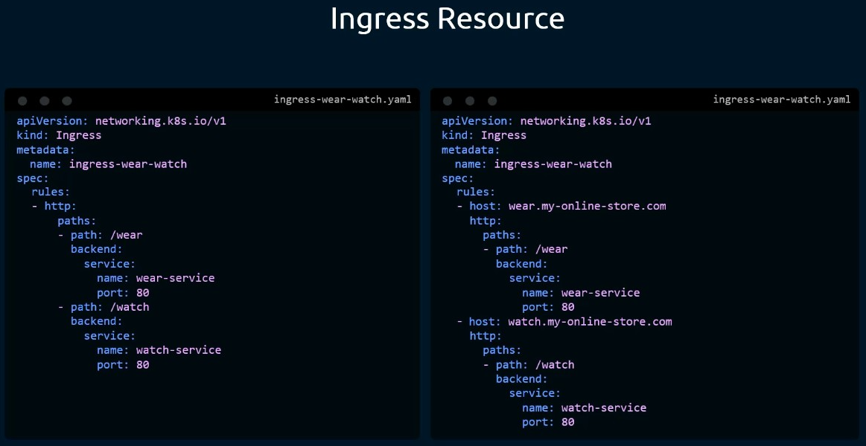

Volume
Access mode
RWO – RW once on only one node
- At a time only one pod can access the data
ROX – Read only shared among many nodes
RWX – RW shared among many nodes
- At a time many pods can access the data volume
- Requires supportive backend storage type such as EFS, NFS
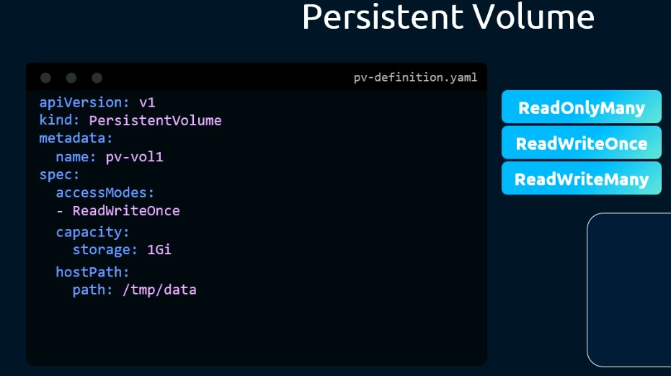
Local volume – using the storage volume from the same node
hostpath:
path: /tmp/data
-- use data volume from the same node itself
❌Not production grade

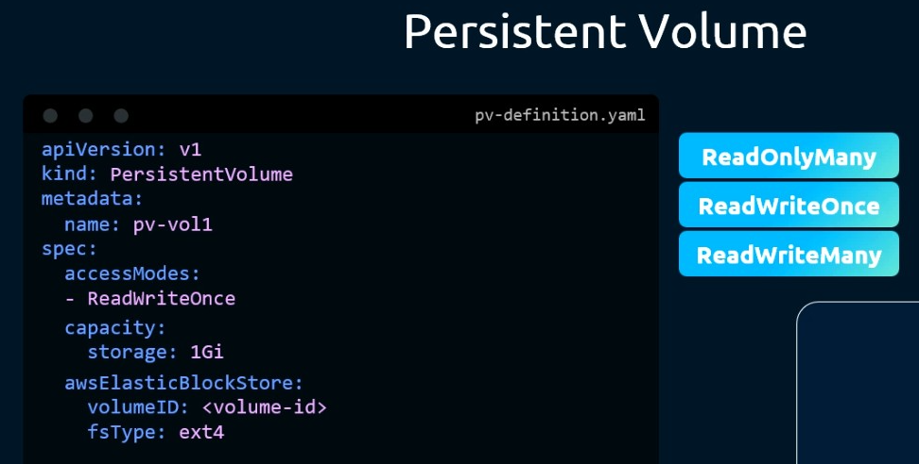
Persistent volume
– Uses the storage volume provided by cloud provider
Eg: EBS
✅Production grade

But,
Instead of manually creating a volume and claiming it with pvc, we can just use the CSP storage service, with PVC specs it creates the reqd volume automatically BTS.

Storage Class: Dynamic provisioning of Volume
- Storage class requests volume from the Cloud service provider as requested by PVC specs and PVC claims it.
PV can be removed providing the combination of PVC + storage class
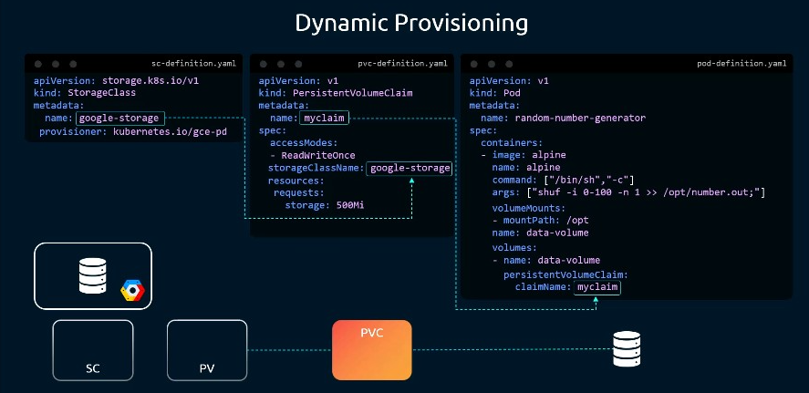

Use case of Storage Class
- Creating storage classes in these formats will help to create volumes as per requirement

Storage class- Silver: standard Hard drive -- for fast RW of data
Storage class- Gold: SSD -- for normal RW usage
Storage class- Platinum: SSD + Replication -- for backup ensured.

Security

Authentication & Authorization
Who can access – Authentication
What can they access – Authorization:
Communication bw components – secured through TLS certificates
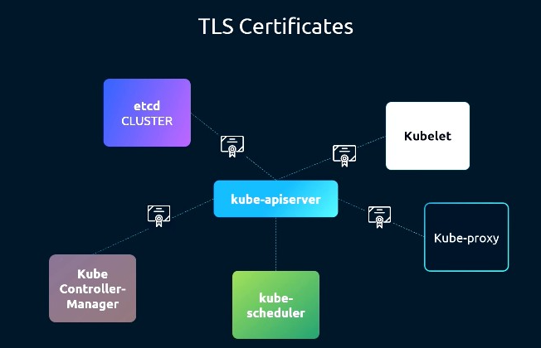
Network policies – Restricting communication between pods
Without network policies:
- Frontend pod can directly talk to database pod if frontend application is calling database
With network policies:
- Frontend pod is restricted to talk to database directly.

Access to cluster – for administrating and managing the cluster
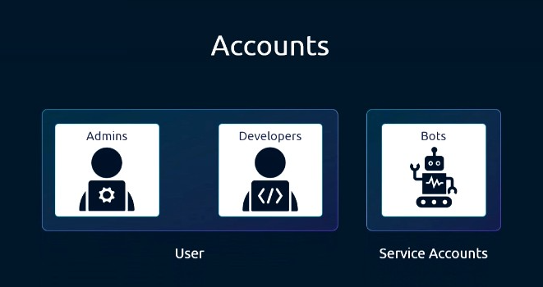
Types of access:
- User access - By humans(k8s admins, k8s developers)
  - Kube ApiServer authenticates all the requests
- Service Account access - By machines/bots/3rd party applications
Ways of authentication:
- Static token file
- Certificates
- Identity services

Accessing kube-api server
2 ways of accessing
- Kubectl
  - Eg: kubectl get pods
- Rest API request –
  - Eg: curl https://kube-master:6443/version
Setting up kubectl:
Kubectl proxy
- This command will setup a proxy service(configured with cluster configs) in the local host, that proxy then forwards the request to the kube api server.
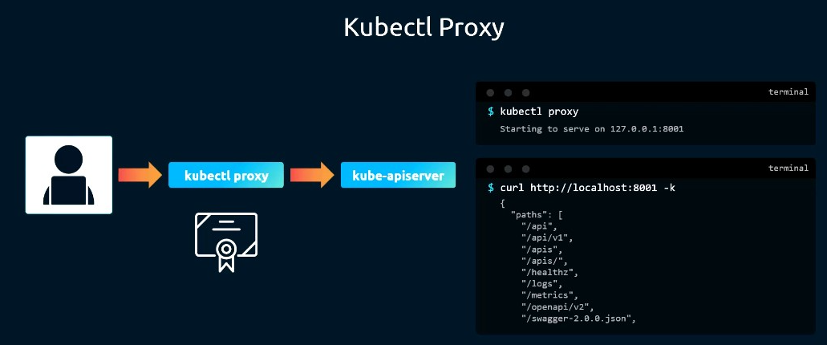
K8s has the api groups, through which we can access the details of our cluster
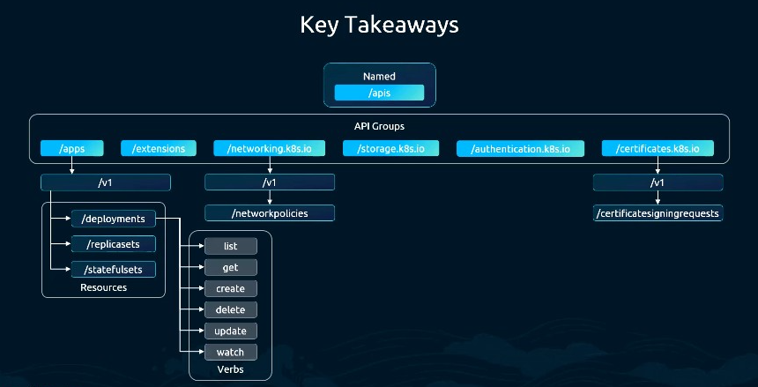

Cert based Auth
Certificate | Your identity card
Private key | Your secret proof you are the owner of that identity

I create private key and public key pair,
and i attach the public key within a cert(Certificate Signing request) and send it for CA.
Upon successfully authorized by CA, I'm using the Certificate to send requests to server, that server verifies the CA then asks me to sign, there i use my private key then the server verifies the private key against the public key and authorizes me.

is it Single time Verification or Every time Verification ?
kubectl logs -f my-pod
- This streams the data continuously, so the connection initiated is reused

kubectl get pods
kubectl get nodes
kubectl get svc
- Initiates new connection on each request/command

Access Control
ABAC – attribute based access control
- Accesses are attached to a user.
  - A policy file is created mentioning accesses a user gets
✨RBAC – Role based access control – standard way of providing access
- Roles like – developers, admins are created and users are associated with the roles.
Webhook – A 3rd party application will be integrated
- The request/command sent by user will be authenticated by the 3rd party application

Multi auth mode
- We can configure multiple auth modes for authorizing a request sent by the user
- If any mode denies the request it will go to the next auth mode
- If any mode accepts the request, the request will be responsed/performed.
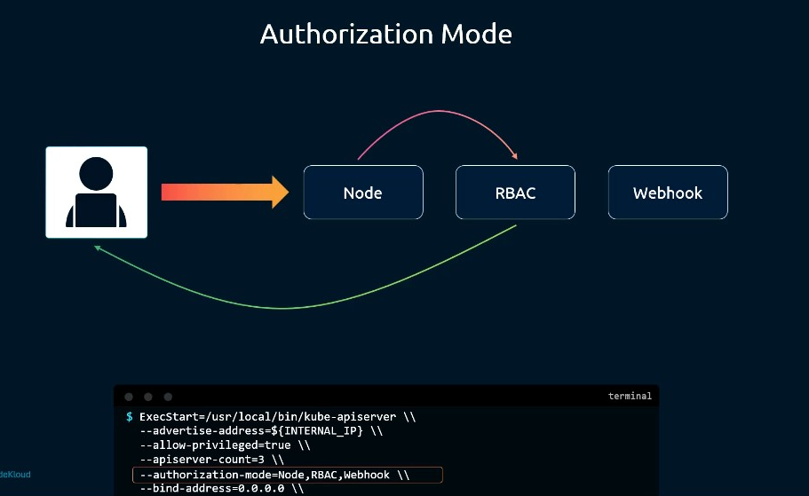

RBAC – Role Based Access Control

Resource Scope
Namespace based Vs cluster based
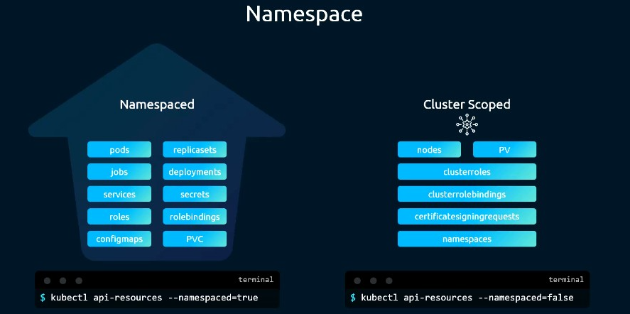

Namespace roles – to manage namespace scoped objects
- Role will be created with resources and actions
- Role binding will be created with role & user
- By default(if namespace isn’t specified) – it creates access for the default namespace
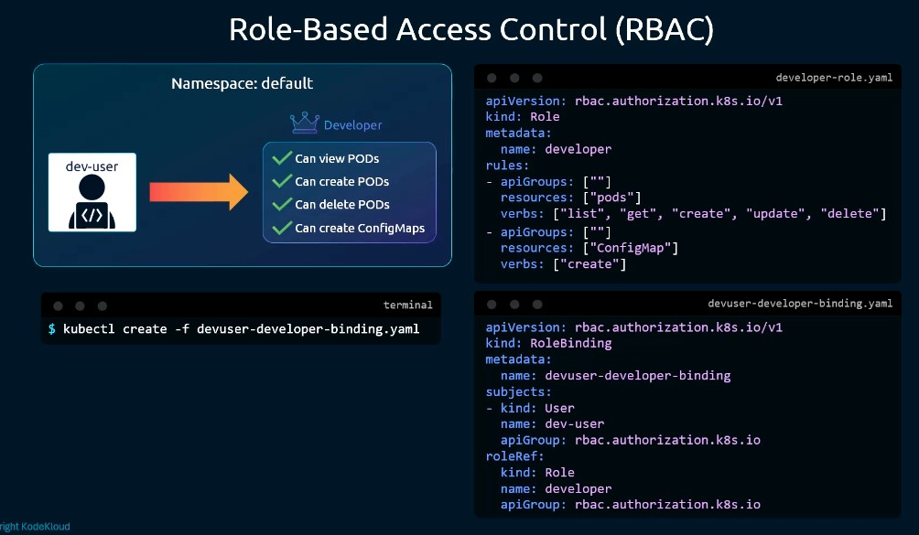

Cluster roles
- Will be created to manage cluster scoped objects

Admission Controllers
Beyond access, auth & authz, we can implement good practices in executing commands/creating objects.
Which can be achieved with controller.
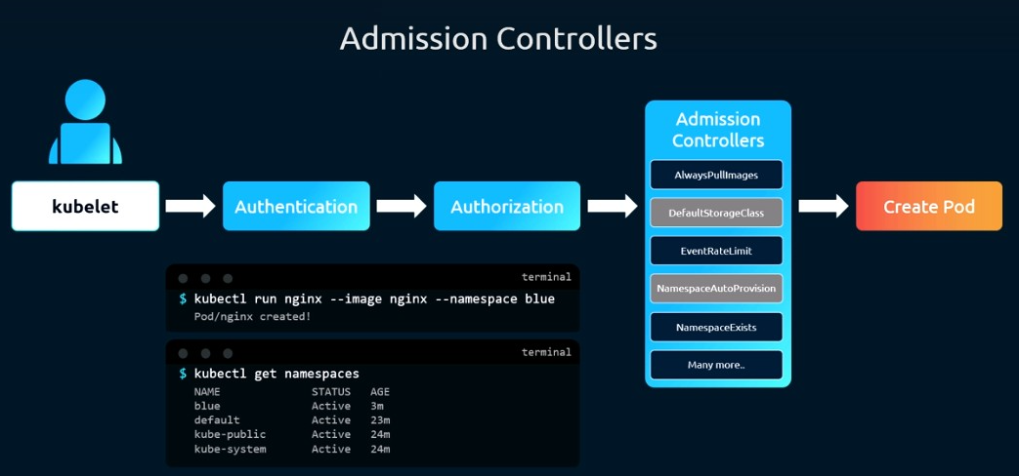
Eg: --enable-admission-plugins=NodeRestriction, NamespaceAutoprovision, NamespaceExists
NamespaceAutoprovision - This will ensure if specified namespace isn’t available, the controller will create namespace by itself rather than showing error.

Helm
- A package manager for k8s
  - Manages the k8s object a whole as packages
  - Helps us with installing, uninstalling, upgrading(release manager), rollback,..

Major Helm Commands:
- helm list
- helm install [release name] [chart name]
- helm uninstall [release name]
- helm pull --untar [chartname]

before Helm:
all the yaml files with the hardcoded values
with Helm:
Helm Chart = yaml files with values used from values.yaml file

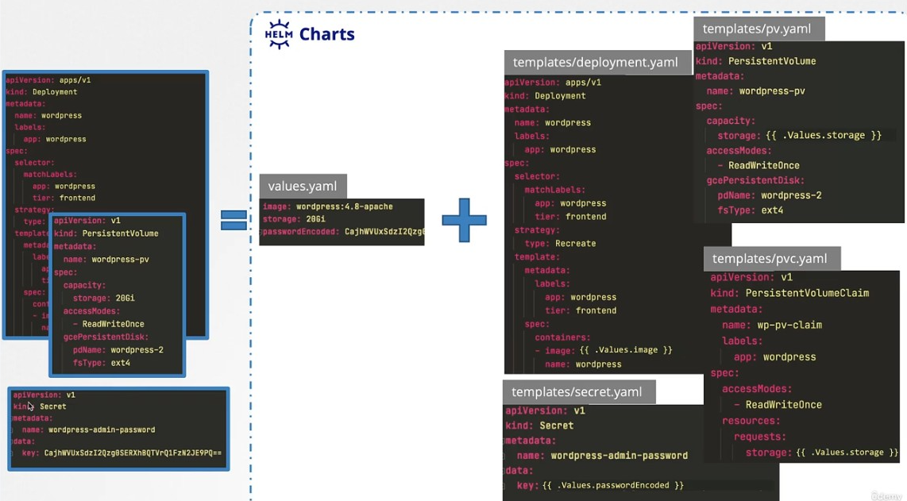

Kustomize

Helm Vs Kustomize
Helm = package manager for Kubernetes ("install this app with these values")
Kustomize = manifest customization tool for the envt ("take these YAMLs and modify them for dev/test/prod")
2 Configs
Base Config: contains the default value/common value of manifests across the envts
Overlays config: contains the envt specific values(overrides the values specified in the base config)
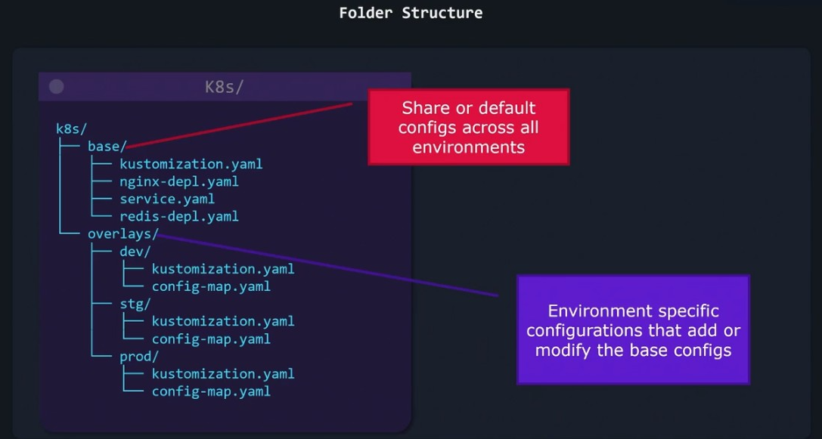

Customizing values in Kustomize Vs Helm:
Kustomize:
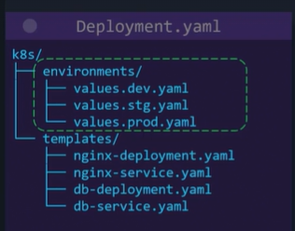
Helm:
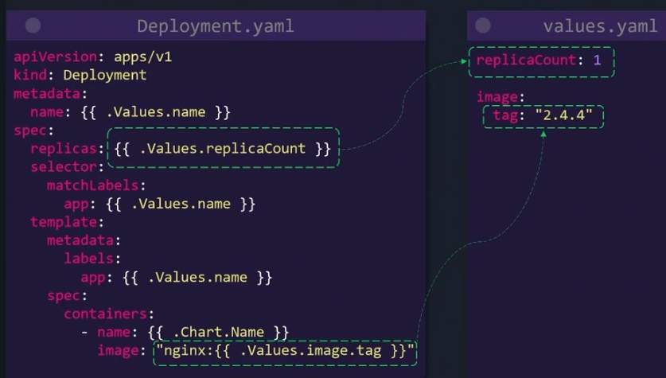

Kustomization.yaml
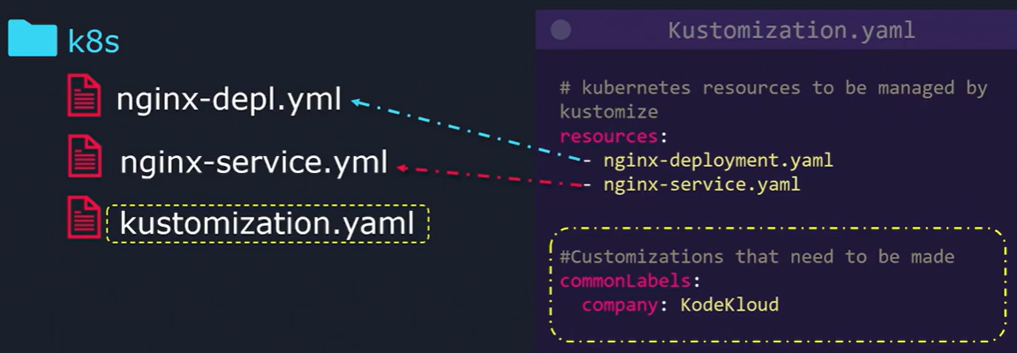
kustomize build k8s/
- this command doesn’t apply/deploy/create.
To apply/deploy: kubectl apply -k k8s/
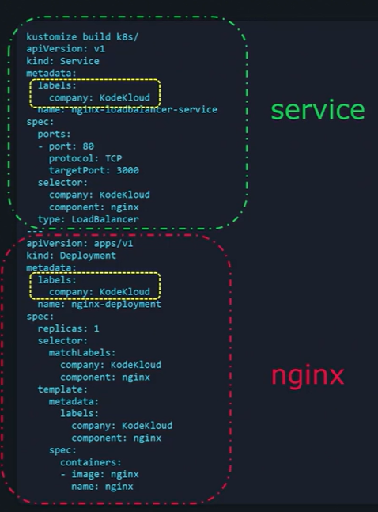

Managing directories with Kustomize
Imagine having 50+ yaml files
Instead of specifying the path for all the yaml files
kubectl apply -k k8s/app/
kubectl apply -k k8s/db/
…
One simple strategy is to create a kustomization.yaml file and specify the path of the yamls in the resources
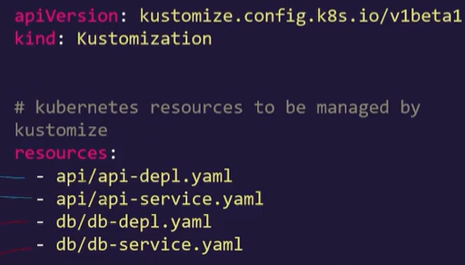
With this we can direclty do: kubectl apply -k k8s/ instead of kubectl apply -k k8s/db/

Kustomizing values
- among all the objects – common transformers
- among specifc objects – patches

Common transformers
- used in the kustomization.yaml to add common values to all the yamls
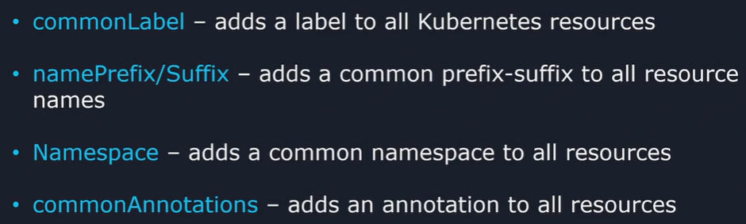

Patches
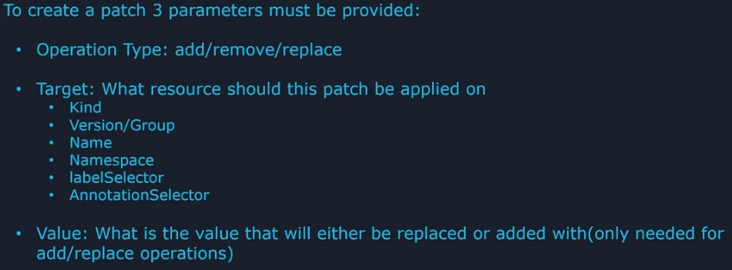

Eg:
patches:
- target:
kind: deployment
name: api-deployment
patch: |-
  - op: replace #operation type
  - path: /spec/replicas #path to the value that need to be updated
  - value: 5 #value need to be updated
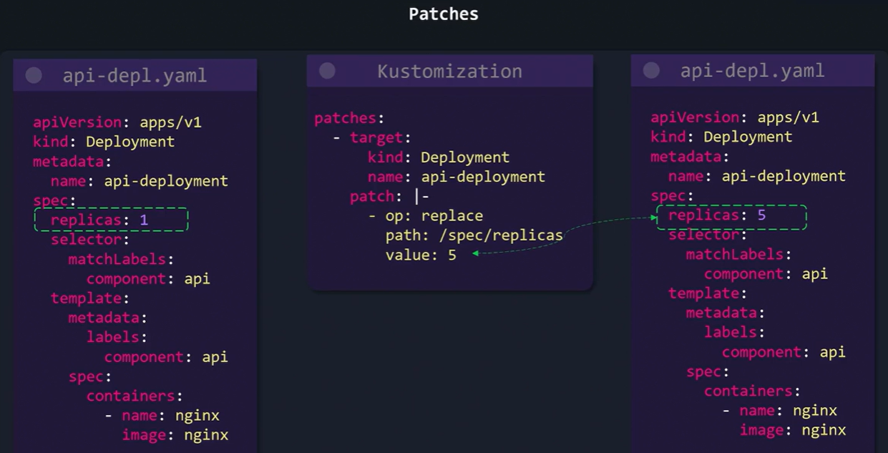

Inline patch
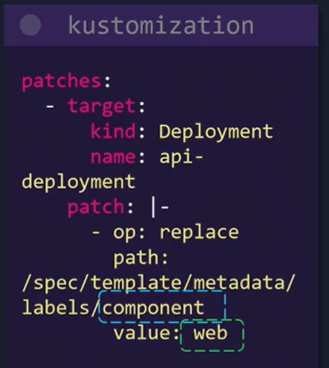
Strategic patch
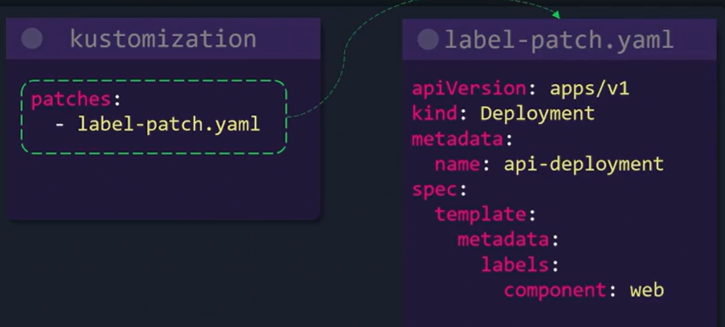

K8s Challenges & Lightning labs

Interview Qoncepts

Scaling
- As usual Horizontal and vertical scaling is there,
  - General resource utilization: Horizontal scaling – HPA(Horizontal Pod Autoscalar)
  - Resource specific utilization: vertical scaling of the resources attached to each pod
High availability kubernetes architecture
- Setting up multiple master nodes + etcd across all 3 AZs with indv Load balancers -> improves fault tolerance and availability
  - Fault tolerance is about never breaking WHO redundancy
  - Resilience is about bouncing back (thanks to recovery and adaptation).
- K8s Engine – Auto repair feature
Node Failure
- Master node fails – node management will be lost
- Worker node fails – scheduler recreates the pods in healthy nodes
Node Failure Interaction among components:
Regular Heartbeats | Kubelet -> API server
On server crash – Heartbeat stops  Node controller from control manager notices the timeout of heartbeat then, | Controller Manager(Node controller) -> API server  API server -> etcd | Node is not ready  Updates node status
Scheduler continuously watches etcd | Scheduler → API Server  API Server → etcd | Assign pod Y to healthy node  Update pod spec
kubelet on the new node notices etcd’s updated pod assignment (via API Server) | Kubelet → Container Runtime: “Run container image nginx:latest.”  Kubelet →API Server → etcd: “Update pod status: Running.”
kube-proxy on the new node updates ip route tables | Kube-proxy → API Server: “Got new endpoints, updating routing rules.”

1. Control-plane requests – to maintain cluster
kubectl apply, create pod, scale deployment → go through API Server.
2. Data-plane requests – reqs to pods
Goes to service: Client → Service → kube-proxy rules → Pod
Eg: http://my-service.default.svc.cluster.local

Service
Service – Stable Nw endpoint(permanent IP) for a set of pods
Ingress= entry | Http/s routing based on host/path
takes care of (load balancing, SSL, Domain hosting ) requests entering in Service
Exposes service to internet through a single IP or Domain name
Types of Services in Kubernetes:
- Cluster IP | Internal microservice-to-microservice communication
Headless Services
  - Cluster IP set to None
  - On Stateful connections – to maintain a consistent nw identity eg: connection with DB
  - Use: directly communicate with pods avoiding the proxy
- Node port | simple external communication for services in each node
  - Node port will be exposed to LB
  - LB -> Nodeport -> Service -> Pods
- Load balancer | External production communication WHO CSP
- External name | DNS to connect with external APIs

Container Initialization
Container = Init container(executes before the apln container starts) + Appilcation container(runs code)
Init container – Intializes
Eg: setting up network/infra configuration, initializing DB schema

Security
Security things in Kubernetes:
- RBAC(role based access control)– least privilege to the user
- Network policies(pod – pod, pod to external)
- Container security - Ensure Secure runtimes and image scanning
- Update and patching – components and node curent version
- K8s Secrets – manage sensitive data with k8s secret

Maintenance
Cluster Maintenance
Node Maintenance
- Cordon the node- prevents it from scheduling any pods - kubectl cordon <node-name>
- Evict the node – kubectl drain <node-name> --ignore-daemonsets --delete-emptydir-data
  - Marks the pod for eviction
  - Reschedules the pods
  - Then terminates the pods
Deamon Sets – to configure pods, monitoring, logging – in each node
- Uncordon the node - kubectl uncordon <node-name>
- Verify node status - kubectl get nodes

Others
Configmap – maps how application behaves
  - Stores application configuration(application behaviour) - application settings at runtime
    - Setting up envt, verbose for logging
  - Secret – stores sensitive data in encrypted fromat

Operators – packages, deploys and manages kubernetes application
Can I run a pod in a specific node ?
Yes, with Node affinity, Node selectors, Node name we can specify the node while scheduling the pod
livenessProbe- Keep the pod running all time at any cost
OOM
Once pod reaches out of memory, it’ll be terminated with SIGKILL msg by kernel OOM Killer
  - Then the process exits with exit code – 137 -> Restart policy – Pod Deployment contains the restart policies
              - Always – always restarts the pod | exit code = 0 -> successful completion
              - On failure – restarts when the pod fails | exit code != 0 -> failure
              - Never- never restarts the pod

Notes from Dynatrace
Architecture Overview from Dynatrace

Logical perspective:
Services - Manages networking inside the cluster
- Keeps a fixed endpoint for pods
  - Pods won’t be stable – use this service’s fixed endpoint for internet connectivity.
Master node/Control plane manages these controller entities
Workloads[Controller]
Types:
- Deployment(tc of stateless apps – microservices, apis, web servers)
- Stateful set (stateful – DB, kafka,..)
- Deamon set
(daemon in every house – daemonset maintains agent in every node(esp. for monitoring) )
- Job(for one time jobs)
- Cronjob(for scheduled jobs)
Namespaces(Environments – dev, stage, prod)
Cluster
Worker nodes/Pods

Workloads/Controller – manifest files
  - API server stores this manifest file in etcd.

K8s Summary

Deployment.yaml | Creates pods
- StatefulSet.yaml | Creates pods with constant name(created on the same name upon recreation) and in linear order
Service.yaml | Service – network abstraction layer.  Forwards traffic to respective pod&port*.
Types of Service:
- LoadBalancer – LB forwards the incoming request from public to pods | not used when ingress is used.
- ClusterIP – Forwards the requests from one pod to another pod in the same cluster. | *mostly used
- ExternalName - Forwards the requests from pods to external services
pvc.yaml  StorageClass | Creates volume  requests volume from the Cloud service provider as requested by PVC specs and PVC claims it.
Ingress.yaml(K8s)  - Route.yaml(OCP) | Creates networking route from public to inside the cluster
Configmap | Creates a config file of all the envt variables needed/used in deployment manifest  envFrom:  - configMapRef:  name: app-config
Secrets | To store secrets in a secured format
Network policies | Restricting communication between pods  Without network policies:  - Frontend pod can directly talk to database pod if frontend application is calling database  With network policies:  - Frontend pod is restricted to talk to database directly.

Setting up a cluster

Setting up networking
Install CNI
- enables pod to pod communication
Install Ingress Controller: Nginx/AWS/AGIC
- enables internet to pod communication
Command:
helm install ingress-nginx ingress-nginx/ingress-nginx \
--namespace ingress-nginx \
--create-namespace

Upon installing the controller, it creates a service(load balancer/gateway) to route traffic from internet to this controller
NGINX Ingress Controller = the controller pod creates a LB and handles traffic. | AGIC = the controller pod configures Azure Application Gateway; the gateway handles the traffic.
Installing nginx controller will also install a service: Load balancer(creates LB in the cloud), that load balancer route the traffic from internet to Nginx pod, then nginx pod to app’s pod.  (based on the ingress resource) | Installing AGIC controller, creates AppGW and configures the AppGW with the paths specified in ingress.yaml.  that AG will route the traffic from internet to app’s respective pod.  (based on the ingress resource)
Internet  |  Load Balancer  |  NGINX Pod  |(ingress.yaml)  Service  |  Pod | Internet  |  Application Gateway  |(ingress.yaml)  Service  |  Pod
OCP has it’s own network controller: OCP Router,
With the provided router,
- we need to create an AG and attach it to the ocp router.
- ocp router will forward the traffic to the pod
(based on the routes)

Internet
|
AppGW
|
OCP Router(provided by OCP by default)
|(routes.yaml)
Service
|
Pod

Access, Authentication, Authorization
Entry point: Kube API Server
- kubectl commands will reach kube API server on executing any commands
Authentication:
- Human users authenticated by
  - OpenIDConnect, Oauth
  - Client certificates
- Machines authenticated by
  - Service accounts
Authorization: authz by RBAC
- binds users/groups/service accounts to the role.
Request sent to node will be authorized by RBAC and then be executed.
Before auth & authz, Communication bw components are secured through TLS certificates.
Eg: communication between kubelet <---> API Server are secured through TLS Channel.
Namespace Vs Cluster Permissions:
- Developers get namespace scoped permissions
- Administrators get Cluster scoped permissions

