Kafka

Index
Introduction

Introduction
Kafka – broker/middleman between the microservice components.
Terms:
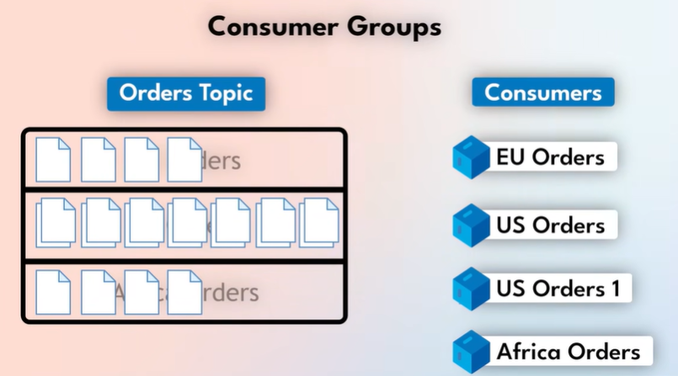
Event – the message(transaction/request) sent by one microservice to another microservice
- Event format: Key-value pair document
Producer – the microservice which sends the message
Topic – the events are organized into topics based on ‘to which service’ the event is sent
Partitions – a topic is divided into partitions i.e, based on regions and consumers are specifically designed to subscribe to specific partitions within topics to avoid overload and regulate a proper distribution.
- The consumers subscribed to the partition are scaled as reqd.
Consumer – the microservice which subscribes to the topic
Broker – the DB which saves the events – data is persistent even after the event is consumed
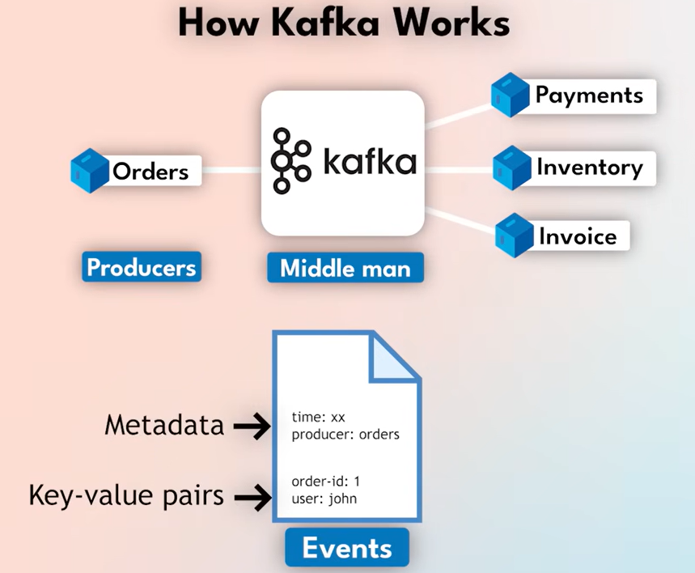

What it does:
- Enables chain reactions – a ‘impacted microservice’ shouldn’t be a bottleneck for a flow of reactions to happen, so kafka takes care of the ‘flow of requests’ between all the microservices.
- Real time analytics
  - Eg: Live sales board, uber location update

