**Hackathon Submission – SmartFarm AI Automation**

**🔹 Problem Statement :**

**Farmers in rural areas often struggle with early detection of crop diseases and unpredictable weather conditions.  
📉 This leads to reduced yield, higher costs, and late interventions.  
🚧 Existing solutions are either too complex, expensive, or require premium tools, making them inaccessible for small-scale farmers.**

**Empathy :**

**We put ourselves in the shoes of farmers:**

* **Most farmers use simple mobile apps like Telegram/WhatsApp for communication.**
* **They need a fast, reliable, and affordable solution that doesn’t require complex installations.**
* **Instead of manual crop inspections, they want an instant digital assistant that works with just a photo.**

**🔹 Ideate :**

**💡 The idea is to build a low-cost, accessible Smart Farming Tool using:**

* **n8n workflow automation (no-code, scalable).**
* **Telegram/WhatsApp as the farmer interface.**
* **AI models for analyzing plant health from photos.**
* **Weather API (OpenWeather) to fetch temperature, humidity, and cloud cover.**

**🔹 Prototype :  
We developed a working prototype in n8n:  
1️⃣ Farmer sends a message/photo via Telegram (later scalable to WhatsApp).  
2️⃣ n8n HTTP Request fetches the image & data.  
3️⃣ Weather API fetches temperature, weather & location details.  
4️⃣ AI Model analyzes plant photo → detects possible disease, stress, or deficiency.  
5️⃣ A doctor-style recommendation is automatically generated.  
6️⃣ The result is sent back to the farmer on Telegram as a simple message.**

**⚙️ Workflow: Telegram Trigger → HTTP Request → AI Analysis → Weather Prediction → Smart Recommendation → Telegram Reply.**

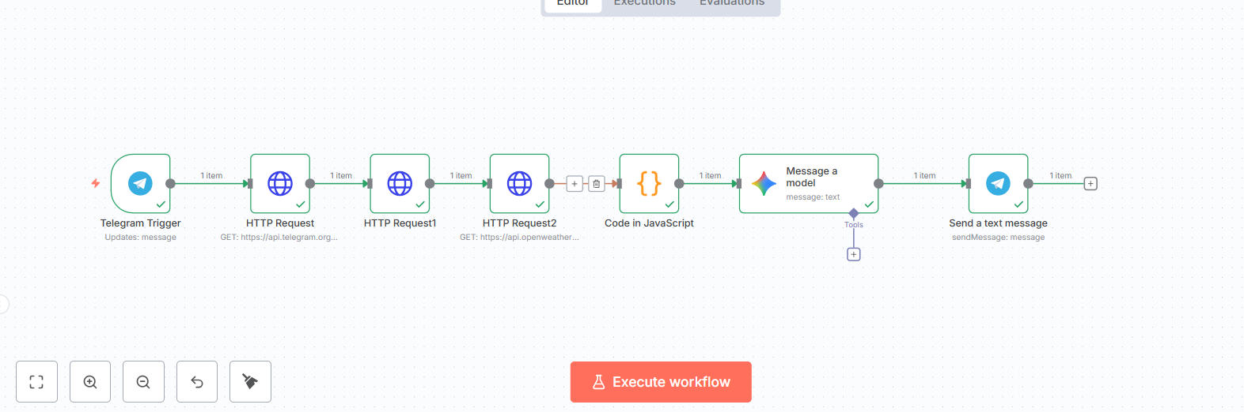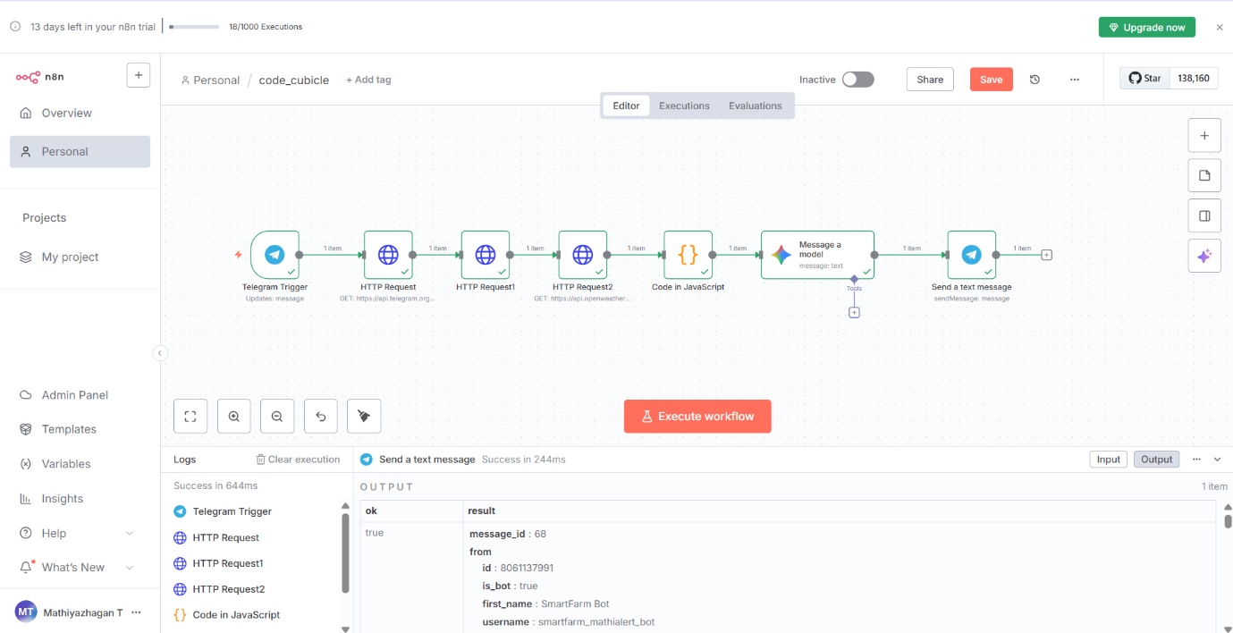

**🔹 Testing**

**✅ The workflow was tested with multiple plant photos.  
✅ Weather predictions matched real-time conditions via OpenWeather API.  
✅ Farmers received instant feedback on Telegram without installing new apps.  
✅ Scalable to WhatsApp for wider reach.**

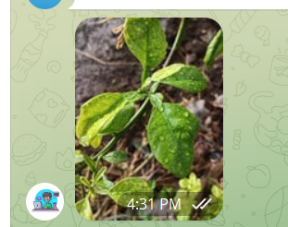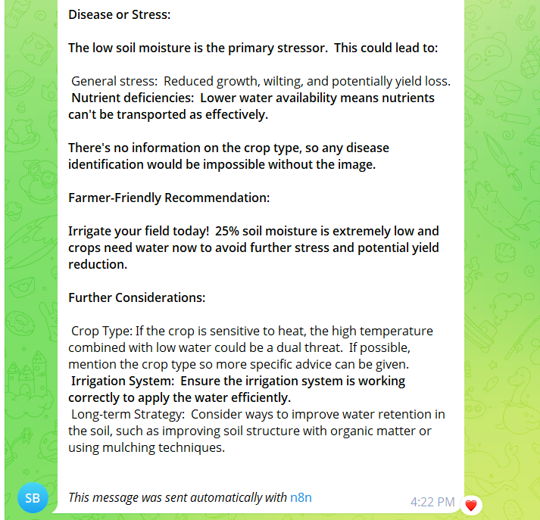

**📌 Impact:**

* **Democratizes smart farming tools.**
* **Provides real-time weather + crop insights directly on farmers’ phones.**
* **Saves time, prevents crop loss, and supports sustainable agriculture.**