G.Akshay 25MCCE28
OOPS Exercise 3
Try out all the code demonstrated in the lectures.
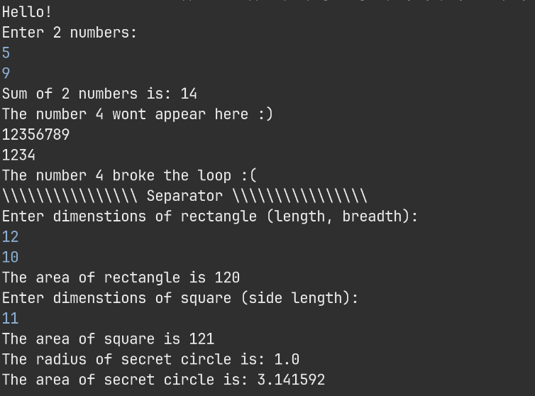
Write a value-returning method, isVowel that returns the value true if a given character is a vowel, and otherwise returns false. In main() method accept a string from user and count number of vowels in that string
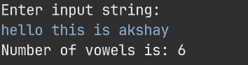
For the Box class demonstrated in the class, write a method to calculate and return the surface area.
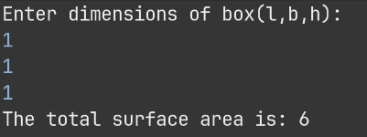
Write a java Class to represent a pair of integers. The class should include a method to check if the pair of numbers are coprime or not?
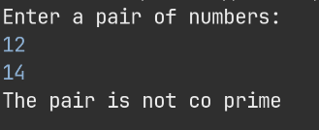
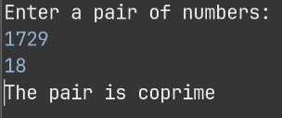
Create a new class to represent a Circle, which should have following : (1.5 points)
radius - Instance field of type double
No-argument constructor - Set radius with default value of 1.0
Constructor - that accept an argument for radius
getRadius - public method that returns the radius of Circle
getArea - Method that returns the area of Circle
Split: Constructors (0.5 points) and the methods and functionality (1 point)
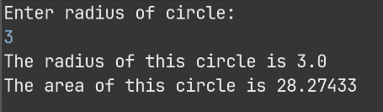
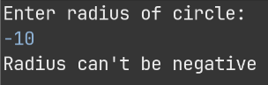
Create a new class named Car that has the following fields: (1 point)
year - The year field is an integer that holds a car's year model (e.g. 2021)
make - The make field is a String object that holds the make of the car (e.g. "Renault")
maxSpeed - The speed field is a double that holds a car's maximum speed (e.g. 90.0)
In addition, the Car class should have the following methods.
Constructor - The constructor should accept the car's year, make, and maxSpeed as
arguments.
Getter Methods - Write three accessor (getter) methods to get the values stored in an
object's fields getYear(), getMake(), getMaxSpeed()
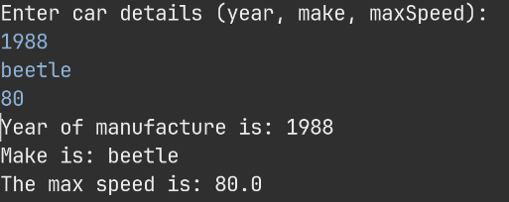

Develop a Java program that performs the following: (2 points)
Model a bank account with these details:
Name and Surname of account holder
Address of the person
Phone number
Balance
Have methods for Credit and Withdraw amounts to the account
Have the accessor getters and setters
Demonstrate at least 5 transactions on a bank account
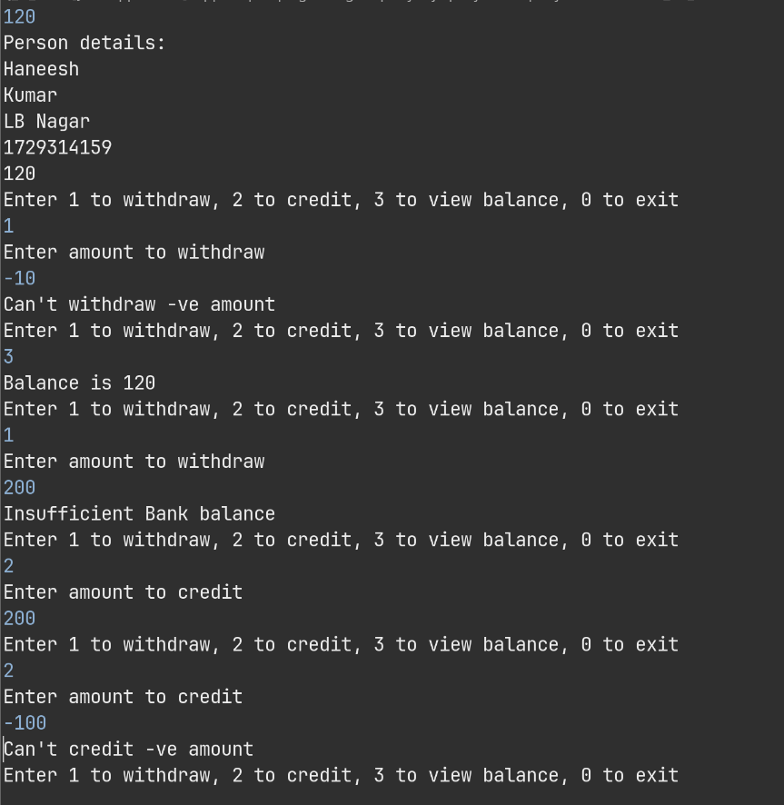

Write a Java program to perform operations of two rational numbers. (2.5 points)
You need to write a class to represent rational numbers. Rational numbers are of the form p/q where p and q are integers and q != 0. Before representing the rational number, you need to make sure that the rational number is in simplified form. A rational number is in simplified form if its p and q are co-primes. For example, the rational number 8/12 is not in simplified form because 8 and 12 are not co-primes, they have a common factor. The simplified form of 8/12 is 2/3. Your program should read four integer numbers a, b, c and d for rational numbers a/b and c/d. Display the simplified form of a/b and c/d and addition, subtraction, multiplication and division of the two rational numbers. All the resulting rational numbers should be in simplified form.
