G.Akshay 25MCCE28
OOPS Exercise 4
Try out all the code demonstrated in the lectures.
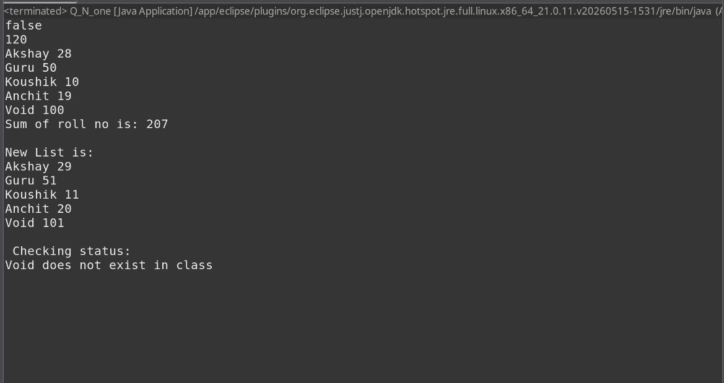

Write a java program to implement recursive Bubble Sort on an array of numbers. Have detailed comments of your logic in the source code, why the method works and how it works with an example.

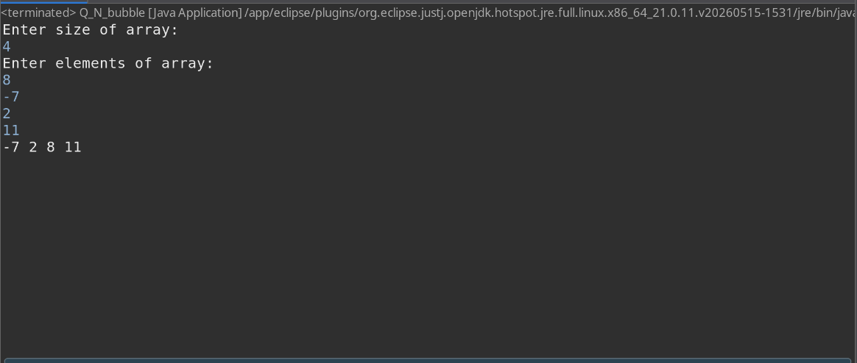

Math class has several static variables and methods.
During the Exercise-3 you designed the Circle class
Implement the methods for area and perimeter of the circle using Math class (0.5 point)
Round the values to hundredth position (i.e. the second position to the right of the decimal)
(0.5 point)
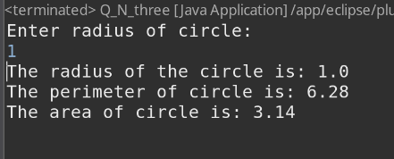
Design your own Math_StudentID class with few static constants and implement at least 5 methods of the Math class yourself. Give proper package name for the class and demonstrate the operations in a MathTest class in a different package. (2 points)
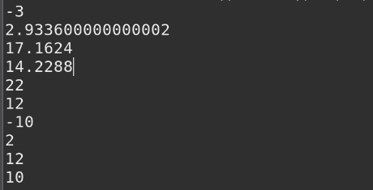

Design a class called LuckyNumber. (2 points)
A lucky number (N, k) is defined as follows:
Add the digits in N to get their sum. Now, add the digits in sum to get a new sum and so on until you reach a single digit. If that single digit is k, then N is a lucky digit of order k.
For example, take the number 1873. If we add the digits, we get 19. If we now add the digits again, we get 10 and then finally 1. Therefore, 1873 is a lucky number of order 1.
Come up with your own methods (at least 3 methods other than the constructor(s)). Have at least one method, which calls by reference.
Use your class and do the following:
How many lucky numbers of order 3 are there less than 1000?
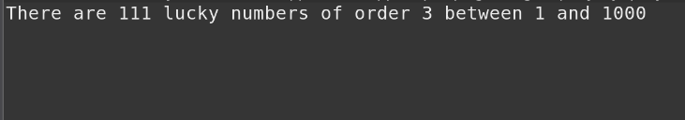
Write a method to verify the validity of a password using regular expressions. Password must be between 8 to 15 characters. It should start with an alphabet, contains at least one uppercase letter, and contains at least one number. Let user enter a password and validate it.
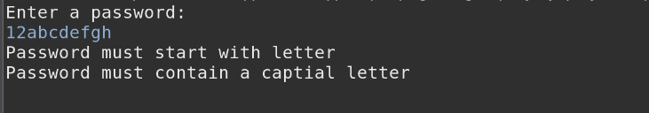
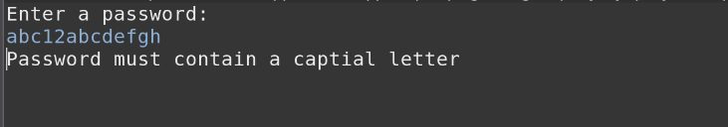
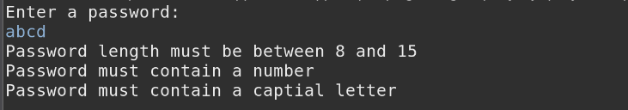
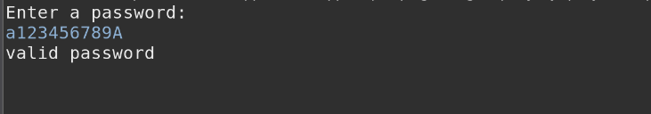

7th question
