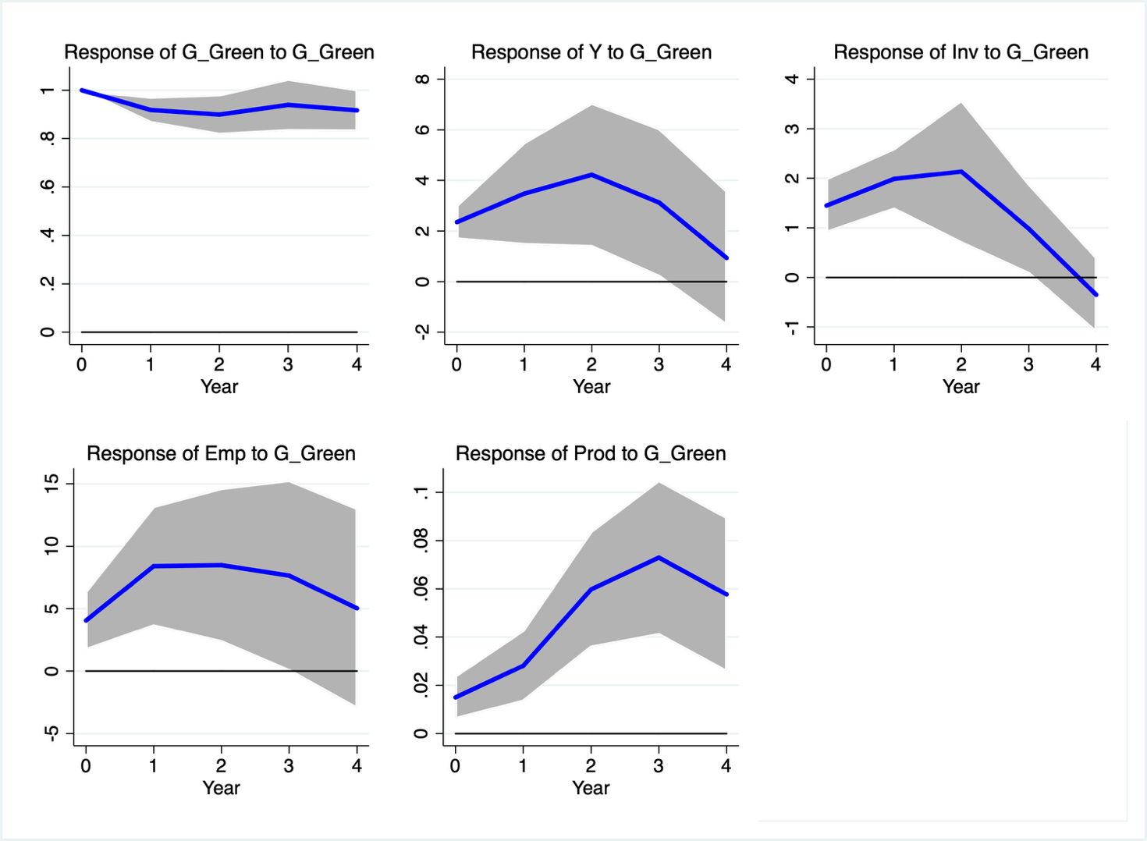
Figure 1. Impulse Response Functions $G_Green$. Shaded areas depict 68% confidence intervals.

 | Year 0 | Year 1 | Year 2 | Year 3 | Year 4 | Mean | Peak
$$Y$$ | 2.35 | 3.04 | 3.57 | 3.51 | 3.02 | 3.10 | 4.22
$$Inv$$ | 1.45 | 1.79 | 1.98 | 1.74 | 1.33 | 1.66 | 2.14
$$Emp$$ | 4.05 | 6.49 | 7.43 | 7.61 | 7.20 | 6.56 | 8.48
$$Prod$$ | 0.015 | 0.022 | 0.037 | 0.047 | 0.050 | 0.034 | 0.073

Table 1. Cumulative multipliers and elasticities $G_Green$. Significant estimates are in bold (68%).

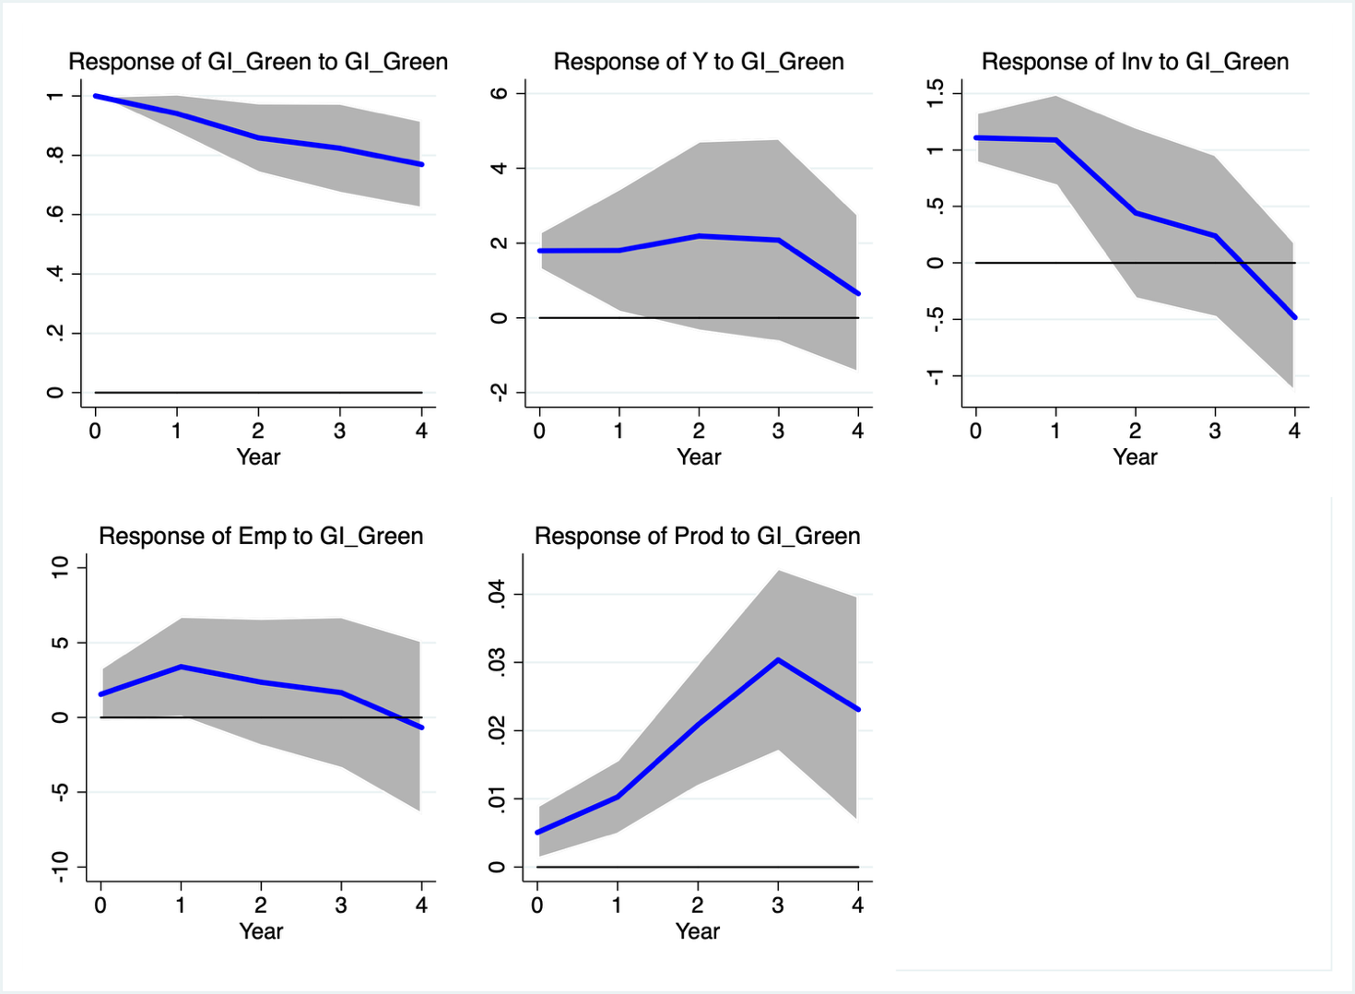
Figure 2. Impulse Response Functions $GI_Green$. Shaded areas depict 68% confidence intervals.

 | Year 0 | Year 1 | Year 2 | Year 3 | Year 4 | Mean | Peak
$$Y$$ | 1.02 | 1.08 | 1.16 | 1.20 | 1.06 | 1.10 | 2.19
$$Inv$$ | 1.11 | 1.13 | 0.94 | 0.80 | 0.55 | 1.11 | 1.11
$$Emp$$ | 1.55 | 2.55 | 2.61 | 2.47 | 1.89 | 2.21 | 3.39
$$Prod$$ | 0.005 | 0.008 | 0.013 | 0.018 | 0.020 | 0.005 | 0.030

Table 2. Cumulative multipliers and elasticities $GI_Green$. Significant estimates are in bold (68%).

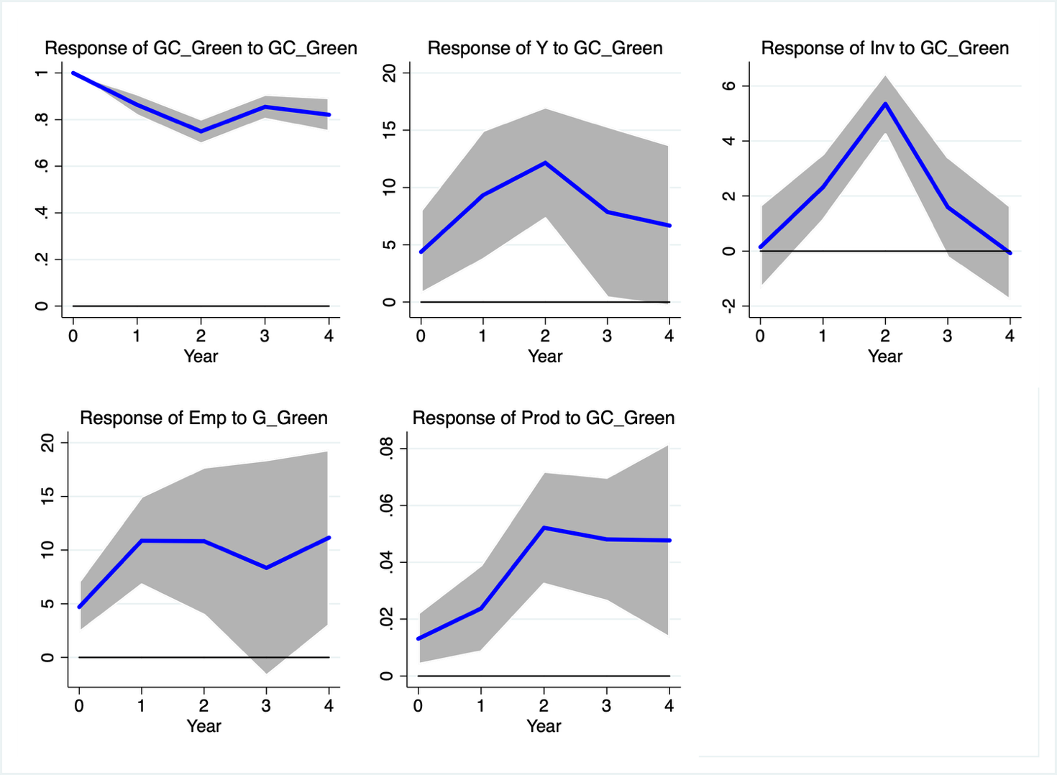
Figure 3. Impulse Response Functions $GC_Green$. Shaded areas depict 68% confidence intervals.

 | Year 0 | Year 1 | Year 2 | Year 3 | Year 4 | Mean | Peak
$$Y$$ | 4.38 | 7.36 | 9.91 | 9.73 | 9.43 | 8.16 | 12.16
$$Inv$$ | 0.15 | 1.33 | 2.99 | 2.72 | 2.18 | 1.87 | 5.40
$$Emp$$ | 4.70 | 8.36 | 10.11 | 10.02 | 10.71 | 8.78 | 10.88
$$Prod$$ | 0.013 | 0.020 | 0.034 | 0.040 | 0.043 | 0.030 | 0.052

Table 3. Cumulative multipliers and elasticities $GC_Green$. Significant estimates are in bold (68%).

Excluding one country at time

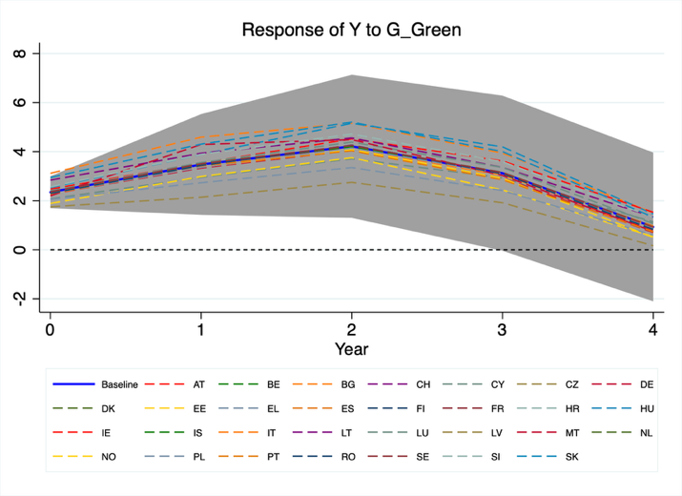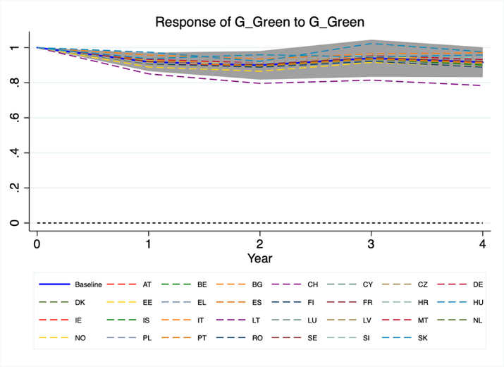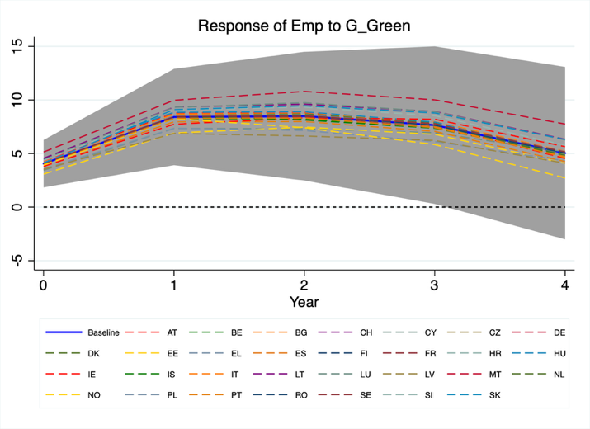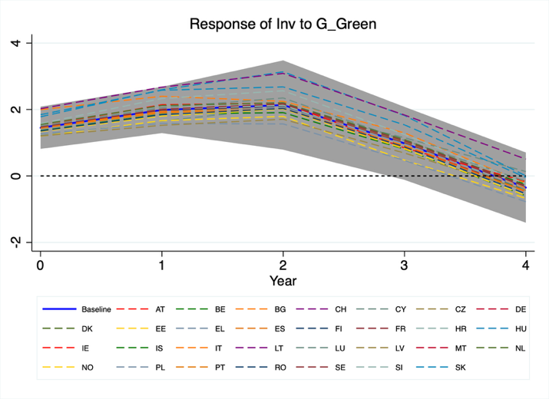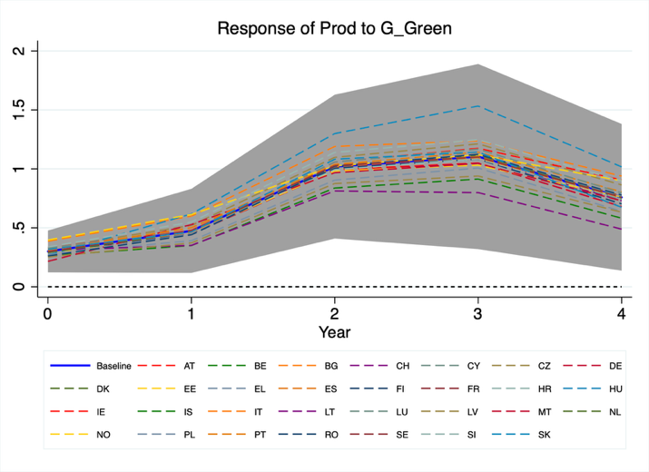
Figure A1. Impulse Response Functions $G_Green$. Shaded areas depict 68% confidence intervals. Excluding one country at time

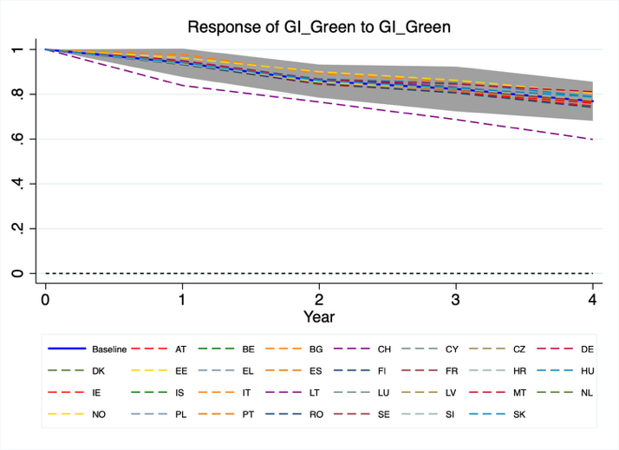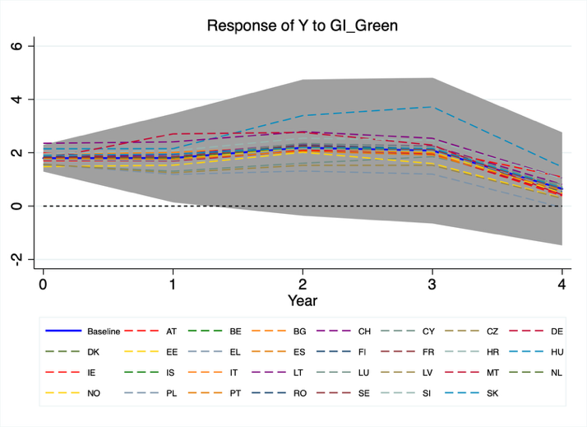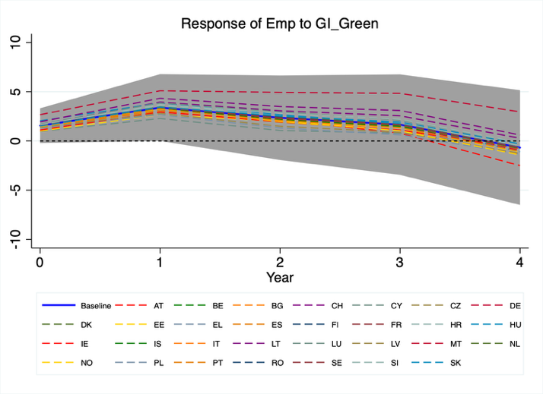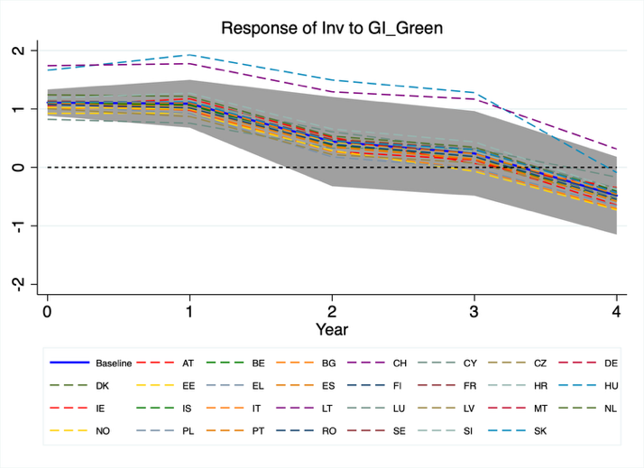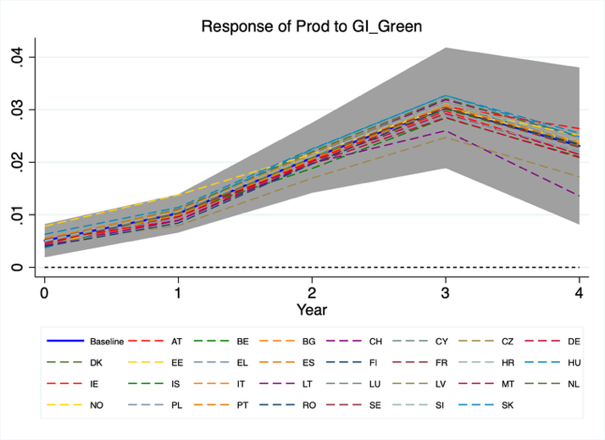
Figure A2. Impulse Response Functions $GI_Green$. Shaded areas depict 68% confidence intervals. Excluding one country at time

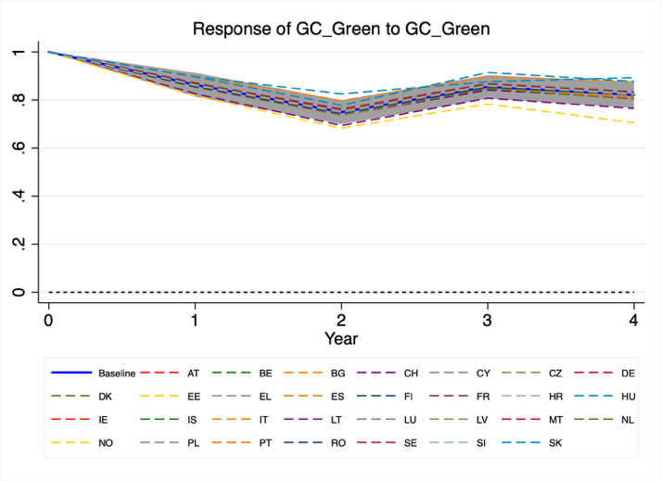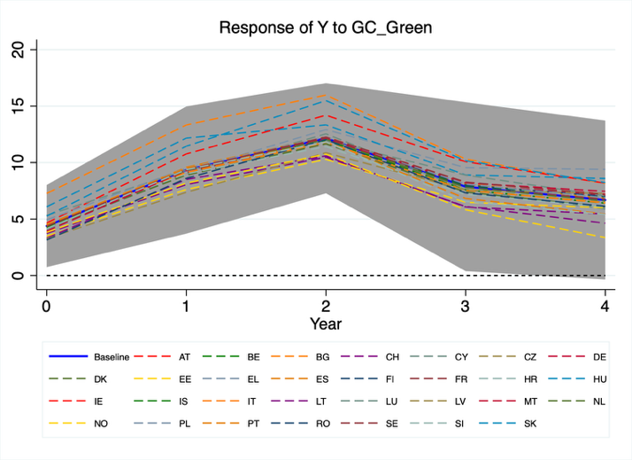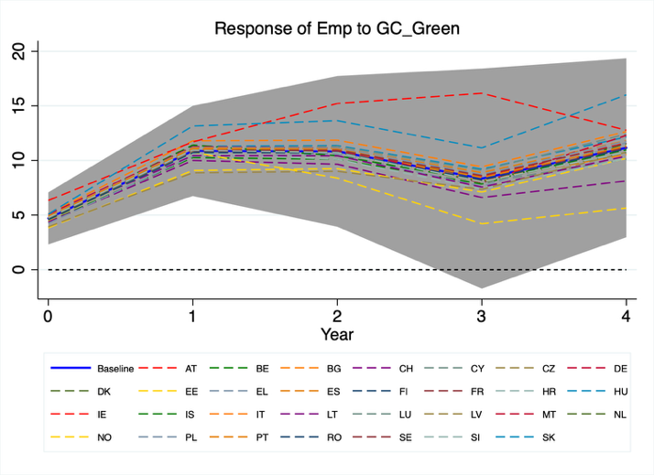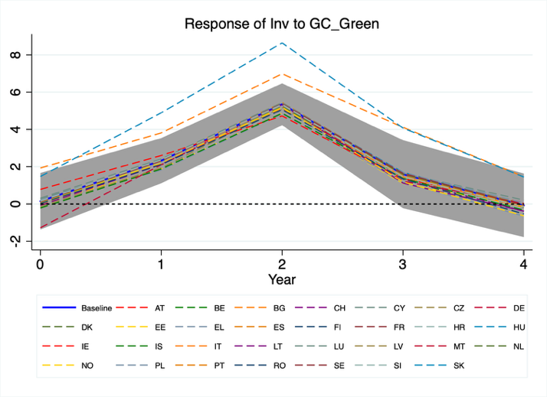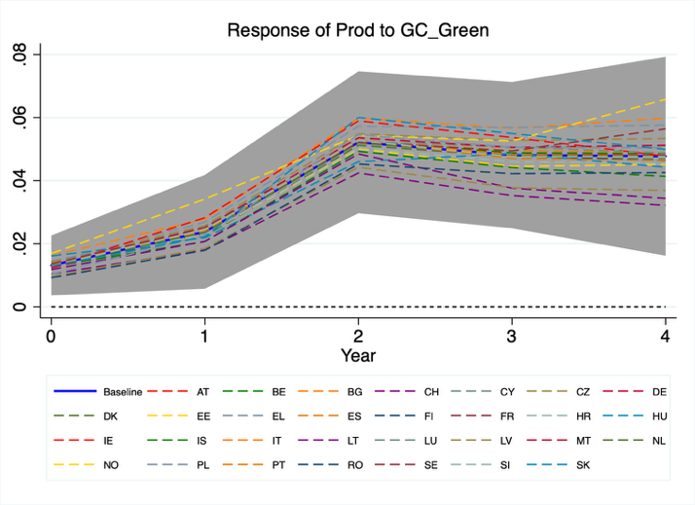
Figure A3. Impulse Response Functions $GC_Green$. Shaded areas depict 68% confidence intervals.

 | Year 0 | Year 1 | Year 2 | Year 3 | Year 4 | Mean | Peak
$$G_Green$$
$$Y$$ | 2.36 | 2.89 | 3.36 | 3.35 | 2.90 | 2.97 | 3.93
$$Inv$$ | 1.45 | 1.66 | 1.82 | 1.63 | 1.23 | 1.56 | 5.40
$$Emp$$ | 4.25 | 6.69 | 7.65 | 7.77 | 7.32 | 6.74 | 7.65
$$Prod$$ | 0.023 | 0.028 | 0.040 | 0.049 | 0.052 | 0.038 | 0.073
$$GI_Green$$
$$Y$$ | 1.83 | 1.77 | 1.97 | 2.10 | 1.88 | 1.91 | 2.08
$$Inv$$ | 1.07 | 1.04 | 0.85 | 0.72 | 0.49 | 0.84 | 1.073
$$Emp$$ | 1.48 | 2.49 | 2.59 | 2.46 | 1.87 | 2.18 | 3.35
$$Prod$$ | 0.007 | 0.009 | 0.013 | 0.019 | 0.021 | 0.014 | 0.030
$$GC_Green$$
$$Y$$ | 4.59 | 7.44 | 9.83 | 9.67 | 9.38 | 8.18 | 11.83
$$Inv$$ | 0.12 | 1.00 | 2.57 | 2.39 | 1.92 | 1.60 | 4.85
$$Emp$$ | 5.34 | 8.90 | 10.65 | 10.43 | 11.04 | 9.27 | 11.32
$$Prod$$ | 0.019 | 0.025 | 0.037 | 0.041 | 0.045 | 0.033 | 0.050

Table A1. Cumulative multipliers and elasticities $G_Green$, $GI_Green$, $GC_Green$ Significant estimates are in bold (68%). Excluding 2020-2022.

