Dataset work
- dataset_builder.py now keeps fully EUR-consistent private investment (gfcf_private, gfcf_private_const_2015) and also preserves the raw legacy column as gfcf_private_legacy_raw (exact values from dataset.xls for documentation).
- Added population_legacy_raw alongside the Eurostat population series (currently from demo_gind, Jan-1 stock). Both legacy columns are merged directly from dataset.xls and verified to match exactly.
- Rebuilt eurostat_green_panel.csv (868 rows, 1995-2022). Overlap with the legacy workbook now spans all 833 shared geo-years; the 35 additional rows are MT 1995-1999 plus UK 1995-2022 and BG/RO 2022.
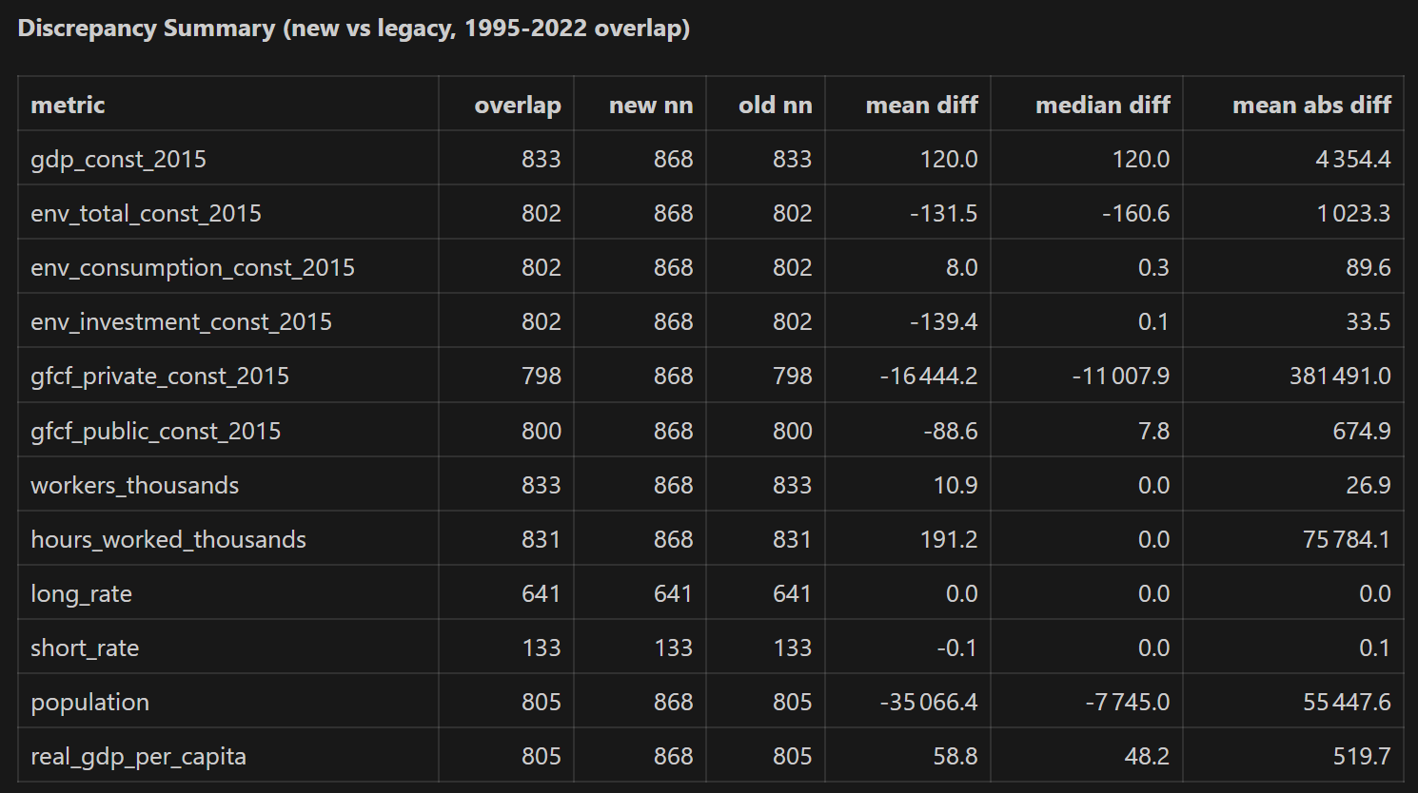
- Private GFCF: The legacy gfcf_ column is stored in national currency units for non-EMU countries, while the rebuilt series is in constant 2015 EUR millions. Top discrepancies are Hungary 2005-2022 where the raw values exceed the Eurostat EUR series by ~3 orders of magnitude (ratios ≈0.002). Mean absolute gap for euro members is only €17.9 bn vs €982 bn for non-EMU, confirming a currency-definition mismatch. The new dataset keeps the EUR-consistent totals and exposes the raw legacy values via gfcf_private_legacy_raw for transparency.
- Population: Eurostat’s demo_gind (Jan-1 population, EU statistical territory) diverges from the legacy source, which appears to mix national statistical office figures (e.g., Italy’s pre/post-2011 census revisions, Cyprus counting the whole island). Large gaps: Poland 2021 (-674 k), Italy 2011-18 (+/-560 k), Germany 2015/2022 (-489 k/-561 k). The new column remains the Eurostat definition, while population_legacy_raw preserves the workbook values for reference.
- Other series: Environmental consumption/investment match within ±€0.1 bn median; GDP per capita differences (~€59) stem from recomputing missing rows via Eurostat GDP/pop (2015 euros). Interest rates are identical.
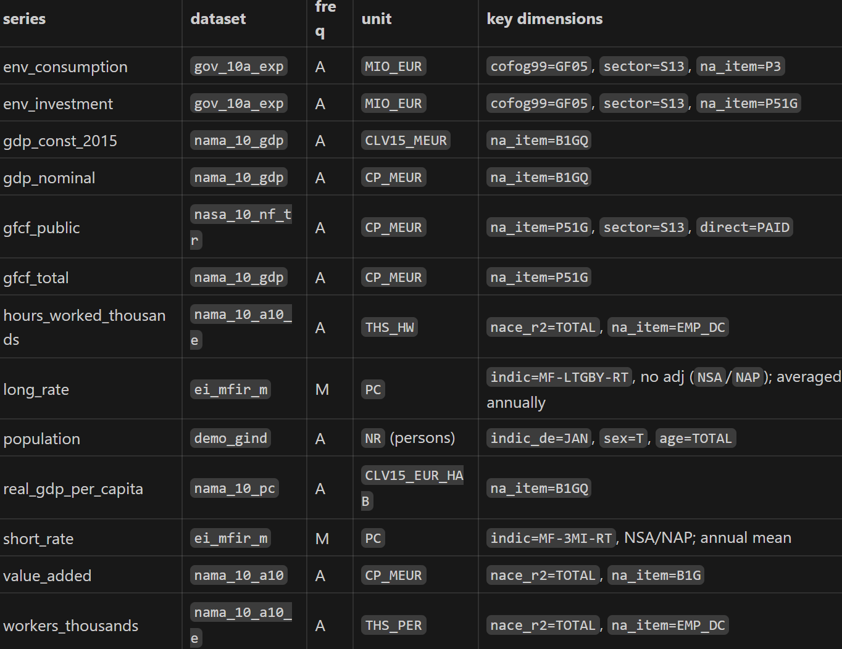

Additional Processing Notes
- Malta (1995‑2020) GDP deflator filled with the manual IndexMundi series before computing constant-price levels for all series.
- env_total is explicitly recomputed as env_consumption + env_investment (no Eurostat aggregate to avoid transfers). Constant-price conversions use the GDP deflator.
- Private investment is derived as gfcf_total - gfcf_public in both nominal and constant prices; the raw legacy column remains for audit (gfcf_private_legacy_raw).
- New dataset includes population_legacy_raw to carry forward the workbook’s population concept without influencing the Eurostat-based per-capita calculations.

