**Home Page from Power-BI Desktop. List of all Table.**

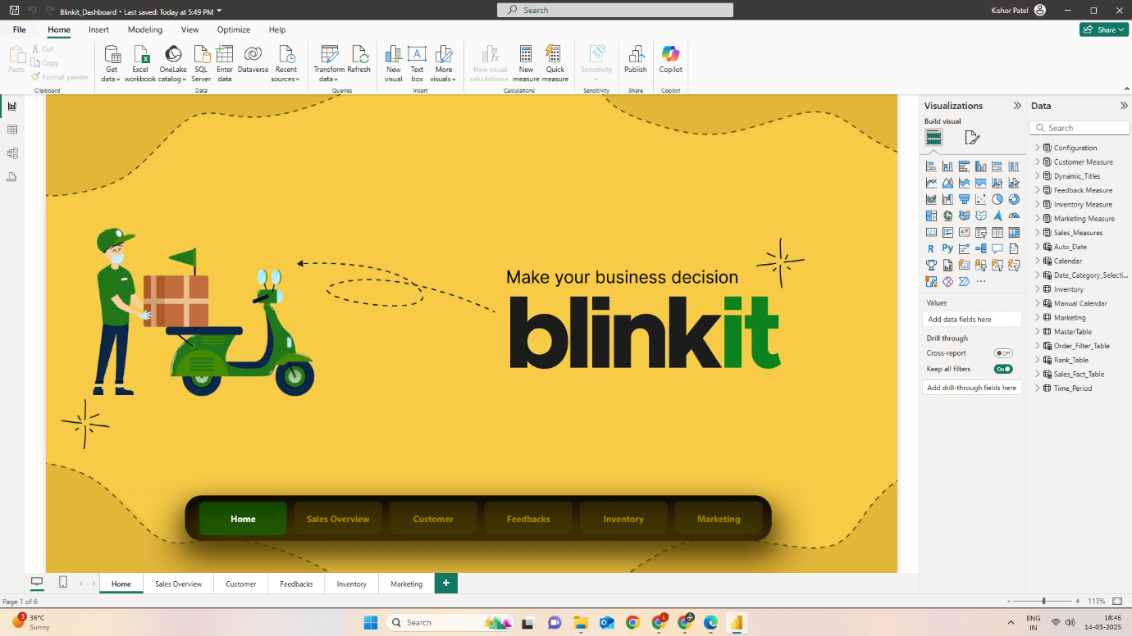

**Sales Page from Power-BI Desktop. List of DAX.**

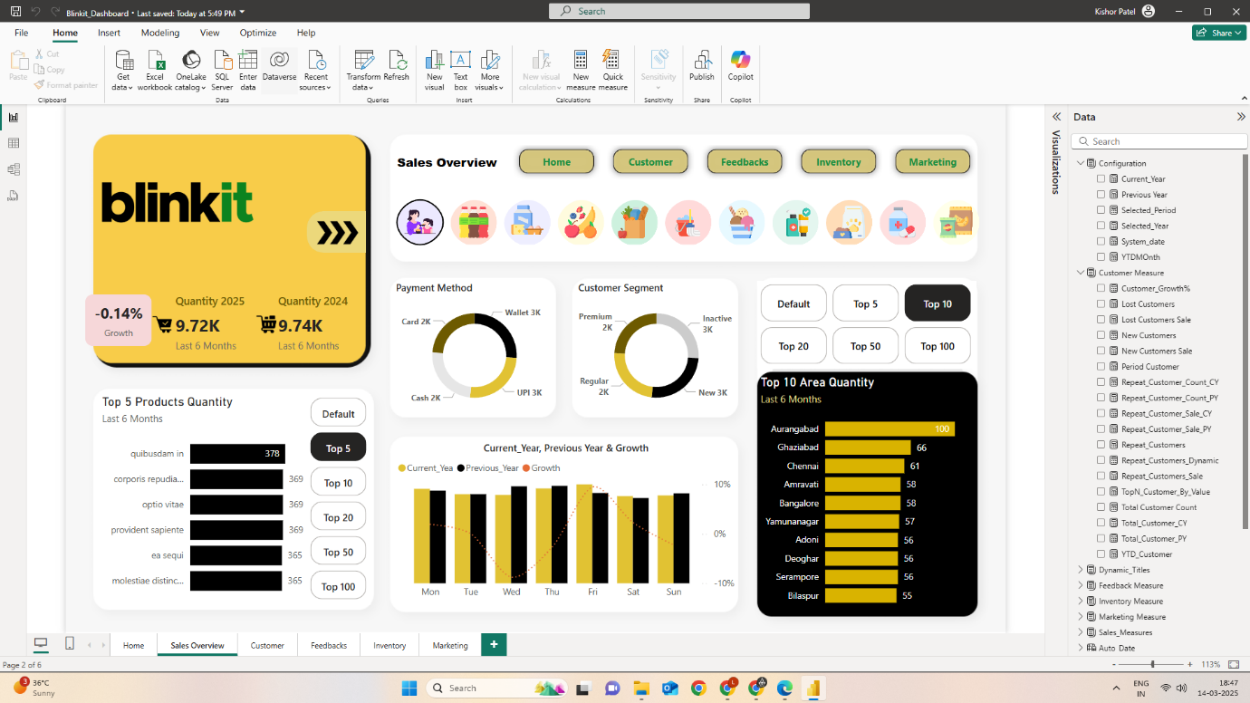

**Customer Page from Power-BI Desktop and List of DAX.**

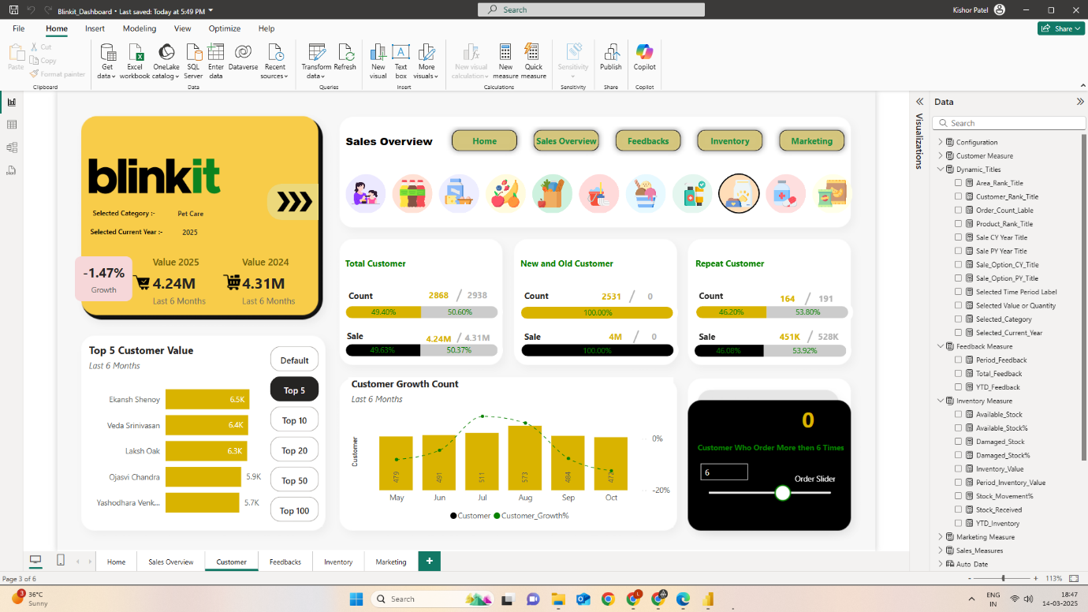

**Feedback Page from Power-BI Desktop and List of DAX.**

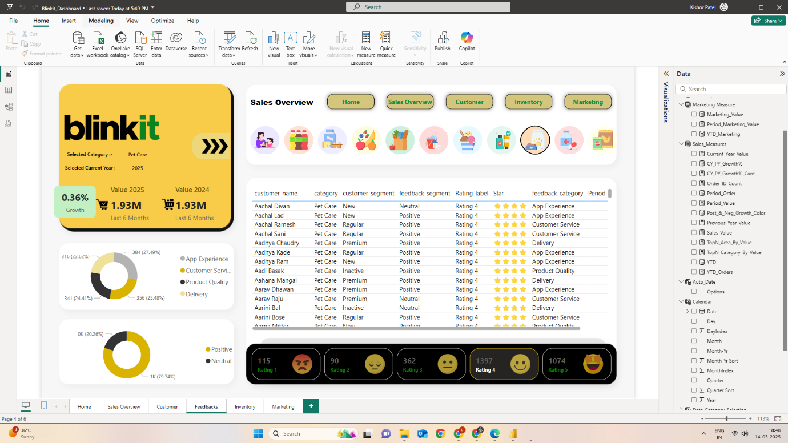

**Inventory Page from Power-BI Desktop.**

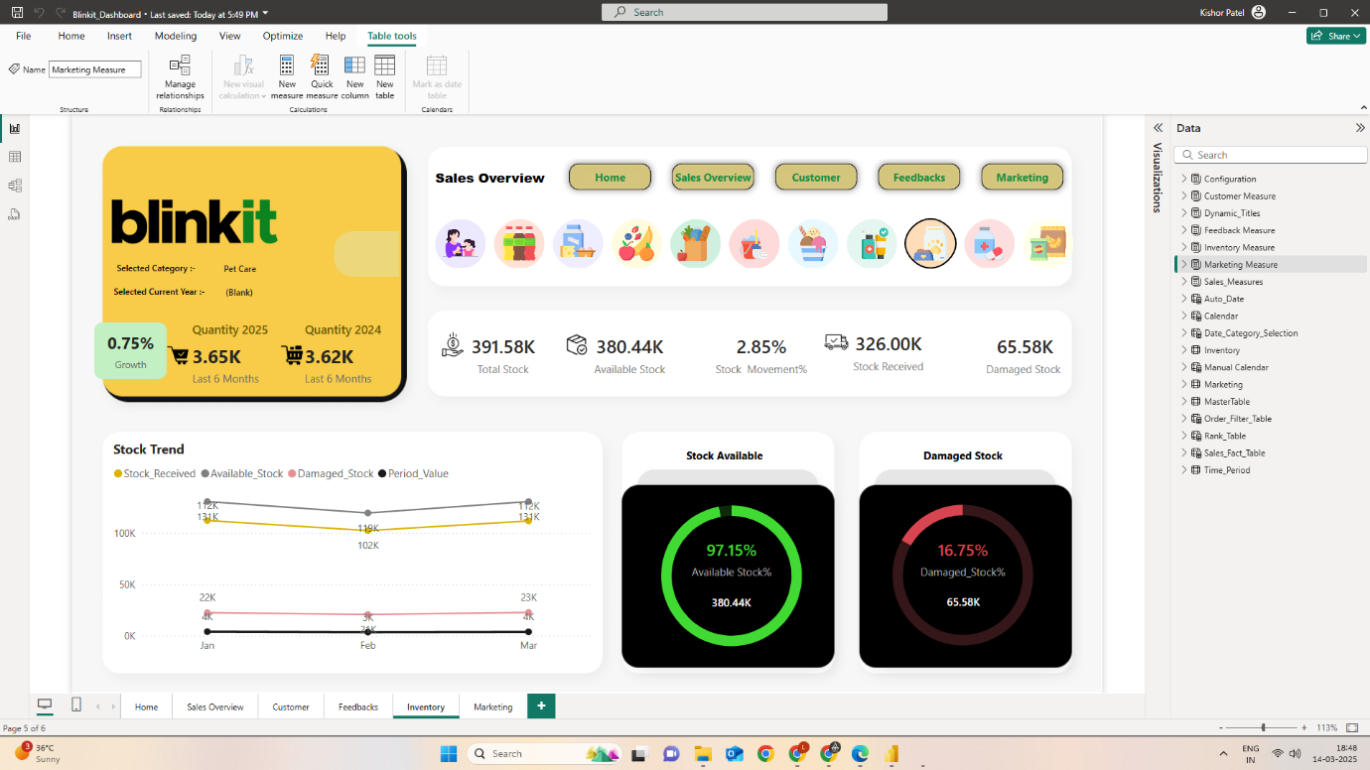

**Marketing Page from Power-BI Desktop.**

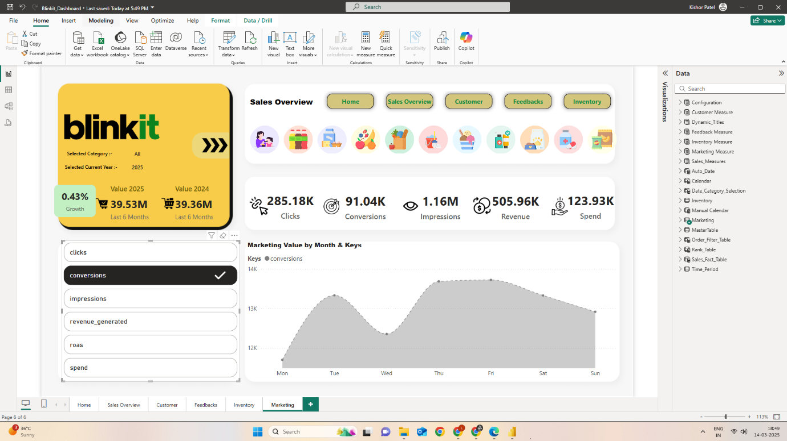

**Customer Page from Power-BI Desktop with Filter Option. Use Bookmark to Achieve this.**

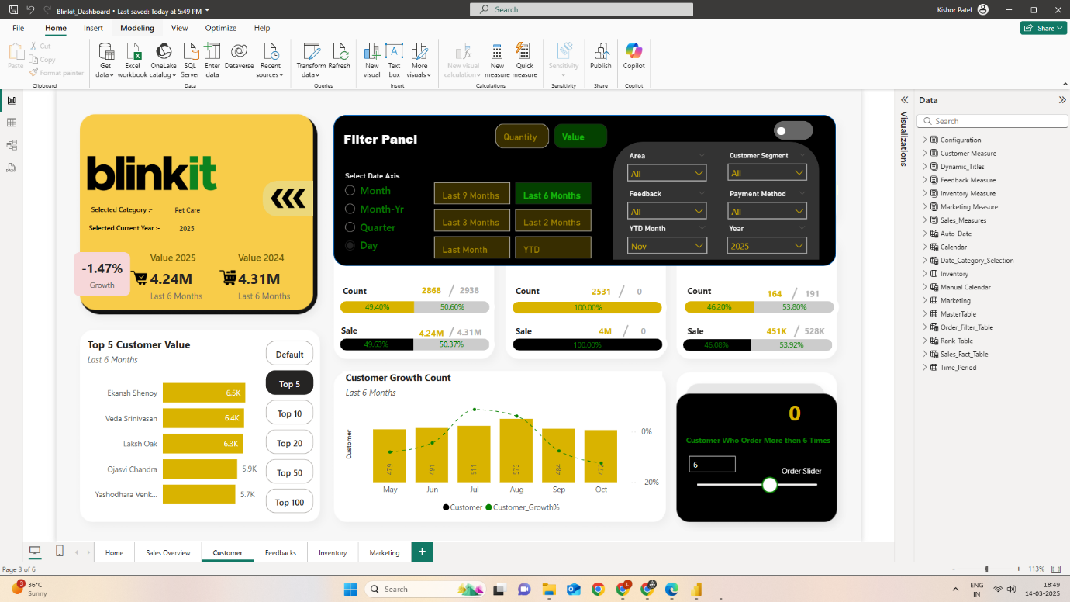

**Data Modelling between table.**

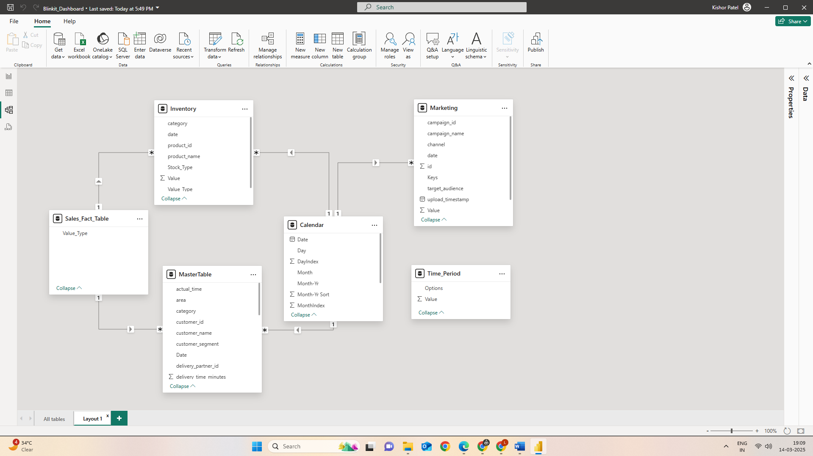

**This is my WebApp from “netlify”.**

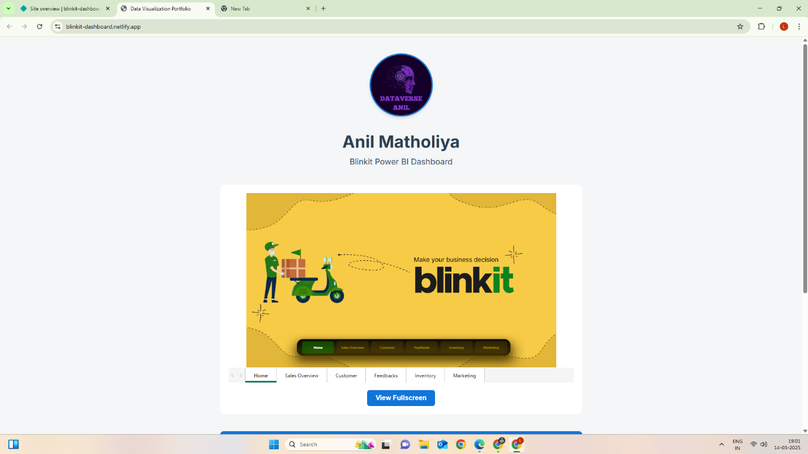

**This is how Dashboard looks online (On Webpage)**

[**https://blinkit-dashboard.netlify.app/**](https://blinkit-dashboard.netlify.app/)

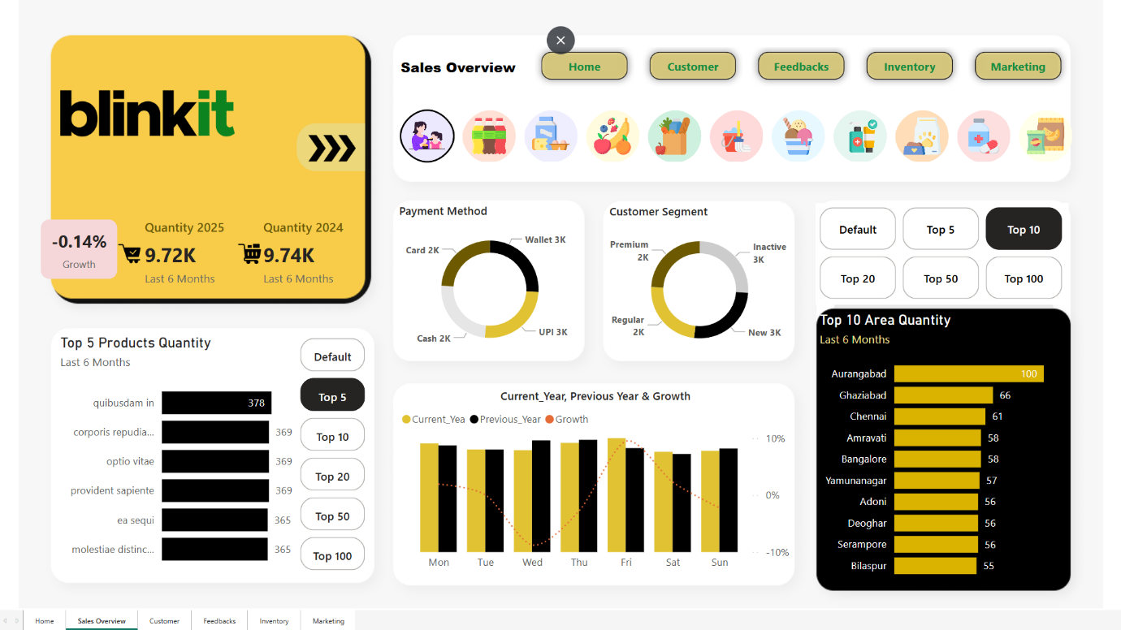

**MySQL Script.**  
