Applied Statistics
Tutorial Sheet 6.

- 300 elderly patients in a nursing home were monitored for the onset of any illness. The number of visits to each patient in the corresponding period was also recorded. The following table shows the results.

No. of visits | <9 | 9-12 | >12
Illness | 42 | 30 | 38
No Illness | 108 | 50 | 32

- Is there a significant association between the number of visitors and the incidence of illness at a significance level of 1%?
- Suggest a possible cause-effect relationship.

- A bank is investigating whether there is an association between a demographic characteristic (split into four groups) and load defaulting. The results are given below:

 | Group 1 | Group 2 | Group 3 | Group 4
No default | 186 (180) | 98 | 76 (80) | 40
Default | 84 | 52 (50) | 44 | 20

- Fill in the remaining expected values.
- Test the hypothesis that there is an association between defaulting and demographic group.

- Two hospitals serve a large town. The following table describes the success rate of operations at each:

 | Hospital A | Hospital B
Unsuccessful | 63 | 16
Successful | 2037 | 784

- Which hospital has the highest success rate?

- The operations carried out can be classified as routine and complex. Which hospital had the highest success rate for a) routine operations, b) complex operations?

 | Routine Operations |  | Complex Operations
 | Hospital A | Hospital B | Hospital A | Hospital B
Unsuccessful | 6 | 8 | 57 | 8
Successful | 594 | 592 | 1443 | 192

- What lurking variables (apart from discrimination against women) might explain the difference between the mean earnings of males and females? How would you test whether discrimination occurs?

- Data from 2009 show that in Ireland there is no significant difference between the mean earnings of Irish and immigrants from English speaking countries, whereas immigrants from non-English speaking countries earn significantly less on average. What factors (apart from discrimination against those from non-English countries) might explain these results?

- A study was carried out to investigate the relationship between the price of bus tickets, X, and the daily number of bus passengers, Y. A scatter plot of the results, together with the correlation and regression analysis (carried out in SPSS) are given below

Price (cents) | 25 | 30 | 35 | 40 | 45 | 50 | 55 | 60
Passengers | 800 | 780 | 780 | 660 | 640 | 600 | 620 | 620

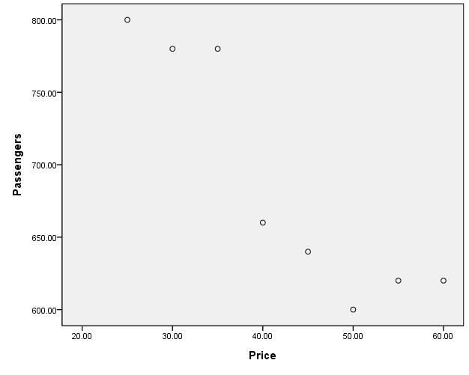
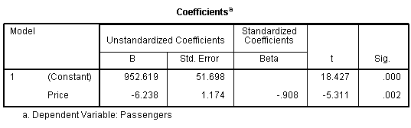

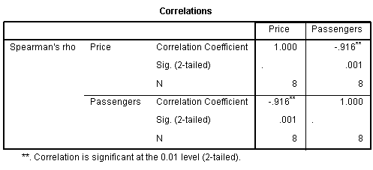
- Interpret the value of the correlation coefficient.
- Give the equation of the regression line which estimates the average daily number of passengers given the price of a ticket, X.
- Use this equation to estimate the average daily number of passengers when the price of the ticket is 50cents. What is the residual in this case?
- Use this equation to estimate the average daily number of passengers when the price of the ticket is €1.
- Which of these estimates is most accurate? Give a brief reason.
- Using this model, if the price is increased by 1cent what is the average change in demand?

- The following table gives the size of a population of bacteria (in thousands) in a Petri dish as time passes.

X-Time (h) | 0 | 1 | 2 | 3 | 4 | 5 | 6 | 7 | 8 | 9 | 10
Y-Population | 1.00 | 1.42 | 1.99 | 2.81 | 3.96 | 5.55 | 7.92 | 11.13 | 15.88 | 22.25 | 31.74

- Suggest a transformation U=f(Y) such that there is a linear relationship between X and U.

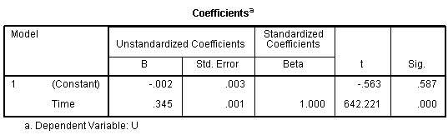
The table above gives the results of the regression analysis for U as a linear function of time.

- Using this analysis, derive a regression equation estimating the size of the population as a function of time.
- Estimate the percentage growth rate of the population per hour.
- Using this regression equation, estimate the population size after 40 hours.
- Explain in physical terms why this estimate may well be an overestimate.

