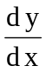 - y sin x = e^{-cos x} ^{in form} + a(x)y = b(x)

intergrating factor μ(x)

