Short author list:
J.M. Ramos-Goñi, M. Ouellet, and O. Rivero-Arias

Long author list:
- Juan Manuel Ramos-Goñi, Maths in Health B.V., Amsterdam, The Netherlands. jramos@mathsinhealth.com
- Melissa Ouellet, Maths in Health B.V., Amsterdam, The Netherlands. mouellet@mathsinhealth.com
- Oliver Rivero-Arias, Maths in Health B.V. and Nuffield Department of Population Health, National Perinatal. Epidemiology Unit, University of Oxford, Oxford, UK. oliver.rivero@npeu.ox.ac.uk

Short title: EQ-5D suite

Long title: A suite of Stata commands to estimate utility values and analyse and report EQ-5D data

Abstract:
The EQ-5D instrument is widely used to measure health-related quality of life in health economics and outcomes research. In this article, we present a series of Stata commands to estimate utility values for the EQ-5D instrument and to analyse and report EQ-5D response data. The commands eq5d3l, eq5d5l and eq5dy3l implement EQ-5D-3L, EQ-5D-5L and EQ-5D-Y value sets respectively to calculate utility scores based on patient responses to the EQ-5D questionnaire. The command eqxw calculate EQ-5D-3L index values from EQ-5D-5L responses using a crosswalk algorithm whereas eqxwr calculate EQ-5D-5L index values from EQ-5D-3L responses using a reverse crosswalk algorithm. Data analysis and reporting of EQ-5D data is implemented using the command eqreport that implements common cross-sectional and longitudinal analysis of this type of data based on best practice guidance. We describe how to prepare the data, including data cleaning and recoding of the EQ-5D responses for successful use with the suite. The Stata commands presented in this article provide a comprehensive framework for estimating EQ-5D utility values and analysing EQ-5D response data in health economic evaluations and other population-based studies.

Keywords:
EQ-5D-3L, EQ-5D-5L, EQ-5D-Y, crosswalk, EuroQol, index values, descriptive system, preferences, health states

Introduction

EQ-5D is a generic health-related quality-of-life instrument developed by the EuroQol group which has been extensively used for a variety of purposes around the world, including clinical trials, population studies and real-word settings. The EQ-5D is recommended for use by many Health Technology Assessment bodies around the world [1].
The EQ-5D questionnaire includes two parts. The first is the EQ-5D descriptive system, where respondents indicate the level of problems they experience on each of the five dimensions: mobility, self-care, usual activities, pain or discomfort, and anxiety or depression. Each dimension contains three levels of responses in the 3L version (EQ-5D-3L and its child-friendly version EQ-5D-Y) and five levels of responses in the 5L version (EQ-5D-5L). The second is the EQ VAS, where respondents assess their own health on a scale from 0 (worst health imaginable) to 100 (best health imaginable) [2-4].
Responses from the EQ-5D descriptive system can be converted into a single number, named index value or utility, using validated value sets [5]. A value set is a set of weights to each of the levels in each EQ-5D dimension and reflect the preferences of the sample used in the elicitation task (normally members of the general population). Value sets are constructed to that EQ-5D index values lie on a scale anchored by the value 1, full health, and 0, dead. Negative values are allowed for health states considered to be worse than dead and the lower bound varies depending on the country-specific value set used.
Member of the EuroQol group have published the textbook “Value Sets for EQ-5D-5L” which includes an inventory of the EQ-5D-5L value sets and their characteristics. EQ-5D-5L value sets are not available yet for many countries, while EQ-5D-3L are [5]. Many economic evaluations have used a country-specific interim crosswalks solutions, which estimates EQ-5D-5L utilities from the EQ-5D-3L value sets [6]. More recently a reverse crosswalk that allows the estimation of EQ-5D-3L utility values from EQ-5D-5L response data (this has been coined reverse crosswalk) [7].
Previous work on calculating utilities for EQ-5D instruments included the eq5d and eq5d5l Stata commands [8]. These commands facilitate the calculation of index values from individual responses of the EQ-5D-3L or EQ-5D-5L instruments using several country-specific value sets. However, both the eq5d and the eq5d5l commands are out of date, i.e., several published values sets are not included. There is no Stata command to facilitate the EQ-5D-Y index values calculations. In addition, to the these commands, the eq5dds tool facilitates the analysis of the EQ-5D-3L and EQ-5D-5L descriptive system for users and programmers working with individual data in Stata. The command implements a set of limited analysis based on the most recent EQ-5D user guide published in 2016 [9]. Recently, a new textbook covering a larger selection of methods called “Methods for analysing and reporting EQ-5D data” has been published by members of the Group [10]. This book reports analysis of both domains/EQ-VAS and utility values for both cross sectional and longitudinal data including time series plots and many other methods which are not incorporated in the eq5dds command.
In this article, we describe a suite of commands to calculate index values (both direct and crosswalk), and to analyse and report EQ-5D utility and response data using best practices.

eq5d3l: A command to calculate EQ-5D-3L index values from EQ-5D-3L responses of the EQ-5D health-related quality-of-life instrument

2.1 Description
eq5d3l computes EQ-5D-3L index values from the individual mobility, self-care, usual activities, pain/discomfort, and anxiety/depression responses of the EQ-5D-3L quality of life instrument. This version of the command can use published value sets from 35 countries.
It also allows users to add EQ-5D-3L country value sets. The command then calculates EQ-5D-3L index values from the user-added EQ-5D-3L value sets. Users can display the countries whose value sets are stored by default or added by the user.

2.2 Syntax
eq5d3l varname₁ varname₂ varname₃ varname₄ varname₅ [if] [in] [, options]
The variables must be introduced in the same order in which they appear in the EQ-5D-3L questionnaire, for example, “mobility” for varname₁, “self-care” for varname₂, “usual activities” for varname₃, “pain/discomfort” for varname₄, and “anxiety or depression” for varname₅. In addition, the levels of each EQ-5D-3L variable must be coded as follows: 1 for “no problems”, 2 for “some problems”, 3 for “extreme problems”.
When there are missing data in any of the EQ-5D-3L dimensions for a particular respondent, the EQ-5D-3L index value for that individual will also be missing.

2.3 Options

- country (#) specifies the country-specific value set to be used in the estimation of the EQ-5D-3L index values. The available countries # and their respective codes are as follows: the United Kingdom (GB), the United States (US), Canada (CA), Argentina (AR), Argentina VAS (AR_VAS), Australia (AU), Belgium VAS (BE_VAS),Chile (CL), China (CN), Denmark (DK), Finland VAS (FI_VAS), France (FR), Germany (DE), Germany VAS (DE_VAS), Hungary (HU), Iran (IR), Italy (IT), Japan (JP), Malaysia VAS (MY_VAS), New Zealand VAS (NZ_VAS), Poland (PL), Singapore (SG), Slovenia (SI), Slovenia (SI_VAS), South Korea (KR), Spain (ES), Sri Lanka (LK), Sweden (SE), Taiwan (TW), Thailand (TH), the Netherlands (NL), Trinidad and Tobago (TT), Tunisia (TN), Portugal (PT) and Zimbabwe (ZW). The default is country (GB). Only one country at a time is allowed. Value sets can be derived from the EQ-5D Visual Analog Scale (VAS) method instead of the default time trade-off (TTO) valuation technique.
- saving (newvarname) specifies the name of the variable under which the index value will be stored.
- by (groupvar) specifies the group variable to be used by eq5d3l when reporting descriptive statistics for each of the groups identified by groupvar.
Users have the option to add/remove value sets which can be used later for future index value calculations using the following advanced options:
- from (varname) specifies the variable which includes the set of EQ-5D-3L index values the user wishes to add, whose country isn't already part of the default list; add (countryname) needs to be specified at the same time
- add (countryname) represents the country name whose 3L index values the user is adding given the country isn't already part of the default ones listed above; from (varname) needs to be specified at the same time
- drop (countryname) represents the country name whose 3L index values the user has added but has decided to remove in the end; user cannot drop default country values display allows the user to visualize the entire list of default or user-added 3L value sets which can be used in the country (#) field.
- display allows the user to visualize the entire list of default or user-added EQ-5D-3L value sets which can be used in the country(#) field

2.4 Examples

Section 2.4.1 gives examples of the use of eq5d3l for calculating index values. In sections 2.4.2 and 2.4.3, we give examples on adding and dropping a new value set to the eq5d3l command.

2.4.1 Calculating index values

To illustrate how eq5d3l works, a hypothetical dataset of 20 individuals with the five EQ-5D-3L domains, along with gender and age, has been simulated. The data have been stored in eq5d3l.dta

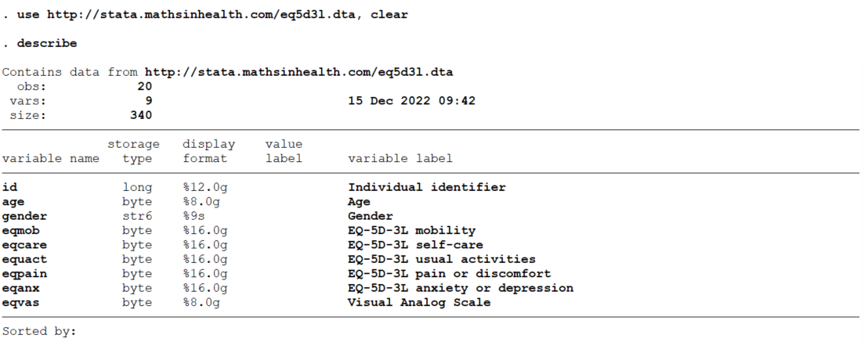
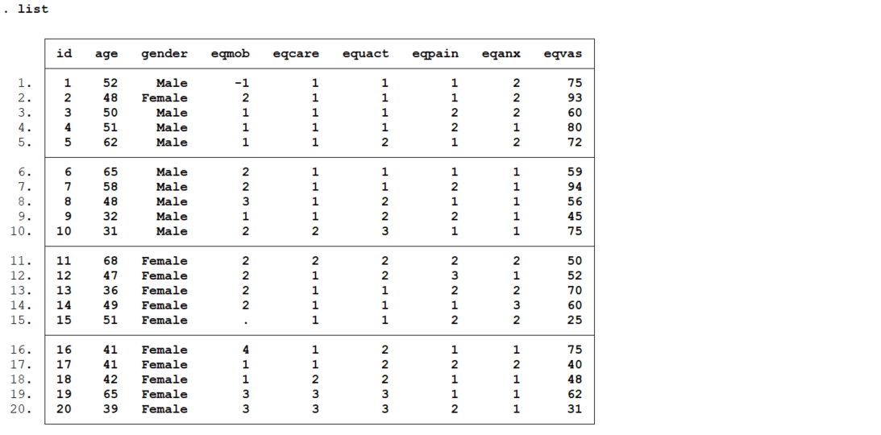

We can execute the eq5d3l command as follows:

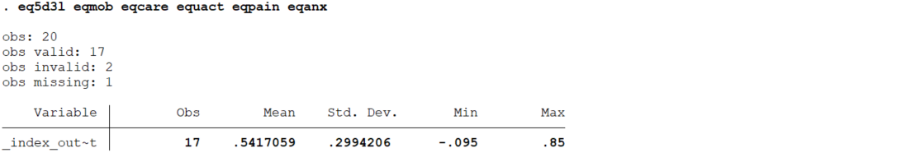

eq5d3l calculates the EQ-5D-3L value index for the 17 valid observations using the default value set and reports summary statistics (mean, std. dev, min and max). In our simulated data there is 1 observation with a missing value and 2 observations with an invalid value in any of the EQ-5D-3L responses. We can tabulate responses in each EQ-5D-3L dimension to identify data anomalies.
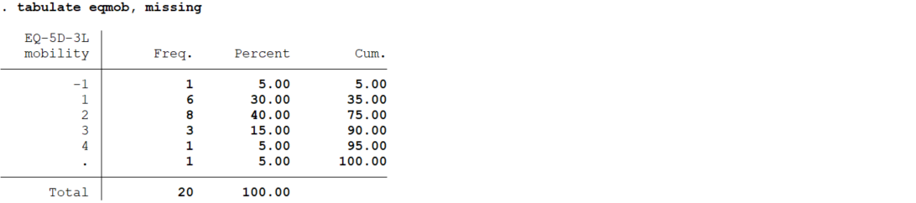
Two values of the mobility variable (eqmob) are not correctly coded (values -1 and 4). In real practice, users should attempt to figure out the nature and the reasons of these anomalies as they can be correcting avoiding a missing value.

eq5d3l displays summary statistics for a group variable with the by () option. In the current dataset, for example, we can display summary statistics for the EQ-5D-3L index value for the gender variable using the Canadian value set as follows:

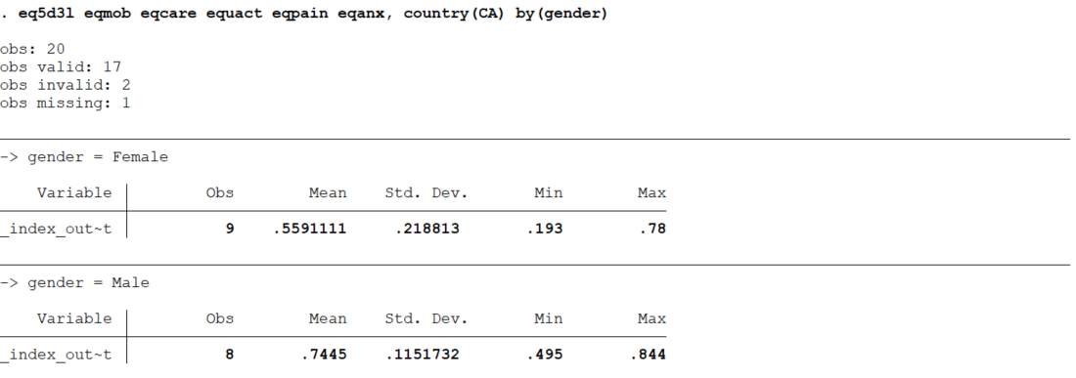

The calculated index values can be stored in a new variable using the saving () option. In the example below, the EQ-5D-3L value index for the 17 valid observations using the Spanish value sets are saved in a new variable named “index”.

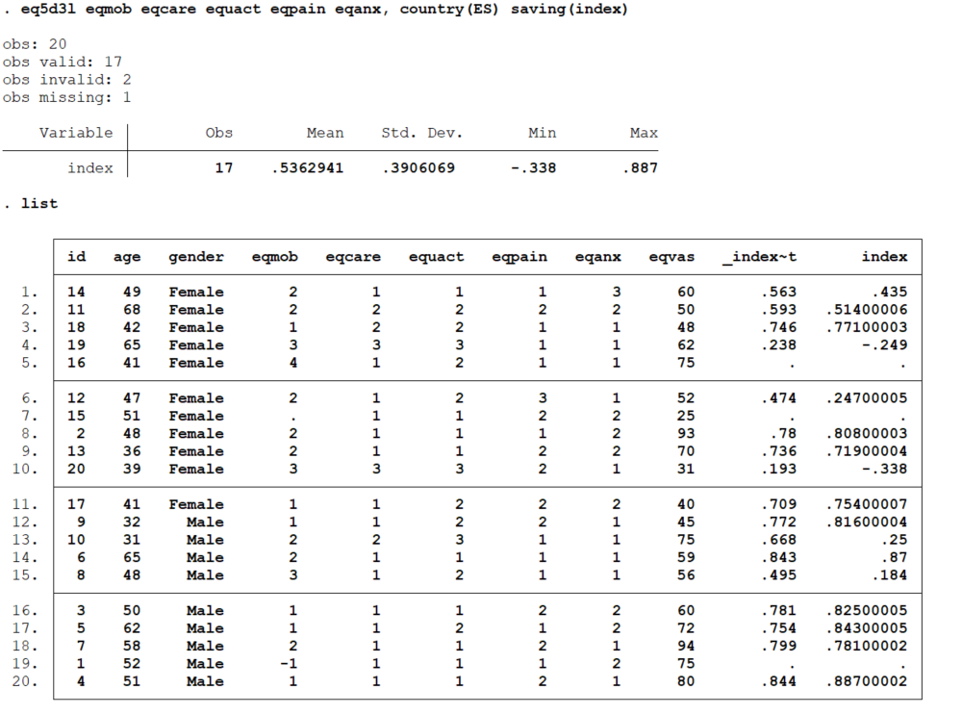

2.4.2 Adding/dropping a new value set to the command
The EQ-5D-3L describes 243 (3⁵) distinct health states. To illustrate how to add a new value set, a dataset of the 243 health states of the EQ-5D-3L along with hypothetical value index has been simulated. The data have been stored in eq5d3l_value_set.dta
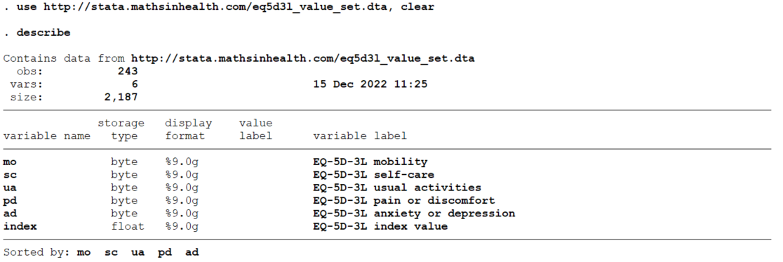
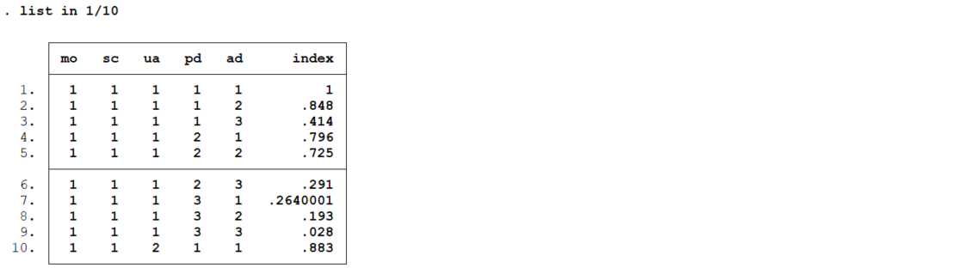
We can add this value set to the list of value sets available using the add () and from () options. In the example below, the simulated value set will be added with the code “NEW_COUNTRY”.
We can display the list of available value sets, both stored by default and added by the user, as follows:
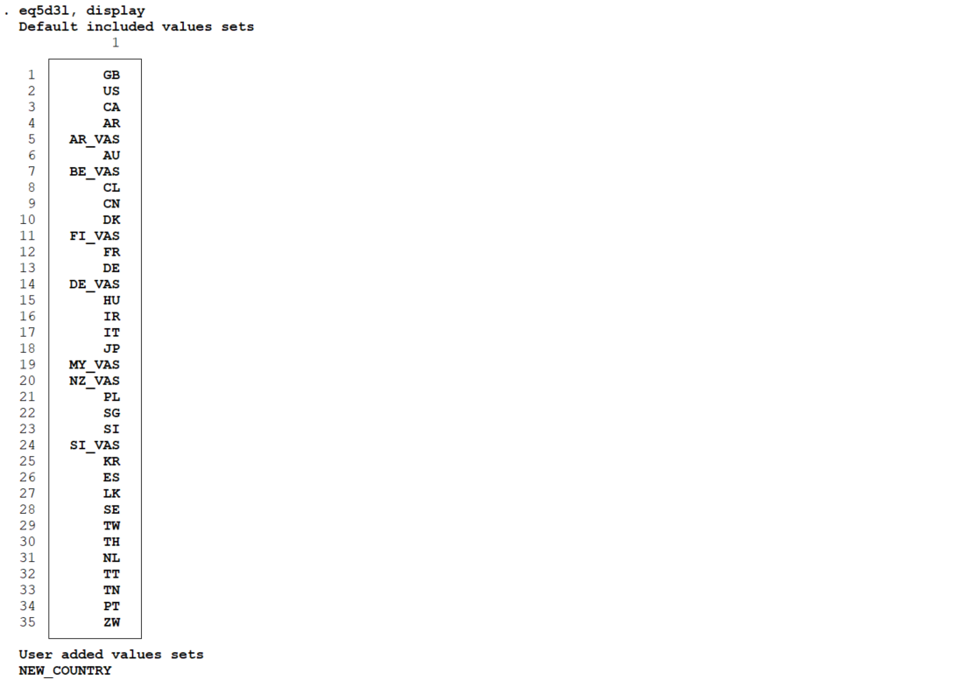
User-added value sets can be used to calculate index values. For example, we can load the dataset “eq5d3l.dta” dataset described in section 2.4.1 and calculate the EQ-5D-3L index values using the “NEW_COUNTRY” value set.
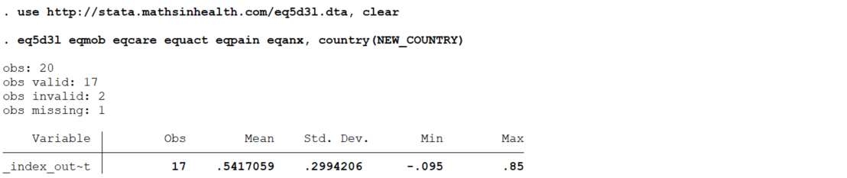

We can drop this value set as follows:

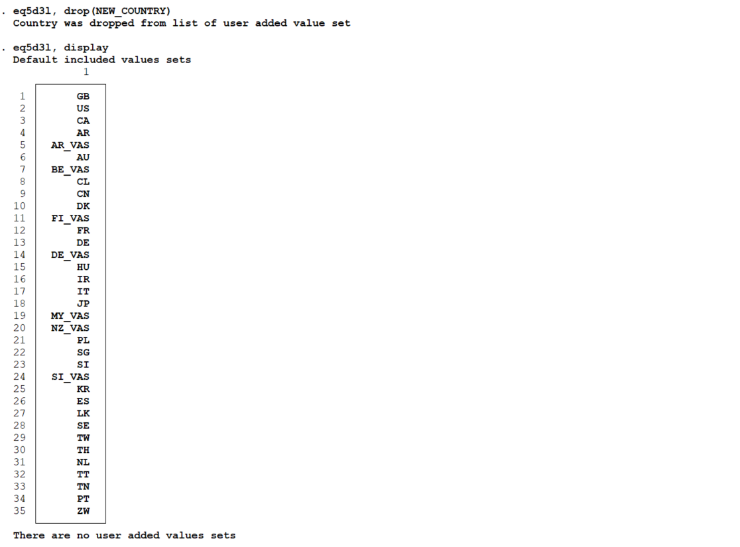

eq5d5l: A command to calculate EQ-5D-5L index values from EQ-5D-5L responses of the EQ-5D health-related quality of life instrument

3.1 Description
eq5d5l computes EQ-5D-5L index values from the individual mobility, self-care, usual activities, pain/discomfort, and anxiety/depression responses of the EQ-5D-5L quality of life instrument. This version of the command can use published value sets from 29 countries.
It also allows users to add EQ-5D-5L country value sets. The command then calculates EQ-5D-5L index values from the user-added EQ-5D-5L value sets. Users can display the countries whose value sets are stored by default or added by the user.

3.2 Syntax
eq5d5l varname₁ varname₂ varname₃ varname₄ varname₅ [if] [in] [, options]
The variables must be introduced in the same order in which they appear in the EQ-5D-5L questionnaire, for example, “mobility” for varname₁, “self-care” for varname₂, “usual activities” for varname₃, “pain/discomfort” for varname₄, and “anxiety or depression” for varname₅. In addition, the levels of each EQ-5D-5L variable must be coded as follows: 1 for “no problems”, 2 for “slight problems”, 3 for “moderate problems”, 4 for “severe problems” and 5 for “extreme problems”.
When there are missing data in any of the EQ-5D-5L dimensions for a particular respondent, the EQ-5D-5L index value for that individual will also be missing.

3.3 Options
- country (#) indicates the country-specific value set to be used in the estimation of the EQ-5D-5L index values. The available countries # and their respective codes are as follows: the United States (US), Canada (CA), Belgium (BE), China (CN), Denmark (DK), Egypt (EG), Ethiopia (ET), France (FR), Germany (DE), Hong Kong (HK), Hungary (HU), India (IN), Indonesia (ID), Ireland (IE), Italy (IT), Japan (JP), Malaysia (MY), Mexico (MX), Peru (PE), Poland (PL), Portugal (PT), South Korea (KR), Spain (ES), Taiwan (TW), Thailand (TH), the Netherlands (NL), Uganda (UG), Uruguay (UY), and Vietnam (VN). The default is country (US). Only one country at a time is allowed.
- saving (newvarname) specifies the name of the variable under which the index value will be stored.
- by (groupvar) specifies the group variable to be used by eq5d5l when reporting descriptive statistics for each of the groups identified by groupvar.
Users have the option to add/remove value sets which can be used later for future index value calculations using the following advanced options:
- from (varname) specifies the variable which includes the set of 5L index values the user wishes to add, whose country isn't already part of the default list; add(countryname) needs to be specified at the same time
- add (countryname) represents the country name whose 5L index values the user is adding given the country isn't already part of the default ones listed above; from(varname) needs to be specified at the same time
- drop (countryname) represents the country name whose 5L index values the user has added but has decided to remove in the end; user cannot drop default country values
- display allows the user to visualize the entire list of default or user-added 5L value sets which can be used in the country (#) field

3.4 Example

Section 3.4.1 gives examples of the use of eq5d5l for calculating index values. In sections 3.4.2 and 3.4.3, we give examples on adding and dropping a new value set to the eq5d5l command.

3.4.1 Calculating index values

To illustrate how eq5d5l works, a hypothetical dataset of 20 individuals on the five domains of the EQ-5D-5L, along with gender and age, has been simulated. The data have been stored in eq5d5l.dta

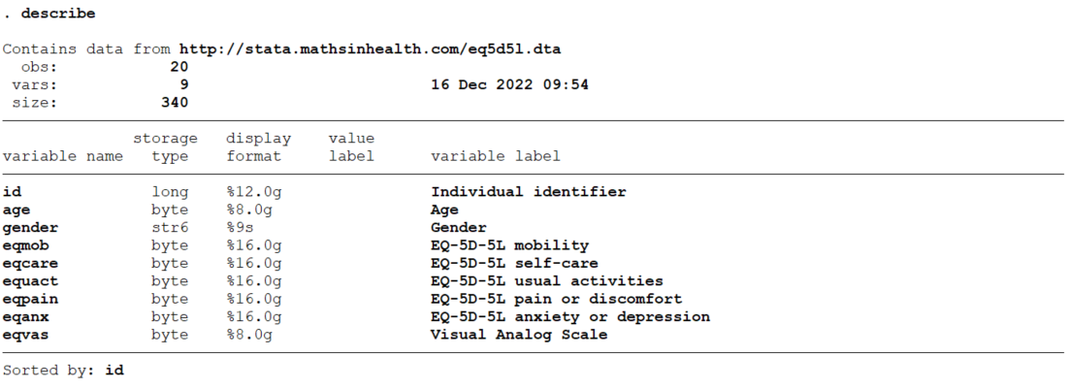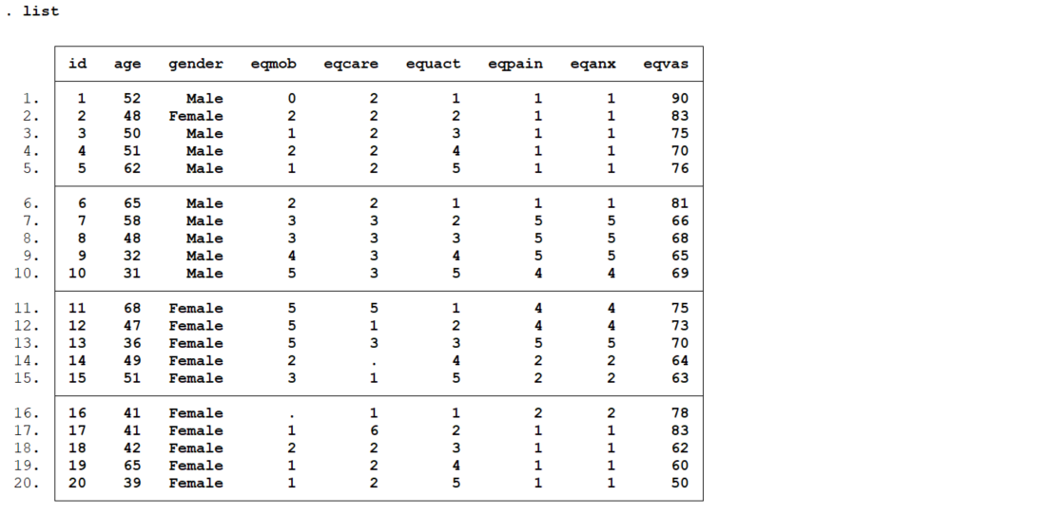

We can execute the eq5d5l command as follows:

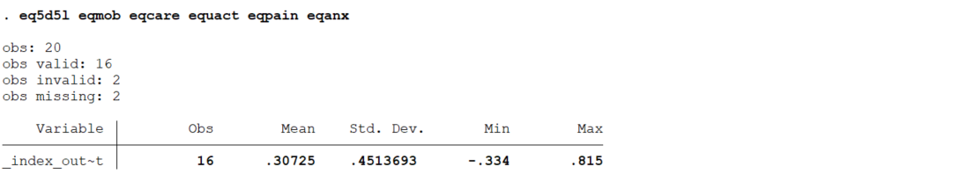

eq5d5l calculates the EQ-5D-5L value index for the 16 valid observations using the default value set (US) and reports summary statistics (mean, std. dev, min and max). In our simulated data there are 2 observations with 2 missing values and 2 observations with invalid values in some of the EQ-5D-5L responses. We can tabulate responses in each EQ-5D-5L dimension to identify data anomalies.

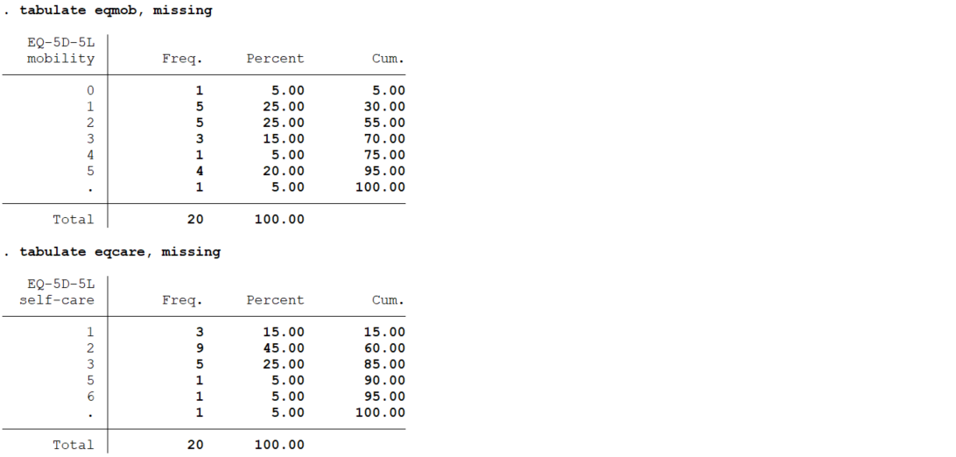

In the mobility and self-care variables (eqmob and eqcare) include one value not correctly coded (values 0 and 6). In real practice, users should attempt to figure out the nature and the reasons of these anomalies as they can be correcting avoiding a missing value.

eq5d5l displays summary statistics for a group variable with the by () option. In the current dataset, for example, we can display summary statistics for the EQ-5D-5L index value for the gender variable using the Belgian value set as follows:

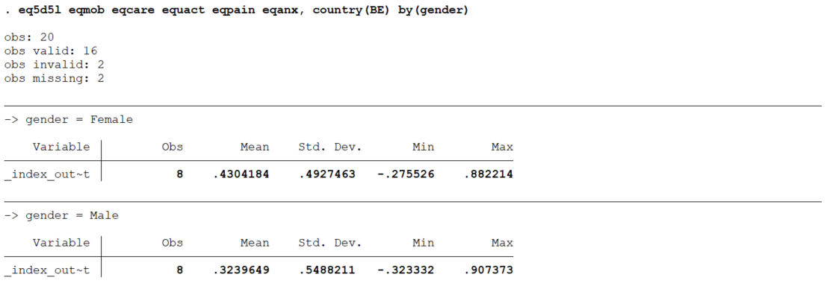

The calculated index values can be stored in a new variable using the saving () option. In the example below, the EQ-5D-5L value index for the 16 valid observations using the Italian value sets are saved in a new variable named “index”.
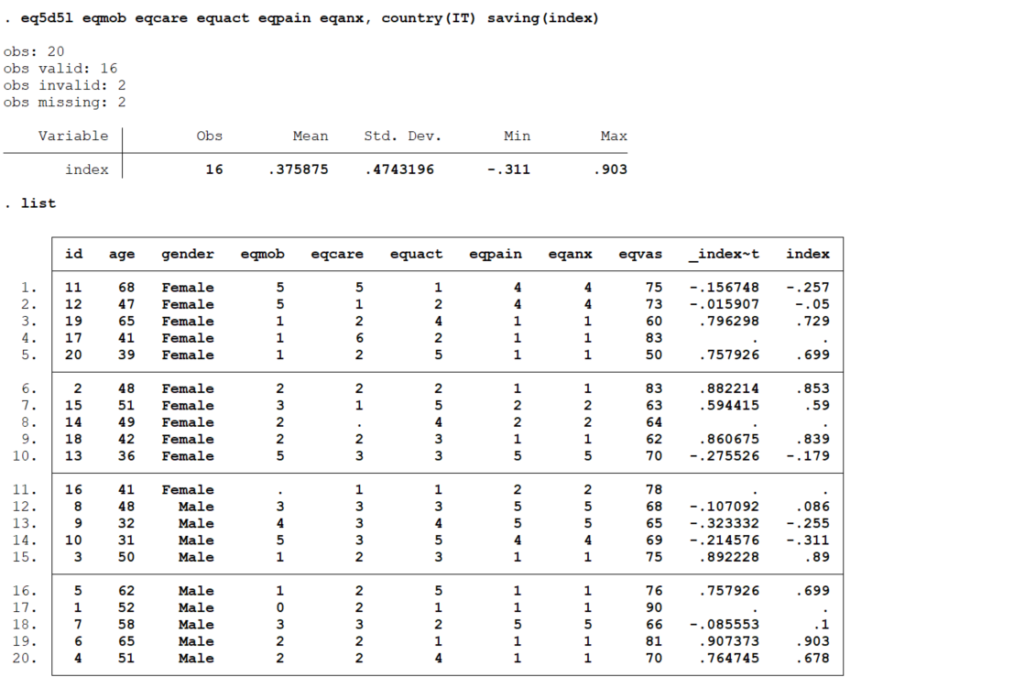

3.4.1 Adding / dropping a new value set to the command
The EQ-5D-5L describes 3,125 (5⁵) distinct health states. To illustrate how to add a new value set, a dataset of the 3,125 health states of the EQ-5D-5L along with hypothetical value index has been simulated. The data have been stored in eq5d5l_value_set.dta
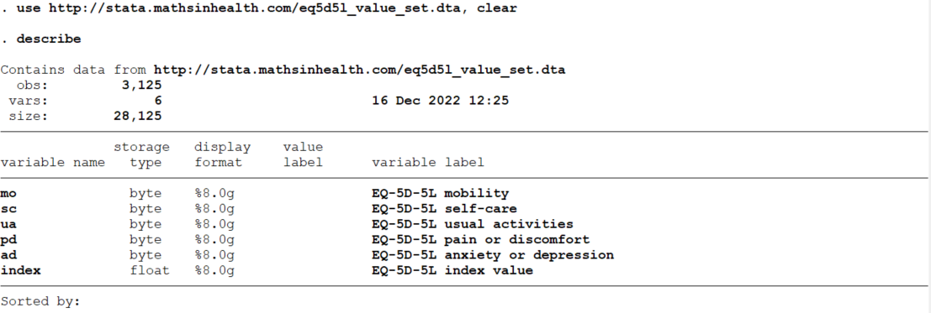
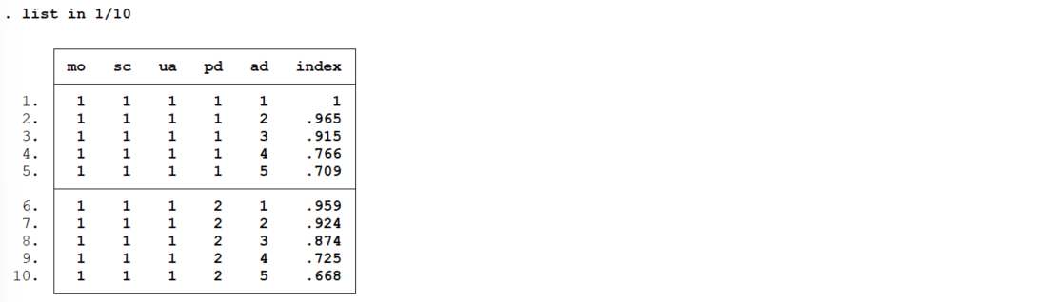
We can add this value set to the list of value sets available using the add () and from () options. In the example below, the simulated value set will be added with the code “NEW_COUNTRY”.
We can display the list of available value sets, both stored by default and added by the user, as follows:
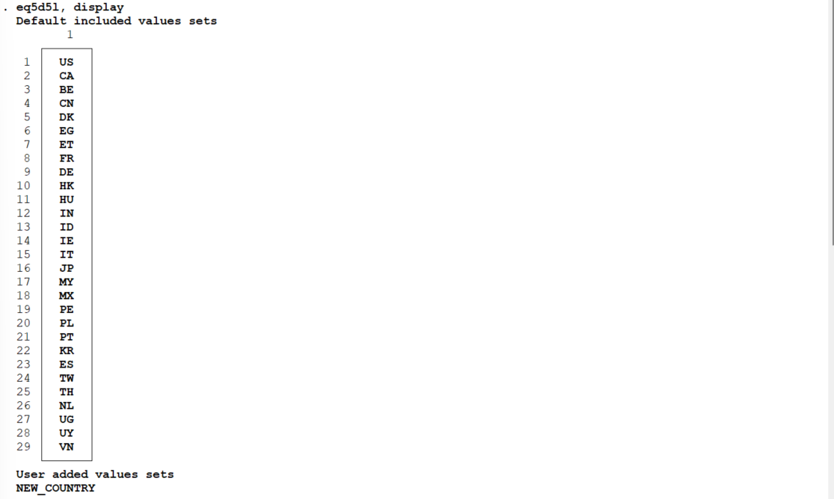
User-added value sets can be used to calculate index values. For example, we can load the dataset “eq5d5l.dta” dataset described in section 2.4.1 and calculate the EQ-5D-5L index values using the “NEW_COUNTRY” value set.
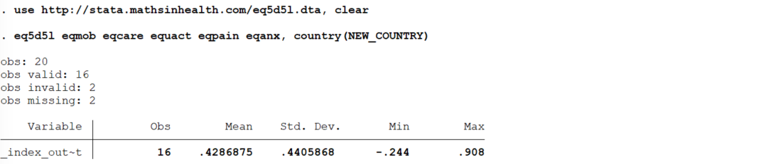
We can drop this value set as follows:

eq5dy3l: A command to calculate EQ-5D-Y-3L index values from EQ-5D-Y-3L responses of the EQ-5D health-related quality of life instrument

4.1 Description
eqy3l computes EQ-5D-Y-3L index values from the individual mobility, self-care, usual activities, pain/discomfort, and anxiety/depression responses of the EQ-Y-3L quality of life instrument. This version of the command can use published value sets from 4 countries.
It also allows the user to add EQ-5D-Y-3L country value sets. The command then calculates EQ-5D-Y-3L index values from the user-added EQ-5D-Y-3L value sets. Users can also display the countries whose value sets are stored by default or added by the user.

4.2 Syntax
eqy3l varname₁ varname₂ varname₃ varname₄ varname₅ [if] [in] [, options]
The variables must be introduced in the same order in which they appear in the EQ-5D-Y-3L questionnaire, for example, “mobility” for varname₁, “looking after myself” for varname₂, “doing usual activities” for varname₃, “having pain or discomfort” for varname₄, and “feeling worried, sad or unhappy” for varname₅. In addition, the levels of each EQ-5D-Y-3L variable must be coded as follows: 1 for “no problems”, 2 for “some problems”, 3 for “a lot of problems”.
When there are missing data in any of the EQ-5D-Y-3L dimensions for a particular respondent, the EQ-5D-Y-3L index value for that individual will also be missing.

4.3 Options
The options for eqy3l are identical to those for eq5d3l (section 2.3). The default EQ-5D-Y-3L value sets which can be used in the country (#) field and their respective codes are as follows: Germany (DE), Japan (JP), Slovenia (SI), and Spain (ES). The default is country (ES).

4.4 Example
To illustrate how eqy3l works, a hypothetical dataset of 20 individuals on the five domains of the EQ-5D-Y, along with gender, age and region, has been simulated. The data have been stored in eq5dy3l.dta

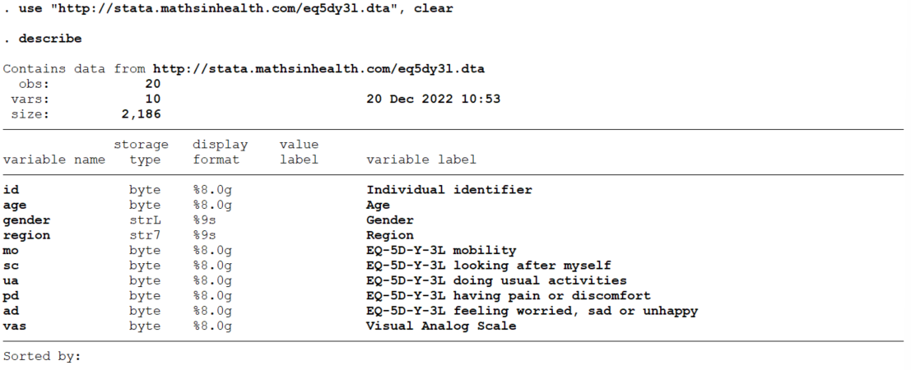
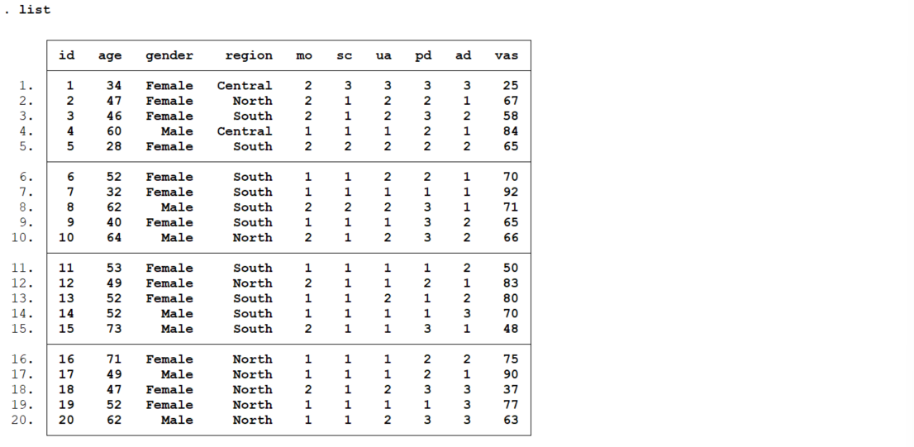
We can execute the eqy3l command as shown below. Eqy3l calculates the EQ-5D-Y-3L value index for the 20 valid observations. Our simulated data does not include any observations with missing nor invalid values.
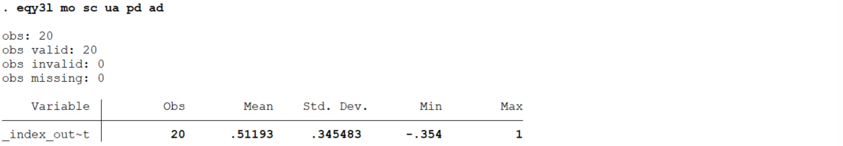

eqy3l displays summary statistics for a group variable with the by () option. In the current dataset, for example, we can display summary statistics for the EQ-5D-Y-3L index value for the region variable using the Slovenia value set as follows:
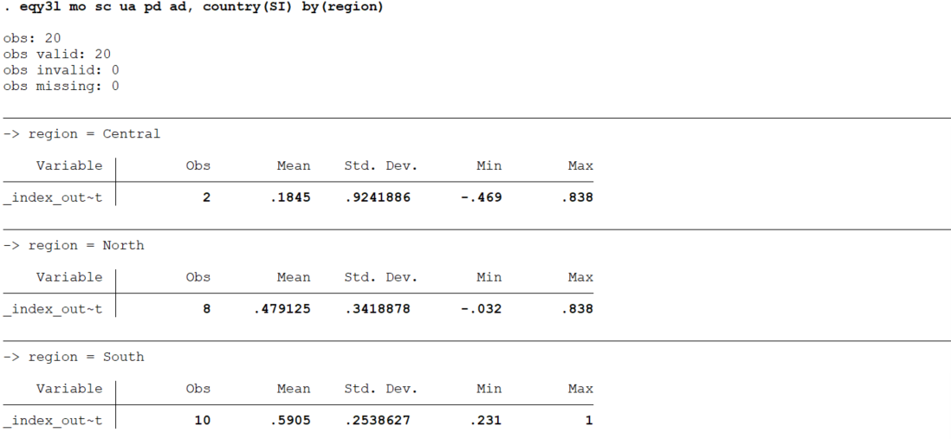
We can use the saving() option to create a new variable with the index value assigned to each individual. In the following example, the name of the new variable is “utility”.
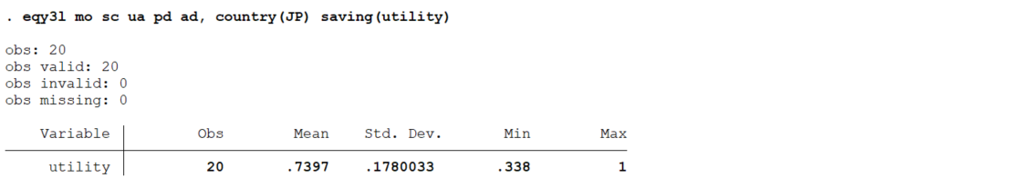
The steps to add/drop a new value set to eqy3l are identical to those for eq5d3l described in section 2.4.1.

5. eqxw: A command to calculate EQ-5D-3L index values from EQ-5D-5L responses of the EQ-5D health-related quality of life instrument using the EuroQol crosswalk algorithm

5.1 Description
eqxw computes EQ-5D-3L index values from the individual mobility, self-care, usual activities, pain/discomfort, and anxiety/depression responses of the EQ-5D-5L quality of life instrument. This version of the command can use published value sets from 35 countries.
It also allows users to add or remove their own EQ-5D-3L country value set from a specific variable. The command then calculates EQ-5D-3L index values from the user-added EQ-5D-3L value sets. Users can display the countries whose value sets are stored by default or added by the user.

5.2 Syntax
eqxw varname₁ varname₂ varname₃ varname₄ varname₅ [if] [in] [, options]
The variables must be introduced in the same order in which they appear in the EQ-5D-5L questionnaire, for example, “mobility” for varname₁, “self-care” for varname₂, “usual activities” for varname₃, “pain/discomfort” for varname₄, and “anxiety or depression” for varname₅. In addition, the levels of each EQ-5D-5L variable must be coded as follows: 1 for “no problems”, 2 for “slight problems”, 3 for “moderate problems”, 4 for “severe problems” and 5 for “extreme problems”.
When there are missing data in any of the EQ-5D-5L dimensions for a particular respondent, the EQ-5D-3L index value for that individual will also be missing.

4.3 Options
The options for eqxw are identical to those for eq5d3l (section 2.3).

4.4 Example
To illustrate how eqxw works, a hypothetical dataset of 20 individuals on the five domains of the EQ-5D-5L, along with gender and age, has been simulated. The data have been stored in eq5d5l.dta and has been previously used in section 3.4.1.

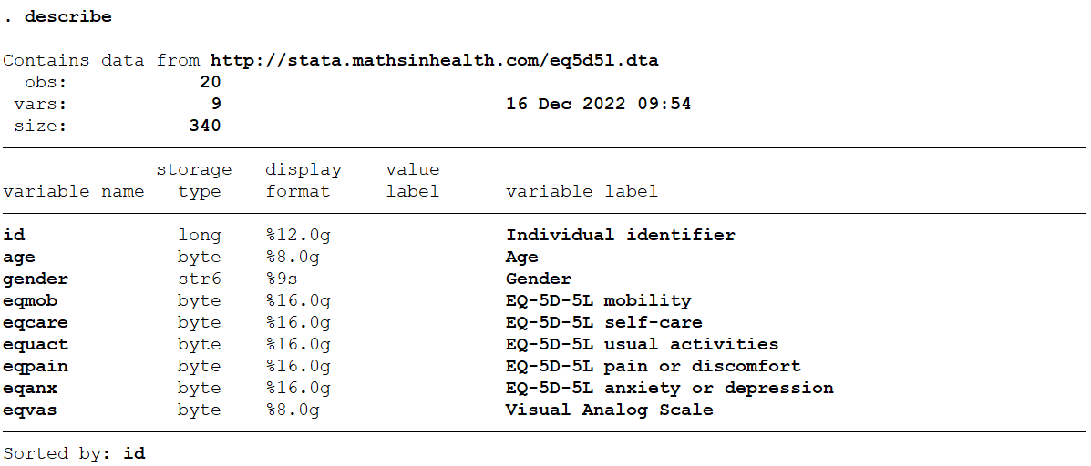
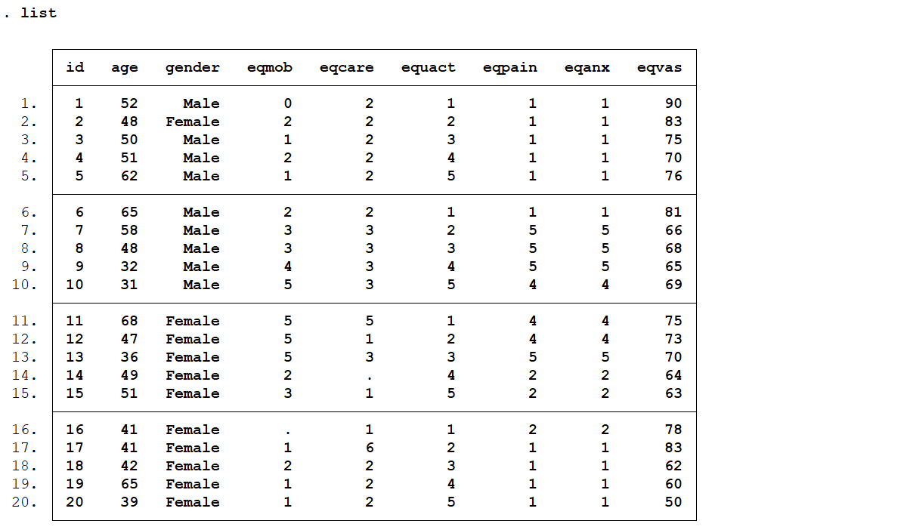
We can execute the eqxw command as follows:
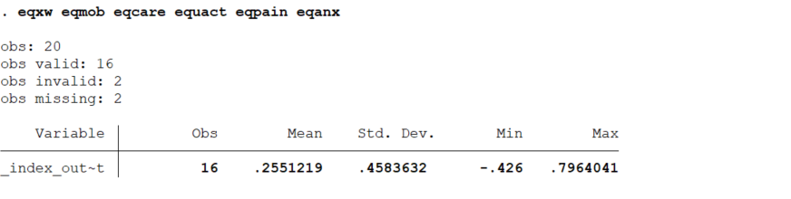
Let’s now assume data was collected in Argentina. The EQ-5D-5L value set does not yet exist in Argentina, while the EQ-5D-3L value set does. Therefore, we cannot use the eq5d5l command and we need to use the eqxw command to estimate index values in our simulated data. eqxw estimates an interim EQ-5D-5L value set for Argentina using the crosswalk methodology developed by the EuroQol group on the basis of the EQ-5D-3L value set.
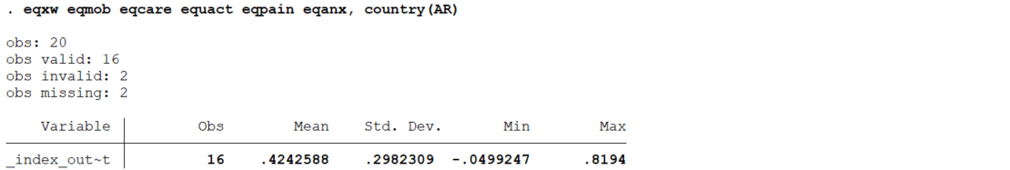

eqxwl displays summary statistics for a group variable with the by () option. In our simulated data, for example, we can display summary statistics for the crosswalk-based EQ-5D-3L index value by gender for individuals older than 50 years.
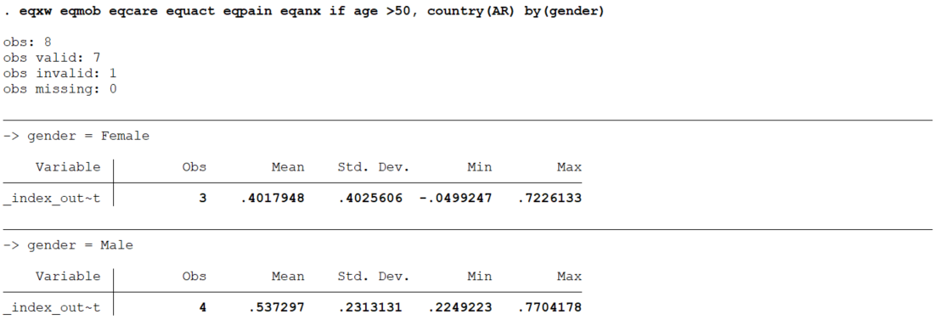
The calculated index values can be stored in a new variable using the saving () option. In the example below, the Argentina crosswalk-based EQ-5D-3L index values are saved in a new variable named “crosswalk_index”.

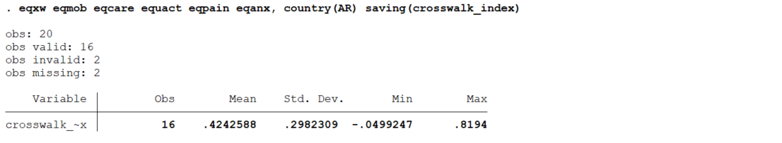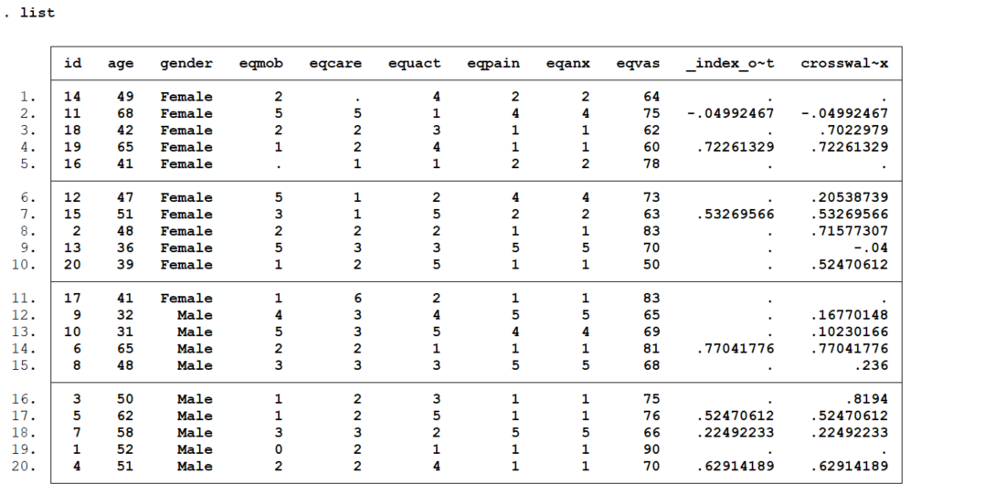
The steps to add/drop a new value set to eqxw are identical to those for eq5d5l described in section 3.4.1.

6. eqxwr: A command to calculate EQ-5D-5L index values from EQ-5D-3L responses of the EQ-5D health-related quality of life instrument using the EuroQol reverse crosswalk algorithm

6.1 Description
eqxwr computes EQ-5D-5L index values from the individual mobility, self-care, usual activities, pain/discomfort, and anxiety/depression responses of the EQ-5D-3L quality of life instrument. This version of the command can use published value sets from 29 countries.
It also allows the user to add or remove their own EQ-5D-5L country value set from a specific variable. The command then calculates EQ-5D-5L index values from the user-added EQ-5D-5L value sets. Users can display the countries whose value sets are stored by default or added by the user.

6.2 Syntax
eqxwr varname₁ varname₂ varname₃ varname₄ varname₅ [if] [in] [, options]
The variables must be introduced in the same order in which they appear in the EQ-5D-3L questionnaire, for example, “mobility” for varname₁, “self-care” for varname₂, “usual activities” for varname₃, “pain/discomfort” for varname₄, and “anxiety or depression” for varname₅. In addition, the levels of each EQ-5D-3L variable must be coded as follows: 1 for “no problems”, 2 for “some problems”, 3 for “extreme problems”.
When there are missing data in any of the EQ-5D-3L dimensions for a particular respondent, the EQ-5D-5L index value for that individual will also be missing.

6.3 Options
The options for eqxwr are identical to those for eq5d5l (section 3.3).

6.4 Example
To illustrate how eqxwr works, a hypothetical dataset of 20 individuals on the five domains of the EQ-5D-3L, along with gender and age, has been simulated. The data have been stored in eq5d3l.dta and has been previously used in section 2.4.1.

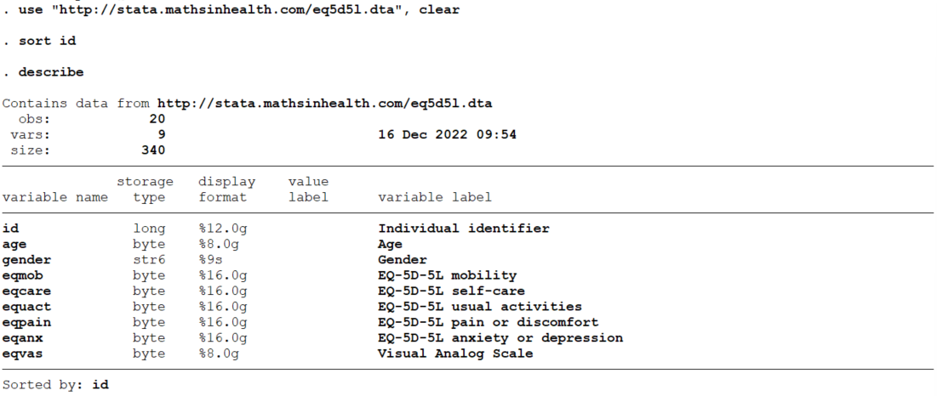

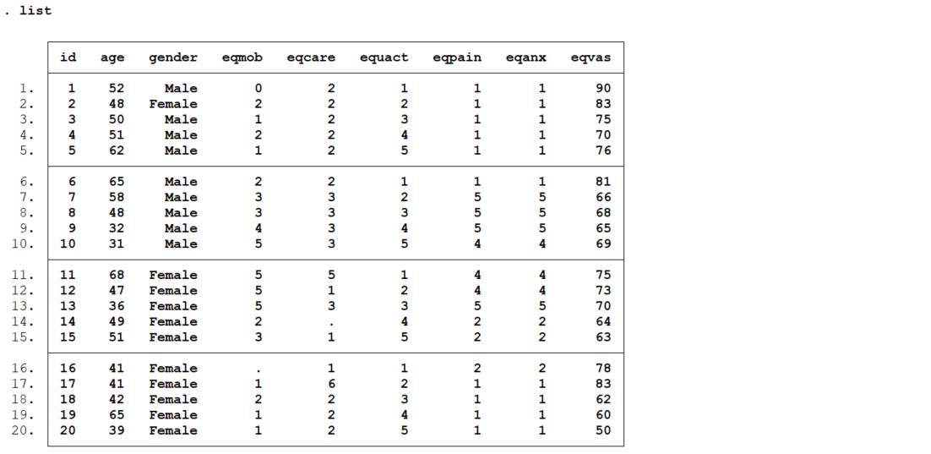

We can execute the eqxwr command as follows:
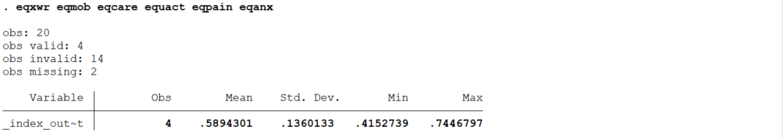
Let’s now assume data was collected in Mexico. The EQ-5D-3L value set does not exist in Mexico, while the EQ-5D-5L value set does. Therefore, we cannot use the eq5d3l command and we need to use the eqxwr command to estimate index values in our simulated data. eqxwr estimates an interim EQ-5D-3L value set for Mexico using the crosswalk reverse methodology developed by the EuroQol group on the basis of the EQ-5D-5L value set. This reverse crosswalk can also be used to analyse EQ-5D-3L data in countries where EQ-5D-5L has become the reference case, for example, Denmark and Portugal.
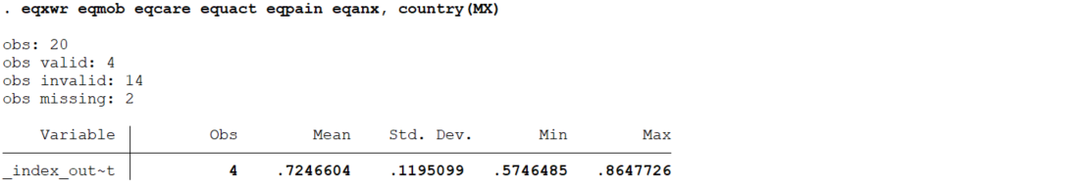

eqxwr displays summary statistics for a group variable with the by () option. For example, we can display summary statistics for the reverse crosswalk-based EQ-5D-5L index value by gender.
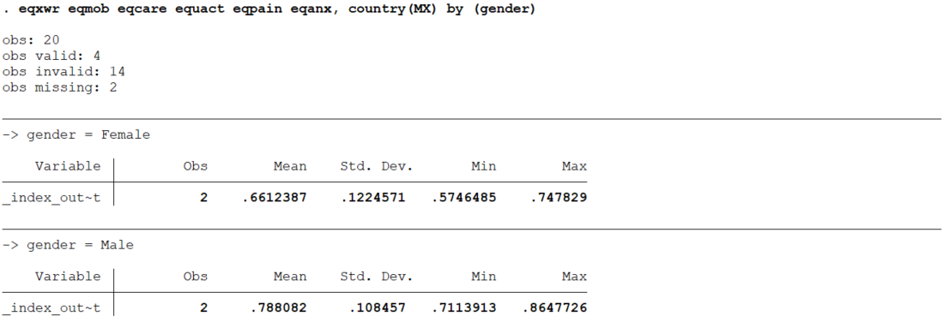

eqxwr stores index values in a new variable using the saving() option. For example, we can create a new variable named “xwrev_index”.
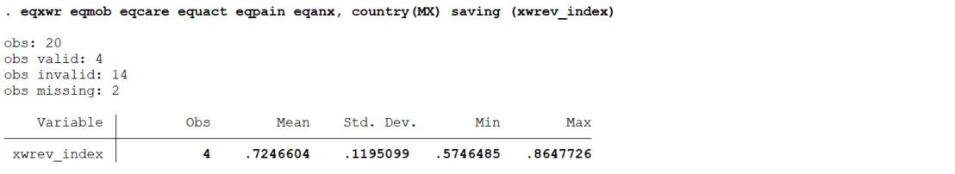
The steps to add/drop a new value set to eqxwr are identical to those for eq5d3l described in section 2.4.1.

7. eq5dreport: A command the analyse and report EQ-5D-xL data using best practices

7.1 Description
eq5dreport conducts common statistical analysis of cross-sectional and longitudinal EQ-5D response and summary values. The command uses the individuals' responses for mobility, self-care, usual activities, pain or discomfort, anxiety or depression, and VAS from the EQ-5D health-related quality-of-life instrument (in its EQ-5D-3L and EQ-5D-5L versions). The statistical methods included in this command are described in detail in the book by Devlin and colleagues about how to analyse and report EQ-5D [10].

7.2 Syntax
eq5dreport varname₁ varname₂ varname₃ varname₄ varname₅ [and/or varname₆] [if] [in], version(3L|5L) [options]
The variables must be introduced in the same order in which they appear in the EQ-5D questionnaire, that is, “mobility” for varname₁, “self-care” for varname₂, “usual activities” for varname₃, “pain/discomfort” for varname₄, “anxiety or depression” for varname₅, and “Visual Analog Scale” (VAS) for varname₆ when used. VAS can also be introduced on its own as varname₁.
In addition, the levels of each EQ-5D-3L variable must be coded as follows: 1 for “no problems”, 2 for “some problems”, 3 for “extreme problems”. The levels in EQ-5D-5L must be coded as follows: 1 for “no problems”, 2 for “slight problems”, 3 for “moderate problems”, 4 for “severe problems” and 5 for “extreme problems”.
While the VAS is an integral part of the instrument in all the versions, the command makes its use optional. When a particular individual has missing or nonvalid values in any of the domains or the VAS (when used), the individual is not considered in the calculations.

Options
- version(3L|5L) specifies the EQ-5D version to be analysed. Currently, the EuroQol Group has different versions for the instrument. However, all the versions use 3 or 5 levels in its descriptive systems. This command was specifically developed for versions named EQ-5D-3L and EQ-5D-5L. version() is required except when only VAS is introduced.
- table(tablename) provides descriptive in a tabular format. The following tables can be created if their corresponding name and options are specified:

Table name | Description | Options required
table_2_1 | *Frequency of levels by dimension of 'some problems' | version, id, time
table_2_3 | Prevalence of the 10 most frequently observed self-reported health states | version
table_2_4 | **Changes in health according to the PCHC (Paretian Classification of Health Change) | version, by, id, time
table_2_5 | **Changes in health according to the PCHC, taking account of those with no problems | version, by, id, time
table_2_6 | *Changes in levels in each dimension, percentages of total and of type of change | version, id, time
table_2_7 | Summary statistics for the EQ-5D values by all the different LSSs (Level Sum Scores) | version, country
table_2_8 | Number of observations in the LFS (Level Frequency Score) according to the EQ-5D values | version, country
table_2_9 | Distribution of the EQ-5D profiles by LFS (Level Frequency Score) | version, country
table_2_10 | Summary statistics of EQ-5D-5L values by LFS (Level Frequency Score) | version, country
table_3_1 | EQ VAS Score: by timepoints | time
table_3_2 | Number of observations in the LFS (Level Frequency Score) according to the EQ-5D
table_3_3 | EQ VAS Scores: t-test between two timepoints | time
table_4_2 | EQ-5D values: by timepoints | version, time, country
table_4_3 | EQ-5D values: by groupvar | version, by, country
table_4_4 | EQ-5D values: by age and groupvar | version, by, ageyears, country
*The tables 2_1 and 2_6 can only be created if the user's dataset is unique at the time, id level
**The tables 2_4 and 2_5 can only be created if the user's dataset is unique at the time, by, id level
- excelsave(#) lists out the exact file location and name where an Excel (.xlsx) version of the table will be saved.
- figure(figurename) provides descriptives in a graphical format. The following figures can be created as long as their corresponding name and options are specified:

Figure name | Description | Options required
figure_2_1 | *PCHC (Paretian Classification of Health Change) | version, by, id, time
figure_2_2 | *Percentage of respondents who improved overall by the dimensions (%) | version, by, id, time
figure_2_3 | *Percentage of respondents who worsened overall by the dimensions (%) | version, by, id, time
figure_2_4 | *Percentage of respondents who had a mixed change overall by the dimensions (%) | version, by, id, time
figure_2_8 | EQ-5D values plotted against the LSS (Level Sum Score) | version, country
figure_2_9 | HSDC (Health State Density Curve) for EQ-5D profiles | version, by
figure_2_10 | EQ-5D values plotted against the LFS (Level Frequency Score) | version, country
figure_3_1 | EQ VAS scores
figure_3_2 | Mid-point EQ VAS scores
figure_4_2 | EQ-5D values by timepoints: mean values and 95% confidence intervals | version, time, country
figure_4_3 | Mean EQ-5D values and 95% confidence intervals: all vs by groupvar | version, by, country
figure_4_4 | *EQ-5D values: smoothed lines and confidences intervals by groupvar | version, by, id, time, country
figure_4_7 | Distribution of EQ-5D values | version, country
figure_4_11 | EQ-5D values plotted against EQ VAS | version, country

- graphsave(#) lists out the exact file location and name where a Stata (.gph) version of the figure will be saved.
- by(groupvar) specifies the grouping variable containing the groups to be used by eq5dds_mo when reporting subgroup statistics. This field is required to be a string variable with at least 2 distinct values.
- id(respondent) specifies the unique identifier for the individual who responded to the EQ-5D questionnaire.
- time(timepoints) specifies a variable which represents specific points in time in increasing order. This field is required to be a numeric variable.
- country(#) specifies the 2-letter ISO code for the country linked to the respondent's answers. For a list of available country codes for EQ-5D-5L and EQ-5D-3L responses, please see eq5d5l and eq5d3l respectively.
- missing treats missing values like any other values

7.4 Example
To demonstrate how to analyse and report EQ-5D data, we will use a subsample of 5000 individuals from the data collected from patients who underwent hip replacement, knee replacement, groin hernia, or varicose vein surgery between 2013 and 2017 in the English National Health Service (NHS) as part of a Patient Reported Outcome Measures (PROMs) program. The dataset includes EQ-5D-3L response data, EQ-VAS, and additional variables such as a unique identifier (ID), pre-op and post-op status (time), the type of surgery (procedure), the year in which the surgery was performed (year), gender, and age range (ageband). The data have been stored in prom_data.dta.
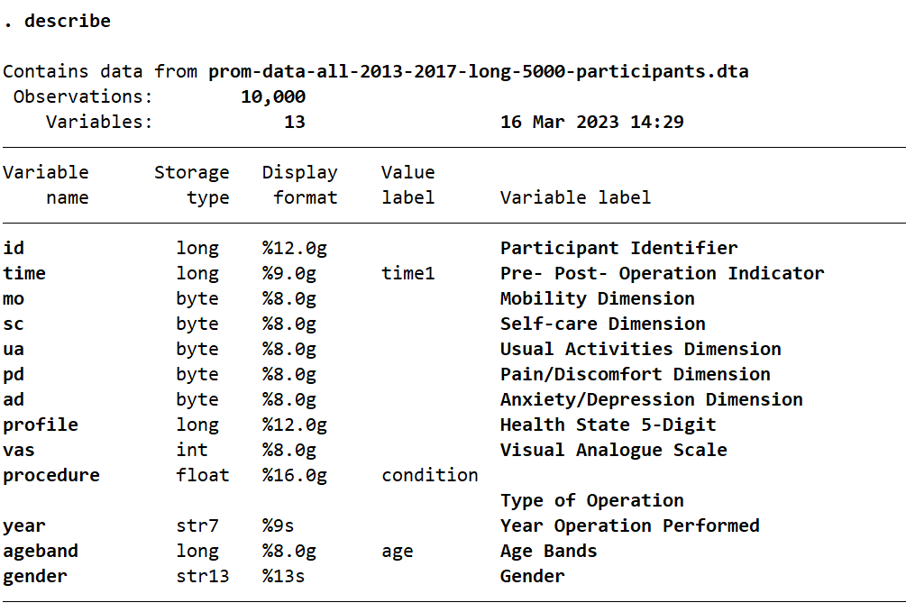
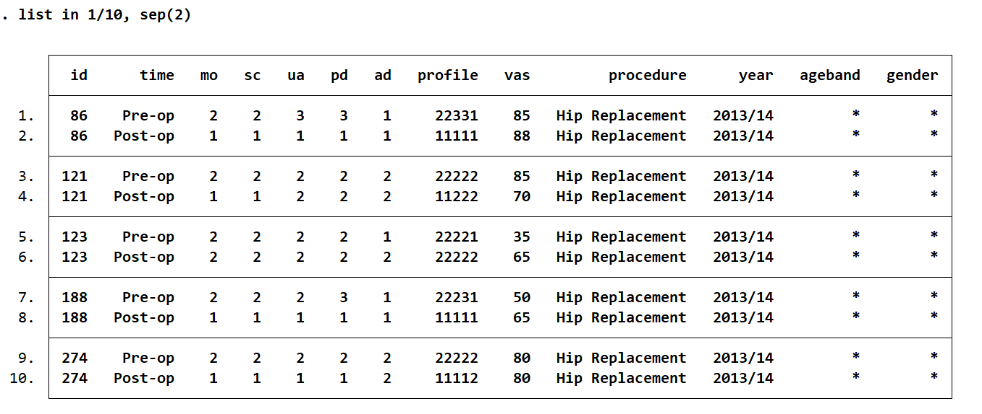
eqreport is a flexible command to analyse and report EQ-5D data. Below we illustrate the use of eqreport with some key examples. Users are referred to the original textbook by Devlin and colleagues for a description and further details of how to use and interpret each of the tables and figures that can be created with eqreport [10].

Example 1: Users can obtained the prevalence of the 10 most frequently observed self-reported health states and frequency of reporting of the worst possible health state as follows:
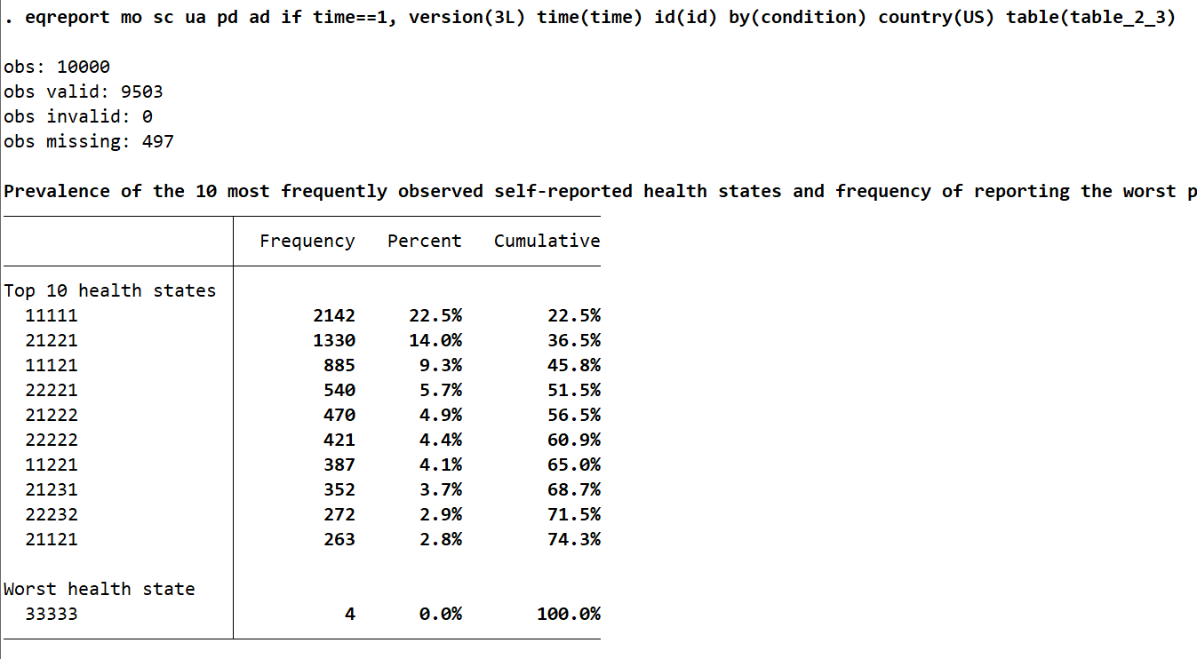
Example 2: The frequency of levels by dimension and number reporting ‘some problems’ pre and post operation can be derived as follows:
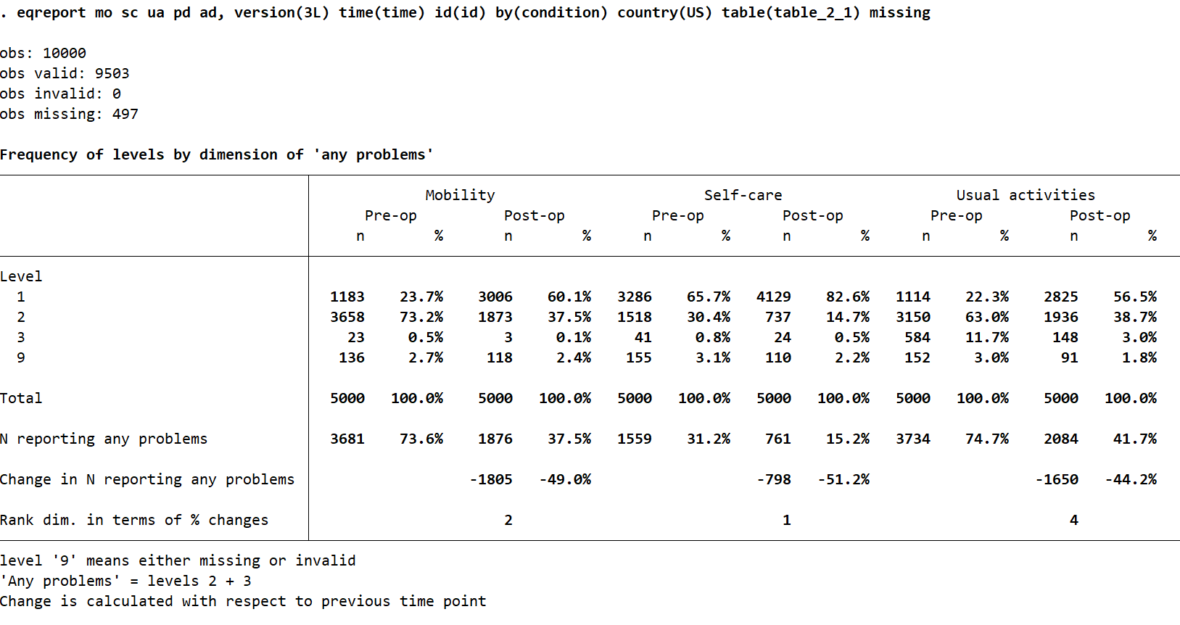
Please note that some of the output is omitted.

Example 3: To estimate changes in health by group according to the Paretian Classification of Health Change (PCHC) by procedure users can use:
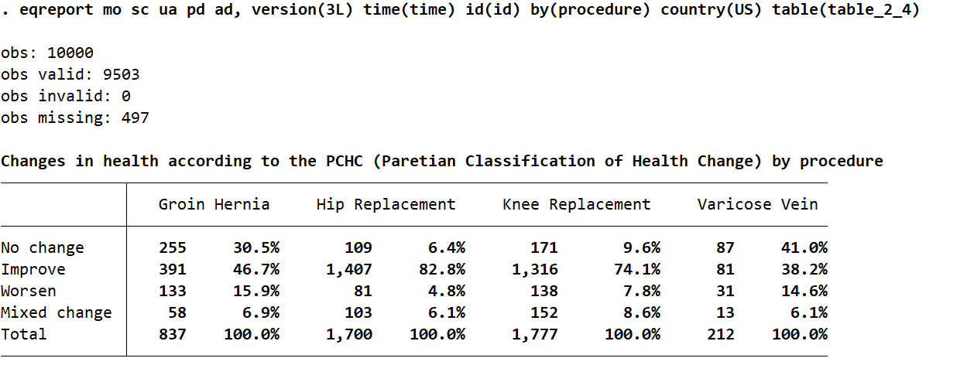

Saved results

The commands eq5d3l, eq5d5l, eq5dy3l, eqxw and eqxwr saves the following in r():
Scalars
- r(Nmissing) number of observations with at least one missing value in any of the 5 EQ-5D dimensions
- r(Ntotal) number of total observations
- r(Nvalid) number of valid observations
- r(Ninvalid) number of invalid observations. That is, observations with at least one value not being 1, 2 or 3 in any of the 5 EQ-5D-3L dimensions or observations with at least one value not being 1, 2, 3, 4 or 5 in any of the 5 EQ-5D-5L dimensions.
- r(mean) mean
- r(Var) variance
- r(sd) standard deviation
- r(min) minimum
- r(max) maximum
The command eqreport displays the following at the very beginning any time the user creates a table or figure:
Scalars
- e(Ntotal) number of total observations
- e(Nvalid) number of valid observations used in the analysis
- e(Ninvalid) number of invalid observations excluded from the analysis
- e(Nmissing) number of observations with at least one missing response to one domain and/or VAS score

Acknowledgments
This work was funded by the EuroQol Foundation with project number EQ Project 450-RA.

References
1. Kennedy-Martin, M., et al., Which multi-attribute utility instruments are recommended for use in cost-utility analysis? A review of national health technology assessment (HTA) guidelines. Eur J Health Econ, 2020. 21(8): p. 1245-1257.
2. EuroQol, G., EuroQol - a new facility for the measurement of health-related quality of life. Health Policy, 1990. 16: p. 199-208.
3. Herdman, M., et al., Development and preliminary testing of the new five-level version of EQ-5D (EQ-5D-5L). Qual Life Res, 2011. 20(10): p. 1727-36.
4. Ravens-Sieberer, U., et al., Feasibility, reliability, and validity of the EQ-5D-Y: results from a multinational study. Qual Life Res, 2010. 19(6): p. 887-97.
5. Devlin, N., S. Pickard, and J. Busschbach, The Development of the EQ-5D-5L and its Value Sets, in Value Sets for EQ-5D-5L, N. Devlin, B. Roudijk, and K. Ludwig, Editors. 2022, Springer International Publishing: Cham. p. 1-12.
6. van Hout, B.A. and J.W. Shaw, Mapping EQ-5D-3L to EQ-5D-5L. Value Health, 2021. 24(9): p. 1285-1293.
7. Hernández-Alava, M. and S. Pudney, eq5dmap: A command for mapping between EQ-5D-3L and EQ-5D-5L. Stata Journal, 2018. 18(2): p. 395-415.
8. Ramos-Goni, J.M. and O. Rivero-Arias, eq5d: A command to calculate index values for the EQ-5D quality-of-life instrument. Stata Journal, 2011. 11(1): p. 120-125.
9. Ramos-Goñi, J.M. and Y. Ramallo-Fariña, Eq5dds: A Command to Analyze the Descriptive System of EQ-5D Quality-of-life Instrument. The Stata Journal: Promoting communications on statistics and Stata, 2016. 16(3): p. 691-701.
10. Devlin, N., D. Parkin, and B.M. Janssen, Methods for Analysing and Reporting EQ-5D Data. 2020, Switzerland AG: Springer.

