YUVA INTERN – WEEK 1
Exploratory Data Analysis on Processed Food Products
Indian Packaged Foods Nutritional Dataset
Prepared using Python, Pandas and Matplotlib

1. Introduction
This project performs Exploratory Data Analysis (EDA) on an Indian packaged food products dataset. The analysis focuses on understanding product categories, nutritional composition, calorie variation, sugar and fat levels, product prices, and relationships among important numeric features. EDA is used to identify patterns, distributions, relationships and possible data-quality issues before further analysis or modelling.

2. Objective
- Collect and load a publicly available packaged-food dataset.
- Inspect the structure, data types, missing values and duplicate records.
- Clean numeric nutrition and price fields for reliable analysis.
- Perform univariate, bivariate and multivariate analysis.
- Create clear visualizations to communicate the main patterns.
- Summarize the major findings and conclusions from the dataset.

3. Dataset Description
Dataset used: packaged_foods_india.csv. The supplied dataset contains 852 product records and 25 columns. It includes product identity and category information, ingredients, serving size, calories, carbohydrates, protein, fats, sugar, sodium, dietary fiber, cholesterol, minerals, price and source-related fields.
Source: Kaggle – Indian Packaged Foods Nutritional Dataset (provided with the project).
Dataset Property | Value
Rows | 852
Columns | 25
Duplicate rows before cleaning | 0
Total missing cells before cleaning | 3465
Categories | 13

4. Data Cleaning
The dataset was inspected for missing values and data types. Several nutritional columns were stored as object/text values, so they were converted to numeric values using pandas to_numeric(..., errors='coerce'). Values that could not be interpreted as numeric were treated as missing. Missing numeric values were then replaced using the median of the corresponding column. This approach preserves all 852 product records while reducing the influence of extreme values compared with mean imputation.
After cleaning, the working dataset remained at 852 rows and 25 columns. All selected numeric analysis columns were converted to numeric format and had their missing/non-numeric values handled using median imputation. Source/date metadata fields were not imputed because most of their values are missing and they were not required for the numeric EDA.

Example cleaning code
numeric_columns = [
"Serving_Size_g", "Calories_kcal", "Carbohydrates_g", "Proteins_g",
"Total_Fat_g", "Saturated_Fat_g", "Trans_Fat_g", "Sugar_g",
"Sodium_mg", "Dietary_Fiber_g", "Cholesterol_mg",
"Calcium_mg", "Iron_mg", "Price_INR"
]
for col in numeric_columns:
df[col] = pd.to_numeric(df[col], errors="coerce")
df[col] = df[col].fillna(df[col].median())

5. Univariate Analysis
Univariate analysis studies one variable at a time. Category counts were used to understand the composition of the dataset, while histograms were used to study the distributions of calories, sugar and price.

5.1 Category Distribution
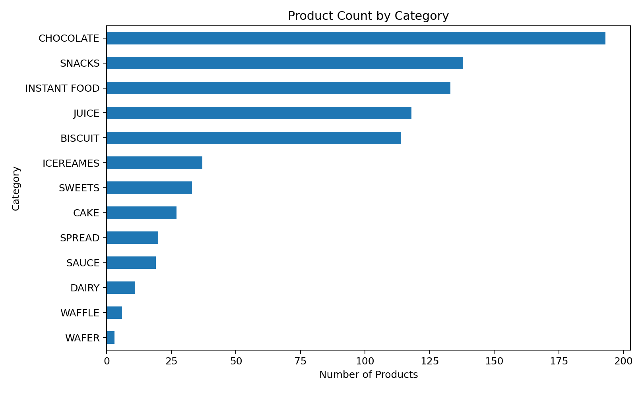
The dataset contains 13 categories. Chocolate is the largest category with 193 products. The category counts are not evenly distributed, so category comparisons should consider the different sample sizes.

5.2 Calories Distribution
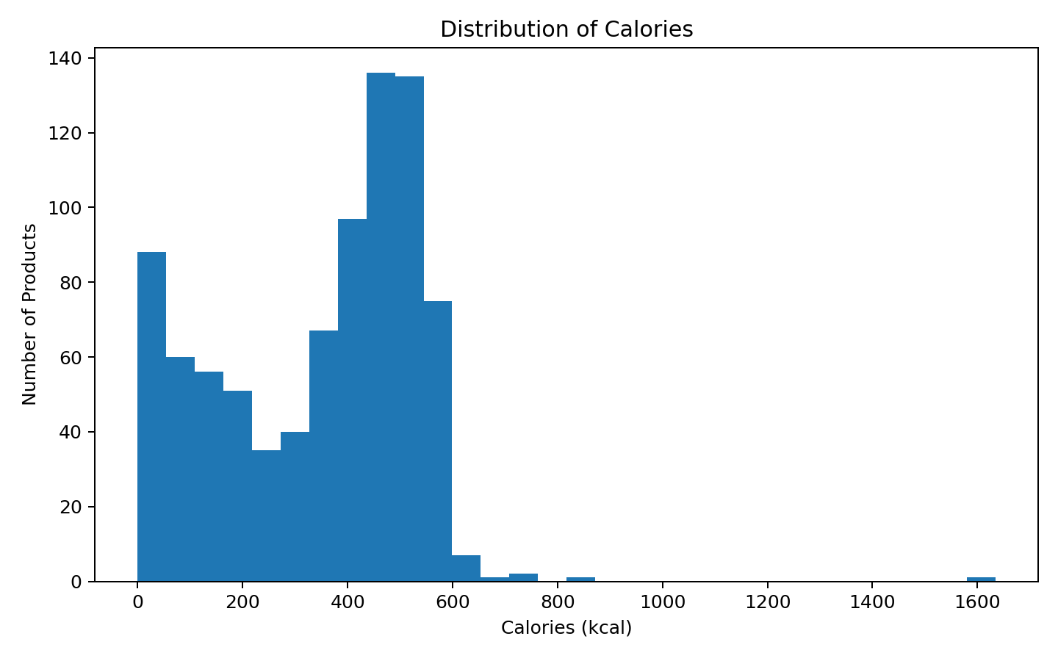
Calories show substantial variation across products. The cleaned mean is 344.69 kcal and the median is 390.00 kcal.

5.3 Sugar Distribution
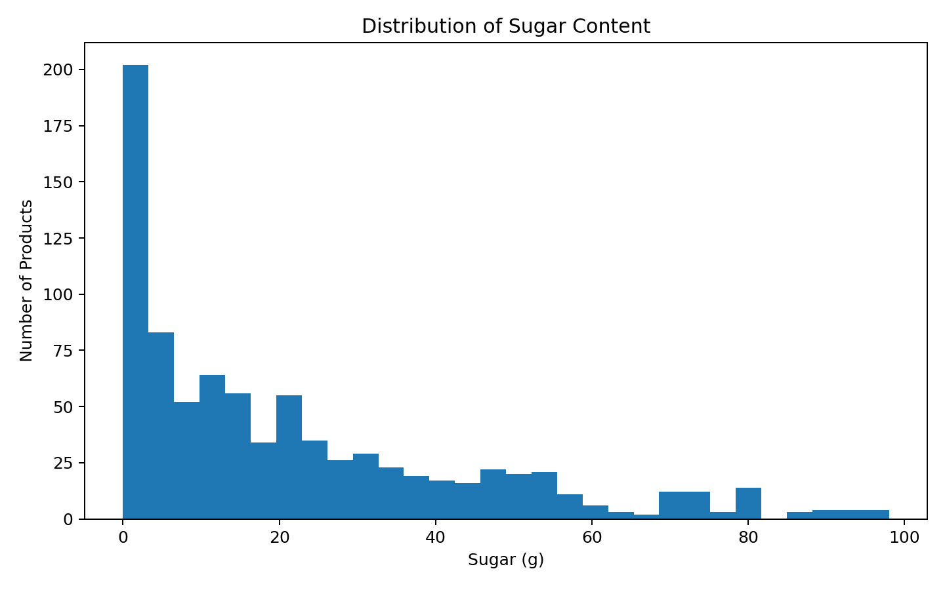
Sugar content varies considerably among products. The mean sugar content is 21.96 g, while the median is 14.23 g.

5.4 Price Distribution
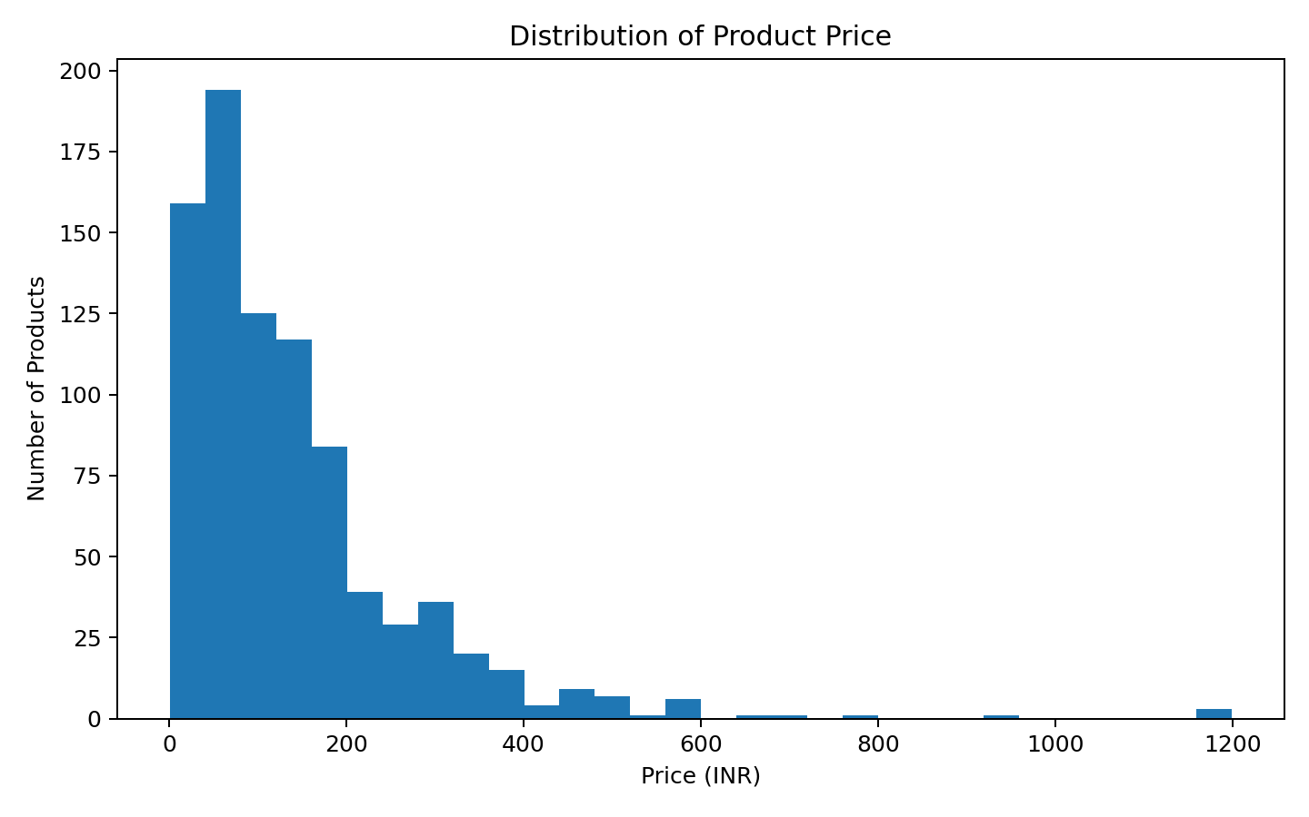
Product prices vary from approximately ₹1.20 to ₹1199.00. The mean price is ₹141.96 and the median price is ₹100.00.

6. Bivariate Analysis
Bivariate analysis examines the relationship between two variables. Scatter plots were used for numeric pairs to identify association patterns.

6.1 Calories vs Total Fat
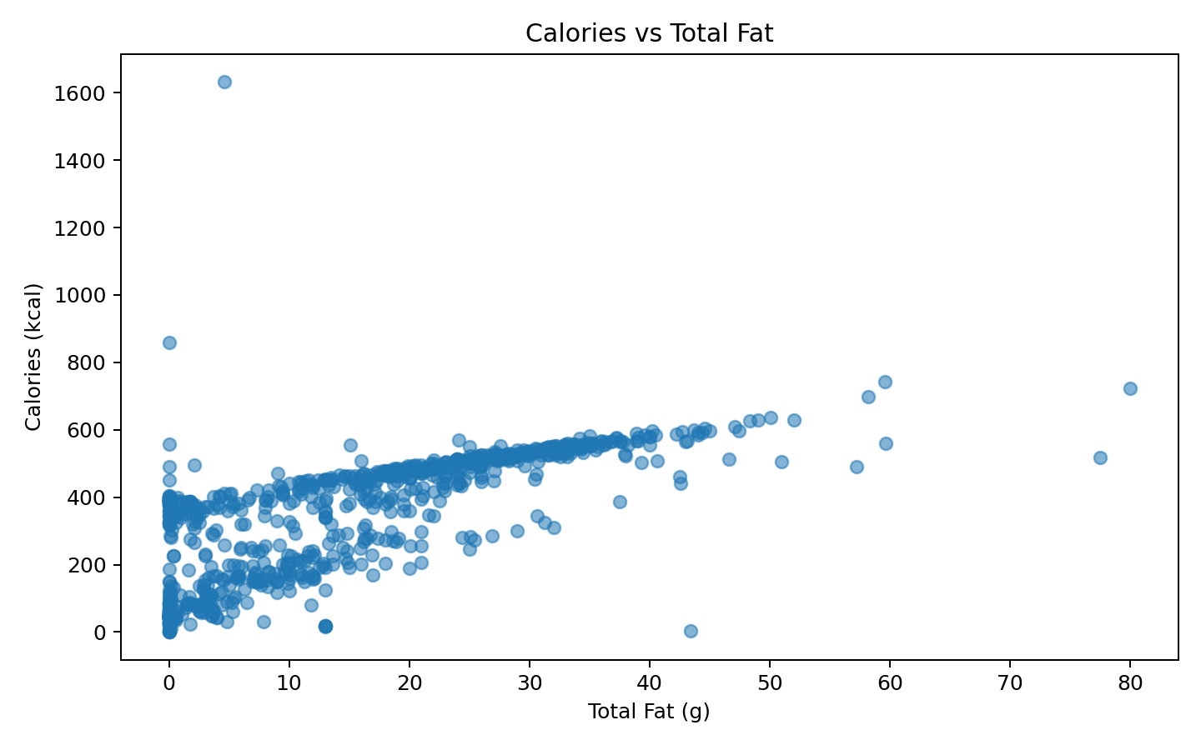
Calories and total fat show a positive association in this dataset, with a Pearson correlation of approximately 0.723. Products with higher fat values generally tend to have higher calories.

6.2 Calories vs Protein
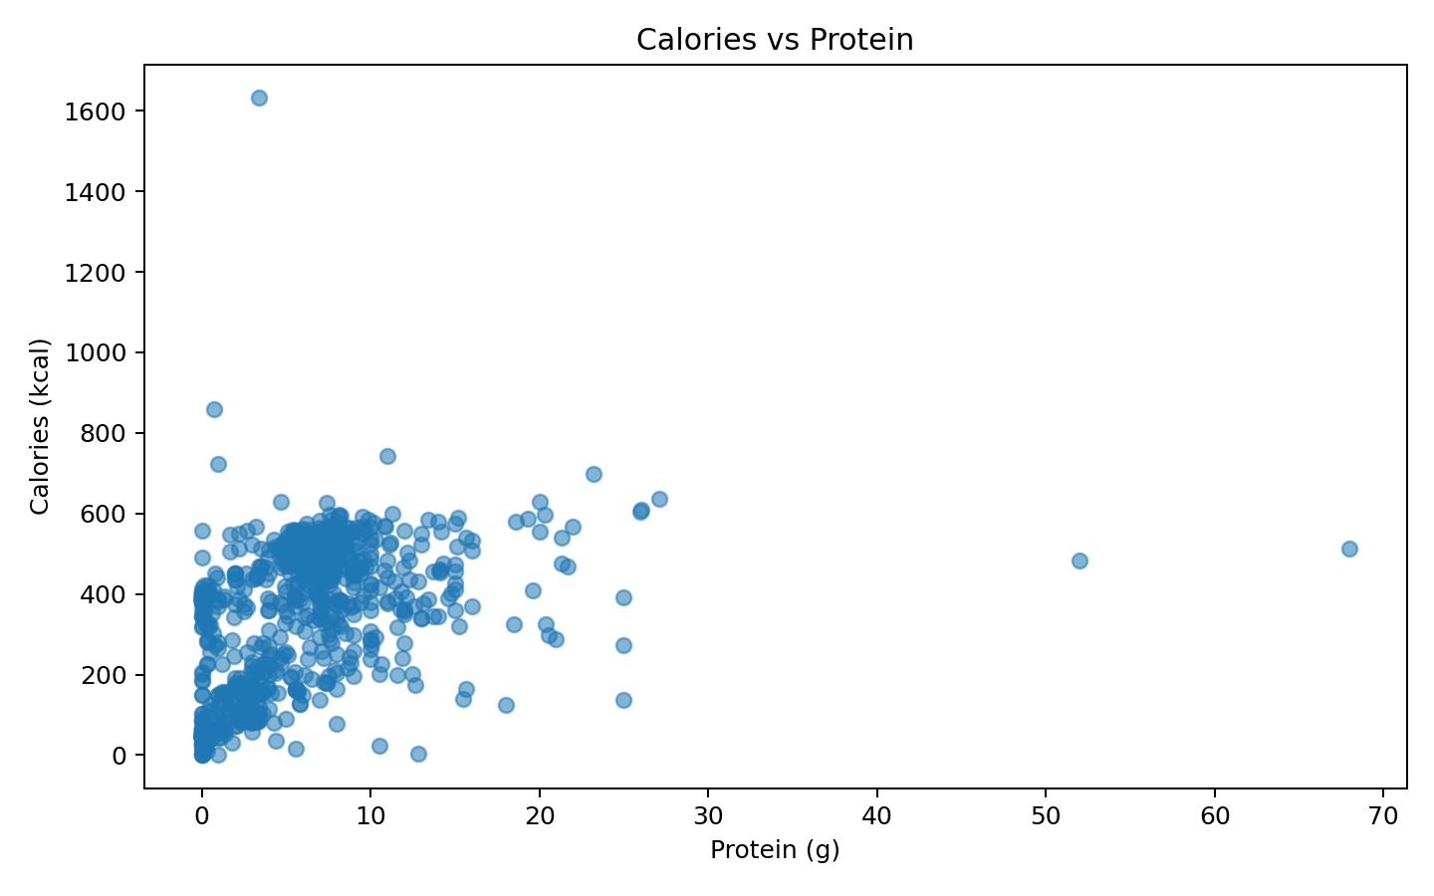
Calories and protein have a positive relationship, with a correlation of approximately 0.445. The relationship is weaker than the calories–fat relationship.

6.3 Price vs Serving Size
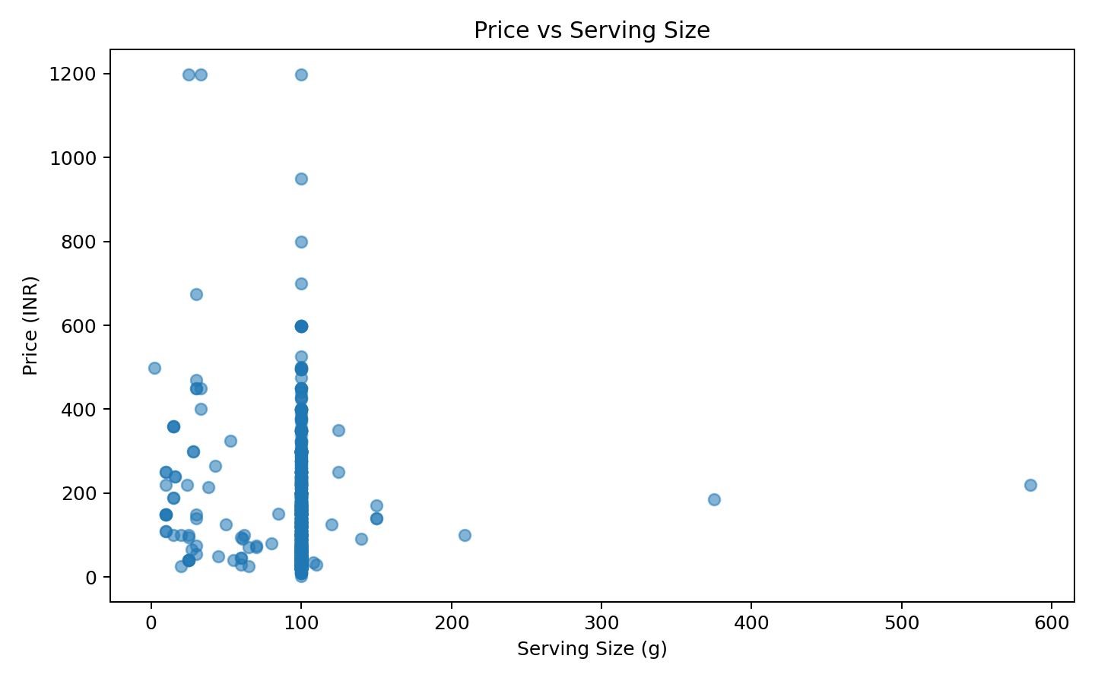
Price and serving size have a weak relationship in the cleaned data, with a correlation of approximately -0.102. This suggests that serving size alone does not explain product price well.

7. Multivariate Analysis
Multivariate analysis considers several variables together. A correlation matrix was created for key nutritional and price variables, and category-wise average calories were compared.

7.1 Correlation Heatmap
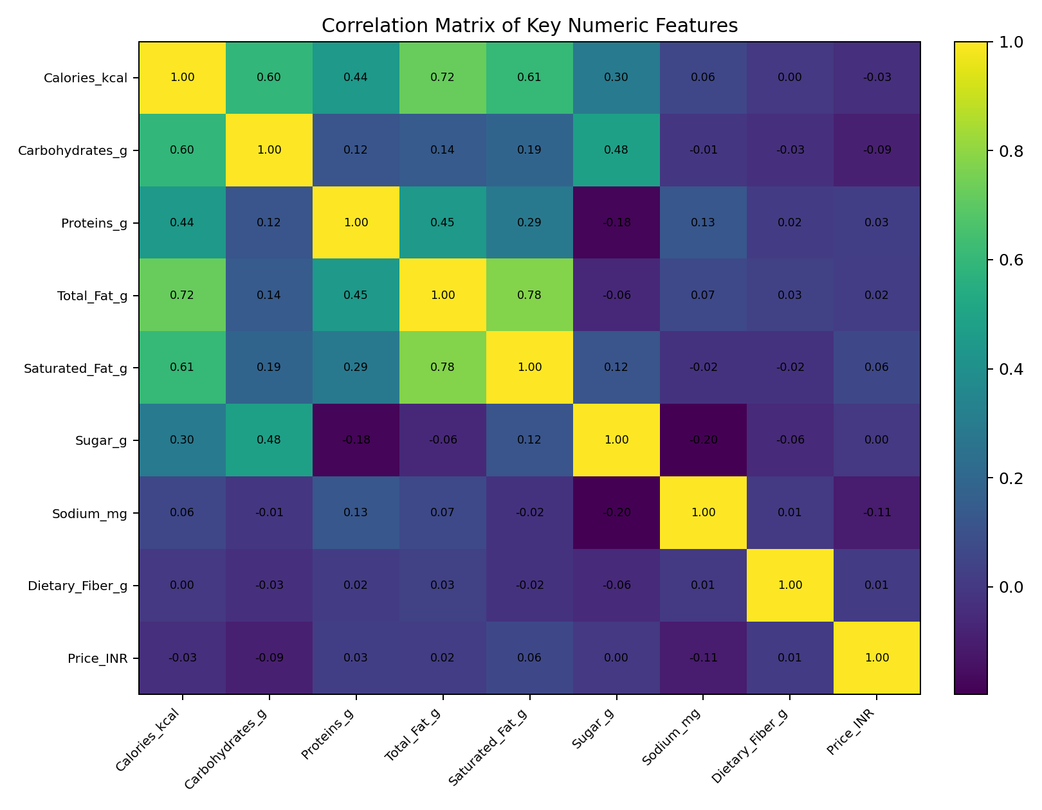
The strongest relationship with calories among the selected variables is with total fat (r ≈ 0.723), followed by saturated fat (r ≈ 0.607), carbohydrates (r ≈ 0.596) and protein (r ≈ 0.445). Correlation indicates association and should not be interpreted as causation.

7.2 Average Calories by Category
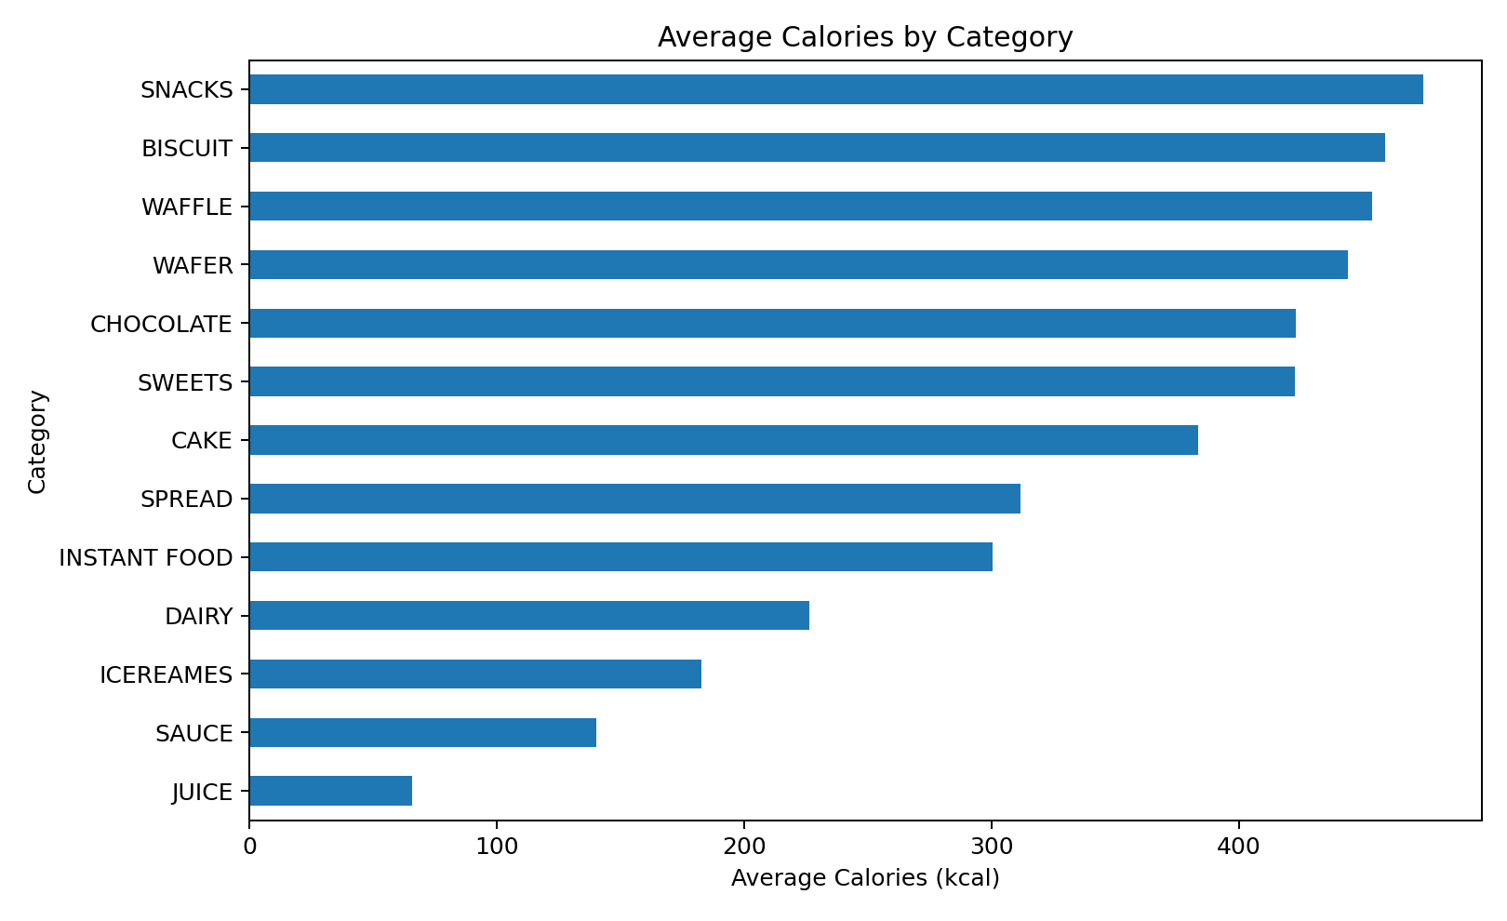
Average calorie levels differ across categories. Snacks has the highest average at approximately 474.51 kcal, while Juice has the lowest average at approximately 65.64 kcal.

8. Key Findings
- The dataset contains 852 packaged food products across 13 categories.
- The supplied data had missing values and several nutrition columns stored as text/object types.
- Numeric conversion followed by median imputation was used to prepare the nutrition and price fields for analysis.
- Calories have a mean of 344.69 kcal and a median of 390.00 kcal.
- Total fat has a positive association with calories (r ≈ 0.723).
- Protein also has a positive association with calories (r ≈ 0.445).
- Price and serving size show only a weak linear association (r ≈ -0.102).
- Average calories vary substantially by category, from about 65.64 kcal in Juice to about 474.51 kcal in Snacks.

9. Conclusion
The EDA provides an overall view of nutritional and commercial characteristics in the Indian packaged food dataset. The analysis shows clear variation in calories, sugar, fat, protein and price across products and categories. Data cleaning was necessary because some nutritional fields were stored as text and several fields contained missing values. Univariate, bivariate and multivariate analysis together provide a structured understanding of the dataset and create a clean foundation for future statistical analysis or machine-learning work.

10. Tools and Technologies
Python, Pandas, NumPy, Matplotlib, Seaborn, Jupyter Notebook / VS Code.

11. Project Folder Structure
Yuva_Intern/
├── dataset/
│ └── packaged_foods_india.csv
├── notebook/
│ └── Yuva_Intern_Week1_EDA.ipynb
├── visualizations/
│ ├── univariate/
│ ├── bivariate/
│ └── multivariate/
├── screenshots/
├── report/
│ └── Yuva_Intern_Week1_EDA_Report.docx
└── README.md

End of Report

