Image processing using OPENCV

UML : Main

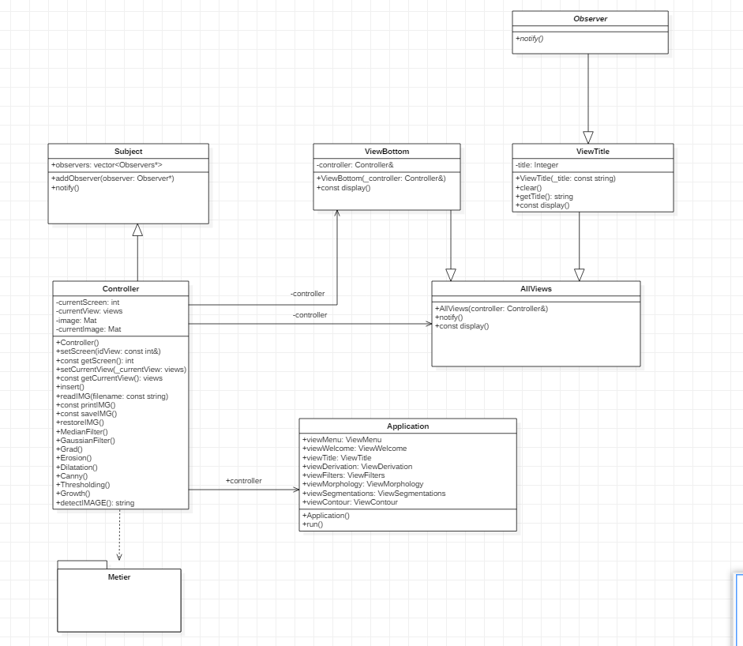

Note : AllViews class contains → viewContour, viewDerivative, viewFilters, viewMenu, viewMorphology, viewSegmentations, viewWelcome

Uml : Metier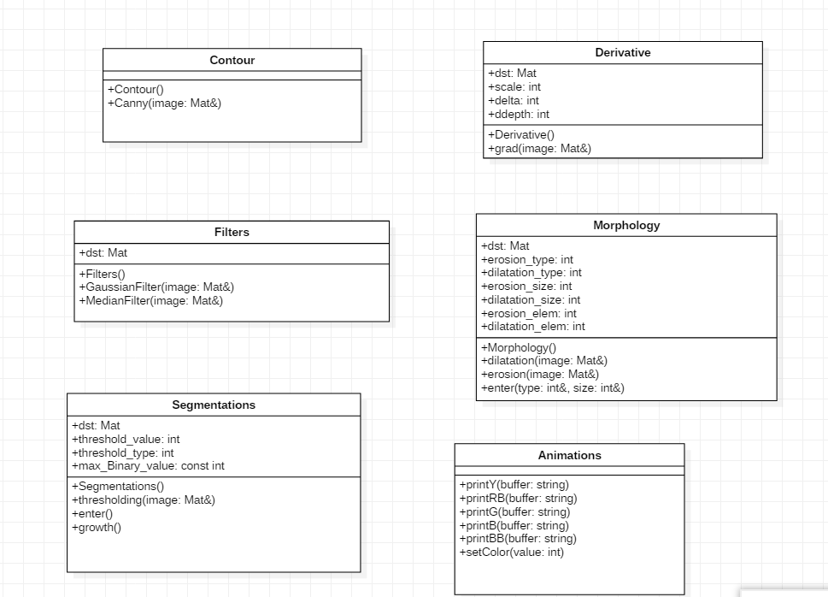

This is the work code part, all functions take in parameters a reference to the current image.

Then the mathematicals operation are applied using opencv functons.

