**Project :** ADO.Net Project

**Condidate Name** : MathuMathi K

**Frame Design:**

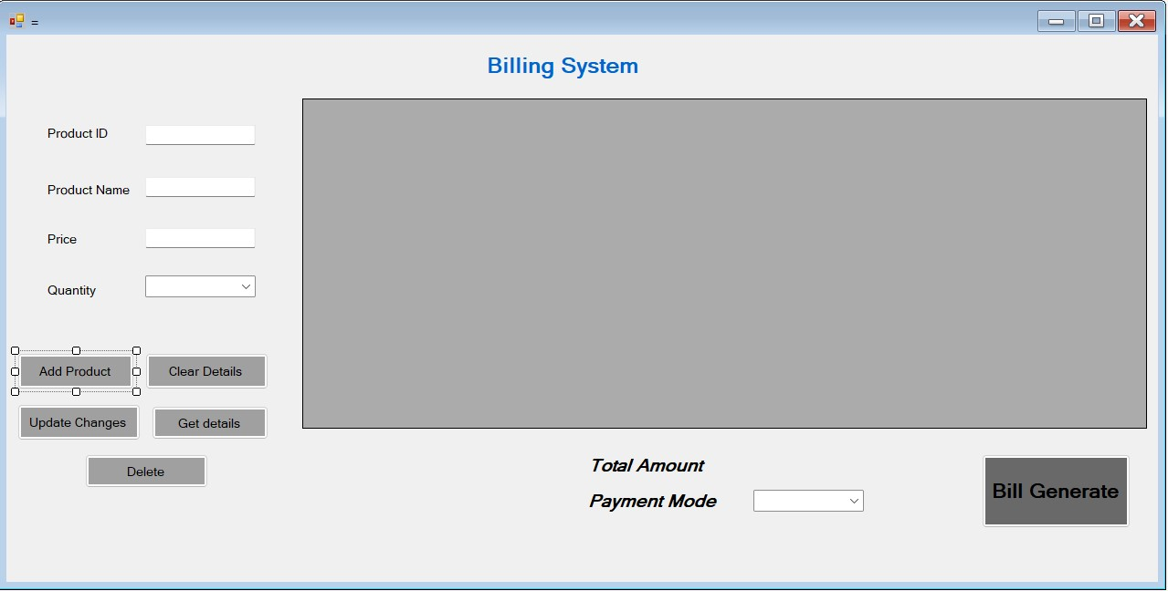

Executing Process:

Executing home Page:

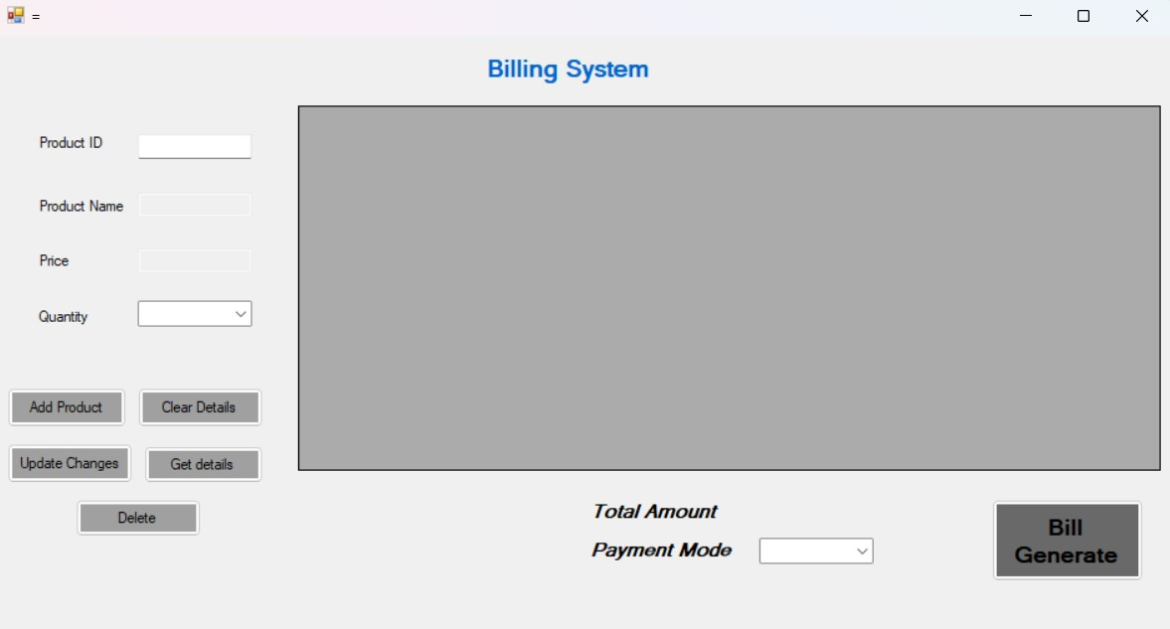

**Adding the Product:**

In Product ID : need to type the Id and **Double Tap** and we will get the Product name and Price

in the separate textbox. Then we need to select the quantity and then press the add Product button.

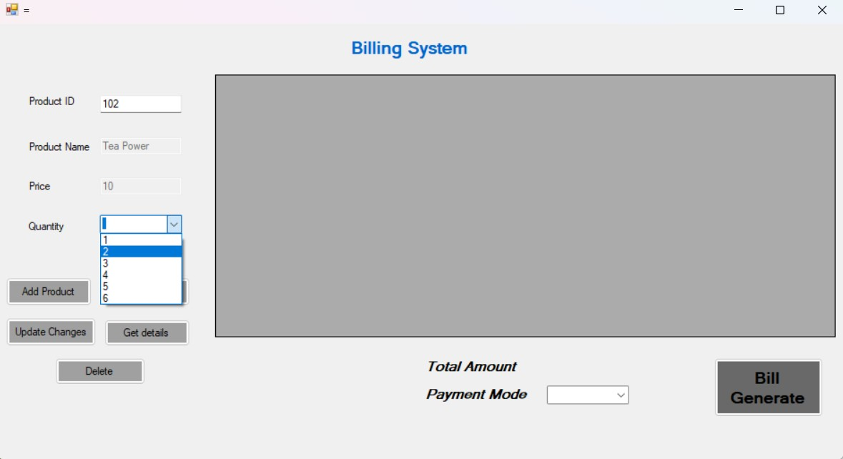

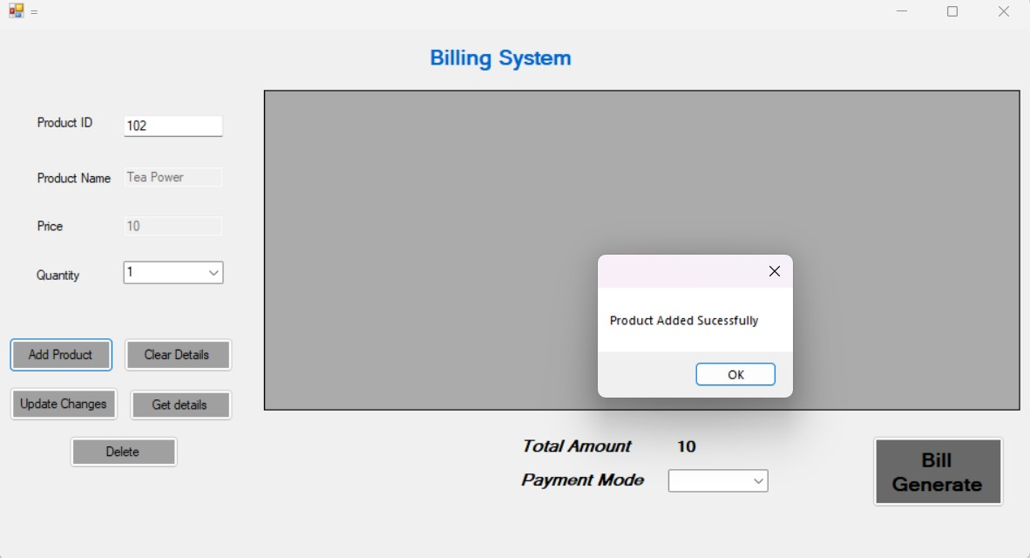

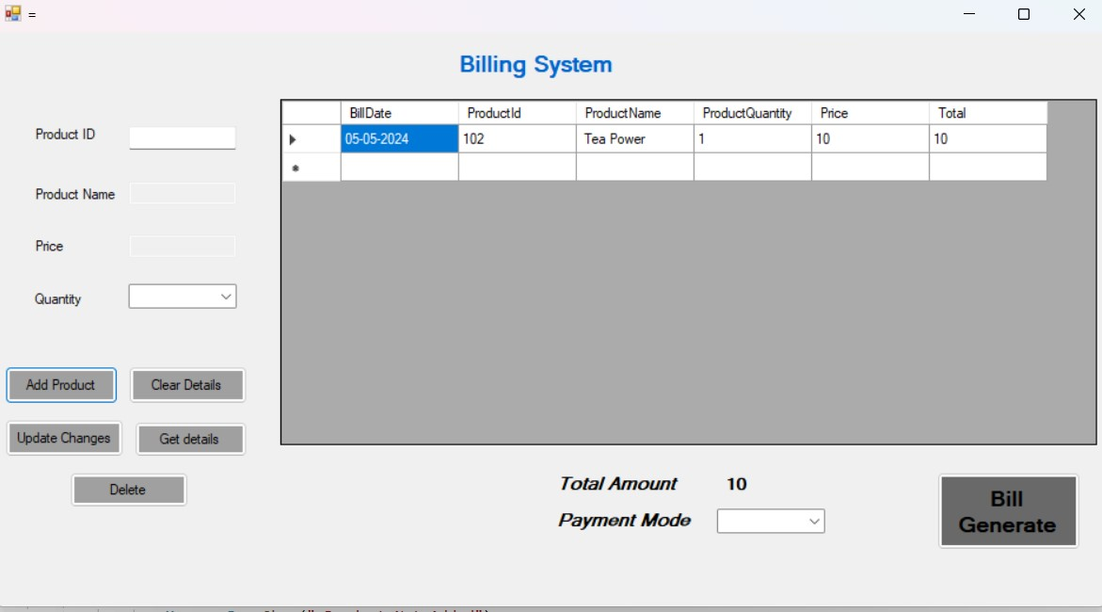

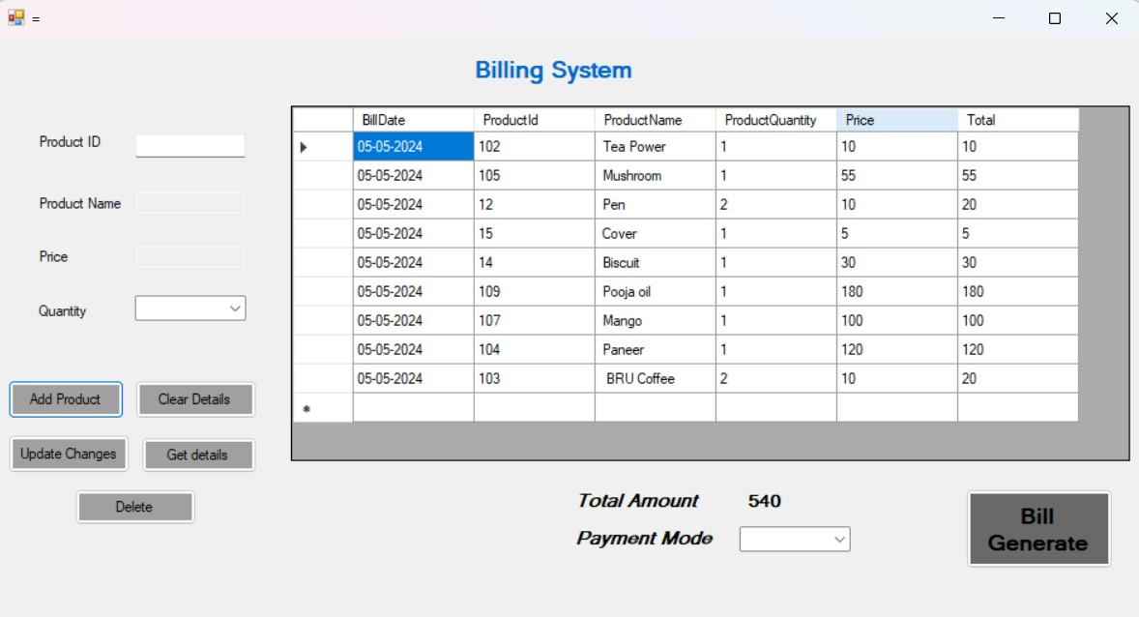

After the product select, choose the Payment Mode and press the bill Generate button

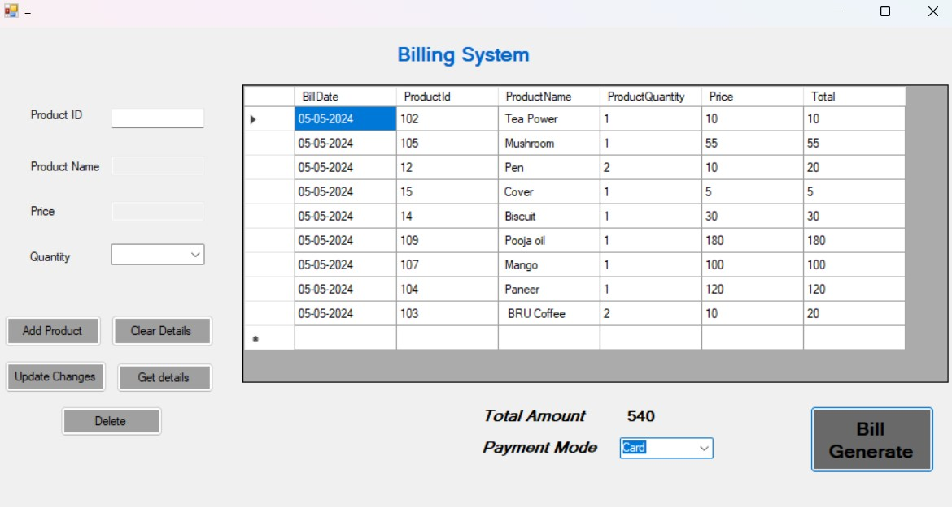

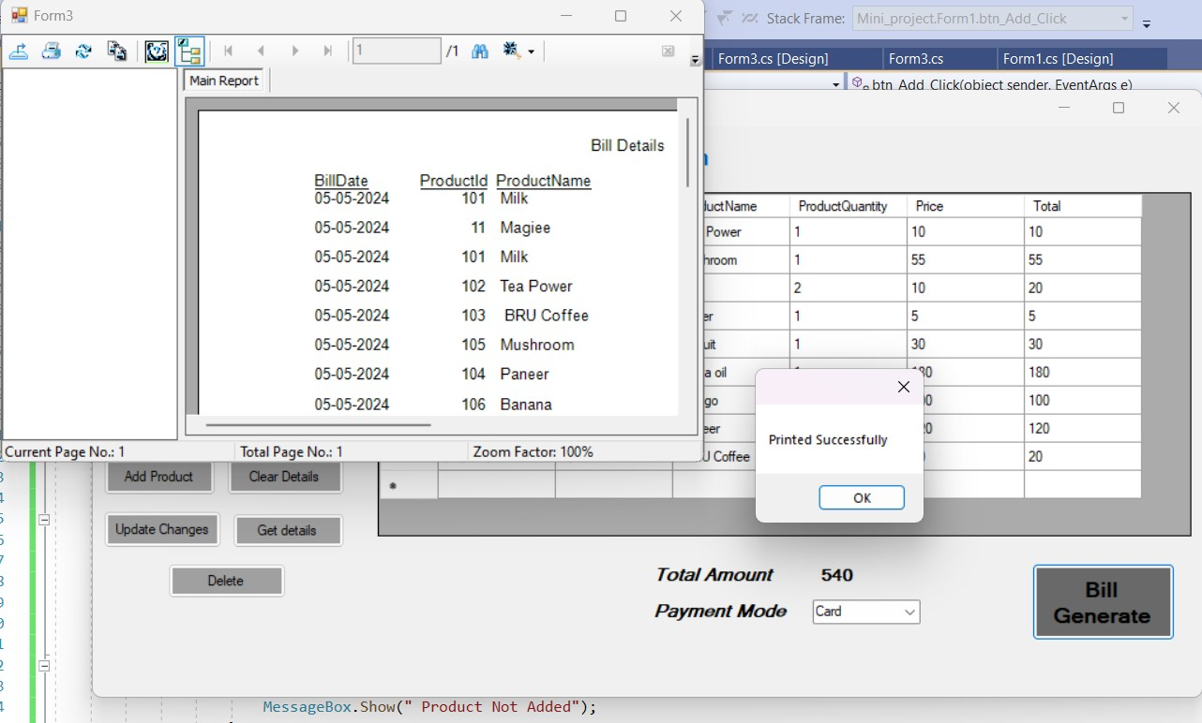

**Crystal Report:**

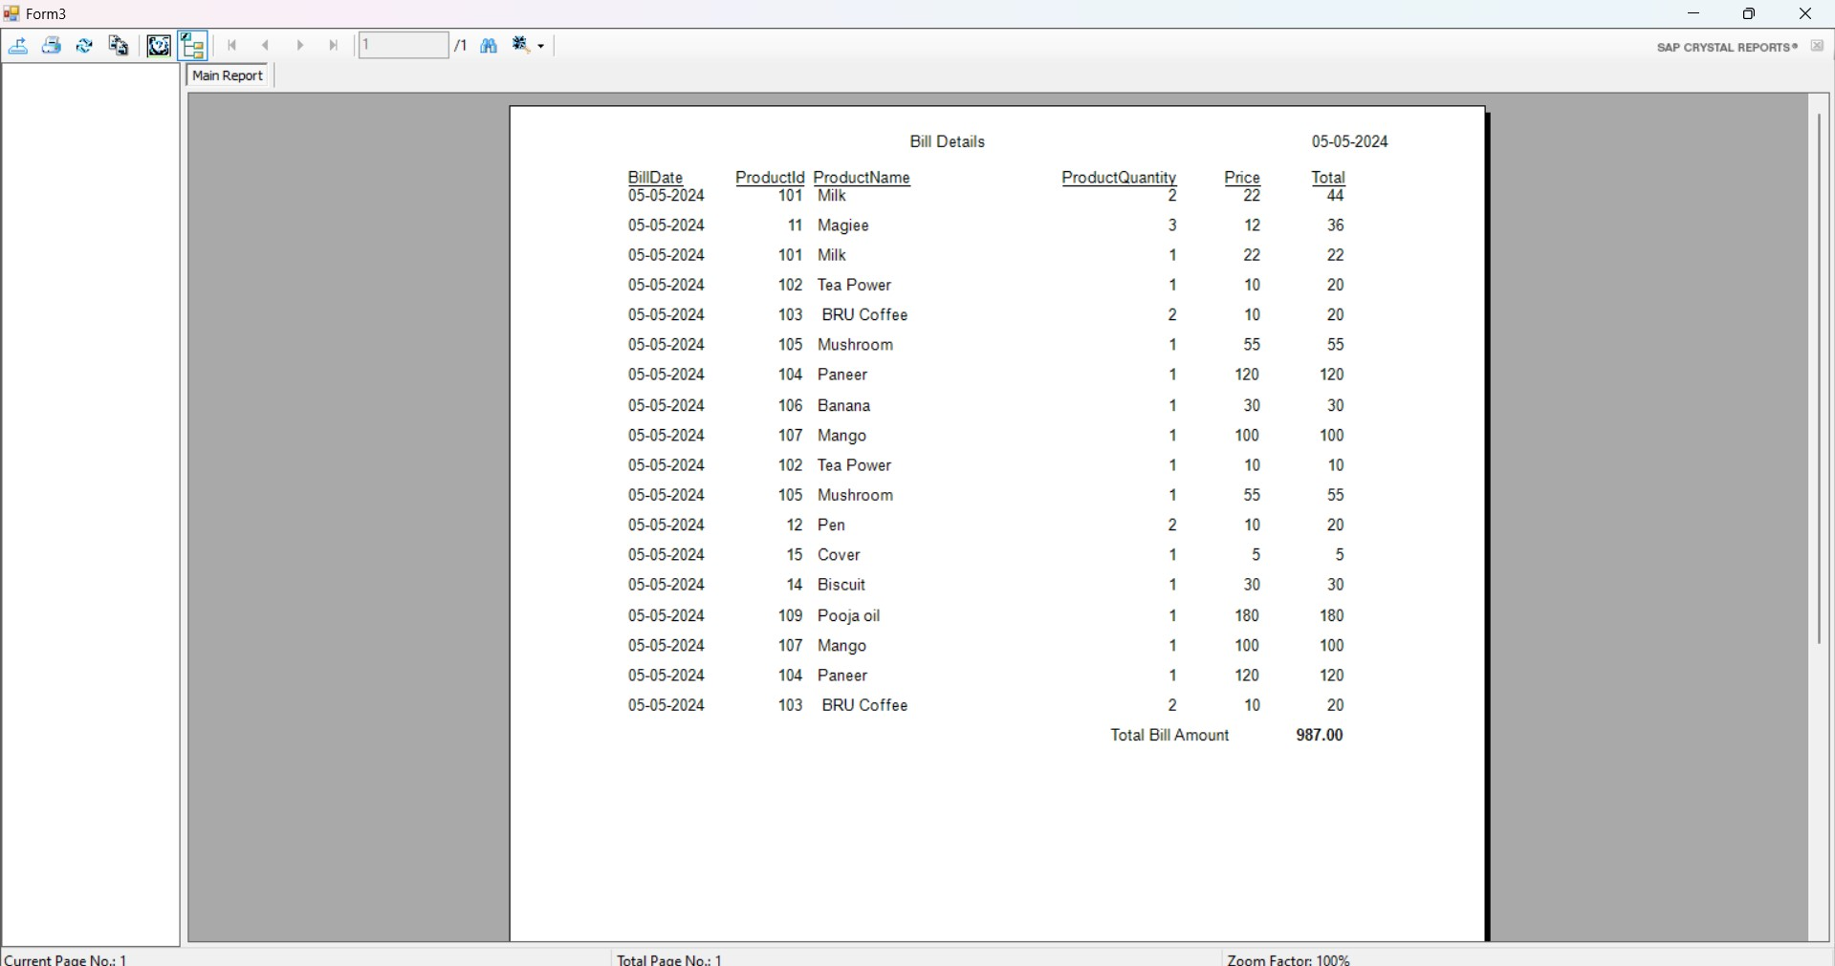

**Validating the buttons:**

1. **Quantity Combo Box validation:**

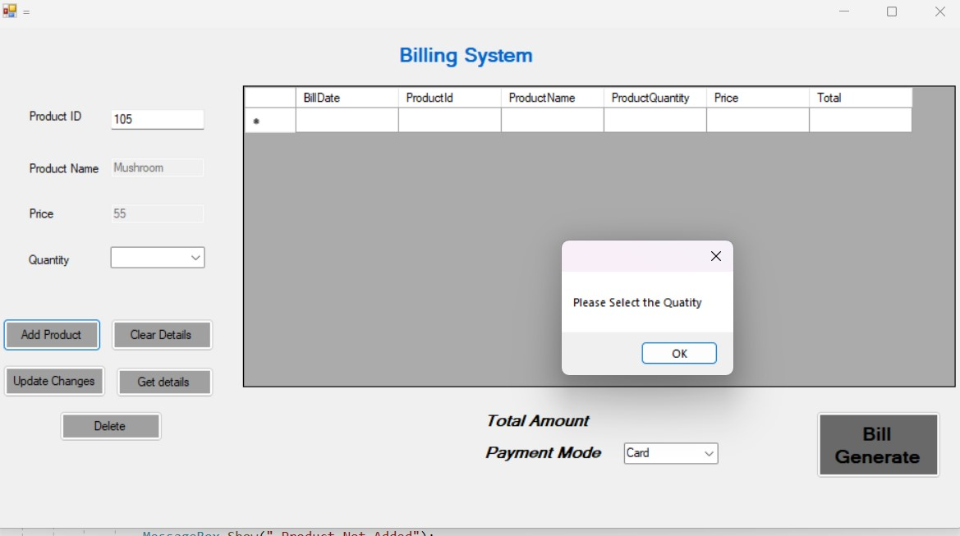

1. Clear Button: It’s used to clear the Text Box.

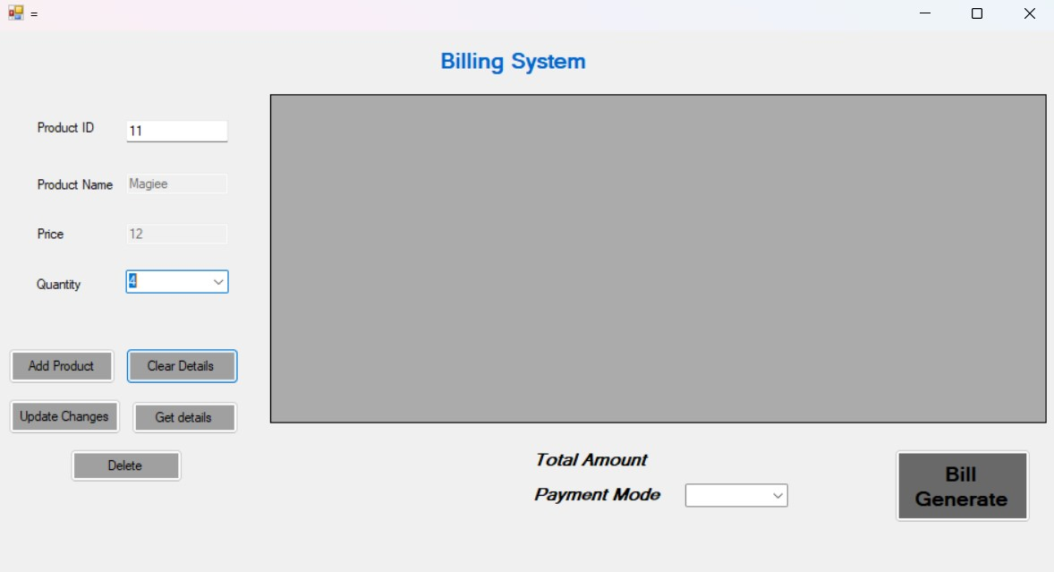

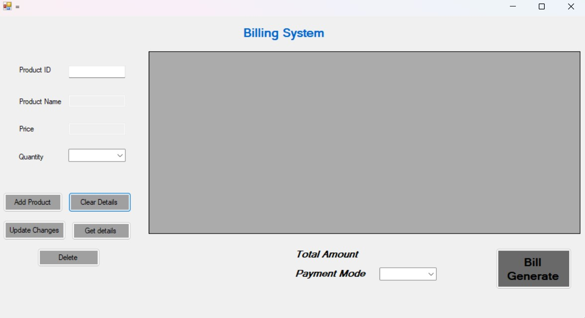

3. Update Button:

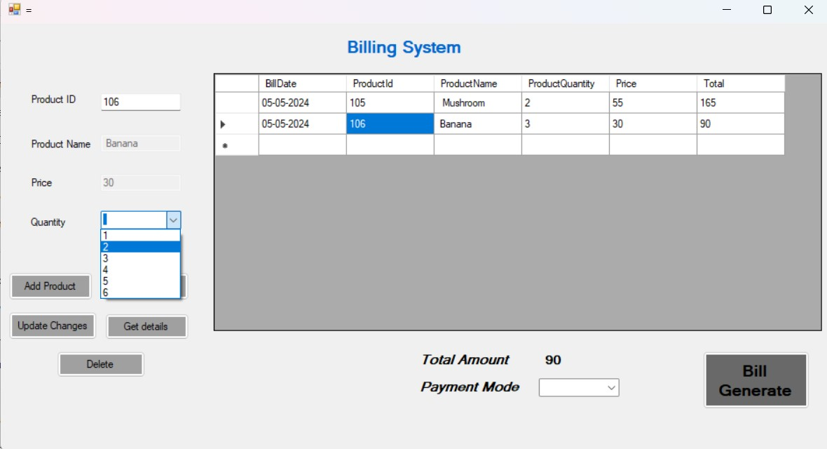

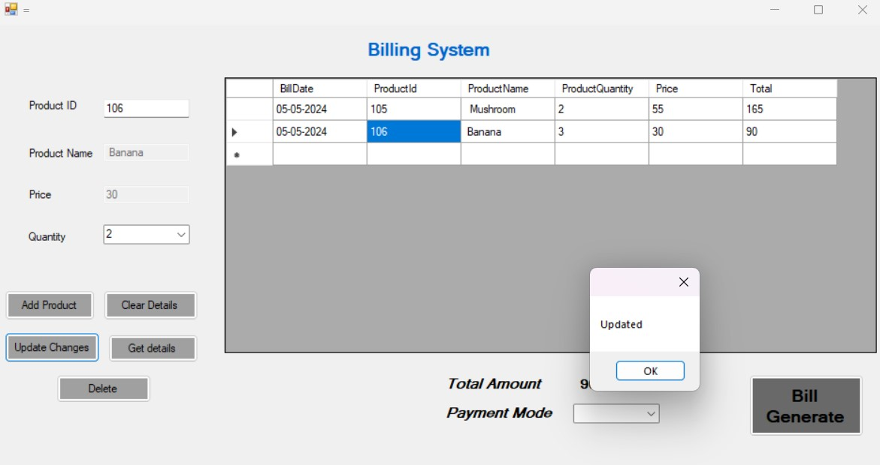

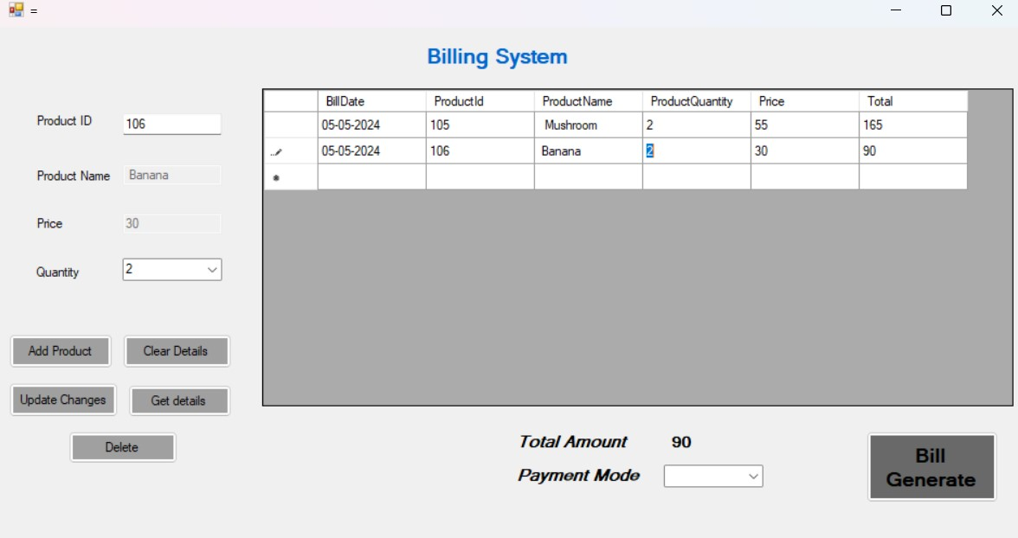

4.Get Details button: It’s used to get the details from the Datagrideview box, while we press the

Product Id and click the get data button.

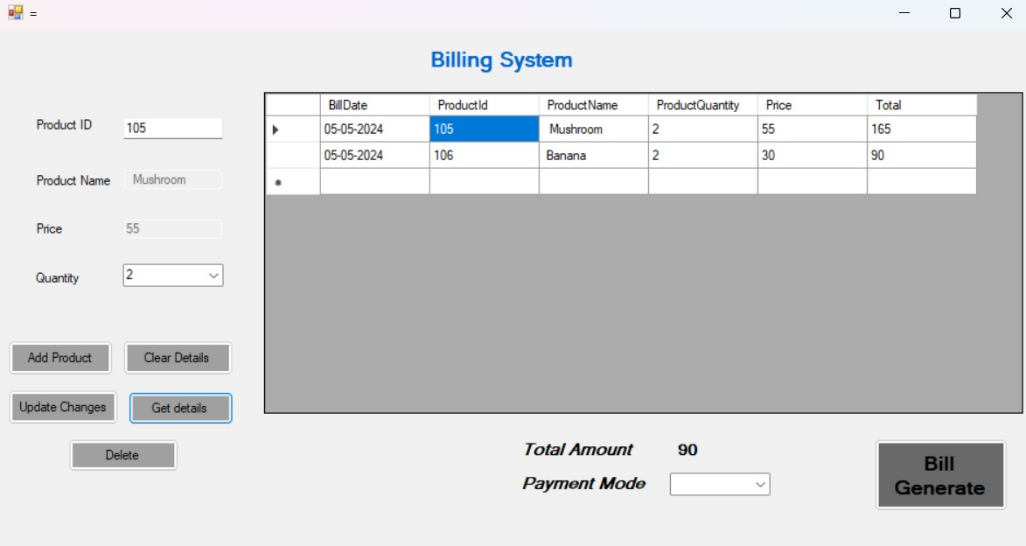

**5. Delete Button:**

