**10.3.1 Top 5 employees (employee id and employee name) with highest rating. (In case two employees have same rating, employee with name coming first in dictionary should get preference).**

Ordering employee by rating in descending order

Limit command is used to get the first five people.

At last generate is used a s a command to get the user name and id.

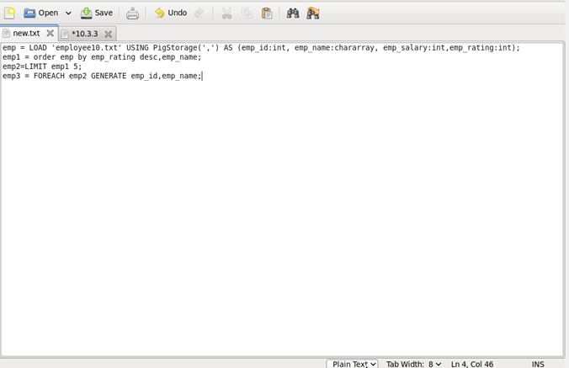

**INPUT:**

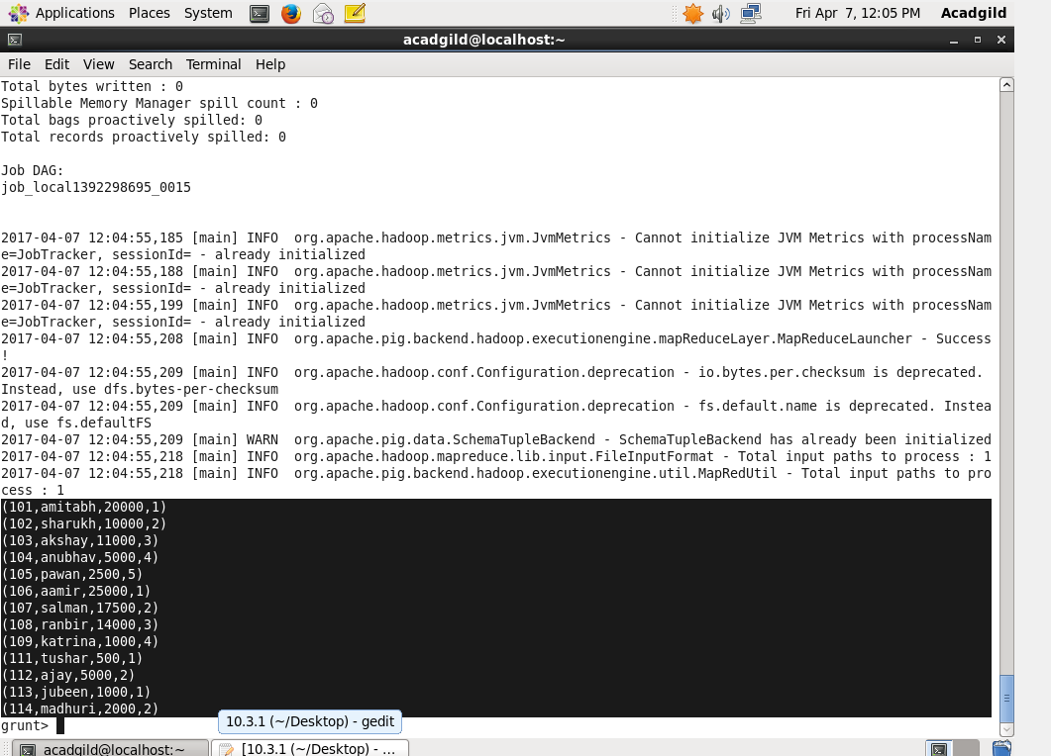

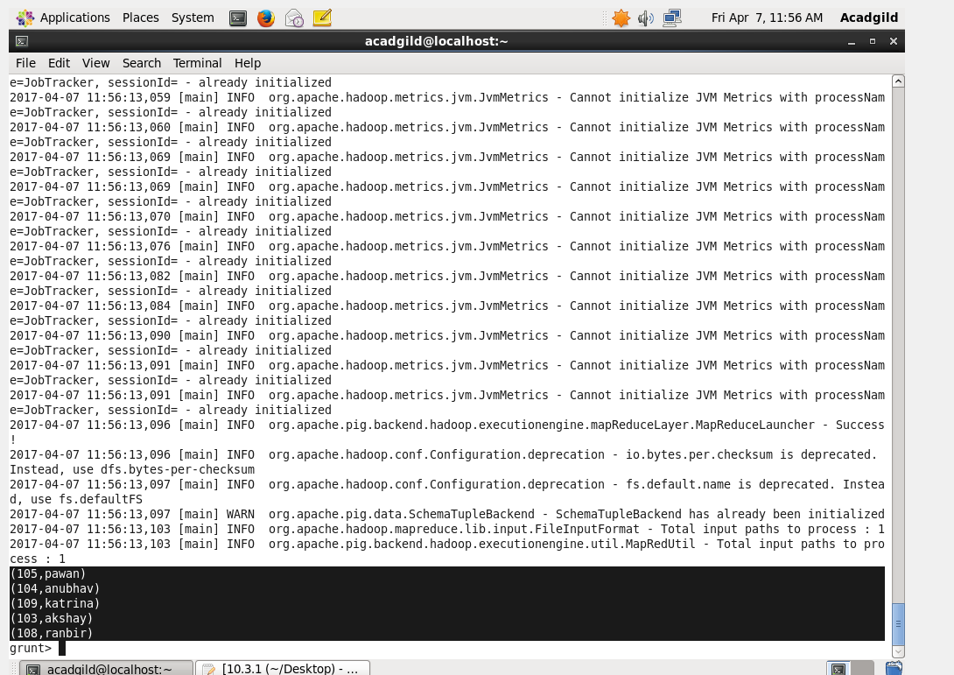

**10.3.2 Top 3 employees (employee id and employee name) with highest salary, whose employee id is an odd number. (In case two employees have same salary, employee with name coming first in dictionary should get preference).**

Salary is ordered in descending order.

Filter command to filter the odd and even id.

Limit command to display the top 3 details.

Generate to display only the name and id of employee’s.



output

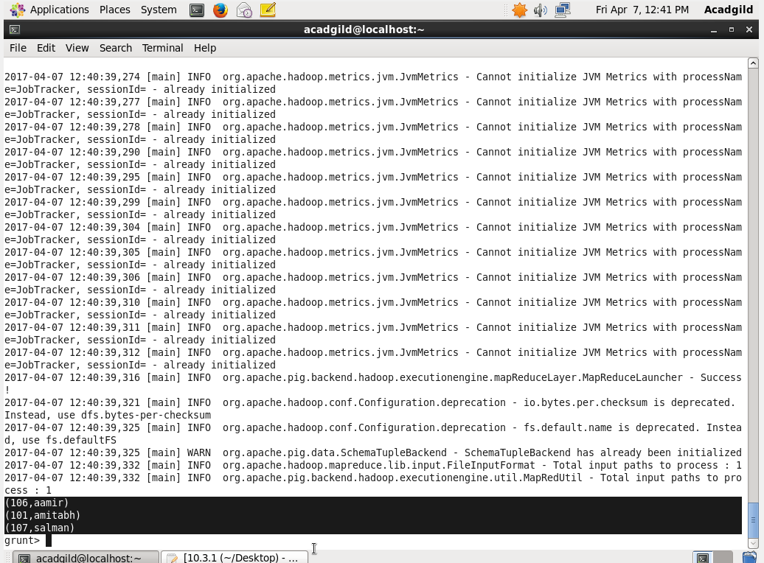

**10.3.3 Employee (employee id and employee name) with maximum expense (In case two employees have same expense, employee with name coming first in dictionary should get preference)**

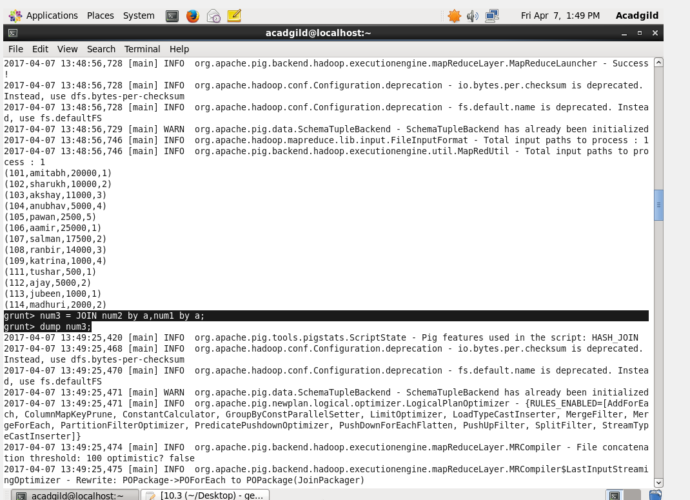

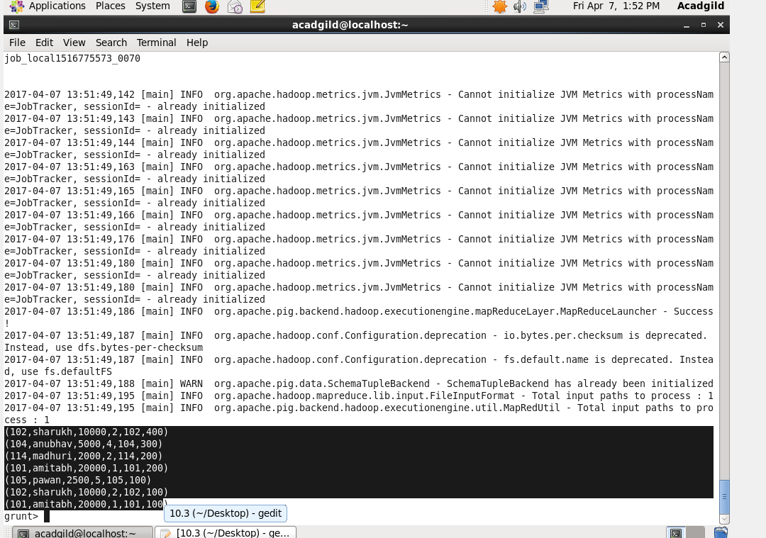

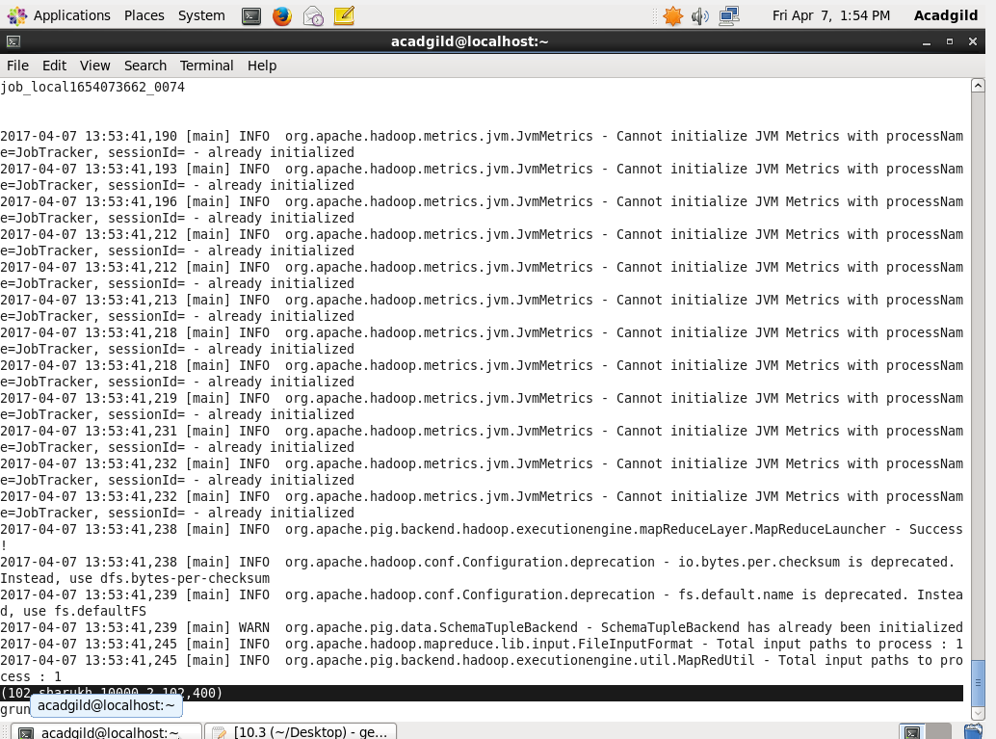



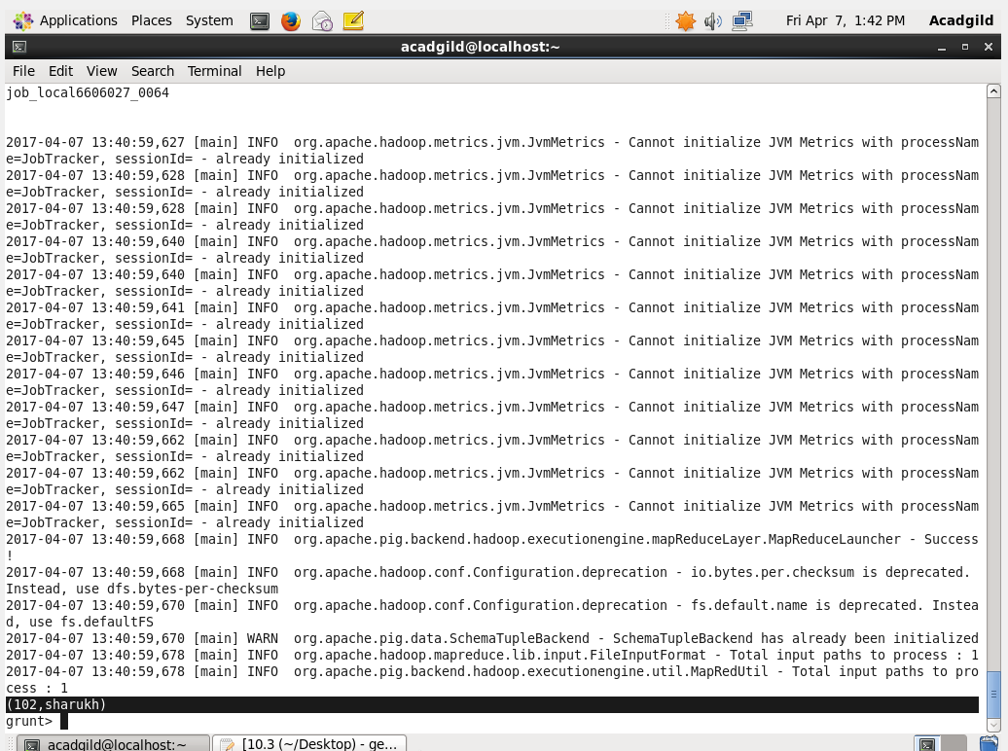

**10.3.4 List of employees (employee id and employee name) having entries in employee_expenses file.**

Inner join is used to join two tables

Generate command id used t pick the name and the id.

Using distinct command to eliminate duplicates.

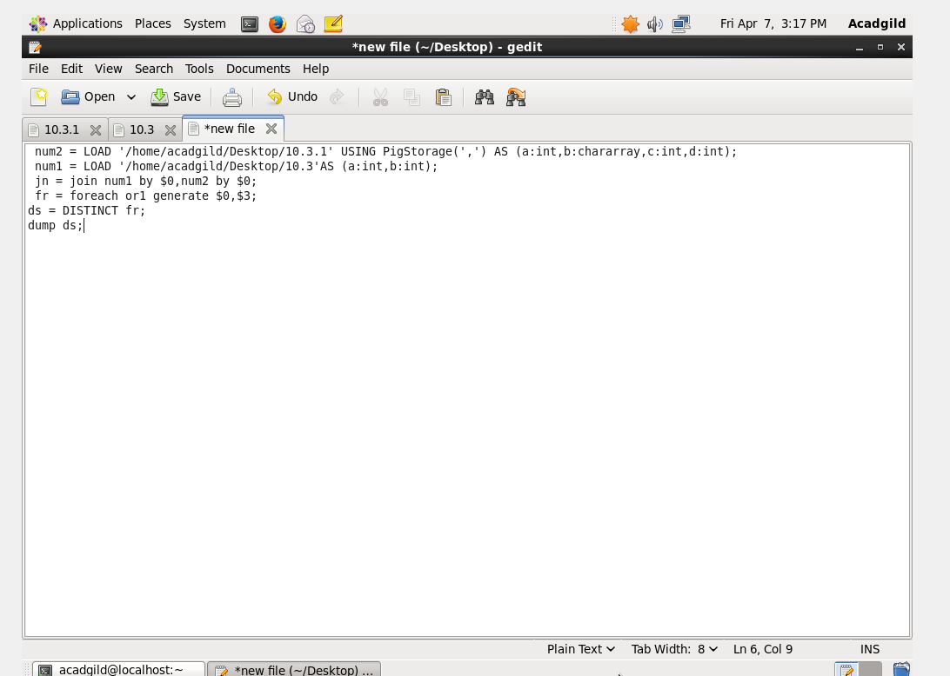

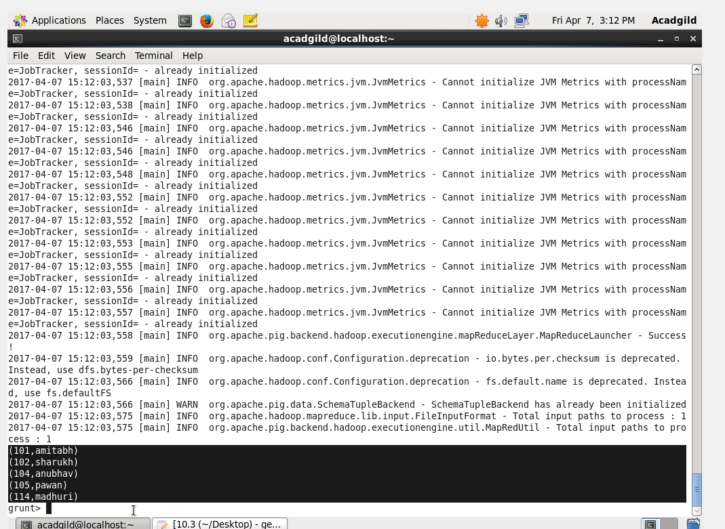

**10.3.5 List of employees (employee id and employee name) having no entry in employee_expenses file.**

Left join to get employee and expense data

Filtering using filter command.

Generating only name and id using generate command.

