1.Write a pig script find the average age of male and female persons died in the titanic tragedy

Method:

* Filter the people who died during the titanic tragedy.
* Group by sex
* And do average in their age so we may know what will be their average age.

2.Write a pig script to find the number of people died and survived in each class

Method:

* Filter the people who all survived
* And then group them
* At last count the number of people using their ID.

**PIG COMMANDS:**

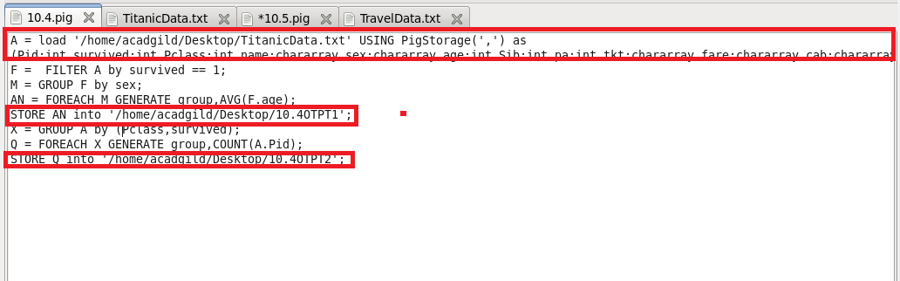

**PIG SCRIPT:**

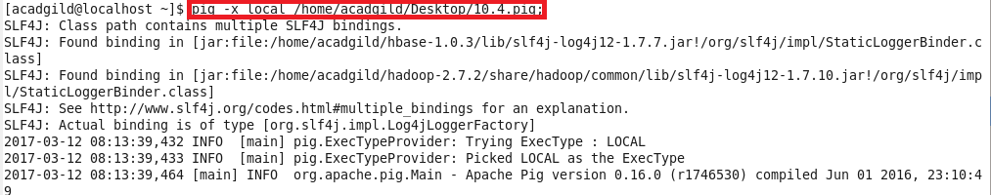

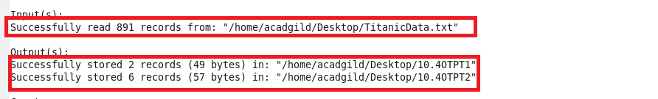

\

**OUTPUT:**

