**10.6.1 Write a pig script to find the minimum temperature observed in a given weather station in a particular year.**

**Grouping by station and getting the minimum temperature using min command**

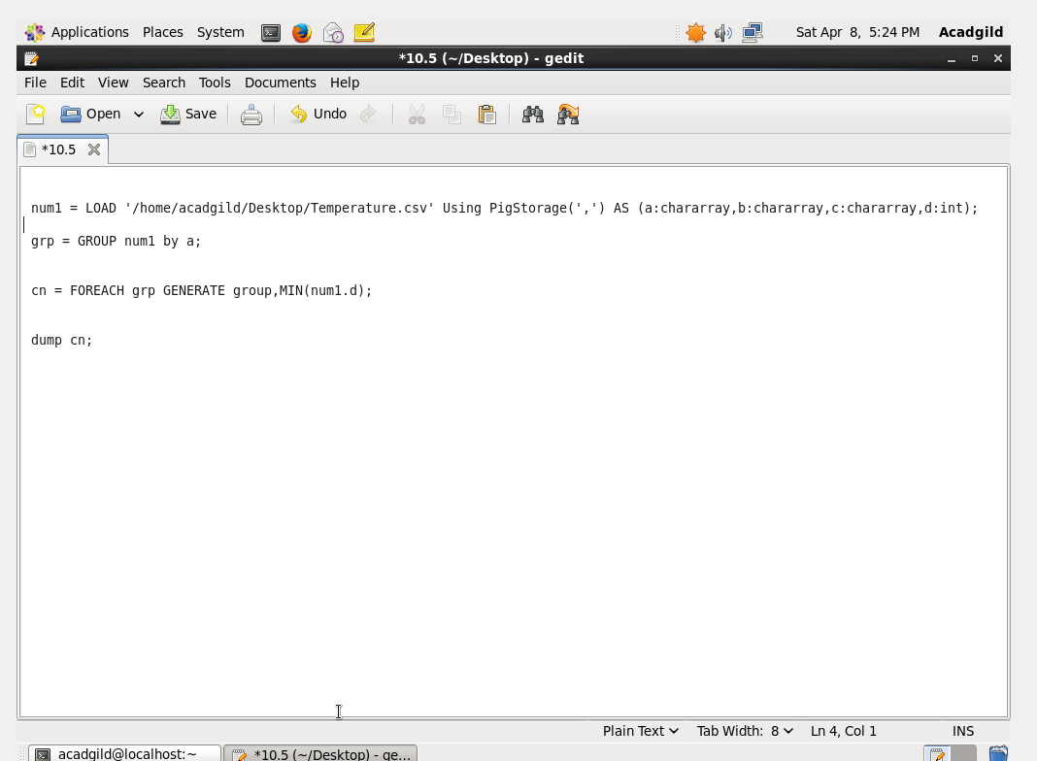

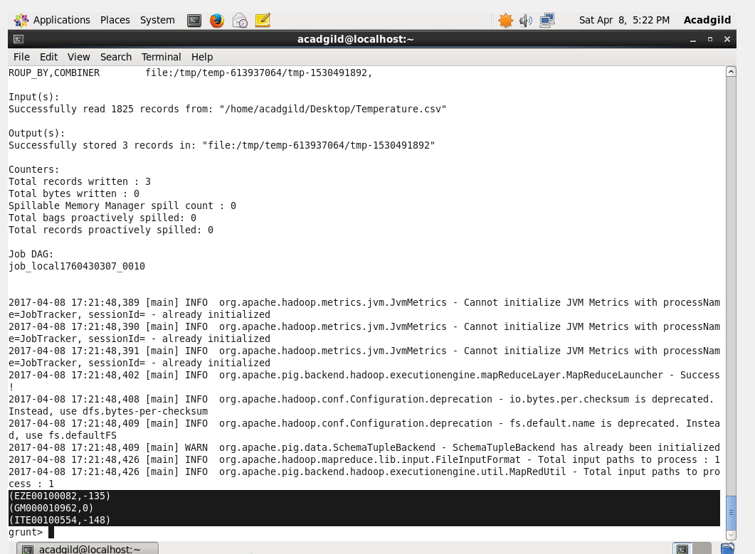

**10.6.2.Write a pig script to find the maximum temperature observed in a given weather station in a particular year.**

**Grouping by station and getting the maximum temperature using group by and max command.**

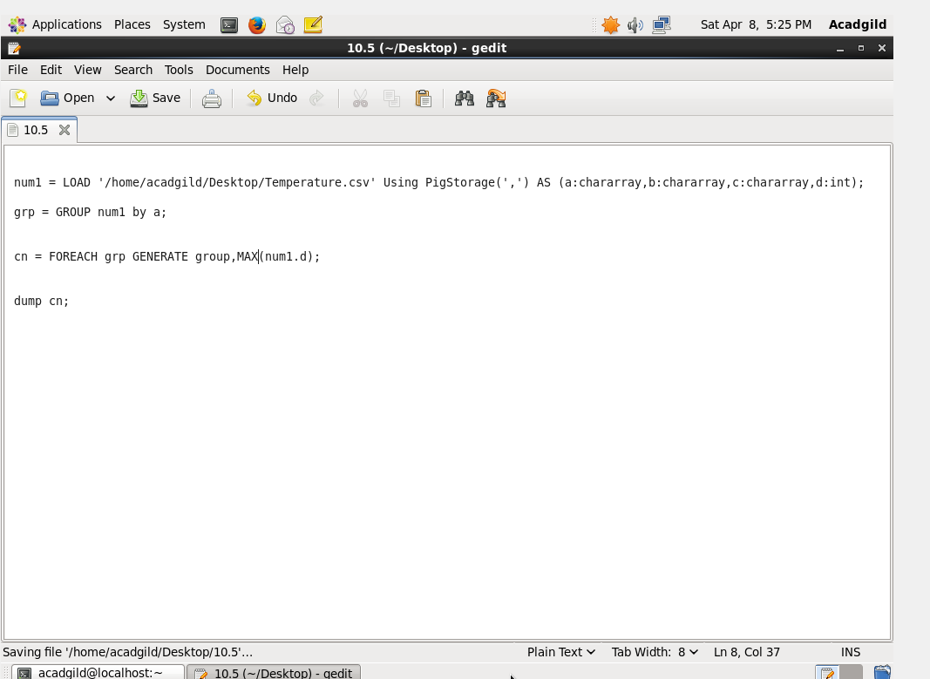

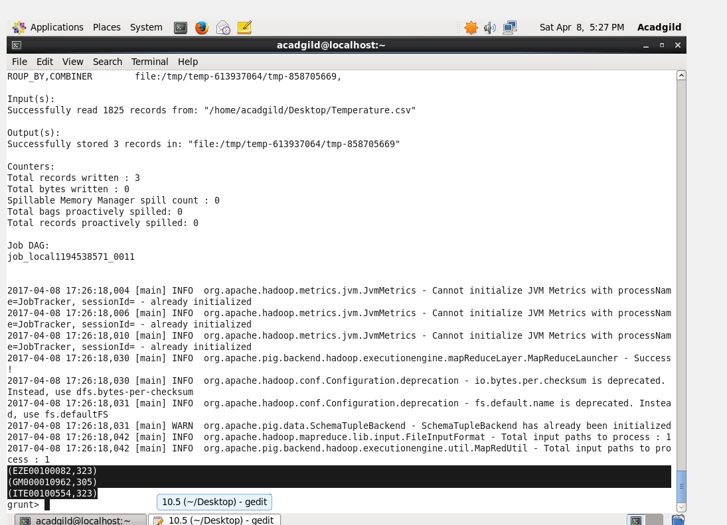

**10.6.3 Write a pig script to find the number of readings given by each weather station according to the dataset.**

**Grouping by station and finding the count of the station using group by and count command.**

