1. **Find the number of students who scored less than 5(50%).**

***Filtering the students data whose marks are less than 5***

***Grouping by all***

***Generating the count of the students who scored less than 5***

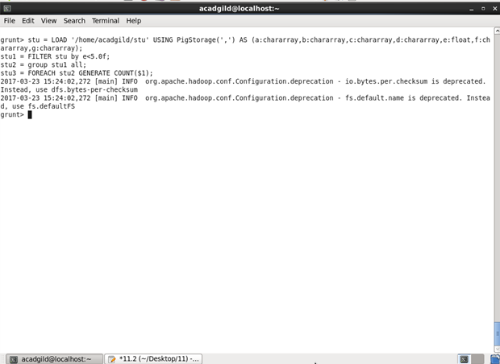

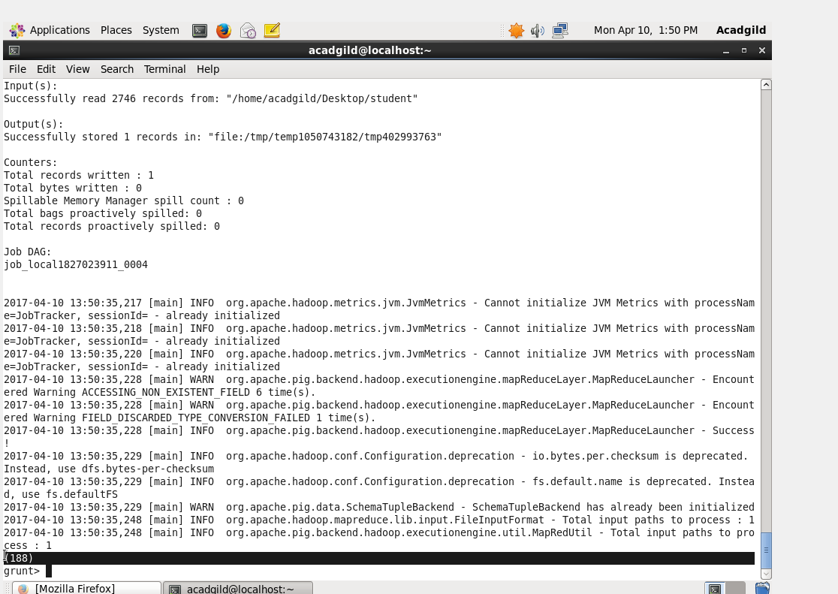

**11.2.2 List the name of students who are from Alaska.**

**Filtering the data with the students from Alaska.**

**Generating only the name of the students.**

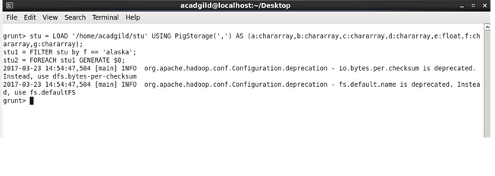

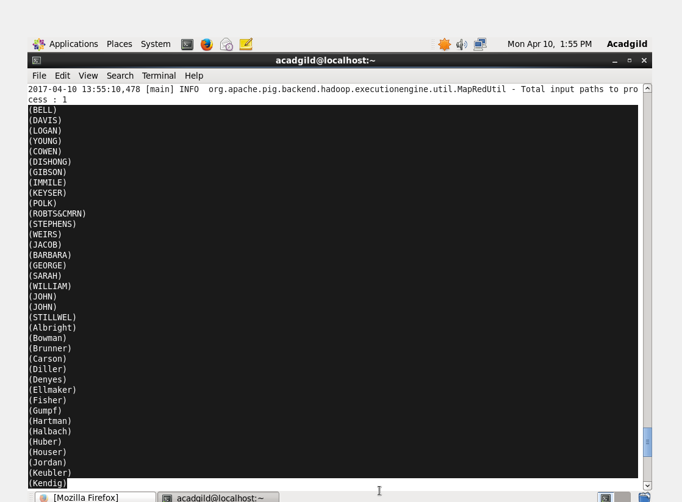

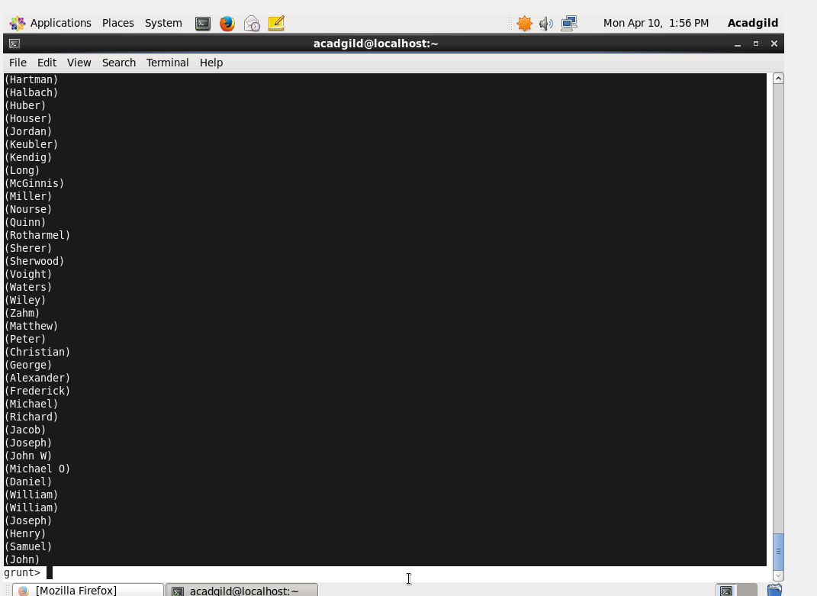

**12.2.3.** **How many government colleges are there in Alabama?**

***Filtering the students from Alabama and studying in govt. colleges***

***Grouping by using Group by cmd.***

***Counting the no. of students using count cmd.***

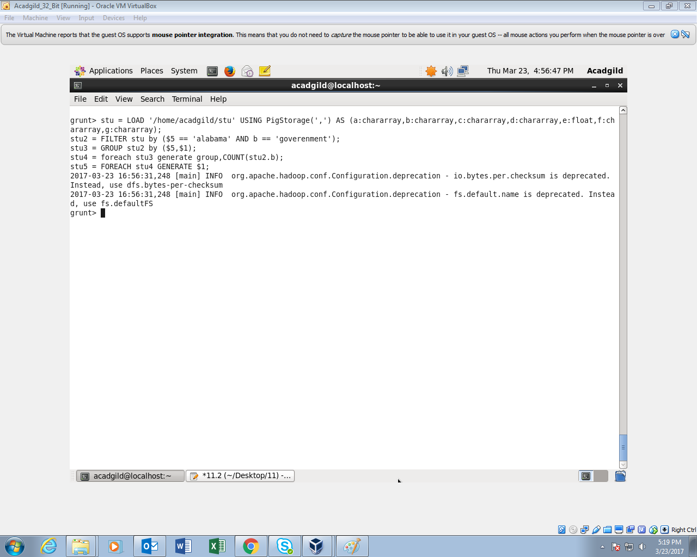

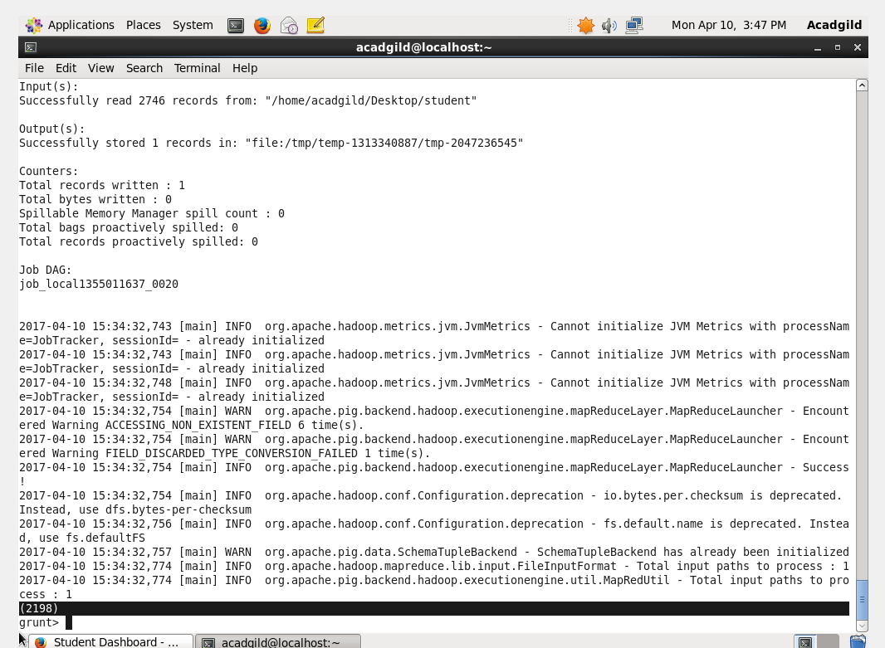

**12.2.4.List the name of students who are from Oregon and persuing BE.**

***Filtering the students by Oregon and studying BE.***

***Generating the names of the students using Generate cmd.***

