***ASSIGNMENT 11.3***

Write a Pig UDF to find the tweets posted by @realDonaldTrump from the given dataset.

UDF:

Only the realdonaldtrump data will be filtered and will be counted

Therefore null details will be removed here.

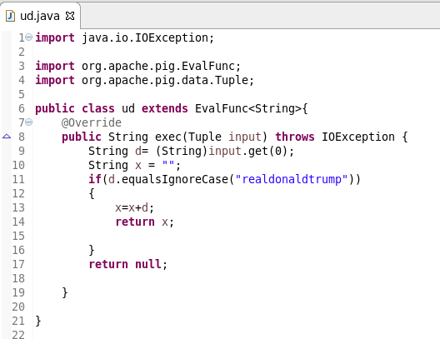

Pig script:

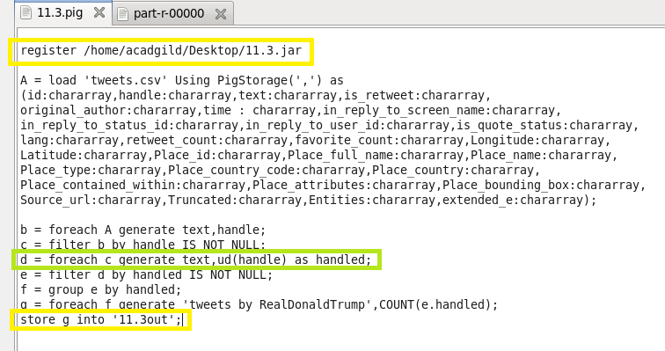

Running pig script:

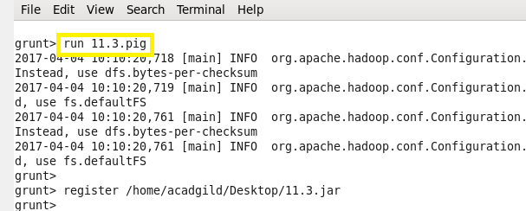

Output:

