***Assignment-11.4:***

Write a pig script to find the count of each Hashtag in the dataset. You can download the twitter data from the below link.

Pig Script:

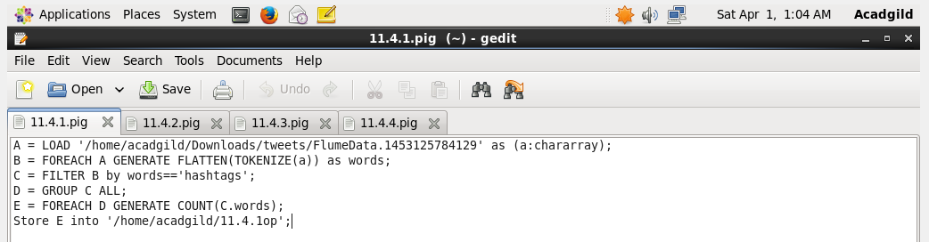

Executing the Pig Script:

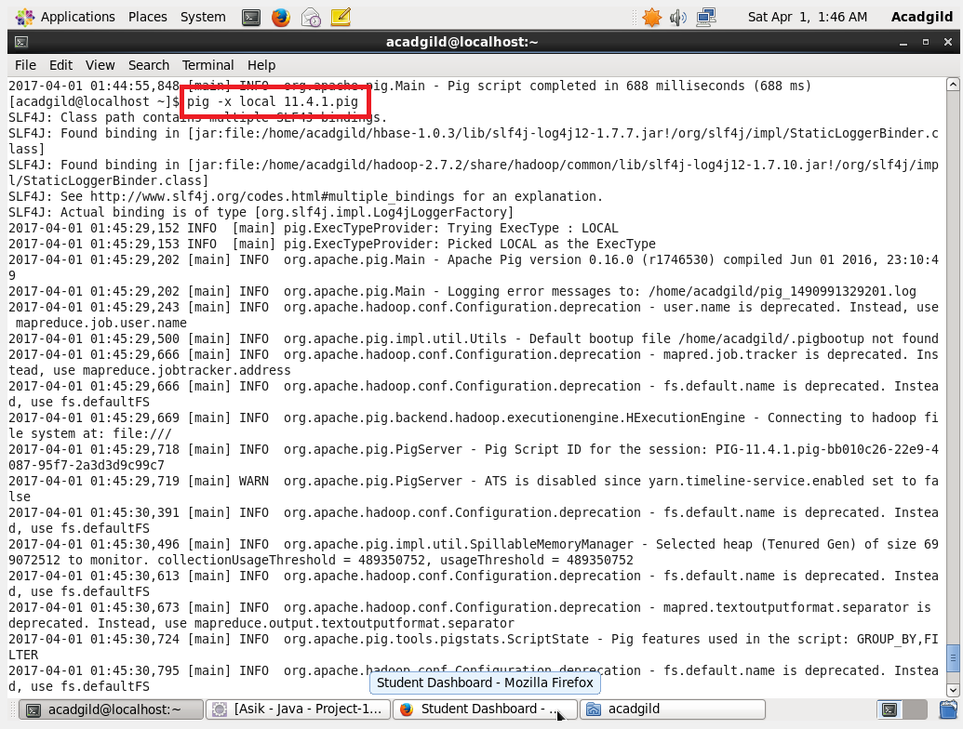

Output:

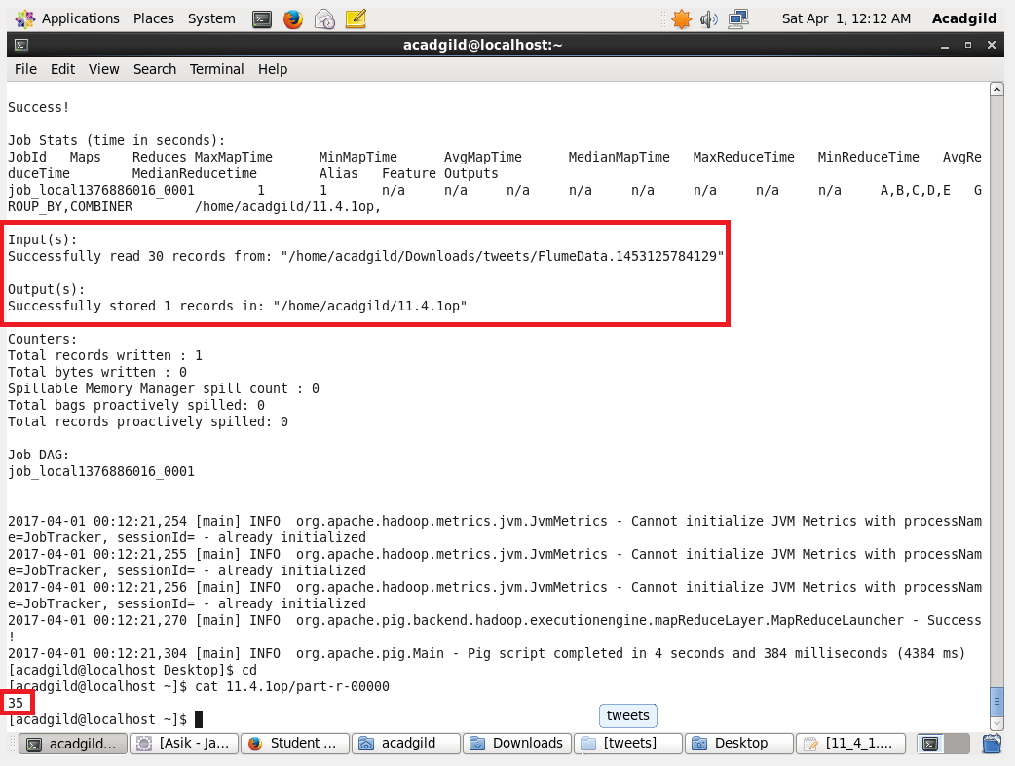

Pig Script:

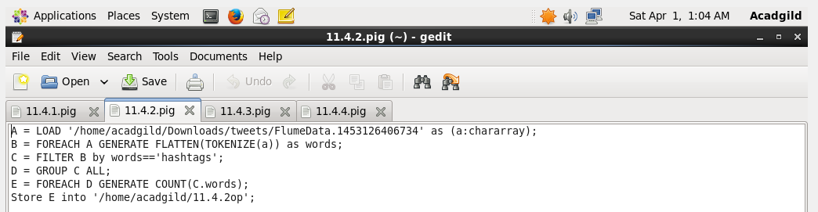

Output:

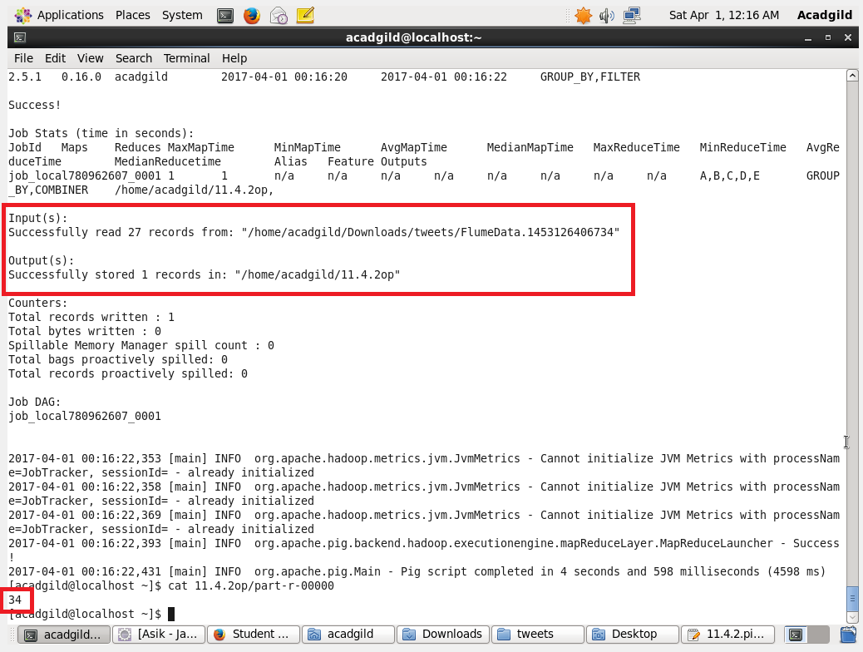

Pig Script:

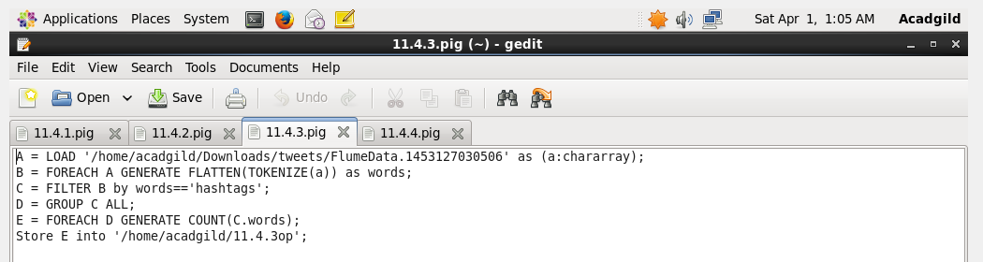

Output:

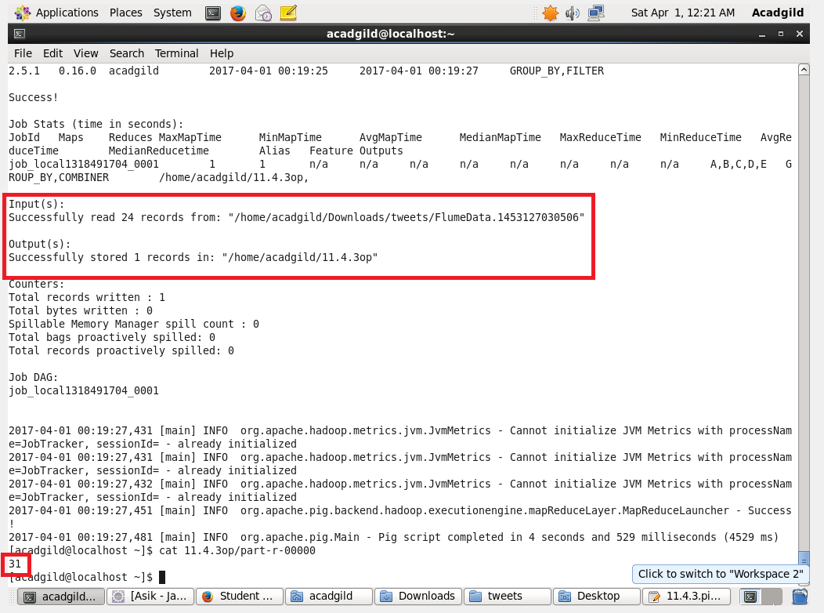

Pig Script:

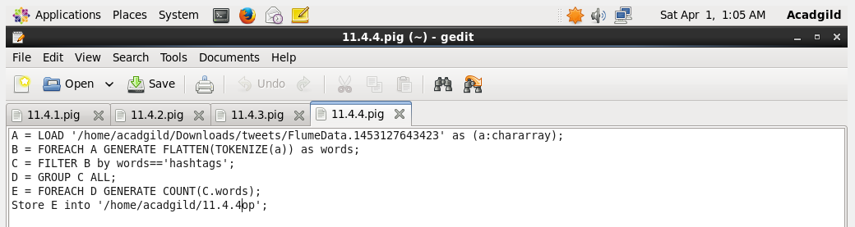

Output:

