**16.1**

**Using Distributed cache join the two datasets and find out the number of temperature variations in each country using mapreduce.**

**Building.csv – BuildingID, BuildingMgr, BuildingAge, HVACproduct,Country**

**HVAC.csv – Date, Time, TargetTemp, ActualTemp, System, SystemAge, BuildingID**

***DRIVER CLASS:***

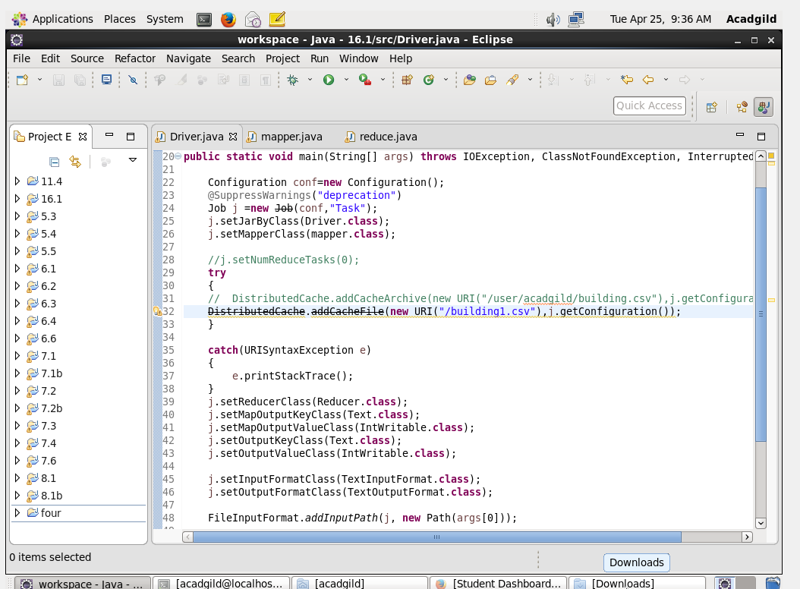

***MAPPER CLASS:***

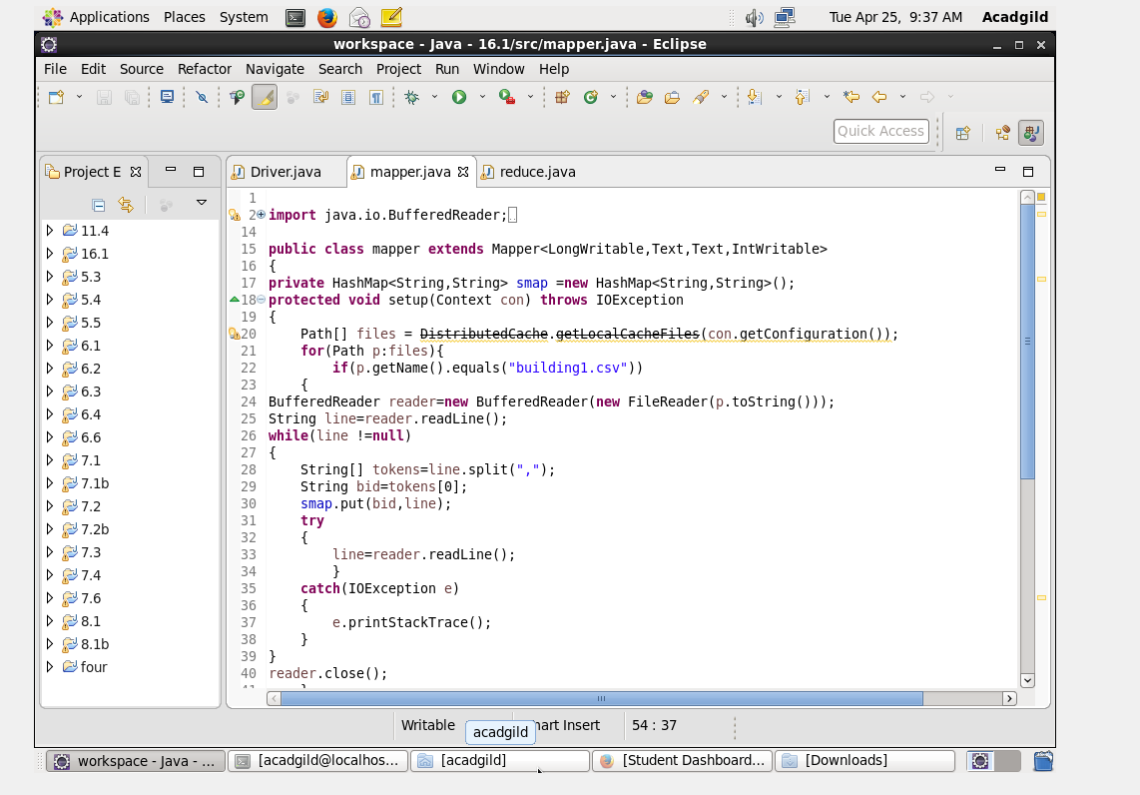

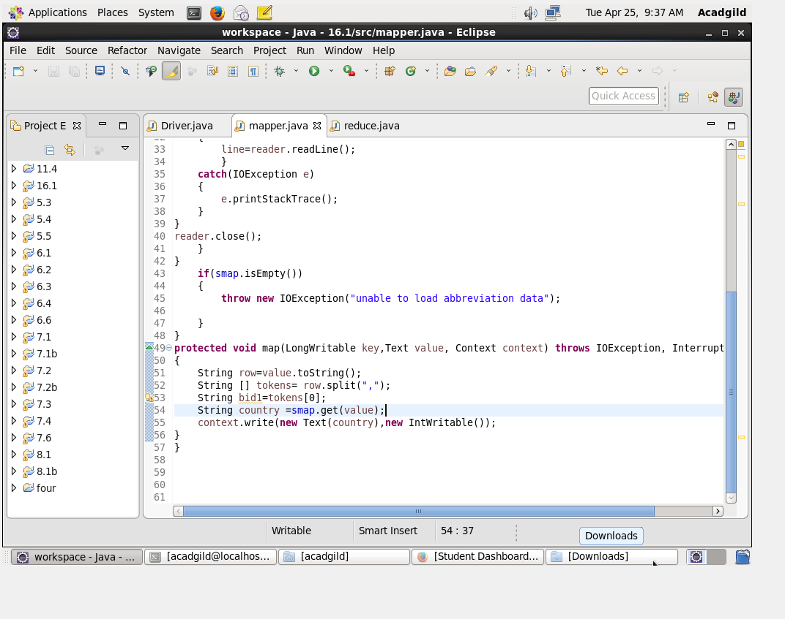

***REDUCER CLASS:***

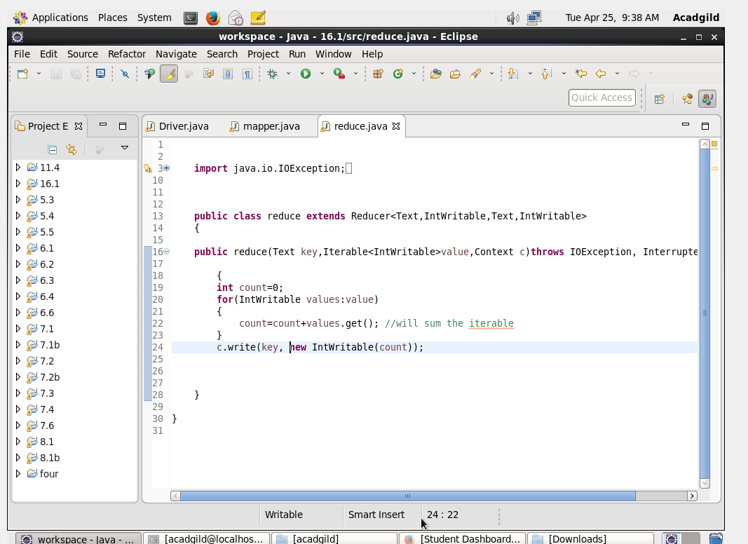

***OUTPUT:***

