**Building.csv – Buildingid, Buildingmgr, Buildingage, HVACproduct, Country HVAC.csv – Date, Time, Targettemp, Actualtemp, System, Systemage, Buildingid Using reduce side join the two datasets and find out the number of temperature variations in each country using mapreduce.**

**DRIVER CLASS:**

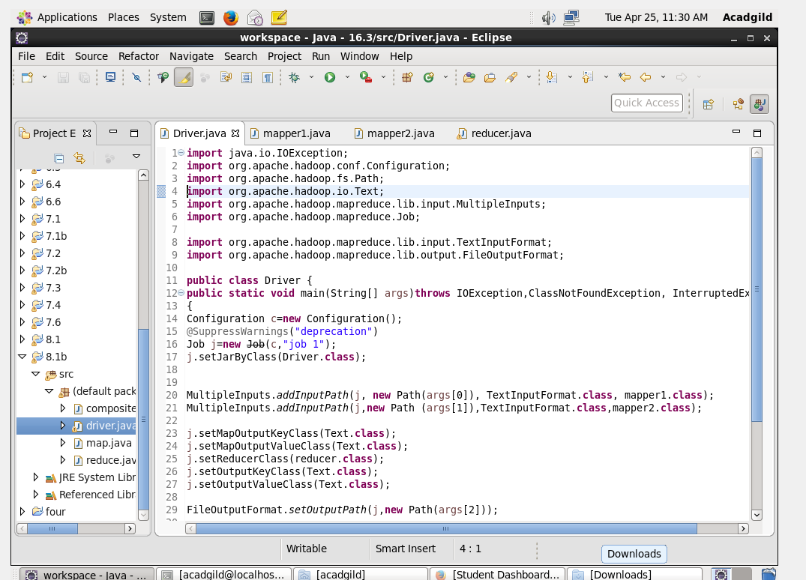

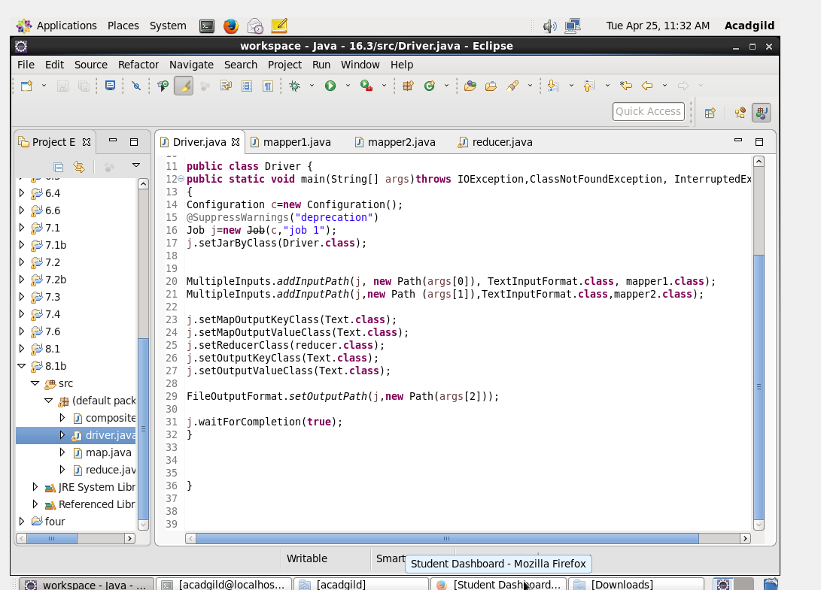

**1ST MAPPER CLASS:**

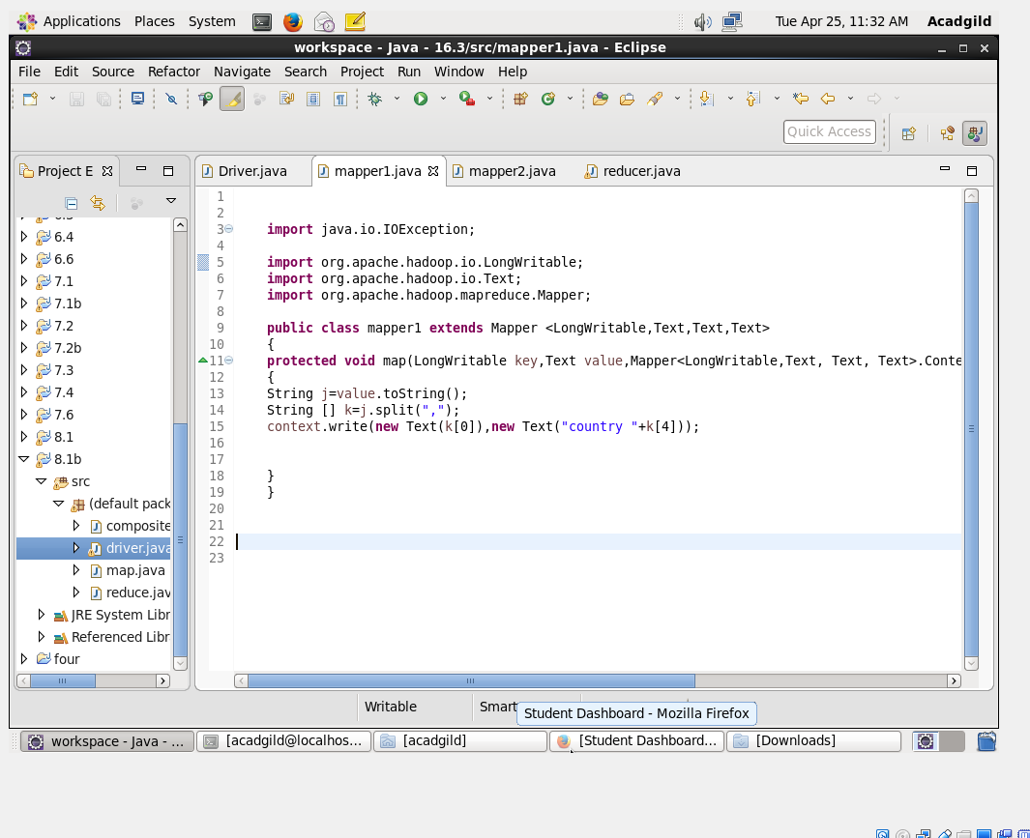

**2ND MAPPER CLASS:**

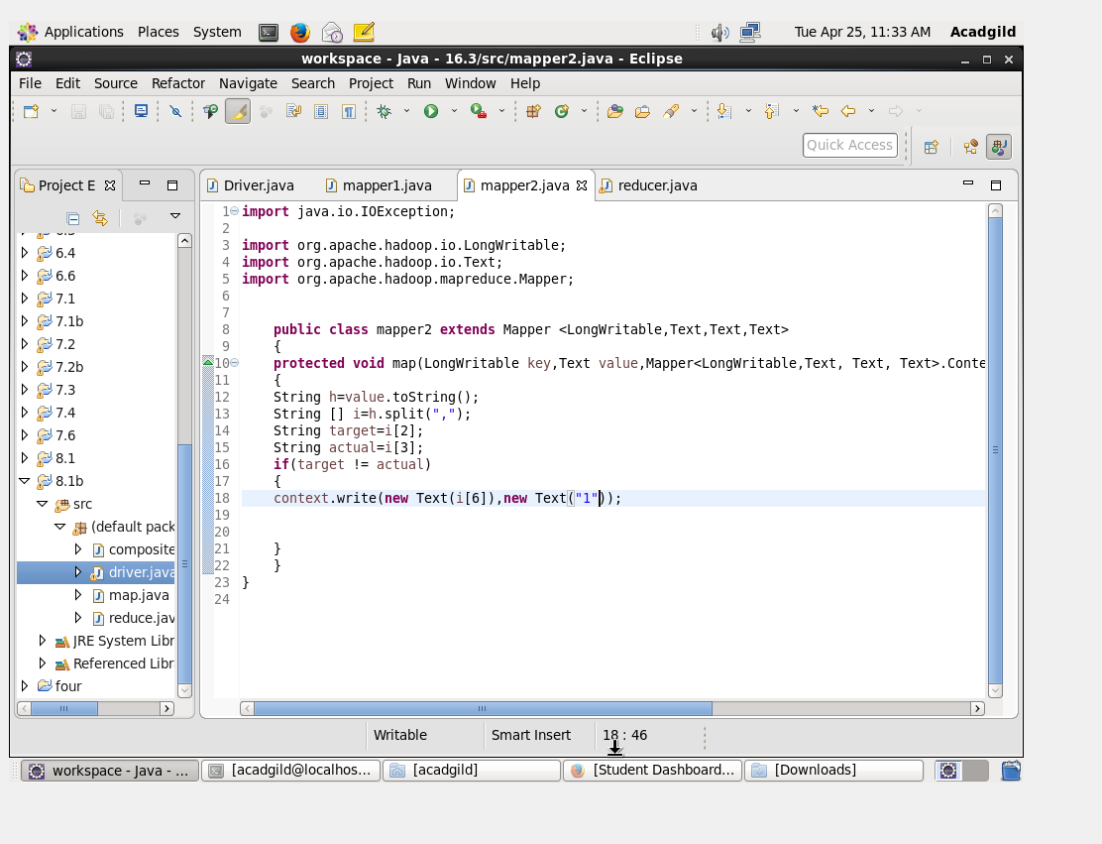

**REDUCER CLASS:**

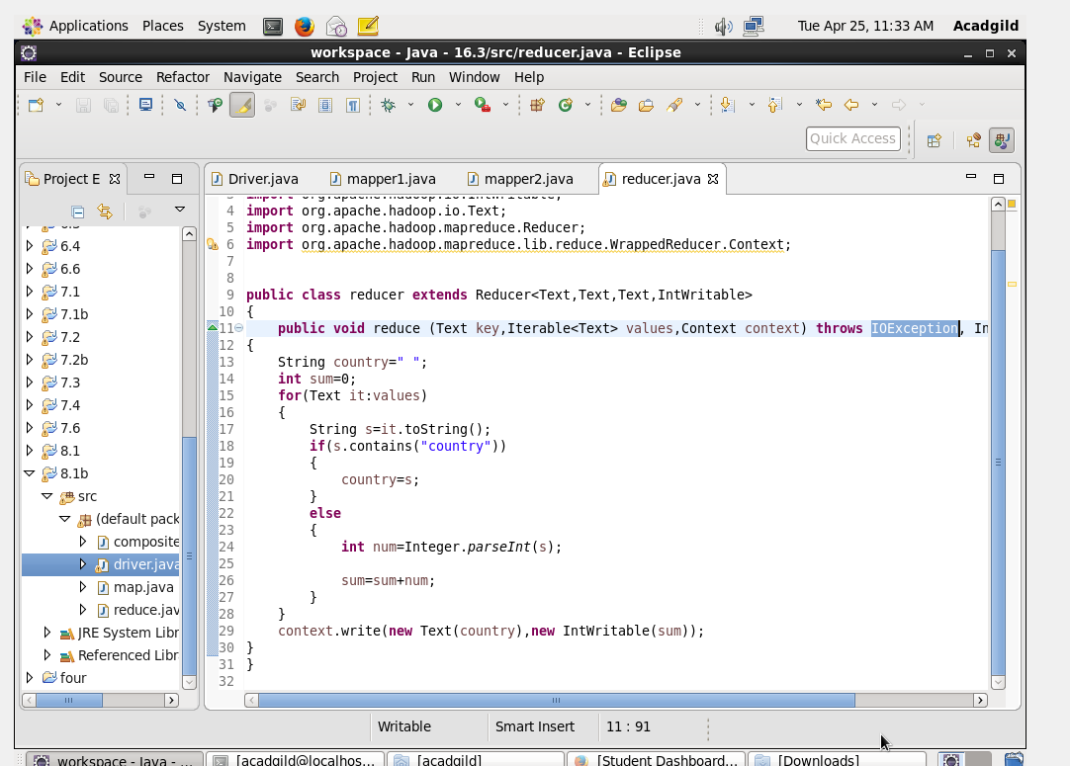

**OUTPUT:**

