**Write a map reduce program to join the below given two datasets**

**using map side join.**

*To download data set from this link:*

https://drive.google.com/open?id=0ByJLBTmJojjzSWhfXzI5NGh4RGM

**Dataset description of dataset1.csv is as follows:**

* id
* first name
* last name
* email
* gender
* ip address

Dataset description of tdataset2.csv is as follows:

* Id
* first name
* last name

***DRIVER CLASS:***

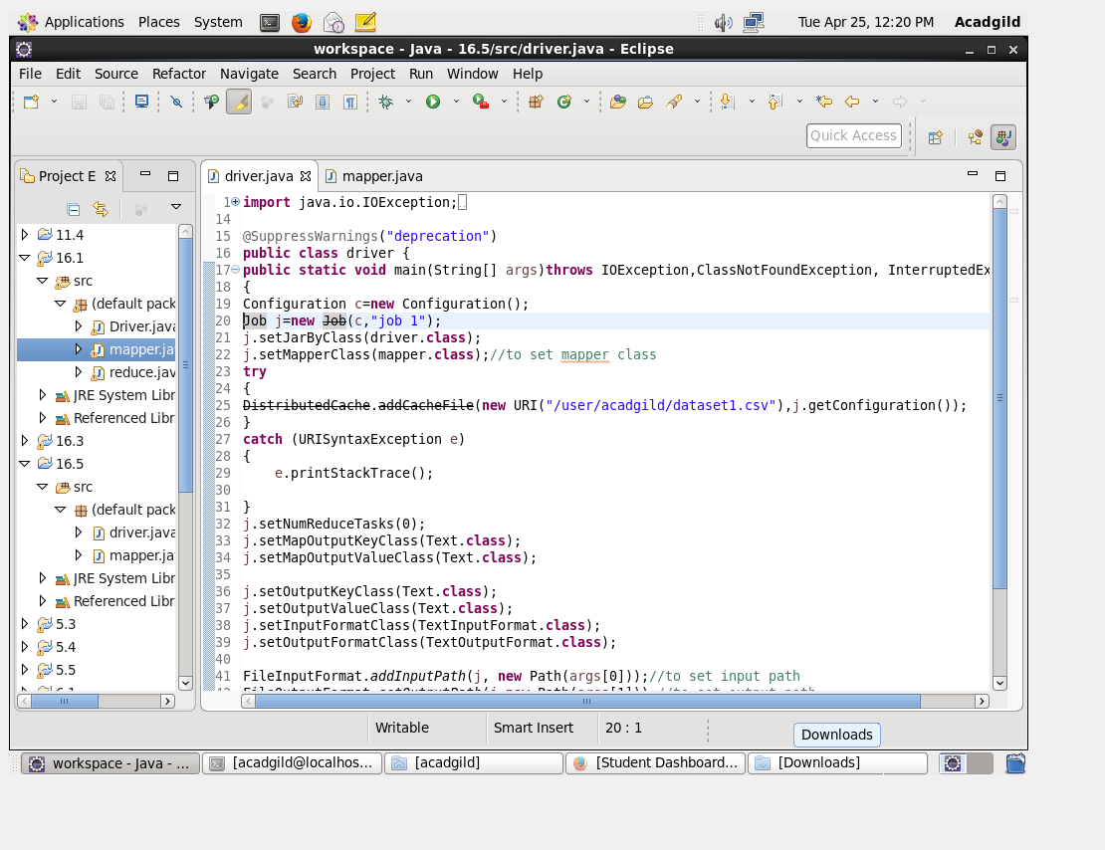

**MAPPER CLASS:**

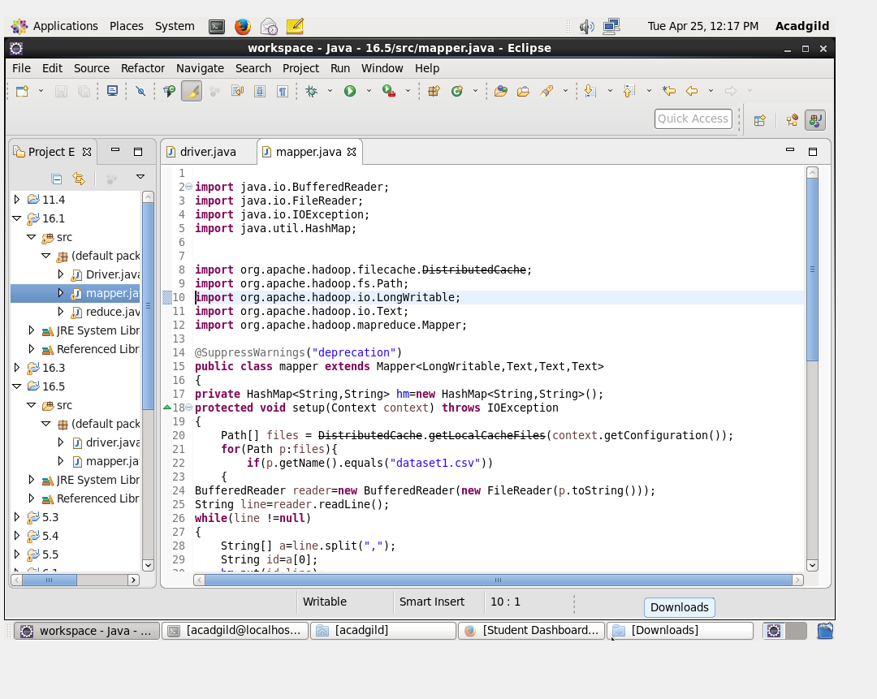

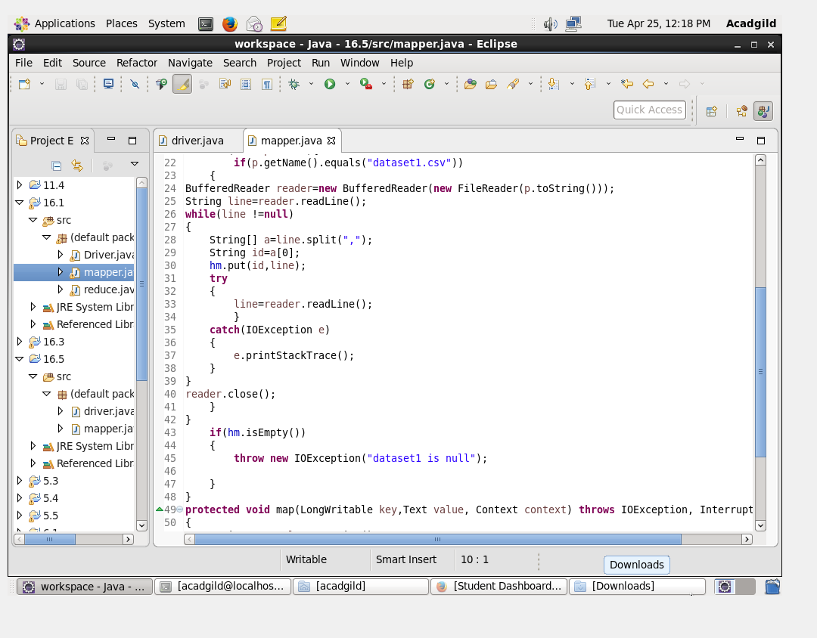

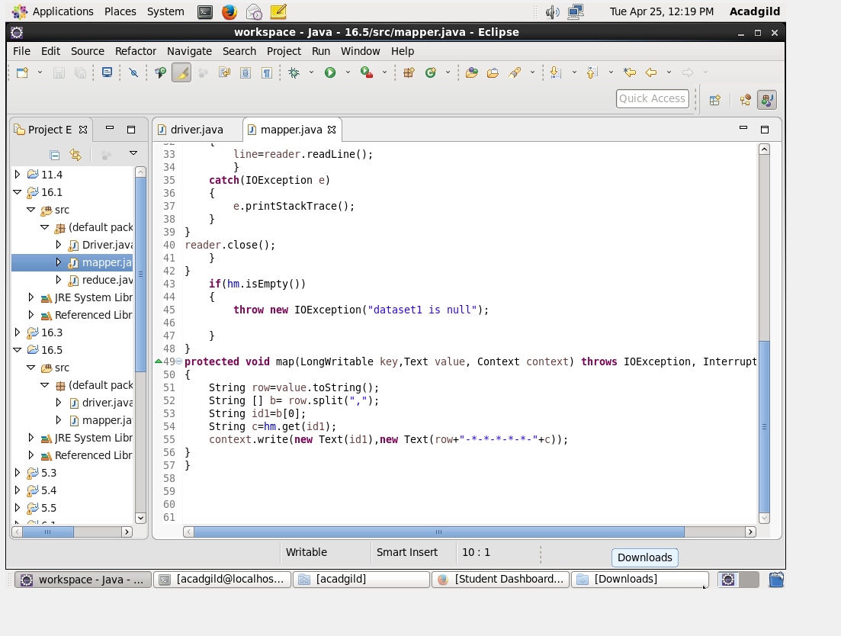

**SNAP OF OUTPUT:**

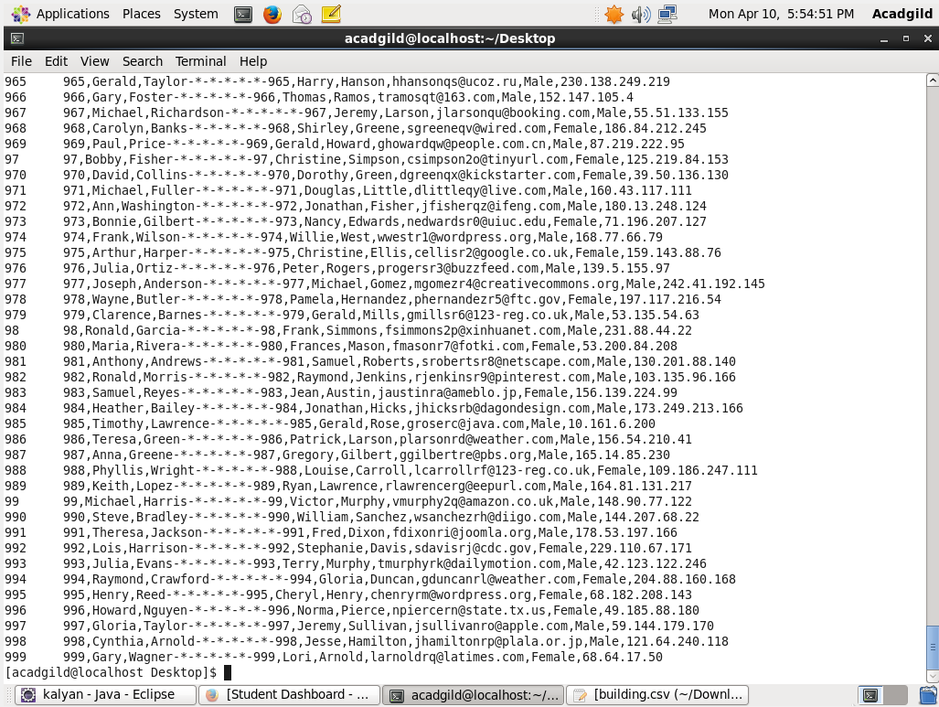

**Last part of the output.**