**16.6. Write a map reduce program to join the below given two datasets using Reducer side join.**

*Dataset can be downloaded from:*

<https://drive.google.com/open?id=0ByJLBTmJojjzSWhfXzI5NGh4RGM>

dataset1.csv Dataset description is as follows:

* Id
* first name
* last name
* email
* gender
* Ip address

tdataset2.csv of Dataset description is as follows:

* Id
* first name
* last name

Note : You can just join the datasets using reducer side join can be used to join

**DRIVER CLASS:**

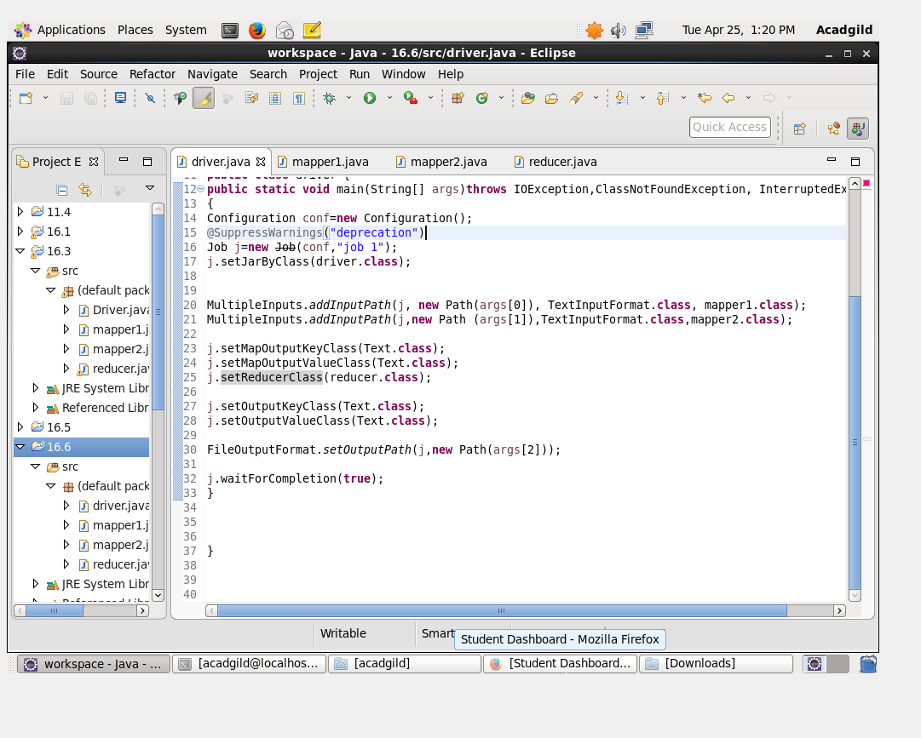

**1ST MAPPER CLASS:**

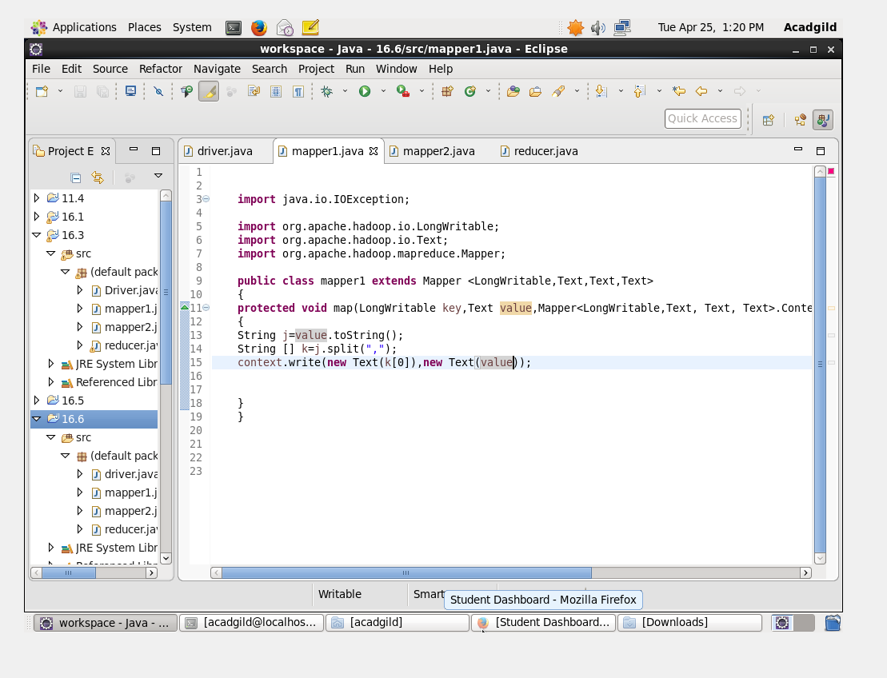

**2ND MAPPER CLASS:**

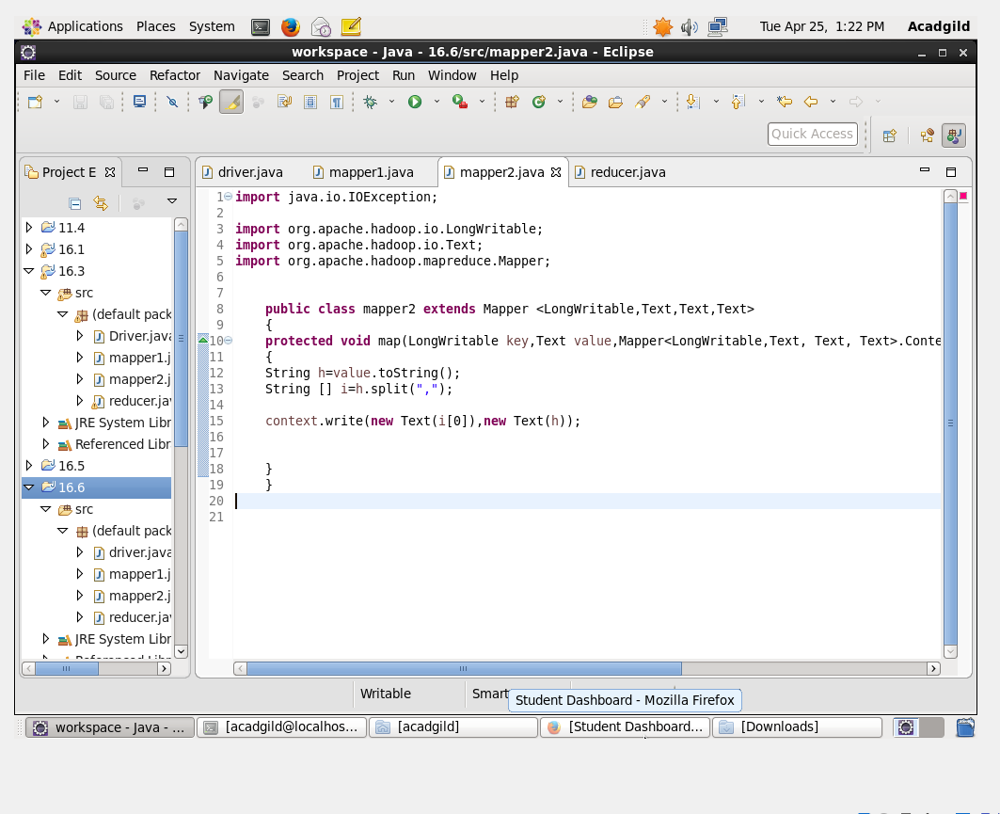

**REDUCER CLASS:**

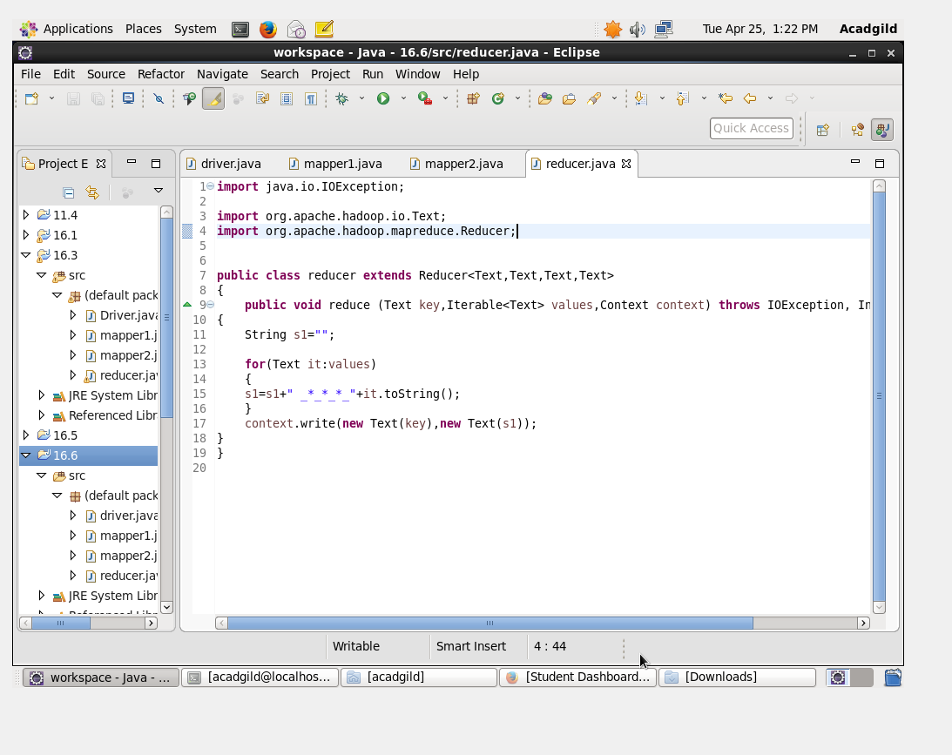

**OUTPUT:**

