**Assignment 17.1**

Write a program that accepts the job_id as argument and returns a custom counter and a system counter (total records input to the map tasks) associated with that job.

**Program:**

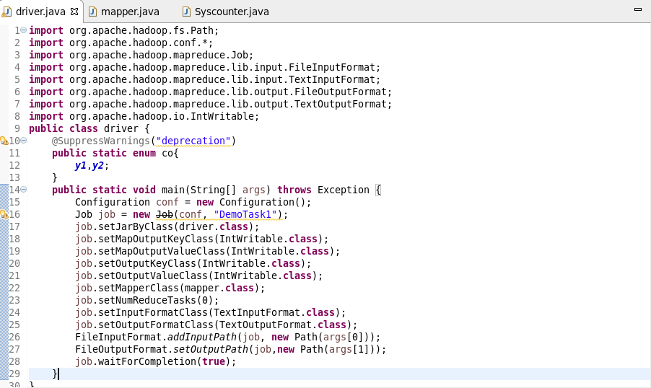

**MAPPER:**

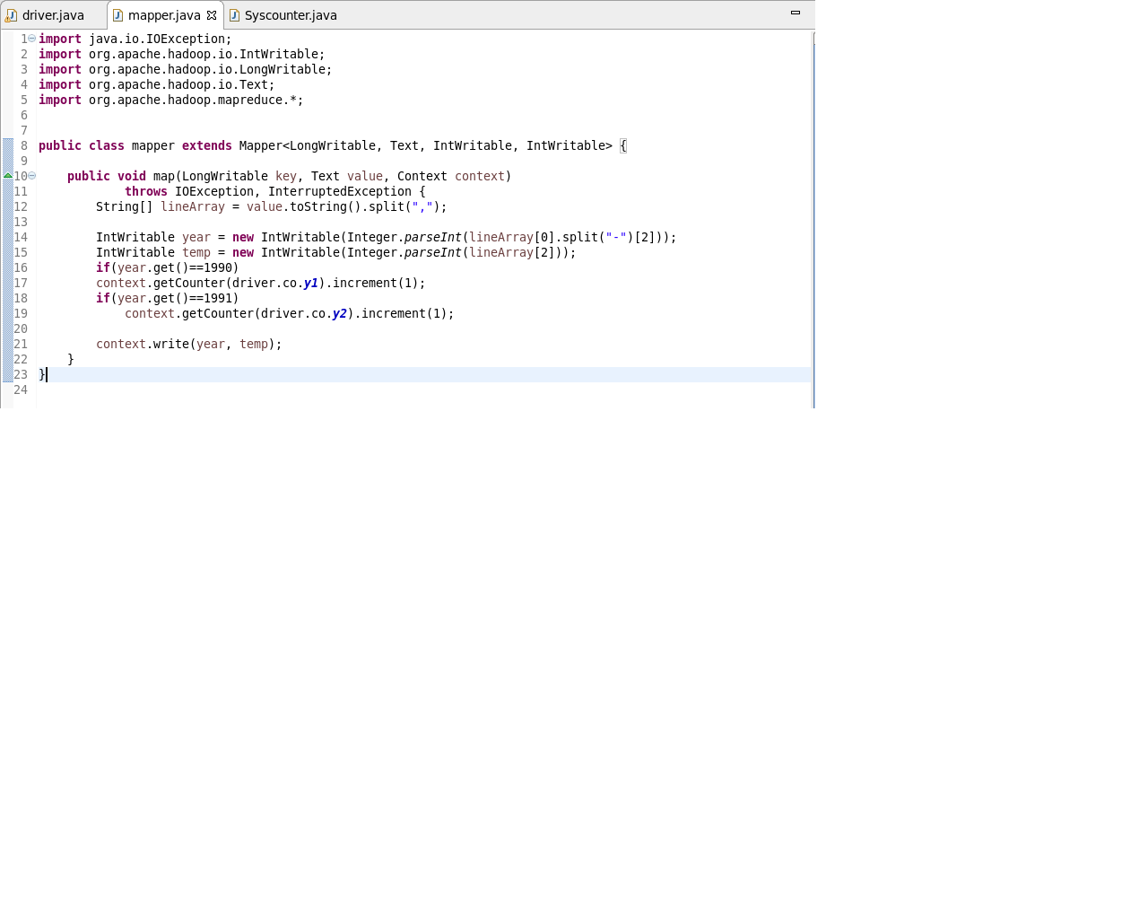

**SYSCOUNTER:**

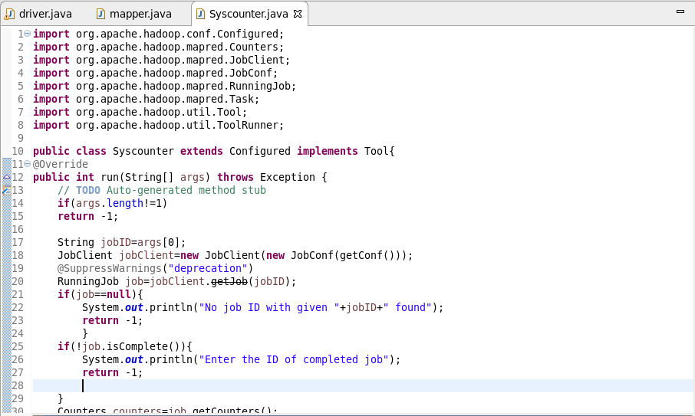

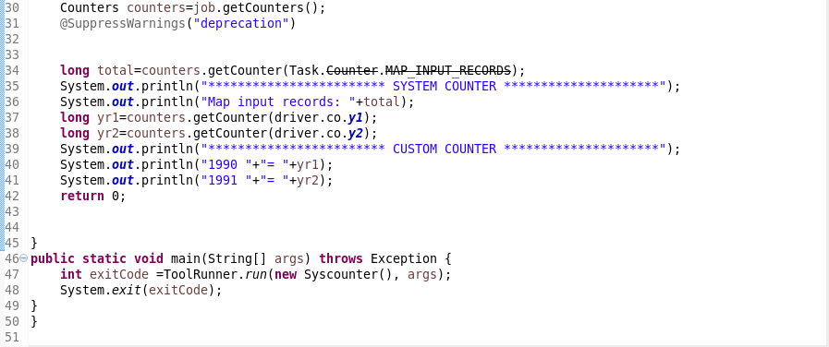

Job id is taken as input and will display the system counter as well the custom counter for the same type of job.

**Output:**

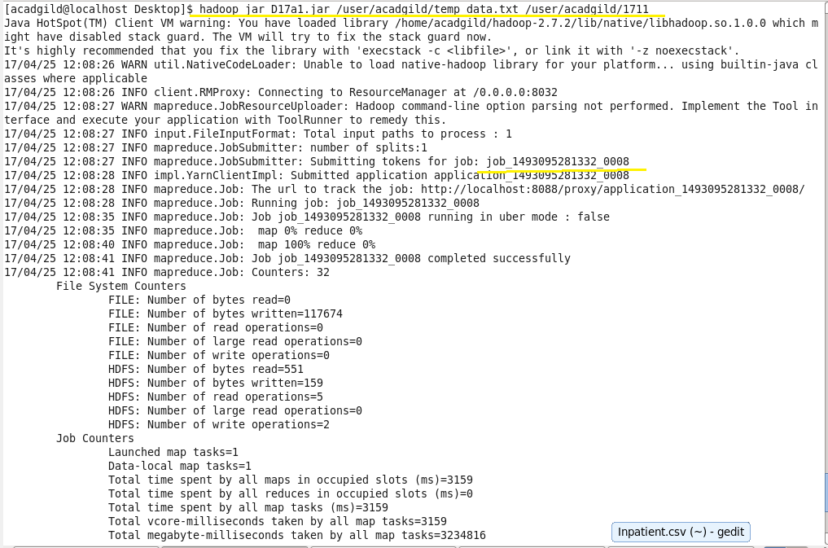

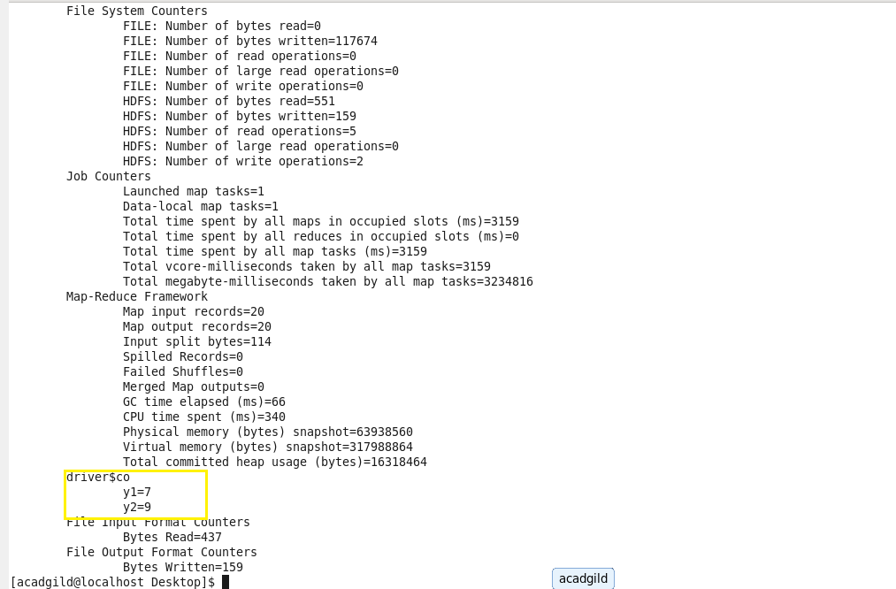

Job history of custom counter:

