**Problem:**

*Write a secondary sort program to generate the top 2 maximum temperatures corresponding to every year from the temperature dataset.*

Codes:

Task class:

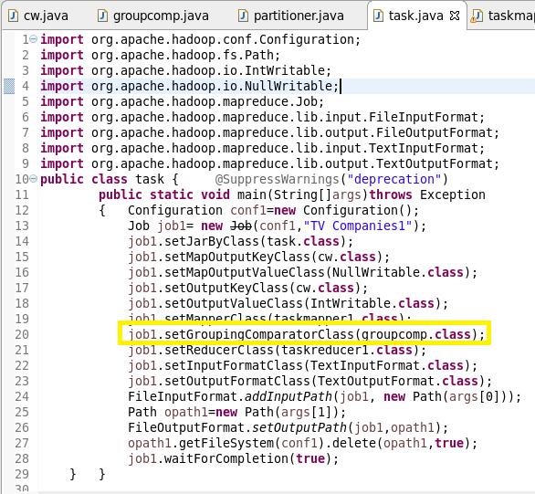

For composite key both year and temperature are taken as key.

Group comparator class is used to group all the incoming keys as natural key instead of composite key.

**Mapper class:**

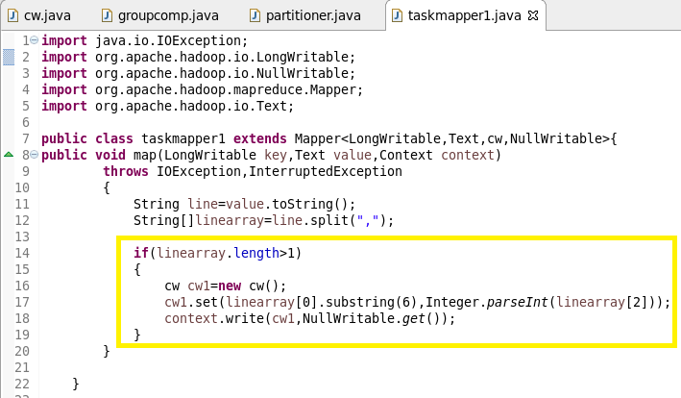

* Composite key is used which acts as a combination of temperature and year where year represents natural key
* And value will be nullwritable.

**Reducer class:**

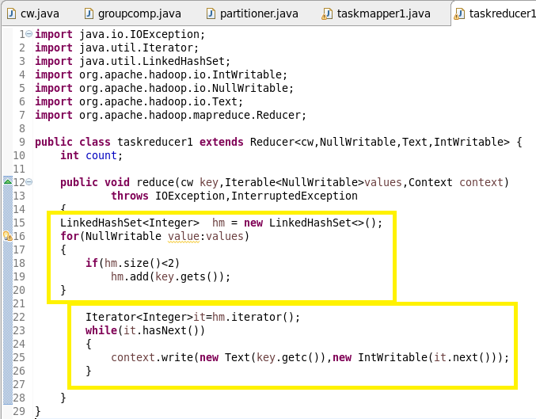

Maximum of 2 temperature in each year is found.

**Groupcomparator class:**

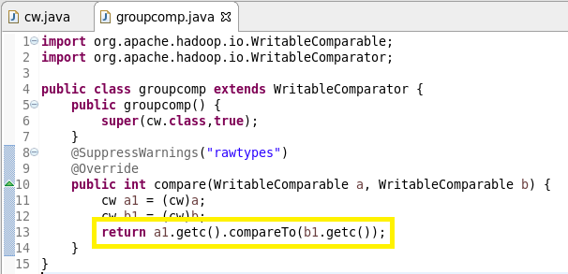

* All data in the reducer will be grouped as a key.
* Since composite key is used we should check the data for natural key as well.
* And this is done using ***groupcomparator***
* Comparator object will take only the year as field.
* And it will group al the data.

***Writable comparable class:***

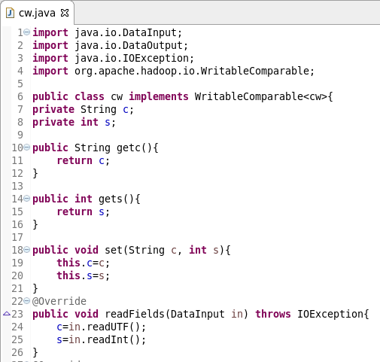

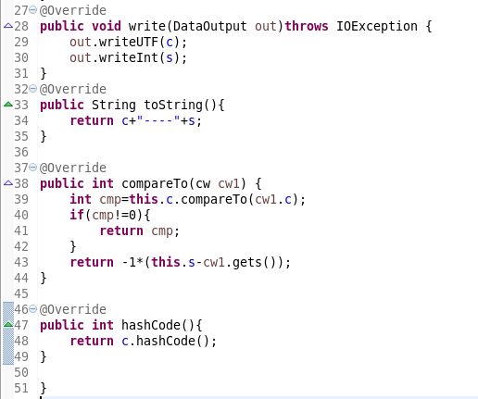

Writable comparator is used to order in descending order since maximum of two temperature is needed.

**Running jar:**



**Output:**

