**Problem Statement**

**Write a map reduce program to design a custom counter to count number of people are affected with 'PULMONARY' disease and 'BRONCHITIS & ASTHMA' in the state 'CA'.**

***Task class:***

Only mapper class and driver class is used since only counters are implemented.

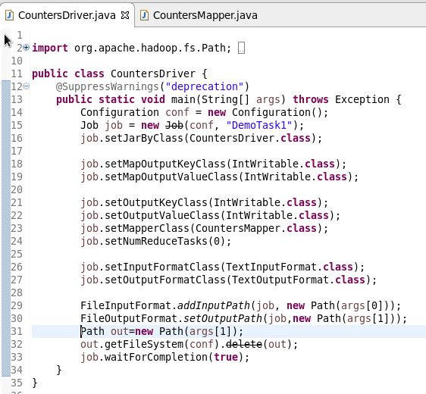

***Mapper class:***

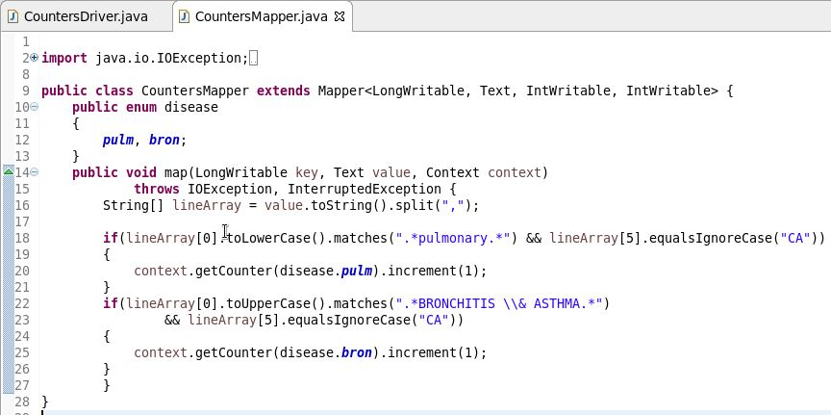

1. Create enum which is needed to group the counters it will group and the fields will later become as fields.
2. Number of counter in mapper will counted.

***Output:***

