**Run a map only job on the word count program using static configurations**

***DRIVER***

* Since only mapper class s used set num reduce task to 0.
* Output format is set as Sequence Output File format.

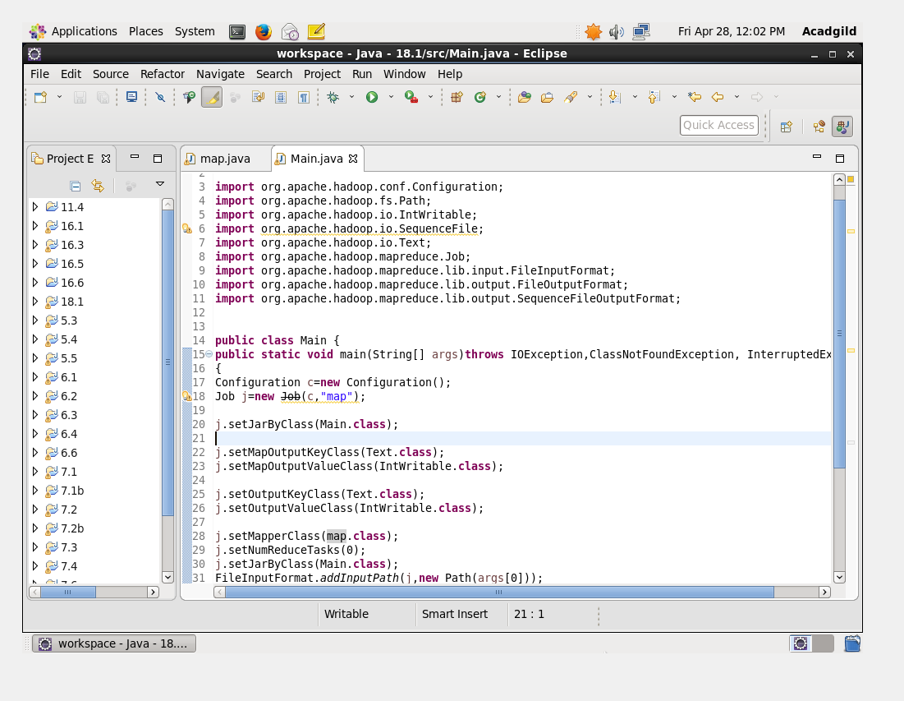

***MAPPER CLASS-***

* In mapper class hashmap is used and its count will be increased by 1 or the value of 1 will be provided whenever the word count gets increased.
* The clean up method will be overrided instead of mapper by using key and value for each line.

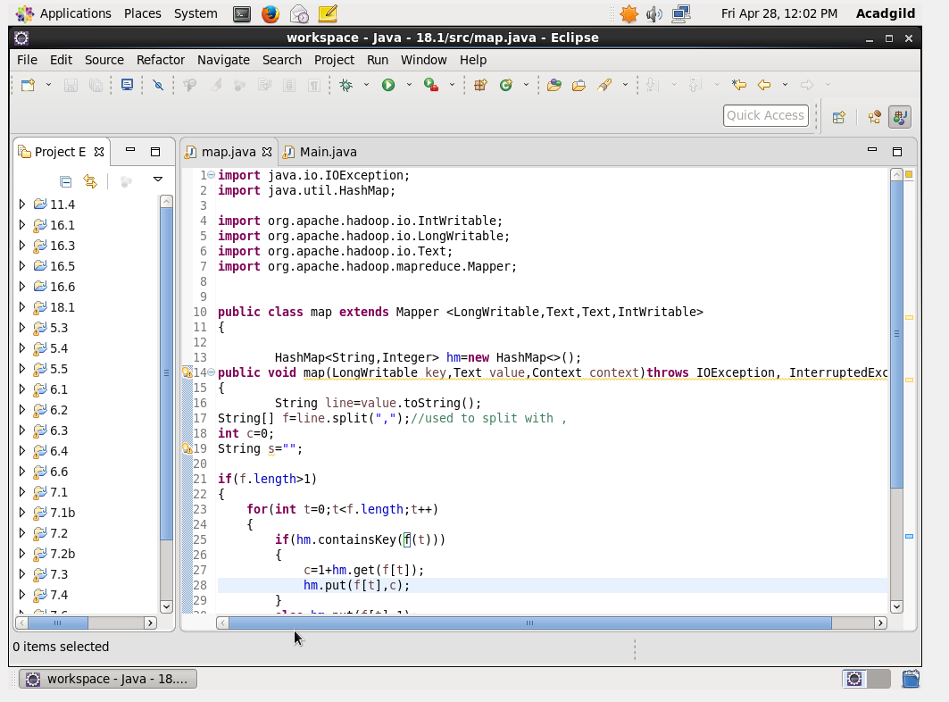

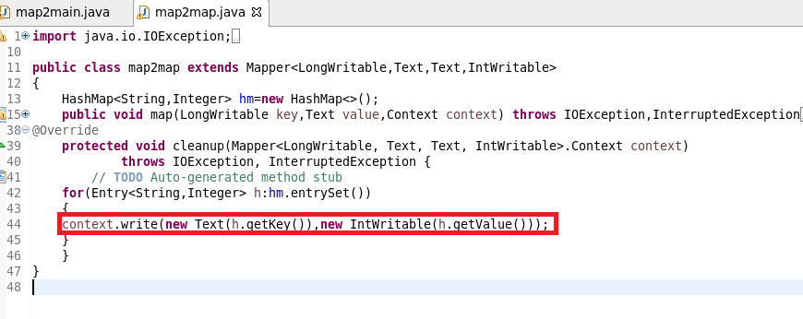

***RUNNING JAR***

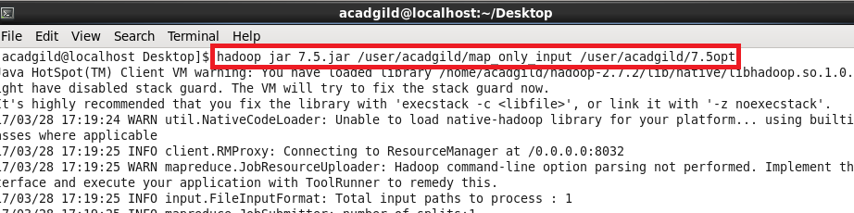

***OUTPUT***

* Text command is used to open the sequence file.

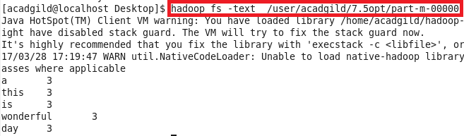

**QN2.Run the mapreduce word count program and set the number of reducers to 2 using static configurations**

***Driver***

***Here We can use SetNumReduceTasks(2)***

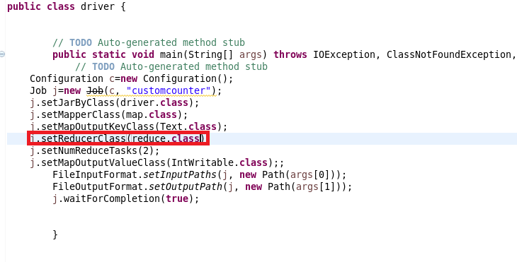

***Mapper***

send the words as key and for each key I will sent 1 as value.So that a count could be made in reducer

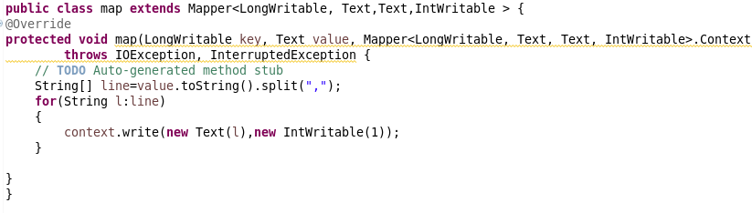

***Reducer***

Made a count of Words

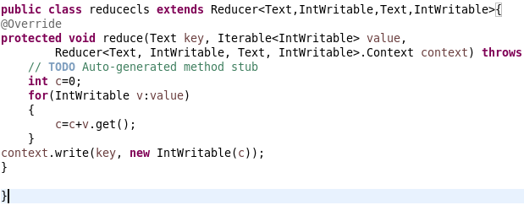

***Running Jar***

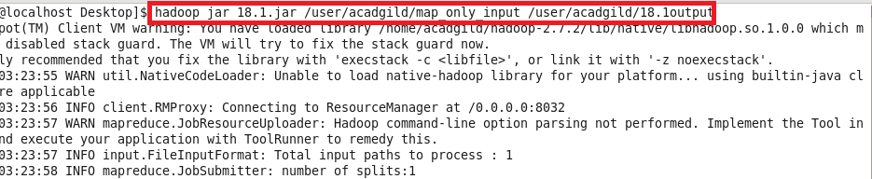

***Output***

