***Qn1.Find out the top 10 destination people travel the most***

**Driver Class**

Set 2 jobs for Top10Destination

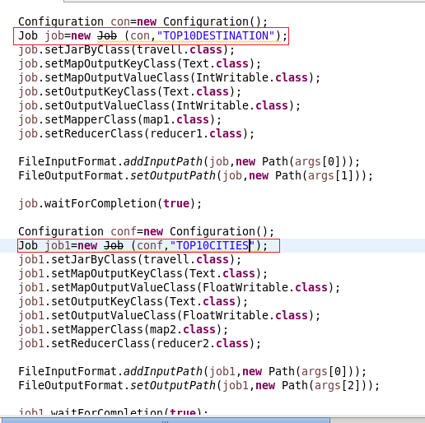

Mapper class

Top 10 destinations were selected depending upon the number of people who travel which even includes the infants.

The destination is set as key and count was made as value.

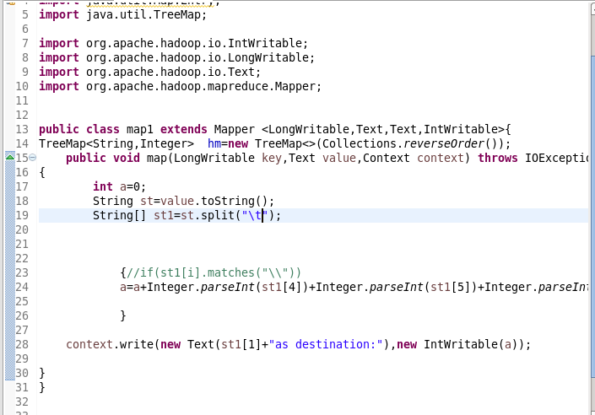

Reducer

***Overriding reduce method***

* By using reducer total one can find the count.
* Then order by is done in descending order.
* Each count is taken as key to the tree map.
* And it will be sorted in descending order.

***overriding cleanup method***

All the top 10 values will be taken and will be copies to a new tree map.

And all the values will be written.

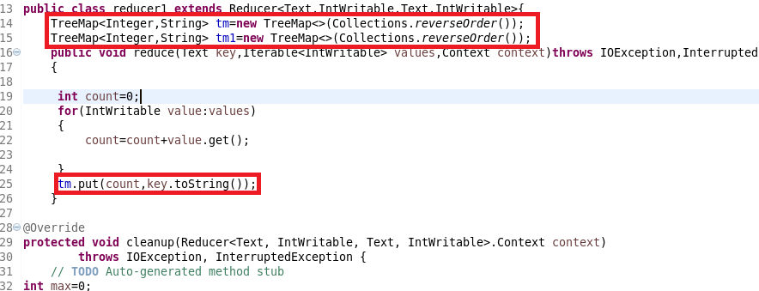

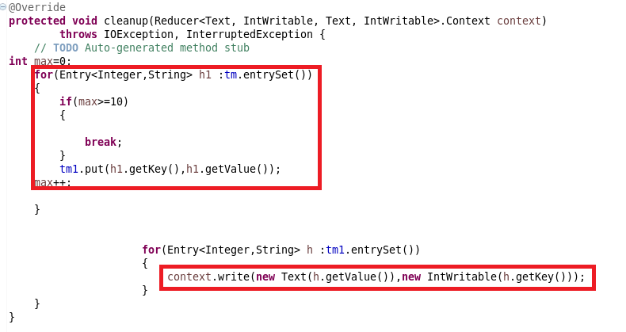

**------------------------------------------------------------------------------------------------------------------------------------------**

**QN2.Find out the top 10 cities that generate high airline revenues for travel, so that the site can concentrate on offering discount on booking, to those cities to attract more bookings.**

**Mapper2**

City is taken as key and price is taken as value.

This is done for airlines travel.

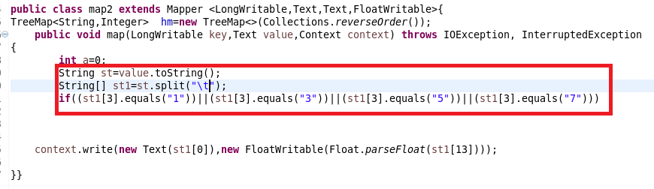

***Reducer2 :***

***overriding reduce method***

in reducer part the revenue will be calculated.

And order by desc is done.

Later the revenue will be sent as key to the tree map

Again will be sorted in the desc order.

***overriding cleanup method***

***Clean up method* :**

since we want top 10 we we will copy top 10 values into a new Tree map and the value will be written.

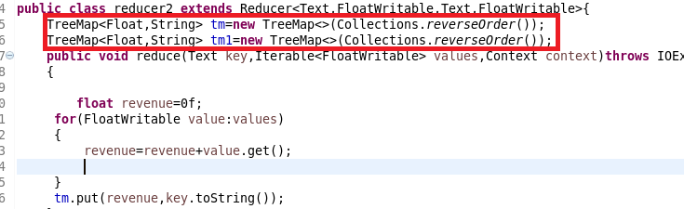

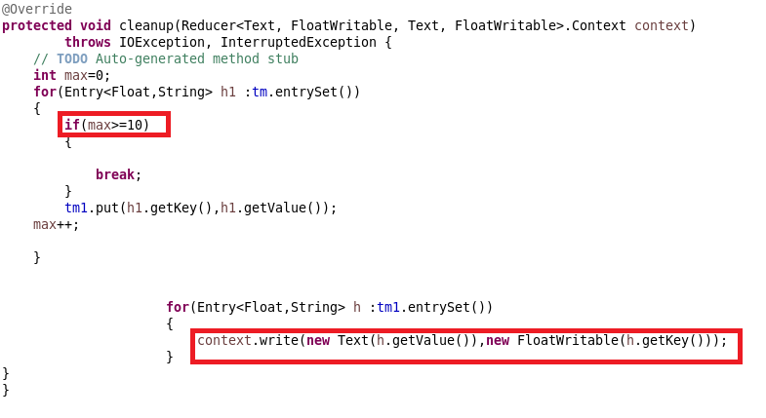

**Running JAR**

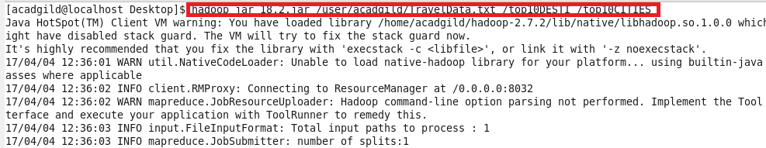

**Output for question 1**

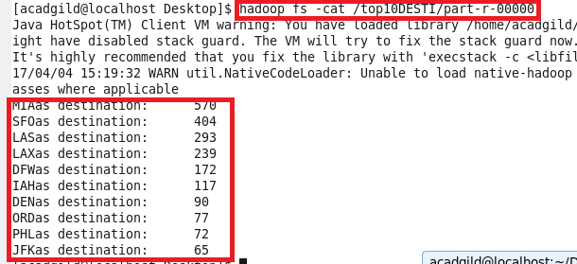

**Output for question 2**

