Assignment 18.3

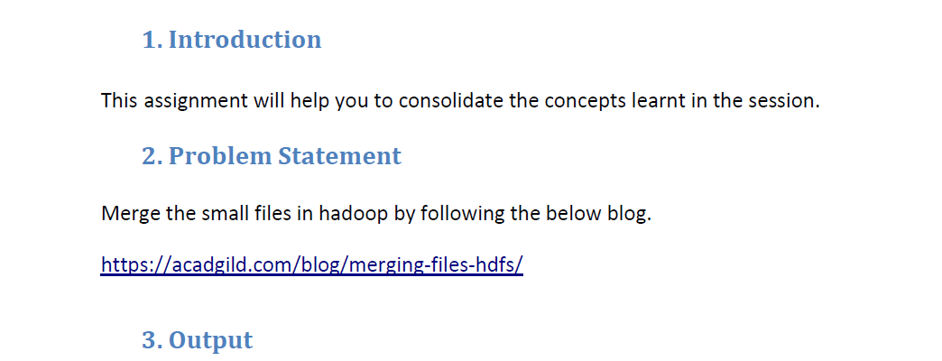

* **Merge the small files in hadoop**

We can merge the small files by using –getmerge command in Hadoop.

-nl will be used If one needs to merge two or more files which should be separated by line

***Hadoop fs -getmerge -nl <source file path> <local system destination path>***

***Input files :***

**file to be merged as well its Content were displayed by using the cat command**

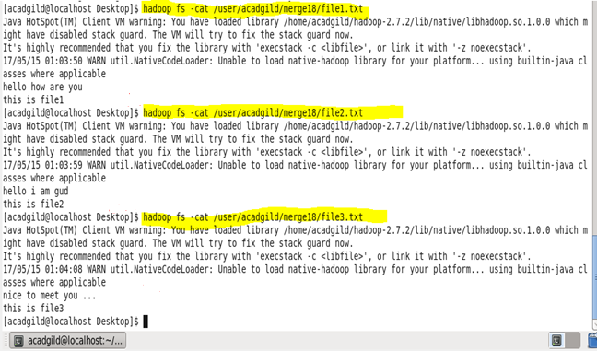

* File1, file2 and file3 were three different files used
* And here we have done merging.
* For merge operation we will copy the files to HDFS.

***Now Executing Merge Command***

*Source path- /user/acadgild/merge18/:*

Local system Destination path - /home/acadgild/Desktop/mergeout 🡪 without –nl (no line between files)

Local system Destination path - /home/acadgild/Desktop/mergeout1 🡪 with –nl (line between files)

* **To Merge files without new line**

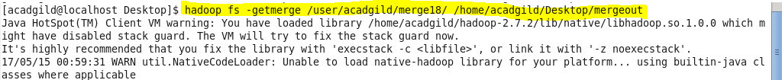

* **To Merge files with new line between files**

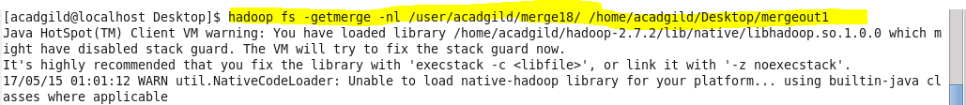

* -nl is Optional
* and will be used for adding new line in result

**Output**

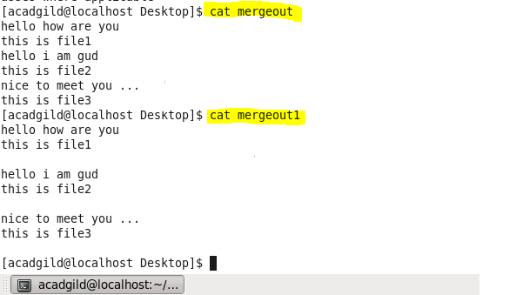

* Op1 -> merged output without using –nl (new line)
* Op2 -> merged output using–nl (new line)
* So that the small files in Input will be merged in the output folder