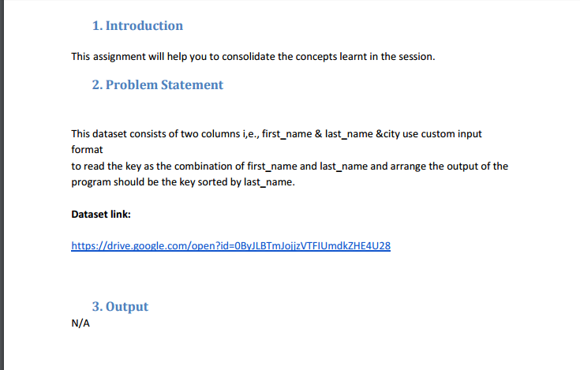

Driver:

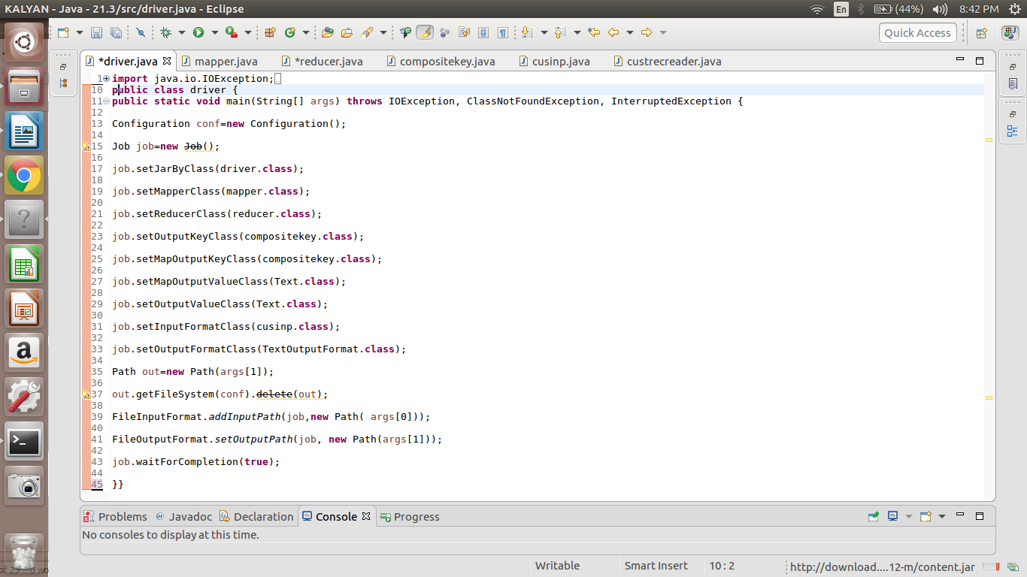

Mapper:

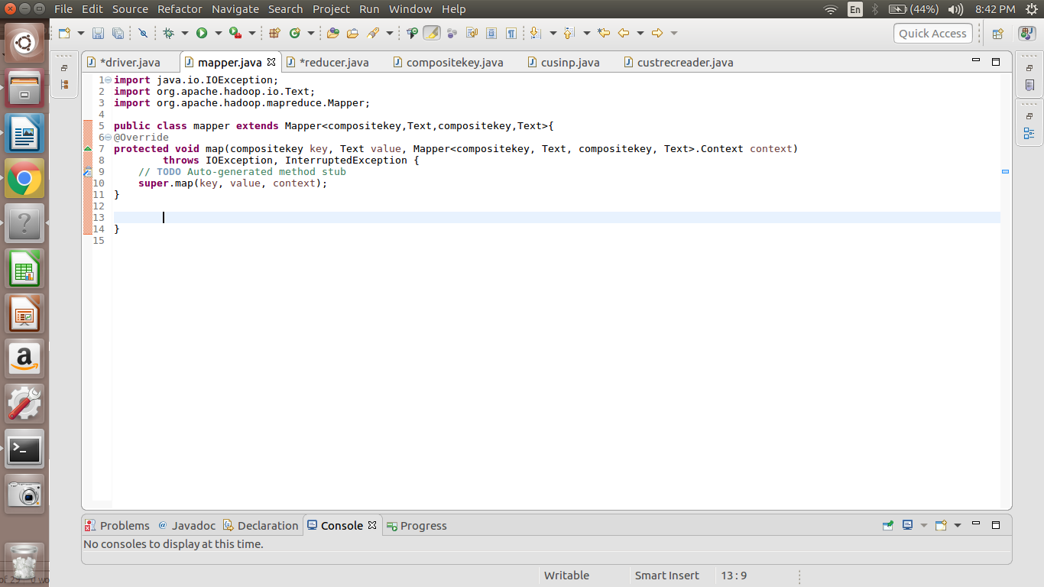

Reducer:

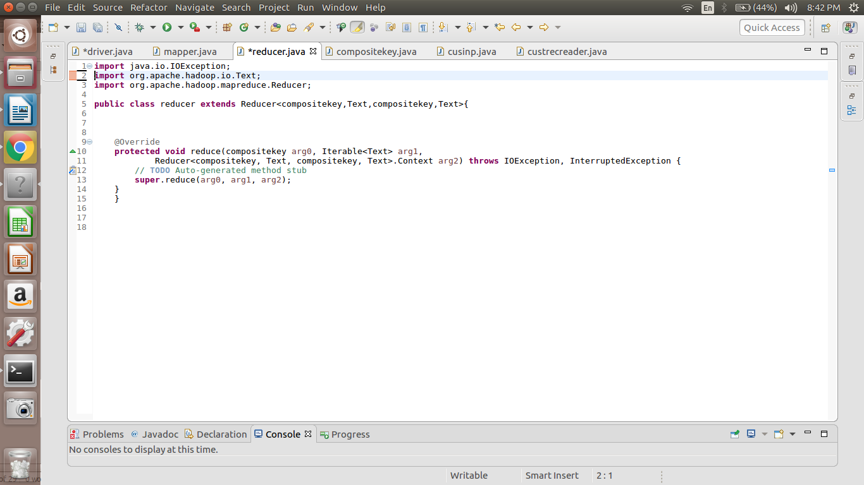

Compositekey:

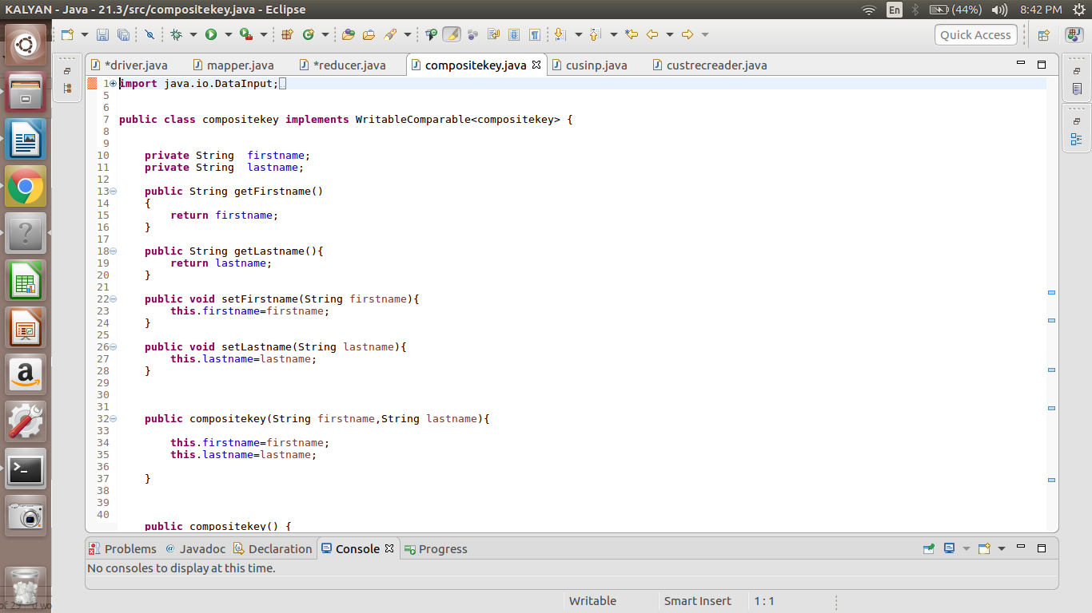

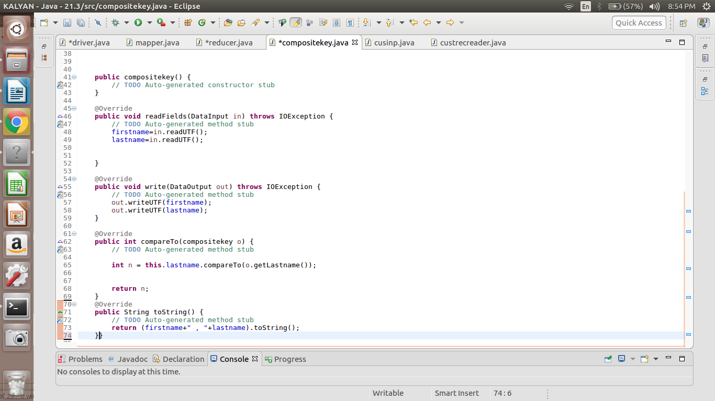

Custom input:

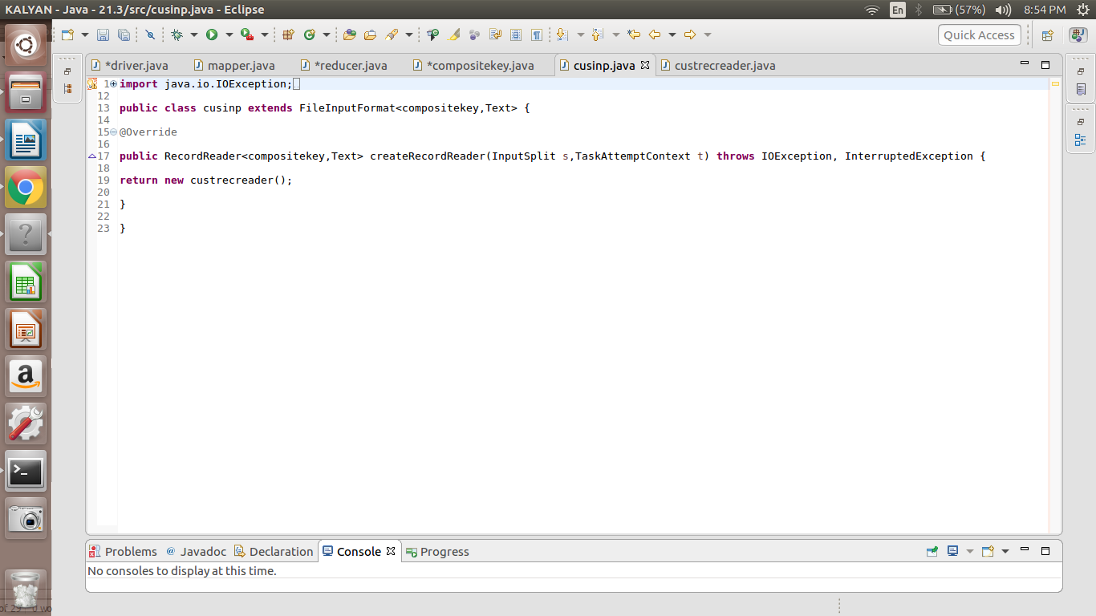

Custom record reader:

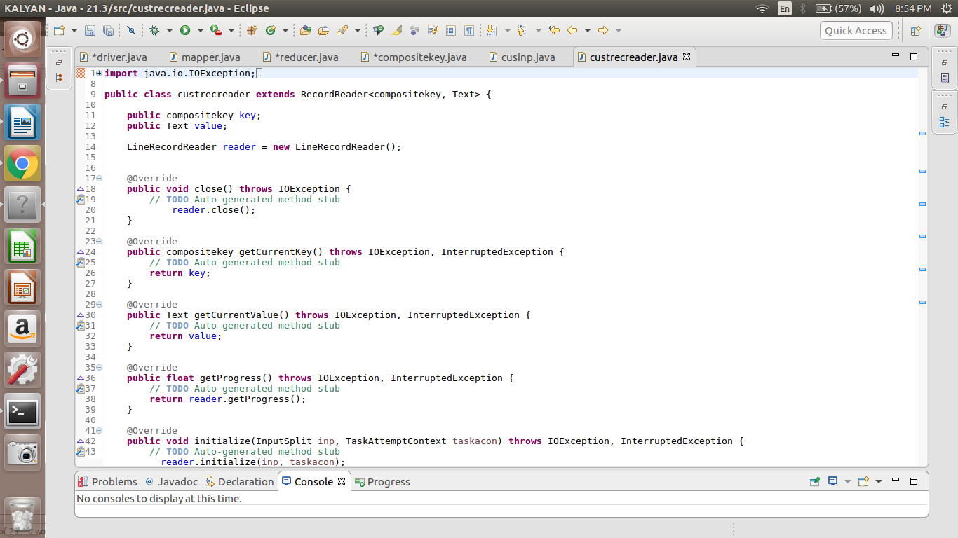

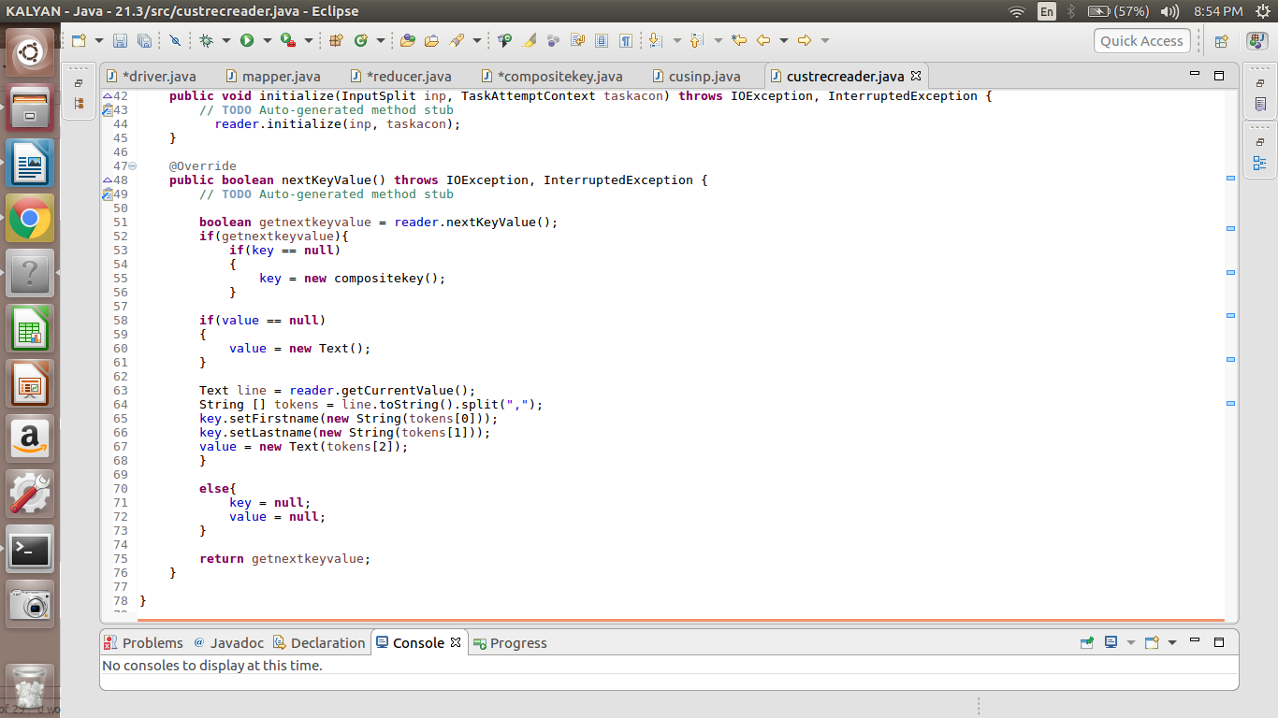

**Output:**

Jessica Adams, Azul Dorothy Adams, Al Marsá Debra Alexander, Sidomulyo Marie Alexander, Ocongate Jessica Allen, Banjar Teguan Ryan Allen, Patique Bonnie Allen, Bambang Timothy Allen, Jobabo Jonathan Allen, Zhen’an Betty Allen, Legrada Martha Allen, Niedźwiedź Kelly Alvarez, Pho Thong Tina Alvarez, Nice Eugene Alvarez, Smara Lori Alvarez, Lichtenburg Eric Alvarez, Uthal Gerald Anderson, Ilihan Arthur Anderson, Khon Kaen Jean Anderson, Lille Douglas Anderson, Zaozerne Brian Anderson, Mawlamyine Stephanie Anderson, Guanshan Roger Andrews, Guiset East Mark Andrews, Opočno Andrea Andrews, Volodars’k-Volyns’kyy Kathleen Armstrong, Keumala Gregory Armstrong, Xikou Alice Arnold, Nova Viçosa Keith Arnold, Kupang Sarah Arnold, Phùng Clarence Arnold, Guadalupe Victoria Arthur Arnold, Balazar Janice Arnold, Lepanto Martha Austin, Yoichi Martin Austin, Den Chai Teresa Austin, Pho Si Suwan Sandra Austin, Bulualto Amy Bailey, Pagak Kulon Stephanie Bailey, Cherepovets Timothy Bailey, Tazemmourt Ruth Bailey, Grand Bank Aaron Baker, Baini Scott Baker, Ferreira Gerald Banks, Npongge Paula Banks, Ponte da Pedra Clarence Banks, Cergy-Pontoise Bonnie Banks, Gandu Kenneth Banks, Xiapu Jean Barnes, Angoulême Joyce Barnes, Paris 02 Scott Barnes, Banaba Timothy Barnes, Sabanagrande Bonnie Barnes, Sasnovy Bor Mark Barnes, Klippan Bobby Bell, Tataouine Eugene Bell, Norfolk Andrea Bell, Tayuan Christina Bell, Vila Moreira Shawn Bell, Svetlyy Adam Bell, Jifarong Linda Bennett, Toyoshina Tammy Bennett, Suhopolje Phyllis Bennett, Sentul Janet Berry, Andou Gloria Berry, Tarauacá Deborah Berry, Shajing Steve Berry, Bokor David Bishop, Semerak Heather Bishop, Tandag Maria Bishop, Ridder Johnny Black, Milton Adam Black, Dongping Maria Black, Melaka Adam Black, Nyzhni Petrivtsi Pamela Black, Józefosław Jose Black, Białośliwie Martin Black, Kisovec Jose Bowman, Redon Timothy Bowman, Quetta Ryan Boyd, Cibatu Diane Boyd, Černožice Roy Boyd, Borek Wielkopolski Craig Bradley, Chongkan Randy Brooks, Songjiang Mark Brown, Shuangjiang Ralph Brown, N'Djamena Joshua Brown, Mocoa Alice Brown, Quichuay Matthew Brown, Apartadó Brian Bryant, Cruces de Anorí Frank Bryant, Jianzhatan Roger Bryant, Szeged Donna Burke, Lao Suea Kok Anthony Burke, Yangjia Thomas Burke, Millau Marilyn Burke, Vimieiro Jennifer Burke, Lidköping Kathy Burns, Illapel Judith Burns, Preobrazhenka Samuel Burns, Paringin Lisa Burton, Phoenix Elizabeth Butler, Limeira Keith Butler, Tempuran Walter Butler, Bandar Seri Begawan Christina Butler, Cachoeirinha Mildred Butler, Longjing Frances Butler, Hufang Lillian Butler, Donnybrook Mary Campbell, Uttar Char Fasson Phyllis Campbell, Urpay Gloria Campbell, Yinhedahan’er Jose Campbell, Polje Stephen Campbell, Boavista Linda Carpenter, Iperó Howard Carpenter, Shapaja Janice Carpenter, Dvůr Králové nad Labem Eugene Carpenter, Blumenau Ernest Carroll, Västra Frölunda Shirley Carroll, Tegalagung Arthur Carroll, Oskarshamn Eric Carroll, Kota Kinabalu Daniel Carroll, Benito Juarez Louis Carroll, Zamora Theresa Carroll, Gomel Carl Carter, Kurume Andrea Carter, Hödrögö Johnny Carter, Nebug Donna Carter, Acolla Michael Castillo, Guocun Patricia Castillo, Pop Shahri Donna Castillo, Ningxi Ernest Castillo, Cortes Louis Castillo, Besançon Robin Chapman, Cilebang Satu Donna Chapman, Calais George Chapman, Chumphon Buri Lois Chapman, Mirsíni Brenda Chapman, Sepīdān Janice Chavez, Zavolzh’ye Rose Chavez, Kożuchów Joyce Chavez, João Câmara Patrick Chavez, Zaña Kelly Chavez, Jōetsu Gloria Clark, Pacho George Clark, Voloshka Kenneth Clark, Pendembu Judy Clark, Gandusari Melissa Clark, Thanh Nê Heather Clark, Santo André Christopher Clark, Farriar Irene Clark, Tiebukenwusan Jeffrey Clark, Tubajon Kelly Clark, Ḩawsh ‘Īsá Martin Cole, Ussel Martha Cole, Médanos Andrew Cole, Nova Viçosa Matthew Cole, Kalinovo Ann Cole, Pulian Ann Coleman, Zhuxi Raymond Coleman, Jindayris Wanda Coleman, Gwoźnica Górna Timothy Collins, Whitchurch Ruth Collins, Pridraga Richard Collins, Libertad Raymond Cook, Guanmian Wayne Cook, Aioi Todd Cooper, Huinca Renancó Diana Cooper, Bonn Jimmy Cooper, Boshi Barbara Cooper, Yabuli John Cooper, Ðà Lạt Angela Cooper, Gakovo Henry Cox, Santa Maria Alan Cox, Xinzheng Maria Crawford, Grand Junction Nicholas Crawford, Wailolong Lois Crawford, Mogok Jeffrey Crawford, Obas Willie Cruz, Zbůch Steve Cruz, Złotów Walter Cruz, Vilhena Ryan Cruz, Úštěk Gregory Cruz, Pachīr wa Āgām Lawrence Cruz, Mouriscas Elizabeth Cunningham, Tigbao Lisa Daniels, Pingdong Sharon Daniels, Dabaozi Ann Daniels, Valencia Phillip Daniels, Hongqi Andrew Daniels, Banyo Kathleen Daniels, Mandapajaya Anna Davis, Diavatá Brenda Davis, Luzhou William Davis, Salavat Matthew Day, Heshan Ronald Day, Petřvald Stephanie Day, Ejigbo Kathy Day, Orleans Alice Dean, Boulogne-Billancourt Joan Dean, Vila Nova Sintra Donna Diaz, Tsil’na Larry Diaz, Ulundi Paul Diaz, Albuquerque Amy Diaz, Krynychky Joseph Diaz, Dahua Teresa Dixon, Williston Rachel Dixon, Huangtian Kelly Dixon, Qādirpur Rān Steve Dixon, Norabats’ Matthew Dixon, Alikalia Maria Dixon, La Concepcion Chris Dixon, Oliveira Walter Dixon, Ílion Robin Duncan, Nangahale Sean Duncan, Luxor Craig Duncan, Satuek James Dunn, El Corozo Paula Dunn, Gondang Henry Dunn, Acopampa Jeffrey Dunn, Cruz Rose Edwards, Tenri Patrick Edwards, Arbuzynka Brandon Edwards, Yanhe Patricia Elliott, Lindome Matthew Elliott, Mora Virginia Elliott, Alīpur Ann Ellis, Fuling Carolyn Ellis, Sumberan Lillian Ellis, Banjeru Alan Ellis, Bogoria Betty Evans, Dziadkowice Dorothy Evans, Bromma Jason Evans, Ängelholm Mildred Evans, Huaicheng Joseph Evans, Tsimasham Gloria Evans, Ichinomiya Walter Ferguson, Gondomar Carolyn Fernandez, Jianghai Bonnie Fernandez, Jadowniki Diana Fields, Bununu Kasa Roger Fields, Agía Paraskeví Martha Fields, Notre-Dame-de-l'Île-Perrot Ronald Fields, San Jose Joe Fields, Muleng Brian Fields, Vuzenica Kimberly Fields, Miguelópolis Ann Fisher, Извор Anna Fisher, Shengao Harry Flores, Chocope Ruth Flores, Maple Ridge Ryan Flores, Haninge Jesse Flores, Stockholm Jessica Flores, Ash Shāmīyah Michael Flores, Nouakchott Fred Flores, Seren Barat Sharon Ford, ‘Abasān al Kabīrah Donna Ford, Gorzyczki Jose Ford, Itaberaba Helen Ford, Tivat Laura Ford, Tanjungkerta Gloria Foster, Colima James Foster, Dongfeng Eugene Foster, Nijmegen Tammy Foster, Cikarang Alice Fowler, Paris 14 Jean Fowler, Los Aquijes Antonio Fowler, Siuna Lawrence Fox, Big Bend Jane Fox, Tando Jām Carolyn Fox, Clichy Mildred Fox, Łysomice Andrea Franklin, Drochia Larry Franklin, Rowokangkung Robin Franklin, Konstantinovskoye Robin Franklin, København James Franklin, Granada Michael Franklin, Krajan Menggare Catherine Frazier, Jinping Laura Frazier, Moriya Amy Frazier, Metz Justin Freeman, Krajan Dua Putukrejo Lisa Freeman, Maliq Antonio Freeman, Götene Emily Fuller, Ardirejo Julia Fuller, São Pedro Cynthia Garcia, Dijon Stephen Garcia, Cha-am Donna Garcia, Gaozhou Joe Garcia, Shouchun Thomas Garcia, Changqing Kelly Gardner, Erechim Terry Gardner, Hanamaki Kenneth Gardner, Chafé Lisa Garrett, Ruma Pamela Garrett, Cornwall Albert Garrett, Paraíso Alan Garrett, Huzhen Phyllis Garrett, Tulsa Antonio Garrett, Tanabe Diane Garza, Zürich Rachel Garza, Martensville Christopher Garza, Zográfos David Garza, Batuidu Carlos George, Independencia Angela George, ‘Amd Pamela George, Byera Village Kenneth George, Malabag Kathryn George, Azteca Brian George, Lammi Norma Gibson, San Antonio Christina Gibson, Pretoria Keith Gibson, Xin’an Rachel Gibson, Saint-Quentin-en-Yvelines Alan Gilbert, Los Angeles Fred Gilbert, Yuncao Randy Gilbert, Virginia Victor Gilbert, Kotovo Cynthia Gilbert, Nidek Jessica Gomez, Ngulahan Jean Gomez, San Marcos Norma Gomez, Jinta Christina Gomez, Ngajum Earl Gomez, Ryazhsk Timothy Gomez, Pórto Chéli Gregory Gomez, Turiys’k Kathleen Gonzales, Tawangrejo Doris Gonzales, Lélouma Joan Gonzales, Isheyevka Julia Gonzales, Ketapang Tina Gonzalez, Osby Anthony Gonzalez, Gafsa Angela Gonzalez, Altavista Rachel Gonzalez, Halton Joe Gordon, Abakan Christine Gordon, Doumé Harold Graham, Bonabéri Sandra Graham, Uijeongbu-si Frank Graham, At Tall al Kabīr Janet Graham, Korotych Thomas Grant, Phon Charoen Michelle Gray, Krajan Rachel Gray, Kebonsari Lois Gray, Toutai Keith Green, Ngujuran Gregory Green, Bezenchuk Joshua Green, Koz’modem’yansk Tammy Green, Chotcza Kathryn Green, Shangju Victor Greene, Eusébio Frances Greene, Mpophomeni Jonathan Greene, Bayeman Mary Greene, Rajsko Ruby Greene, Svyatogorsk Roger Greene, Luau Douglas Greene, Tamot Henry Griffin, Beauvais Rebecca Griffin, Dagang Cheryl Griffin, Tsurusaki Clarence Griffin, Pilar do Sul Philip Griffin, Medveđa Charles Griffin, Uppsala Gary Griffin, São Mamede Nicholas Gutierrez, Nashtā Rūd Julia Gutierrez, Huimin Brenda Gutierrez, Dehui Denise Hall, Brocēni Lillian Hamilton, Putinci Carolyn Hamilton, Dahua Laura Hamilton, Zamboanguita Amanda Hamilton, Stockholm Jane Hansen, Santo Tomas Randy Hansen, Dalsjöfors Philip Hansen, Tupiza Kevin Hansen, Horad Pinsk Billy Hansen, Jadów Lawrence Hanson, Tønsberg Adam Hanson, Calabugao Anne Hanson, Bharatpur Nicholas Hanson, Gandra Irene Hanson, Ibarra Lawrence Hanson, Banjar Tengah Robert Harper, Keli Laura Harper, Nadezhda Lawrence Harper, Kranggan Wayne Harper, Uruobo-Okija Kimberly Harper, Wang Thonglang Donald Harris, Kamal Amanda Harrison, El Tambo Dorothy Harrison, Louisville Andrea Harrison, Polonne Kenneth Harrison, Guapimirim Fred Hart, As Salţ Carolyn Hart, Stakhanov Steve Harvey, Yongfeng Wayne Harvey, Fermont Susan Harvey, Bakıxanov Anna Harvey, Bembèrèkè Tammy Harvey, Oak Bay Brenda Hawkins, São Vicente Louis Hayes, Ōita Nicole Hayes, Hongqi Shirley Hayes, Xin’an Peter Hayes, Pacarkeling Irene Henderson, Loreto Harold Henderson, Limanowa Kathleen Henderson, Arujá Fred Henry, Khabarovsk Brian Henry, Daur Fred Hernandez, Salta Beverly Hicks, Huerta Grande Jack Hicks, Tangal Helen Hill, Ōmamachō-ōmama Donald Hill, Maninihon Jean Hill, Kudang Jonathan Hill, Araxá Gregory Hill, Banakaja Samuel Hill, Haarlem David Hill, Dongxiang Carl Holmes, Borås Harold Holmes, Chon Daen Amanda Holmes, Gaocang Carolyn Holmes, Long’anqiao Chris Holmes, Urus-Martan Judy Howard, Huishangang Roger Howard, Heling Nicole Howard, Sumberpucung Jack Howard, Trat Walter Howell, Pointe-à-Pitre Andrea Hudson, Luoyang Denise Hudson, Taurisma Peter Hudson, Tanahmerah Melissa Hudson, Changtan Joe Hudson, Levallois-Perret Doris Hudson, Staraya Kupavna Nicole Hughes, Chernogorsk Helen Hughes, Dembeni Marilyn Hughes, Bečej Alice Hunt, Buan Dennis Hunt, Artemisa Betty Hunter, Lunéville Ann Hunter, Oliveira Wanda Hunter, Ishikawa Diane Hunter, Säffle Larry Hunter, Pangapisan Kevin Hunter, Sidi Slimane Margaret Jackson, Sharkawshchyna Harry Jackson, Olszanica Kathy Jackson, Xiaolong Teresa Jackson, Siva Debra Jacobs, Phù Mỹ Emily Jacobs, Patía Jean Jacobs, Wuqiao Ann Jacobs, Göteborg Phyllis James, Al Wuday‘ Dorothy James, Nkayi Christina James, Atbasar Rose Jenkins, Sidu Jonathan Jenkins, Mattawa Sandra Jenkins, Watergrasshill Benjamin Jenkins, Jawor Julie Jenkins, Pacobamba Steve Jenkins, Krebetkrajan Raymond Johnson, Ķegums Jessica Johnson, Berëzovka Louise Johnson, Yuli Albert Johnson, Cluny Larry Johnson, Smiřice Phyllis Johnson, Koina Brenda Johnston, Niamey Cynthia Johnston, Saint-Ambroise Ruby Johnston, Koski Tl Philip Jones, Yuli Eric Jones, Budënnovsk Mary Jones, Smolenskaya Ann Jordan, Maglajani Carol Jordan, Tongda Jose Kelley, Kalemie Diana Kelley, Mino Joe Kelley, Huanggu Christina Kelley, Juigalpa Dorothy Kelly, Shuitianhe Jacqueline Kelly, Laguna Limpia Roger Kelly, Paris La Défense Daniel Kelly, Zhongxin Terry Kelly, Saint-Quentin-en-Yvelines Annie Kelly, Kalá Déndra Jeffrey Kelly, Sosnytsya Patricia Kelly, Qiulu Carl Kennedy, Saihan Tal Ernest Kennedy, Jinze Christine Kennedy, Cubará Rebecca Kennedy, Waepau Randy Kennedy, Krajan Nglinggis Donald Kim, Sigou Kevin Kim, Necoclí Victor Kim, Taikang Laura Kim, Pingshan Brian Kim, Unity Dorothy Kim, Monteros Ryan Kim, Pulong Gubat Wanda Kim, Quintão Randy Kim, Agara Diane King, Qiaodong Judy King, Jaguaquara Ryan King, Kalapanunggal Linda King, Örebro Donald King, Sepekov Ann Knight, Casa Nova Samuel Knight, Oton Clarence Knight, Funehikimachi-funehiki Barbara Knight, Mantingantengah Mark Knight, Didi Lilo Sharon Knight, Tumbi Rebecca Knight, Nagu Judy Knight, Morelos Frances Lane, Le Bourget-du-Lac Patricia Lane, Campo Alegre Philip Lane, Valvedditturai Gregory Lane, Plérin Tammy Lane, Qelëz Maria Lane, Daduo Jose Larson, Shixi Gregory Larson, Pringgoboyo Ralph Larson, Mvuma Kenneth Lawrence, Navoiy Eric Lawrence, Stockholm Evelyn Lawrence, Port Colborne Christine Lawrence, Nanterre Stephanie Lawrence, Proletar Wayne Lawson, Bennäs Judith Lawson, Zhonghechang William Lawson, Kuala Bhee Eugene Lee, Aeka Douglas Lee, Telheira Melissa Lee, Kuala Lumpur Heather Lee, Danchang Andrew Lewis, Rumāh Shirley Lewis, Kotuń Scott Little, Zhongcheng Robert Little, Tanza Andrea Little, Huoshaodian Bobby Long, Paris La Défense Victor Long, Hyrynsalmi Juan Long, Velké Svatoňovice Johnny Long, Krajan Laura Lopez, Kisasa Judith Lopez, Sinanju Lori Lopez, Jinzao Marie Lopez, Tangxia Albert Lynch, Dimbokro Eric Lynch, Málaga Eugene Lynch, Sunja Cheryl Marshall, Ayna Keith Marshall, Evansville Lois Marshall, Maricá Theresa Marshall, Dadiharja Andrea Marshall, Le Mans David Marshall, Kalāt Carl Marshall, Poříčany Randy Marshall, Marovoay Anthony Martin, Gueset Carol Martin, Maceo Kimberly Martin, Estância Wanda Martinez, Paso de Carrasco Denise Martinez, Tiron Steve Martinez, Akouda Marie Martinez, Liqi Victor Martinez, Banjar Kampungbugis Henry Mason, Basseterre Alice Mason, Vukojevci Linda Mason, Brnaze Diane Matthews, Chengyang Kimberly Matthews, Nandu Kevin Matthews, Soledad Paul Matthews, Voznesen’ye Kevin Matthews, Carpiquet Irene Matthews, Talangnan Nicholas Matthews, Margotuhu Kidul Alan Mccoy, Vatutine Jerry Mccoy, Pasolapida Aaron Mccoy, Krrabë Kevin Mccoy, Daytona Beach Linda Mccoy, Toulouse Henry Mcdonald, Esil Lois Mcdonald, Kikerino Roy Medina, Duqu Jonathan Medina, Baiqi Harold Mendoza, Brahin Sandra Mendoza, Sipoholon Judy Mendoza, Beidu Janice Mendoza, Bollnäs Antonio Mendoza, Péplos Willie Meyer, Bohorodchany Thomas Meyer, Watubuku Frances Meyer, San Antonio Joan Meyer, Oskarshamn Ryan Miller, Mae Lan Marilyn Miller, Marseille Andrea Miller, Auki Arthur Miller, Zárate Rebecca Mills, Oymak Ronald Mills, Uyutne Wanda Mitchell, Vredendal Jose Mitchell, Igrejinha Margaret Montgomery, Mombok Kathryn Montgomery, Siedleczka Amy Montgomery, Jiangti Philip Montgomery, Caminauit Wayne Montgomery, Bharatpur Peter Moore, Đắk Song Edward Moore, Pandan Joyce Moore, Krasnolesnyy Kenneth Moore, Kiili Evelyn Moore, Cereté Scott Morales, Linfen Judith Morales, Aş Şūrah aş Şaghīrah Jeffrey Morales, Robīt Dorothy Morales, Charopó Eugene Morales, Milovice Carolyn Morales, Jacksonville Andrea Morales, Passos Joyce Morales, Wierzchowo Marie Morales, Booterstown Evelyn Morales, Stavropol’ Nicole Morales, Shënmëri Norma Moreno, Silago Jonathan Moreno, Pułtusk Jennifer Moreno, Jomboy Kelly Moreno, Boa Viagem Henry Morgan, Sundbyberg Anne Morgan, Ciénaga Martha Morris, Vukovar Roy Morris, Buenos Aires Louise Morrison, Chishui Jacqueline Morrison, Pilar Rachel Morrison, Strathmore Donald Morrison, San Bartolomé Milpas Altas Nicholas Morrison, Siedliska Antonio Murphy, Jinan-gun Jose Murphy, Naftalan Fred Murphy, Santana do Paraíso Laura Murray, Blagoveshchenka Keith Murray, Banjarmasin Susan Murray, Tagta Judy Murray, Longquan Phillip Myers, Shënmëri Theresa Myers, Cibitung Timothy Myers, Gansa Gary Nelson, Maayong Tubig James Nelson, Nantes Edward Nelson, Oslo Dorothy Nguyen, Cileunyi Martha Nguyen, Sŭedinenie Dennis Nguyen, Banjar Sengguan Peter Nguyen, Fengmen Terry Nguyen, Chunhu Judy Nichols, Guanajay Cheryl Nichols, Fleury-les-Aubrais Betty Nichols, ‘Izrā Philip Nichols, Nowshera Cantonment Beverly Nichols, Landvetter Frances Oliver, Pristen’ Debra Oliver, Mikun’ Jennifer Oliver, Ciawi John Oliver, Parnamirim Robin Olson, Rîşcani Laura Olson, Shangfang Edward Olson, Benito Juarez Douglas Olson, Gulou Jane Olson, Ma’an Virginia Ortiz, Ayotupas Chris Ortiz, Sukarara Utara Heather Ortiz, Zhaxirabdain Lawrence Owens, Columbus Martin Owens, Xiashixiang Catherine Owens, Tadrart Gloria Owens, Ngadri Jason Owens, Konga Justin Palmer, Niort Anna Palmer, Sutton Lillian Palmer, Bamut Howard Palmer, Ritaebang Earl Palmer, Wlingi Michael Palmer, Alcaria Karen Palmer, Qingfeng Juan Parker, Luqa Pamela Parker, Cauto Cristo Janice Parker, Telêmaco Borba Wayne Parker, Minas de Matahambre Michael Parker, Apaga Sandra Parker, Stráž Joshua Parker, Brwinów Gary Patterson, Cipicung Timur Marie Perez, Nikhom Phattana Robin Perez, Legionowo Martha Perez, Almirante Tamandaré Daniel Perez, Lourido Jesse Perez, Kadugedong Stephen Perkins, Ros’ Jason Perkins, Sanjiao Mary Perkins, Néa Smýrni Willie Perkins, Hengshan Beverly Perry, København Mark Perry, Överkalix Mark Perry, La Suiza Kevin Perry, Beilun Alan Perry, Durrës Adam Perry, Oropéndolas Roy Peters, Fengqiao Keith Peters, Pedamaran Charles Peters, Embu Guaçu Roger Peterson, Kristiansund N Judith Peterson, Aracataca Louis Peterson, Kavadarci Frank Peterson, Dawuhanmangli Harold Phillips, Mîndreşti Kenneth Phillips, Hŭngnam Joan Phillips, Suponevo Louise Phillips, Chapayevka Frank Phillips, Yong’an Jessica Phillips, Rio Claro Michelle Pierce, San Juan de Manapiare Ashley Pierce, Robertsfors Carolyn Pierce, Jinping Rose Pierce, Weishan Roy Pierce, Severnyy Carolyn Pierce, Bendo Cynthia Porter, Piracicaba Ernest Porter, Shiḩan as Suflá Denise Powell, Goiás Michael Powell, Phan Thong David Powell, Wołczyn Sharon Price, Vila Chã Andrew Price, Xumu Gloria Price, Marabá Joe Price, Verkhovyna Bruce Price, Norak Dennis Ramirez, Kamnica Doris Ramirez, Kremidivka Amanda Ramirez, Jishigang Dorothy Ramirez, Oke Mesi Joseph Ramos, Tsibulev Louise Ramos, Putatbasiun Kimberly Ray, Yangzhuang Mary Ray, Tres Isletas Judy Ray, Villa Santa Rita Mark Reed, Peña Anna Reed, Campinho Susan Reed, Kónitsa Joan Reid, Hobo Jonathan Reid, Zhangxiang Ernest Reid, Sävedalen Eric Reyes, Pakokku Steve Reyes, Taihe Chengguanzhen Jennifer Reynolds, Baoluan Jean Rice, Yuscarán Phyllis Rice, Maguilling Carlos Rice, Kaya Deborah Richards, Bilajari Ruby Richards, Barroco Paula Richards, Nanhu Gary Richards, Płock Edward Richards, Pittsburgh Catherine Richards, Dapeng Michelle Richards, Daloa David Richards, Springfield George Richardson, Jepat Kidul Roger Richardson, Nanger Catherine Richardson, Radès Wayne Richardson, Toktogul Barbara Riley, Kosh-Agach Anne Riley, Dom Pedrito David Rivera, Helsingborg Andrea Rivera, Mallow Beverly Roberts, Lianglin Phillip Roberts, Sembalunbumbung Charles Roberts, Porsgrunn Brenda Roberts, Chư Prông Jennifer Roberts, Lidzbark Steven Roberts, Caimitillo Larry Roberts, Nizui Walter Roberts, Luoluopu Betty Roberts, Kloangrotat Andrew Robertson, Qarāwat Banī Zayd Heather Robertson, Al Fashn Clarence Robertson, Bago Timothy Robinson, Wutumeiren George Robinson, Kumbo Evelyn Robinson, Mahébourg Ernest Robinson, Stara Kornica Kimberly Rodriguez, Xixiang Johnny Rogers, Fosca Marilyn Rogers, Prokhorovka Ashley Rogers, Svetlyy Carol Rogers, Mandal Harold Romero, Rybatskoye Pamela Romero, Valparaíso Kathryn Romero, Tungoo Katherine Rose, Warnes Louise Rose, Buštěhrad Jerry Ross, Segezha Bonnie Ross, Gueltat Zemmour Cheryl Ross, Wakefield Harold Ross, Nago Robin Ross, Malausma Kidul Paula Ross, Bondoukou Jose Ruiz, Delmiro Gouveia Jack Ruiz, Nogent-le-Rotrou Howard Ruiz, Denver Juan Ruiz, Burnaby Ashley Ruiz, Bulakan Raymond Ruiz, Nagqu Frances Russell, Fayaoué Ruby Russell, Saubara Evelyn Russell, Kalengwa Samuel Russell, Calasgasan Shawn Russell, Dengmingsi William Russell, Yaozhou Jeffrey Ryan, Tomaševac Edward Sanchez, Ongi David Sanchez, Igreja Rachel Sanchez, Osypenko Sara Sanchez, Brikcha Lori Sanchez, Nashville Jerry Sanders, Lhabupu Angela Sanders, Nakhon Si Thammarat Christine Sanders, Jahrom Norma Sanders, Caherconlish Willie Schmidt, Waipawa Albert Schmidt, Ekibastuz Nicholas Schmidt, Palopat Louise Schmidt, Bol’shoye Selo Janice Schmidt, Jiaoqiao Thomas Scott, Gorzyczki Betty Scott, Labog Steve Scott, Celorico de Basto Katherine Scott, Burgaltay Nicholas Shaw, Svitlovods’k Deborah Shaw, Bijeli Martha Shaw, Totoras Charles Shaw, Celorico de Basto Phillip Simmons, Dashiren Thomas Simmons, Baishan Judy Simmons, Igrejinha Carolyn Simmons, Tian’an Michelle Simmons, Tanjungsari Barat Frances Simmons, San Francisco Joan Simpson, Povedniki Sarah Simpson, Khovd Beverly Simpson, Bethlehem Sara Simpson, Asquipata Edward Sims, Dahao Steven Sims, Santa María Ixhuatán Victor Sims, Villeneuve-la-Garenne Janice Smith, Banyumas Adam Smith, Bol’shoye Skuratovo Louise Smith, Zhanjia Billy Smith, Dzoraghbyur Lawrence Snyder, Batagay-Alyta George Snyder, Pérama Albert Spencer, Baiguo Eric Spencer, Rajhradice Kevin Spencer, Sitiarjo Helen Spencer, Los Nogales Robin Spencer, Paris 09 Chris Spencer, Hangzhou Kathy Stanley, Kedatuan Donna Stanley, Laocheng Michelle Stanley, Ramat HaSharon Betty Stanley, Altanbulag Lisa Stanley, Sanjiazi Joseph Stephens, Tshikapa Wayne Stephens, Baláo Terry Stephens, Nakuru Jack Stephens, Novopokrovskaya Katherine Stephens, Kertayuga Stephen Stevens, Lesnoy Ruth Stevens, Verona Katherine Stewart, Plavsk Steven Stone, Chiclayo Roy Stone, Mem Martins Anne Stone, Crato Andrew Stone, Leeuwarden Ronald Stone, Gouping Joseph Sullivan, Tinabogan Helen Sullivan, Kuteynykove Tammy Sullivan, Maranura Jeffrey Sullivan, Bayabas Andrea Taylor, Mabasa Helen Taylor, Almeirim Richard Taylor, Ciperang Debra Taylor, Murmashi Paul Taylor, Odeleite Irene Taylor, Bertioga Mary Taylor, Kraśnik Diana Taylor, Smoky Lake Louis Thomas, Durazno Amy Thompson, Złotów Wayne Thompson, Monte Carmelo Dennis Thompson, Ar Rujum Susan Thompson, Batsari Nancy Thompson, Békéscsaba Sara Torres, Daba Nicholas Torres, Ningzhong Joan Tucker, Ban Mai Doris Turner, Kakata Jason Turner, Jingzhou Sandra Turner, Taung Ann Turner, Hamberang Sabrang Gregory Turner, Atsugi Linda Turner, Wiang Chiang Rung Keith Turner, Sieroszewice Peter Turner, Kouvola Paula Vasquez, Ol’gino George Vasquez, Prozor Jeffrey Wagner, Klwów Randy Wagner, Pergan Johnny Wagner, Sopla Julia Wagner, Santa Inês Jane Wagner, Fushan Jacqueline Wagner, Liufeng Cynthia Wagner, Concepción Mildred Wallace, Kiangan Anthony Wallace, Cola Ruth Wallace, Sakākā Ann Wallace, Intipucá Rose Wallace, Évreux Anna Wallace, Jianxin Michelle Ward, Tacoma Bruce Ward, Louisville Johnny Warren, Mansa Harry Warren, Moyynkum Johnny Warren, Santo Domingo Andrew Washington, Bender James Washington, Aromashevo Bonnie Watkins, Dahua Jeremy Watkins, Charlotte Larry Watkins, Pobral Anthony Watkins, Cran-Gevrier Jennifer Weaver, Mourelos Frank Weaver, Koreiz Carlos Weaver, Skaudvilė James Weaver, Tarnowskie Góry Rebecca Webb, Ryki Tammy Webb, Ludvika Joyce Webb, Beringovskiy Carlos Webb, Ādīs Zemen Ashley Welch, Novi Pazar Jack Welch, Strzelin Howard Welch, Vratsa Joe Welch, Albania Jeffrey Wells, Banjar Tengah Norma Wells, Xiaxi Philip Wells, Suicheng Shirley Wells, Izhmorskiy Jeremy Wells, Stari Lec Carol West, Cimo de Vila Denise West, Huangmei George Wheeler, Al Ghizlānīyah Nicholas Wheeler, Wugui Eric Wheeler, Tomelilla Shirley Wheeler, Huanghua Sara Wheeler, Souto da Casa Jack Wheeler, Saint Petersburg Clarence White, Władysławowo Richard White, Mantampay Peter White, Zhujiatai Andrew White, Gachalá Donald White, Linhó Keith White, Toroy Harold White, Tobruk Martin Williams, Itapecuru Mirim Marilyn Williams, Ujar Peter Williams, Mthatha Sharon Williams, Kigali Joshua Williams, Kedungdoro Angela Williamson, Hŭkkyo-ri Christina Williamson, Jieshi Pamela Willis, La Esperanza Frank Willis, Luchenza Irene Willis, Suhe Benjamin Willis, Wanling Evelyn Willis, Port Moody Raymond Willis, Kotel Joshua Wilson, Guanban Patrick Wilson, Bissau Amy Wilson, Jeruk Carl Wood, Qishn Jose Wood, Pawili Steve Wood, Pedra Azul Shirley Wood, El Mirador Scott Wood, Daguo Brandon Woods, Sindangjawa Joan Woods, Tampa Louis Woods, Dao’er Todd Woods, Engure Irene Wright, Galtek Rachel Young, Boise James Young, Kastsyukovichy Donna Young, Sundbyberg